How to delete third-party promotions for RJR scan Data?
- Login to BOS with your user credentials.
- On the top left side, click on three-line hamburger  menu.
- Choose a Third-party promotion option from settings.
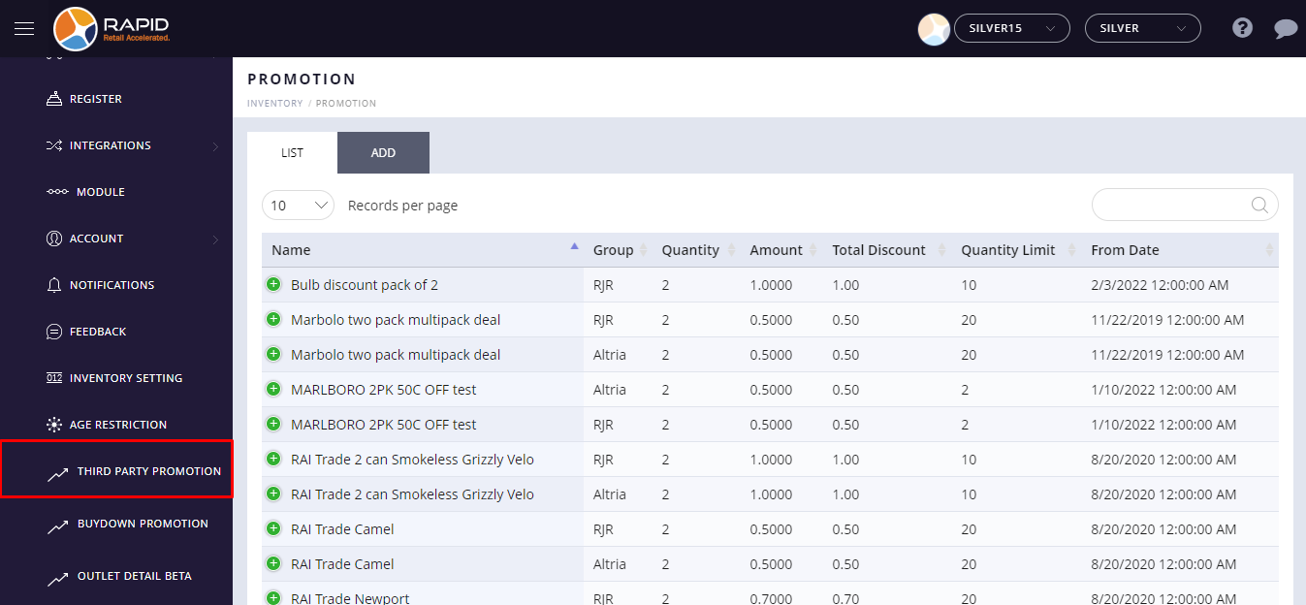

- Select the existing third party discount from the list.
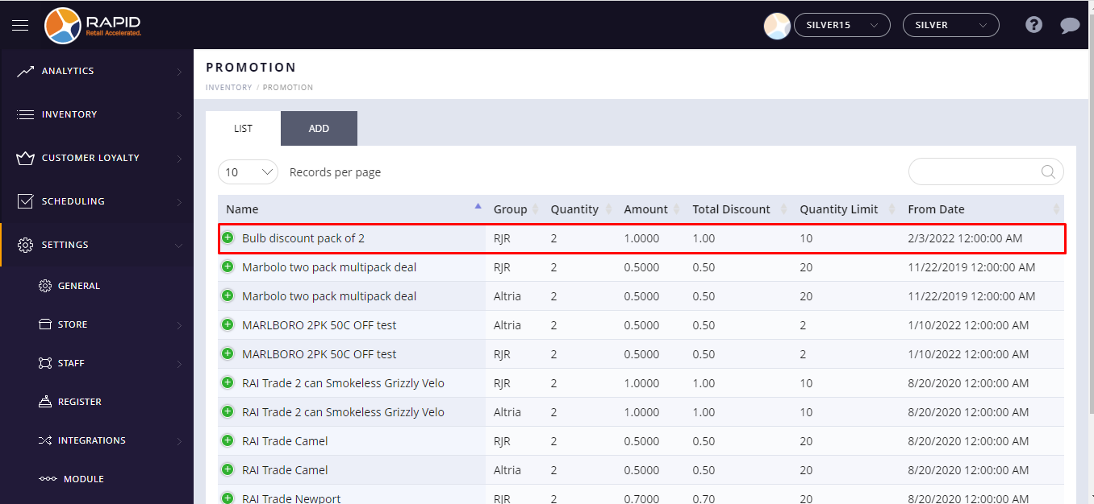

- Click on  plus button is located beside the Item name.
- Click on the action button and select the delete option from the drop-down list.
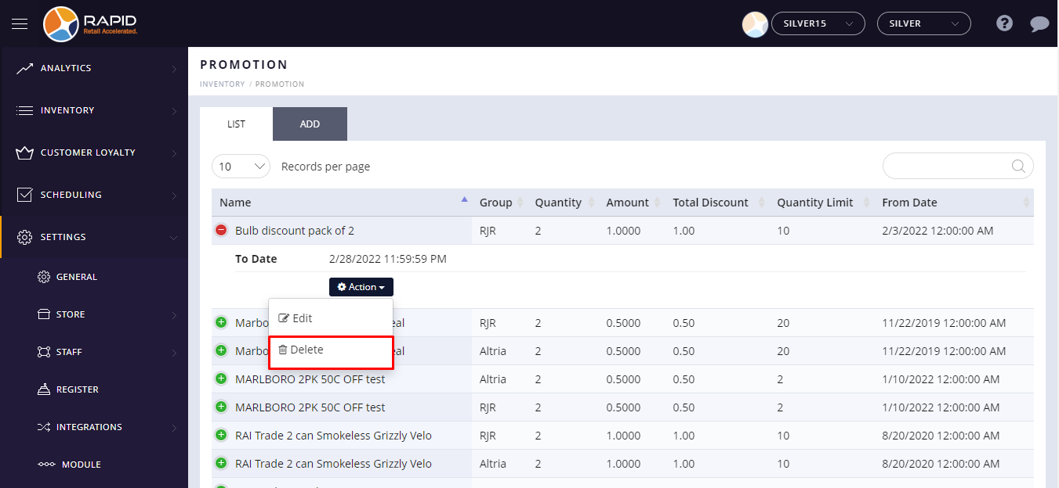
- It will not appear deleted third-party discount promotions in the list.

