How can I add the item to the back-order from receiving pending?
- When you have not received any item from the vendor and you want to purchase that item later, you can add those items to the backorder for future Purchase orders.
- At a time to reconcile order, you can add items to backorder from receiving pending option.
- Please follow the below steps:-
- Open receiving pending module.
- To open the order, click on order.
- Click on the radio button to select the item that you want to add to the back office. You can select as many items as you want.
- The backorder button will not appear in enable mode until you select any item.
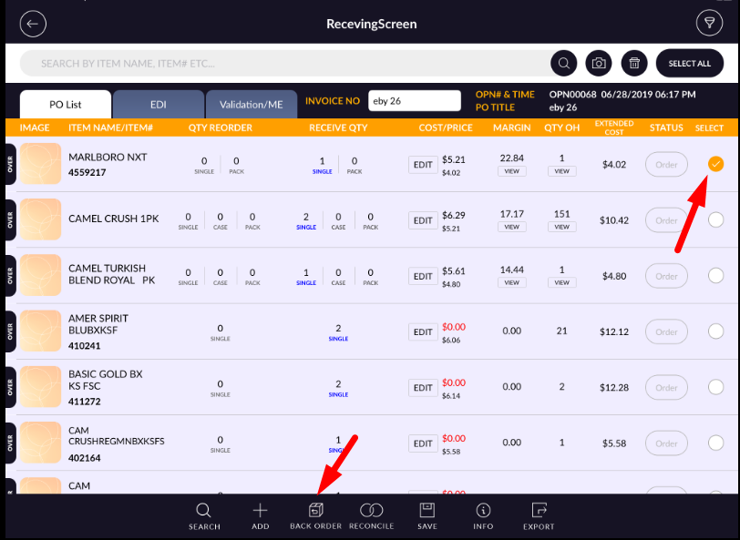

- At the bottom, click or tap on the Backorder button.
- It will appear the message to item move to backorder successfully.
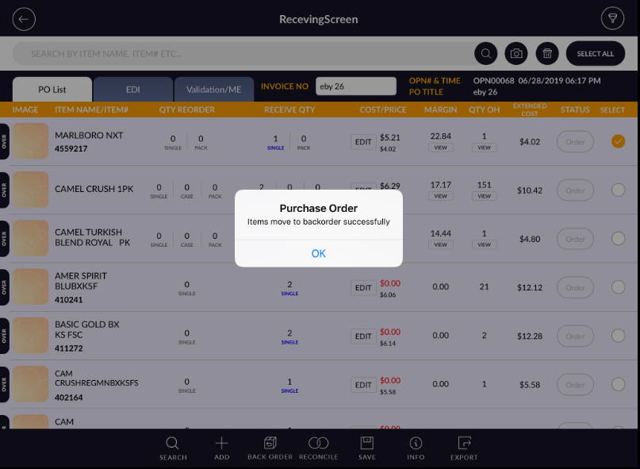
- To view the back order list, open generate order module.
- Click on the back order list.
- Added items will have appeared in the Backorder list.
