How to create a new invoice entry from manual entry?
- Open rapid RMS application.
- Open the Manual entry module from the dashboard.

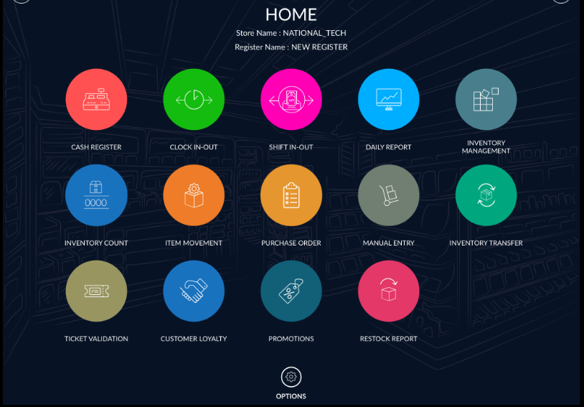
- It will appear manual entry option.
- To create a new invoice or new manual entry, click on the new option from the manual entry.
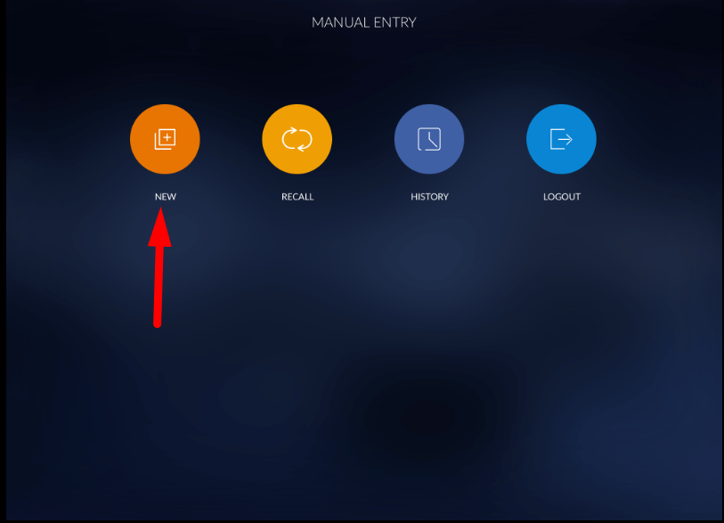

- It will prompt you to receive the info window.

Field | Definition
Receiving Date | It allows you to select a date from the receiving date picker window. Select the date on which you have received items from the vendor.
Vendor | It allows you to select a vendor from the vendor list. Select the vendor from the list.
Invoice # | It allows you to enter the invoice number.

- Select the date on which you want to receive the purchased item.
- Select the vendor from the list. The vendor field is not compulsory. If you receive purchased items from multiple vendors, you need not select a vendor from the list.
- Enter the Invoice number.
- Click on the Next button
- Enter your user-defined invoice number. You can enter alphabet or numeric values in invoice field.
- Click on the Next button.

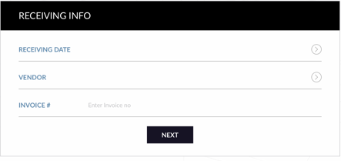
- When you click on the Next button, it will move to the manual entry page.
- It will open the new blank manual entry screen.
- There are New Item, Search, Hold, Print, Item Info, Reconcile, and Aggregate buttons available bottom of the screen.

Button | Definition
New Item | It allows you to create a new item from Manual entry. When you create a new item from manual entry, it will also be added to the item master in Inventory Management.
Search | It allows you to select an item from the item master.
Hold | It allows you to hold the manual entry.
Print | It allows you to review, copy, save, print, and share an entry on other social media apps
Item Info | It allows you to review the Invoice number, Vendor, Date received, total number of Products, and total cost of the product.
Reconcile | It allows you to reconcile or update your receiving order to Inventory.
Aggregate | It allows you to match your purchased items with all of your inventory items.

- Click on the search button to add items.
- Select items from the list which you want to add in manual entry and click on add button.
- You can also add the item to the Purchase order and print the label of which selected item from the list.

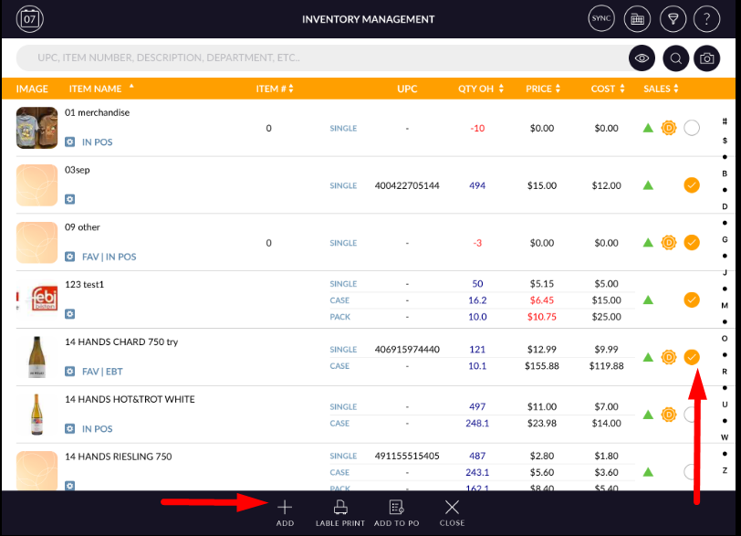

- If you have selected a vendor at invoice creation time, it will only appear item, which belongs to the selected vendor in the list or it will appear all items from the list.
- Select the items which you want to receive.
- Click on add button.
- All added items will appear in the list.
- It will appear all item details like Image, UPC, item name, Qty OH, Qty received Price, cost, and with an extended cost.

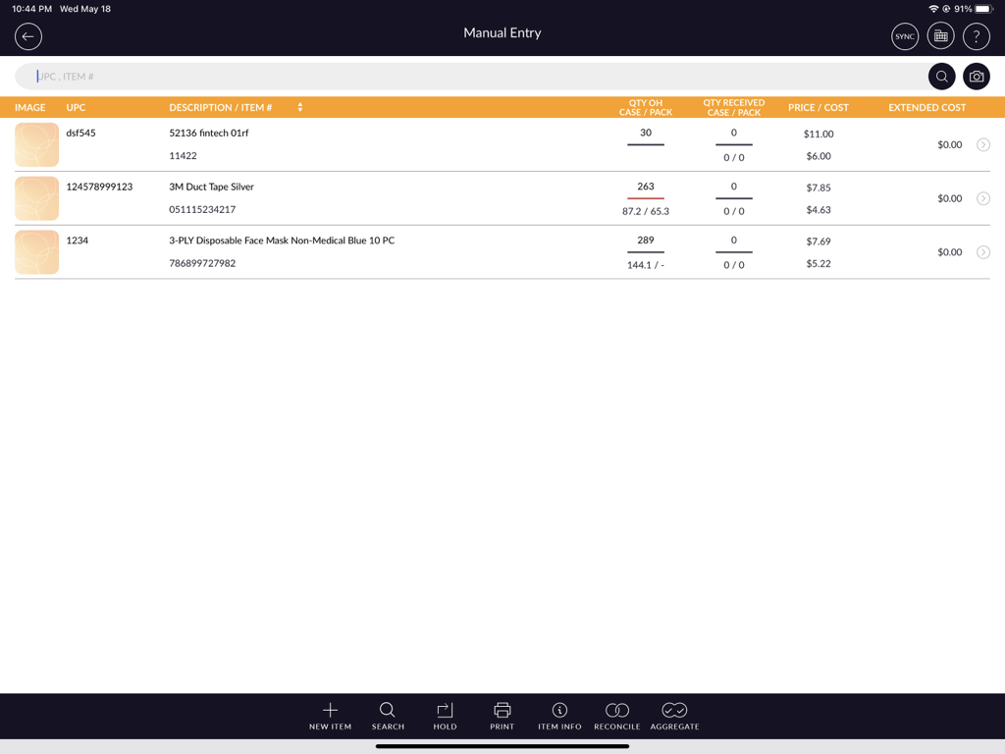
- Click on the item to add the received quantity.
- When you click on the item, it will open the item to edit mode to enter from the manual entry.
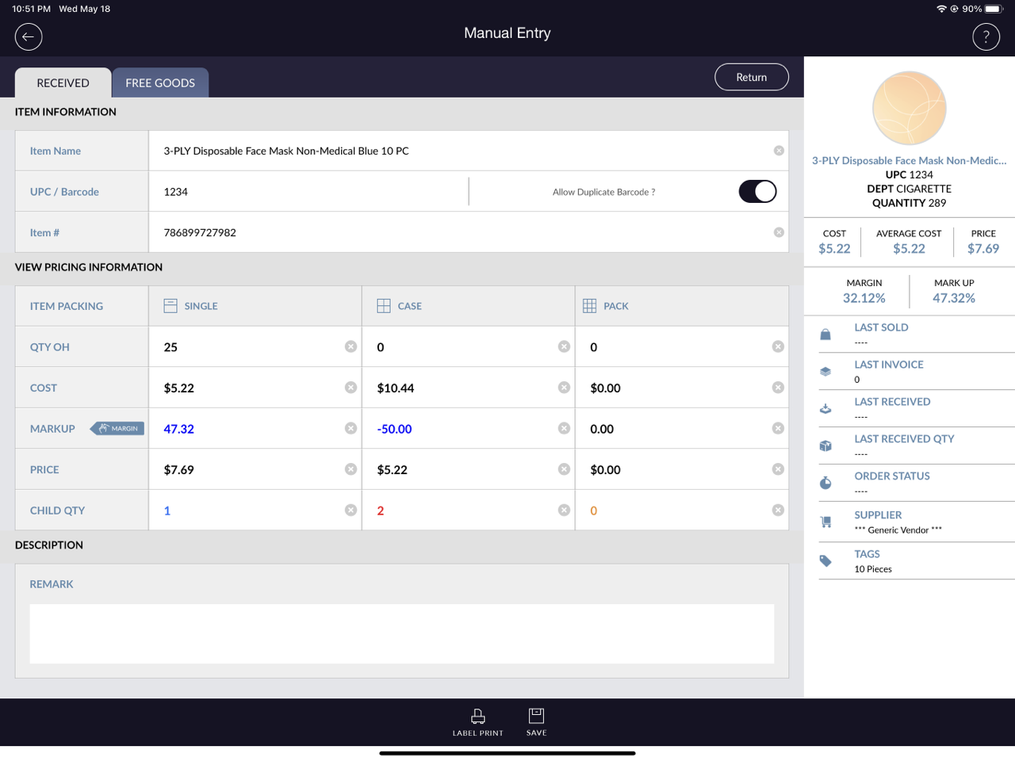
- Enter your received quantity in the QTY OH field. You can enter Single, Cash or Pack received quantity in the QTY OH field.
- At the bottom, click on the Save button.

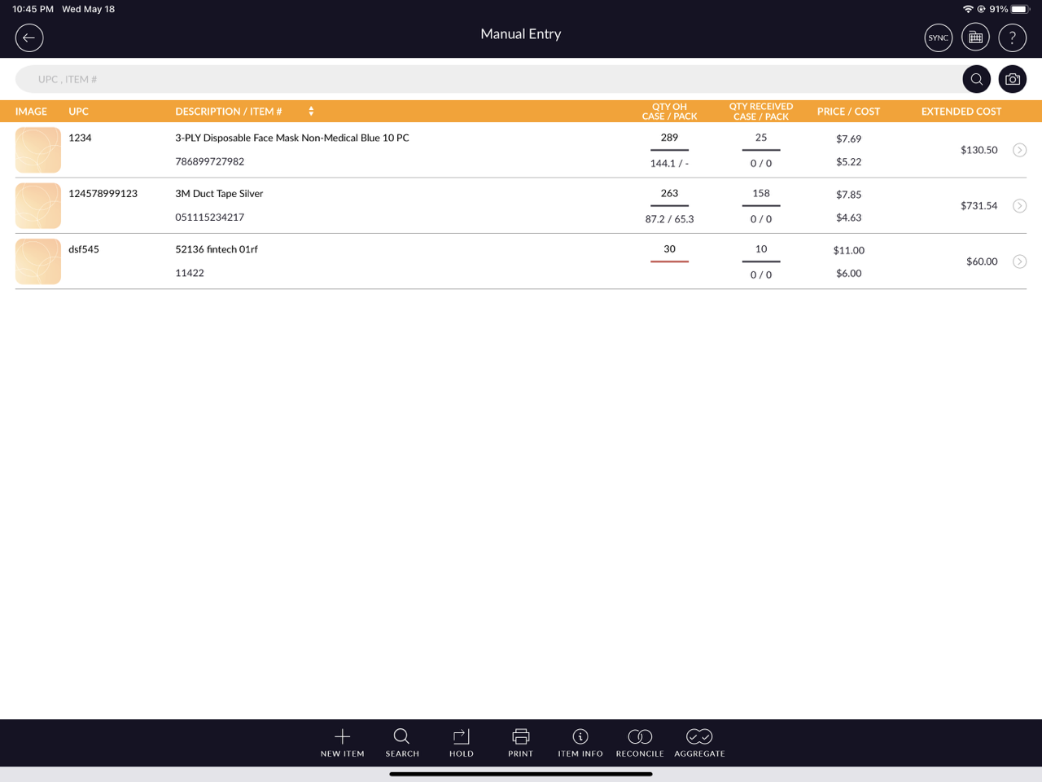

- If you want to return the item from the vendor.
- If a return is enabled then the quantity of that item would be returned from available stock and this item quantity will display with a negative sign in the invoice.
- If you want to hold the invoice, click on the hold button from the bottom bar.
- If you want to hold invoice then click on hold. The invoice will hold and display in the recall list. An invoice will stay in recall list till it not reconcile.
- After you enter all items quantity, cost, or price and want to update store click on reconcile button from the bottom bar.
- Click on Reconcile button to complete update the stock in Inventory.
- After reconciling, item stock would update in inventory.
- The invoice entry will be moved to the History section.

