How to set Emergency stopping pump?

In gas pump rapid there is one facility to stop all pump simultaneously. For that there is setting available in dispenser setting to start pump again.

- Open rapid rms application.
- Go to setting module.
- Tap on dispenser setting.
- There is section available for emergency stop.

- If option ‘auto enable all pumps after using emergency stop all pumps’ selected then after stop all pump from RCR then all pumps would be ON automatically.
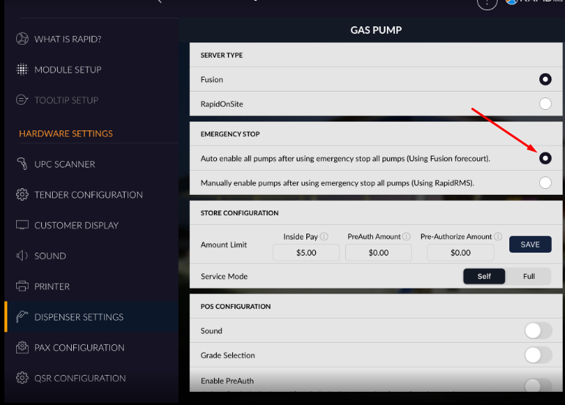

- If option ‘manually enable pumps after using emergency stop all pumps’ selected then after stop all pumps from RCR then all pumps would not be ON automatically, manually need to ON pumps.
