How can delete the item from order?

Any of the items which are available in order can be deleted.
Items can be deleted till they are in either purchase order list, open order or delivery pending list.
For delete item from order follow below procedure.
- Open any order.
- Item list would display.
- Select item(S) which you want to remove.
- Apply delete button which is available at the top of the screen.
- Till the time item not selected delete button will not enable.
- Deleted items will remove from the list.

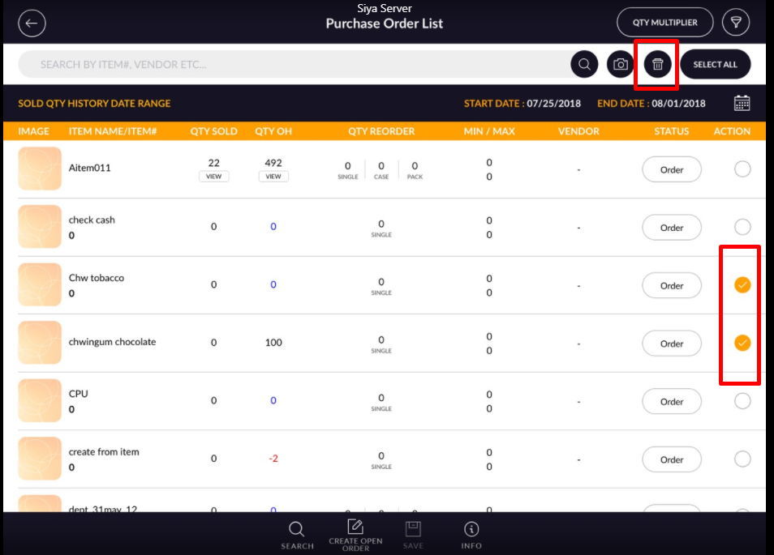

- Another way to a deleted item is swipe item.
- By swapping also item can be deleted.
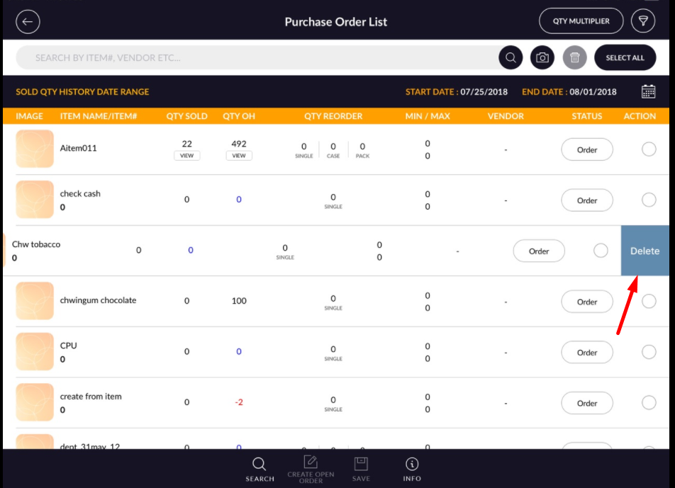

Note: This will be same for open order also.

