EXPERIMENT 6 REPORT
Employee Payroll Management System using Inheritance

Name: Nirmam Shah
PRN: __________________
Subject: Java Programming Lab
Experiment No.: 6

Aim:
To create an Employee hierarchy using inheritance and polymorphism in Java, and calculate CTC for full-time employees, contract employees, and managers based on their roles and allowances.

Classes Implemented:
1. Employee - abstract root class with common employee details and abstract calcCTC().
2. FullTimeEmployee - calculates CTC for SWE and HR roles.
3. ContractEmployee - calculates CTC using number of hours and hourly rate.
4. Manager - extends FullTimeEmployee and adds travel allowance and education allowance.

Output Screenshot:
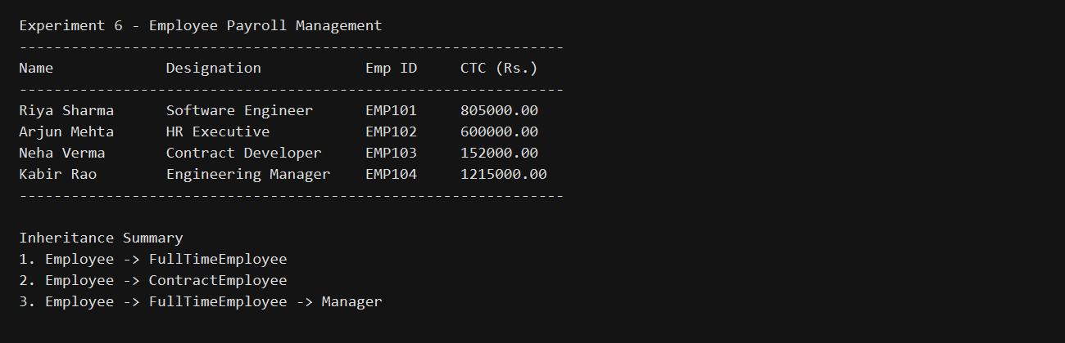

Conclusion:
This experiment demonstrates single inheritance, hierarchical inheritance, multilevel inheritance, and method overriding through a payroll management example.

