**SOFTWARE DESIGN DOCUMENT**

**FOR**

**SERIAL COMMUNICATION WITH 8051**

**MICROCONTROLLER**

|  |  |  |
| --- | --- | --- |
| REFERENCE NO. | REV NO. | EFFECTIVE DATE |
| SCW8051MC/SDD/07/20 | 01 | 22/07/2020 |
| TITLE | **SOFTWARE DESIGN DOCUMENT**  **FOR**  **SERIAL COMMUNICATION WITH 8051**  **MICROCONTROLLER** | |
| CUSTOMER |  | |
| PROJECT | SERIAL COMMUNICATION WITH 8051  MICROCONTROLLER | |
| PREPARED BY | Niranjan patil | |
| VERIFIED BY |  | |
| IV &V | Oak Systems Private Limited | |

|  |  |  |  |
| --- | --- | --- | --- |
| **Revision#** | **Date** | **Details** | **Author initials** |
| 01 | 22/07/2020 | First draft | Niranjan patil |
|  |  |  |  |

**TABLE OF CONTENTS**

1. Introduction…………………………………………………………..4
   1. Purpose………………………………………………………….4
   2. Scope……………………………………………………………4
   3. Abbreviations and Acronyms…………………………………...4
2. System Overview……………………………………………………..4
   1. System architecture……………………………………………...4
3. Software Overview…………………………………………………...5
   1. Software architecture……………………………………………5
4. Port connection.…………………………………………….5
5. Sender………..……………………………………………..6
6. Receiver…………………………………………………….7
7. **INTRODUCTION**
   1. **Purpose**

This is the standard “software design description document”. This document establishes the software design description for the “Serial communication(SC) with 8051 Microcontroller(MC)”.

Primary audiences of this document are software developers.

* 1. **Scope**

This document contains the complete description of the SC between computer and 8051 MC.

**1.3 Abbreviations and Acronyms**

|  |  |
| --- | --- |
| EBC | Ethernet based communication |
| IV & V | Independent verification and validation |
| SC | Serial Communication |
| MC | Microcontroller |

**2.SYSTEM OVERVIEW**

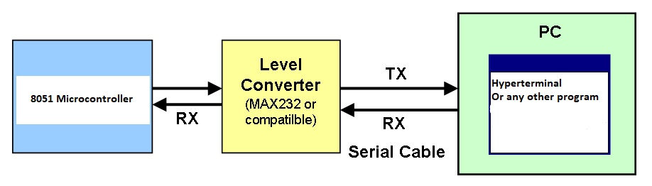

Figure: system architecture block diagram

Above figure shows the architecture of the serial communication between computer and the 8051 MC. Basically our system is running at the PC side. Once the connection between MC and PC has been established they can send and receive data each other.

These two systems communicates with the help of the intermediate called MAX232.

Here the MAX232 is the gate between these two systems it will collects the data from the PC and send to the MC and it can also collect the data from MC and send it to the PC.

System should provide an space for the user sitting on the PC side to enter there data, for that our system should provide the console window to enter the data.

Similarly the user should able to see the received data/message on the PC side, for that our system should display what ever data it has received on the console window.

1. **SOFTWARE OVERVIEW**

* 1. **Software Architecture**

Software architecture is divided into three parts

1. Port connection
2. Sender
3. Receiver
4. **Port connection**

stop

Disconnected

CONNECTED

If the connection is OK

Open the port

Input port number and baud rate

start

No

Yes

The above flow chart describes, how the opening of the communication ports happens in the system. System will opens the specified com port and configures it with the specified baud rate.

1. **Sender**

stop

Collect data to send

Initialize serial port

NO

Finish data transmission?

Yes

yes

The sender waits for the user at the console window to enter the data one the user entered and pressed the enter the data will transmitted to the MC via the MAX232.

This sender waits for the user to enter the data.

1. **Receiver**

The receiver waits for the incoming data from MC. If it is received any data it will immediately displays it on the console window.

Show on console

Received the last bit? transmission?

received data from MC

Initialize serial port

NO

Yes

Stop