

Summer Internship
(07/05/2025 to 14/07/2025)

Name: Nirupam Mondal
Adm. No.: 22JE0631
Mechanical Engineering
(Mining Machinery Engineering)
Guide: Mr. Javed Akhter

Variable Energy Cyclotron Centre
Department of Atomic Energy (Govt. of India)
Kolkata, India

About:

Variable Energy Cyclotron Centre (VECC) is a premier research and development unit of the Department of Atomic Energy, Government of India.It performs research in basic and applied nuclear sciences and development of the latest nuclear particle accelerators. It has a collaboration with the European Organization for Nuclear Research.^{[2]} The Centre houses a 224 cm cyclotron—the first of its kind in India—which has been operational since 16 June 1977.^{[3]} It provides proton, deuteron, alpha particle and heavy ion beams of various energies to other institutions.
At present VECC has 3 operating cyclotrons. K130 Cyclotron has been operating since 1977, K500 Superconducting Cyclotron has been delivering heavy-ion beams to the users for basic science research and 30 MeV Medical Cyclotron has been operating for the production and delivery of radiopharmaceuticals to the hospitals for cancer diagnostics, as a societal services to the nation by the DAE.
The importance of the Cyclotron for research in nuclear physics was conceived by Dr. Homi J. Bhabha in 1965 and the K130 machine similar to LBL K130 machine was decided upon. The activity at Kolkata (the then Calcutta) started in 1969 by BARC. The machine was commissioned in 1977 and the first beam of alpha particles came out on 16th June, 1977.
Over the years the expertise grew in other fields of science like accelerator design and related technology development, cryogenics, detector development and VECC emerged as a hub for international collaboration in High Energy Physics and accelerator technology. VECC has active collaborations with CERN, BNL, FAIR, TRIUMF, RIKEN, GANIL, DUBNA.

Project:

Design and simulation of liquid target for the production of F18 isotope using 18 MeV proton beam.

Abstract:
The design and simulation of a niobium-based water target for the production of hydrous 18F isotopes through proton irradiation of 18O-enriched water, with a particular focus on thermal engineering aspects. The target is designed to operate at high proton beam currents (up to 50 µA, 18MeV) and elevated pressures (up to 2.7 MPa) while ensuring efficient heat dissipation and structural integrity. To optimize thermal performance under high-energy proton bombardment, computational fluid dynamics (CFD) and finite element analysis (FEA) simulations were extensively employed.

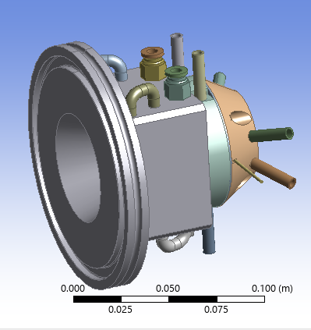
INTRODUCTION :
The production of fluorine-18 (18F) from oxygen-18 (18O) water targets is crucial for nuclear medicine, particularly positron emission tomography (PET) imaging. 18F is widely used as a radiotracer due to its favorable half life and decay properties. The process involves irradiating 18O-enriched water with high-energy protons, triggering a nuclear reaction that produces 18F. Optimizing this production process enhances isotope yield, ensuring a stable supply for clinical applications.
The project is based on design of a compact, high pressure, high-yield 18O-enriched water target, emphasizing thermal aspects.

BACKGROUND:
There are many medical imaging techniques used today. Most of these techniques look at the internal anatomical structure of the body. Other techniques emphasize imaging of metabolic functions. One such method used in the diagnosis of cancer is Positron Emission Tomography (PET). PET is a technique that takes advantage of radionuclides and radiolabeled com pounds, in particular, fluorine-18 (18 9F). Fluorine-18 decays by positron emission with a half-life of 109.7 minutes. The positron travels a short distance while slowing down until it combines with an electron. This annihilation reaction results in the emission of two 511 keV photons 180 apart. The detectors in the PET scanner detect these photons, and, if they occur in coincidence, those data are recorded. [4] The 18F radionuclide is injected into the patient as a form of sugar. This radi olabeled sugar, 2-deoxy-2-[18F]fluoro-D-glucose (18FDG), is metabolized by the cells in the body. Since cancer cells metabolize sugars much faster than healthy cells, the concentration of 18FDG is greater around cancer or pre-cancerous cells. Besides hav ing the ability to locate tumors, which many medical imaging techniques can do, this 2 procedure also locates metabolic activities which occur prior to anatomic changes. This allows for earlier diagnosis and treatment. [4] One of the advantages of PET technology is its use in detecting breast cancer at an earlier stage than is possible through conventional imaging techniques. Studies have shown that 93% of PET scans are true positives, as compared to 78% for conventional scanning techniques. These studies also have shown that PET gives a lower false positive, 16%, compared to 34% with conventional imaging. This allows for earlier and more accurate detection and specification regarding what type, and if, treatment(s) should be used. [6] The 18F radionuclide used in PET imaging is commonly produced through the 18O(pn)18F reaction, where the high energy protons are produced in an accelerator. The protons are accelerated above the reaction threshold energy of 2.4 MeV and directed into an 18O enriched liquid water target. The heat generated from the protons slowing down must be removed to prevent target boiling which can lead to over pressurization of the target and/or voiding of the beam strike volume. Development of targets with greater heat removal capabilities is an active research area.

YIELD :
The yield experiment evaluated the production capabilities of the target. Since natural water contains 0.2% 18O, the 18F isotope could be produced and its activity measured. Knowing the beam current, initial activity and the time irradiated, the expected saturation yield of 18F can be determined. The measured activities of the natural target water after irradiation are presented in Table 5.3. The decay time was chosen to allow short lived isotopes, predominantly 13N and 15O, to decay leaving 18F as the only significant decaying isotope present. The initial 18F activity was estimated to be about 4734 Ci.
The theoretical saturation yield of 18O(pn)18F with 18O2 gas at 27 MeV is 440.7 mCi/A. For 100% 18O water, the theoretical yield is decreased by 17% to 365.8 mCi/A. [3] The initial activity of the fluorine isotope was corrected for not being at saturation conditions. This was done by determining the concentration of 18F, NF, as a function of time.
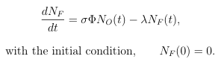
Assuming the 18O concentration does not change during irradiation then utilizing an integrating factor, becomes
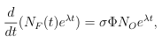
which gives the analytical solution of
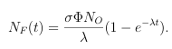
The saturation factor, which accounts for not being at saturated conditions is
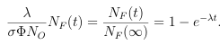
After 30 minutes of irradiation, the saturation factor using was 0.1722. The measured activity at end-of-beam, EOB, was corrected by the saturation factor to 2.74104 Ci. By dividing by the beam current and accounting for only 0.2% of the target water containing 18O, the actual saturation yield becomes 342.1 mCi/ A. This actual yield was then compared to the theoretical yield of 365.8 mCi/ A, with a relative difference of 6.5%.

TARGET ASSEMBLY DESIGN :
Figure 1 presents the exploded view of the 3D model of the target assembly. The front of the target has a cylindrical shape, while the back is fan-shaped. The target chamber has a depth of 5 mm and a total volume of 1.6 mL (with 1.27 mL active volume). The target chamber is machined from niobium, chosen for its high melting point, resistance to chemical contamination, and favorable nuclear activation properties, ensuring consistent 18F yields. The target volume is accessed via two stainless steel tubes brazed to the cavity. Active cooling is achieved by water flow within a copper cooling cavity at the back. A Havar foil serves as a beam window, separating the accelerator vacuum from the target chamber. The foil is mounted on a 12 mm thick aluminum grid with hexagonal windows (3.5 mm across flat, 0.25 mm septa), actively cooled by two parallel water lines. The grid is designed to withstand 2.7 MPa bursting pressure for a 0.025 mm Havar foil. The target cavity and grid design are similar to the work of Jonathon A. Nye [2]. A collimator directs the proton beam onto the target. The modular design facilitates easy replacement of the target body and foil, enhancing versatility for various isotope production applications. This design highlights the importance of thermal stability, and underscores the critical role of CFD-FEA simulations in the engineering of compact cyclotron targets for radiopharmaceutical production.

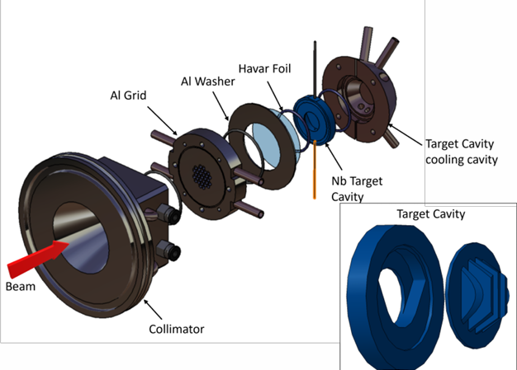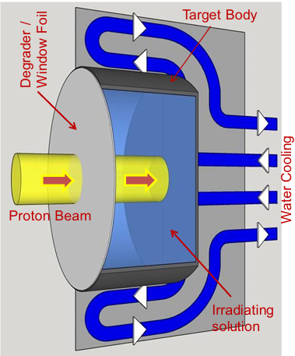
Figure 1: Exploded view of the 3D model of the target assembly.

SIMULATION :
The below table summarizes the fraction and total energy deposited in each target component for an incident beam current of 50 µA. These energy deposition values serve as input for the thermal analysis of the target assembly.
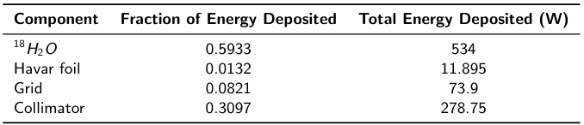

TARGET THERMAL SIMULATION :

• Phase change and temperature rise within the target is modelled using transient CFD thermal analysis in Ansys Fluent.
• The Eulerian multiphase model in ANSYS Fluent, incorporating a thermal phase change model, simulates boiling.
• The k −ϵ turbulence model is used for turbulence modeling.
• The liquid phase is modeled at a constant saturation temperature of 500 K.
• The vapor phase follows the Redlich-Kwong equation of state.
• Energy deposition is applied as a volumetric heat source.
• Cooling water flows at the back of the niobium cavity.
• A separate CFD simulation determines the heat transfer coefficient for a 10 LPM cooling water flow, which is applied as a boundary condition in the simulation of the target.

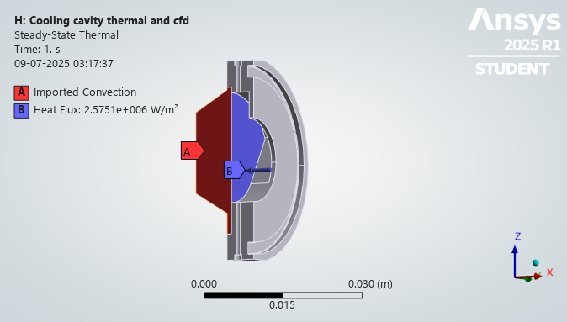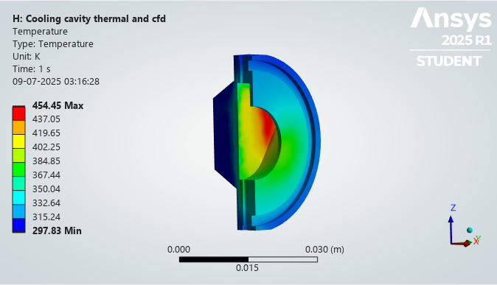
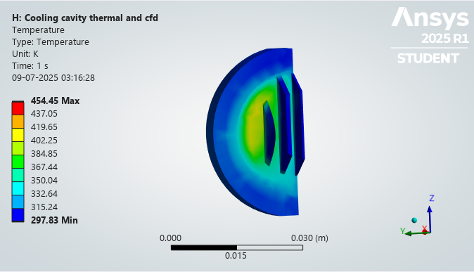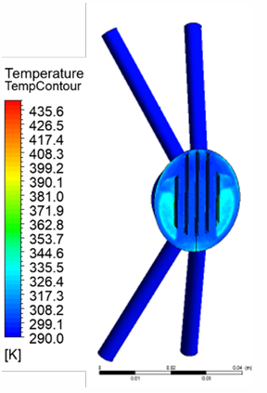

GRID THERMAL SIMULATION :

• Coupled CFD-thermal simulation of the grid is conducted to analyze its temperature distribution.
• The water flow rate is set to 5 LPM.

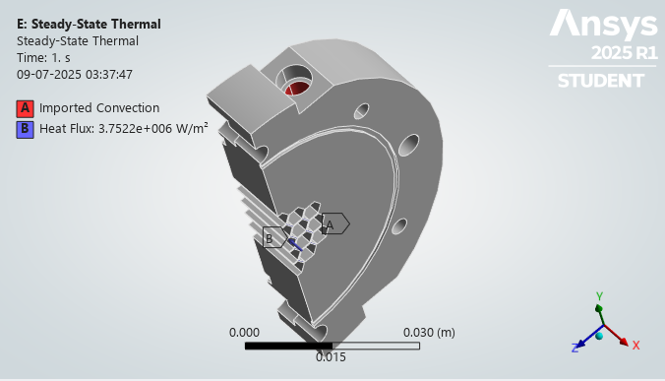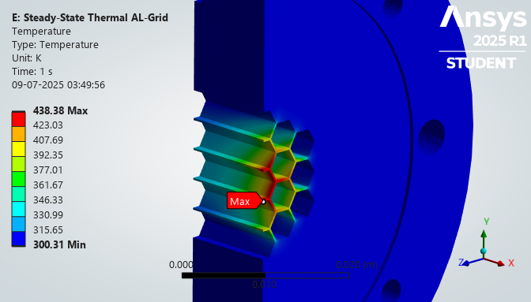

CONCLUSION :
• This study presents the design and simulation of a compact, high-pressure, high-yield 18O-enriched water target for 18F isotope production.
• CFD-FEA simulations ensure thermal stability and structural integrity.
• The design enables efficient heat dissipation and safe operation under high beam currents and pressures, making it a reliable solution for radiopharmaceutical production.

