1. While creating maven project, first error was this:

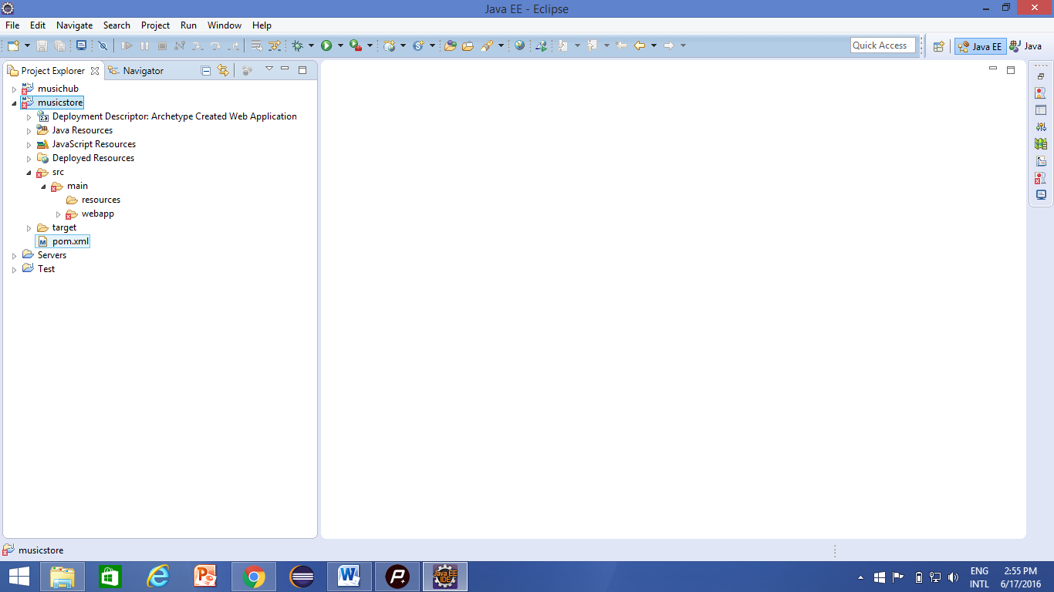

To solve this following steps are followed:

Right Click on the project->Properties->Java Build Path->Add Library->Server Runtime->Apache Tomcate 8.0->finish

1. In web.xml and dispatcher-servlet page links were not visible; they were in normal text mode.

Solution:- Right Click on the xml page->Open with->XML Mode