Cookes, local storage and session storage

These are 3 different ways to store data inside the browser

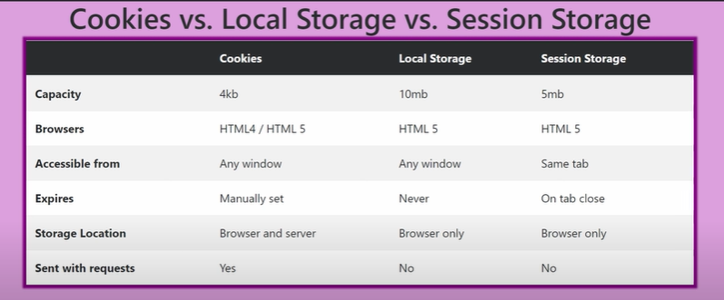

All three are browser independent. So, if I am using chrome, my data is limited to chrome .

IT won’t get stored on another browser on the same pc.

User don’t share SESSIONS and local storage among them. None of the other user using the browser can see the data of the other user because it gets saved in the users PC.

Why less capacity?

Because, every time the request is sent to server to access a particular resource, cookies will also be sent with the request. So, storage capacity is limited so as to ensure low latency.

Cookies are good to do some authentication.

Examples:

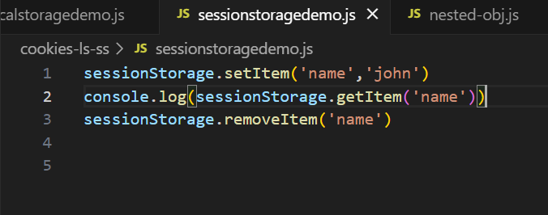

Cookies don’t have a good way to interact with. The only way is to use

Document.cookie

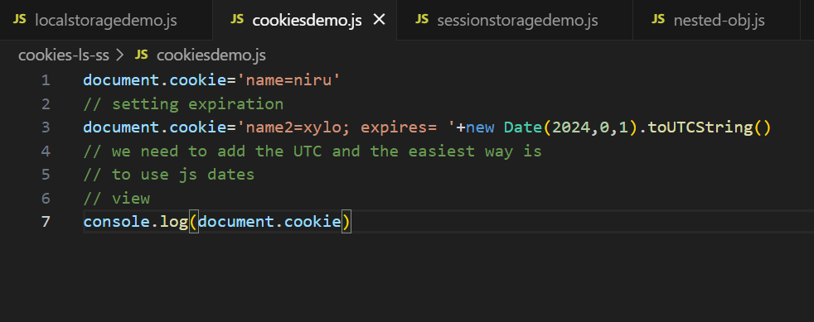

Prototypes:

It is a behaviour.

The default behaviour of JS is prototypal.

We get classes, new, this - comes becoz of this.

In javascript, object is the parent of all. And everything is an object in js.

