DOM:

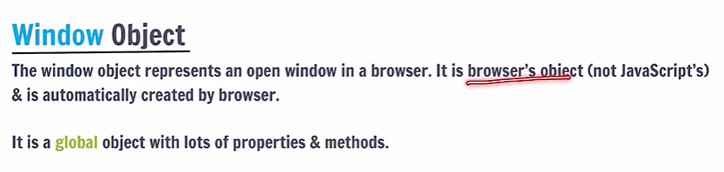

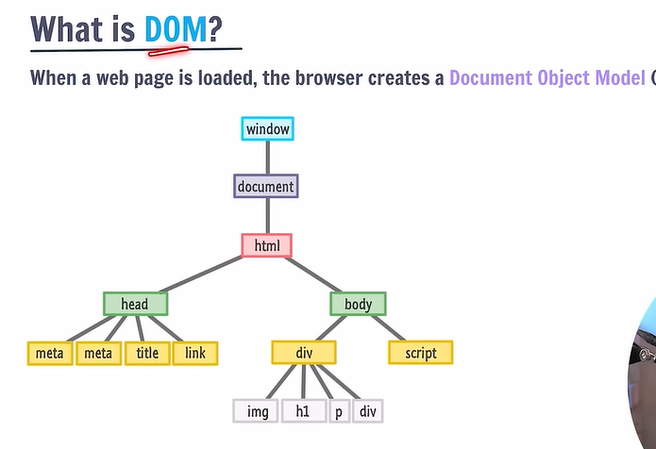

All the HTML elements are accessible using js. All these elements get converted into object. This special object is called document. It is available in window object.

Console.dir(window.document) -> Gives all the properties of the document object.

The properties of special objects are printed using this console.dir()

Console.log(window.document) -prints the HTML code.

Window.document – used to print our html code.

This document is just a model which is a representation of the HTML code.

Every element in the DOM tree is called node.

When the browser is loaded, the browser creates the DOM of the page.

**Console.dir(window.document) == console.dir(document)**

**Console.dir(document.body.childNodes[1]) - gives the props of 1st child object.**

**We use DOM to make dynamic manipulations to the webpage.**

**DOM Manipulation:**

If we write the script tag above the body tag, then the DOM elements are not loaded in the browser and they are not accessible.

So, we always load our script only after completely loading the HTML.

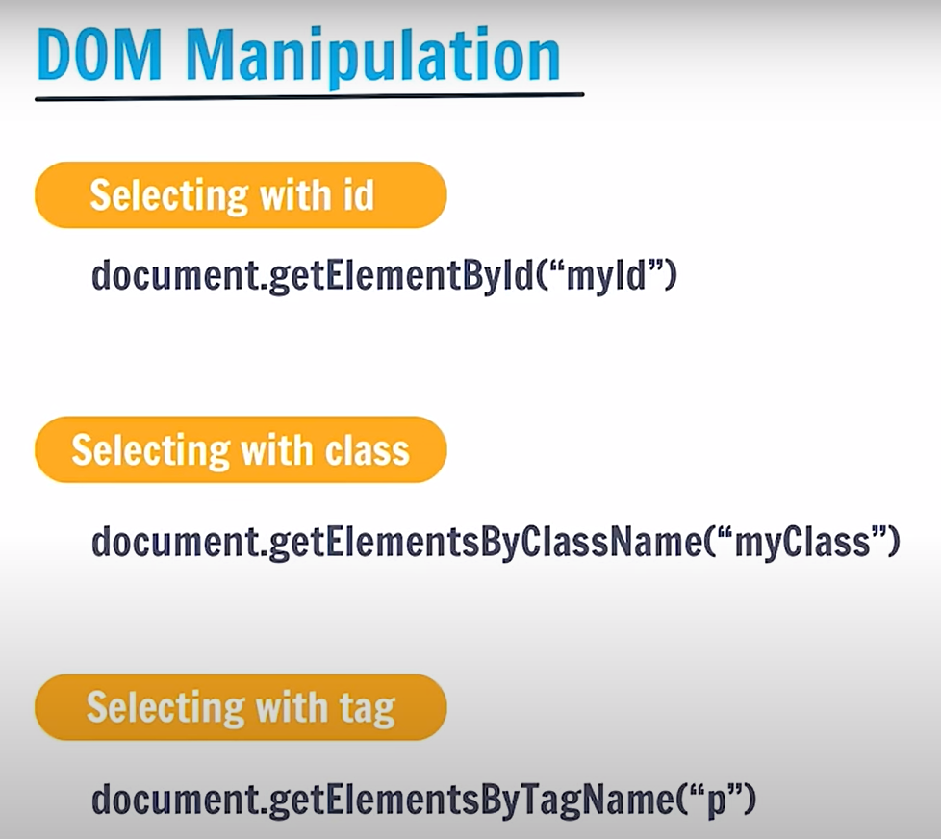

When we do not have any element with id using doc.getelementbyid – it gives NULL

When we do not have any elements withclass using doc.getelemenstbyclassname – it gives empty html collection – 0 elements in the collection.

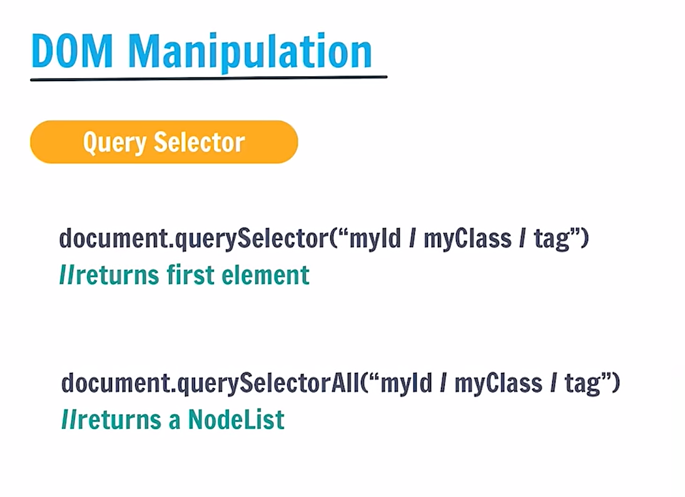

QuerylistAll returns a collection of nodes in case of multiple elements.

Queryselector with elements:

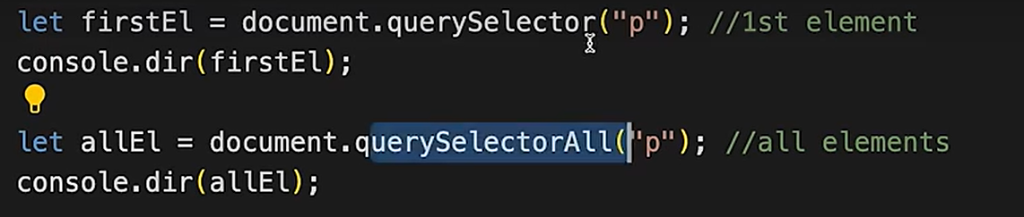

Queryselector with class – We need to give .className when using query selector with class name.

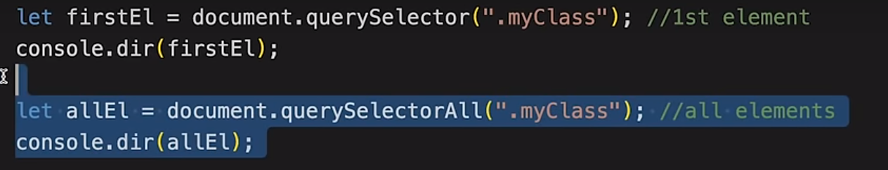

With id – need to give #



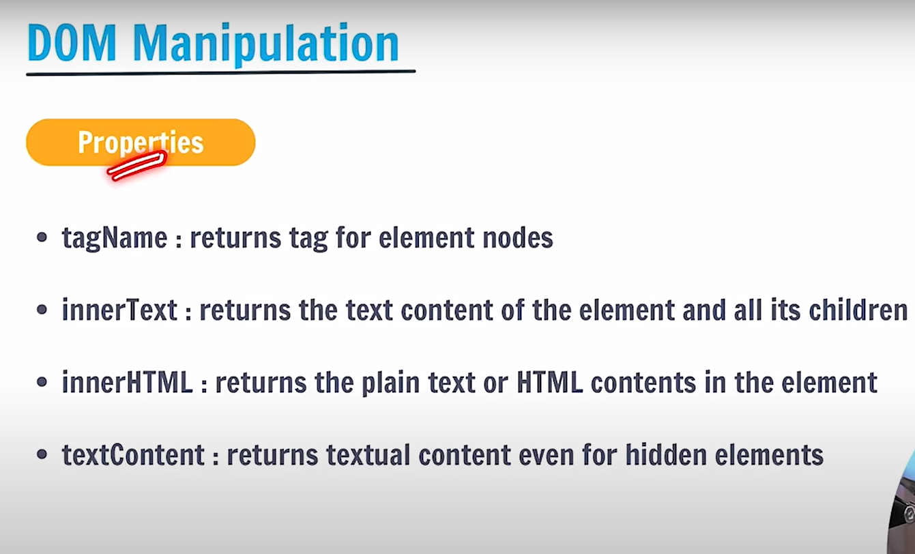

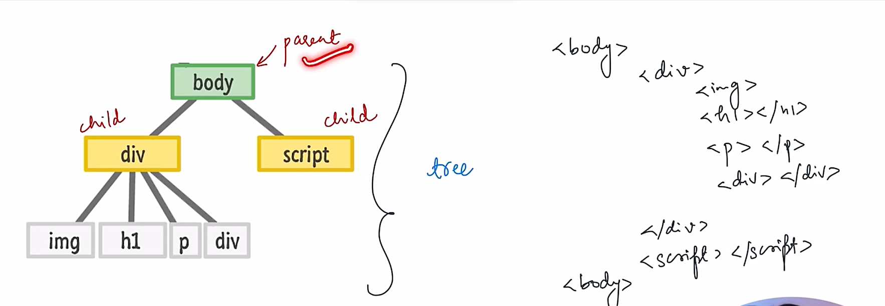

When the DOM tree is generated, then 3 types of nodes are created.

1. Text nodes
2. Comment nodes
3. Element nodes

Generally all the nodes are element nodes during the development.

Nodes has important properties :  
1. FirstChild

2.LastChild

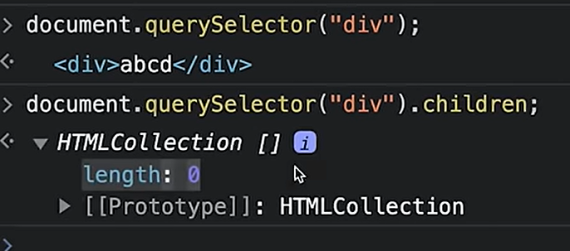

These are basically used for navigation through elements.

NOTE:

1. innerText – Gives just the plain text
2. innerHTML – Gives a string with text along with the html related information



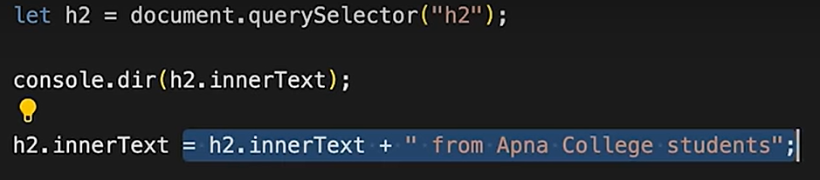



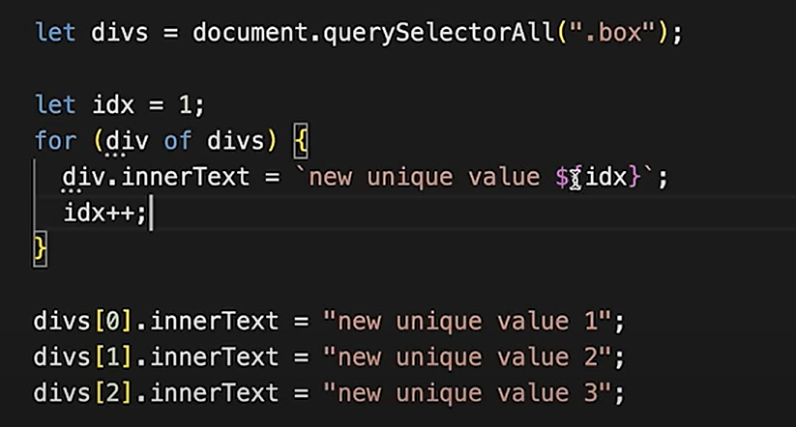

Attributes:

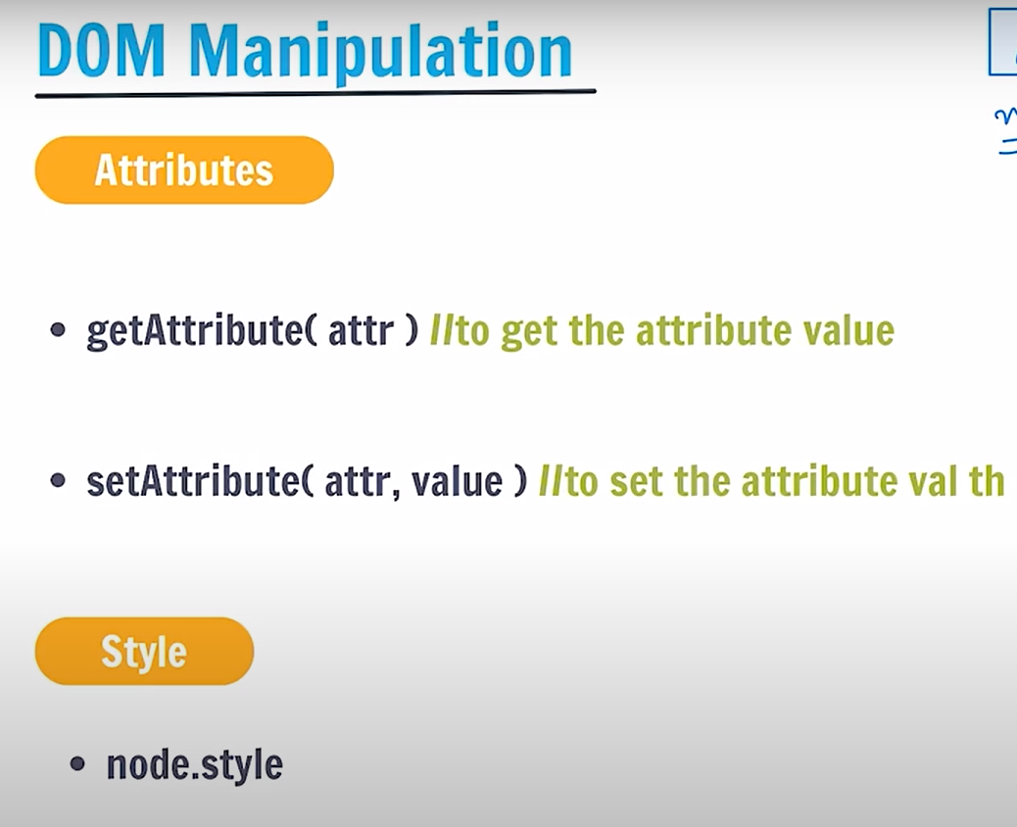

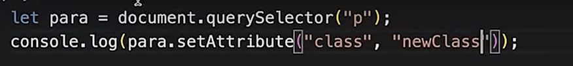

Access Style attribute of an element:

