Functions:

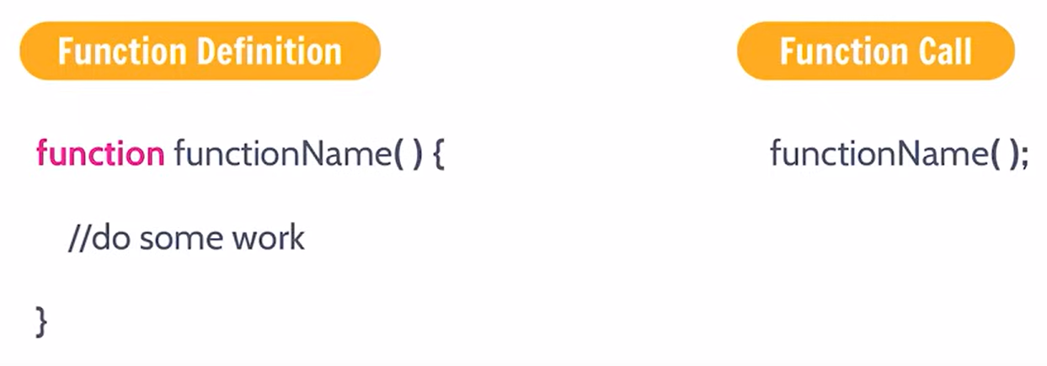

At the Call - arguments

At the definition – parameters

Arrow Functions:

If there is a single line of code, then curly braces are also not required.



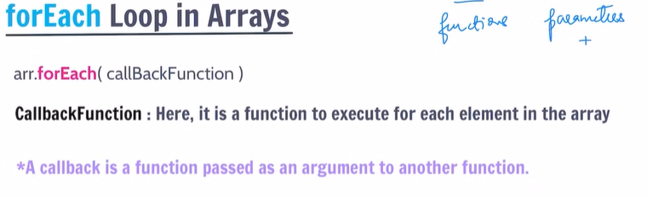

forEach accepts 3 parameters.

Value, index, array itself

Higher Order Functions:

Higher Order Functions are those which takes some other function as a parameter or returns some other function.

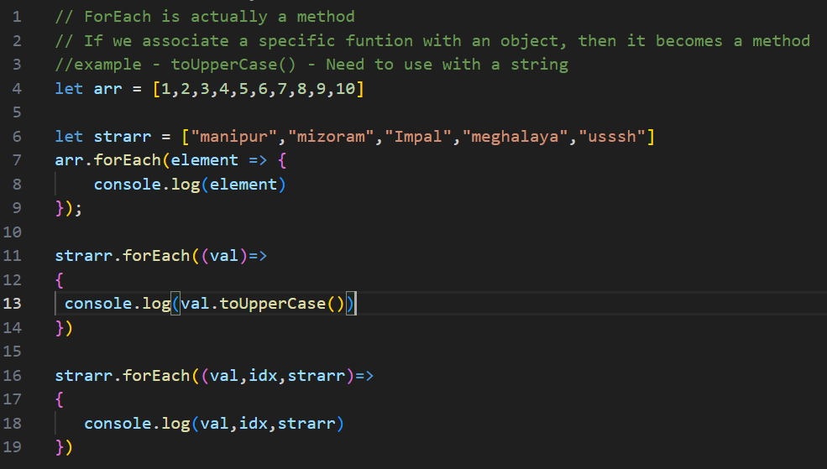

Important Array Functions for day-to-day life:

Map:

Map Creates a new array. (whereas foreach does not create any new array)

It also takes 3 parameters.

Creating new array with map:

Create new array, to save the all the values based on the returned value.

The difference between forEach and map is that, we can use map to create a new array using the values whereas forEach is just used to perform some calculations.

Filter:

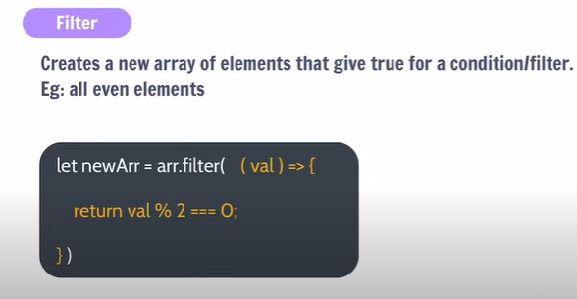

Original Values don’t get changed.

Reduce:

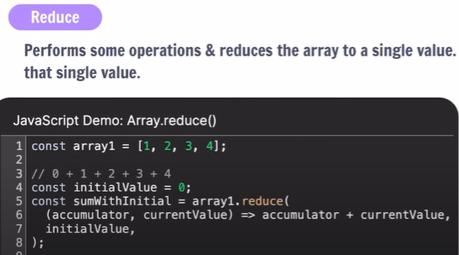

Find Maximum element:

