Lab28

Save the excel as

Create s3

Region can be anywhere:

Upload productdata.csv into the bucket

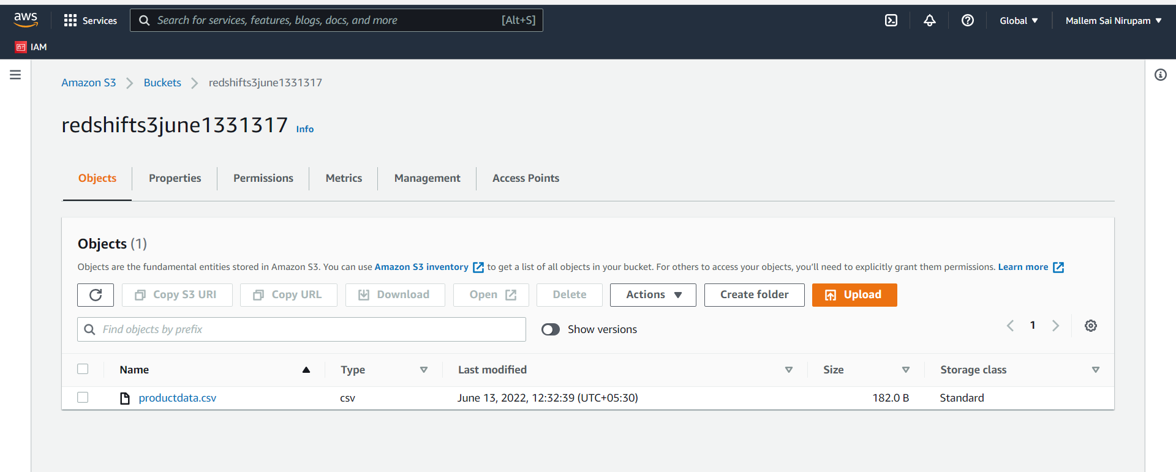

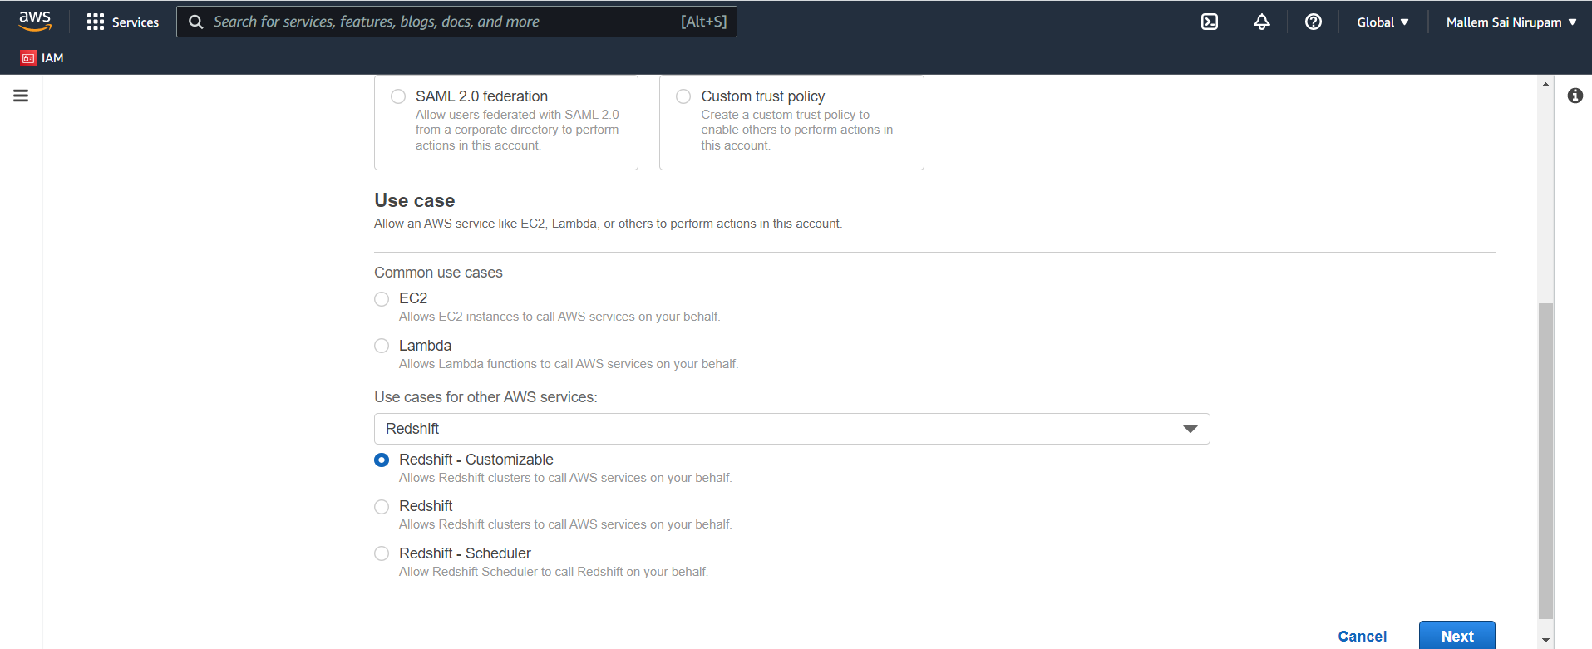

Attach IAM role to redshift:

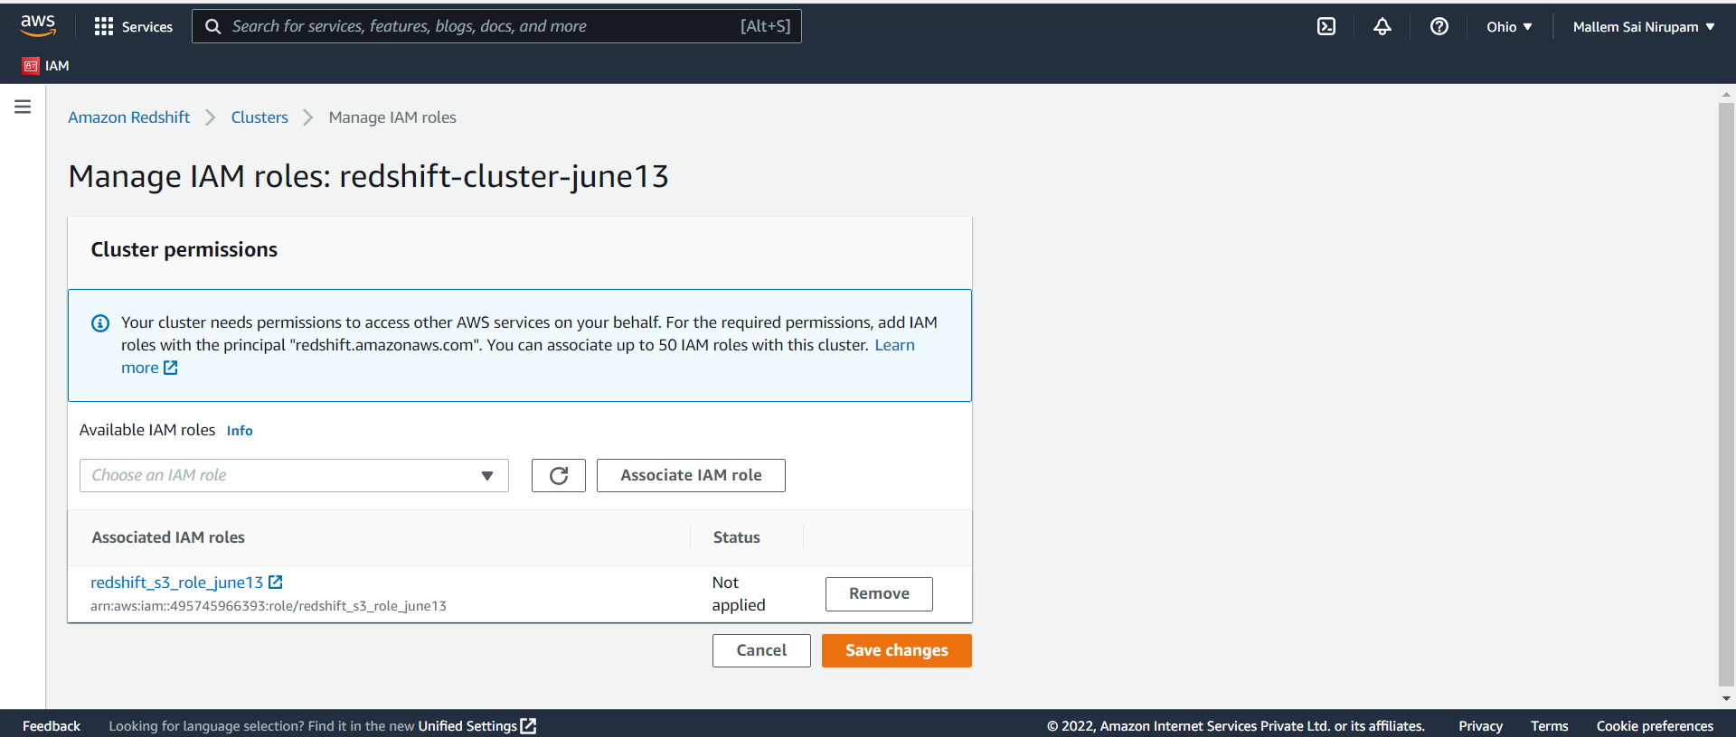

COPY dev.public.product (id, name, price) FROM 's3://redshifts3june1331317/productdata.csv' IAM_ROLE 'arn:aws:iam::495745966393:role/redshift_s3_role_june13' FORMAT AS CSV DELIMITER ',' QUOTE '"' REGION AS 'us-east-2';