Lab-29

Deploying Django application using Django application.

Go for ubuntu instead of linux. (Just a recommendation)

EC2- Created Successfully

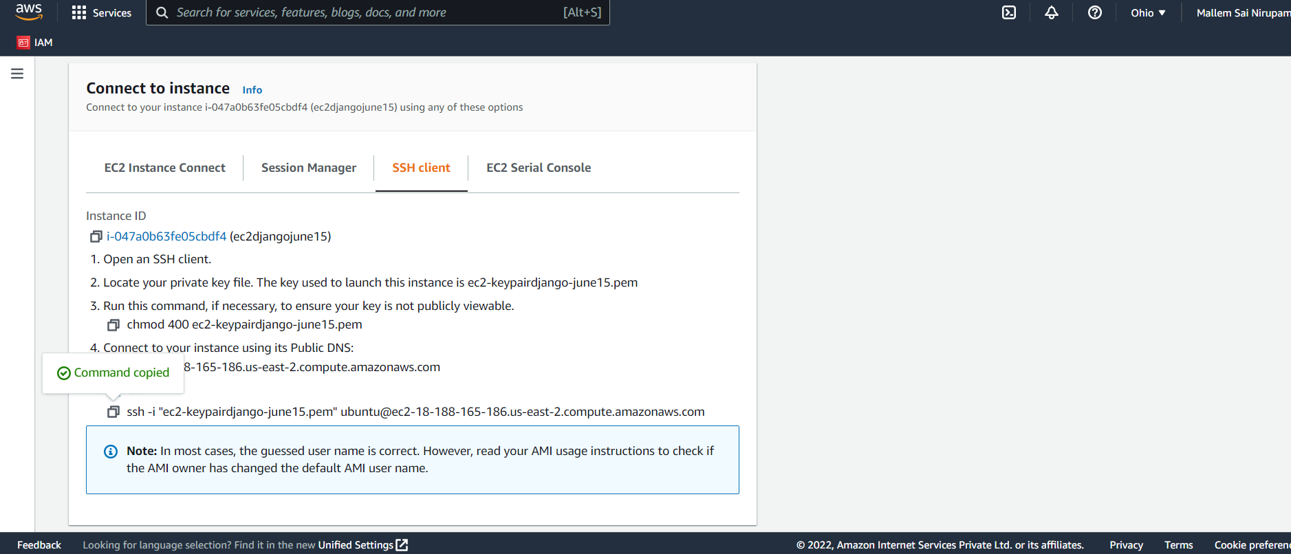

This is the path :

Note: Don’t use my path. That will not work for you. Its just related to my local host. Generate the path by following the above steps and then you are good to go.

ssh -i "C:\Users\nirup\Downloads\ec2-keypairdjango-june15.pem" [ubuntu@ec2-18-188-165-186.us-east-2.compute.amazonaws.com](mailto:ubuntu@ec2-18-188-165-186.us-east-2.compute.amazonaws.com)

Add the complete path of the file to the command as showed above.

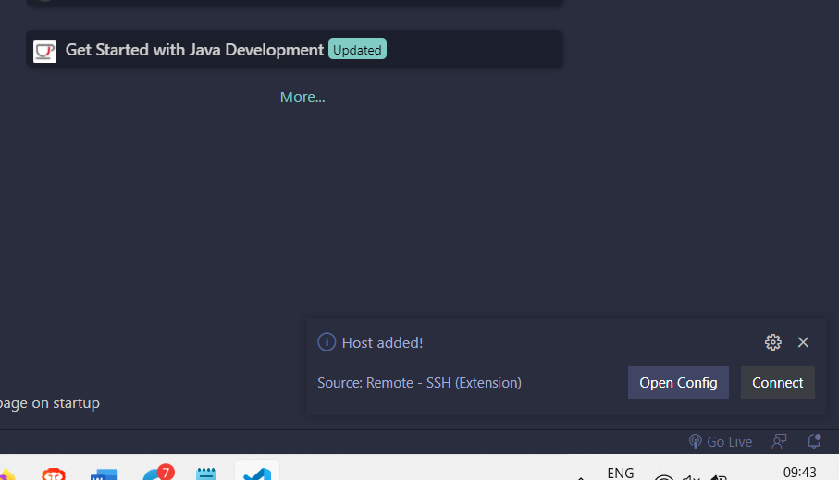

Enter the commands :

Sudo apt-get update

Sudo apt-get install python3-pip

Sudo pip3 install gunicorn

Sudo apt-get install ngnix

Sudo pip3 install Django

After all the commands , the screen looks like this

Sudo pip3 install virtualenv

Ls

Source awsshell/bin/activate

pip3 install Django

Django-admin startproject awsdjangoproject

Cd awsdjangoproject

Python3 manage.py migrate

Python manage.py runserver

