Creating a RDS

Cloud9

Connecting to rds from cloud9 using python :::😊

Connection Established Successfully :

@@@@@@@@@@@@@@@@@@@@@@@@@@@@@@@@@@@@@@@@@@@@@

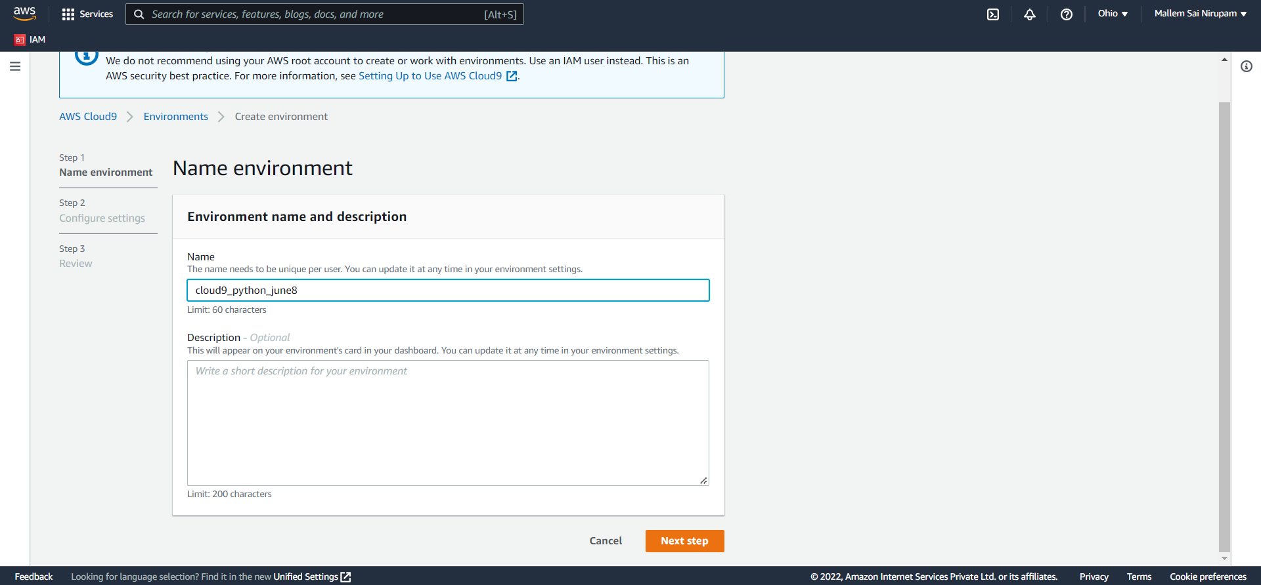

Database

Cloud-9

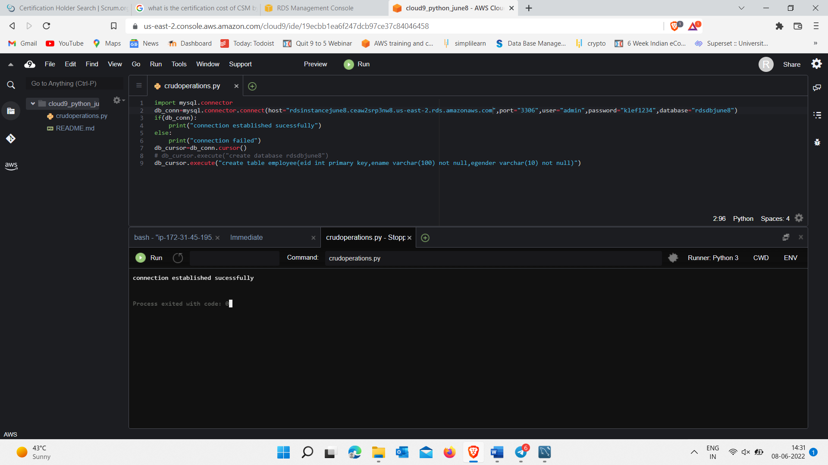

Inserting 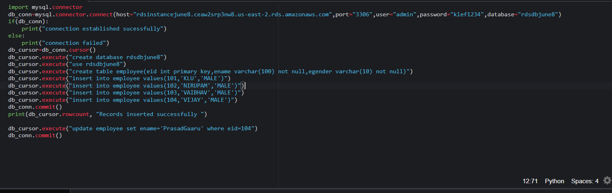

Updating 104 record

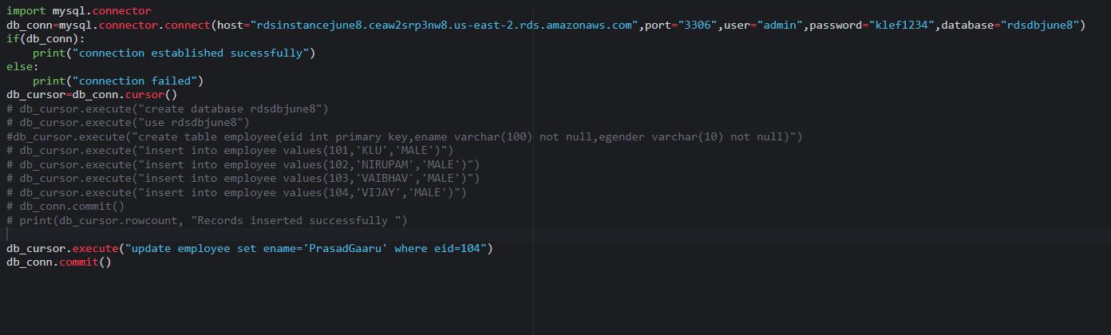

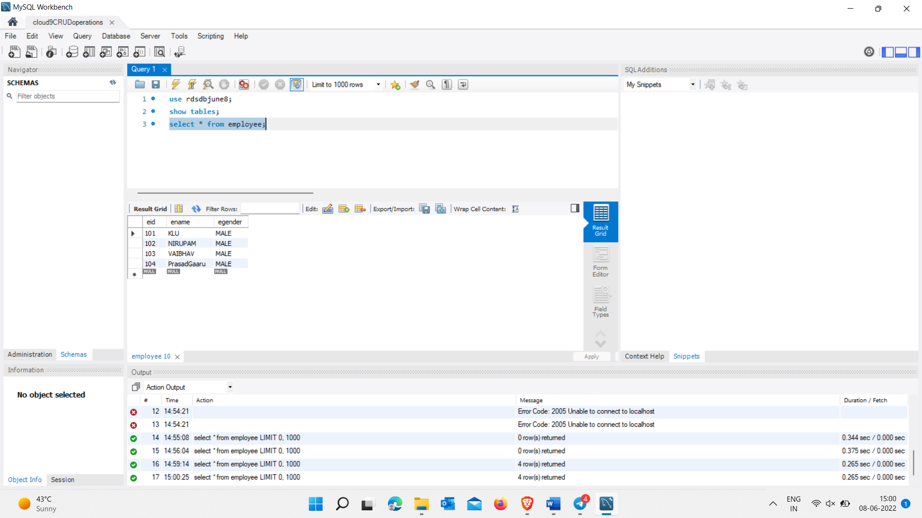

Deleting:

Printing records :

