Lab21

Demonstration of copying data into s3 bucket using ec2 instance by creating a file in ec2:

S3-BUCKET

EC2:

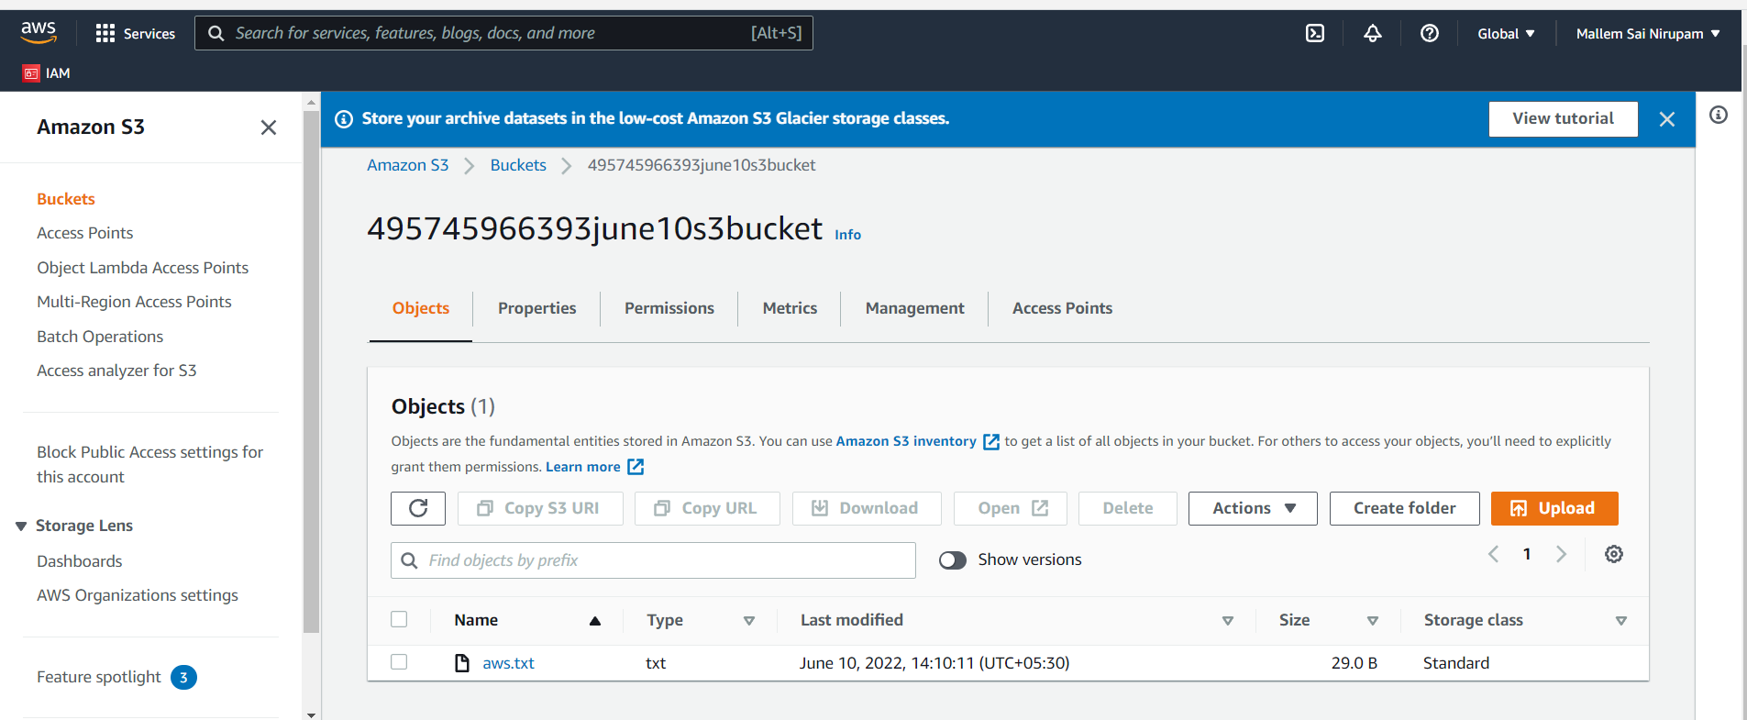

IF WE MODIFY IAM ROLE TO NO IAM ROLE:

