Lab 41:  
cloudwatch events to trigger lambda fn

Go to rules :

Go to cloudwatch and logs and log groups

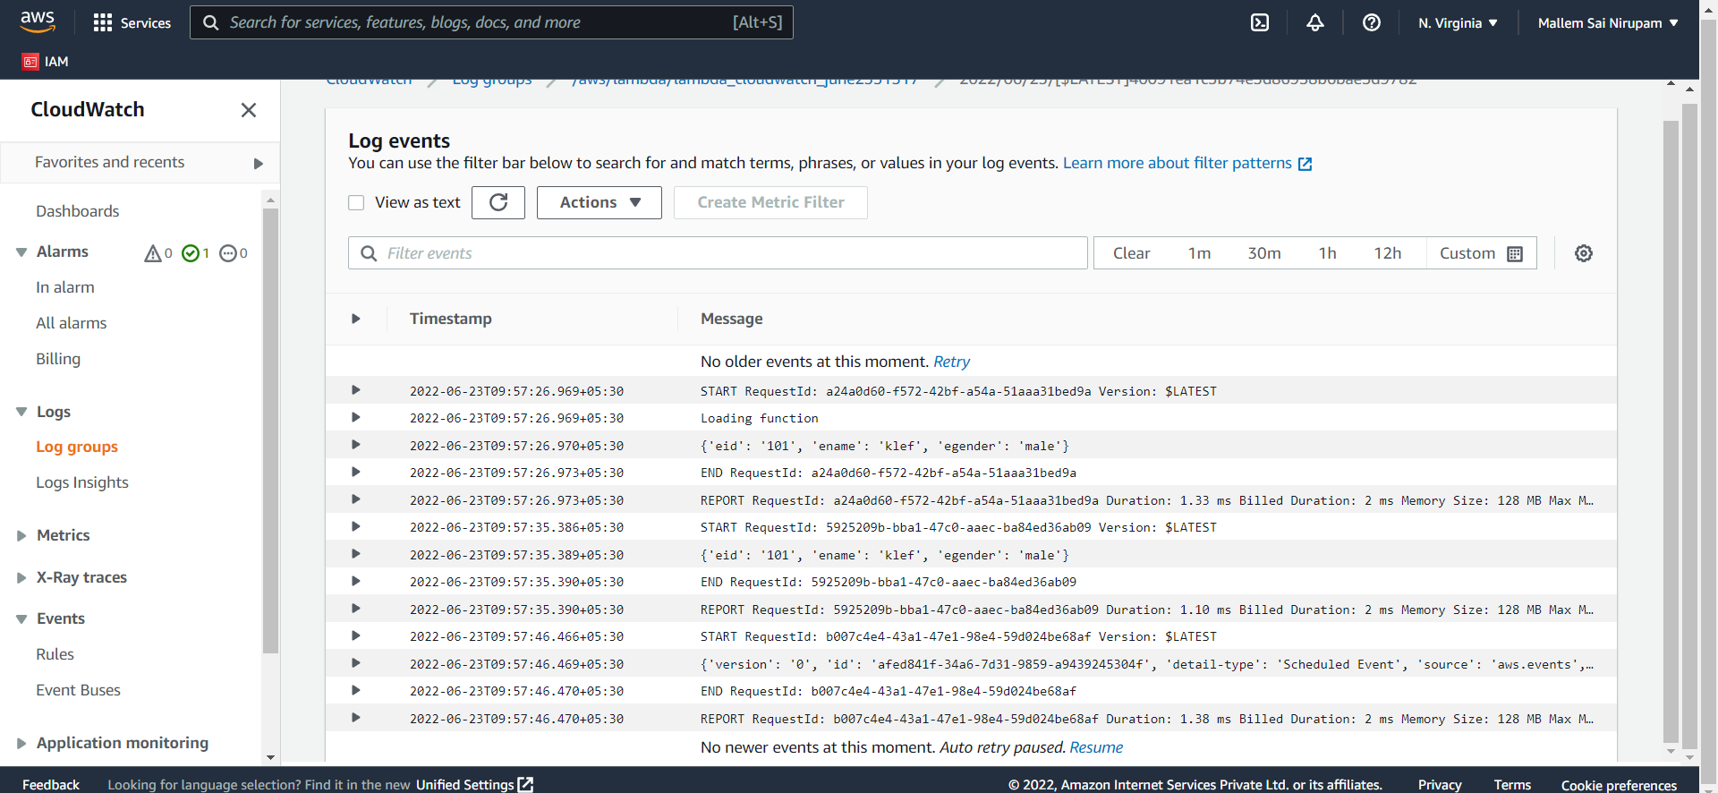

New log strem is created whenever u update ur lambda……………..!

Code :

import json

print('Loading function')

def lambda_handler(event, context):

print(event)

return "event"

json:

{

"eid": "101",

"ename": "klef",

"egender": "male"

}