**Lab-42**

Dynamodb table :

API

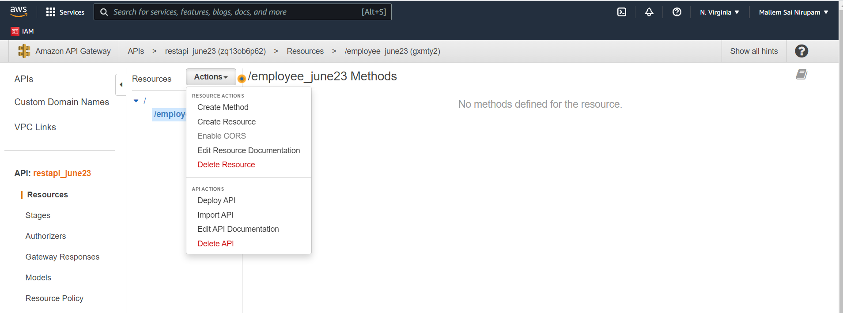

Post man

Delete request :

🡪Deleting an item

import json

import boto3

database=boto3.resource('dynamodb')

table=database.Table('employee')

def lambda_handler(event,context):

table.delete_item(Key=event)

response={

'statusCode':200,

'body':'deleted item successfully'

}

return response

🡪Update Item

import json

import boto3

database=boto3.resource('dynamodb')

table=database.Table('employee')

def lambda_handler(event,context):

table.update_item(Key=event,UpdateExpression='SET edept=:v',ExpressionAttributeValues={':v':'MECH'})

response={

'statusCode':200,

'body':'updated an item successfully'

}

return response

Get……………………………………

🡪Get item (select)

import json

import boto3

database=boto3.resource('dynamodb')

table=database.Table('employee')

def lambda_handler(event,context):

response = table.get_item(Key=event)

return response['Item']

🡪select all items

import json

import boto3

database=boto3.resource('dynamodb')

table=database.Table('employee')

def lambda_handler(event,context):

response = table.scan()

return response

