Lab-52:

Demo on developer tools using ec2 instance using codebuild

Create an ec2 linux only instance first:

Create a codecommit repository:

Create a code commit repository:

Go to d drive

Git clone https url of the repository

Now copy the files into the folder which is created in the file exxporer

Git add .

Git commit

Git push

Git status

Code Deploy part:

Create an app

Create a deployment group

Pipeline Settings:

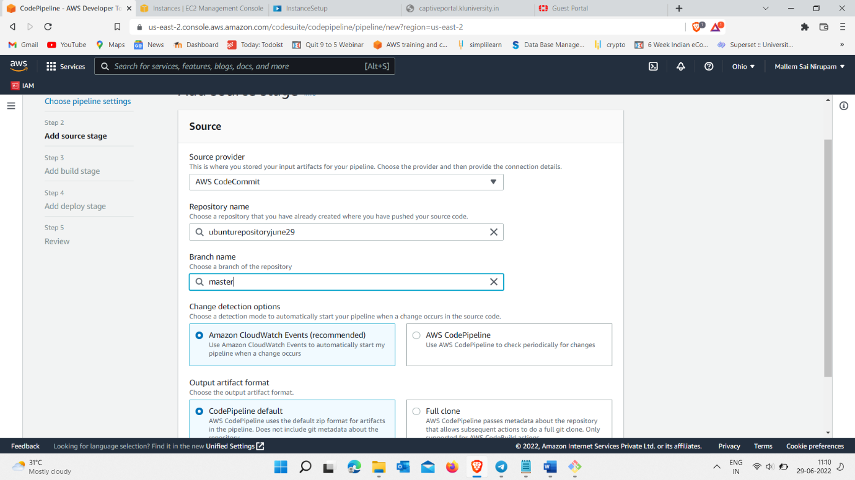

Code Build

Every thing is done :

Now check the public url of ec-2 instance

