Certificate of Completion

Congratulations, PEDDIREDDY PALLAVI DURGA

# R Programming in Data Science: High

T

# Variety Data

Course completed on Mar 21, 2023 at 10:54AM UTC • 1 hour 27 min

## By continuing to learn, you have expanded your perspective, sharpened your skills, and made yourself even more in demand.

Head of Content Strategy, Learning

## LinkedIn Learning 1000 W Maude Ave Sunnyvale, CA 94085

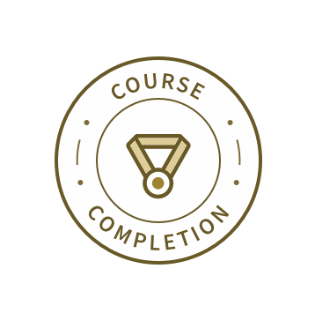

Certificate ID: AaevDthbXSt1NGdNghz7VmOMKsKg



Apr 19, 2022

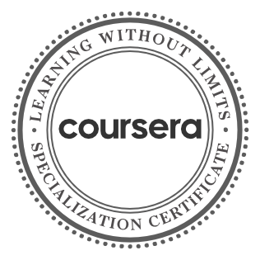

**Introduction to Big Data**

**Big Data Modeling and Management Systems**

**Big Data Integration and Processing**

**Machine Learning With Big Data**

**Graph Analytics for Big Data Big Data - Capstone Project**

**6 Courses**

**PEDDIREDDY PALLAVI DURGA**

has successfully completed the online, non-credit Specialization

**Big Data**

You will gain an understanding of what insights big data can provide through hands-on experience with the tools and systems used by big data scientists and engineers. By following along with provided code, you will experience how one can perform predictive modeling and leverage graph analytics to model problems. This specialization will prepare you to ask the right

questions about data, communicate eﬀectively with data scientists, and do basic exploration of large, complex datasets. In the final Capstone Project, developed in partnership with data software company Splunk, you’ll apply the skills you learned to do basic analyses of big data.

The online specialization named in this certificate may draw on material from courses taught on-campus, but the included courses are not equivalent to on-campus courses. Participation in this online specialization does not constitute enrollment at this university. This certificate does not confer a University grade, course credit or degree, and it does not verify the identity of the learner.

Ilkay Altintas, Chief Data Science Officer Amarnath Gupta, Research Scientist San Diego Supercomputer Center

Verify this certificate at:

[https://coursera.org/verify/specializat](https://coursera.org/verify/specialization/HFGY88HPZGCL)

[ion/HFGY88HPZGCL](https://coursera.org/verify/specialization/HFGY88HPZGCL)

A pr 15 , 2023

PALLAVI DURGA PEDDIREDDY

has successfully completed

Introduction to Big Data

an online non-credit course authorized by University of California San Diego and offered through Coursera

Ilkay Altintas

Chief Data Science Of cer

San Diego Supercomputer Center

Amarnath Gupta Research Scientist

San Diego Supercomputer Center



Verify at: <https://coursera.org/verify/P35L4TL353YB>

Cour se r a ha s confir me d the ide ntity of this individua l a nd the ir

pa r t icipa t ion in the cour se .