OmniSpace: UI Design System and Interface Elements

1. Purpose
This document records the proposed starting design system for the initial OmniSpace interface concept. The colors, sizes, and spacing values below are suggestions for planning the 2D design frames; they are not official project requirements or real-world AR measurements. They can be revised after team research and feedback.

2. Color Palette
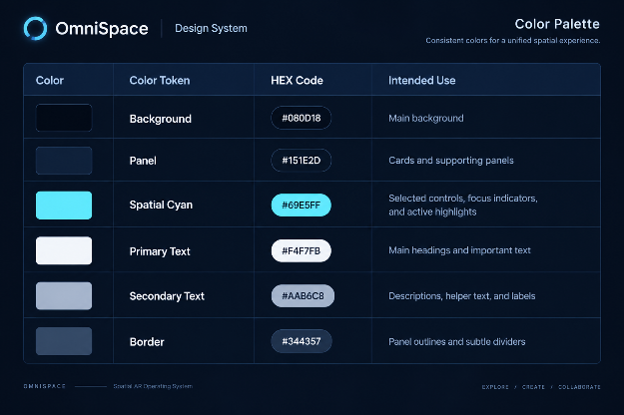

Color use
- Use the dark background as the base surface.
- Use off-white for important text and muted grey for supporting text.
- Apply cyan selectively to active or important elements.
- Use borders to separate panels without making the screen look crowded.
- Check contrast and readability on both plain and visually complex backgrounds.

3. Typography
Suggested font: Inter
Fallback: Arial or a similar sans-serif font.
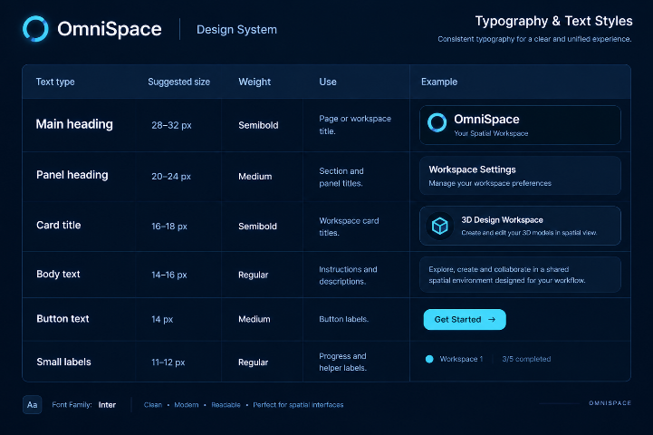

Use a clear text hierarchy. Important titles should stand out, while body text and labels should remain readable.

4. Suggested Layout and Spacing
These are provisional values for a desktop concept frame:
- Frame size: 1440 × 900 px
- Outer margin: 32 px
- Gap between cards: 16–24 px
- Panel padding: 20–24 px
- Button height: 40–44 px
- Card corner radius: 12–16 px
- Main panel corner radius: 16–20 px
- Border thickness: 1 px

Use consistent alignment and spacing. Keep the central content area visually dominant and group related controls together. These pixel values describe the design frame only; they are not spatial distances or ergonomic measurements.

5. Main UI Elements
Top Navigation Bar
Elements: OmniSpace name/logo, current screen title, Back action, and Help or Settings where needed.

Use: Keep navigation in a predictable place and show only relevant actions.

Workspace Cards
Elements: Workspace title, short description, optional icon/preview, and Open Workspace button.
Use: Use a consistent card structure for Design Studio, Training Space, and My Workspace.

Spatial Viewport
Element: Large central area labelled **3D Model View** in the low-fidelity layout.
Use: This is the main content area. Keep it clear and avoid unnecessary decoration at the wireframe stage.

Instructions Panel
Elements: Instructions heading and concise task guidance.
Use: Keep instructions close to the content they explain.

Position and Scale Controls
Elements: Position label and slider; Scale label and slider. Optional value indicators can be considered later.
Use: Make each control's purpose clear. The exact axis behavior and value ranges still need to be defined.

Primary and Secondary Buttons
Examples: Open Workspace and Next as primary actions; Back and Previous as secondary actions.
Use: Keep button styling and wording consistent. Make the main next step easy to identify.

Progress Indicator
Example: Step 1 of 5.
Use: Show where the user is in a guided flow and update it as the user progresses.

6. Material Direction
Glass-like surfaces
Proposed use: Primary floating panels. Explore partial transparency and subtle edge definition while preserving text readability.

Matte surfaces
Proposed use: Instructions and secondary control panels. Explore a low-glare appearance and stable contrast.

Emissive accents
Proposed use: Active controls, selected items, and focus highlights. Use a restrained cyan glow rather than glowing every component.
These are visual directions to explore. Do not describe lighting or material properties as simulated or validated unless that work has actually been done in Spline or another tool.

7. Spatial UX Design Checks
- Keep important content within a comfortable viewing area.
- Avoid unnecessary repeated head and eye movement.
- Make controls easy to identify and group related controls together.
- Avoid overlapping panels that hide important information.
- Keep text readable against complex backgrounds.
- Use depth and scale to support hierarchy rather than as decoration.
- Avoid excessive motion and too many simultaneous panels.
- Do not rely on color alone to communicate an interaction state.

The team's spatial ergonomics research should guide the final placement and scale decisions. A 2D wireframe alone cannot validate real-world spatial comfort.

8. Design Consistency Checklist
- [ ] Use the same color roles across both screens.
- [ ] Keep heading and body text hierarchy consistent.
- [ ] Use consistent button styles and labels.
- [ ] Align panels and group related controls.
- [ ] Make active and selected states identifiable.
- [ ] Check text contrast and readability.
- [ ] Review the design with teammates' research before finalizing.

9. Reference
Apple Human Interface Guidelines — Spatial Layout: https://developer.apple.com/design/human-interface-guidelines/spatial-layout/

10. Current Status
This is the proposed starting design system for the initial low-fidelity concept. The values and components should be revised as the screens, research, and feedback develop.

