HCIN Automation - Test Execution Report
Generated: 8/11/2026, 5:16:13 PM
Overall Result: PASSED
1  Total | 1  Passed | 0  Failed | 0  Skipped

Test Summary
# | Test Name | File | Status | Duration (ms) | Error
1 | Sales RM All Screen Automation | 4-salesRmAllScreenAutomation.spec.js | PASSED | 54250

1. Sales RM All Screen Automation
Status: PASSED | Duration: 54250 ms
Logs in as Sales RM and exercises menu navigation across OEM, Programs, Cases, and Configuration end-to-end: OEM record view/edit sections, a program view + a full edit-wizard-to-Submit, a post-underwriting case view plus browsing Rejected/Credit Returned/Ops Returned Cases, and Configuration > Masters (downloading a master file) followed by the Dynamic Field screen. Pure navigation smoke test - no new data is created.
Field-by-Field Results
# | Field | Value Entered | Status | Screenshot
1 | Toggle Sidebar | - | PASS | 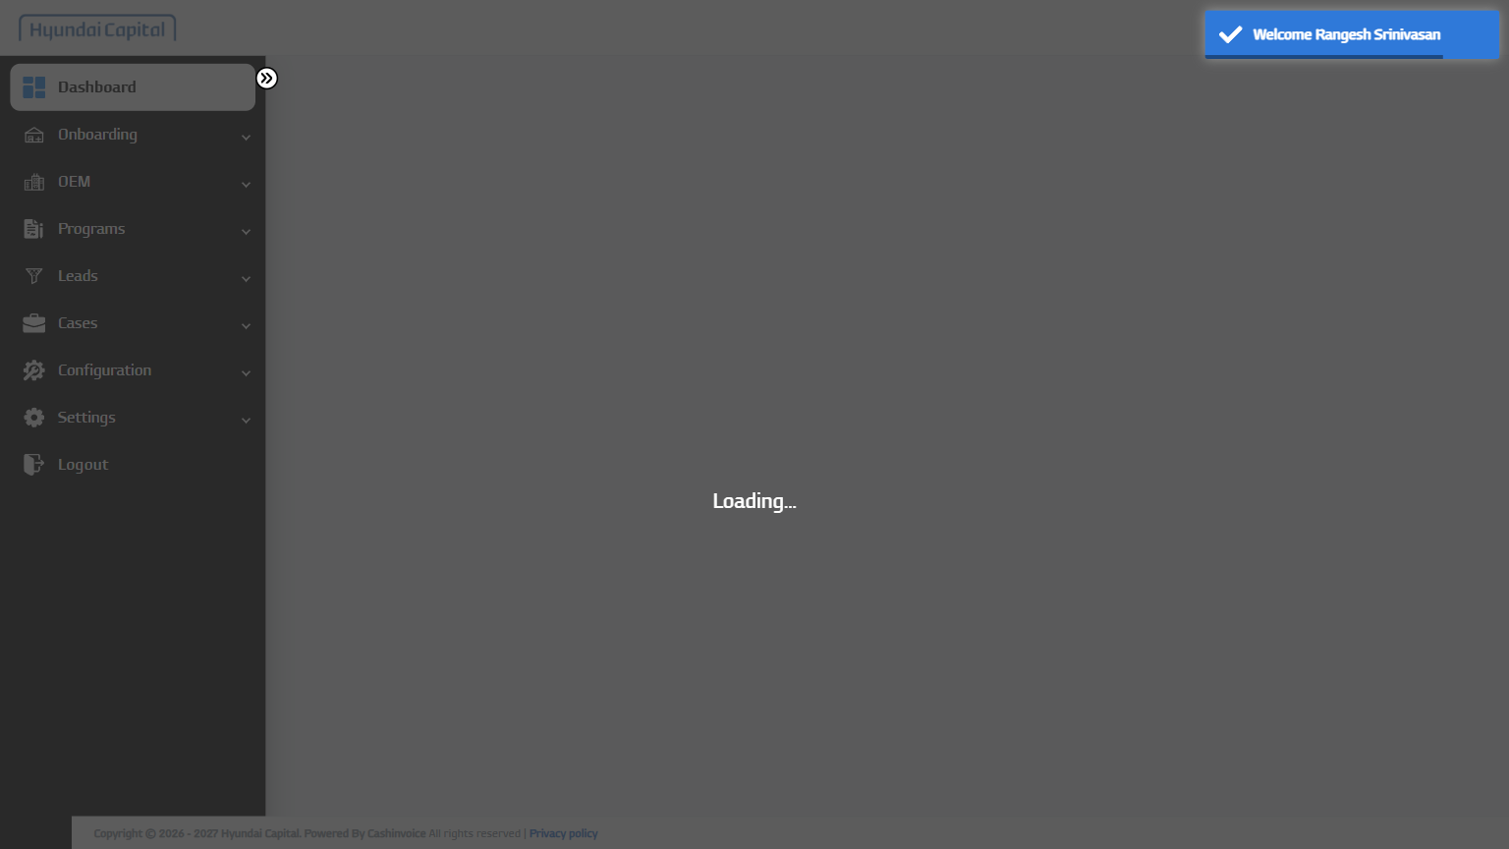
2 | Open OEM Menu | - | PASS | 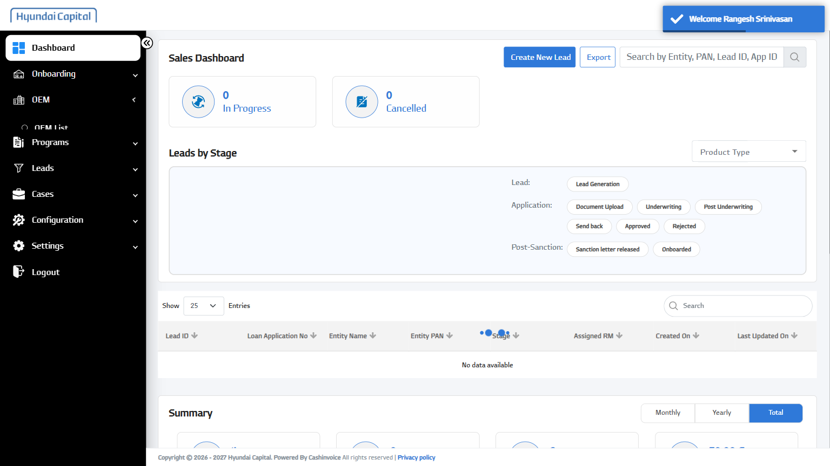
3 | Open OEM List | - | PASS | 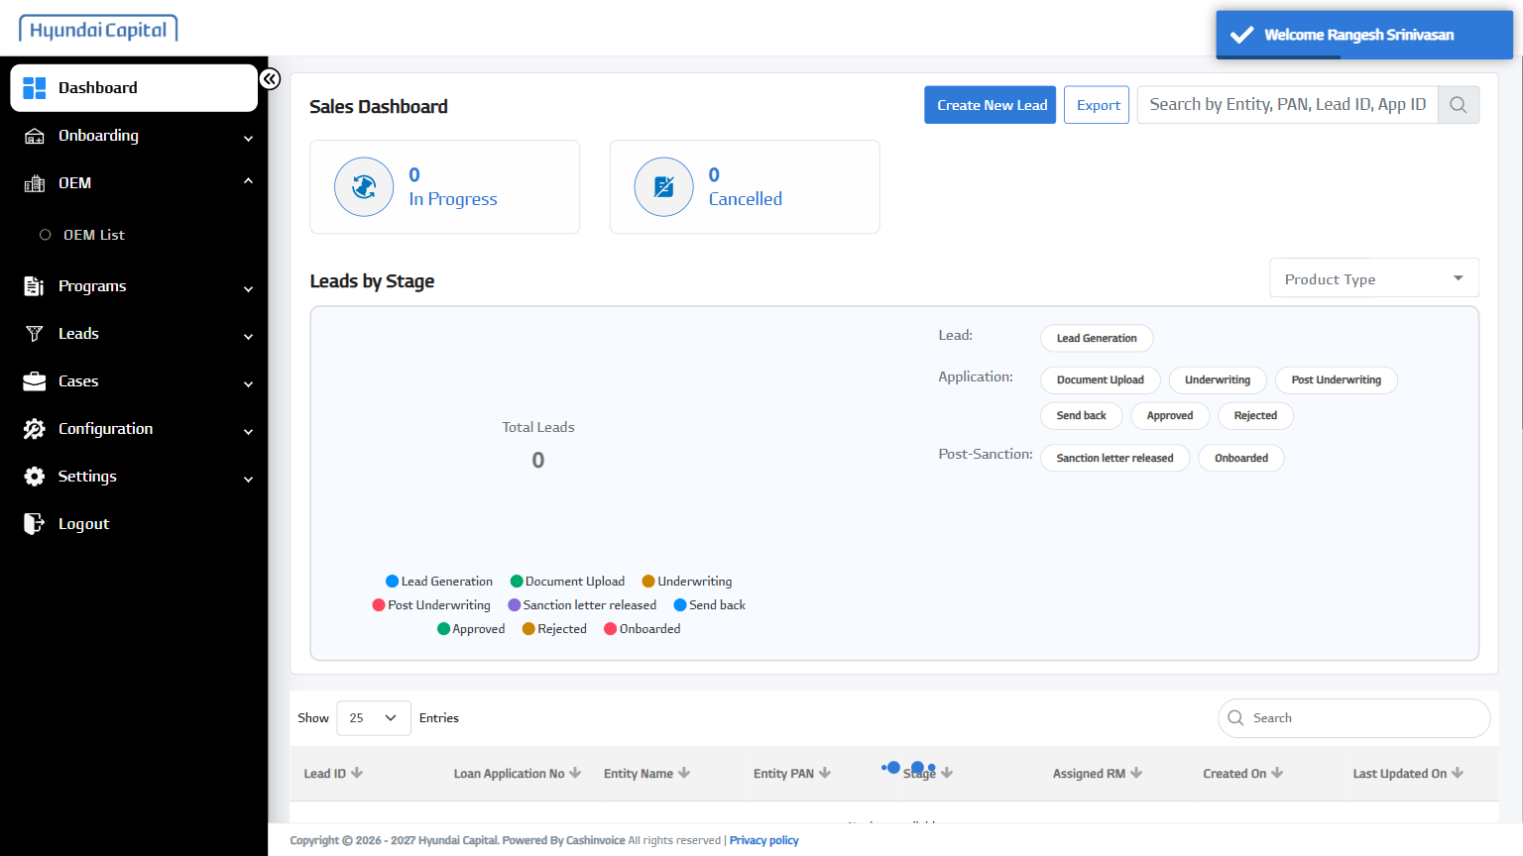
4 | Open OEM Row | KIA INDIA PRIVATE LIMITED | PASS | 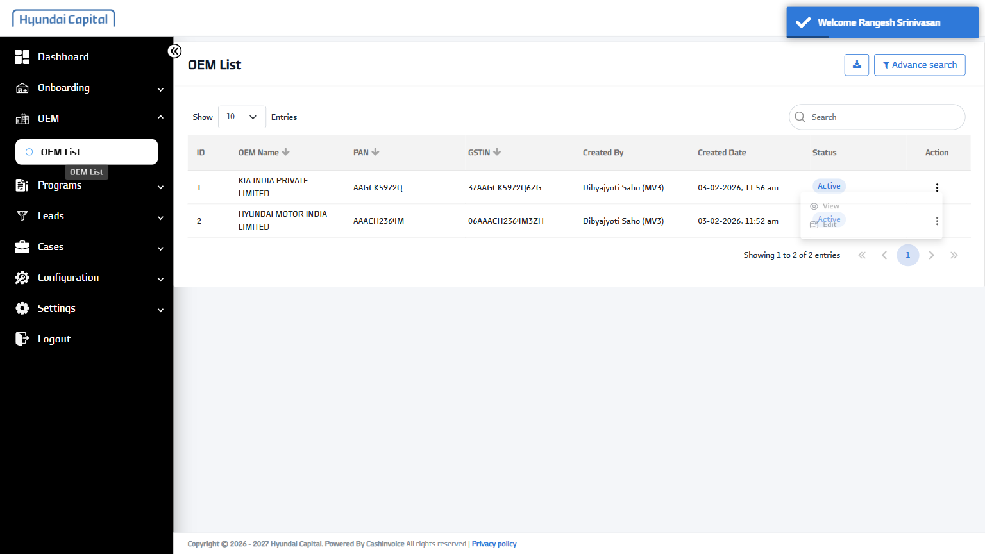
5 | View OEM | - | PASS | 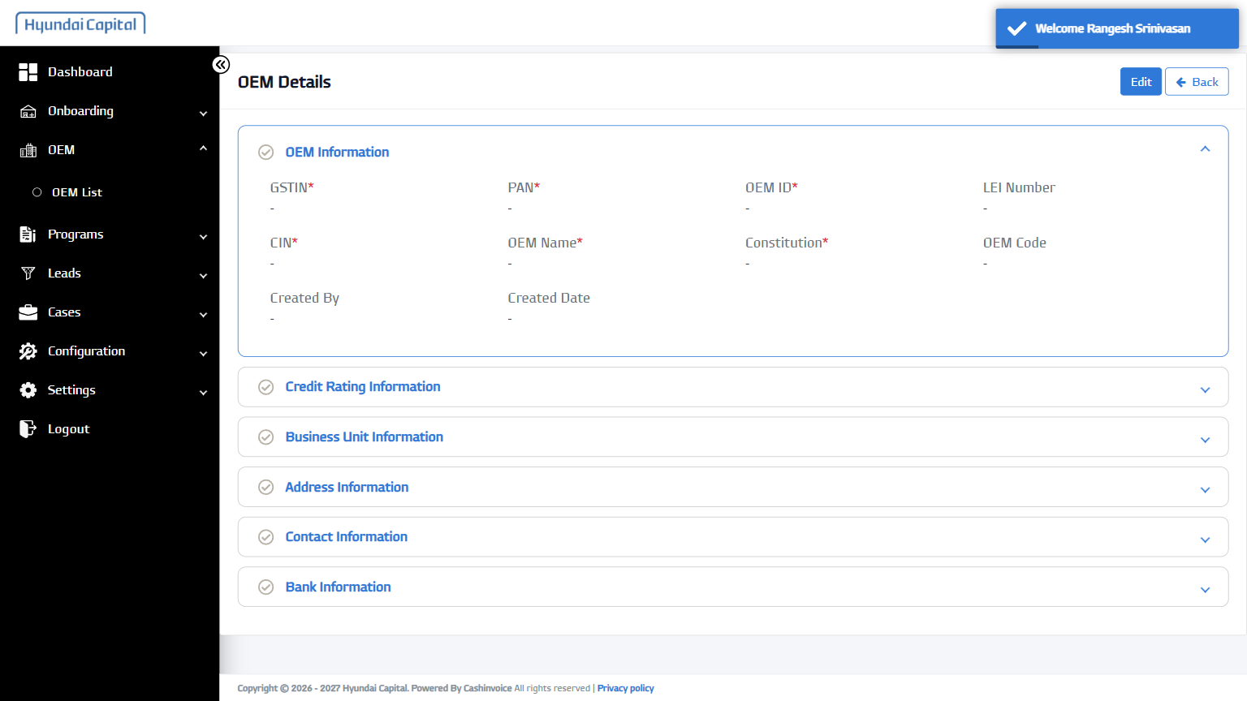
6 | Open Credit Rating Information | - | PASS | 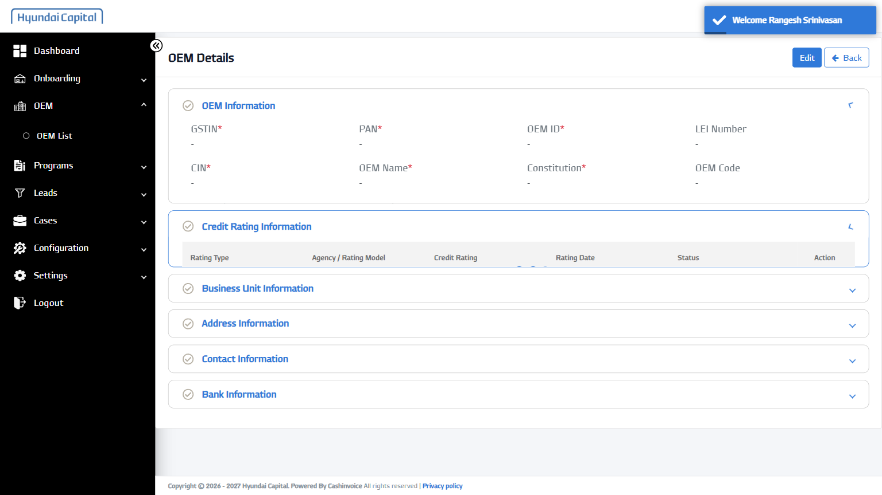
7 | Open Address Information | - | PASS | 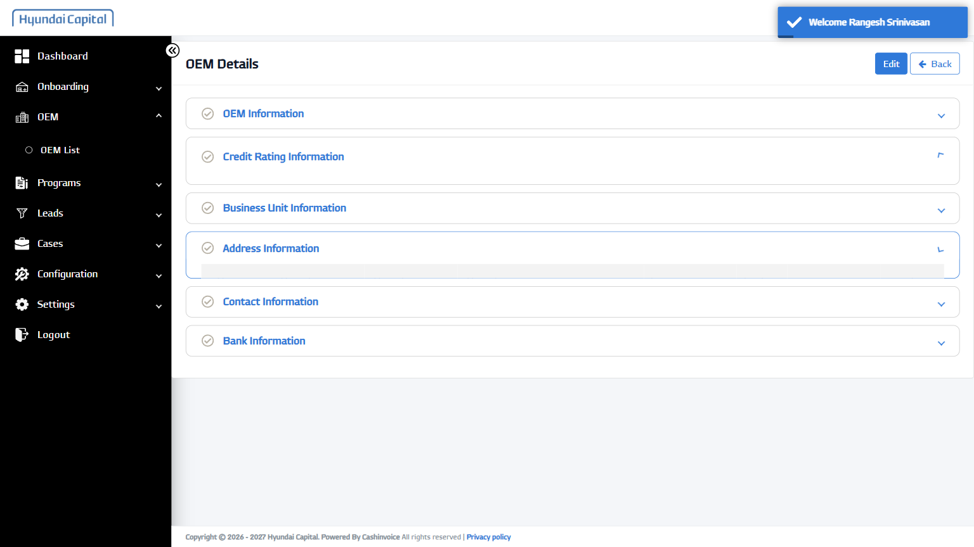
8 | Open Contact Information | - | PASS | 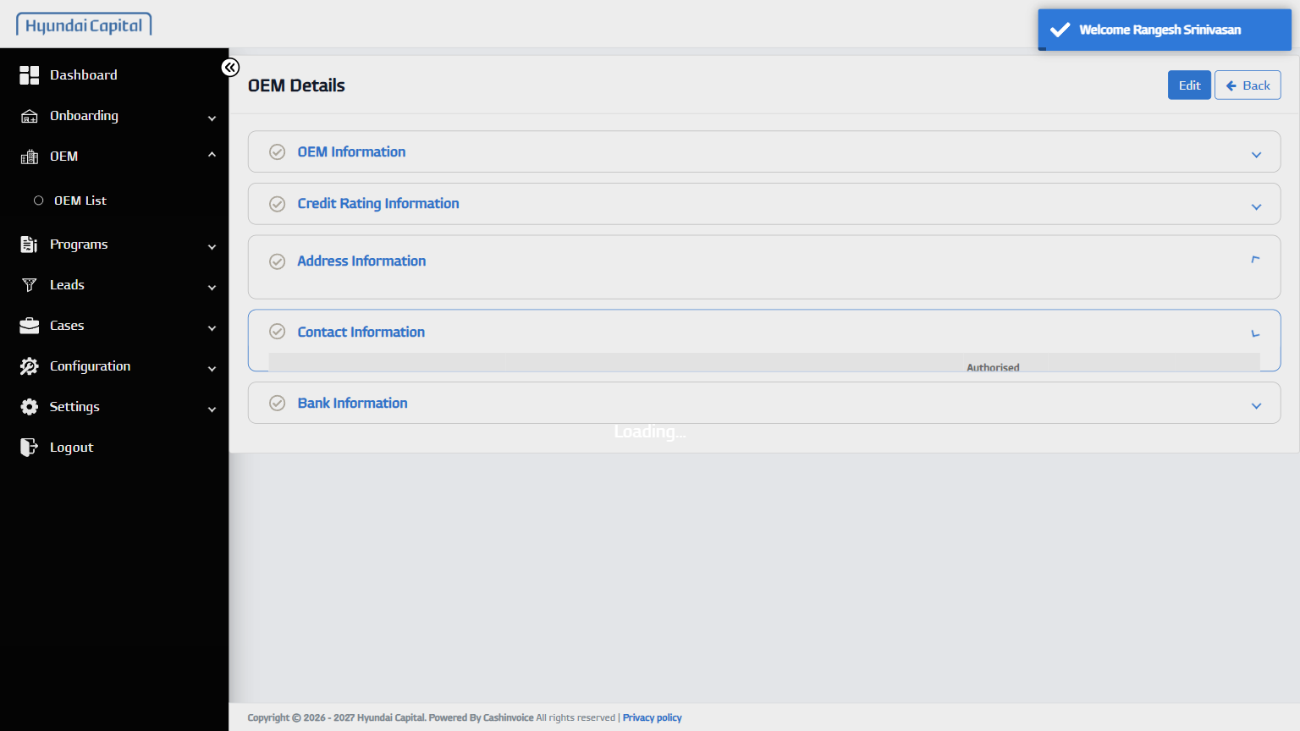
9 | Open Bank Information | - | PASS | 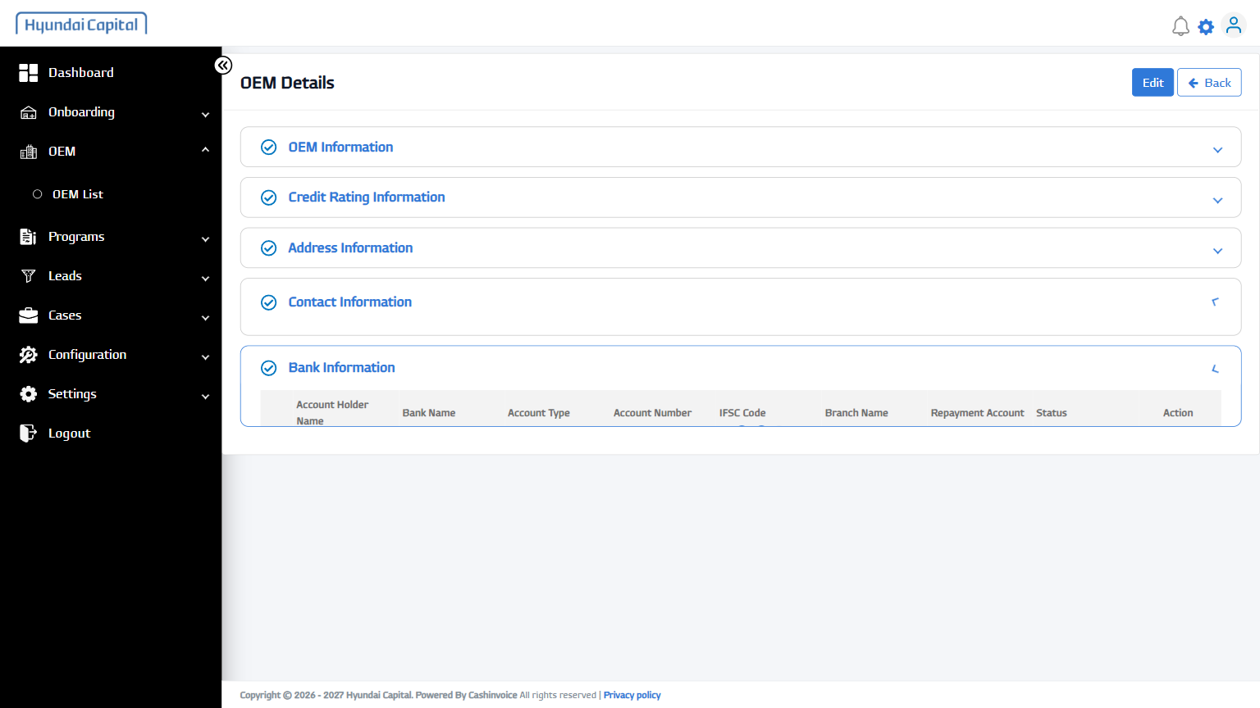
10 | Edit OEM | - | PASS | 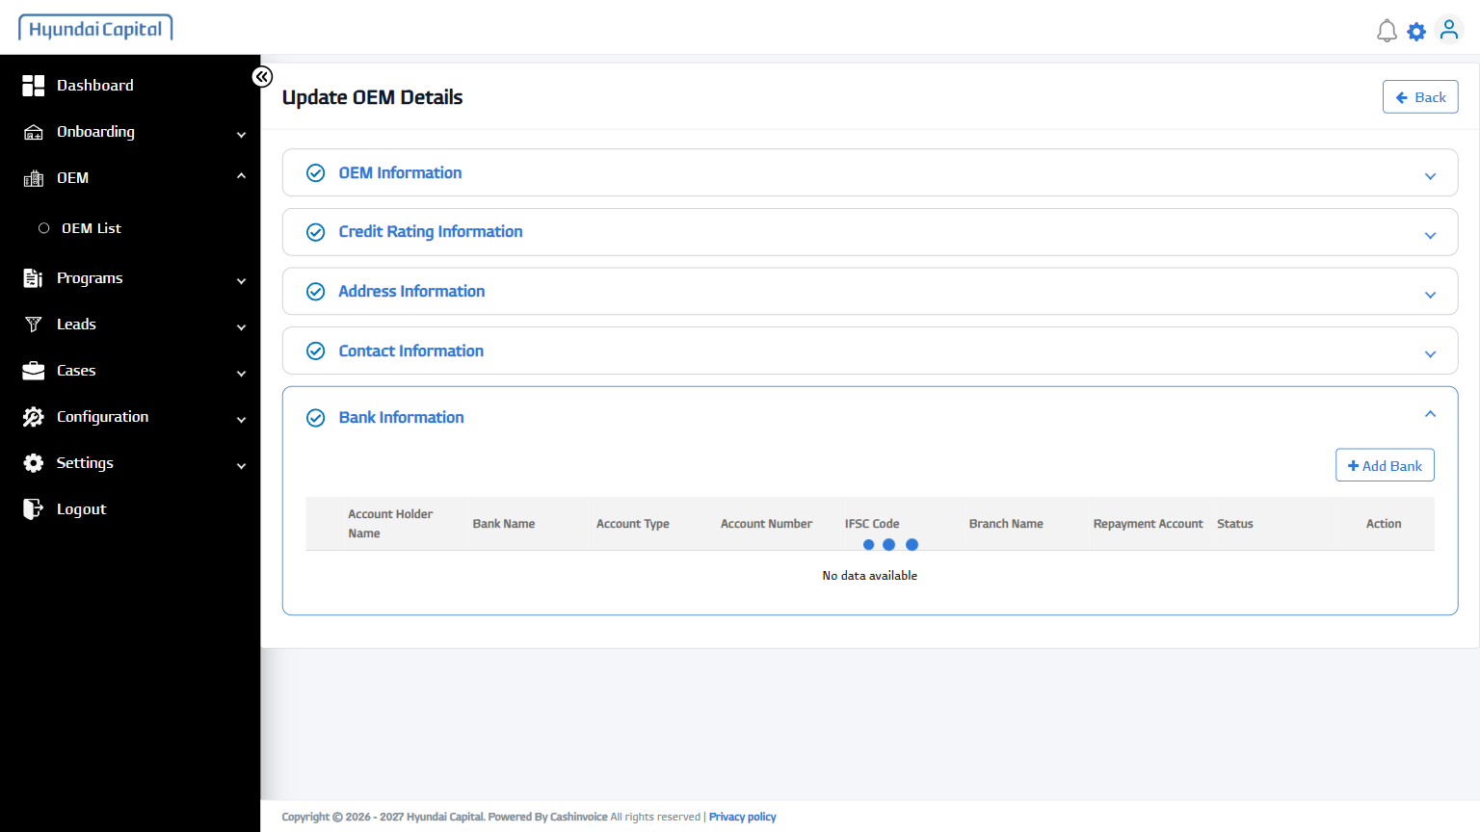
11 | Open Contact Information | - | PASS | 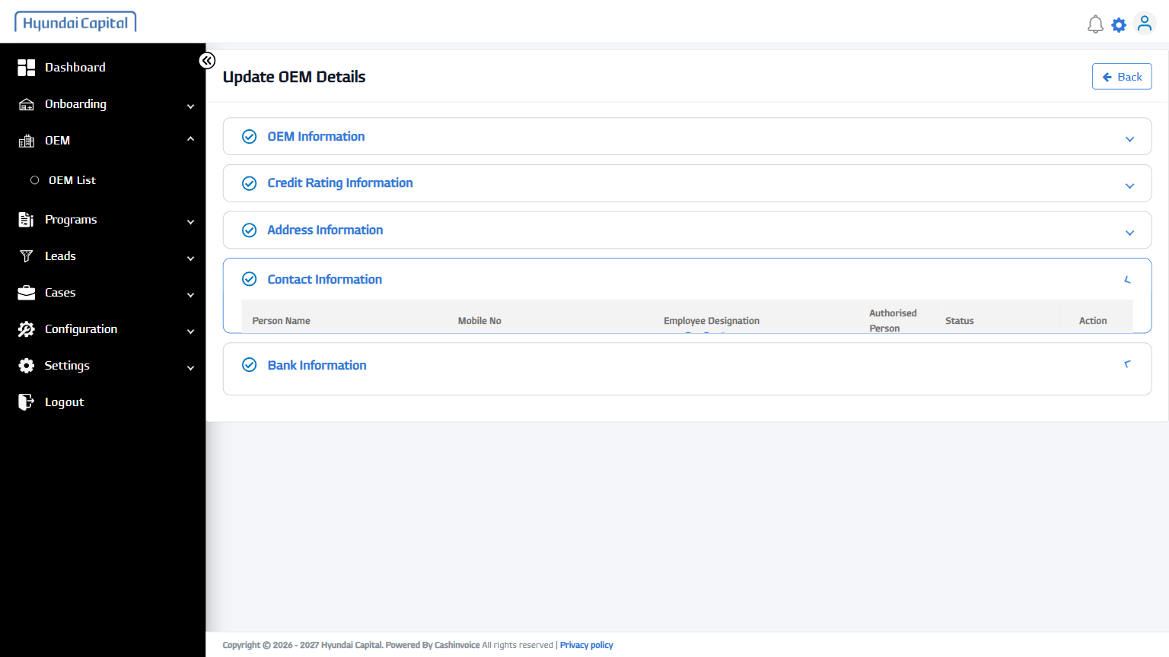
12 | Open Contact Information | - | PASS | 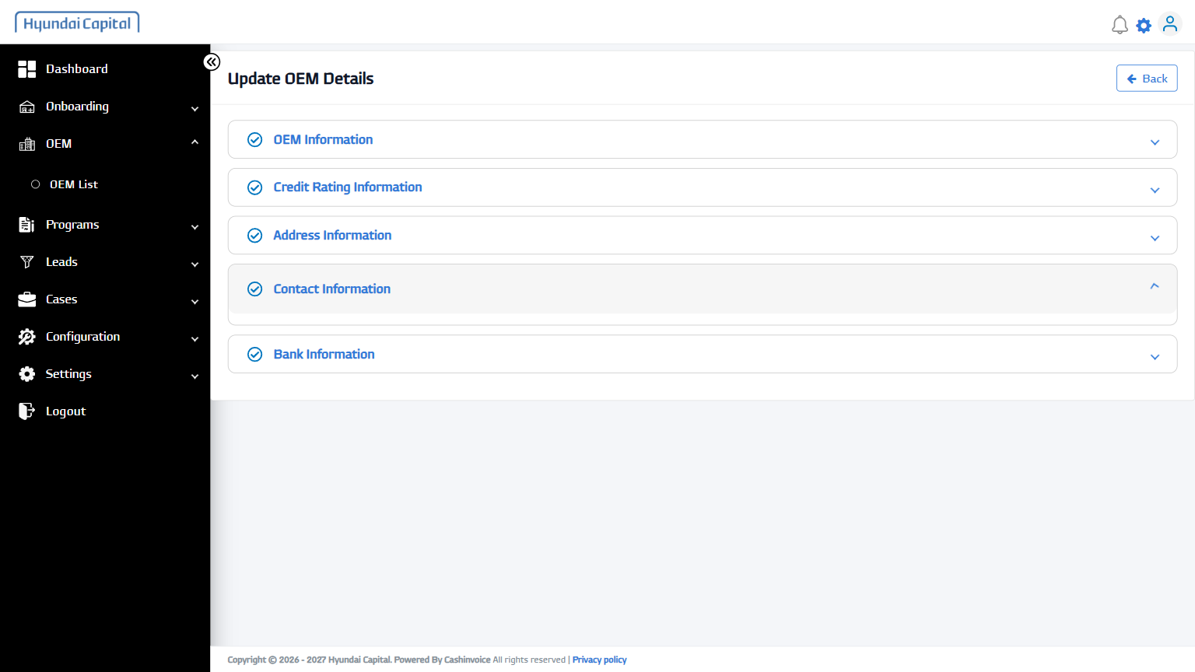
13 | Open Bank Information | - | PASS | 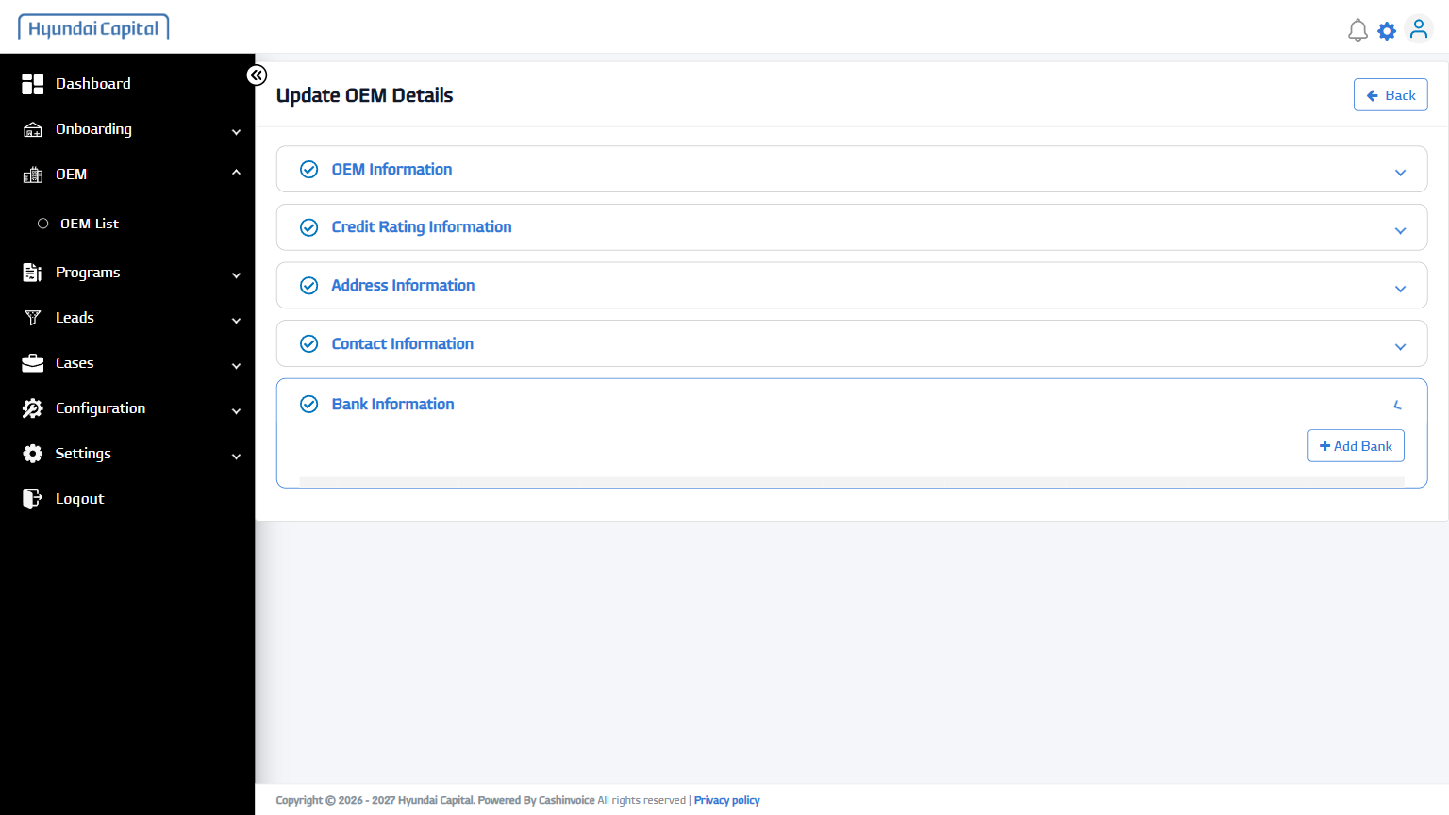
14 | Back | - | PASS | 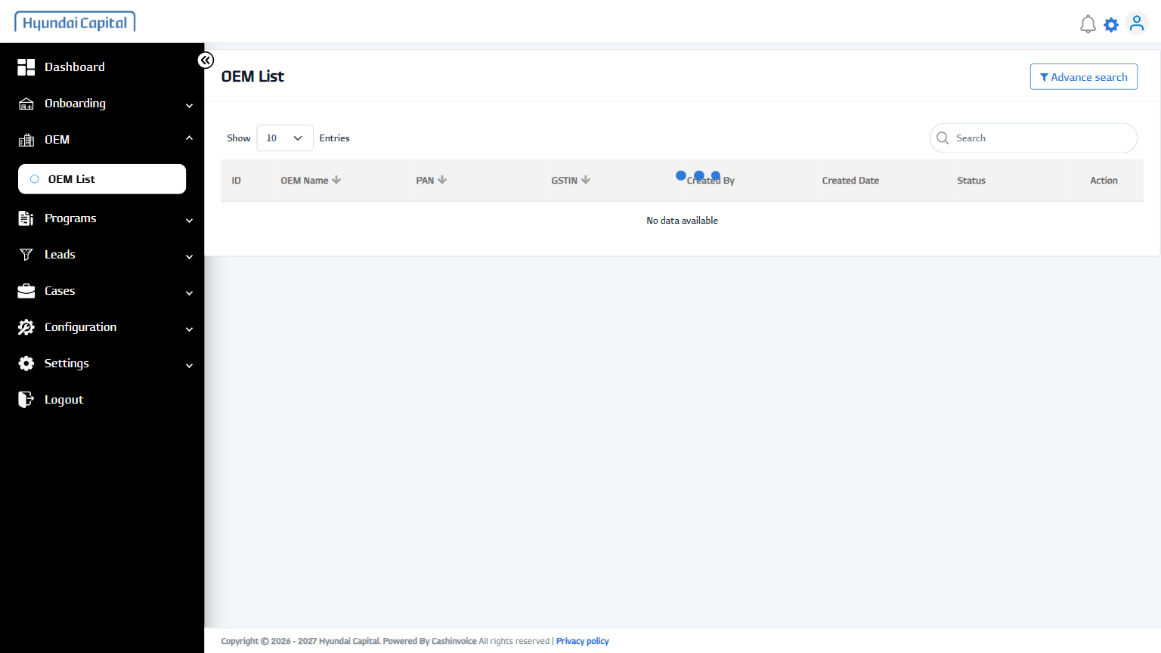
15 | Open OEM Row | KIA INDIA PRIVATE LIMITED | PASS | 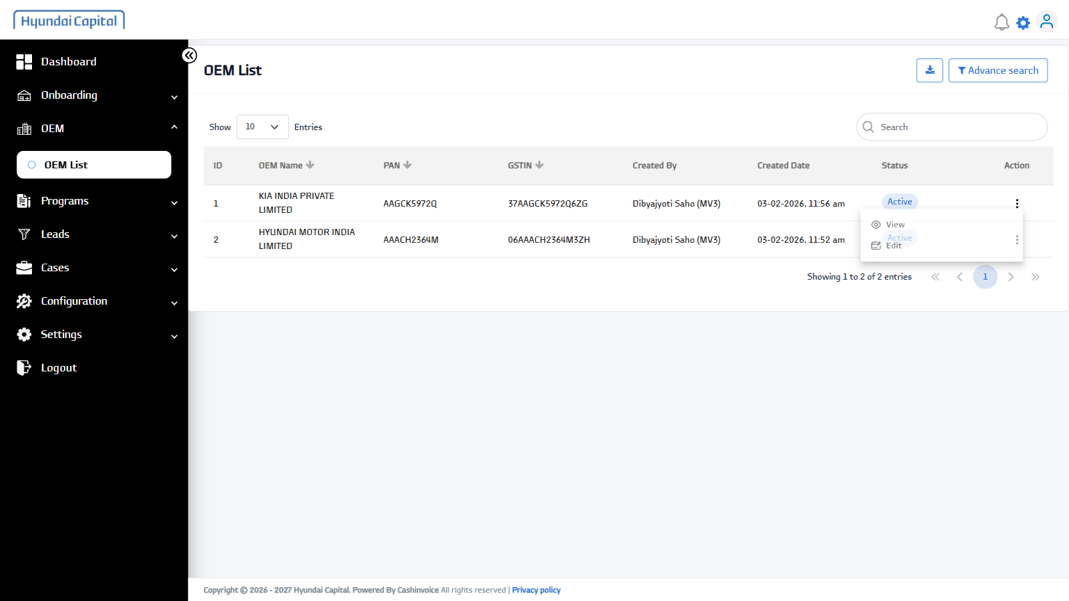
16 | Edit OEM (from list) | - | PASS | 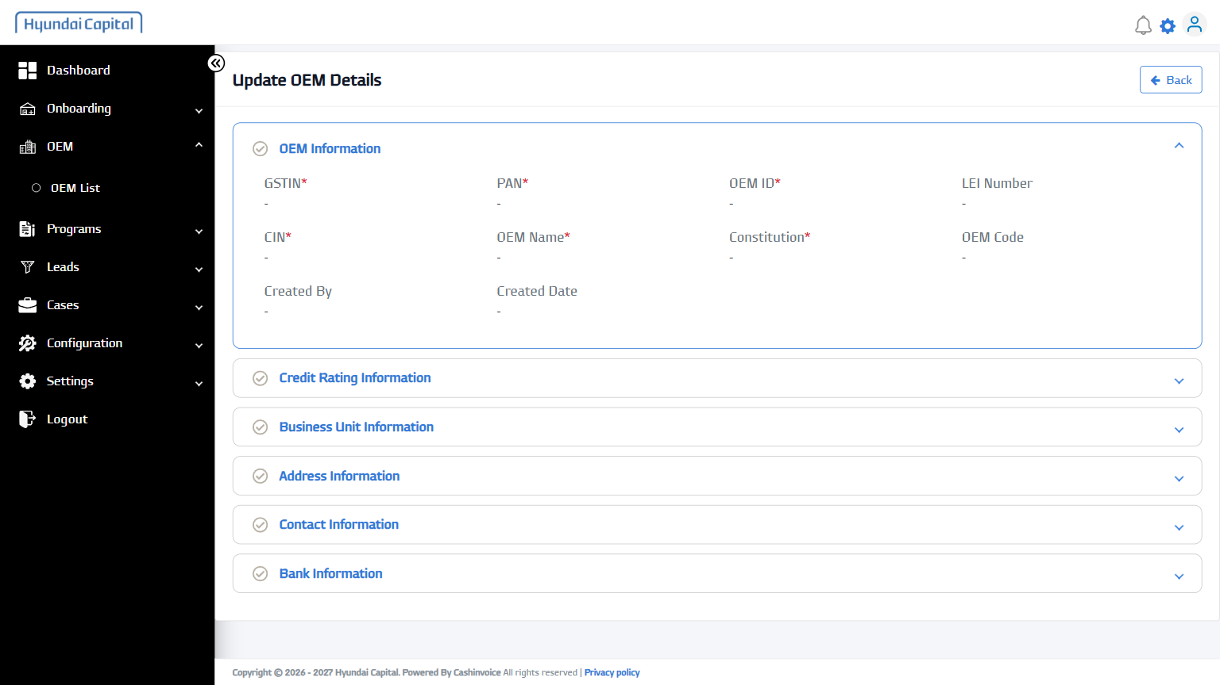
17 | Open Contact Information | - | PASS | 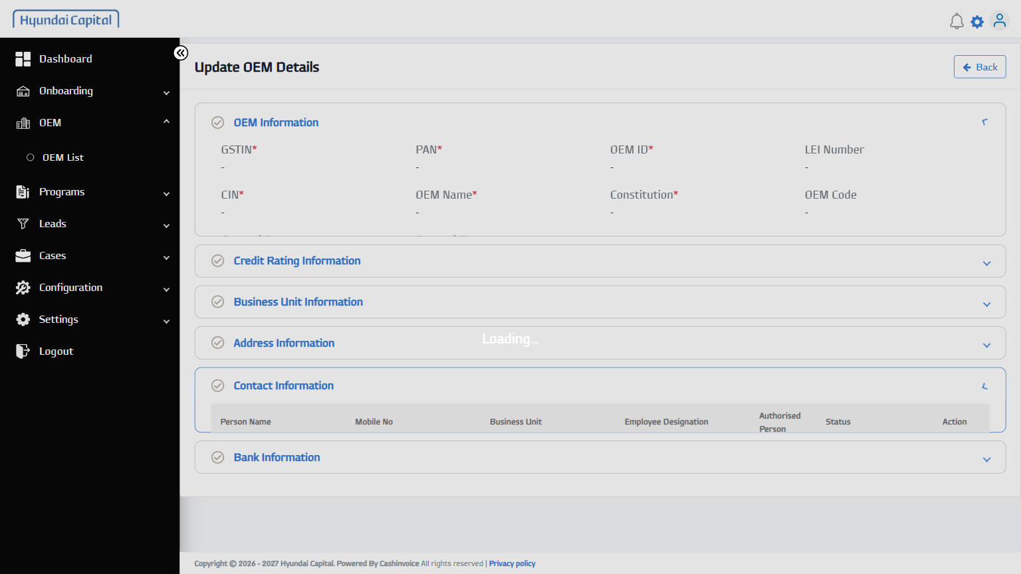
18 | Back | - | PASS | 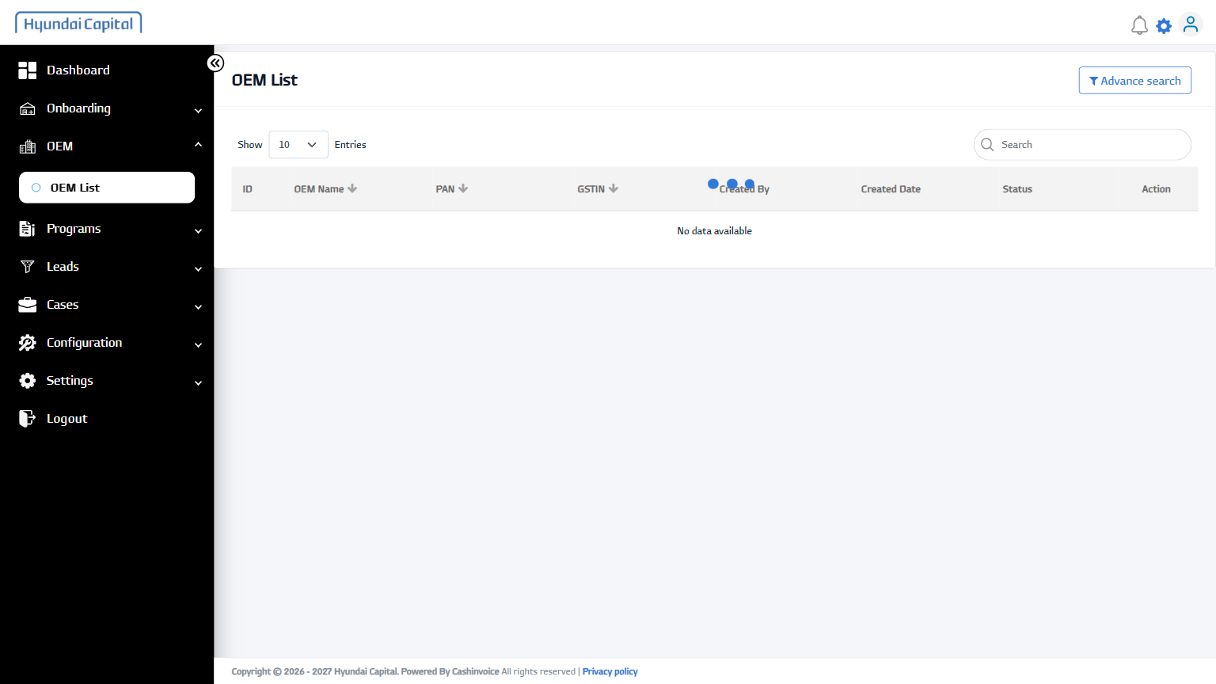
19 | Open Programs Menu | - | PASS | 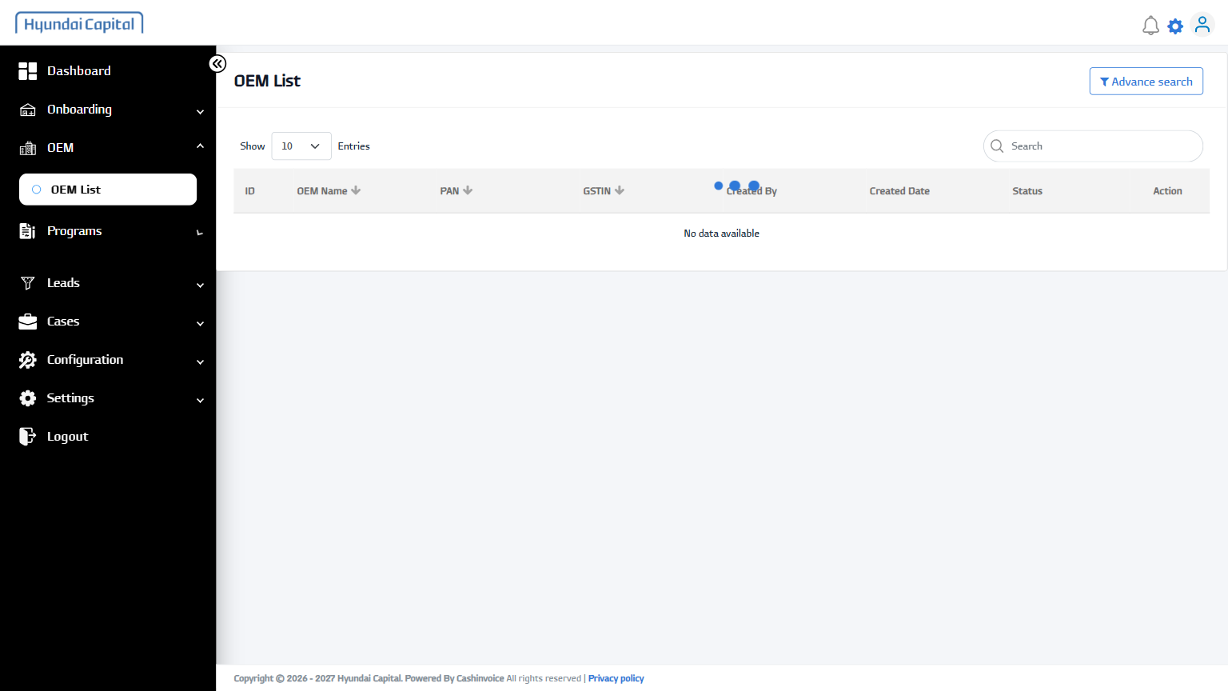
20 | Open All Programs | - | PASS | 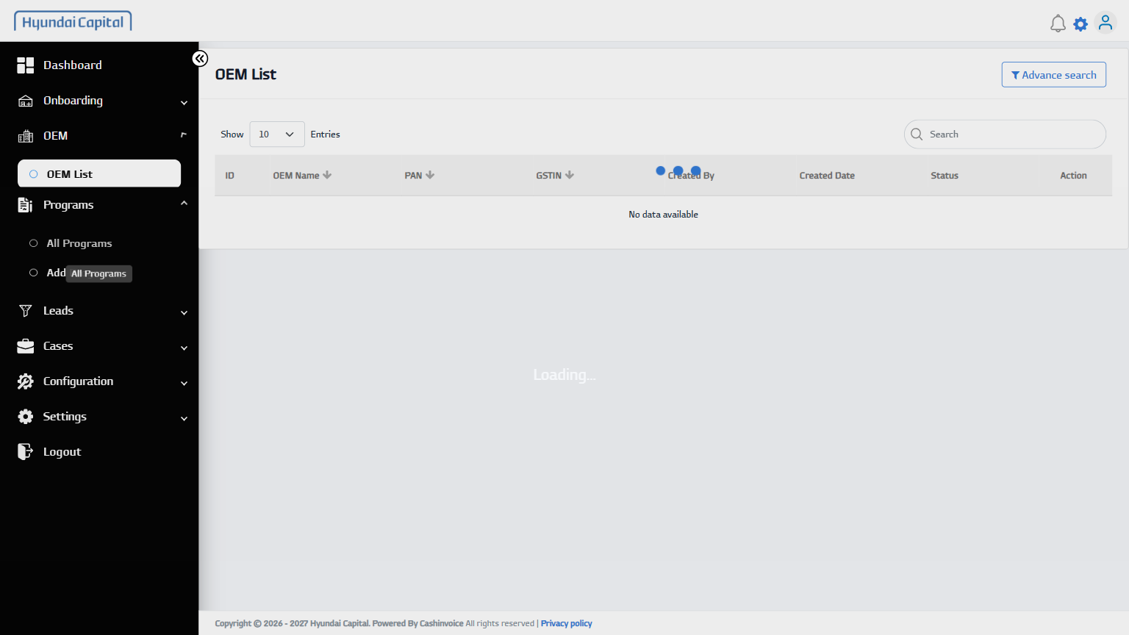
21 | Open All List Tab | - | PASS | 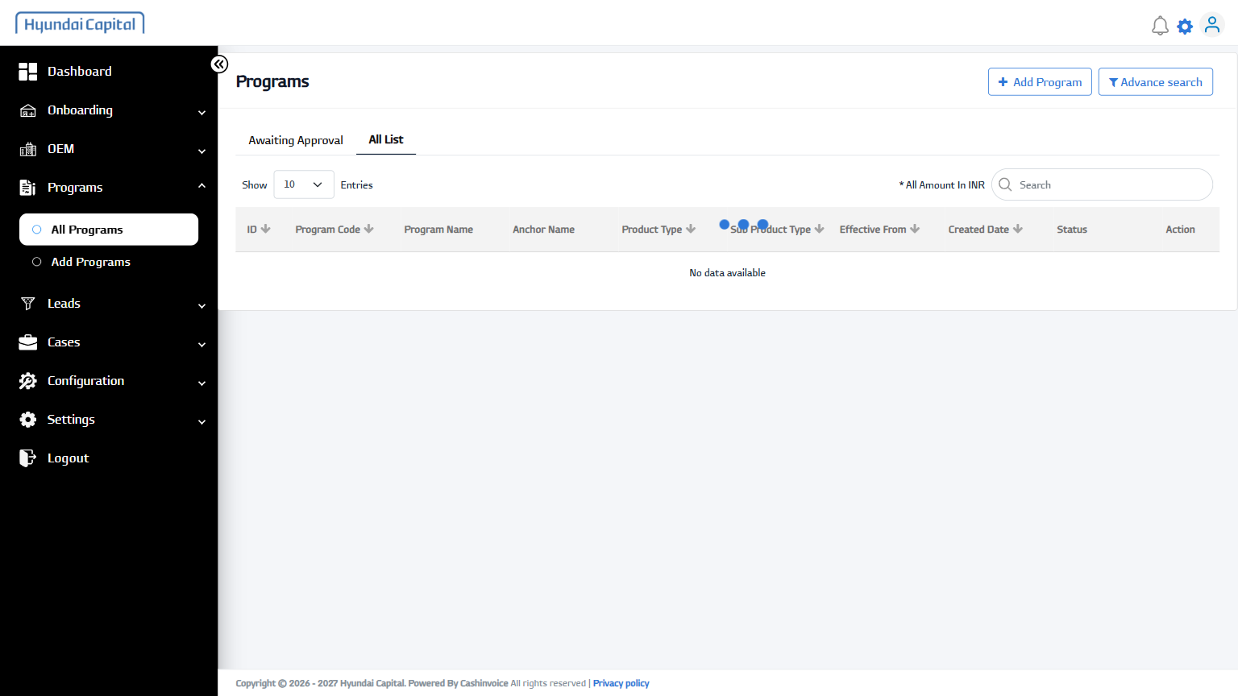
22 | Open Program Row | IM_HMIL_29062026171016 | PASS | 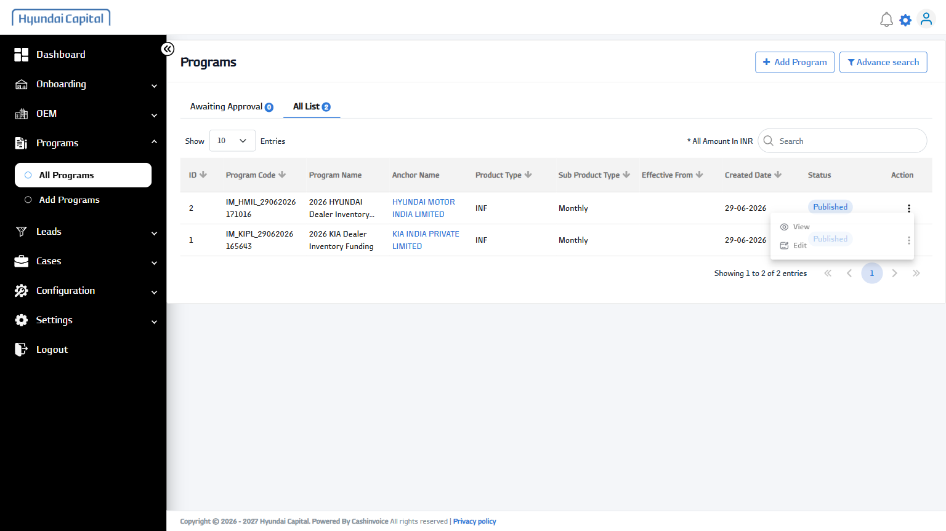
23 | View Program | - | PASS | 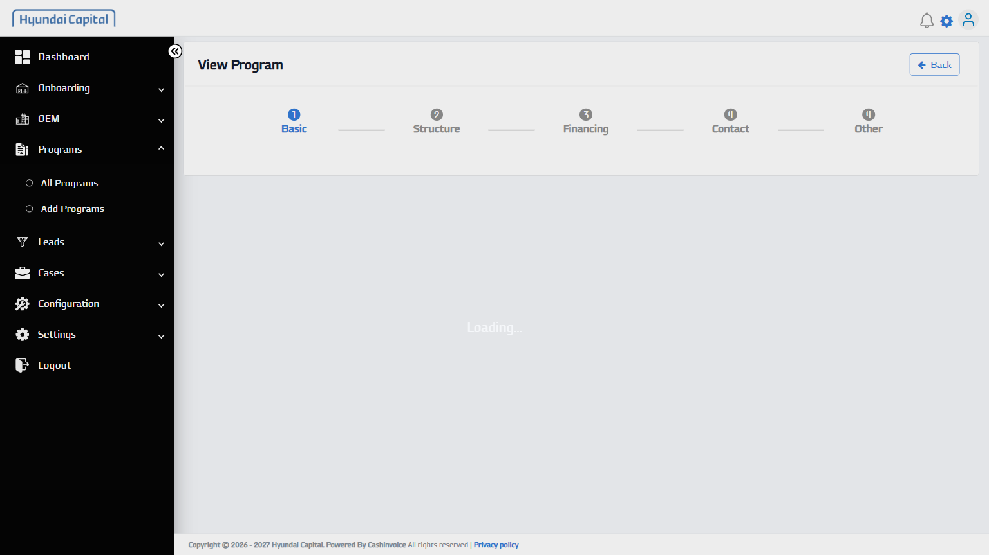
24 | Open Structure Step | - | PASS | 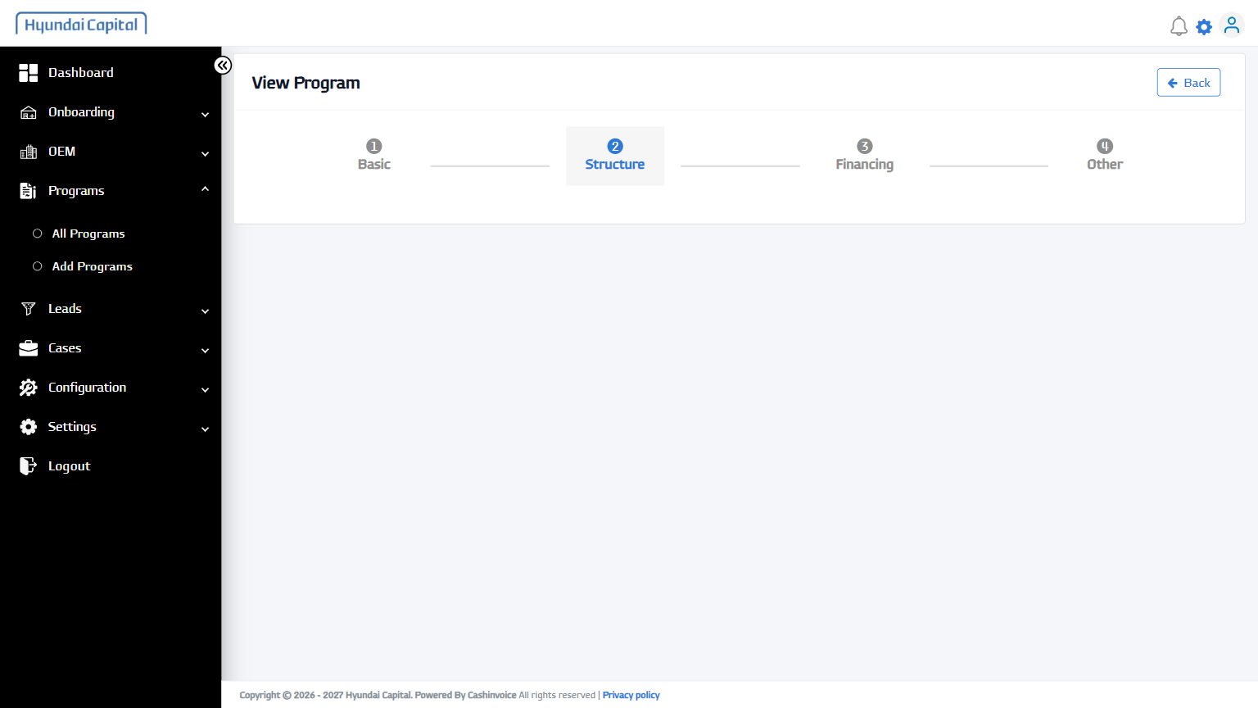
25 | Open Financing Tab | - | PASS | 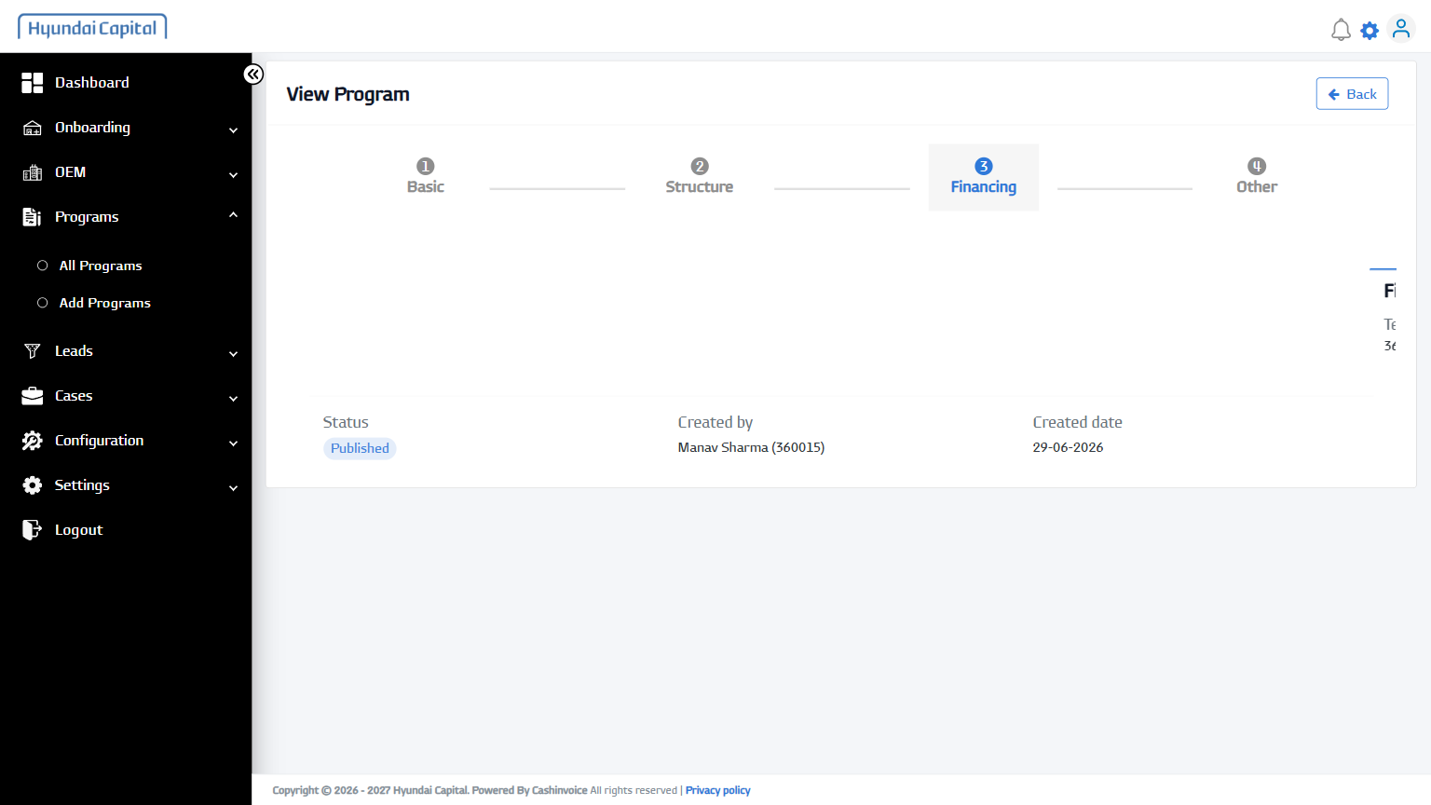
26 | Open Other Tab | - | PASS | 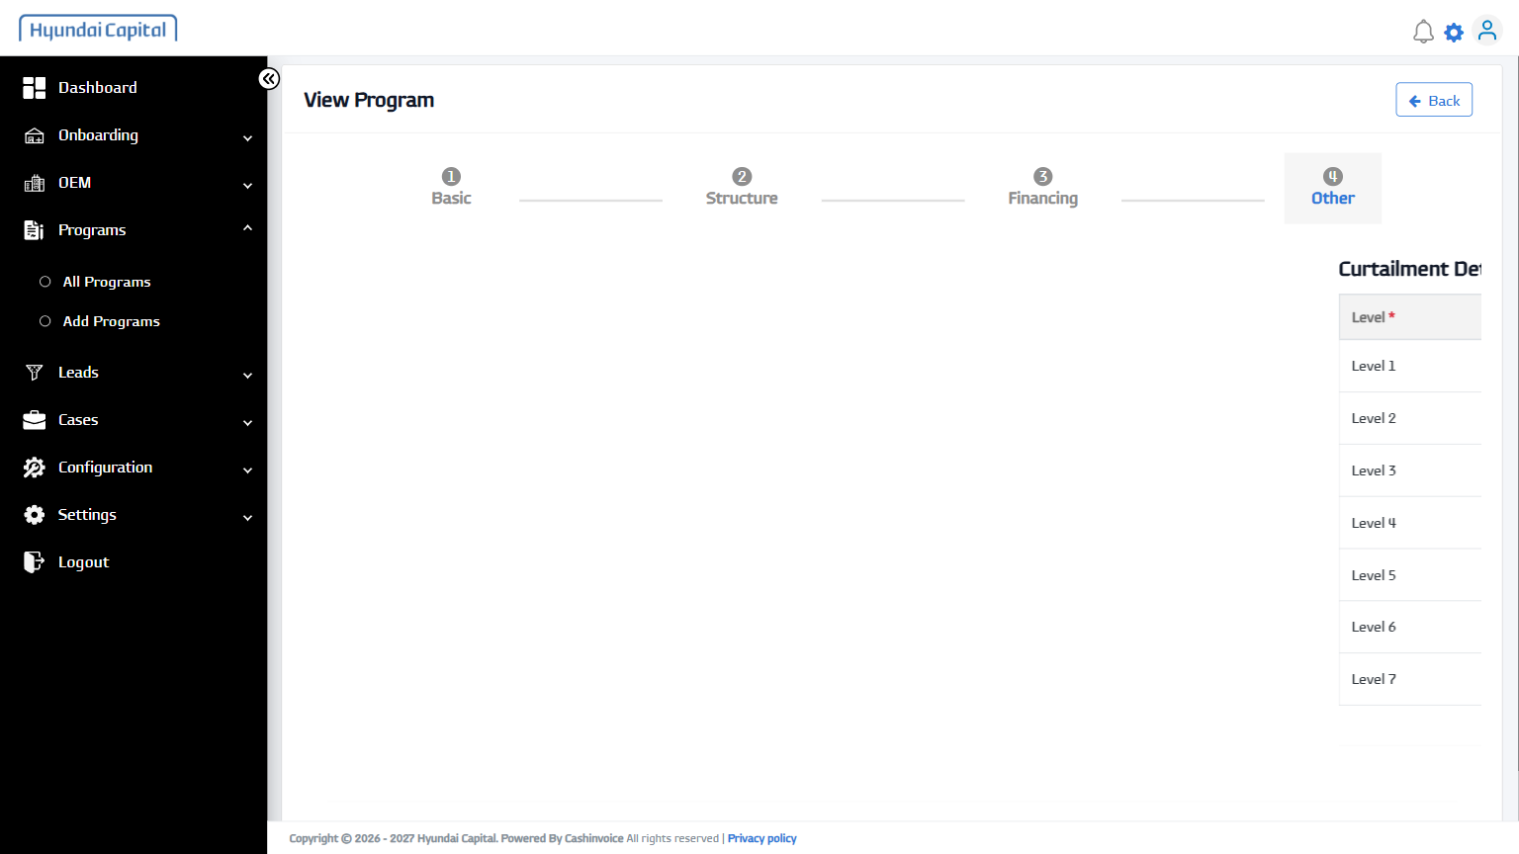
27 | Back | - | PASS | 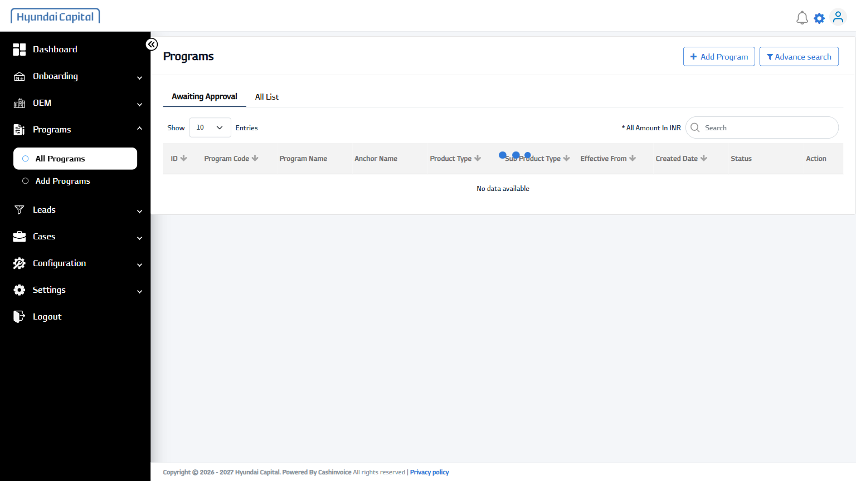
28 | Open All List Tab | - | PASS | 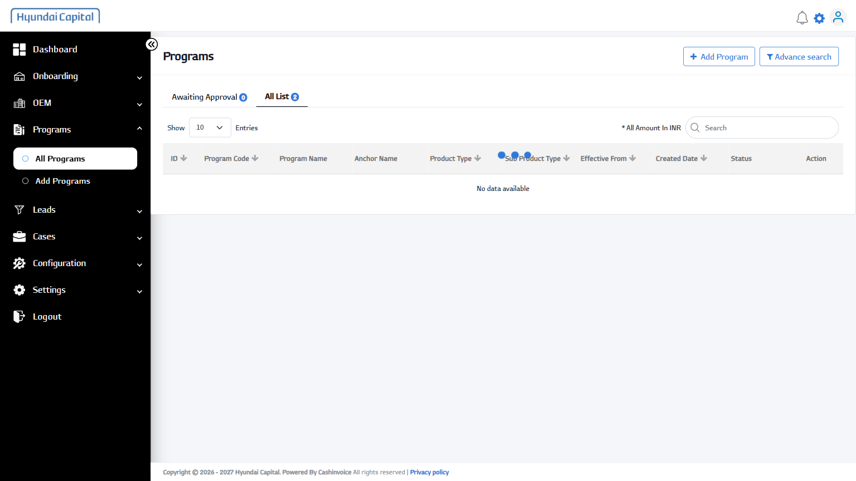
29 | Open Program Row | IM_KIPL_29062026165643 | PASS | 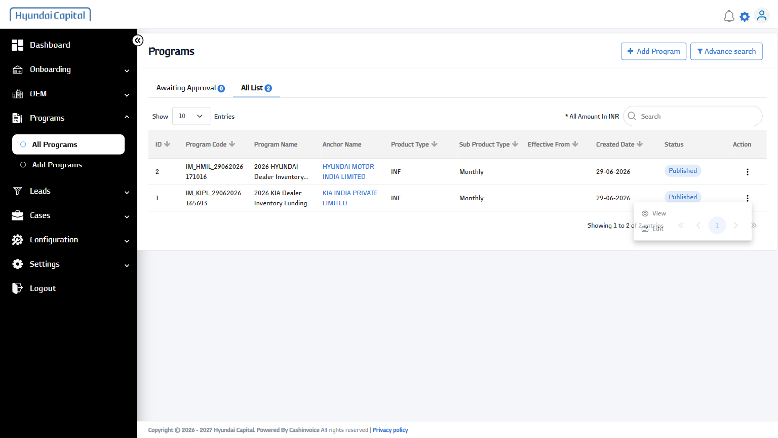
30 | Edit Program (from list) | - | PASS | 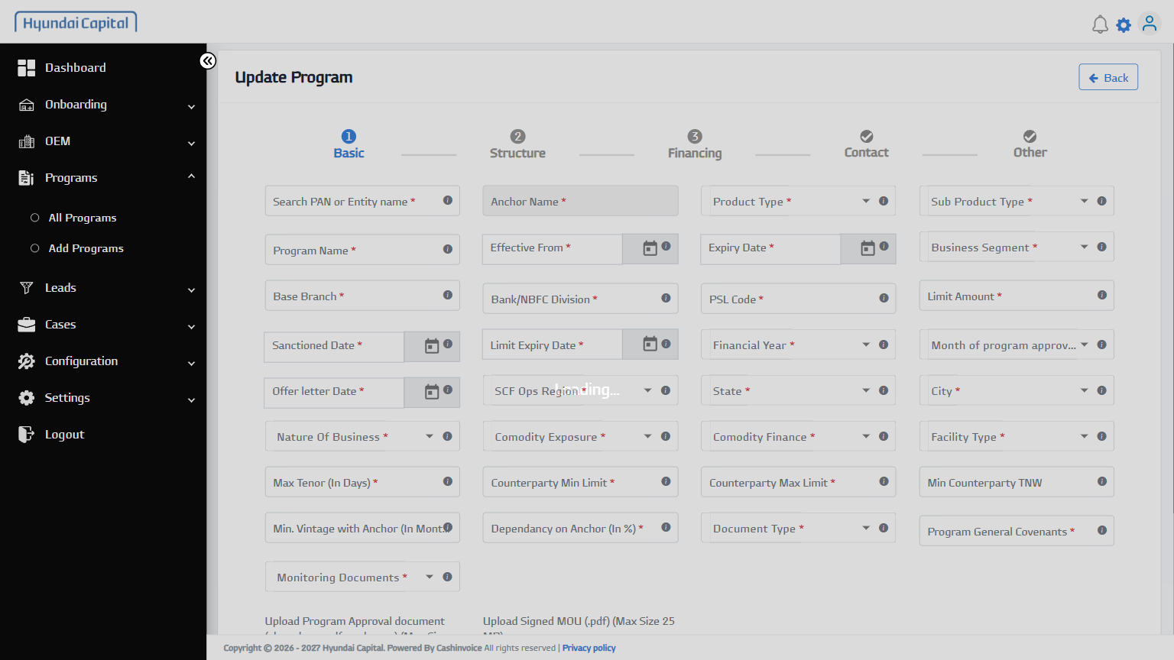
31 | Next | - | PASS | 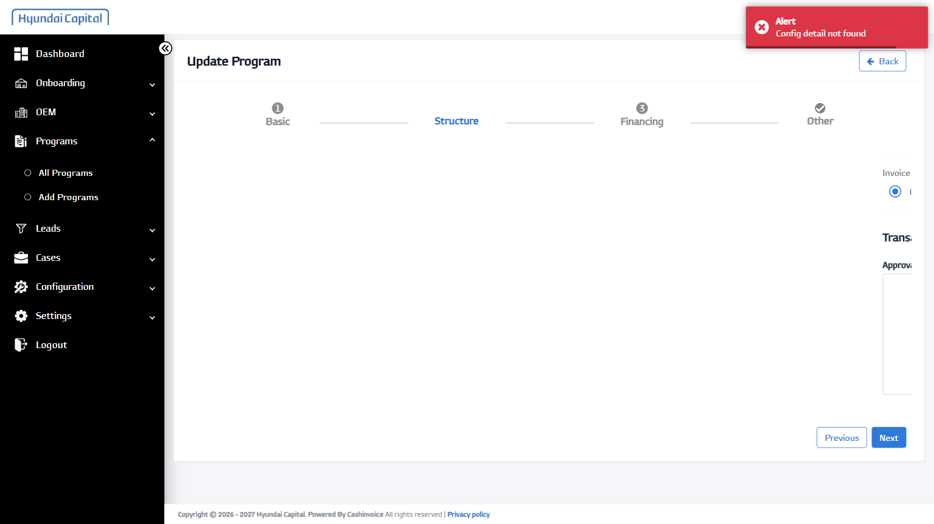
32 | Next | - | PASS | 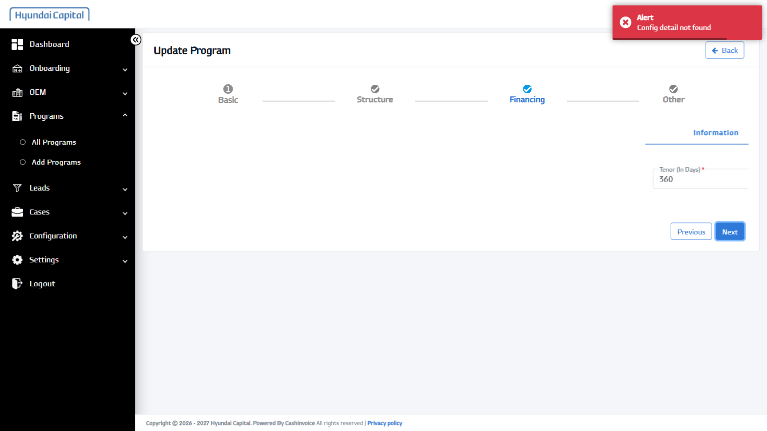
33 | Next | - | PASS | 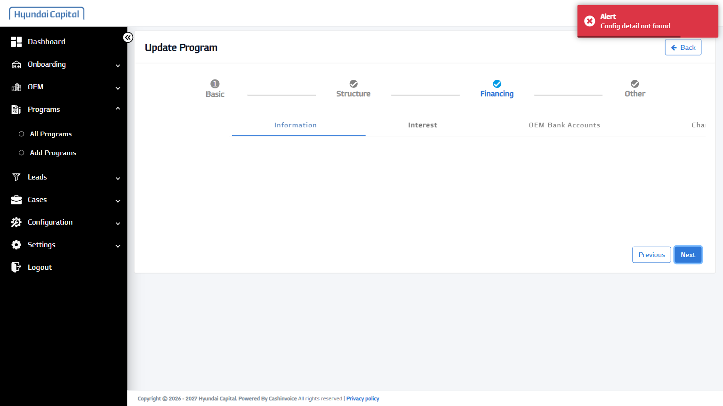
34 | Next | - | PASS | 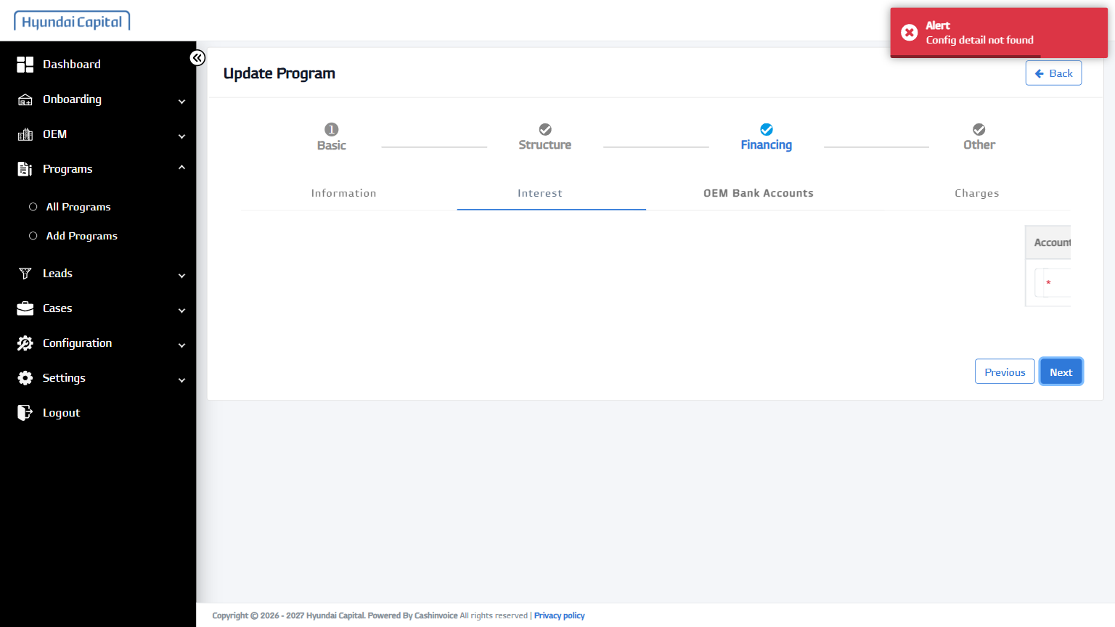
35 | Next | - | PASS | 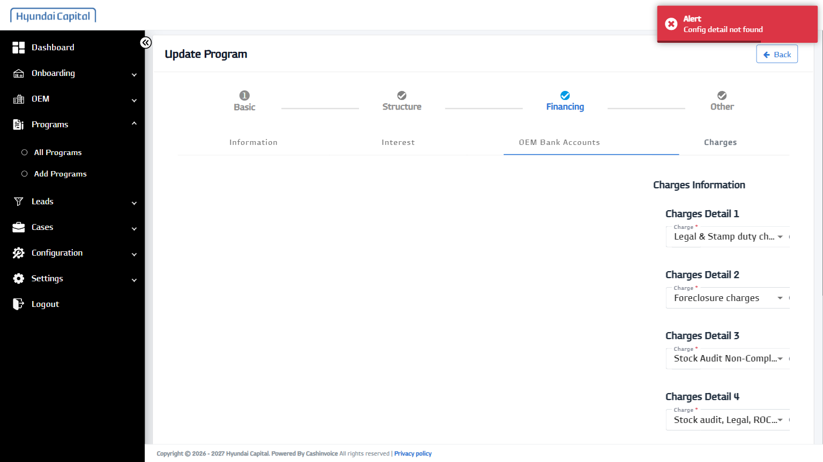
36 | Next | - | PASS | 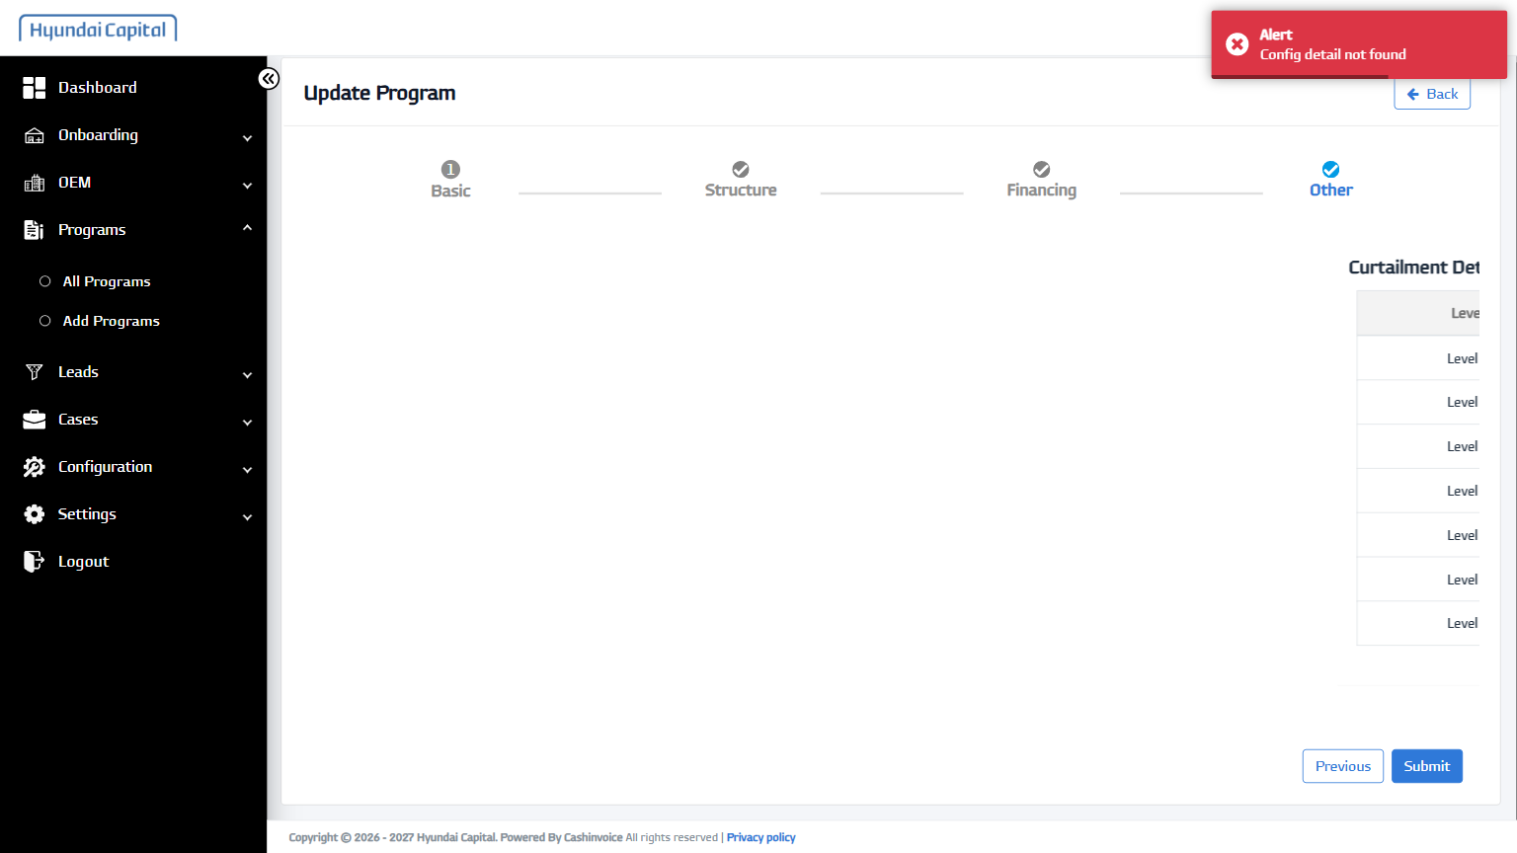
37 | Submit | - | PASS | 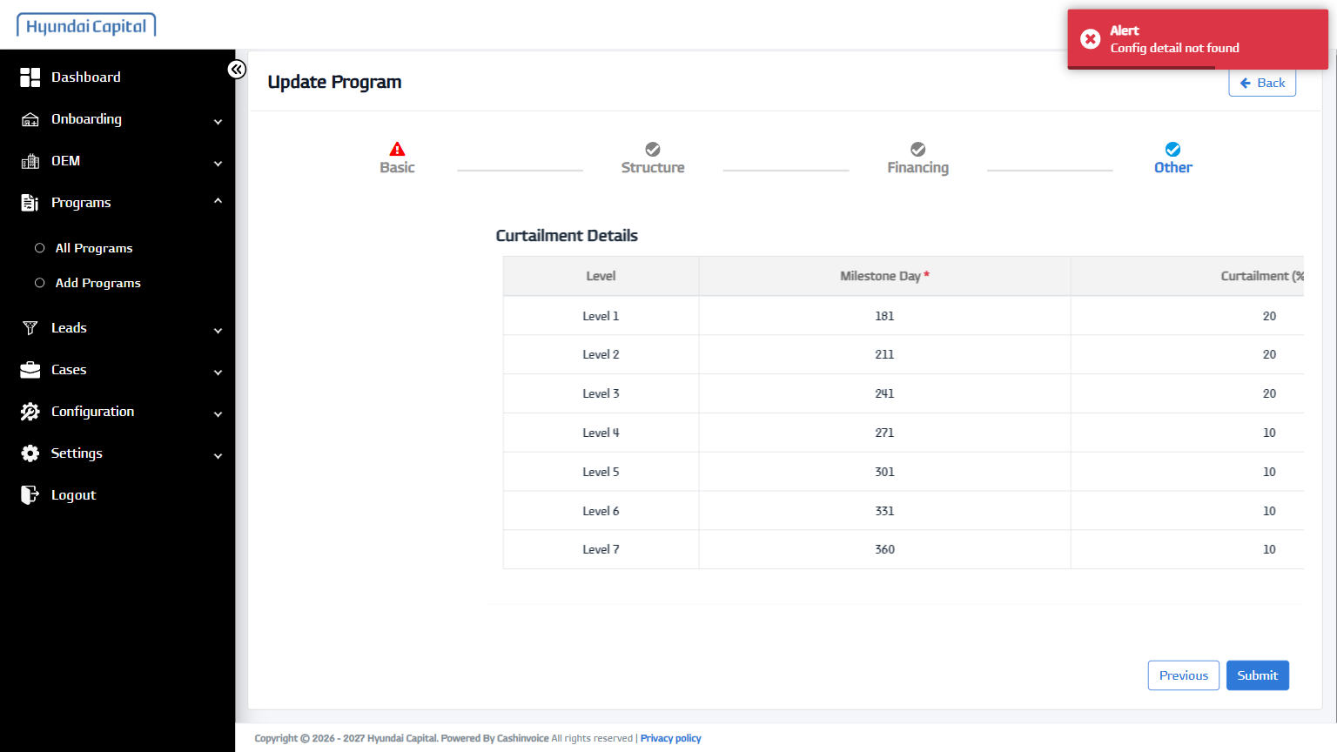
38 | Back | - | PASS | 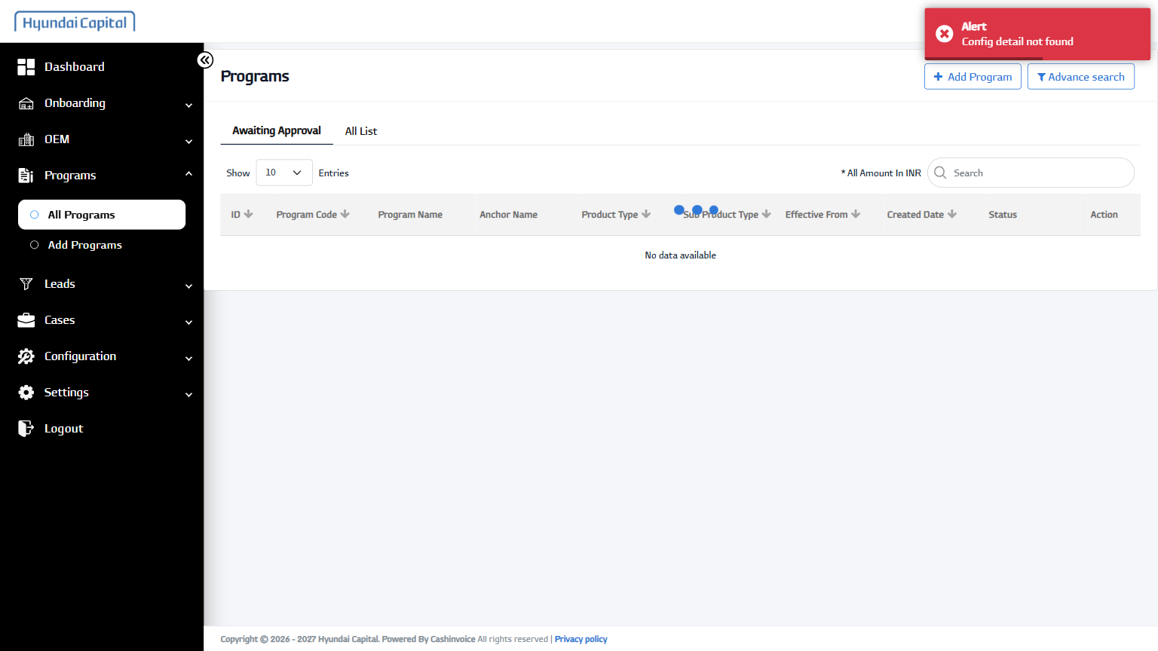
39 | Open Cases Menu | - | PASS | 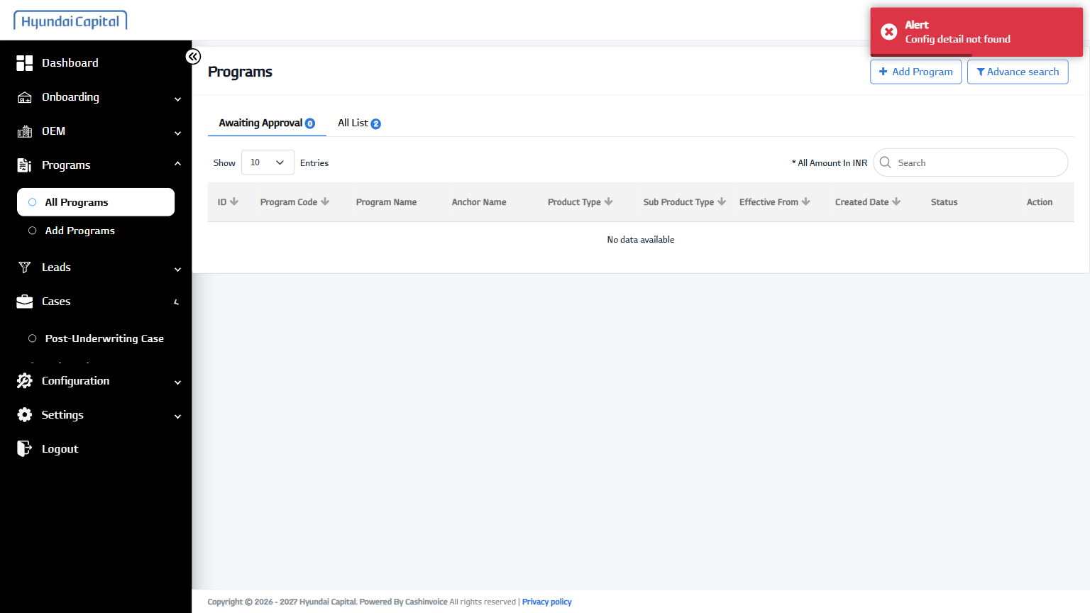
40 | Open Post-Underwriting Cases | - | PASS | 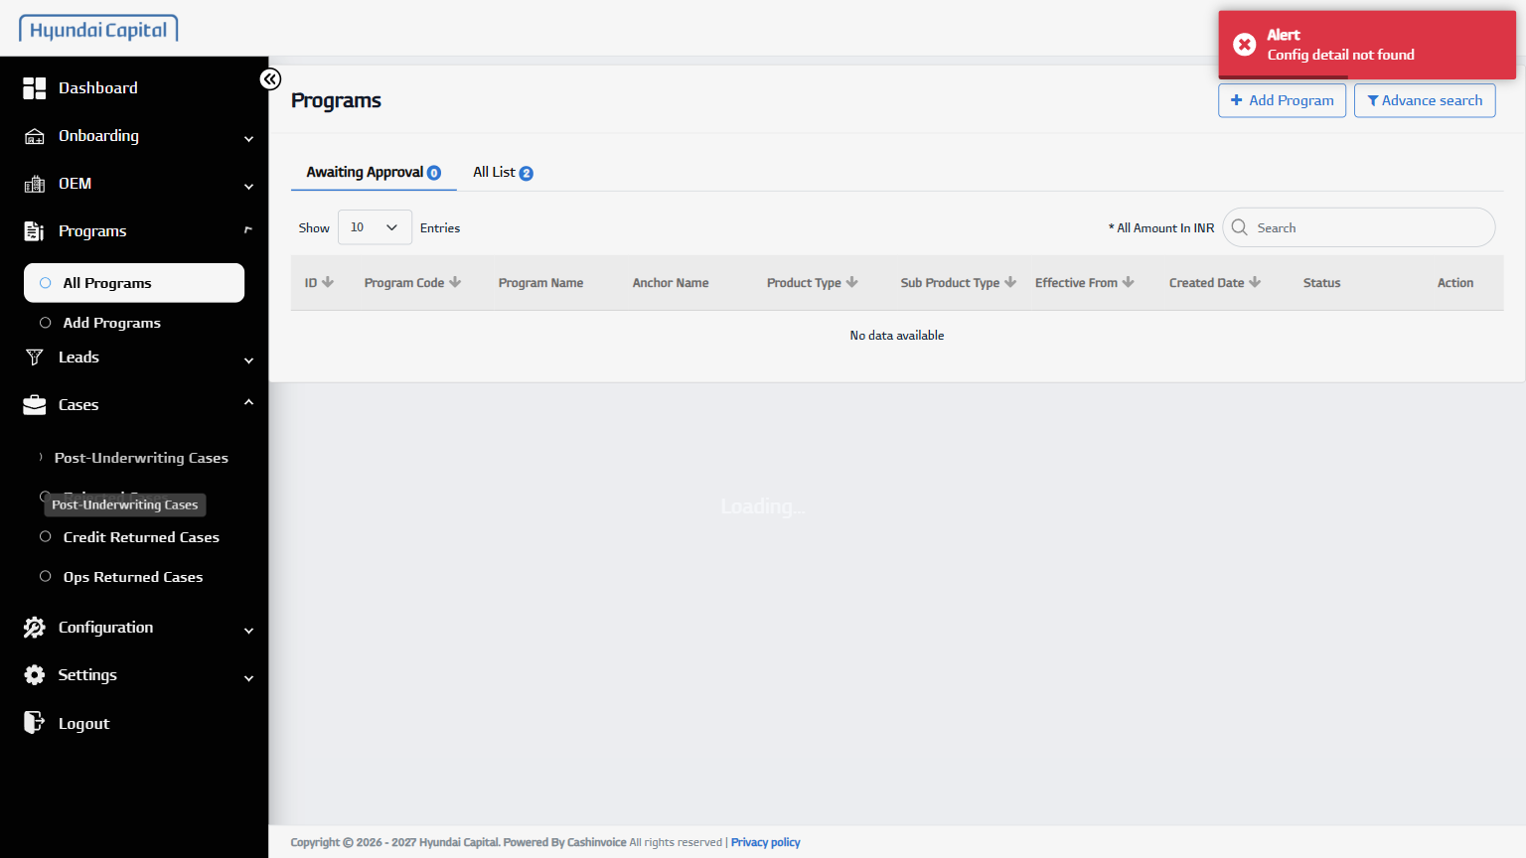
41 | Open Case Row | Hridya Cars Private | PASS | 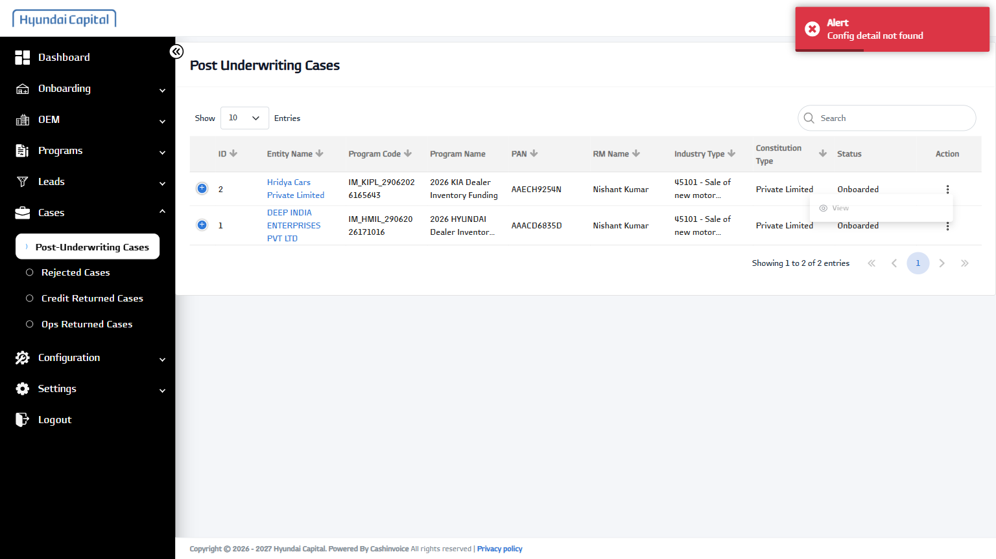
42 | View Case | - | PASS | 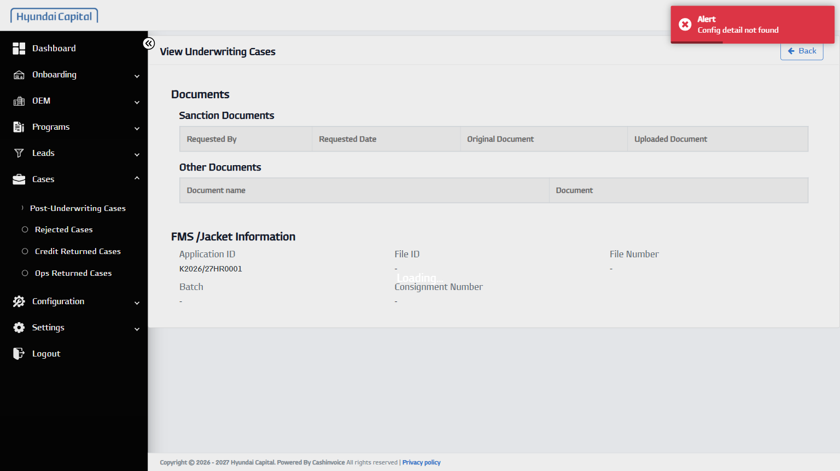
43 | Back | - | PASS | 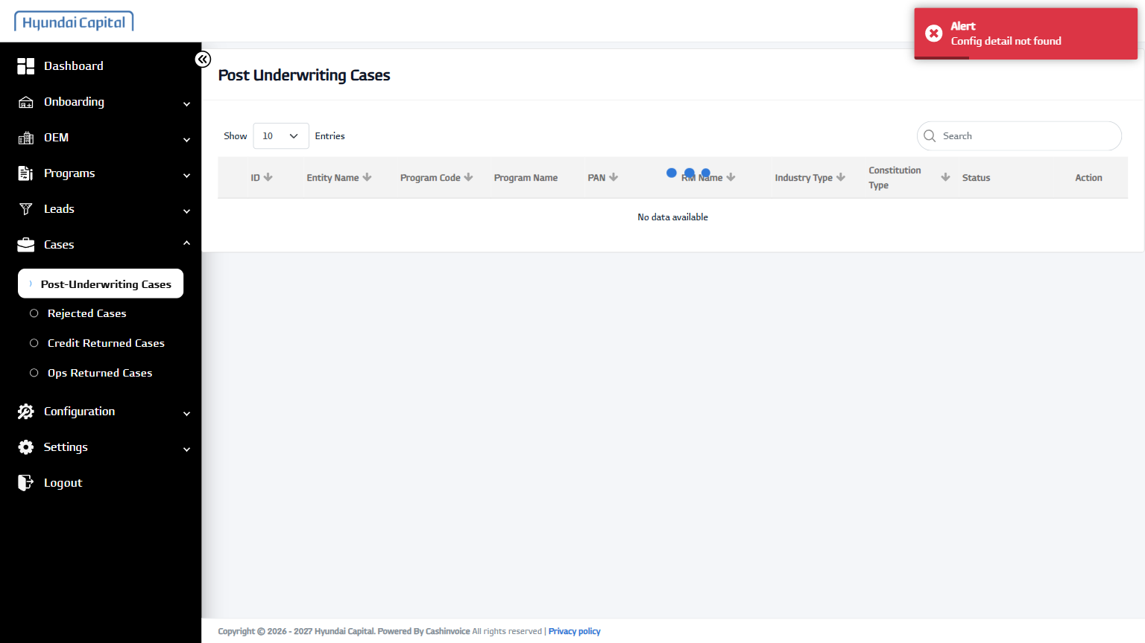
44 | Open Rejected Cases | - | PASS | 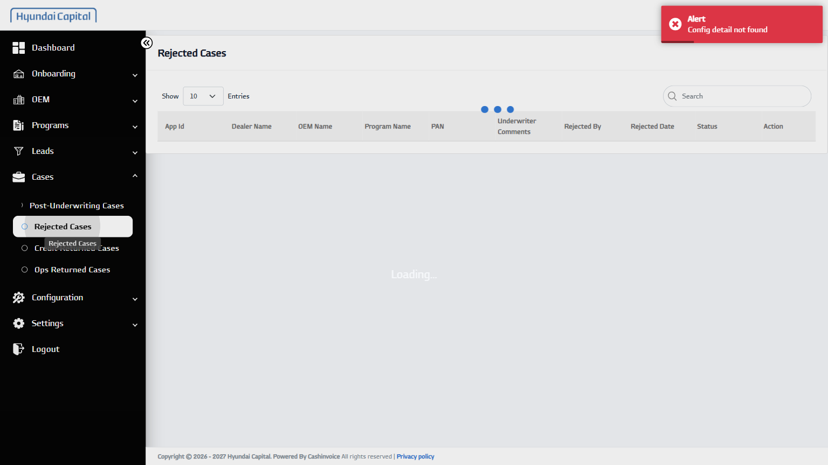
45 | Open Credit Returned Cases | - | PASS | 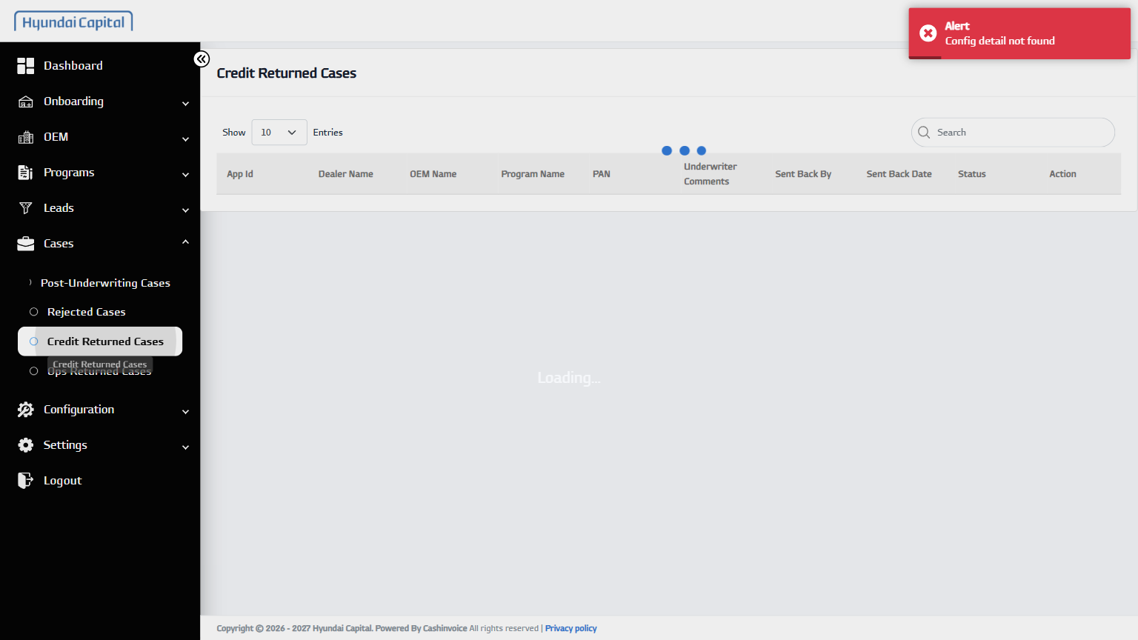
46 | Open Ops Returned Cases | - | PASS | 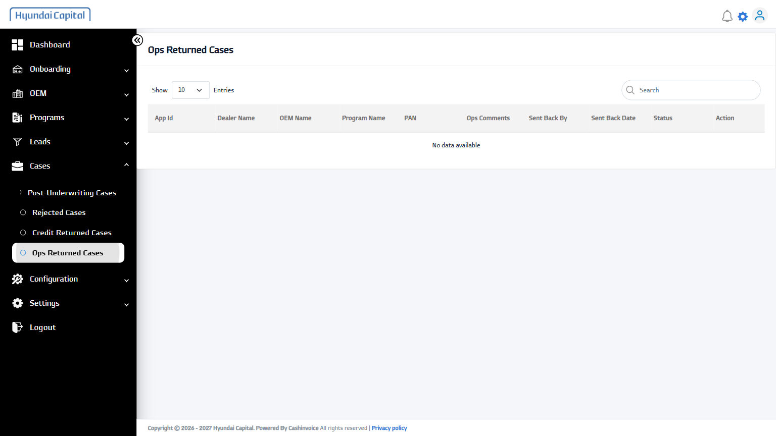
47 | Open Configuration Menu | - | PASS | 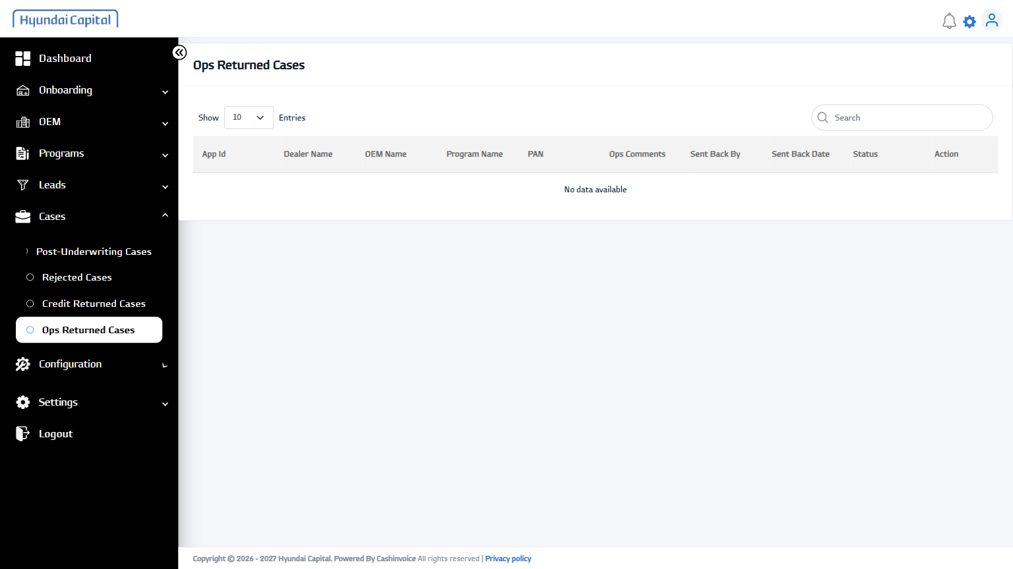
48 | Open Masters | - | PASS | 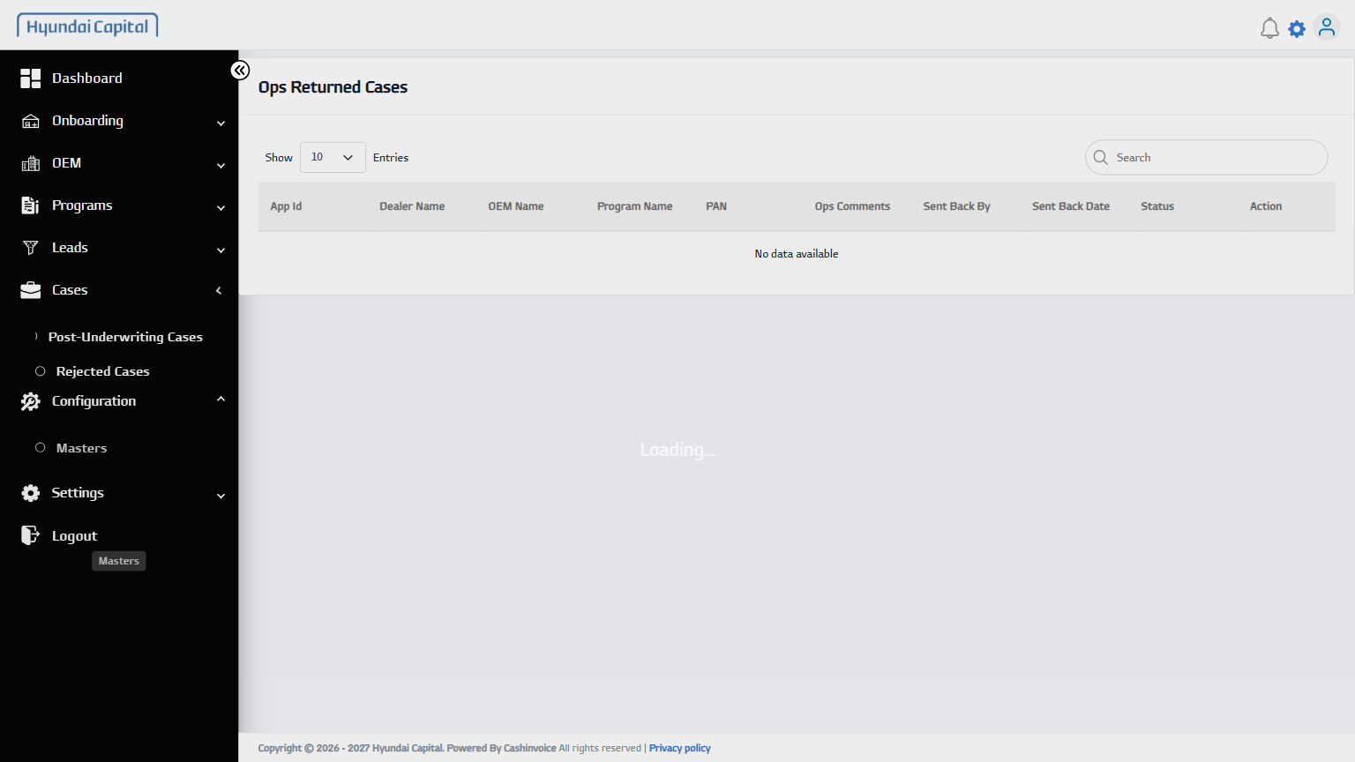
49 | Select Master Type (download) | - | PASS | 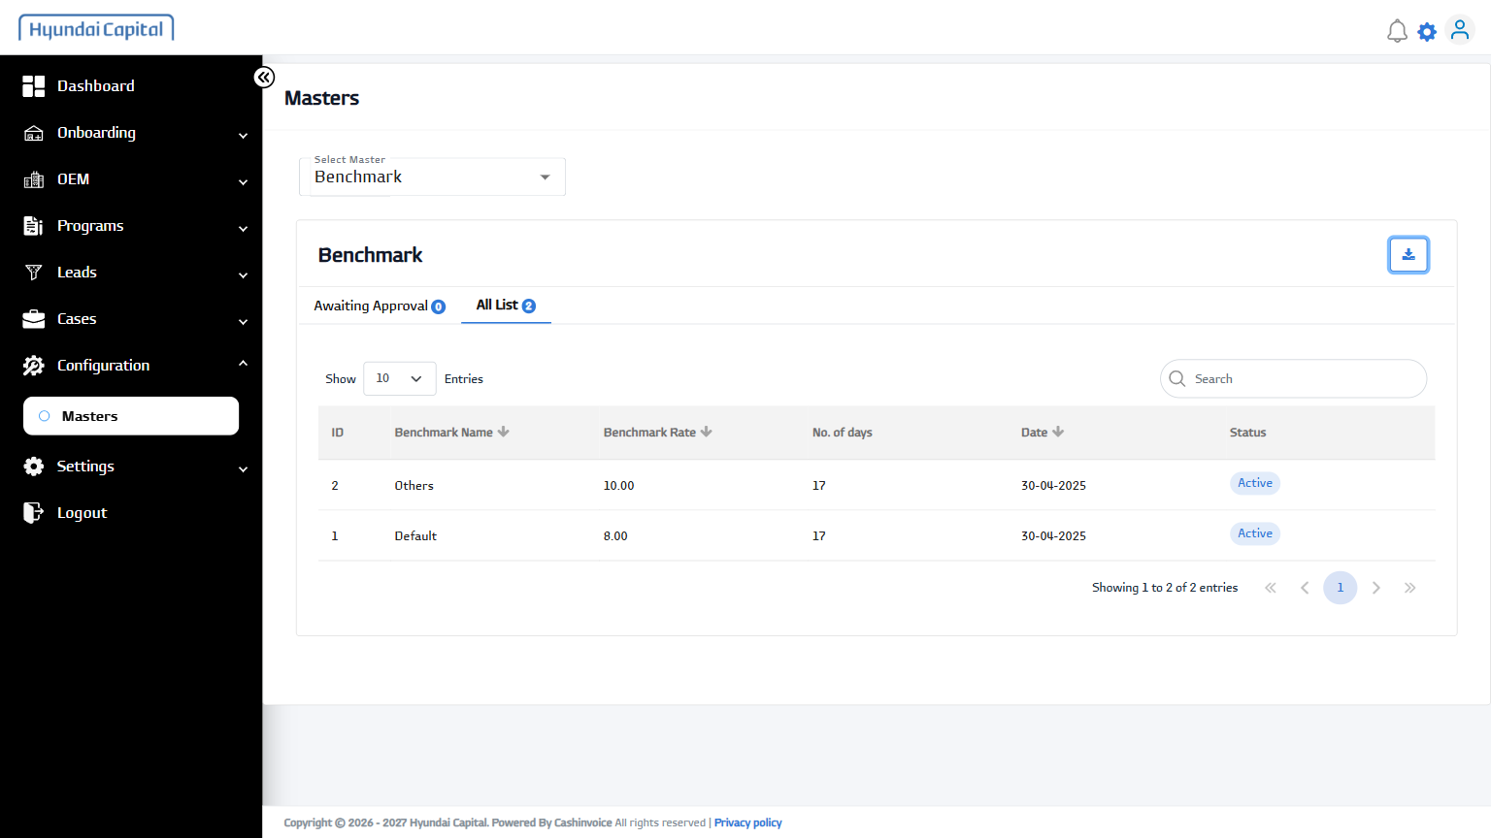
50 | Open Dynamic Field Screen | https://hcinlosdev.cashinvoice.in/los/ | PASS | 