HCIN Automation - Test Execution Report
Generated: 8/11/2026, 4:14:54 PM
Overall Result: FAILED
1  Total | 0  Passed | 1  Failed | 0  Skipped

Test Summary
# | Test Name | File | Status | Duration (ms) | Error
1 | Sales RM - OEM & Programs Menu Navigation | 4-salesRmNavigation.spec.js | FAILED | 37998 | TimeoutError: locator.click: Timeout 30000ms exceeded.  Call log:  [2m - waiting for getByRole('button', { name: 'toggle sidebar' })[22m

1. Sales RM - OEM & Programs Menu Navigation
Status: FAILED | Duration: 37998 ms
Logs in as Sales RM and exercises the OEM and Programs menu navigation end-to-end: views an OEM record's Credit Rating/Address/Contact/Bank Information sections, edits it, then views a program's Structure/Financing/Other sections and edits another program through its full step wizard to Submit. Pure navigation smoke test - no new data is created.
Field-by-Field Results
# | Field | Value Entered | Status | Screenshot
1 | Toggle Sidebar | - | FAIL | 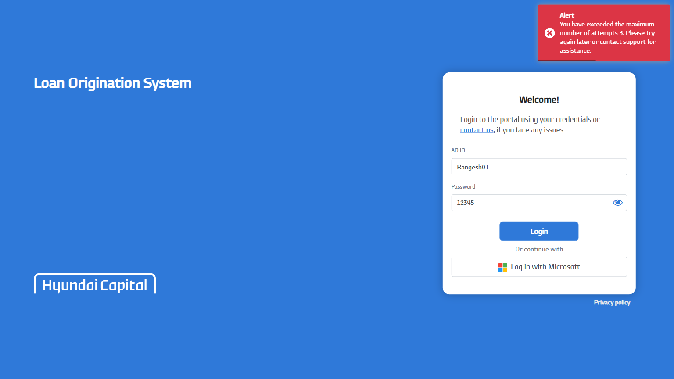
Error:
TimeoutError: locator.click: Timeout 30000ms exceeded.
Call log:
[2m - waiting for getByRole('button', { name: 'toggle sidebar' })[22m

