HCIN Automation - Test Execution Report
Generated: 8/4/2026, 11:35:15 AM
Overall Result: PASSED
1  Total | 1  Passed | 0  Failed | 0  Skipped

Test Summary
# | Test Name | File | Status | Duration (ms) | Error
1 | Create New Company Lead | 2-onboardCompanyLead.spec.js | PASSED | 29143

1. Create New Company Lead
Status: PASSED | Duration: 29143 ms
Logs in as Sales RM, creates a new lead for a company/corporate entity (GSTIN, CIN, LEI, key person, address & program details), uploads a KYC document and submits it, using test data read from fixtures/companyLeadData.xlsx. A fresh GSTIN/CIN/Entity Name are generated and written back to the same file each run so the lead is never rejected as a duplicate.
Field-by-Field Results
# | Field | Value Entered | Status | Screenshot
1 | Create New Lead | - | PASS | 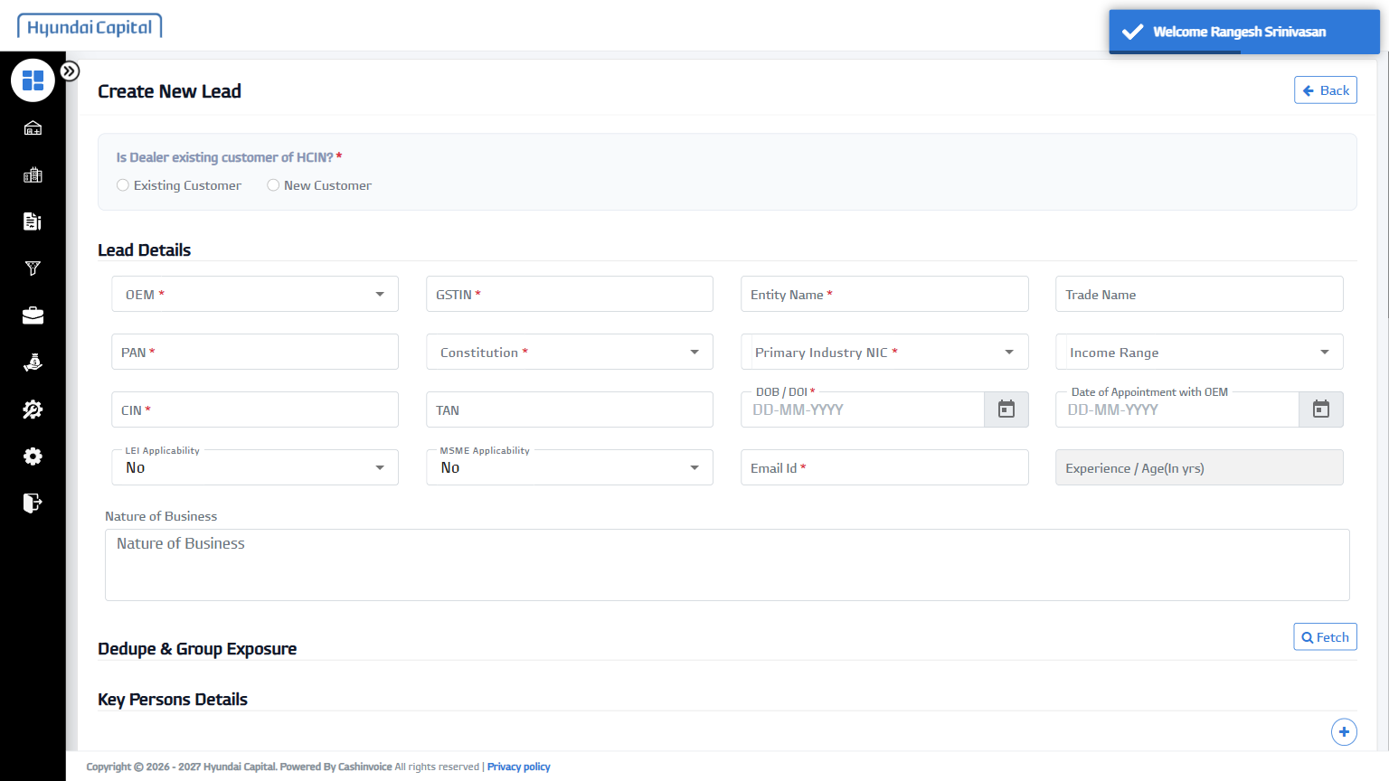
2 | Existing/New Customer | New Customer | PASS | 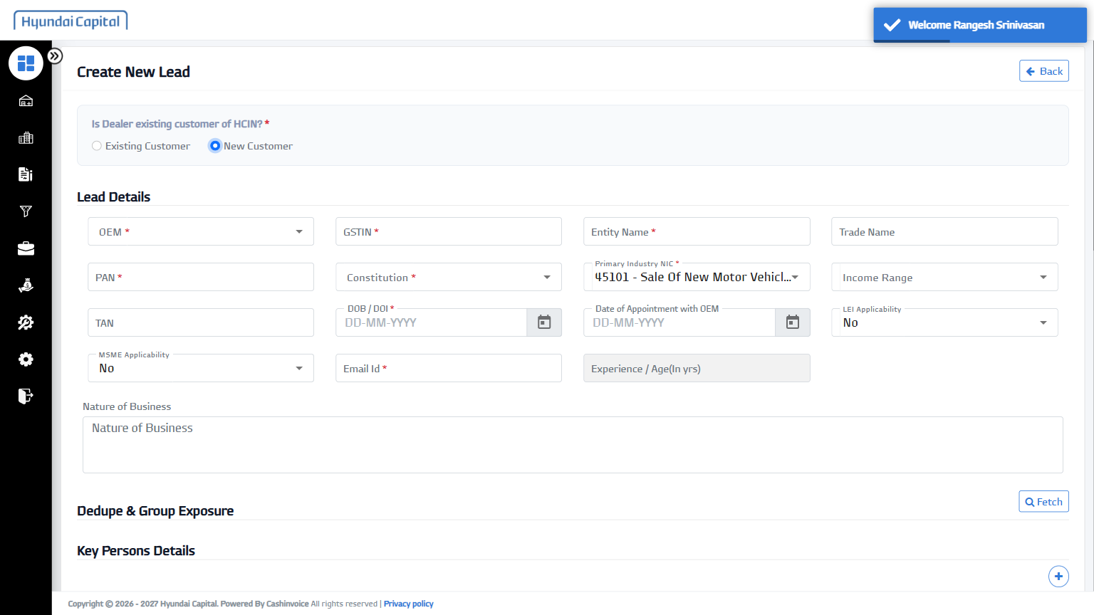
3 | OEM | Hyundai Motor India Limited | PASS | 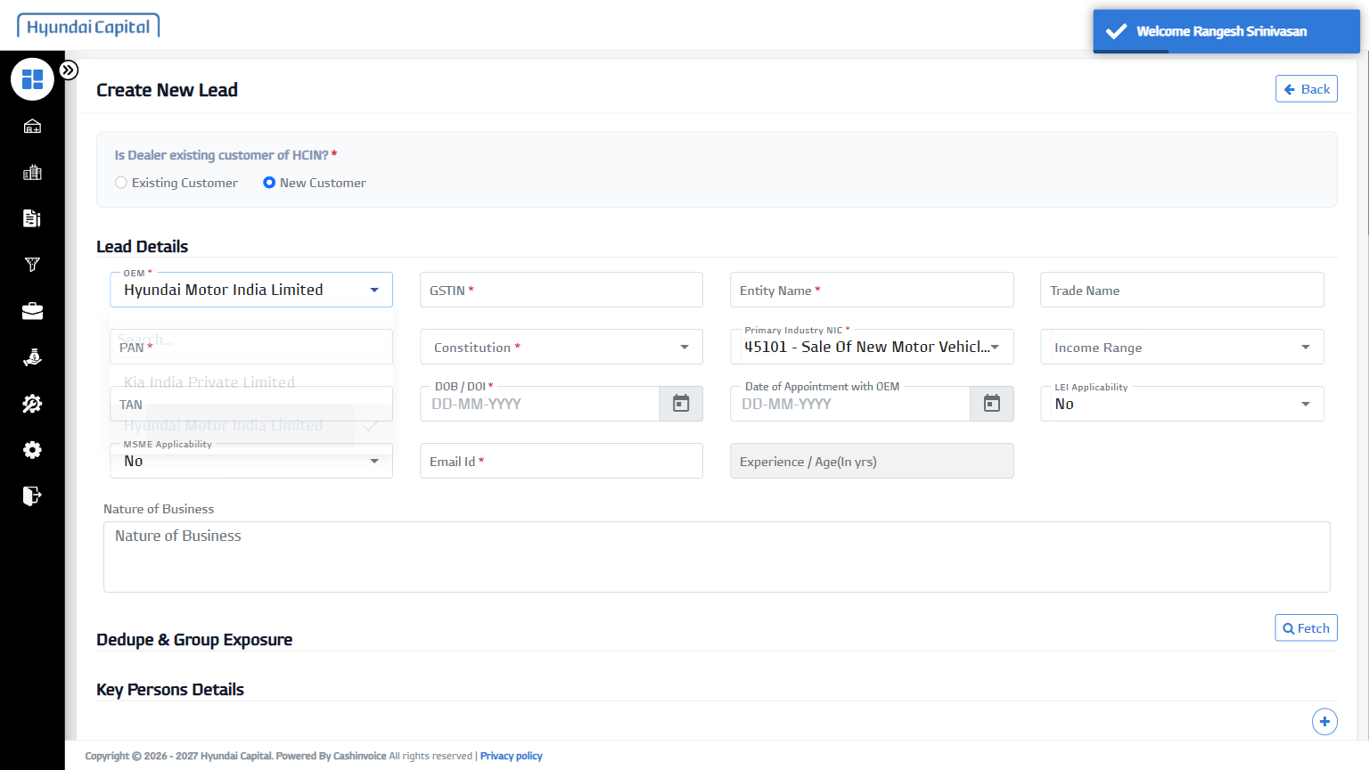
4 | GSTIN | 27VUZGA8015A1Z2 | PASS | 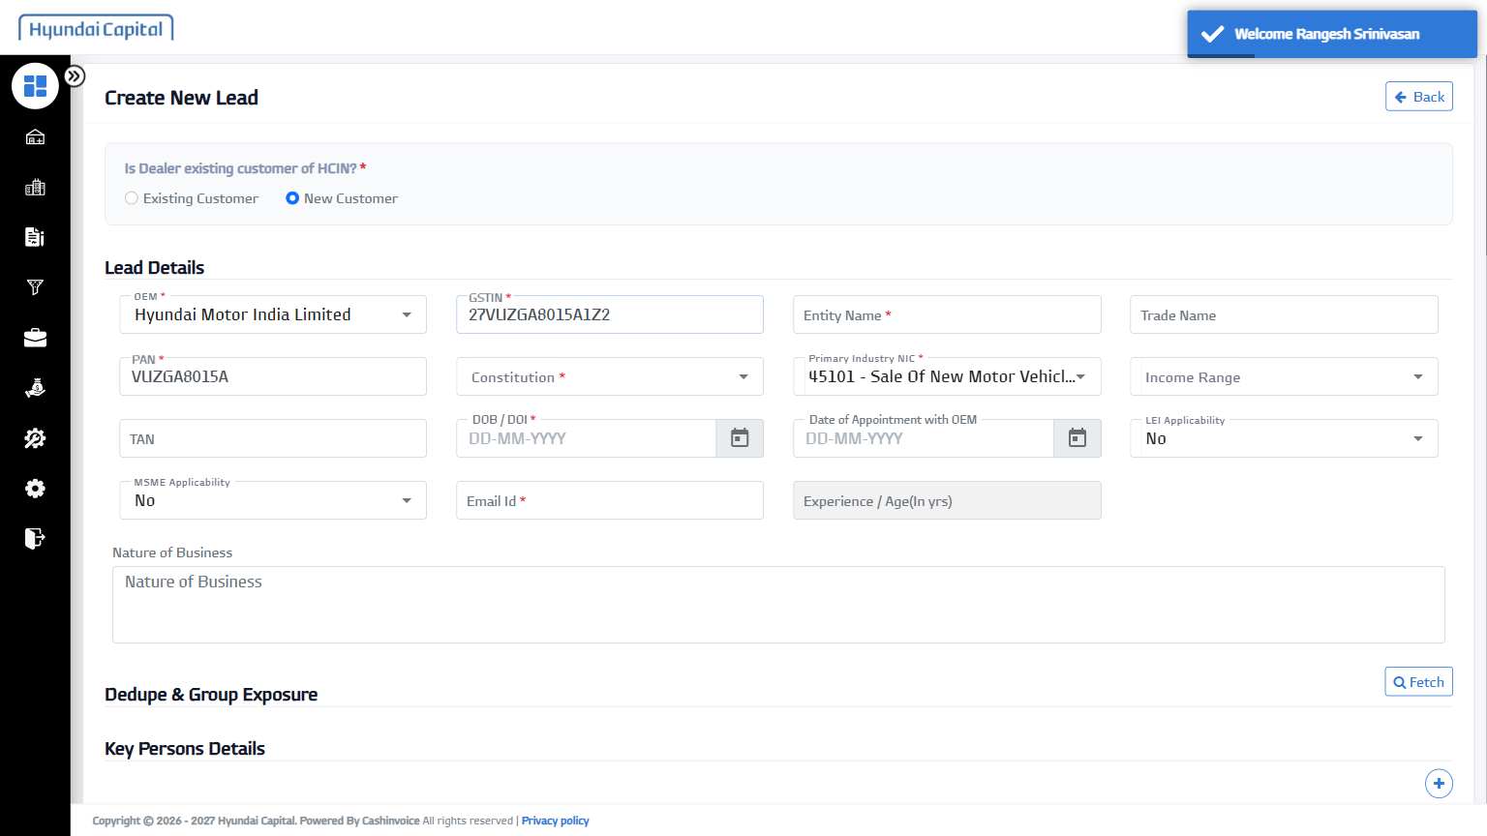
5 | Entity Name | Automation Test 517016 | PASS | 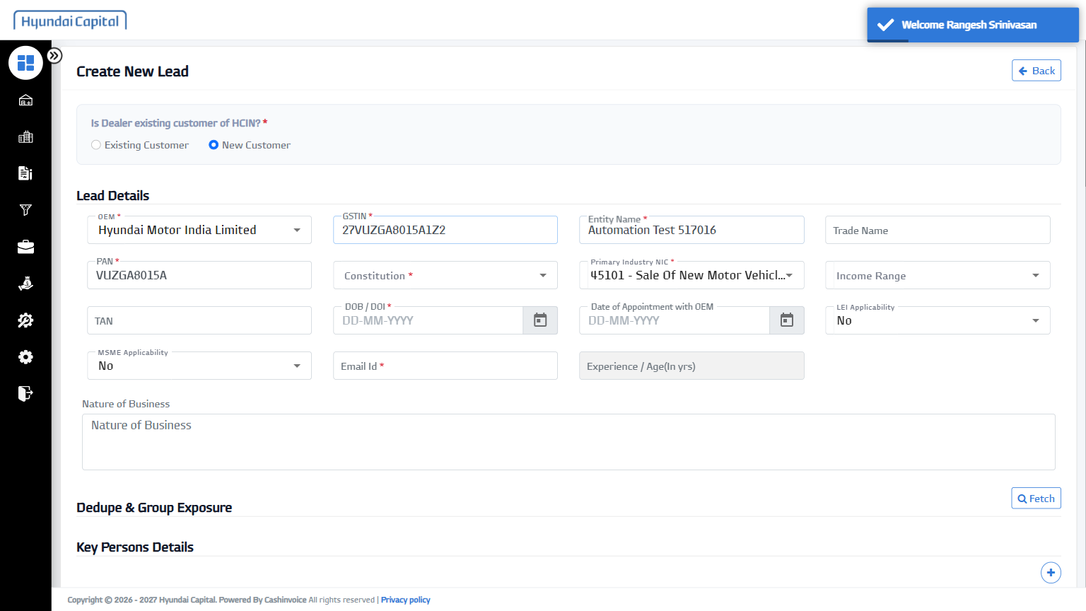
6 | Trade Name | AT2 | PASS | 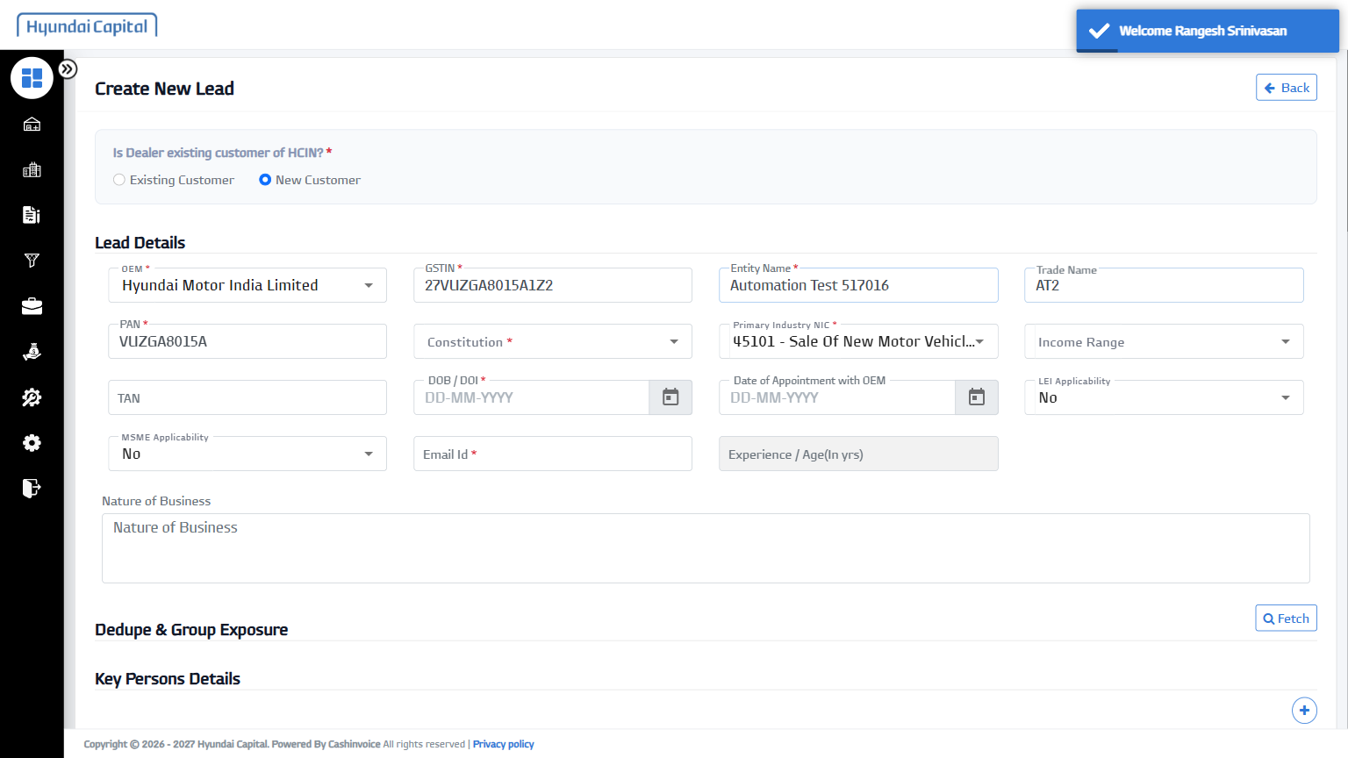
7 | Constitution | Private Limited | PASS | 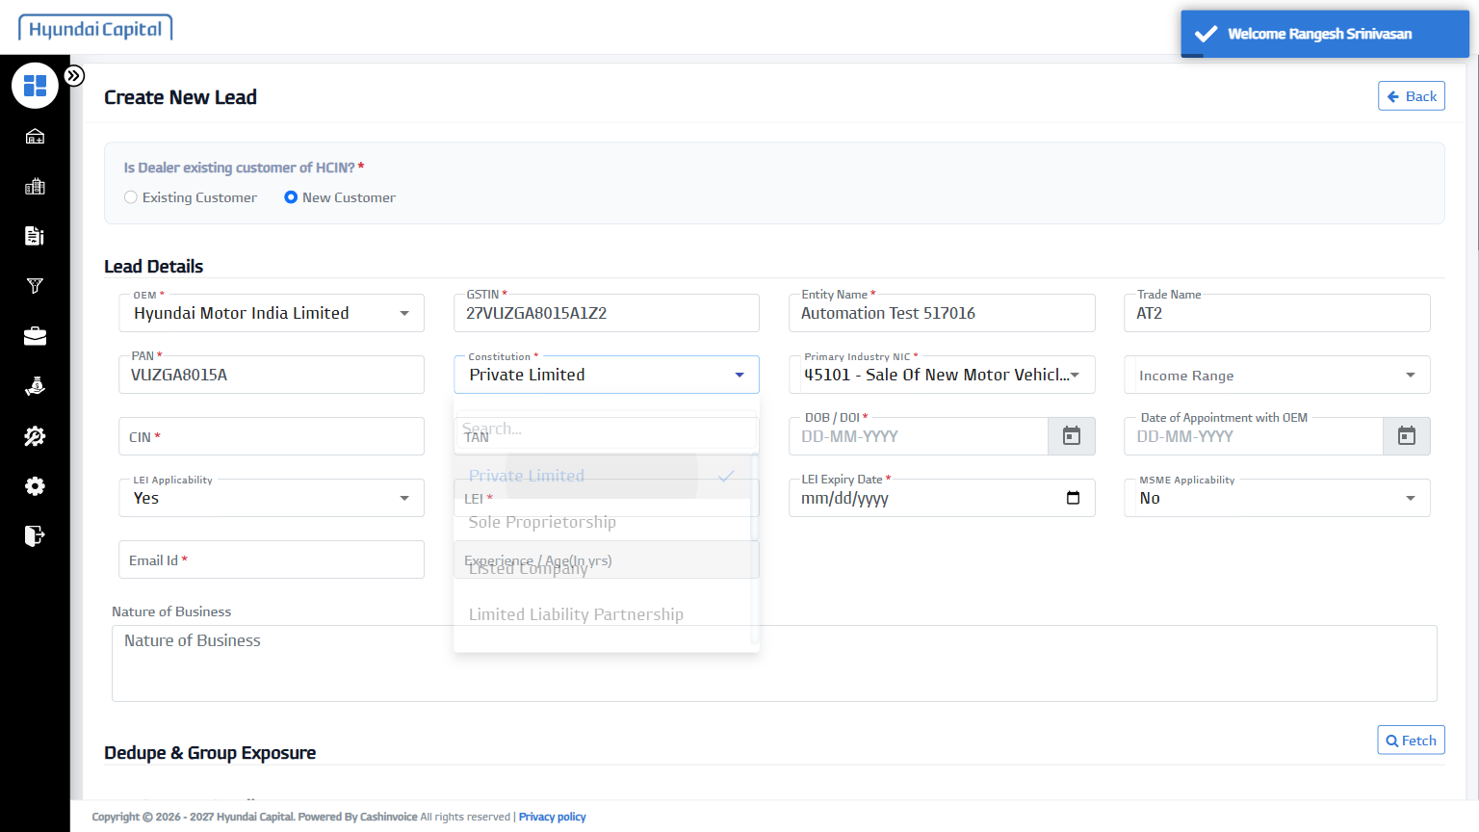
8 | Income Range | 200-500 Cr | PASS | 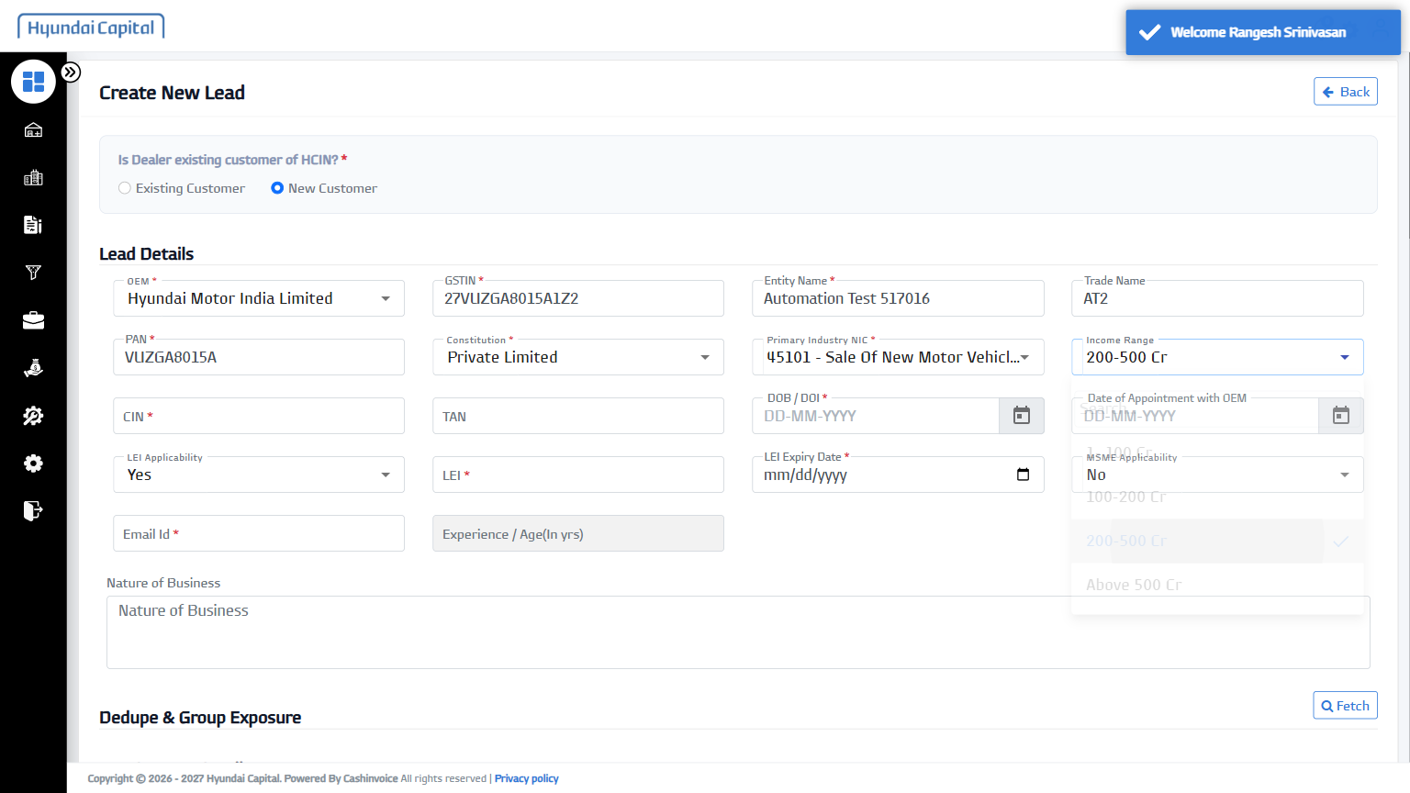
9 | CIN | U61452MH2026PTC434792 | PASS | 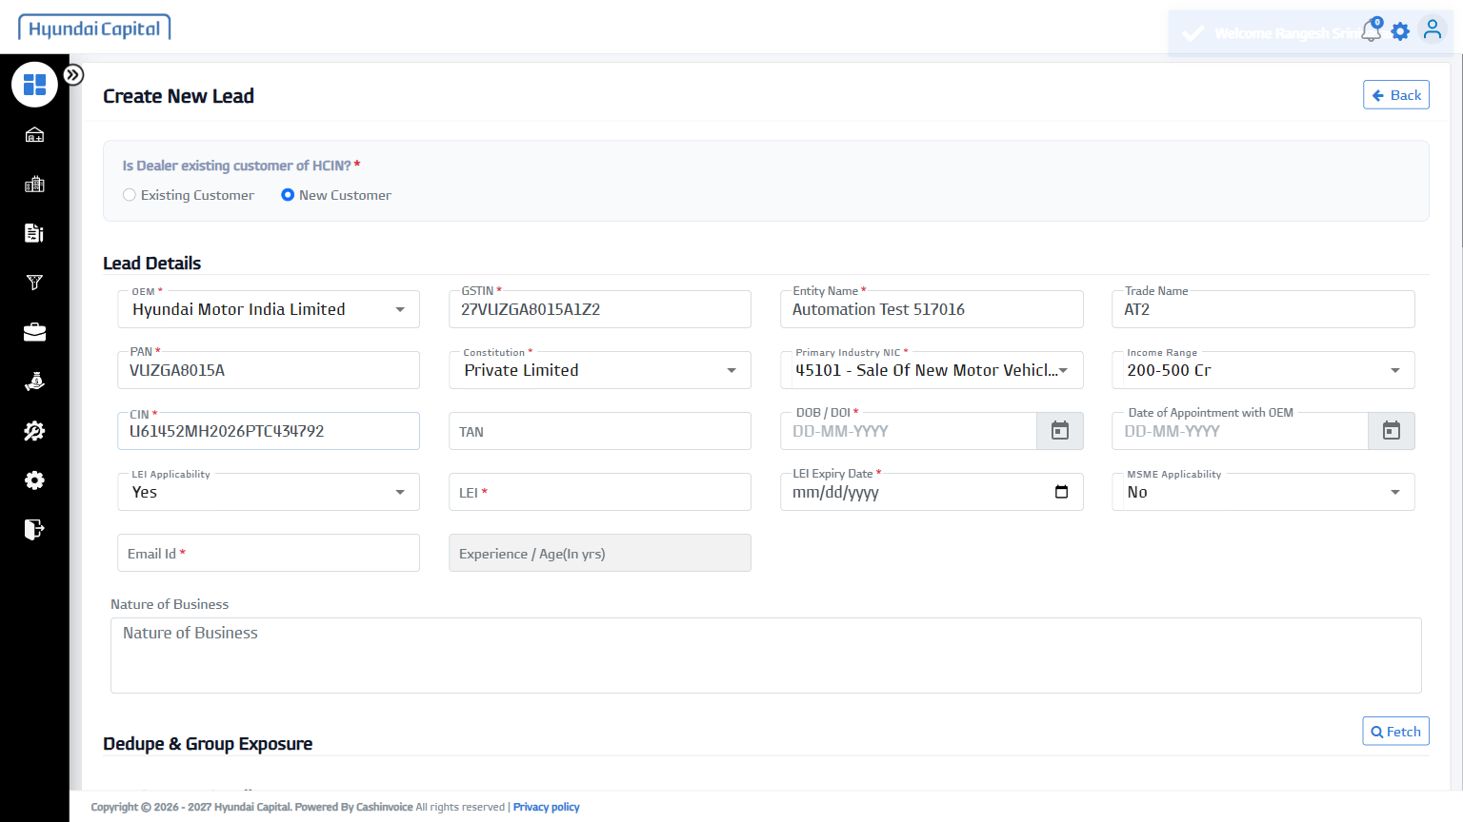
10 | DOB / DOI | 10-March-2010 | PASS | 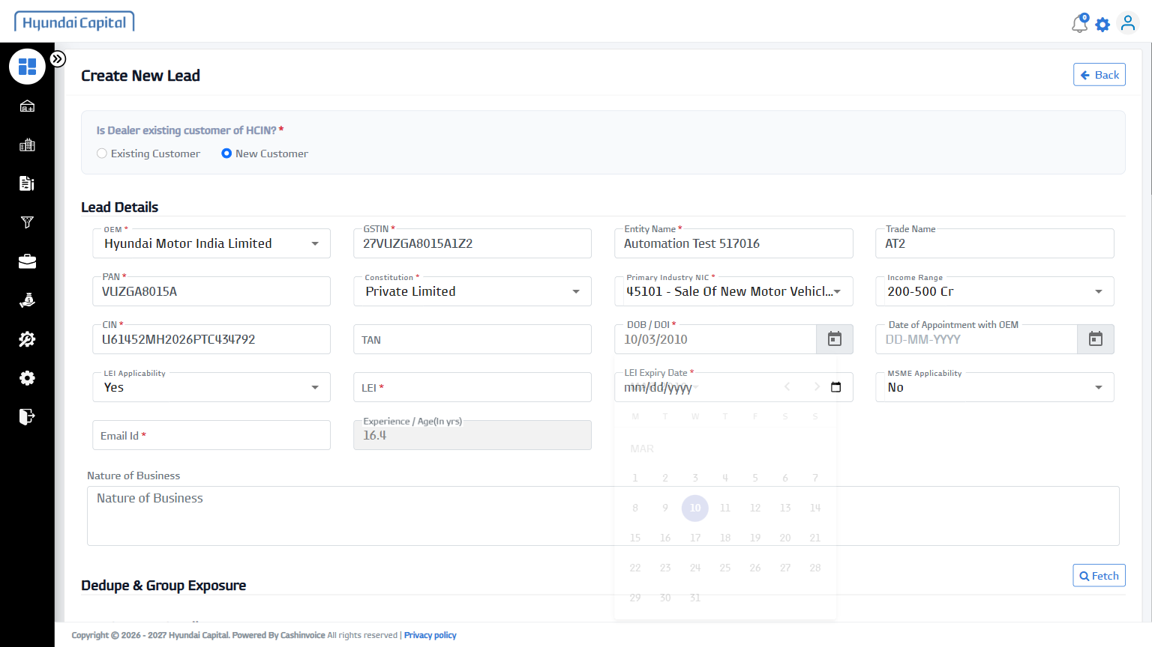
11 | LEI Applicability | No | PASS | 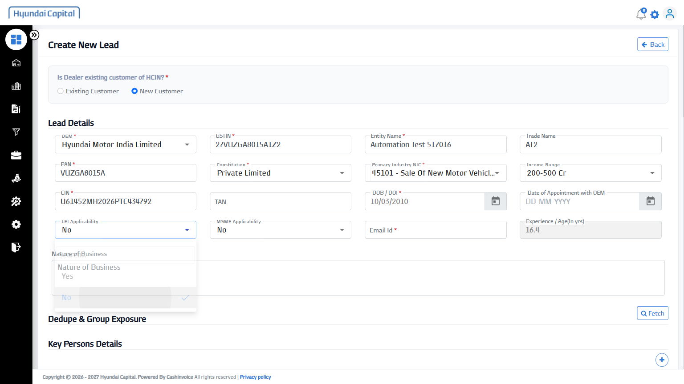
12 | MSME Applicability | No | PASS | 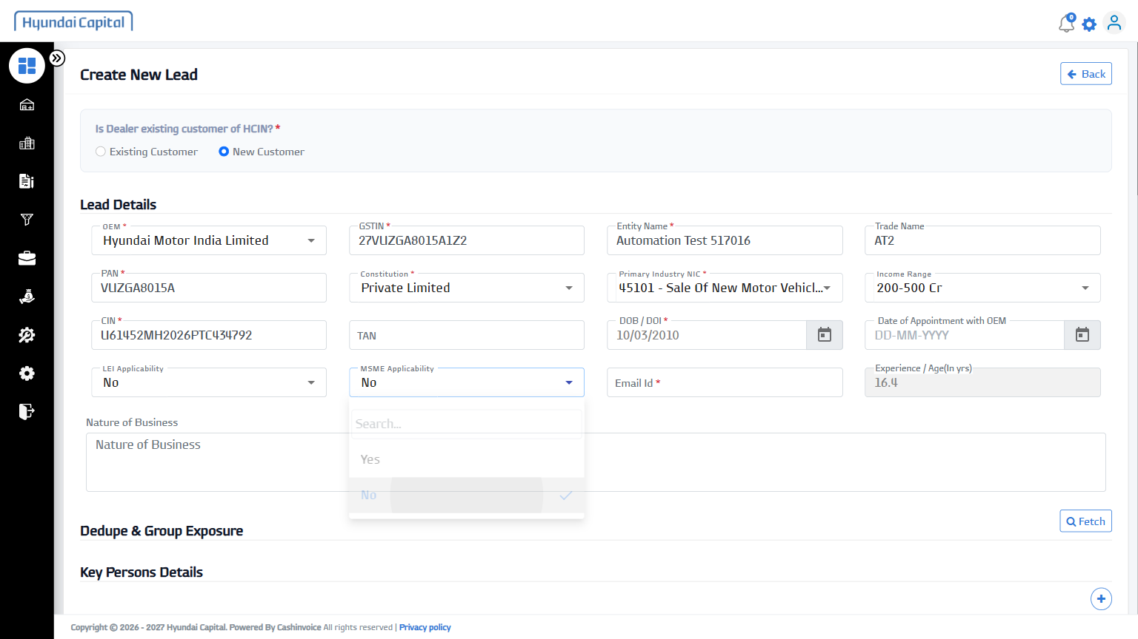
13 | Nature of Business | Automobile Trading | PASS | 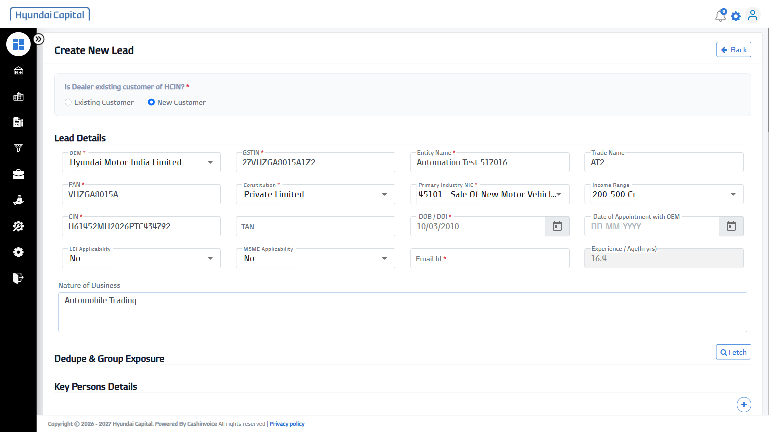
14 | Fetch (Dedupe & Group Exposure) | - | PASS | 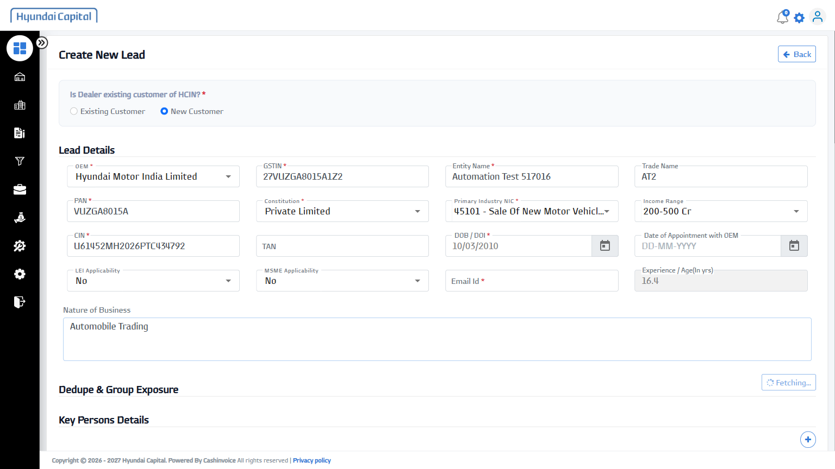
15 | Salutation | Ms. | PASS | 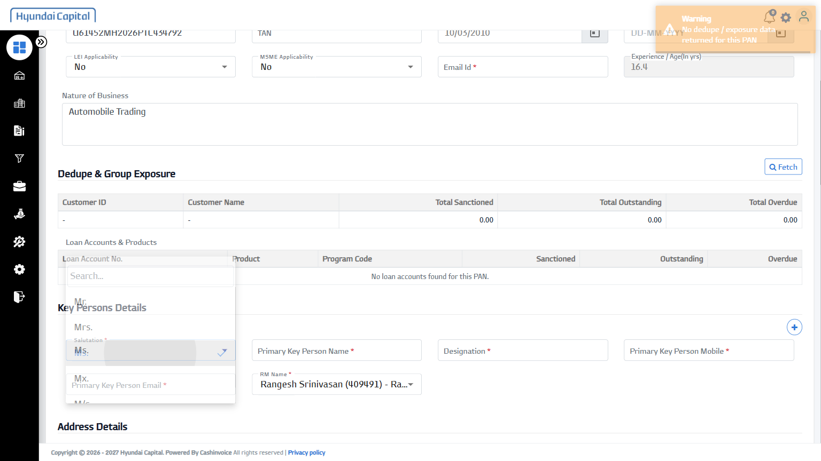
16 | Primary Key Person Name | Chinmay Kumar | PASS | 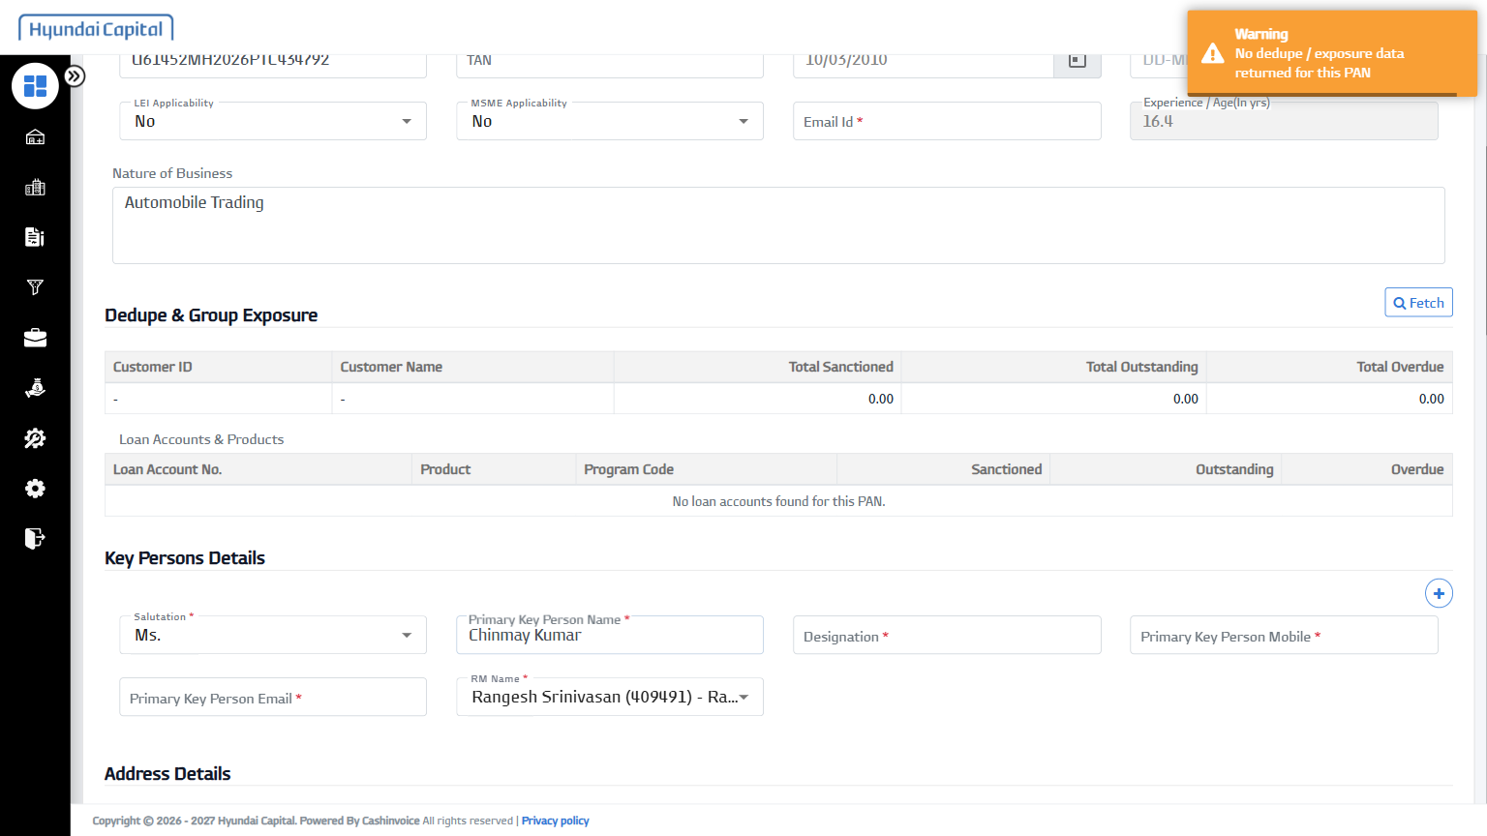
17 | Designation | Operations Manager | PASS | 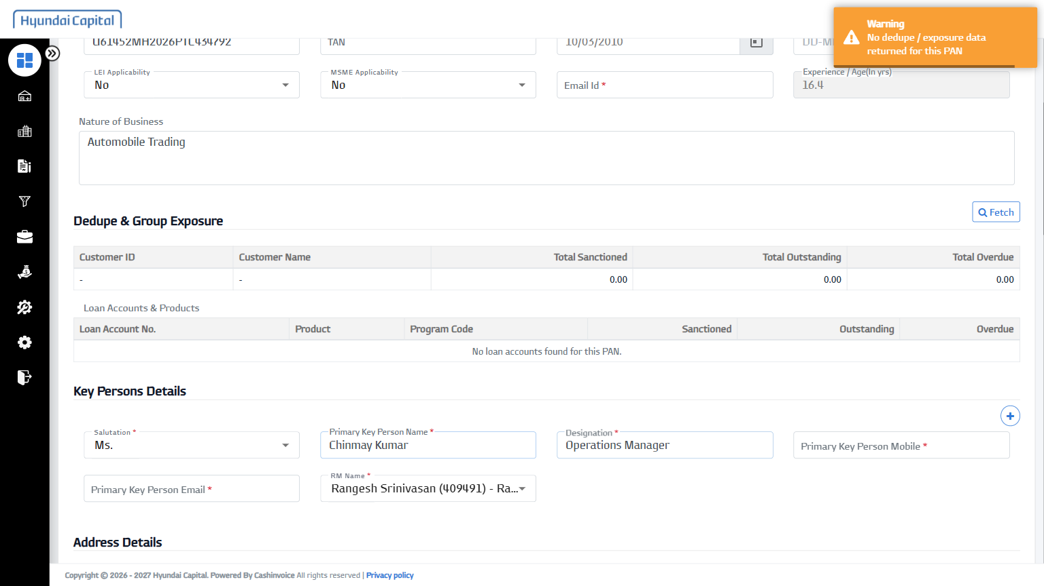
18 | Primary Key Person Mobile | 9280328710 | PASS | 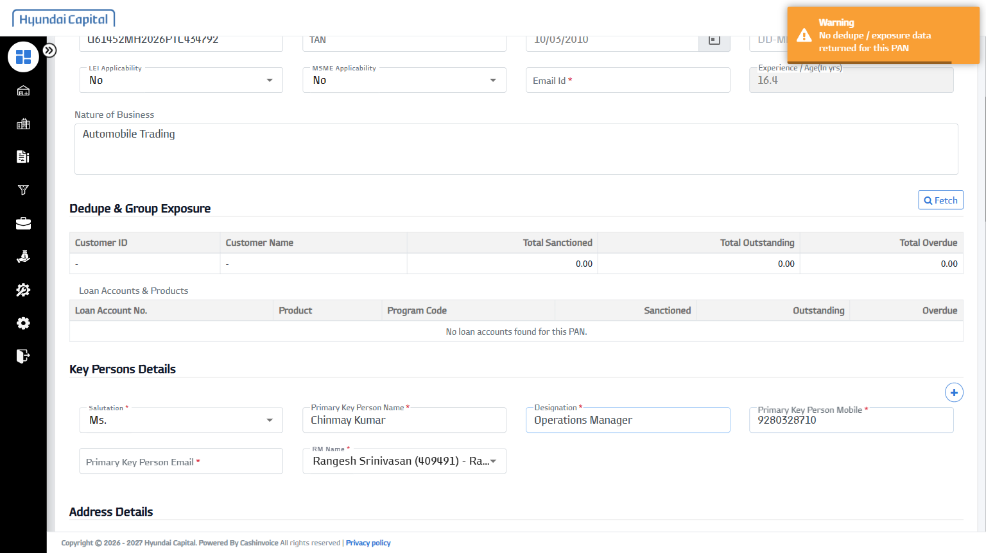
19 | Primary Key Person Email | chinmay.srma@example.com | PASS | 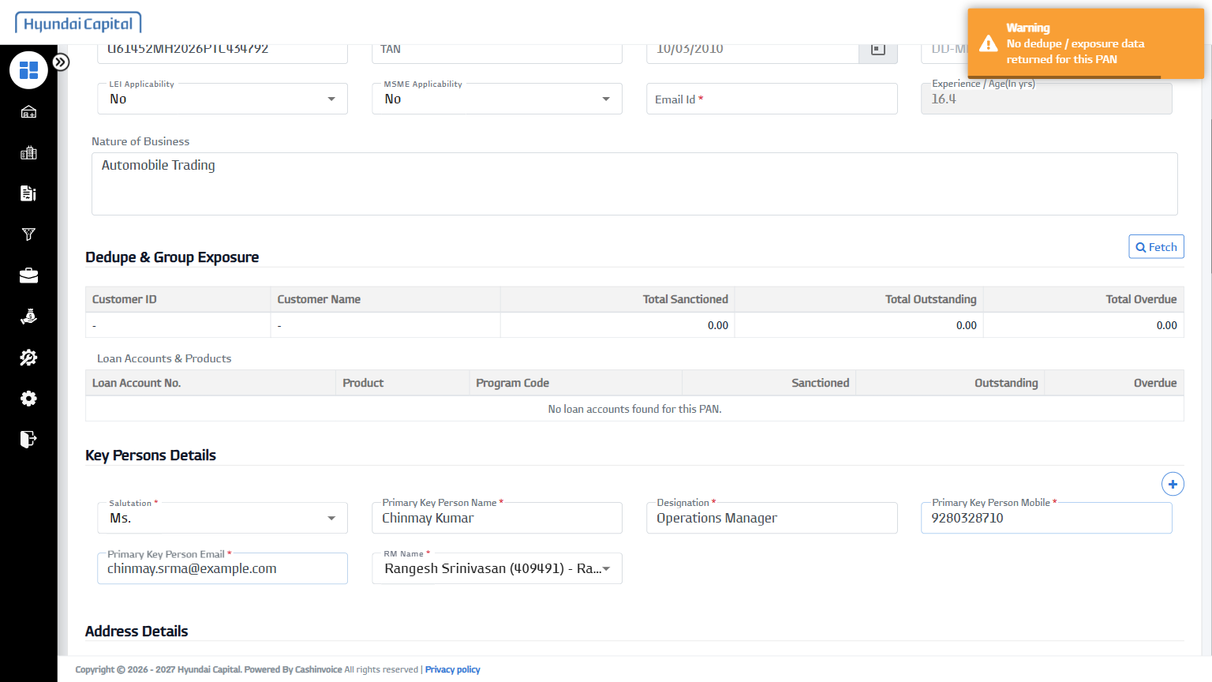
20 | Address Type | Office | PASS | 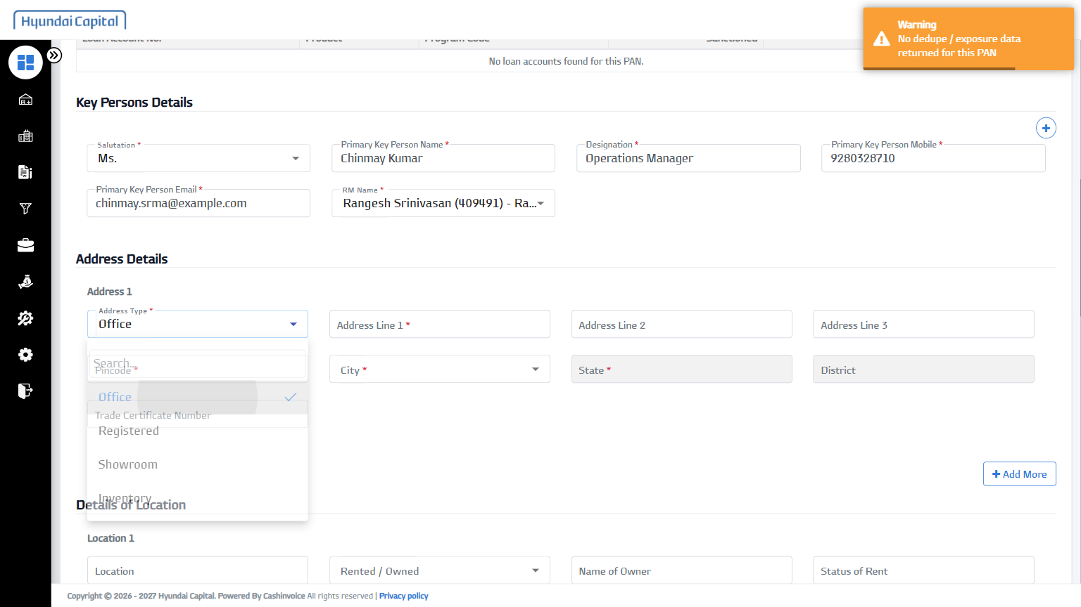
21 | Address Line 1 | 12 MG Road, Andheri East | PASS | 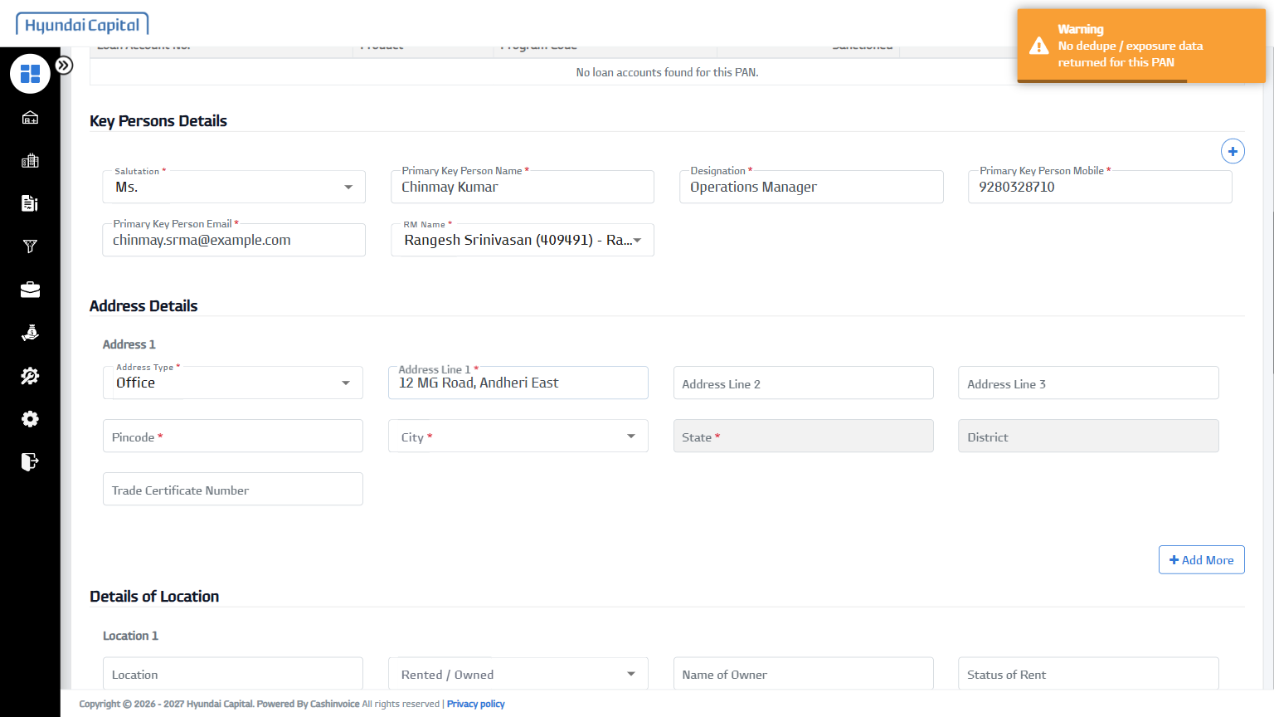
22 | Pincode | 110016 | PASS | 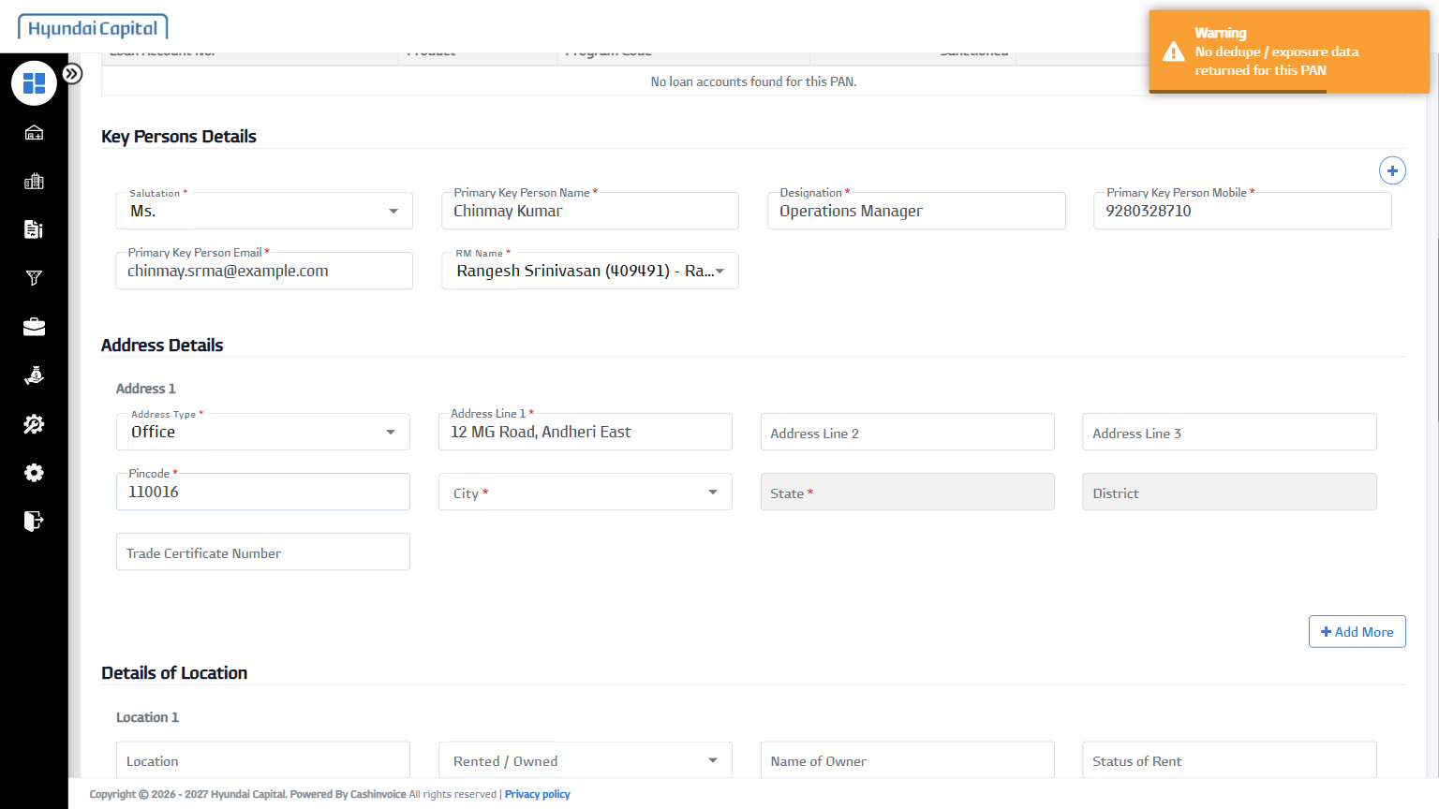
23 | Outlet Code (Dealer Code) | MH19 | PASS | 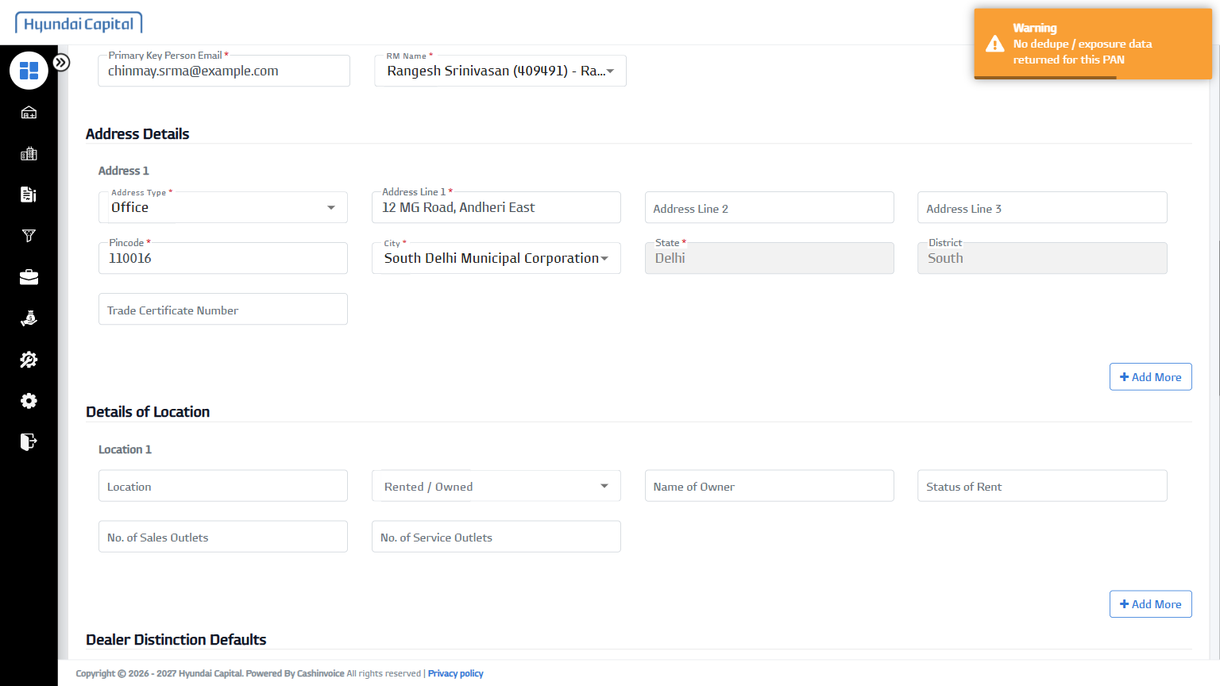
24 | Main Dealer Code | MH19 | PASS | 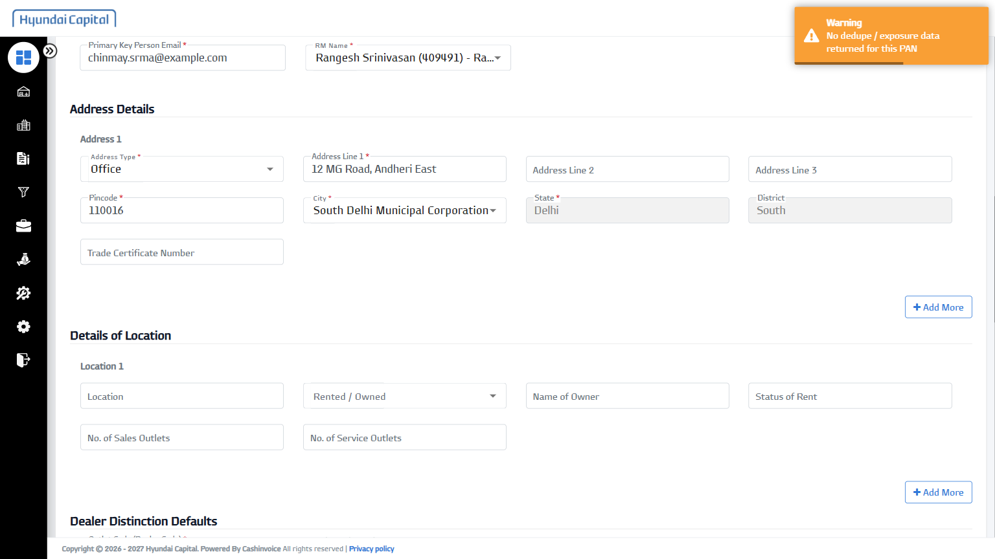
25 | Program Name | Program Name Hyundai_TD_07 ( | PASS | 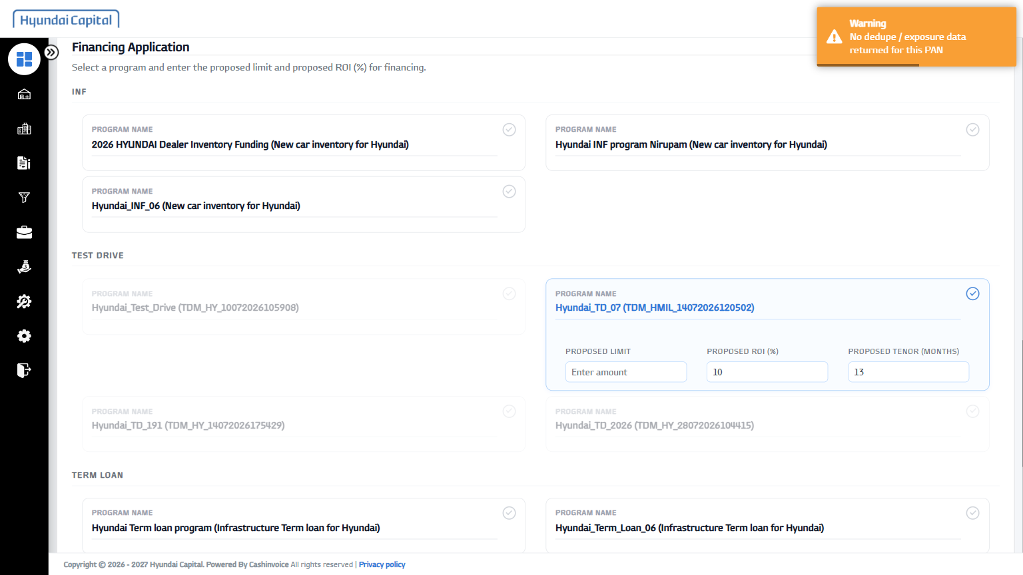
26 | Proposed Limit | 750000 | PASS | 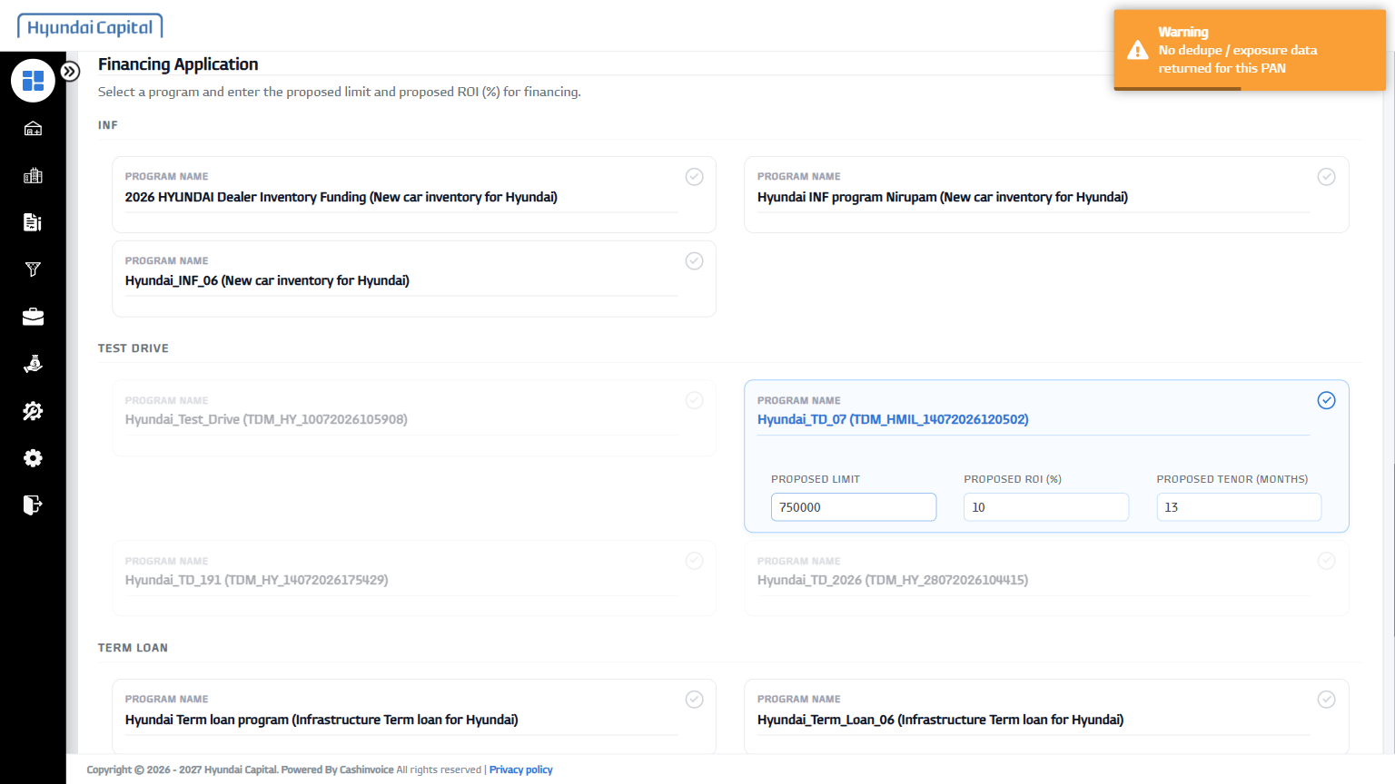
27 | Physical Application File | D:\OneDrive - Indinvoice Tech Solutions Pvt. Ltd\Desktop\HCIN-Automation\fixtures\sample-document.pdf | PASS | 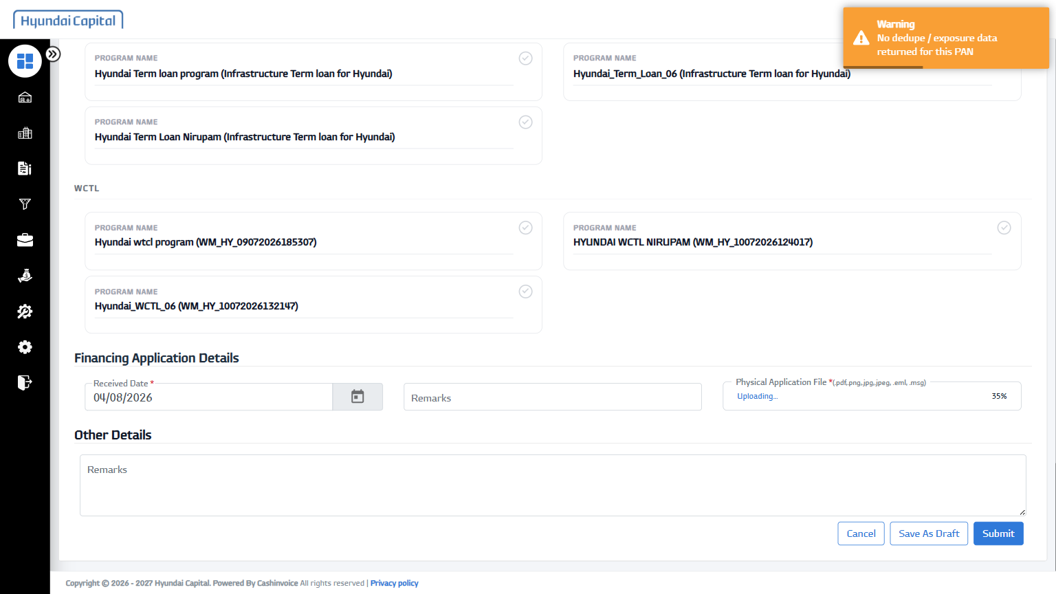
28 | Remarks | Documents verified and in order | PASS | 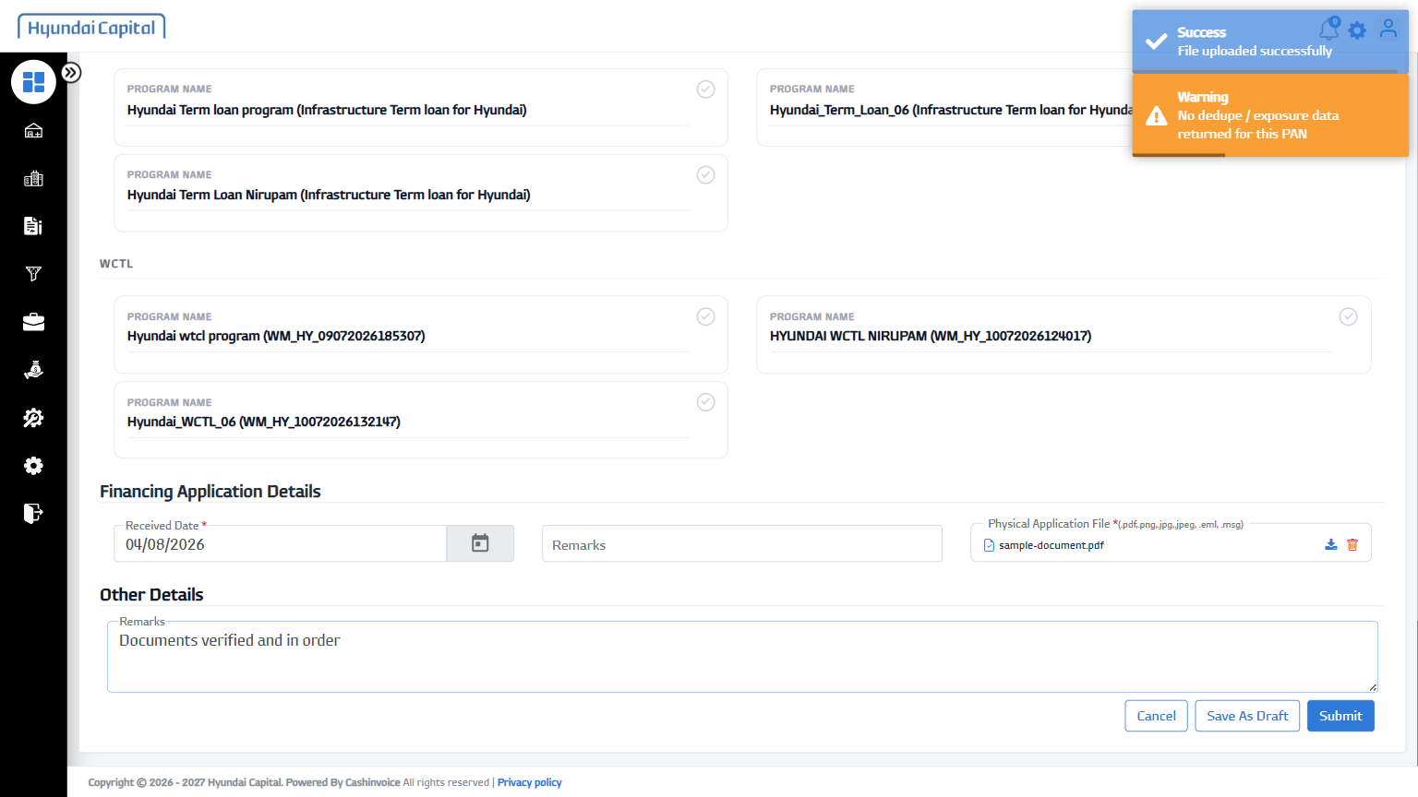
29 | Submit | - | PASS | 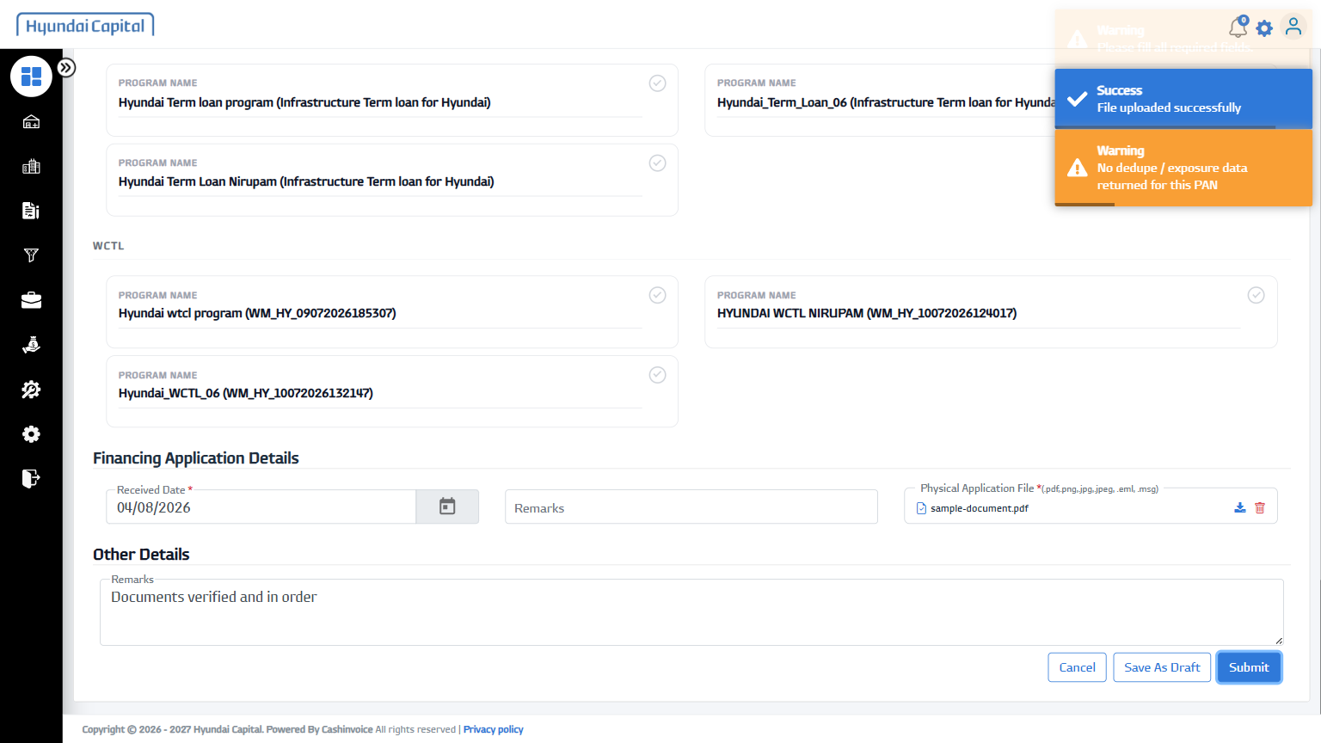
30 | Follow-up Email Id | mh@example.com | PASS | 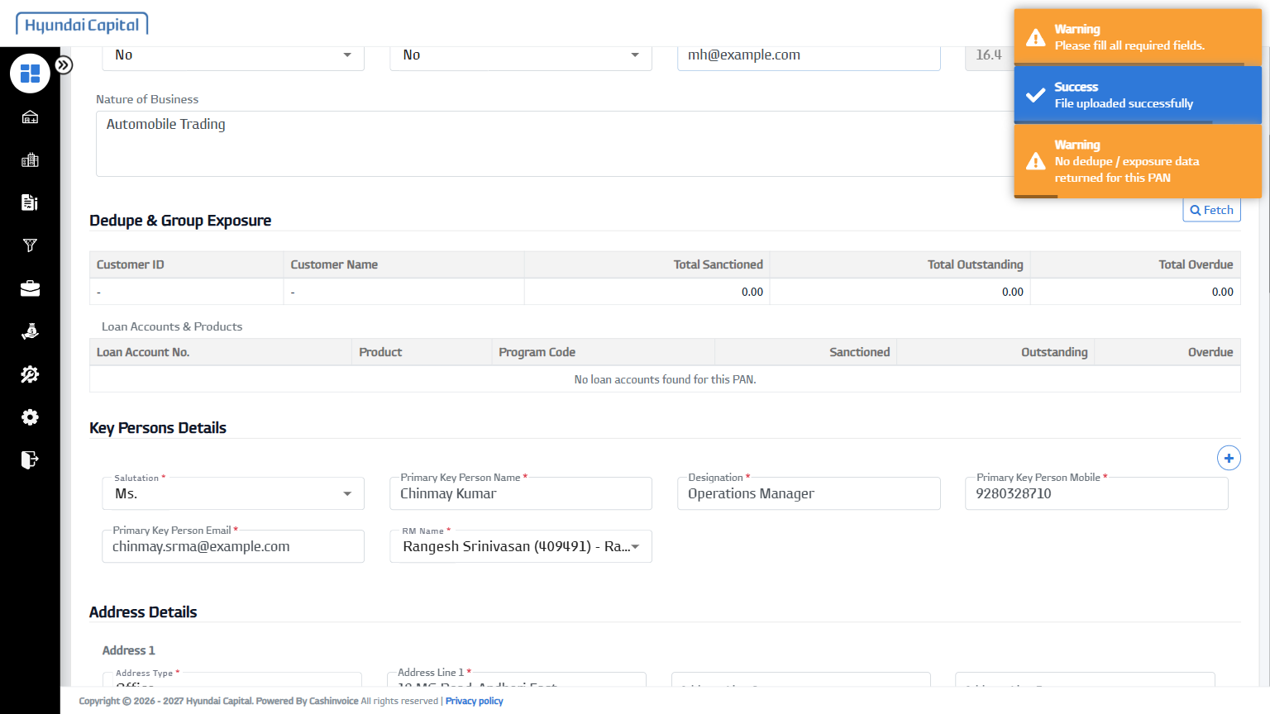
31 | Submit | - | PASS | 