HCIN Automation - Test Execution Report
Generated: 8/4/2026, 11:42:55 AM
Overall Result: FAILED
3  Total | 2  Passed | 1  Failed | 0  Skipped

Test Summary
# | Test Name | File | Status | Duration (ms) | Error
1 | Login and Logout | 1-login.spec.js | PASSED | 15193
2 | Create New Company Lead | 2-onboardCompanyLead.spec.js | PASSED | 25835
3 | Add Promoter/Director Details to Existing Lead | 3-addPromoterDetails.spec.js | FAILED | 30044 | Error: page.reload: Target page, context or browser has been closed  Call log:  [2m - waiting for navigation until "load"[22m  [2m - navigated to "https://hcinlosdev.cashinvoice.in/los/#/counter-party/view-leads"[22m

1. Login and Logout
Status: PASSED | Duration: 15193 ms
Logs into LOS with a valid Sales RM user, verifies the Sales Dashboard is visible, then logs out and confirms the login screen reappears.

2. Create New Company Lead
Status: PASSED | Duration: 25835 ms
Logs in as Sales RM, creates a new lead for a company/corporate entity (GSTIN, CIN, LEI, key person, address & program details), uploads a KYC document and submits it, using test data read from fixtures/companyLeadData.xlsx. A fresh GSTIN/CIN/Entity Name are generated and written back to the same file each run so the lead is never rejected as a duplicate.
Field-by-Field Results
# | Field | Value Entered | Status | Screenshot
1 | Create New Lead | - | PASS | 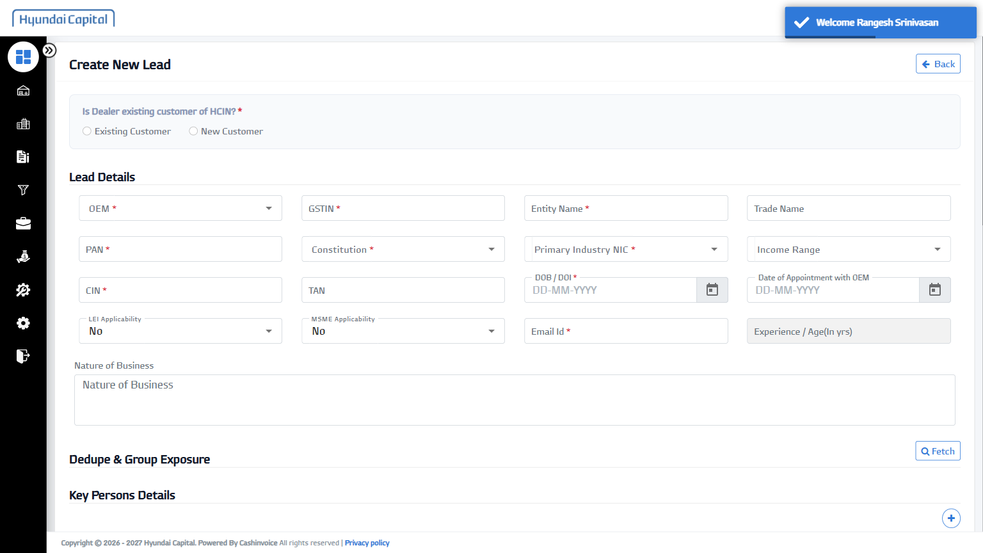
2 | Existing/New Customer | New Customer | PASS | 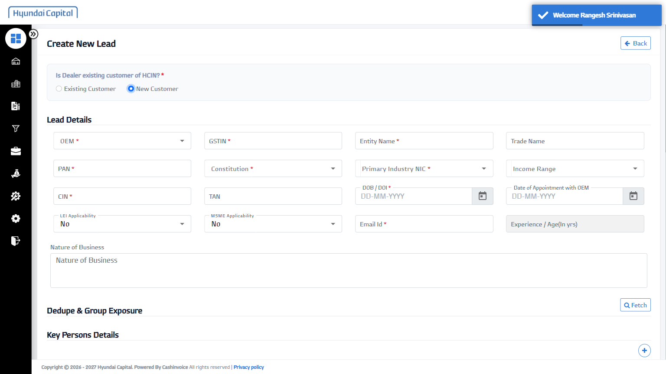
3 | OEM | Hyundai Motor India Limited | PASS | 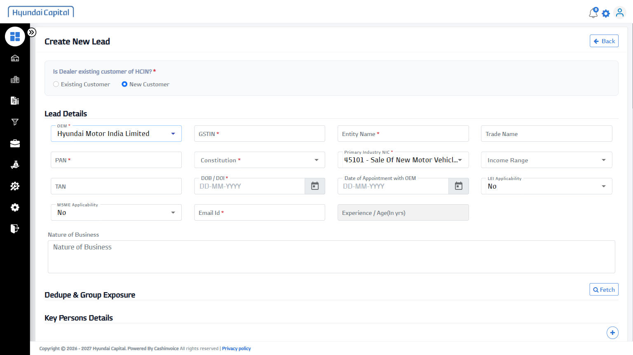
4 | GSTIN | 27THSHC3517P1Z2 | PASS | 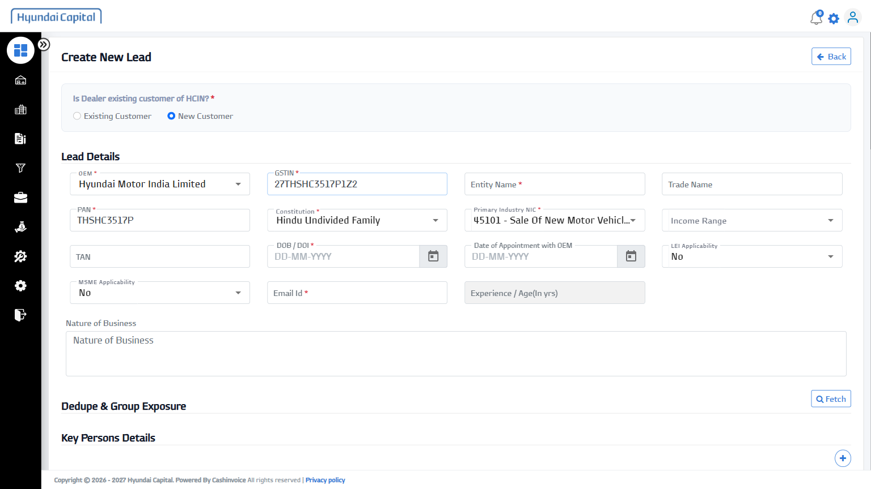
5 | Entity Name | Automation Test 993040 | PASS | 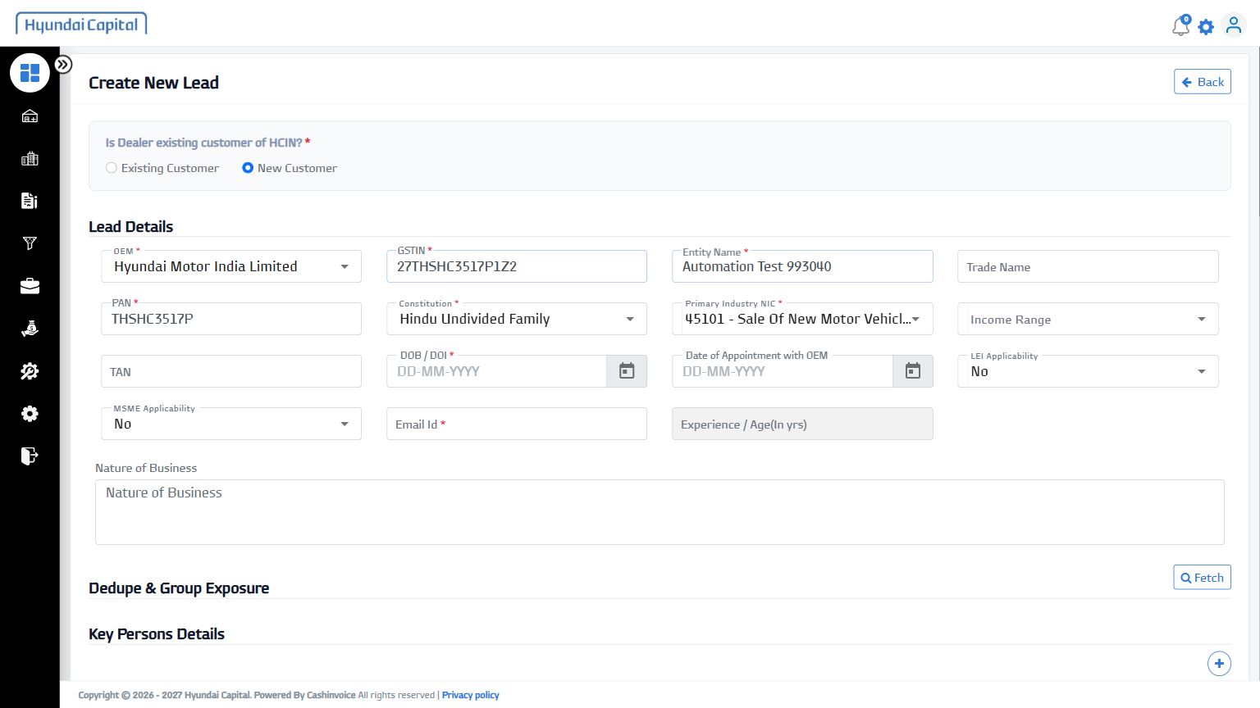
6 | Trade Name | AT2 | PASS | 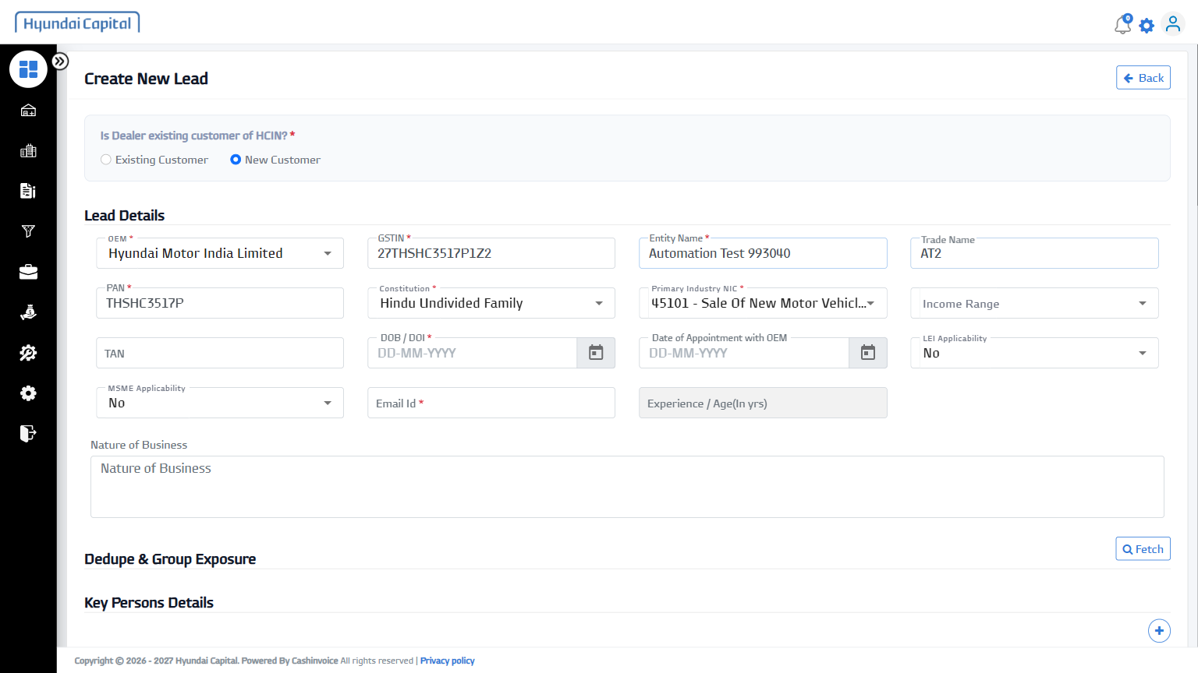
7 | Constitution | Private Limited | PASS | 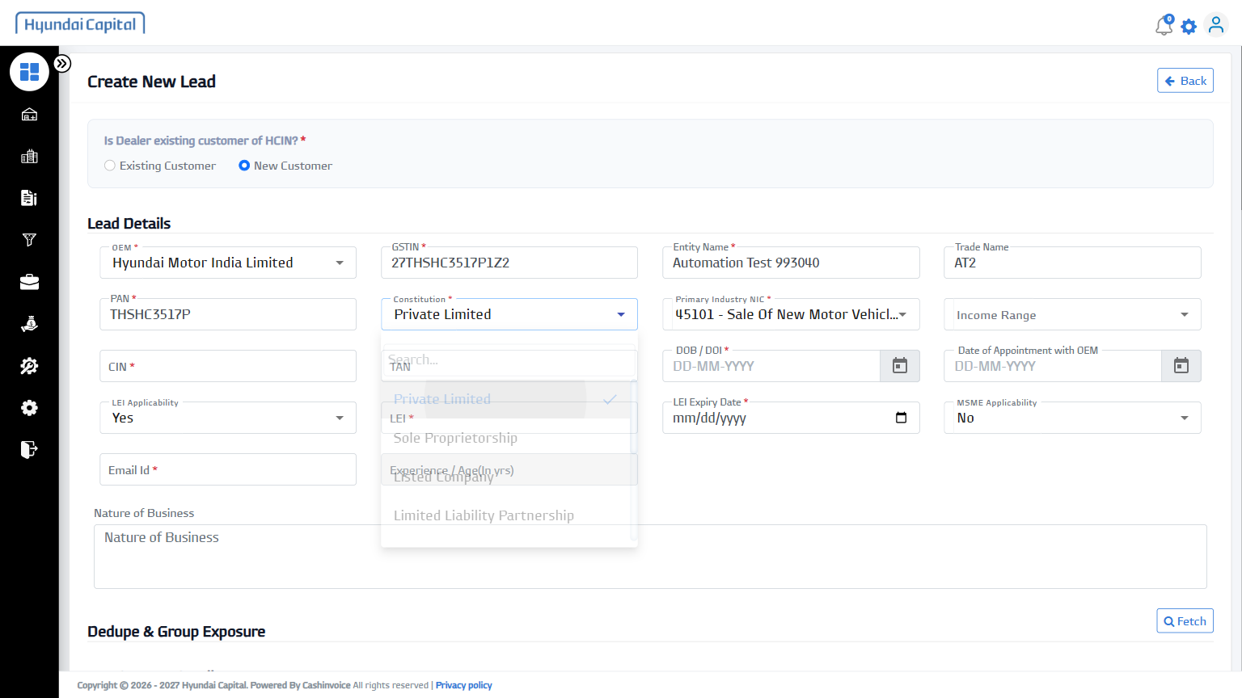
8 | Income Range | 200-500 Cr | PASS | 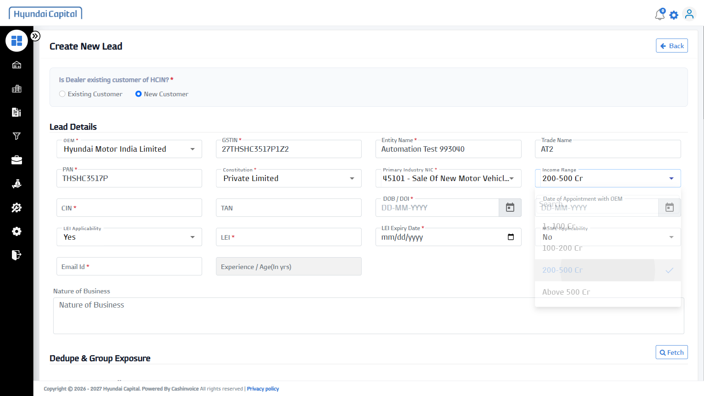
9 | CIN | U46384MH2026PTC473420 | PASS | 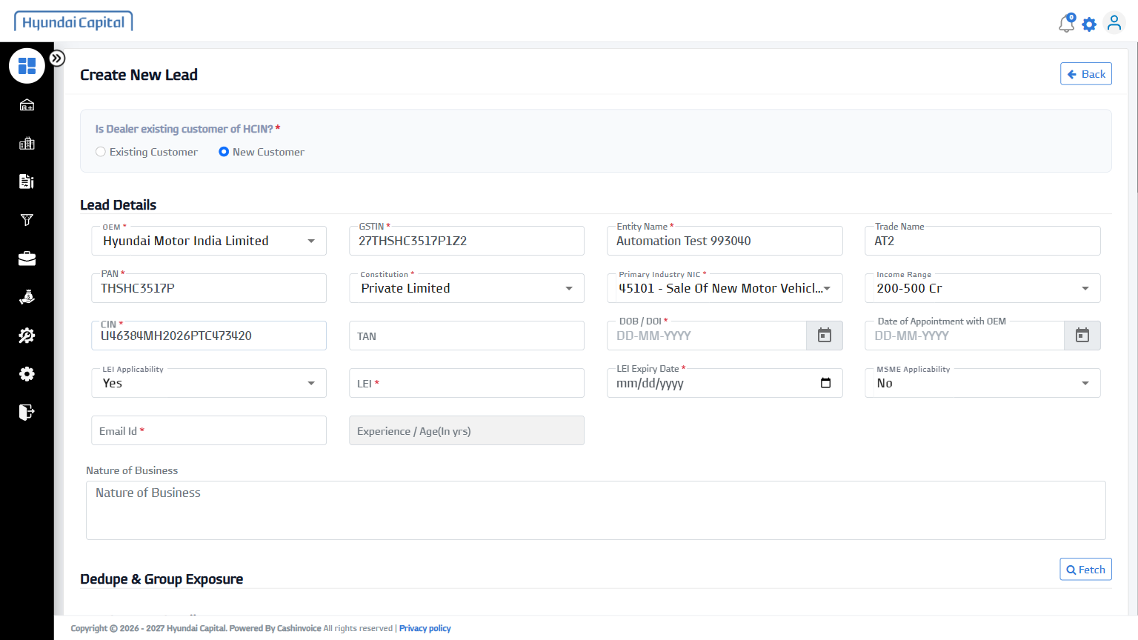
10 | DOB / DOI | 10-March-2010 | PASS | 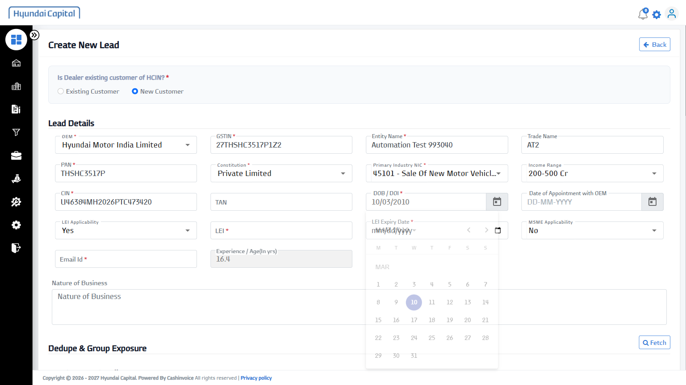
11 | LEI Applicability | No | PASS | 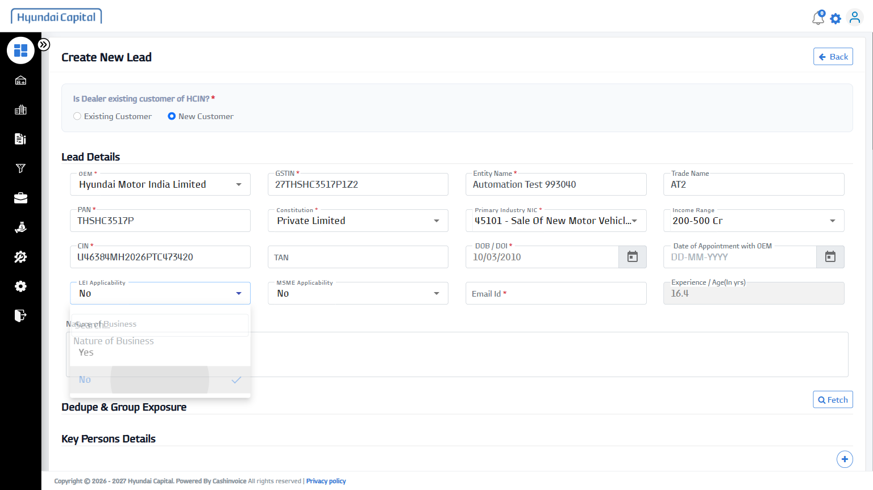
12 | MSME Applicability | No | PASS | 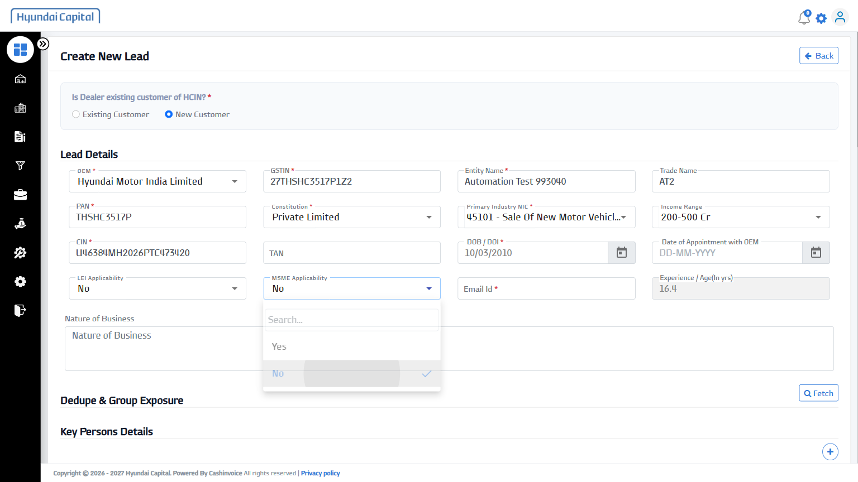
13 | Nature of Business | Automobile Trading | PASS | 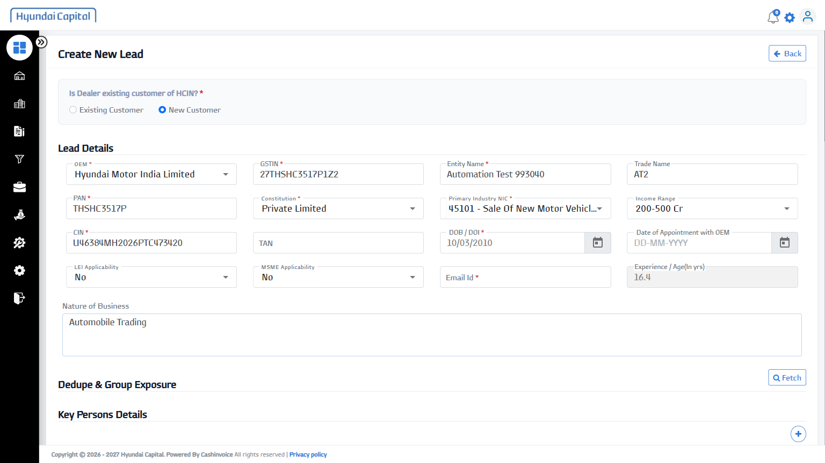
14 | Fetch (Dedupe & Group Exposure) | - | PASS | 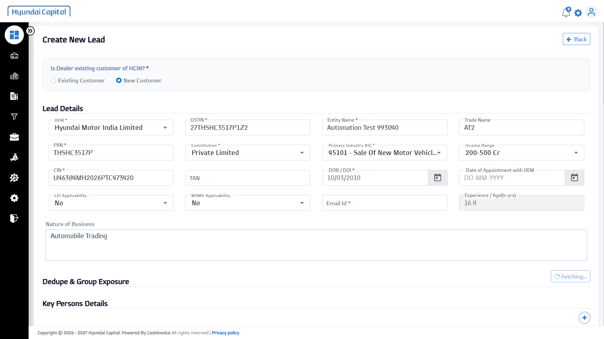
15 | Salutation | Ms. | PASS | 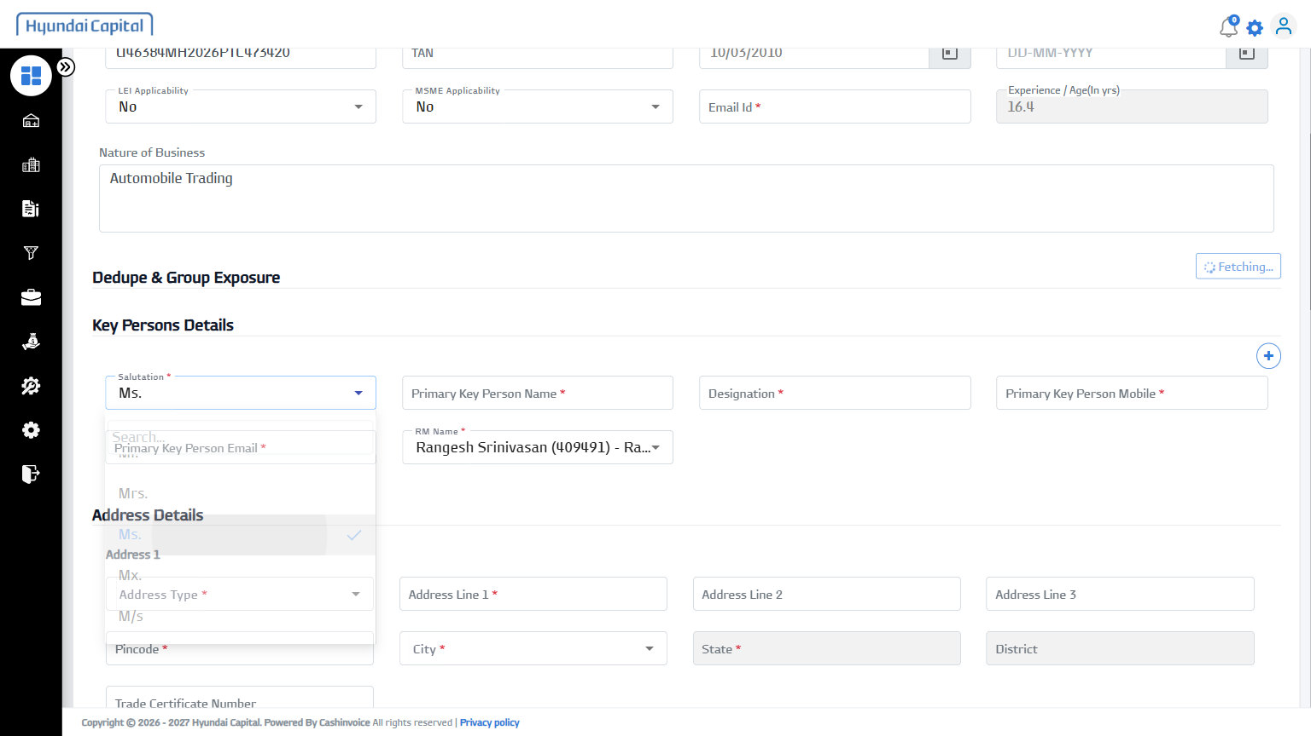
16 | Primary Key Person Name | Chinmay Kumar | PASS | 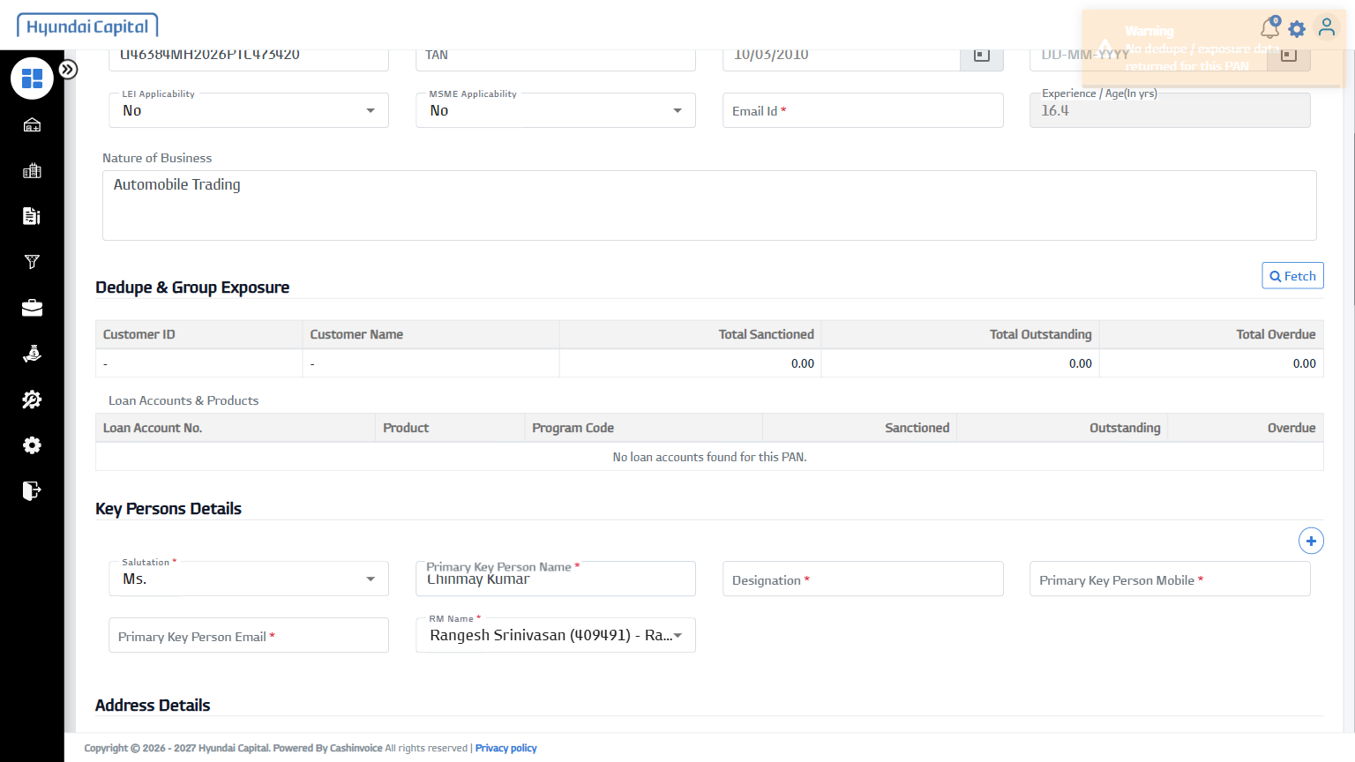
17 | Designation | Operations Manager | PASS | 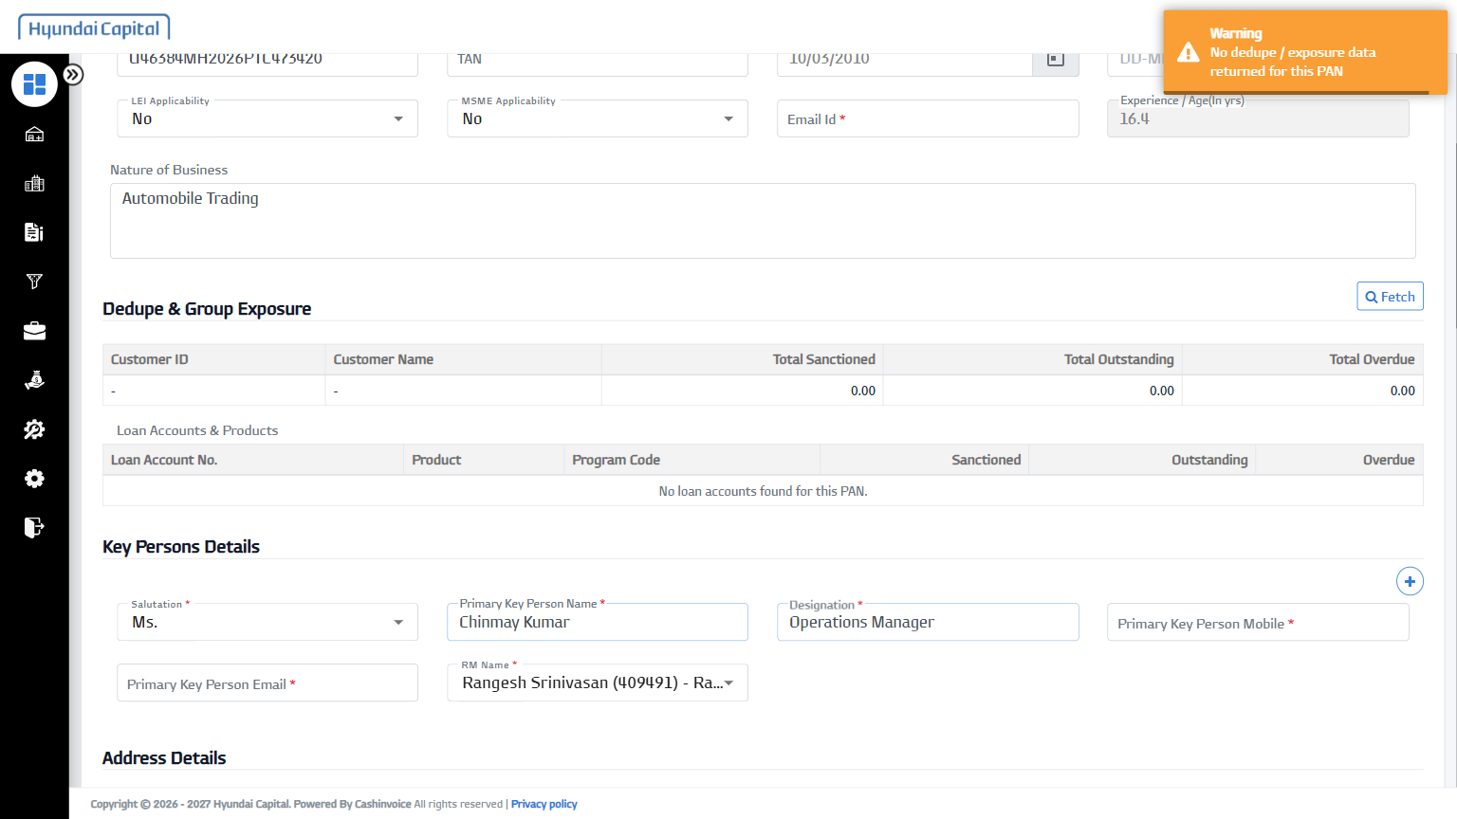
18 | Primary Key Person Mobile | 9280328710 | PASS | 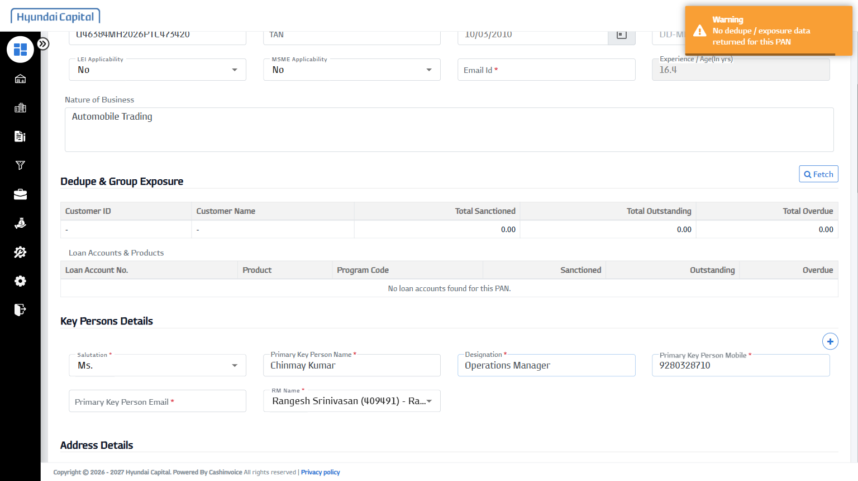
19 | Primary Key Person Email | chinmay.srma@example.com | PASS | 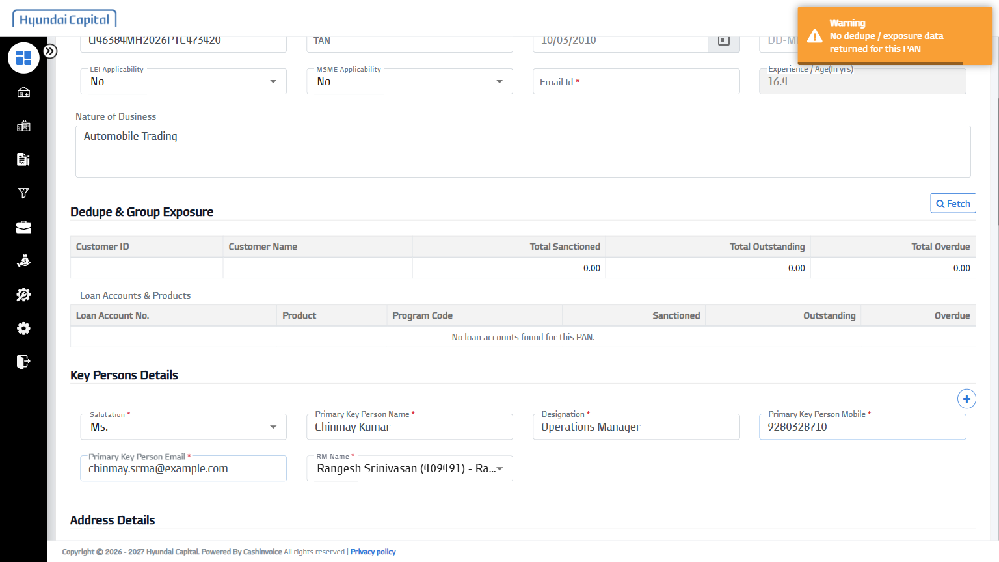
20 | Address Type | Office | PASS | 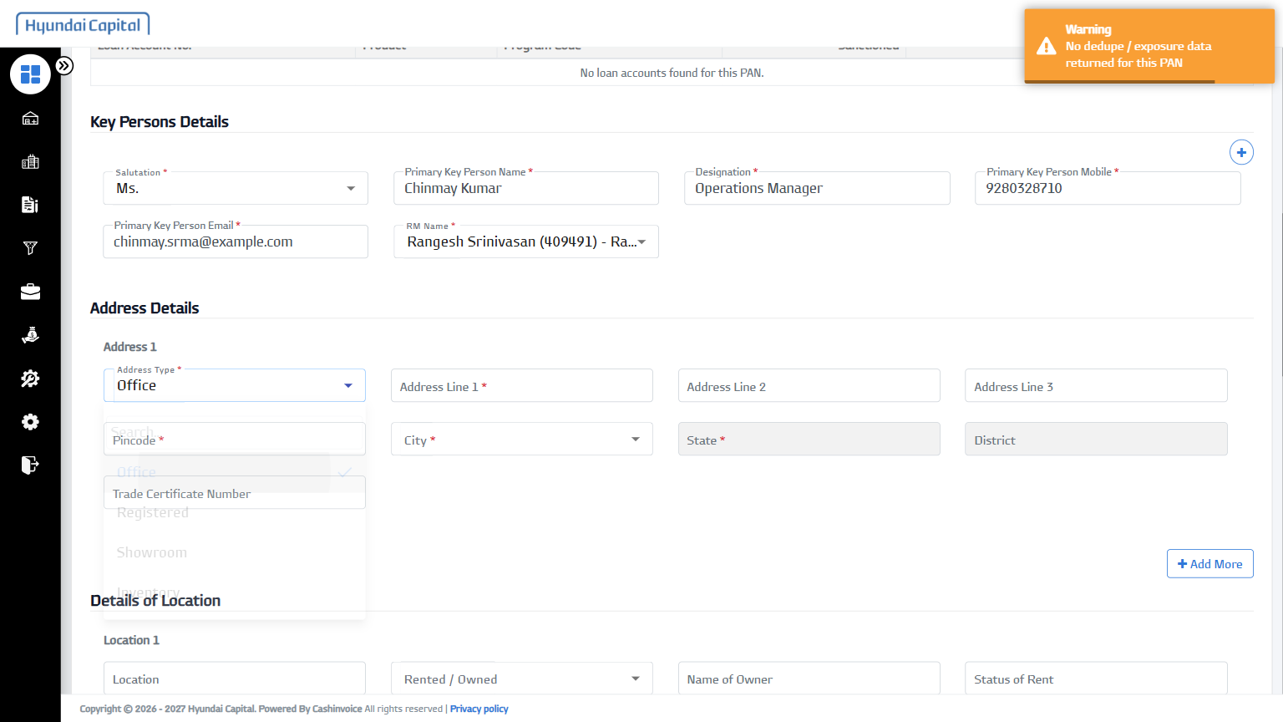
21 | Address Line 1 | 12 MG Road, Andheri East | PASS | 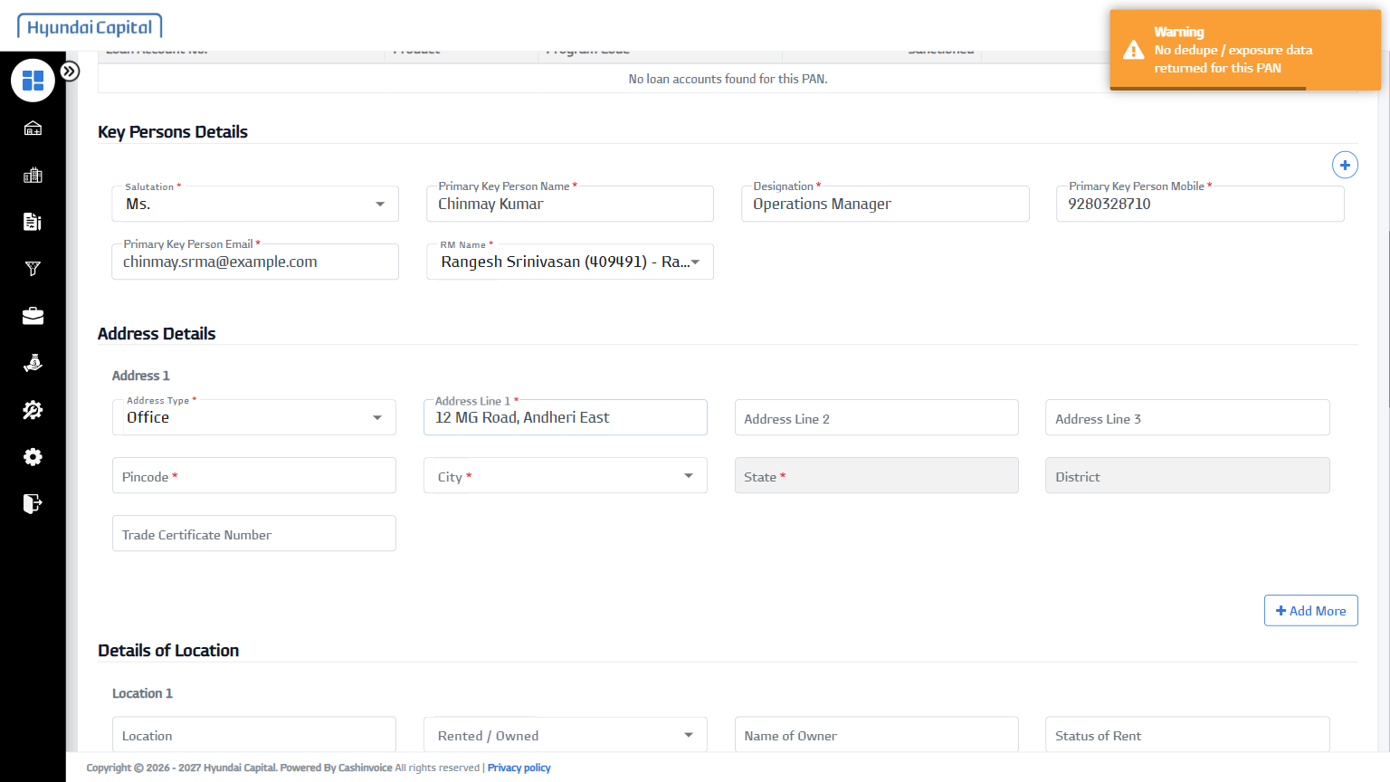
22 | Pincode | 110016 | PASS | 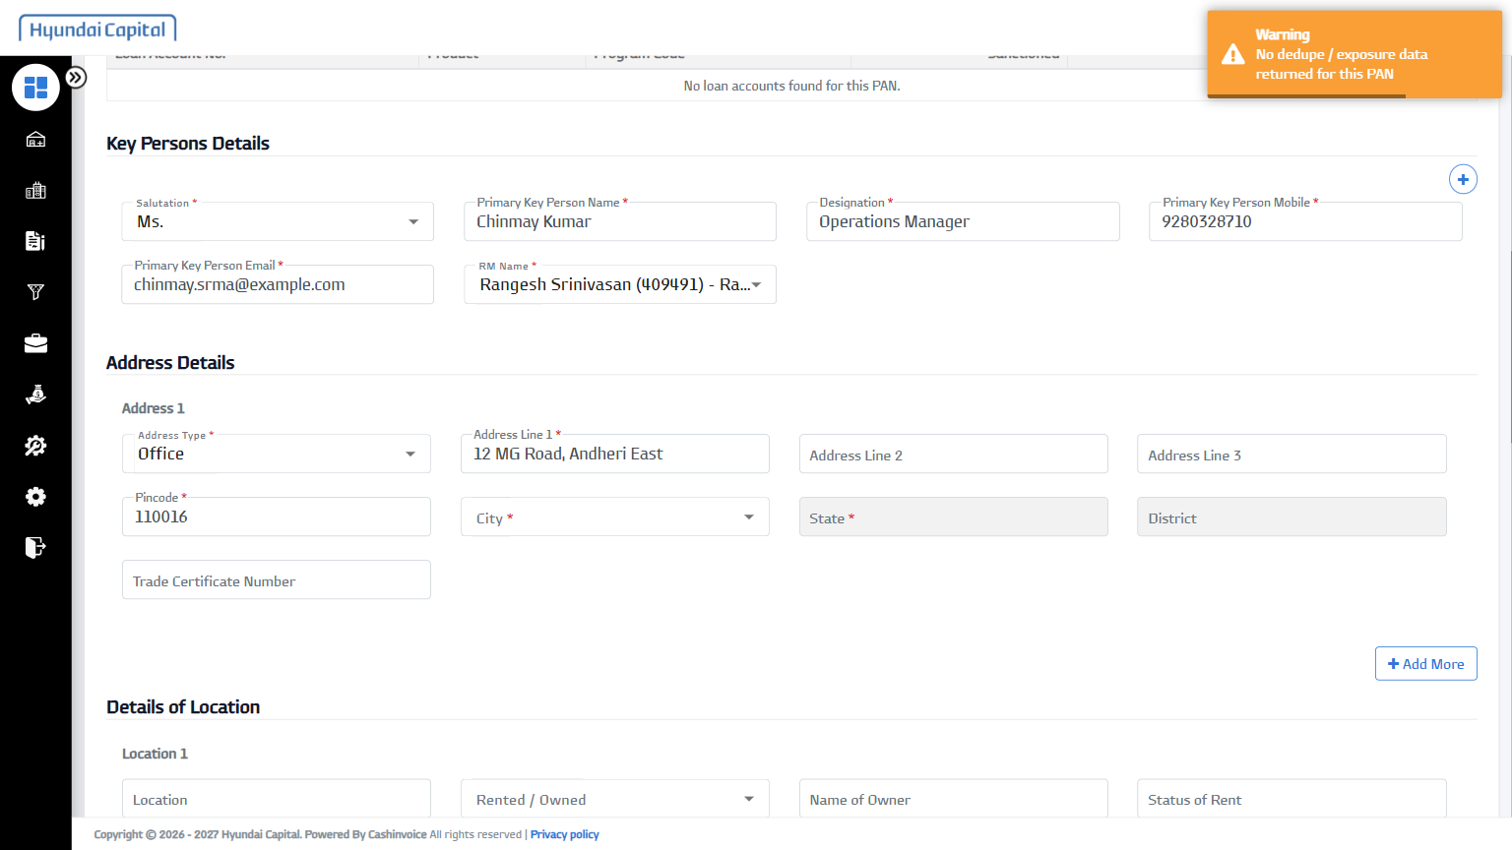
23 | Outlet Code (Dealer Code) | MH19 | PASS | 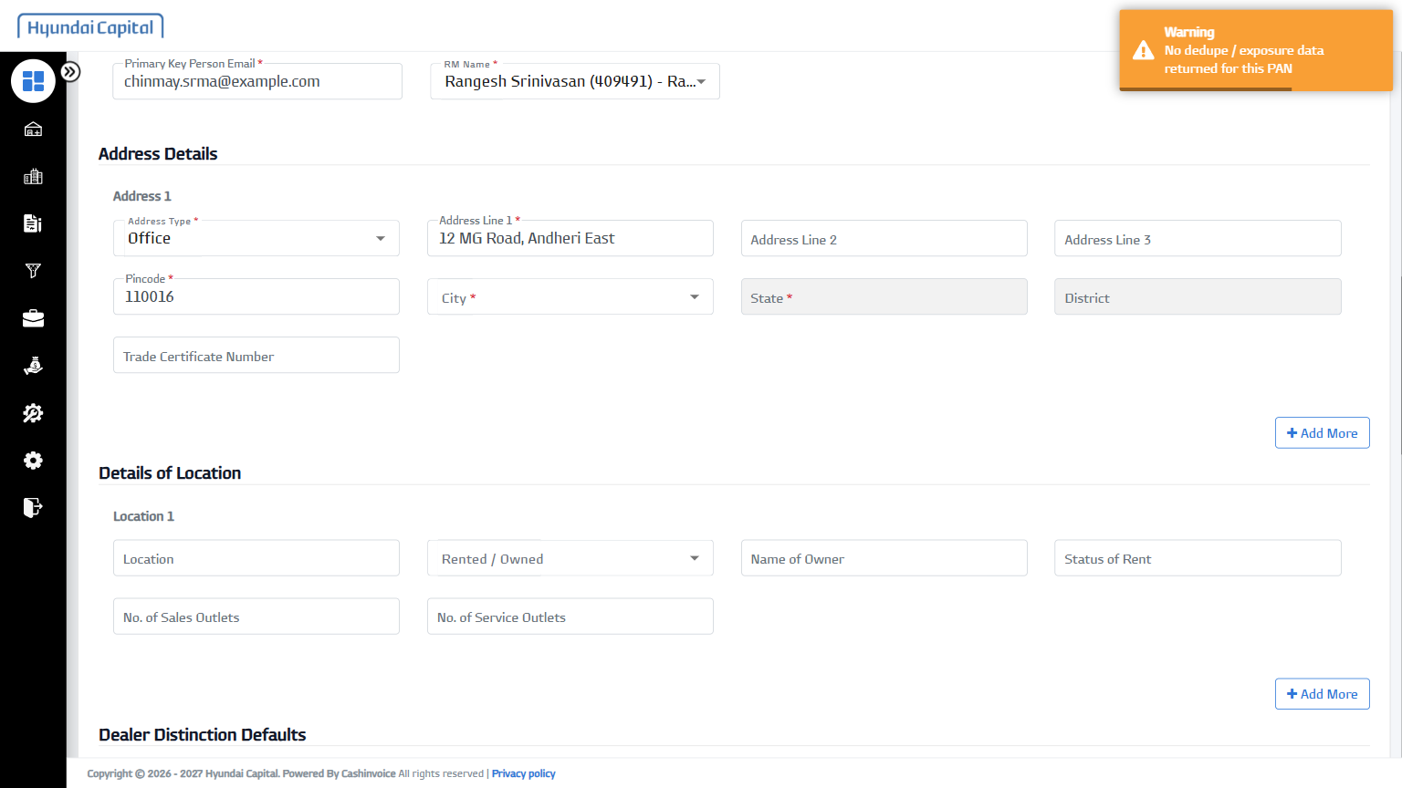
24 | Main Dealer Code | MH19 | PASS | 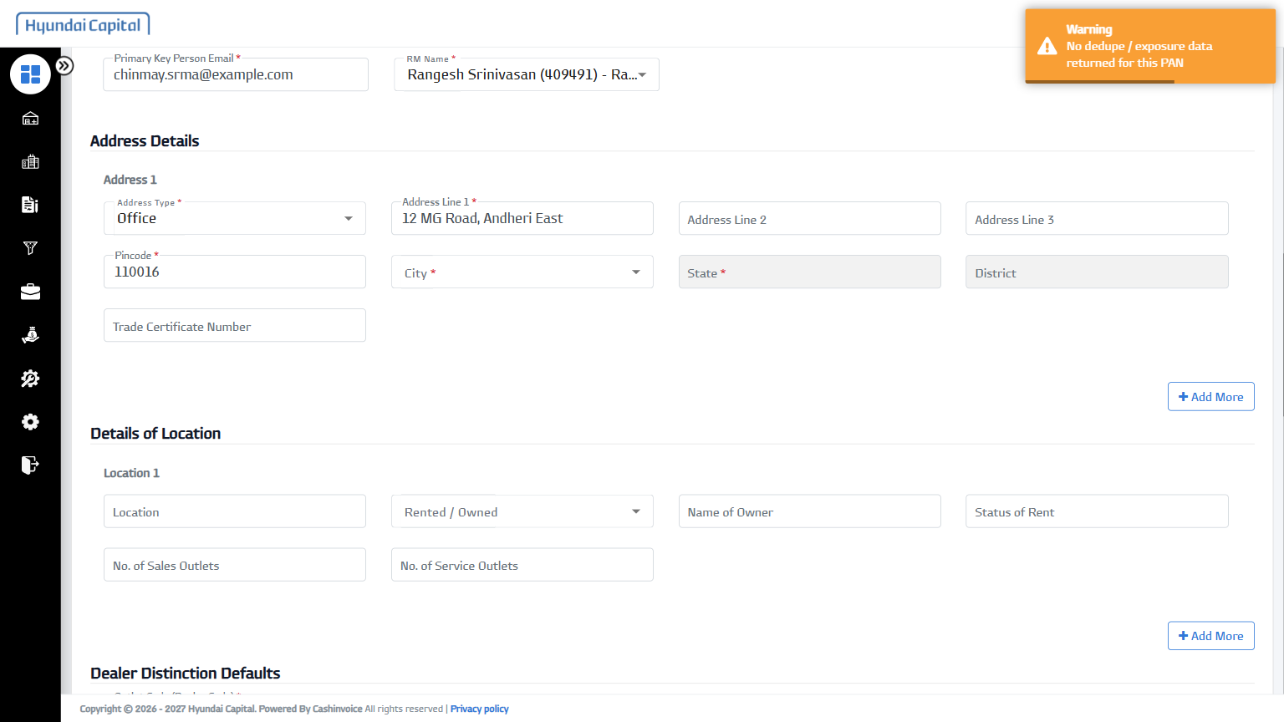
25 | Program Name | Program Name Hyundai_TD_07 ( | PASS | 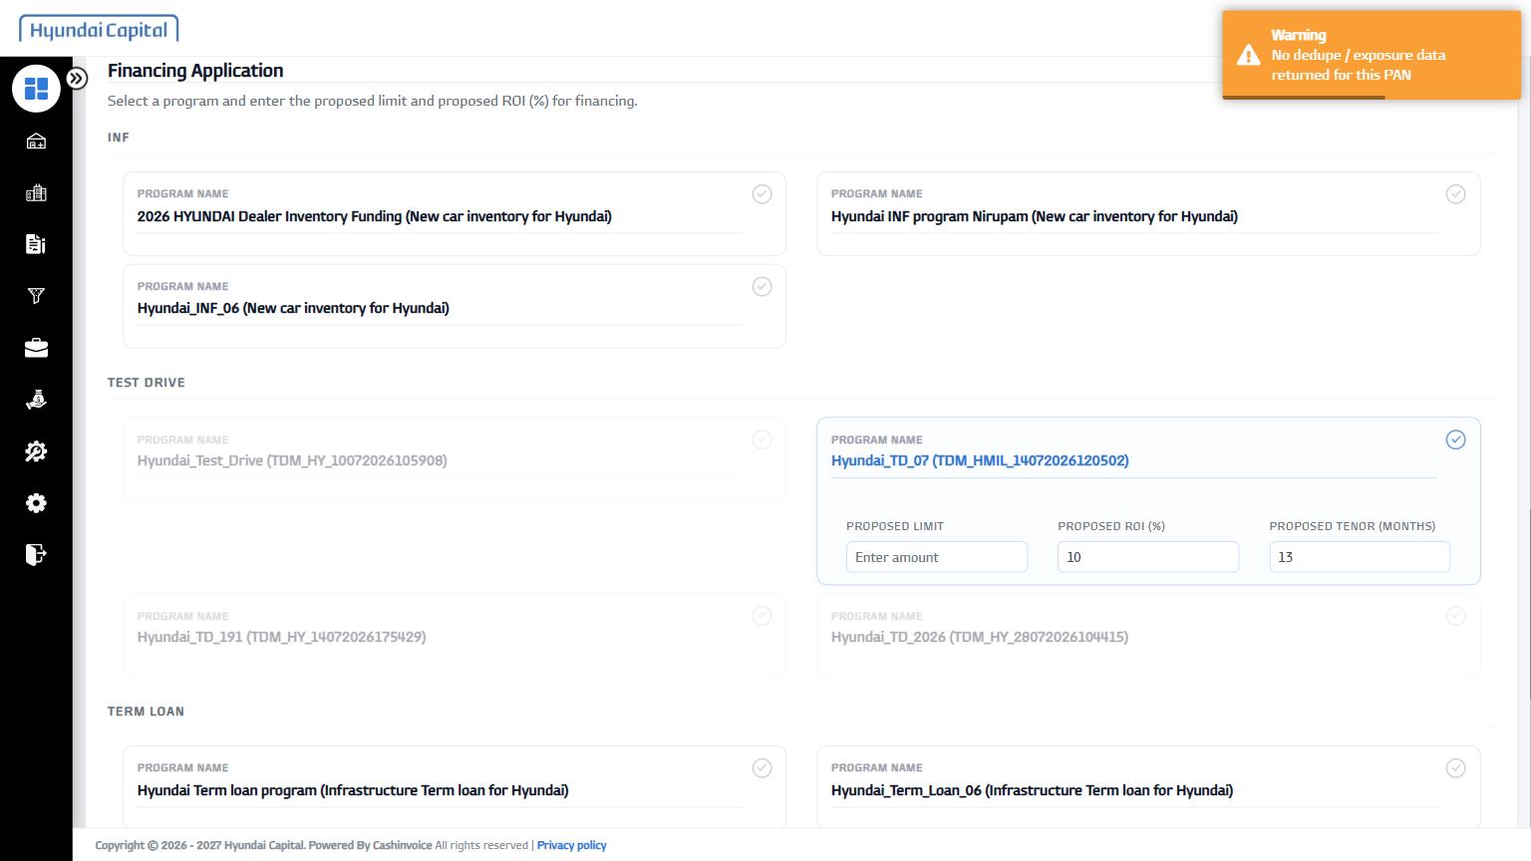
26 | Proposed Limit | 750000 | PASS | 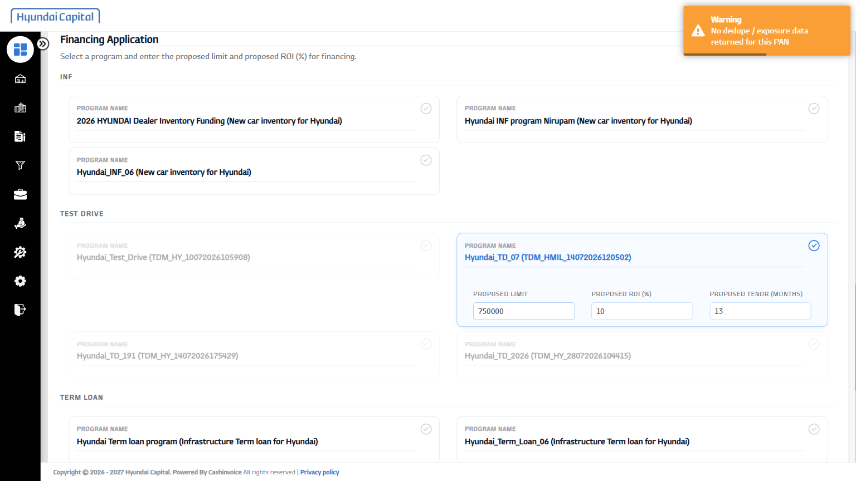
27 | Physical Application File | D:\OneDrive - Indinvoice Tech Solutions Pvt. Ltd\Desktop\HCIN-Automation\fixtures\sample-document.pdf | PASS | 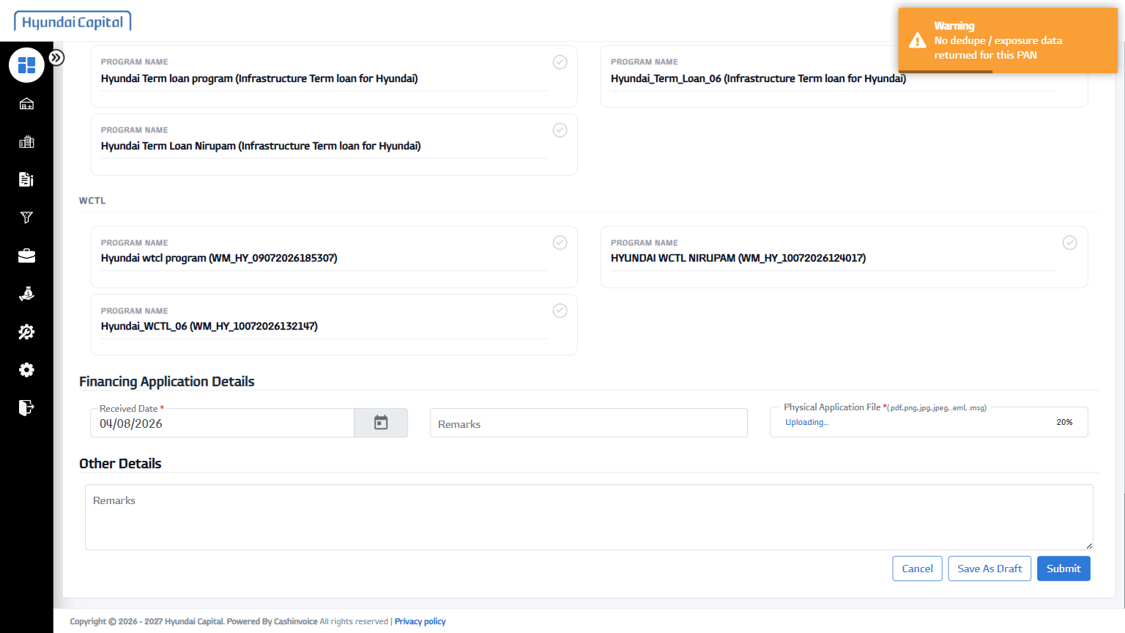
28 | Remarks | Documents verified and in order | PASS | 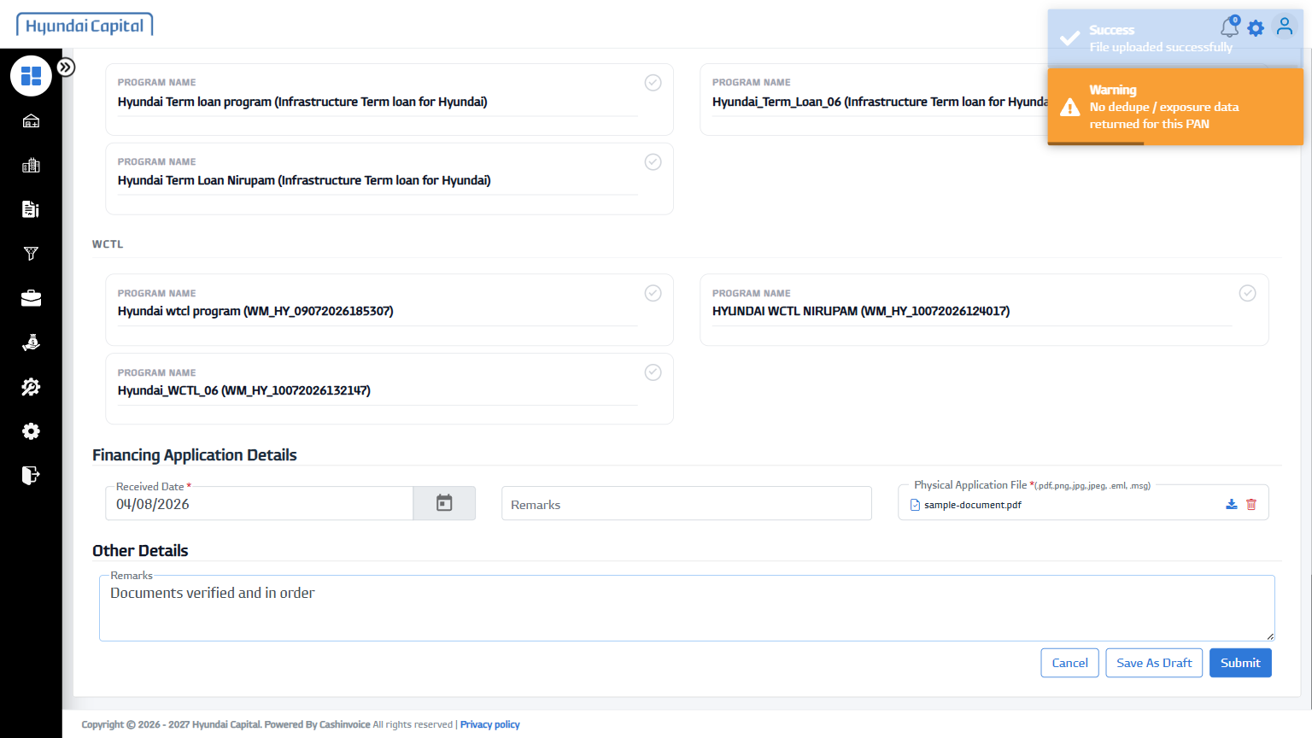
29 | Submit | - | PASS | 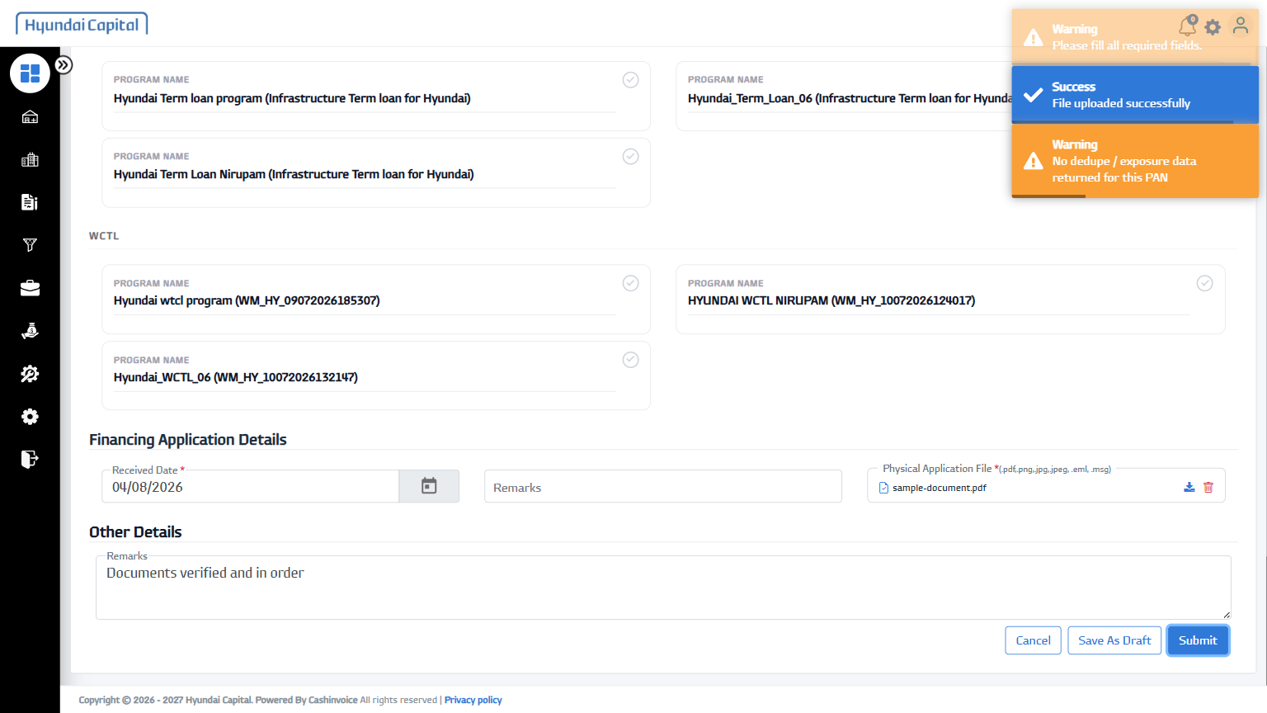
30 | Follow-up Email Id | mh@example.com | PASS | 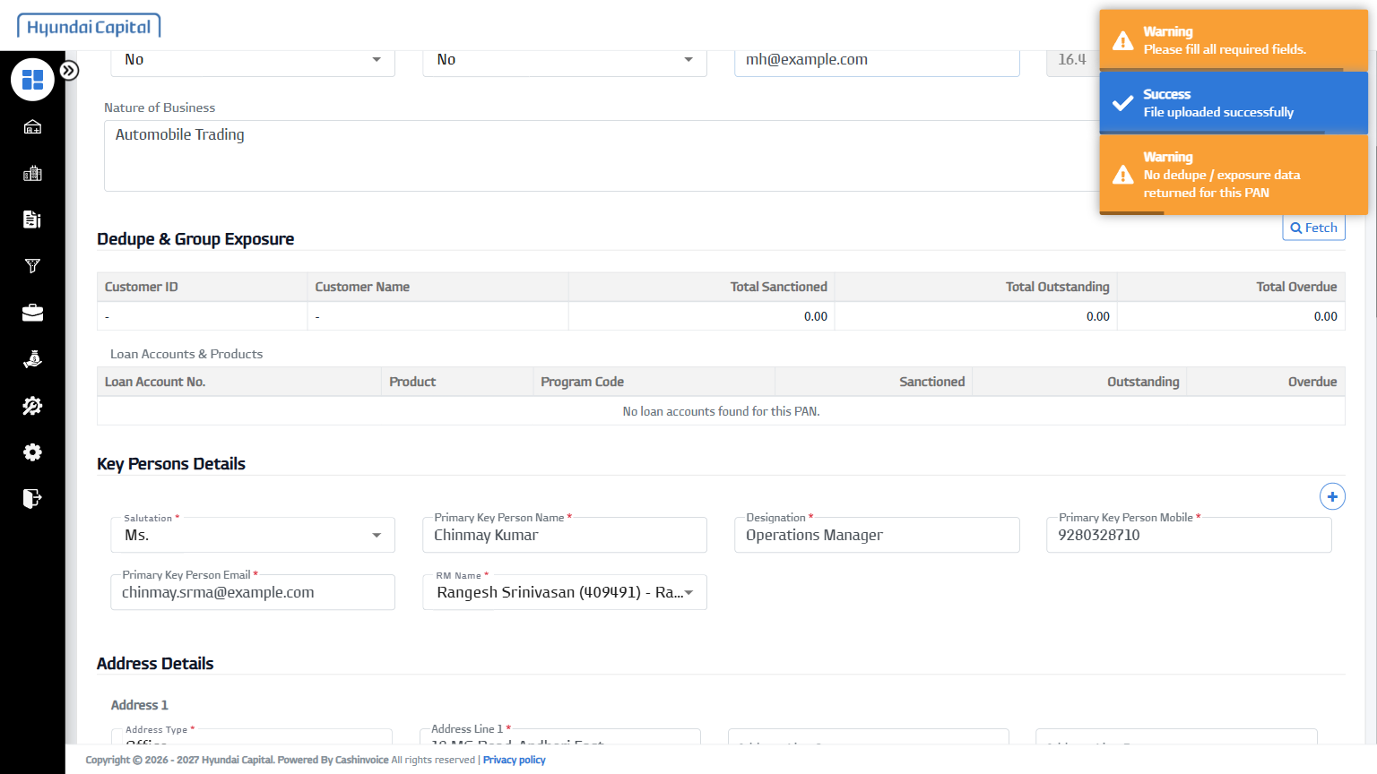
31 | Submit | - | PASS | 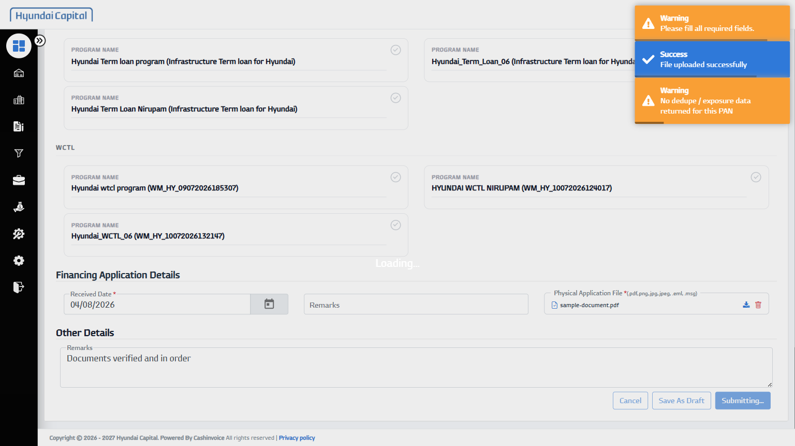

3. Add Promoter/Director Details to Existing Lead
Status: FAILED | Duration: 30044 ms
Logs in as Sales RM, searches for the lead created by onboardCompanyLead.spec.js (by its entityName), opens its "Promoters, Owners & Management" section, adds a director's personal details, uploads their KYC/net-worth/bank documents, and submits - using the same fixtures/companyLeadData.xlsx as the lead-creation test.
Field-by-Field Results
# | Field | Value Entered | Status | Screenshot
1 | Toggle Sidebar | - | PASS | 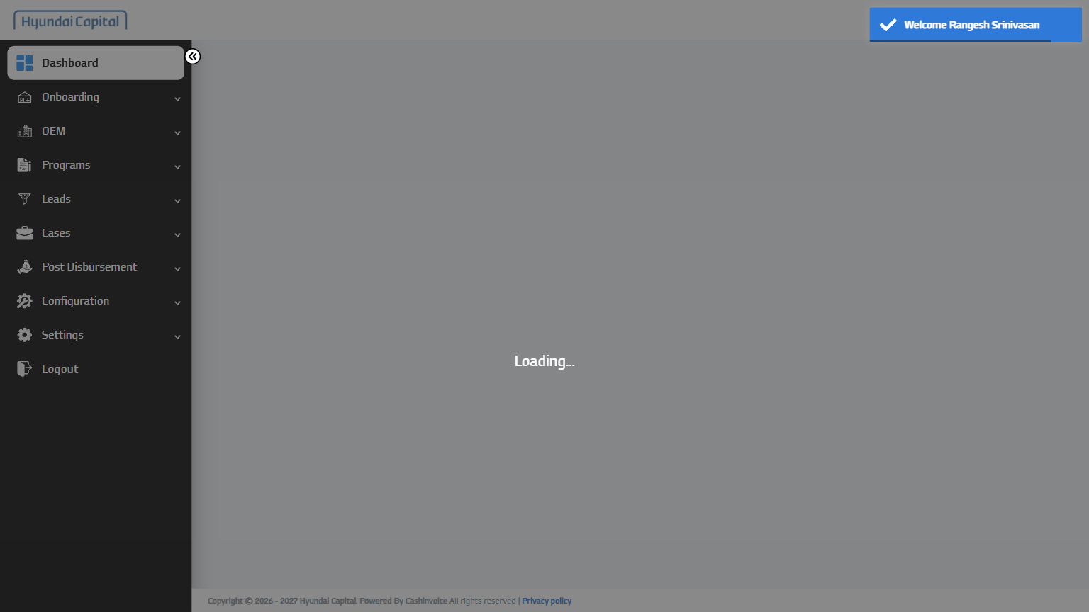
2 | Open Leads Menu | - | PASS | 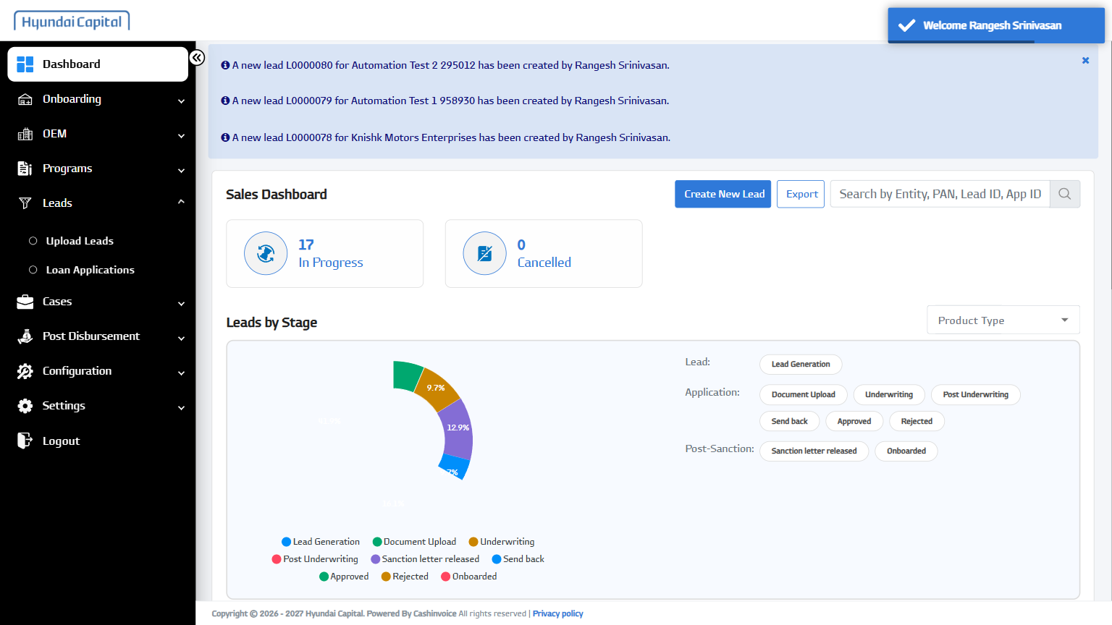
3 | Open Loan Applications | - | PASS | 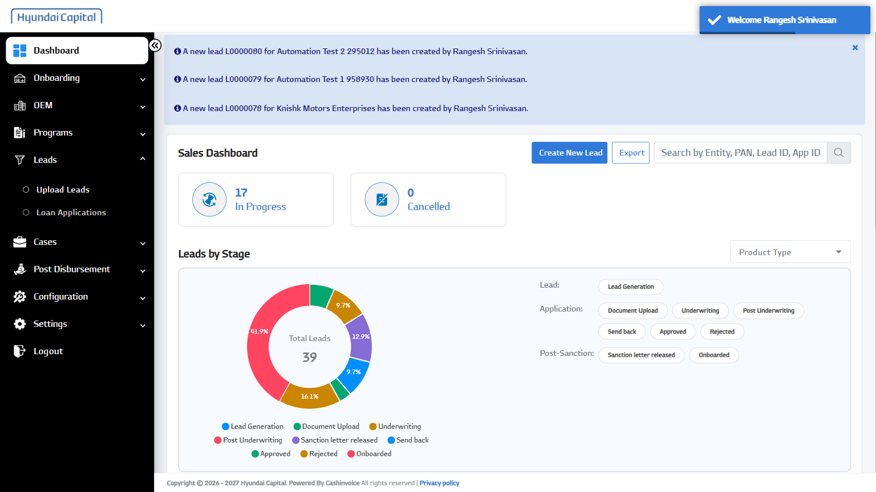
4 | Search Entity | Automation Test 993040 | FAIL | -
Error:
Error: page.reload: Target page, context or browser has been closed
Call log:
[2m - waiting for navigation until "load"[22m
[2m - navigated to "https://hcinlosdev.cashinvoice.in/los/#/counter-party/view-leads"[22m

