**CHAPTER 1**

**INTRODUCTION**

**1.1. Introduction to HTML**

Hypertext Markup Language (HTML) is the standard markup language for creating web pages and web applications. Web browsers receive HTML documents from a web server or from local storage and render the documents into multimedia web pages.HTML elements are the building blocks of HTML pages.

HTML5 is a markup language used for structuring and presenting content on the World Wide Web. It is the fifth and current major version of the HTML standard and subsumes XHTML.HTML5 was first released in public-facing form on 22 January 2008,with a major update and "W3C Recommendation" status in October 2014.Its goal is to improve the language with support for the latest multimedia and other new features.

**1.2. Introduction to CSS**

Cascading Style Sheets, fondly referred to as CSS, is a simple design language intended to simplify the process of making web pages presentable.

CSS handles the look and feel part of a web page. Using CSS, we can control the color of the text, the styles of fonts, the spacing between paragraphs, how columns are sized and laid out, what background images or colors are used ,layout designs, variations in display for different devices and screen sizes as well as a variety of other effects.

**1.3. Introduction to JavaScript**

JavaScript was developed by Brendan Eich in 1995, which appeared in Netscape, a popular browser of that time. JavaScript is a programming language that can be included on web pages to make them more interactive. You can use it to check or modify the contents of forms, change images, open new windows and write dynamic page content

**1.4.Introduction to PHP**

PHP is server side scripting language designed primarily for web development but also used as a general purpose programming language. Originally created by Rasmus Lerdorf in 1944, the PHP reference implementation is now produced by the PHP Development Team.PHP originally stood for personal home page but now stands for the recursive acronym PHP: hypertext Pre-processor.

PHP code may be embedded into HTML or HTML5 mark-up, or it can be used in combination with various web template systems, web content management systems and web frameworks.PHP code is usually processed by a PHP interpreter implemented as a module in the web server or as a Common Gateway Interface (CGI) executable.

**CHAPTER 2**

**REQUIREMENT ANALYSIS**

The main objective of this online medicine shopping is to take the whole medical store online so that it is reachable to customers 24/7. It also aims at going towards cashless transactions. This will impart a wider visibility to the customers. Thus boosting the business to higher levels. The online medicine shopping be a web based system with a very user friendly interface which indeed will make the whole management process easy to manage and operate with zero redundancies. Overall online medical booking store will become an efficient, highly responsive and an extremely accurate system.

**Existing System**

The existing medical Booking Store system is time consuming and requires more man power to function well. Secondly the scope of offline medical store is limited to local area and is available for fixed timing. All the data management involving product availability, searching, billing and other report generation are done manually which indeed are very time consuming.

**Proposed System**

The proposed medical Booking Store system will completely Revolutionize the industry. Searching of products, order placing, billing and product stock can be maintained by a single click. The order placed can be easily tracked At any time. The payment of the order can also be done by credit cards.

**CHAPTER 3**

**SOFTWARE REQUIREMENT SPECIFICATION**

**3.1 Hardware Requirements:**

* Pentium-IV (Processor).
* 256 MB Ram
* 512 KB Cache Memory
* Hard disk 10 GB
* Microsoft Compatible 101 or more Key Board

**3.2 Software Requirements:**

* Operating System **:** Windows
* Web-Technology : PHP
* Front-End: HTML,CSS,
* Back-End: My SQL
* Web Server:WAMP SERVER

**CHAPTER 4**

**ANALYSIS AND DESIGN**

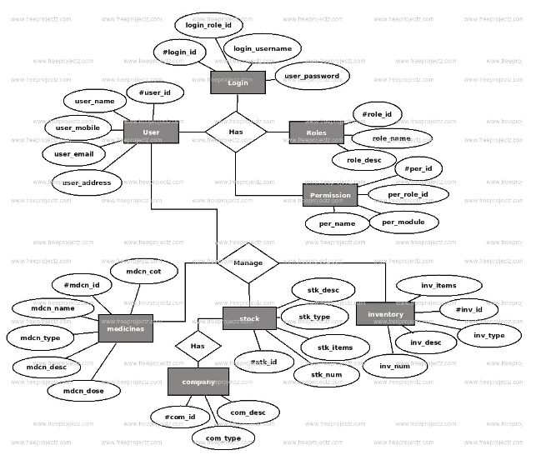

**CHAPTER 5**

**IMPLEMENTATION**

Implementation is the stage where the theoretical design is turned into working system. The most crucial stage in achieving a new successful system and in giving confidence on the new system for the users that it will work efficiently and effectively.

The system can be implemented only after thorough testing is done and if it is found to work according to the specification.

It involves careful planning, investigation of the current system and its constraints on implementation design of methods to achieve the changes over and an evaluation of changes over methods a part from planning. Two majors’ tasks of preparing the implementation are education and training of the users and testing of the systems

The project application that was approved by the programmers is the base line for project implementation. To implement a project means to carry out the activities proposed in the application from with the aim to project objectives and deliver the results and outputs.

Its success depends on the many internal and external factors some of the most important ones are very well organised project team and effective monitoring of project progress and related expenditure

**CHAPTER 6**

**TESTING**

Software testing is an investigation conducted to provide stack holders with information about the quality of software product or service under test. Software testing can also provide an objective, independent view of software to allow the business to appreciate and understand the risk of software implementation. Test technique include the process of executing a program or application with the intent of finding software bugs and verifying that the software product is fit for use.

Software testing involves the execution of a software component or system component or system component to evaluate one or more properties of interest. Software testing can provide objective, independent information about quality of software and risk of its failure to users or sponsors.

Software testing can be conducted as soon as executable software exists. The overall approach to software development often determines when and how testing is conducted. For examples, in a phased requirements have been defined and then implemented in testable programs. In contrast, under an agile approach, requirements, programming, and testing are often done concurrently.

**SNAPSHOTS**

MAIN FORM

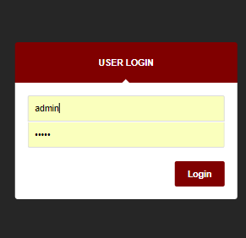

HOME PAGE  
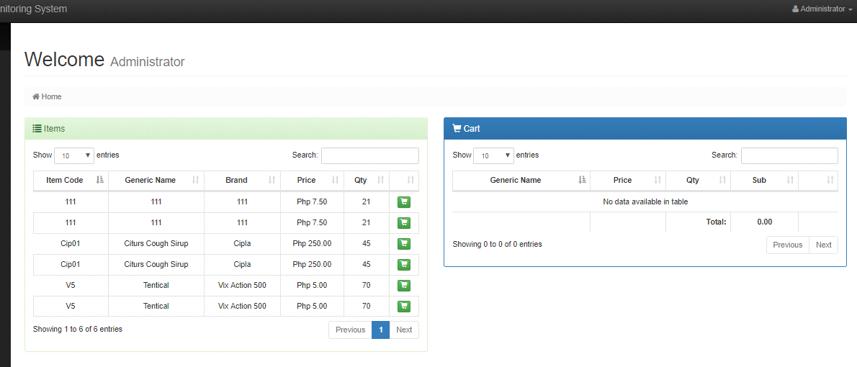

ITEM LIST

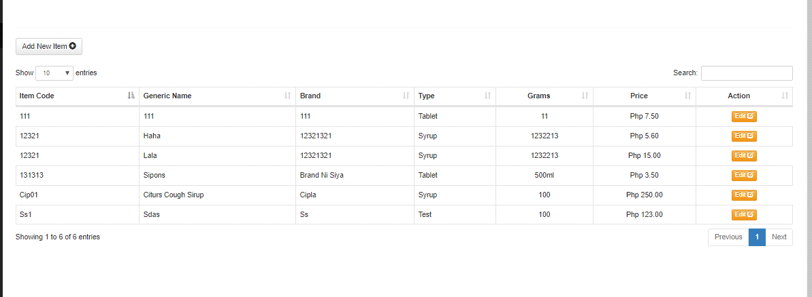

ADD NEW ITEM

NEW STOCK

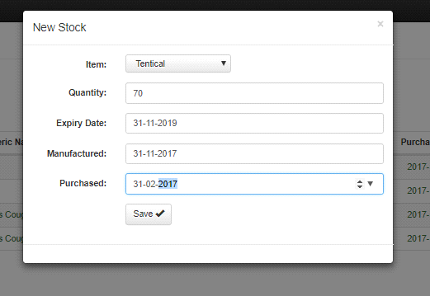

EXPIRED LIST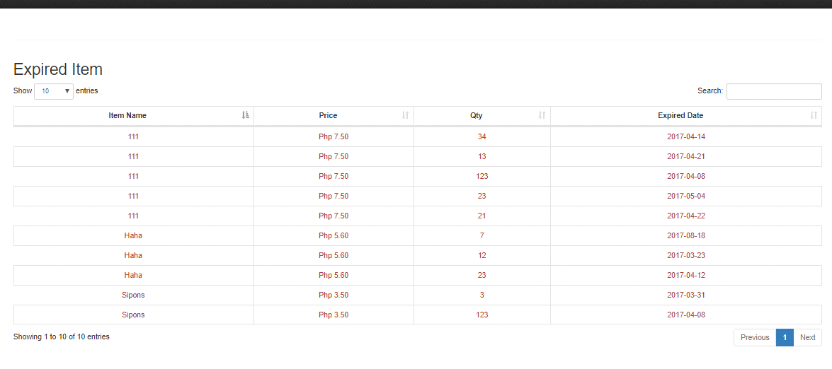

**CONCLUSION**

Pharmacy management system is actually a software which handle the essential data and save the data and actually about the database of a pharmacy and it's management. This software helps in effectively management of the pharmaceutical store or shop. It provide the statistics about medicine or drugs which are in stocks which data can also be updated and edited. It works as per the requirement of the user and have options accordingly. It allow user to enter manufacturing as well as the expiry date of medicine placing in stock and for sales transaction. This software also have ability to print the bill and invoices etc..The record of suppliers supplies can also be saved in it. There are other function available too . The main purpose is effectively and easily handling of pharmacy data and it's management.

This system provides an easy way for the operator to interact with database and to manipulate the data in database. The operator can add, delete and update records in database with ease.

**BIBLIOGRAPHY**

**REFERENCE BOOKS:**

* Programming PHP, Kevin Tatroe, Peter Macltyre, Rasmus Lerdorf,2013.
* My SQL, Joel Murach, 2nd edition.
* Web database applications with PHP and My SQL, Hugh E. Williams, David Lane, 2004.
* PHP ans My SQL for Dummies, Janet Valade, 2009.