
NexUse
SELL · RENT · SHARE · DONATE
Interim Report
A unified platform driving Sri Lanka's circular economy
through reselling, renting, sharing and donating.
Group CS-31 · Second-Year Group Project
Member | Name | Index number
Member 1 | [Member 1 name] | [Index number]
Member 2 | [Member 2 name] | [Index number]
Member 3 | [Member 3 name] | [Index number]
Member 4 | [Member 4 name] | [Index number]

Supervisor: [Supervisor name]
[Department / Faculty / University]
September 2026

Contents
1. Introduction 3
1.1 Domain description 3
1.2 Current system and its limitations 3
1.3 Goal and objectives 4
1.4 Assumptions 4
2. Feasibility Study 5
2.1 Technical feasibility 5
2.2 Economic feasibility 5
2.3 Social feasibility 5
2.4 Legal and ethical feasibility 6
2.5 Operational feasibility 6
3. Requirements 7
3.1 Stakeholders and actors 7
3.2 Functional requirements 7
3.3 Non-functional requirements 11
3.4 In scope and out of scope 11
3.5 Constraints and limitations 12
4. Proposed System's Architecture 13
4.1 Components and their functionalities 14
4.2 Component interactions 14
5. System Design Diagrams 17
5.1 Use case diagrams 17
5.2 Class diagrams 21
5.3 ER diagram 23
5.4 Activity diagrams 24
6. Current Progress 29
6.1 Progress against the system requirements 29
6.2 Estimated completion 31
6.3 Remaining tasks 31
6.4 Member contributions 32
Appendix A — Data dictionary 34
Appendix B — Screens of the current system 38

1. Introduction

1.1 Domain description
NexUse works in the domain of the circular economy — keeping usable goods in use for longer instead of letting them sit idle or be thrown away. In most homes, a large share of what people own is rarely used: studies cited in our proposal suggest households regularly use only around 20–30% of the items they own. At the same time, other people buy the same items new, often for a single short-term need, because they have no easy way to reach the idle ones.
An item that is no longer needed can leave its owner in four ways, and NexUse supports all four on one platform:
Table 1: The four exchange types NexUse supports
Exchange type | What happens | Ownership | Payment
Sell (resell) | A member lists an item; a buyer requests it; the seller accepts; they complete the exchange off-platform | Transferred permanently | Yes — arranged between the two parties
Rent | A lender lists an item with a price per day; a renter requests dates; the item is used and returned, and its condition is checked | Stays with the lender | Yes — arranged between the two parties
Share (free lending) | As renting, but free of charge | Stays with the lender | No
Donate | A donor lists an item; a receiver requests it; the donor hands it over | Transferred permanently | No

The platform is aimed at individuals across Sri Lanka. It connects people who have usable items with people who need them; it deliberately does not handle payment or delivery, which the two parties arrange directly (see section 3.3).

1.2 Current system and its limitations
There is no single system in Sri Lanka for circulating idle items. People currently use a mix of general platforms and informal channels. Our survey of 30 people found that half use ikman.lk, half use Daraz.lk, 43.3% use Facebook Marketplace, 20% use WhatsApp, Viber or Telegram groups, and 23.3% use none at all.
Table 2: Comparison with existing platforms (from the project proposal)
Feature | NexUse | ikman.lk | FB Marketplace | Daraz.lk | karuna.lk
Second-hand selling | Yes | Yes | Yes | No | No
Managed renting | Yes | Limited (houses and vehicles) | No | No | No
Free temporary sharing | Yes | No | No | No | No
Several exchange types in one place | Yes | No | No | No | No
In-app chat | Yes | No | Yes | Yes | No
Donations | Yes | No | No | No | Yes

The limitations of the current situation are:
- Fragmentation. Selling, renting, lending and donating each need a different platform, or none exists. No local platform supports all four.
- No managed renting or lending. Classified sites stop at the advert; nothing records the rental period, the return or the condition of the item.
- Low trust. Survey respondents named unclear item conditions (70%) and scams and fake profiles (63.3%) as their biggest frustrations. When lending an item, 70% worry about trusting the borrower and 60% about damage or theft.
- Informal channels do not scale. Group chats have no search, filters, history or accountability.
- Idle items stay idle. Asked what they do with items they no longer need, 46.7% keep them in storage and 20% throw them away; only 10% donate them to charity.

1.3 Goal and objectives
Goal. To develop an integrated web platform that lets people exchange under-used items by selling, renting, sharing or donating them, improving how well existing resources are used by making idle items accessible to the people who need them.

Project objectives
- Develop a functional web-based platform that supports selling, renting, sharing and donating.
- Implement the core features: user management, item listing, search, request handling and notifications.
- Provide basic trust mechanisms: ratings, reviews and dispute reporting.
- Ensure the system is user-friendly, reliable and tested within the project timeline.
- Demonstrate successful item exchanges during testing.

Business objectives
- Promote efficient use of under-used resources by making them accessible to others.
- Reduce unnecessary purchasing by encouraging reuse, renting and sharing.
- Let people gain value from items they no longer use.
- Give affordable access to goods for people who cannot buy new.
- Encourage a culture of sharing and responsible consumption.

1.4 Assumptions
- Users have internet access and a modern web browser, on a computer or a phone.
- The two parties to an exchange arrange payment, hand-over and any delivery themselves, outside the platform.
- Users give truthful information about themselves and their items; the platform records disputes but cannot verify goods.
- One person holds one account, which can sell, buy, lend, rent, donate and receive (see section 3.1).
- Prices are in Sri Lankan rupees, the interface is in English for this phase, and only lawful items may be listed.

2. Feasibility Study
This section refines the feasibility study in our proposal in the light of what we learned while building the interim system. Where the actual environment differed from the plan, the difference and its consequence are stated.

2.1 Technical feasibility
The proposal chose HTML, CSS and vanilla JavaScript, PHP and MySQL, with no frameworks or external libraries. The interim build confirms this is feasible: the whole system runs on that stack.
Table 3: Technical environment — planned and actual
Area | Planned in the proposal | Actual, and consequence
Server | Apache via XAMPP | PHP's built-in development server. The code is Apache-ready: an .htaccess file routes requests the same way, so it can move to XAMPP or a host unchanged
PHP | PHP (XAMPP) | PHP 8.5, with the pdo_mysql, session and mbstring extensions — all the system needs
Database | MySQL | MySQL 8.0, ten tables with foreign keys, accessed only through PDO prepared statements
Images | — | The gd and fileinfo extensions are not installed, so uploads are validated with getimagesize() and an allow-list, and stored at original size
Email | — | No mail server and no openssl extension, so the machine cannot send email. An email one-time-code step was prototyped, and the group then decided to remove it; see section 3.4
Architecture | Not specified | A hand-written Model–View–Controller structure with a single front controller; see section 4

Conclusion: technically feasible. The only capability the environment cannot provide is outbound email, and no requirement in the proposal depends on it.

2.2 Economic feasibility
Unchanged from the proposal. All tools are free (VS Code, PHP, MySQL, Git, Figma and Canva free tiers), development uses the team members' own laptops, and no domain or paid hosting is needed during development. For the final demonstration the system can be deployed to a free-tier PHP and MySQL host. The platform is itself planned to be funded by voluntary donations from its users (a donation dialog is already in the footer), not by fees or commission.
Conclusion: economically feasible at effectively zero cost.

2.3 Social feasibility
We surveyed 30 members of the public from different regions of Sri Lanka using Google Forms. The results support the need for the platform and have shaped both the interim build and the plan for the final phase:
Table 4: Survey findings and how they are used
Question | Key result | What it means for NexUse
How often do you hold on to items you no longer use? | 53.3% occasionally, 23.3% very often | Idle items are common
Would you use one platform to sell, rent and donate? (1–5) | 40% chose 5, 26.7% chose 4 | Two thirds are likely users
Wanted to use an item briefly without buying it? | 66.7% sometimes, 30% frequently | Strong demand for renting and sharing
Biggest frustration with current platforms | Unclear conditions 70%, scams 63.3%, delivery 43.3% | Condition details, reviews and reporting are core, not extras
Biggest concern when lending your items | Trusting the borrower 70%, damage or theft 60% | Return condition is recorded; ratings are visible before accepting
Fairest late-return penalty | 24-hour grace period 40%, flat fee per day 26.7% | The planned late-return rule (section 6.3)
What would make donating most convenient? | Doorstep pickup 40%, knowing the receiver 26.7% | Receiver profiles visible; donation requests planned
Most important features | Detailed search filters, verified profiles, chat | Filters and chat built; verification planned

Conclusion: socially feasible, with a clear message that trust features matter as much as listing features.

2.4 Legal and ethical feasibility
The system does not handle payments or any regulated financial data. The interim build has already put the proposal's legal and ethical commitments into practice:
- Data minimisation. Only the data the platform needs is collected; phone number, city and address are optional.
- Controlled disclosure. A member's contact details are shown to the other party only after a request is accepted. Item locations and member profile pages are visible only to signed-in members.
- Security. Passwords are stored only as bcrypt hashes; every database query uses prepared statements; every form carries a CSRF token; all output is escaped.
- Transparency. Terms and conditions, a privacy notice and a contact page are published in the site footer.
- Fair trading. Prices and item conditions are shown on every listing, and members can report a listing or a member.
One commitment is not yet met: the proposal states that "users are verified through admin approval". Accounts are currently active as soon as they are created. An administrator-granted verified badge is planned (section 6.3).

2.5 Operational feasibility
The system is operated through ordinary web pages: members need no training beyond using a website, and administrators manage users, categories, complaints and announcements from an admin area with its own menu. The layout adapts from a phone to a wide desktop screen, and the interim milestones were met on schedule.

3. Requirements

3.1 Stakeholders and actors
Table 5: Stakeholders and actors
Stakeholder / actor | Description
Admin | Manages users, categories, complaints and announcements, and monitors activity on the platform
Seller / Reseller | Lists items for sale and responds to buyers
Buyer | Finds items for sale and requests them
Lender | Lists items to rent out or lend free, and records their return
Renter | Requests an item for a set period and returns it
Donor | Gives items away free of charge
Donation receiver | Receives donated items
Guest (unregistered visitor) | Can browse and search listings, but must register to request, message, or see locations and member profiles
CS-31 project team and supervisor | Build, maintain and evaluate the system

How the actors are implemented. The proposal lists seven actors, but a real person moves between roles — someone may sell a bicycle and borrow a drill in the same week. The system therefore stores only two account roles, admin and member. Every member can act as seller, buyer, lender, renter, donor or receiver; which one depends on the exchange:
Table 6: Mapping proposal actors to account roles
Actor | Is a member who… | Determined by
Seller | owns a listing of type sell | listings.listing_type
Buyer | sends a buy request | requests.request_type
Lender | owns a listing of type rent or share | listings.listing_type
Renter | sends a rent or borrow request | requests.request_type
Donor | owns a listing of type donate | listings.listing_type
Donation receiver | sends a donation request | requests.request_type

3.2 Functional requirements
The functional requirements below are taken from section 8 of our proposal and its use-case diagrams, grouped by actor and given identifiers so that their progress can be reported in section 6. Priority: M must have, S should have, C could have, X out of scope (see 3.3).

Admin
ID | Requirement | Priority
FR-AD-01 | Log in and log out | M
FR-AD-02 | View users by role | M
FR-AD-03 | Edit or delete any user account | M
FR-AD-04 | View a summary dashboard (users, transactions) | M
FR-AD-05 | View all product listings and transaction records | S
FR-AD-06 | Manage and resolve disputes or complaints | M
FR-AD-07 | Send notifications to individual users or user groups | S
FR-AD-08 | Generate reports (monthly, custom — e.g. activity by type) | S
FR-AD-09 | Manage product categories | M
FR-AD-10 | Validate products and donation requests | C
FR-AD-11 | Suspend or delete users and view their profiles | M
FR-AD-12 | Verify users through admin approval | S

Buyer
ID | Requirement | Priority
FR-BU-01 | Create an account | M
FR-BU-02 | Log in securely with email and password | M
FR-BU-03 | Maintain and update profile | M
FR-BU-04 | Browse available products | M
FR-BU-05 | Search products by keyword | M
FR-BU-06 | Filter by category, price, location or condition | M
FR-BU-07 | View product details with images and description | M
FR-BU-08 | Add products to a wishlist | C
FR-BU-09 | Add products to a shopping cart | C
FR-BU-10 | Place orders (buy requests) | M
FR-BU-11 | View order status and purchase history | M
FR-BU-12 | Communicate with sellers through chat | M
FR-BU-13 | Rate and review products and sellers after a transaction | M
FR-BU-14 | Make payment | X
FR-BU-15 | Track delivery | X

Seller
ID | Requirement | Priority
FR-SE-01 | Register, log in, log out and manage profile | M
FR-SE-02 | Create product listings | M
FR-SE-03 | Edit descriptions, prices and other details | M
FR-SE-04 | Delete or remove listings | M
FR-SE-05 | Be notified of new orders or inquiries | M
FR-SE-06 | Communicate with buyers through chat | M
FR-SE-07 | Report suspicious activity, fraudulent buyers or scams | M
FR-SE-08 | Verify account information | S
FR-SE-09 | View orders and update order status | M
FR-SE-10 | Reset a forgotten password | S
FR-SE-11 | View ratings and reviews | M
FR-SE-12 | Reply to reviews | C
FR-SE-13 | View payments | X

Donor
ID | Requirement | Priority
FR-DO-01 | Log in, log out and manage profile | M
FR-DO-02 | Browse active donation requests | S
FR-DO-03 | Filter donation requests by category, location or type | S
FR-DO-04 | Cancel a donation pledge before it is accepted | S
FR-DO-05 | View the status of pledged donations | S
FR-DO-06 | Communicate with receivers | M
FR-DO-07 | View notifications about donation activity | M
FR-DO-08 | View donation history | S
FR-DO-09 | Be notified when a pledge is accepted or rejected | S

Donation receiver
ID | Requirement | Priority
FR-DR-01 | Log in, log out and manage profile | M
FR-DR-02 | Create and manage a donation request | S
FR-DR-03 | Delete a donation request | S
FR-DR-04 | View donation pledges received for a request | S
FR-DR-05 | Accept a donation pledge | S
FR-DR-06 | Reject a donation pledge | S
FR-DR-07 | Communicate with donors | M
FR-DR-08 | View notifications about requests and pledges | M
FR-DR-09 | Notify a requester when a donor pledges | S
FR-DR-10 | Mark a donation as received | S

Lender
ID | Requirement | Priority
FR-LE-01 | Log in and log out | M
FR-LE-02 | List items for rent with description, condition, price and availability | M
FR-LE-03 | View and manage listed items | M
FR-LE-04 | Receive rental requests | M
FR-LE-05 | Accept or reject rental requests | M
FR-LE-06 | Set rental duration (start and return date) | M
FR-LE-07 | Track rented items and their status | M
FR-LE-08 | Verify item condition on return | M
FR-LE-09 | Request compensation for damaged or unreturned items | S
FR-LE-10 | View ratings and reviews from renters | M
FR-LE-11 | Set an availability period | C
FR-LE-12 | Chat with renters | M
FR-LE-13 | Reply to reviews | C
FR-LE-14 | Report damaged or missing items and late returns | S
FR-LE-15 | Reset a forgotten password | S

Renter
ID | Requirement | Priority
FR-RE-01 | Log in and log out | M
FR-RE-02 | Search and view items available for rent | M
FR-RE-03 | Send rental requests for selected items | M
FR-RE-04 | View request status (pending, accepted, rejected) | M
FR-RE-05 | View rental details (duration, conditions, return date) | M
FR-RE-06 | Receive notifications for request updates | M
FR-RE-07 | Receive return reminders | S
FR-RE-08 | Use the item for the agreed period | M
FR-RE-09 | Return the item within the agreed time | M
FR-RE-10 | Confirm return of the item | S
FR-RE-11 | Rate and review lenders | M
FR-RE-12 | Edit a rental request or its period | C
FR-RE-13 | View rental history and report issues | M
FR-RE-14 | Make payment | X

System-wide requirements from the proposal scope
Table 7: System-wide functional requirements
ID | Requirement | Priority
FR-SYS-01 | Track rental and sharing periods with start and return dates | M
FR-SYS-02 | Send return reminders and late-return alerts | S
FR-SYS-03 | Manage late returns with penalties (recorded, not charged) | S
FR-SYS-04 | Allow compensation requests for damage or non-return | S
FR-SYS-05 | Allow items to be listed for disposal, coordinated between the parties | C
FR-SYS-06 | Notify users of requests, approvals and rejections | M
FR-SYS-07 | Show ratings and reviews of users | M

3.3 Non-functional requirements
Table 8: Non-functional requirements
ID | Quality | Requirement
NFR-01 | Security | Passwords stored only as bcrypt hashes; all SQL through prepared statements; a CSRF token on every form; all output HTML-escaped; session id regenerated on sign-in; uploads checked to be real images under 2 MB and stored under random names
NFR-02 | Privacy | Contact details shared only with the other party after a request is accepted; item locations and member profiles visible only to signed-in members; a published privacy notice
NFR-03 | Usability | One consistent layout and navigation on every page; forms keep what was typed when validation fails; every action confirms its result with a clear message
NFR-04 | Responsiveness | Usable from a 390-pixel phone screen to a wide desktop without sideways scrolling
NFR-05 | Performance | Pages render in under two seconds on the demonstration machine; searched and filtered columns are indexed; long result lists are paginated
NFR-06 | Reliability and integrity | Foreign keys enforce relationships; requests follow a fixed status sequence and cannot skip or reverse a step
NFR-07 | Maintainability | Model–View–Controller layering with one module per team member; no framework, so every line can be explained by its author
NFR-08 | Portability | Runs unchanged on PHP's built-in server and on Apache (XAMPP); configuration held in a single local file
NFR-09 | Compatibility | Works in current versions of Chrome, Edge and Firefox; JavaScript is used only as an enhancement, so core features work without it
NFR-10 | Accessibility | Labels on every form control, keyboard-operable dialogs, sufficient colour contrast
NFR-11 | Availability | Deployed to a server reachable for the final demonstration

3.4 In scope and out of scope

In scope
- User registration, login, profile management and reviews, and reporting of disputes.
- Listing any type of item with a description, condition and exchange type, with ownership rules per type.
- Requesting items to buy, rent, borrow or receive, with the owner accepting or rejecting — no automatic approval.
- Tracking rental and sharing periods with start and return dates, reminders, late returns with penalties, condition verification and compensation requests.
- Selling as a permanent transfer, donating as a free permanent transfer, and sharing as a free temporary exchange with return tracking.
- Listing items for disposal, with the platform only coordinating.
- Notifications for requests, approvals or rejections, return reminders and late returns.
- Rating and reviewing other users involved in transactions.
- Admin management of users, complaints, notifications and analytics, and monitoring of transactions.

Out of scope
- Native mobile apps for iOS or Android — the web application is responsive instead.
- Delivery management, tracking of delivery personnel, or responsibility for transport.
- In-app payments, escrow or refunds; all money changes hands outside the platform.
- Mediation or enforcement of disputes — the platform records complaints and their outcome only.
- Insurance or legal penalties; the platform is a facilitator between users.

Scope clarifications made during the interim phase
Table 9: Scope clarifications
Item | Decision
Shopping cart, make payment, track delivery (Buyer and Seller use cases) | These conflict with the out-of-scope list above. "Place orders" is met by the buy request, which the seller accepts. Payment and delivery remain out of scope (priority X)
"Admin manages and resolves disputes" (proposal §6) versus "without providing resolution mechanisms" (§3) | The administrator records an outcome — reviewing, resolved or dismissed — with a note the member can read. Nothing is enforced
Email verification of new accounts | Built as a one-time code in an earlier iteration, then removed by group decision: the development machines cannot send email, and the proposal does not require it. Admin-granted verification is planned instead
Actor names | "Donar" and "Render" in the proposal are corrected to Donor and Renter

3.5 Constraints and limitations
- The initial phase is restricted to a responsive web application, built by four student developers within the academic timetable.
- The system does not handle in-app payments or delivery.
- No frameworks or external libraries may be used — plain HTML, CSS, JavaScript, PHP and MySQL only.
- The development machines cannot send email (no mail server, no openssl extension), so features that depend on email, such as self-service password reset, need a deployed server.
- The gd image extension is not available, so photos are stored at their original size rather than resized.
- The interface is English-only in this phase, although the survey shows interest in Sinhala and Tamil.

4. Proposed System's Architecture
NexUse is a three-tier web application — browser, PHP application, MySQL database — structured internally as Model–View–Controller (MVC) behind a single front controller. No framework is used: the router, the base controller and model classes, and the view renderer were written by the team, which keeps every part of the system explainable by its author.
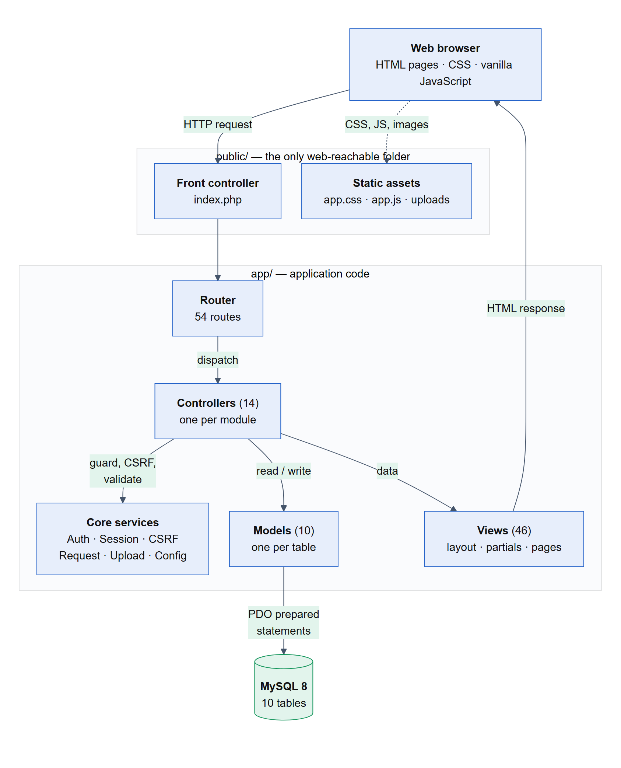
Figure 1: System architecture: components and the path of a request

4.1 Components and their functionalities
Table 10: Components and their functionalities
Component | Location | Functionality
Front controller | public/index.php | The single entry point for every page request. Loads configuration, starts the session and hands the request to the router
Router | routes.php, app/Core/Router.php | Maps 54 method-and-path pairs to controller actions, including path parameters such as /listings/{id}
Controllers (14) | app/Controllers/ | Handle one module each: check access, validate input, call models, choose the view. Four admin controllers sit in app/Controllers/Admin/
Models (10) | app/Models/ | One per table. The only place SQL is written; every query uses PDO prepared statements through a shared base Model
Views (46) | app/Views/ | PHP templates: one shared layout, reusable partials (listing card, admin menu, dialogs) and one folder per module. All output is escaped
Core services | app/Core/ | Auth (sign-in, guards, ownership), Session (CSRF tokens, flash messages, old input), Request (typed input), Upload (image validation), Config, Database, View
View helpers (28) | app/Helpers/functions.php | Escaping, URLs, prices, dates, badges, avatars and other small formatting functions
Stylesheet and script | public/assets/ | A hand-written design system (app.css) and a progressive-enhancement script (app.js) for dialogs, dropdowns, image previews and password reveal
Database | MySQL 8.0 | Ten tables with foreign keys and indexes; see section 5.3

The same components group into four functional modules, one per team member:
Table 11: Functional modules
Module | Owner | Controllers | Models
Listings and catalogue | Member 1 | ListingController, HomeController | Listing, ListingImage, Category
Requests, rentals and messaging | Member 2 | RequestController, MessageController | ItemRequest, Conversation, Message
Profiles, reviews and complaints | Member 3 | ProfileController, ReviewController, ComplaintController, PageController | Review, Complaint
Authentication, notifications and administration | Member 4 | AuthController, NotificationController, Admin controllers (4) | User, Notification

4.2 Component interactions
Every request follows the same path: the browser sends a request to the front controller; the router selects a controller action; the controller checks the user's access and the form's CSRF token, validates the input, and calls one or more models; the models read or write the database; and the controller passes the result to a view, which returns HTML. After any change, the controller redirects (the post–redirect–get pattern), so refreshing a page never repeats an action. Figure 2, on the landscape page at the end of this section, traces one real example: an item owner accepting a request.
The modules also interact through events: an action in one module updates another module's data and raises a notification. These interactions are what make the system more than a set of separate pages:
Table 12: Cross-module interactions
Event | Module | Effects in other modules
New account registered | Auth | Welcome notification raised
Request sent | Requests | Owner notified
Request accepted | Requests | Listing set to reserved; requester notified; contact details become visible to both
Request rejected | Requests | Requester notified
Request withdrawn | Requests | Owner notified; if it had been accepted, the listing is released back to available
Exchange completed or item returned | Requests | Sold or donated listing closed, or rented / shared listing available again; requester notified; reviews unlocked for both parties
Review written | Reviews | Reviewed member notified; their average rating and rating breakdown updated
Message sent | Messaging | Recipient notified; unread badge shown in the header
Complaint filed | Complaints | Every administrator notified; complaint added to the admin queue
Complaint status changed by admin | Admin | Complainant notified of the outcome
Member suspended or reactivated | Admin | Member notified; a suspended member can no longer sign in
Broadcast sent | Admin | Notification raised for every active member of the chosen group

Sequence: accepting a request
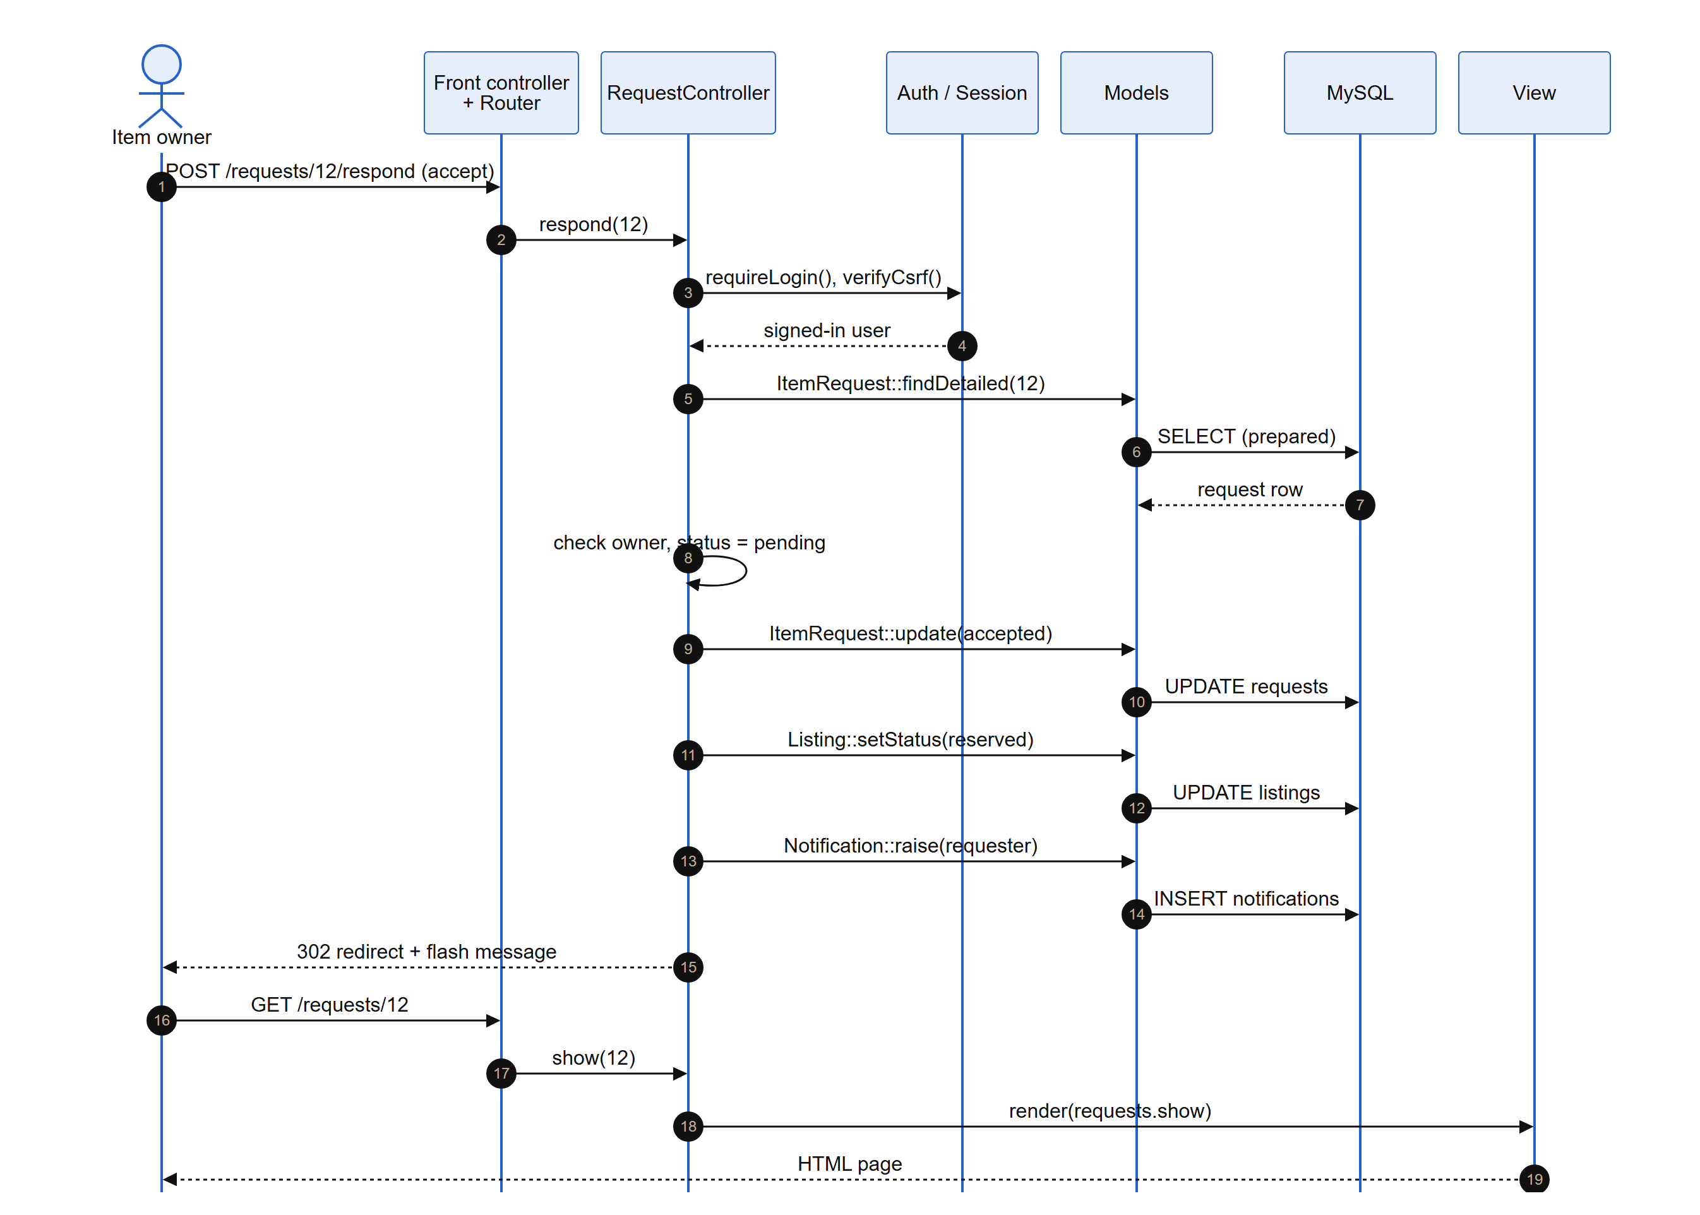
Figure 2: Component interaction when an owner accepts a request

5. System Design Diagrams
The diagrams in this section describe the system as built at the interim stage, extended with the features planned for the final phase. In the use-case diagrams, solid blue use cases are implemented and dashed grey use cases are planned.

5.1 Use case diagrams
One diagram per proposal actor. All non-admin actors are the same member account acting in different roles (section 3.1).
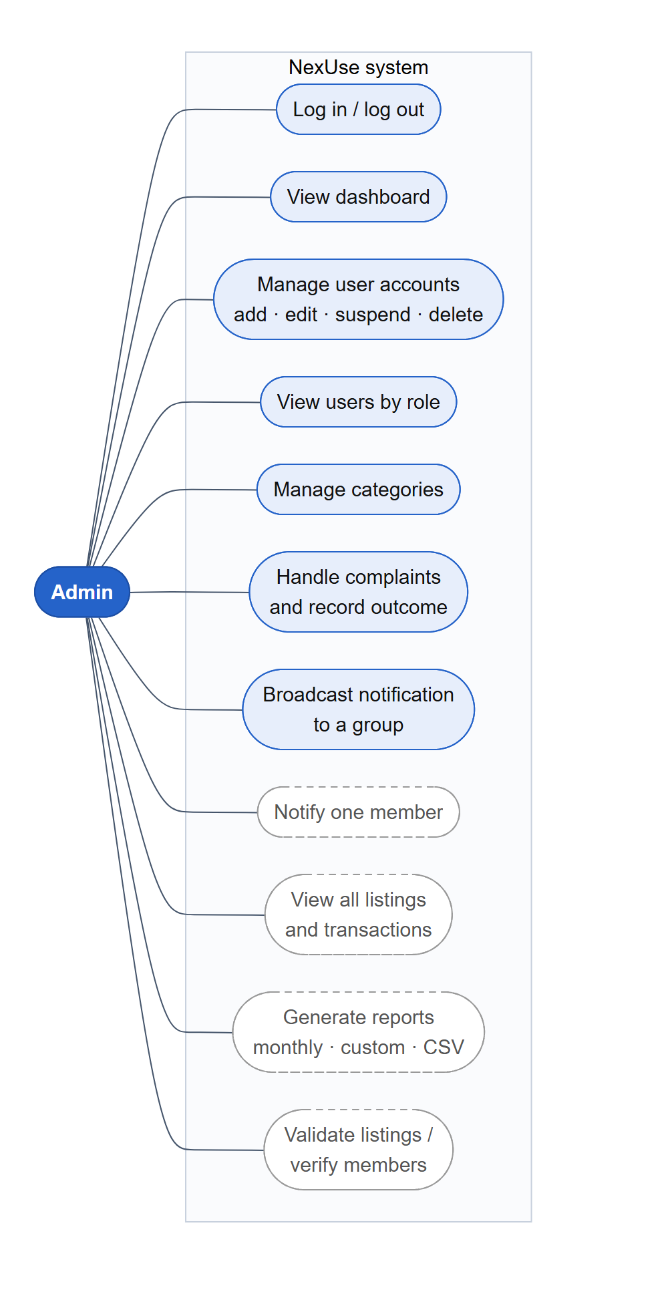  Figure 3: Use cases — Admin | 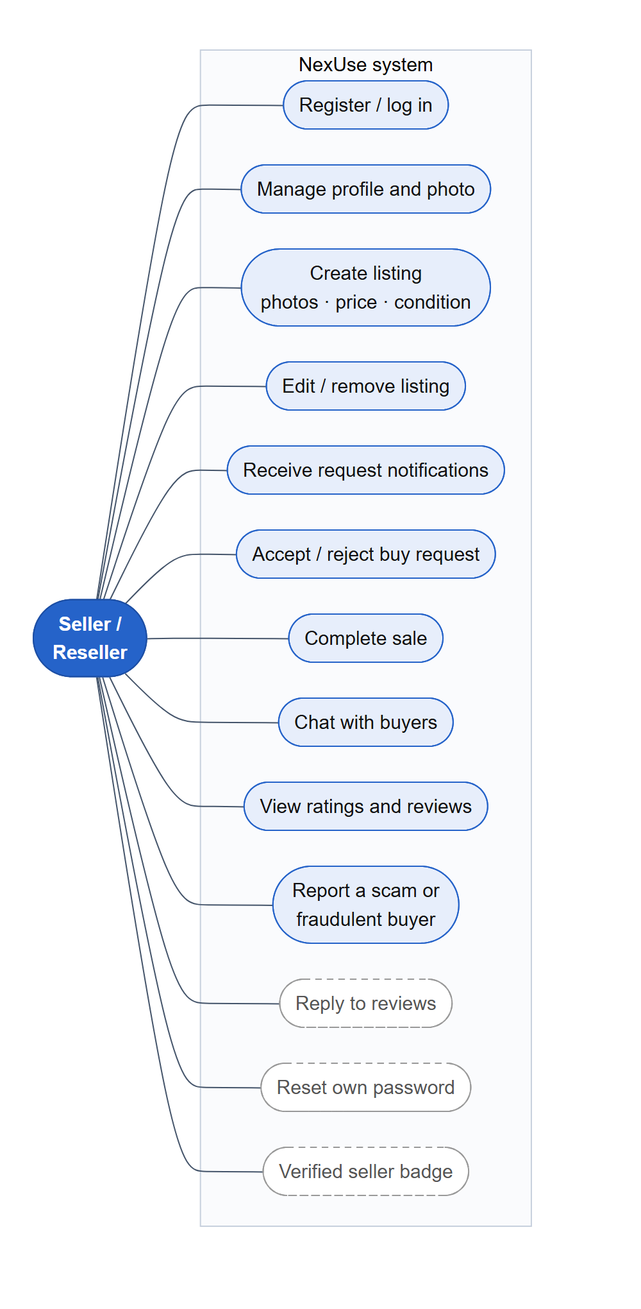  Figure 4: Use cases — Seller / Reseller
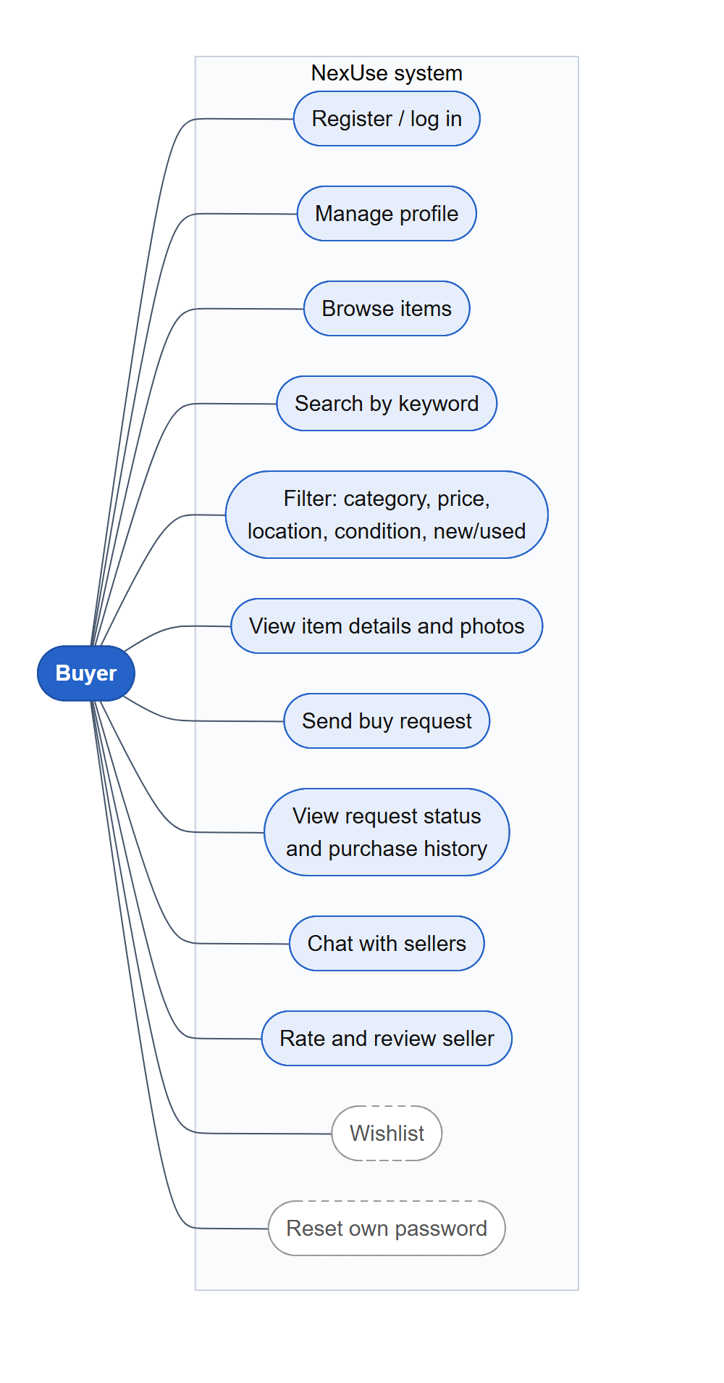  Figure 5: Use cases — Buyer | 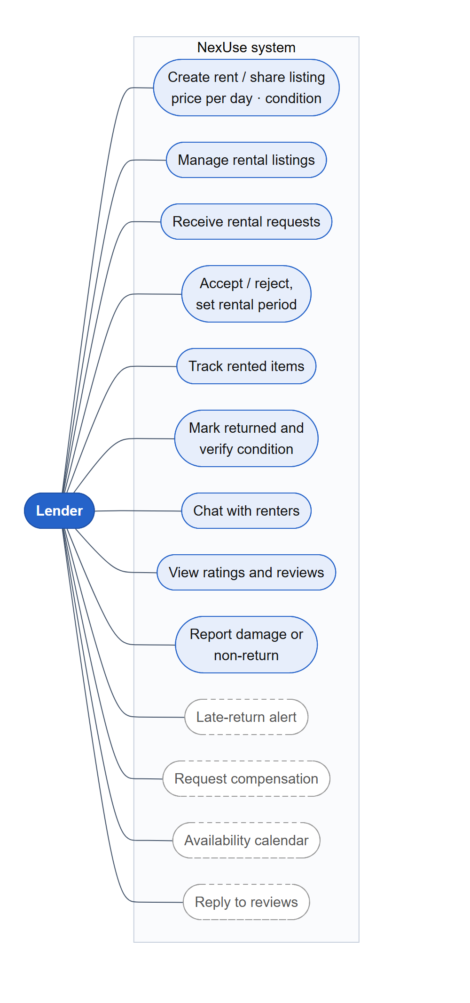  Figure 6: Use cases — Lender
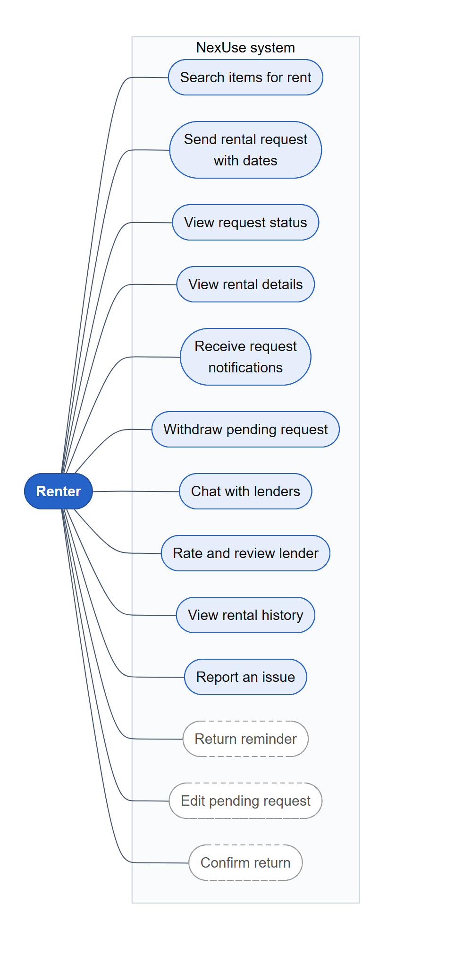  Figure 7: Use cases — Renter | 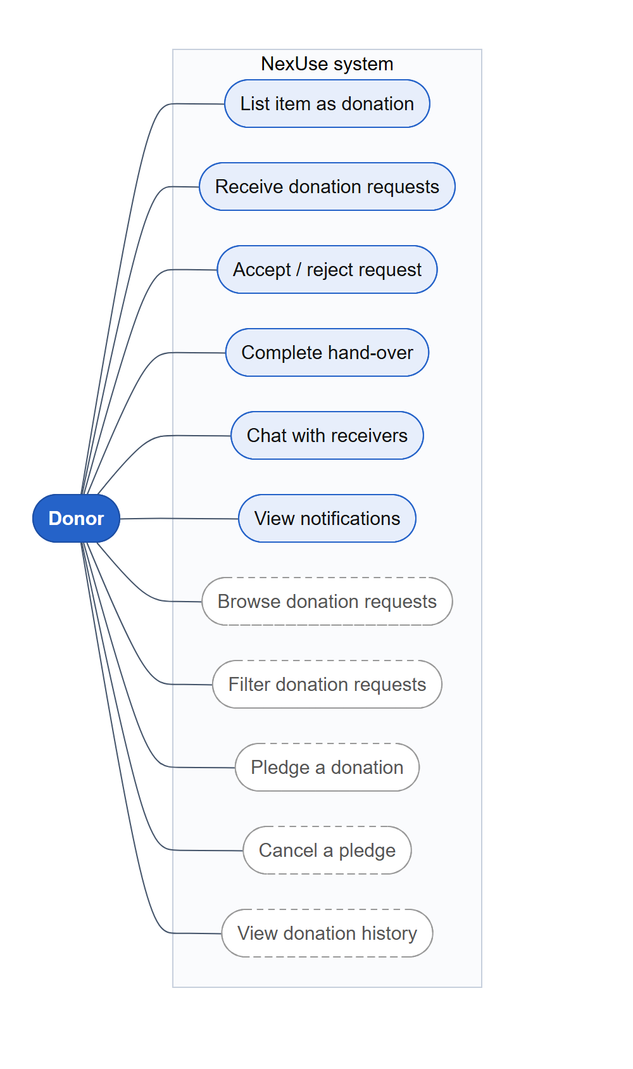  Figure 8: Use cases — Donor
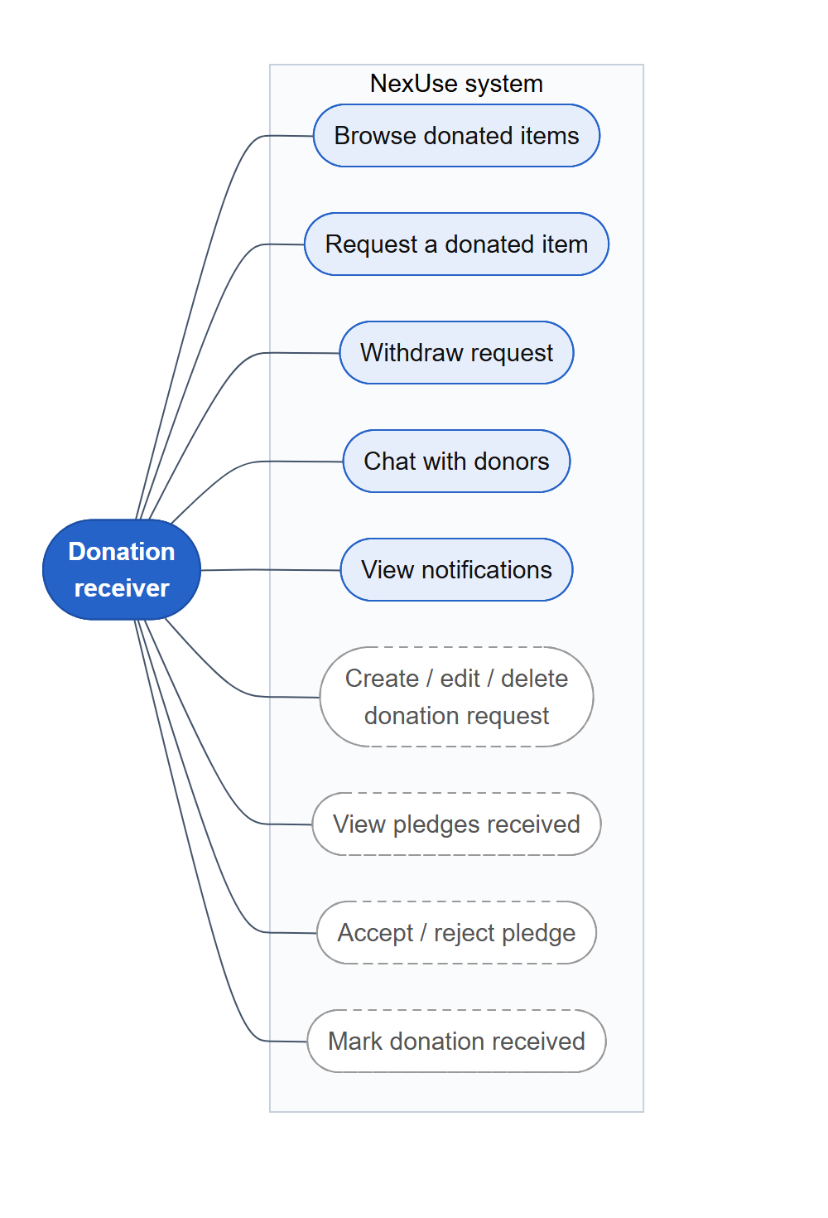
Figure 9: Use cases — Donation receiver

5.2 Class diagrams
Figure 10 shows the domain model: the ten model classes, their main attributes and operations, and their associations. Static operations (underlined) are called on the class; each class maps to one database table.
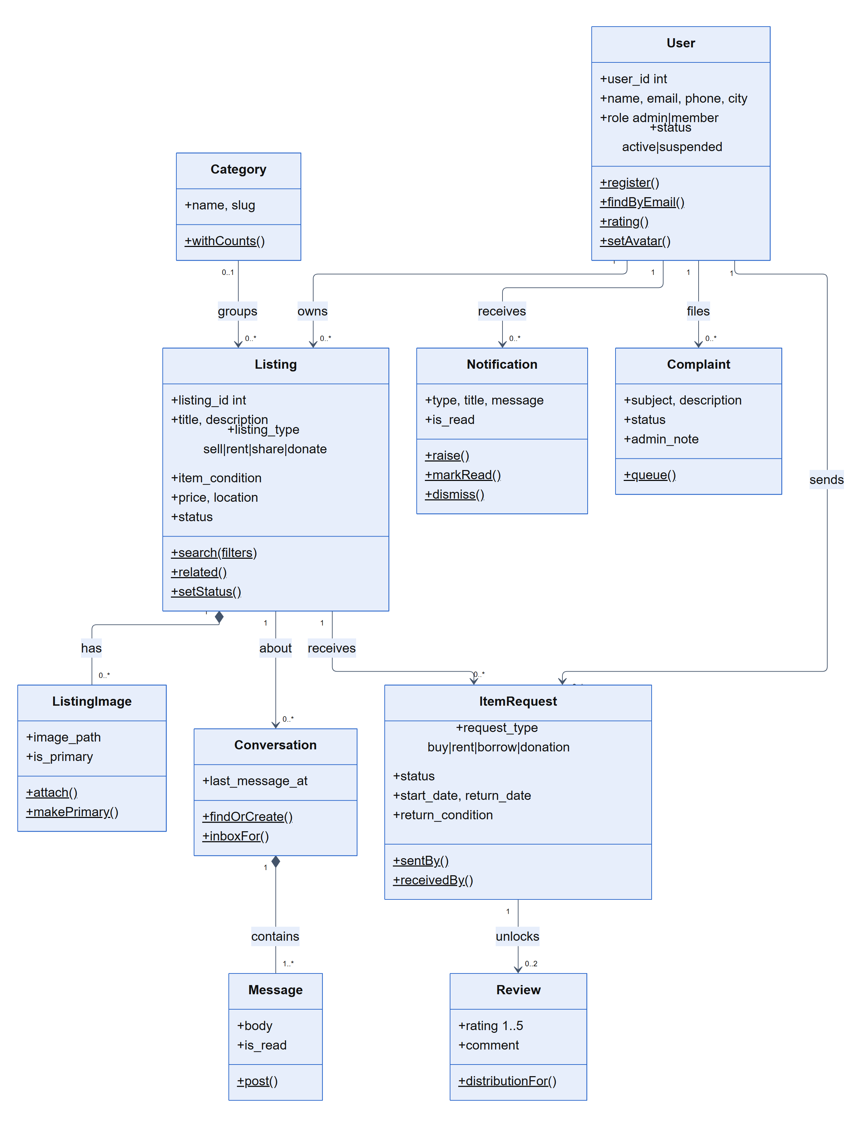
Figure 10: Class diagram — domain model
Figure 11, on the landscape page that follows, shows the framework layer the team wrote: every controller extends an abstract Controller and every model extends an abstract Model, which is how access checks, CSRF protection and safe database access are shared by all modules. Three of the fourteen controllers and two of the ten models are drawn, as examples.

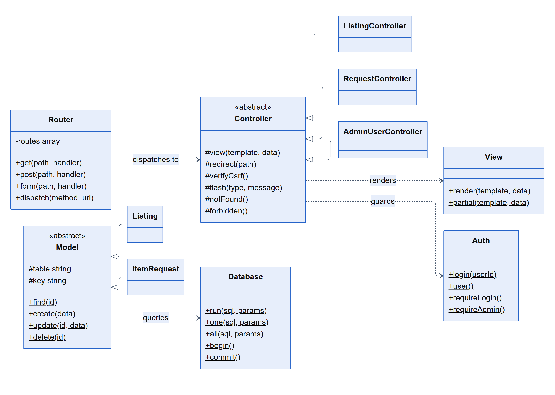
Figure 11: Class diagram — MVC framework layer

5.3 ER diagram
The database has ten tables in third normal form. Every table has a surrogate integer primary key; relationships are enforced by foreign keys. A request links a listing to both the requester and the owner, and a review belongs to a completed request. Only keys and the most important attributes are drawn below; every column is listed in the data dictionary in Appendix A.
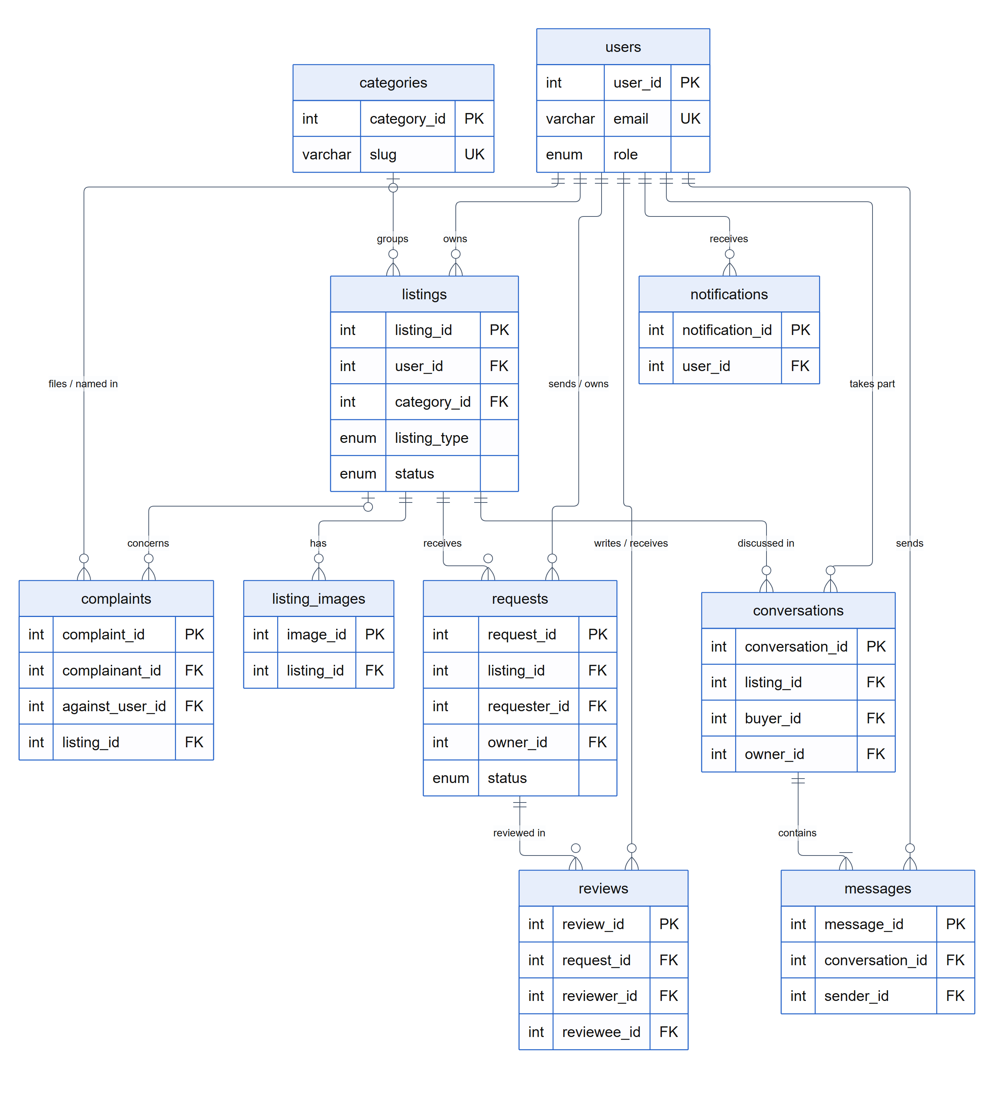
Figure 12: Entity–relationship diagram (keys and main attributes)
Normalisation. Repeating groups are split into their own tables (a listing's photos into listing_images, a conversation's messages into messages). Categories are held once and referenced by id. Derived values — a member's average rating, unread counts, listing counts per category — are calculated by queries rather than stored, so they cannot drift out of date.

5.4 Activity diagrams
Four activities are shown: registering an account, posting a listing, a sell or donate exchange, and a rental in two parts. Dashed steps are planned for the final phase.
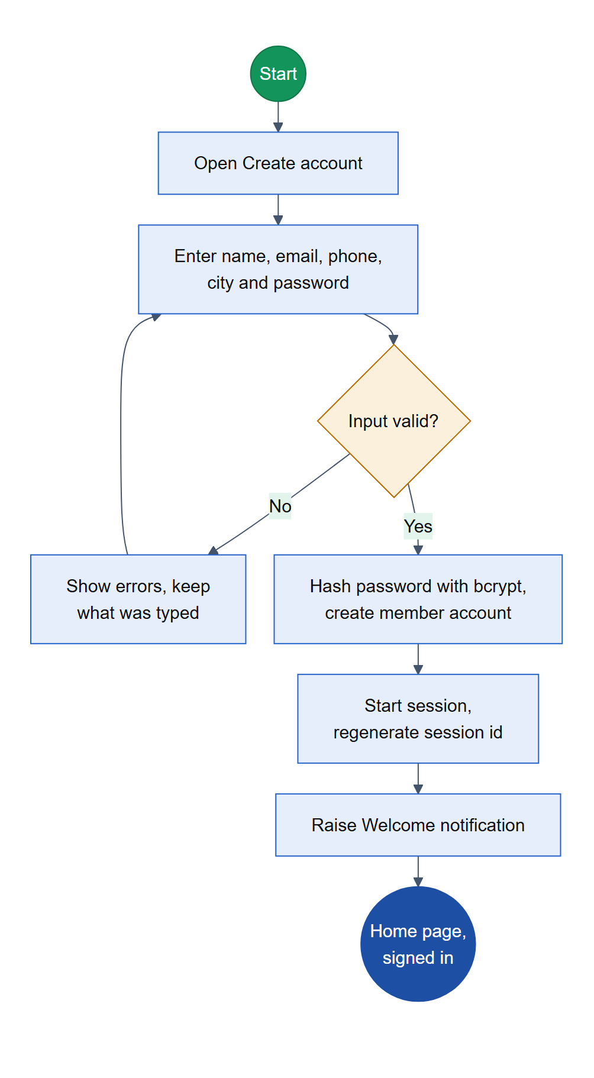
Figure 13: Activity — registering an account
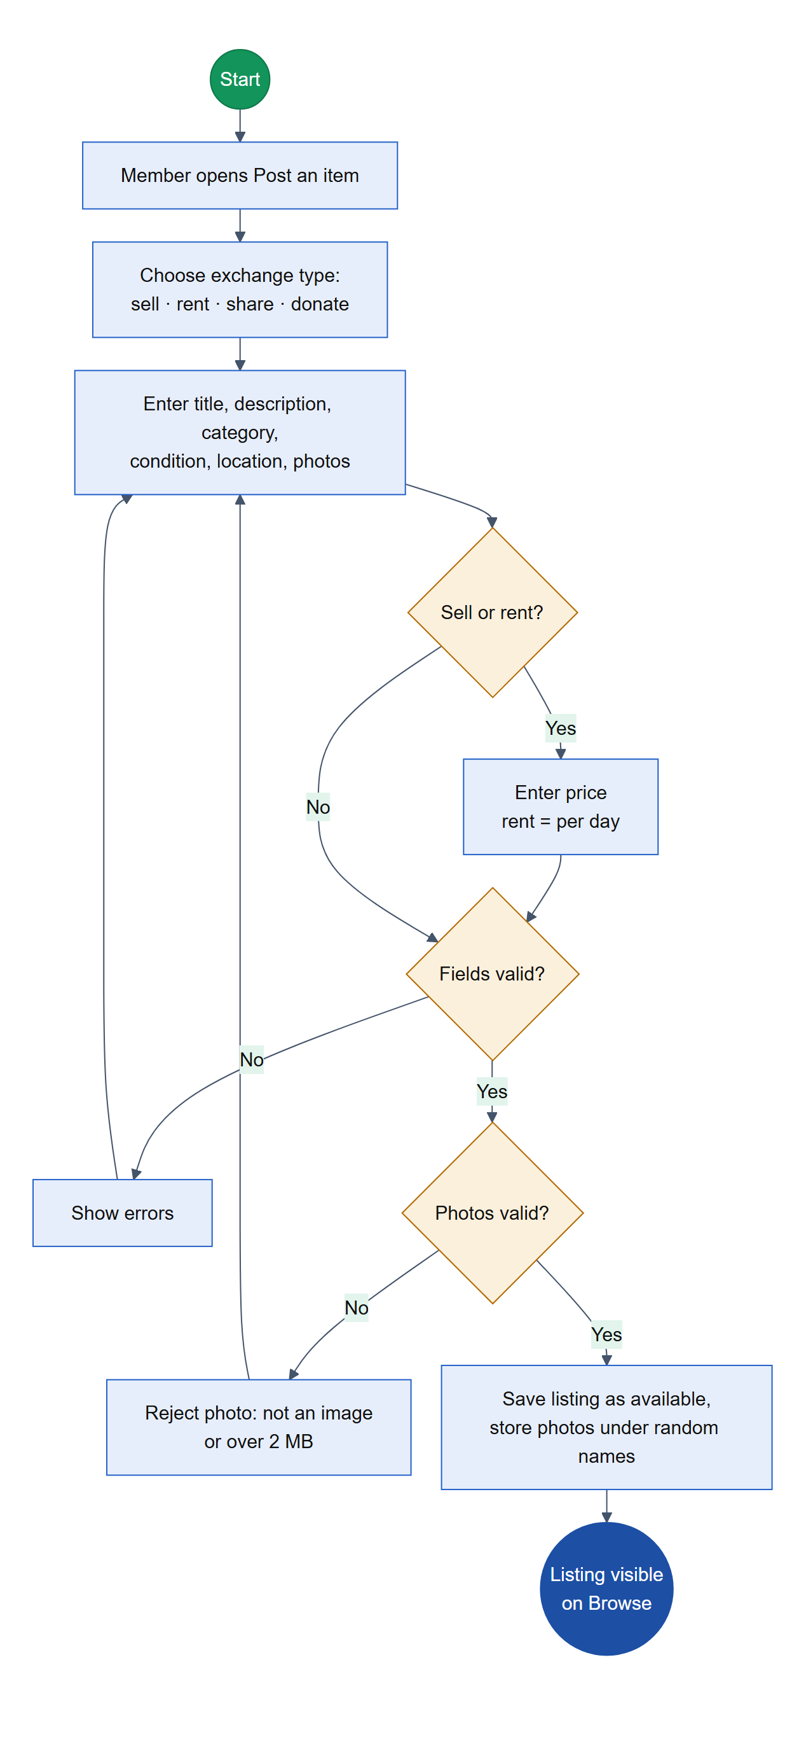
Figure 14: Activity — posting a listing
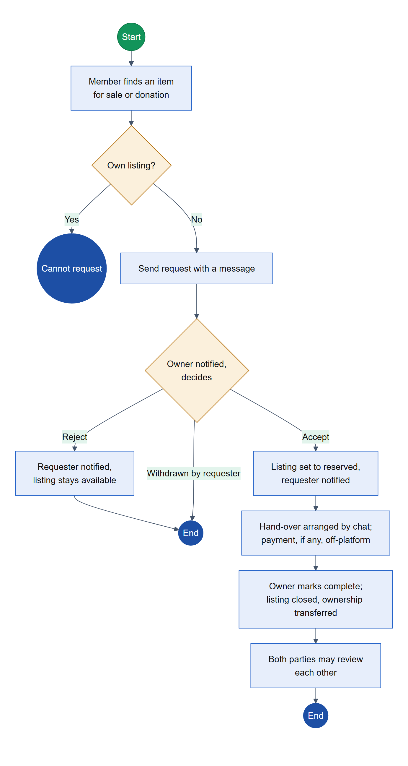
Figure 15: Activity — buying or receiving an item (sell and donate)
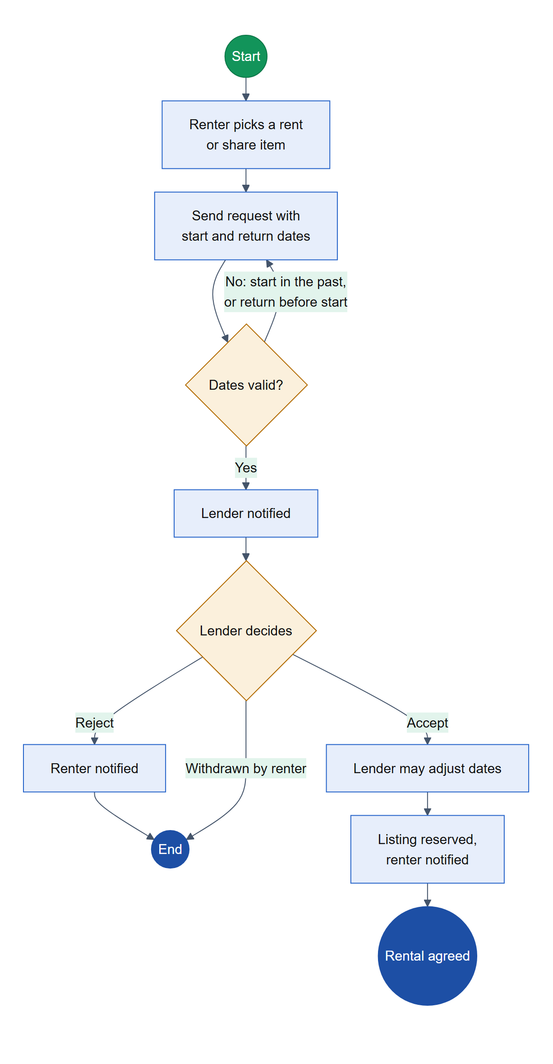
Figure 16: Activity — renting or borrowing, part 1: agreeing the rental
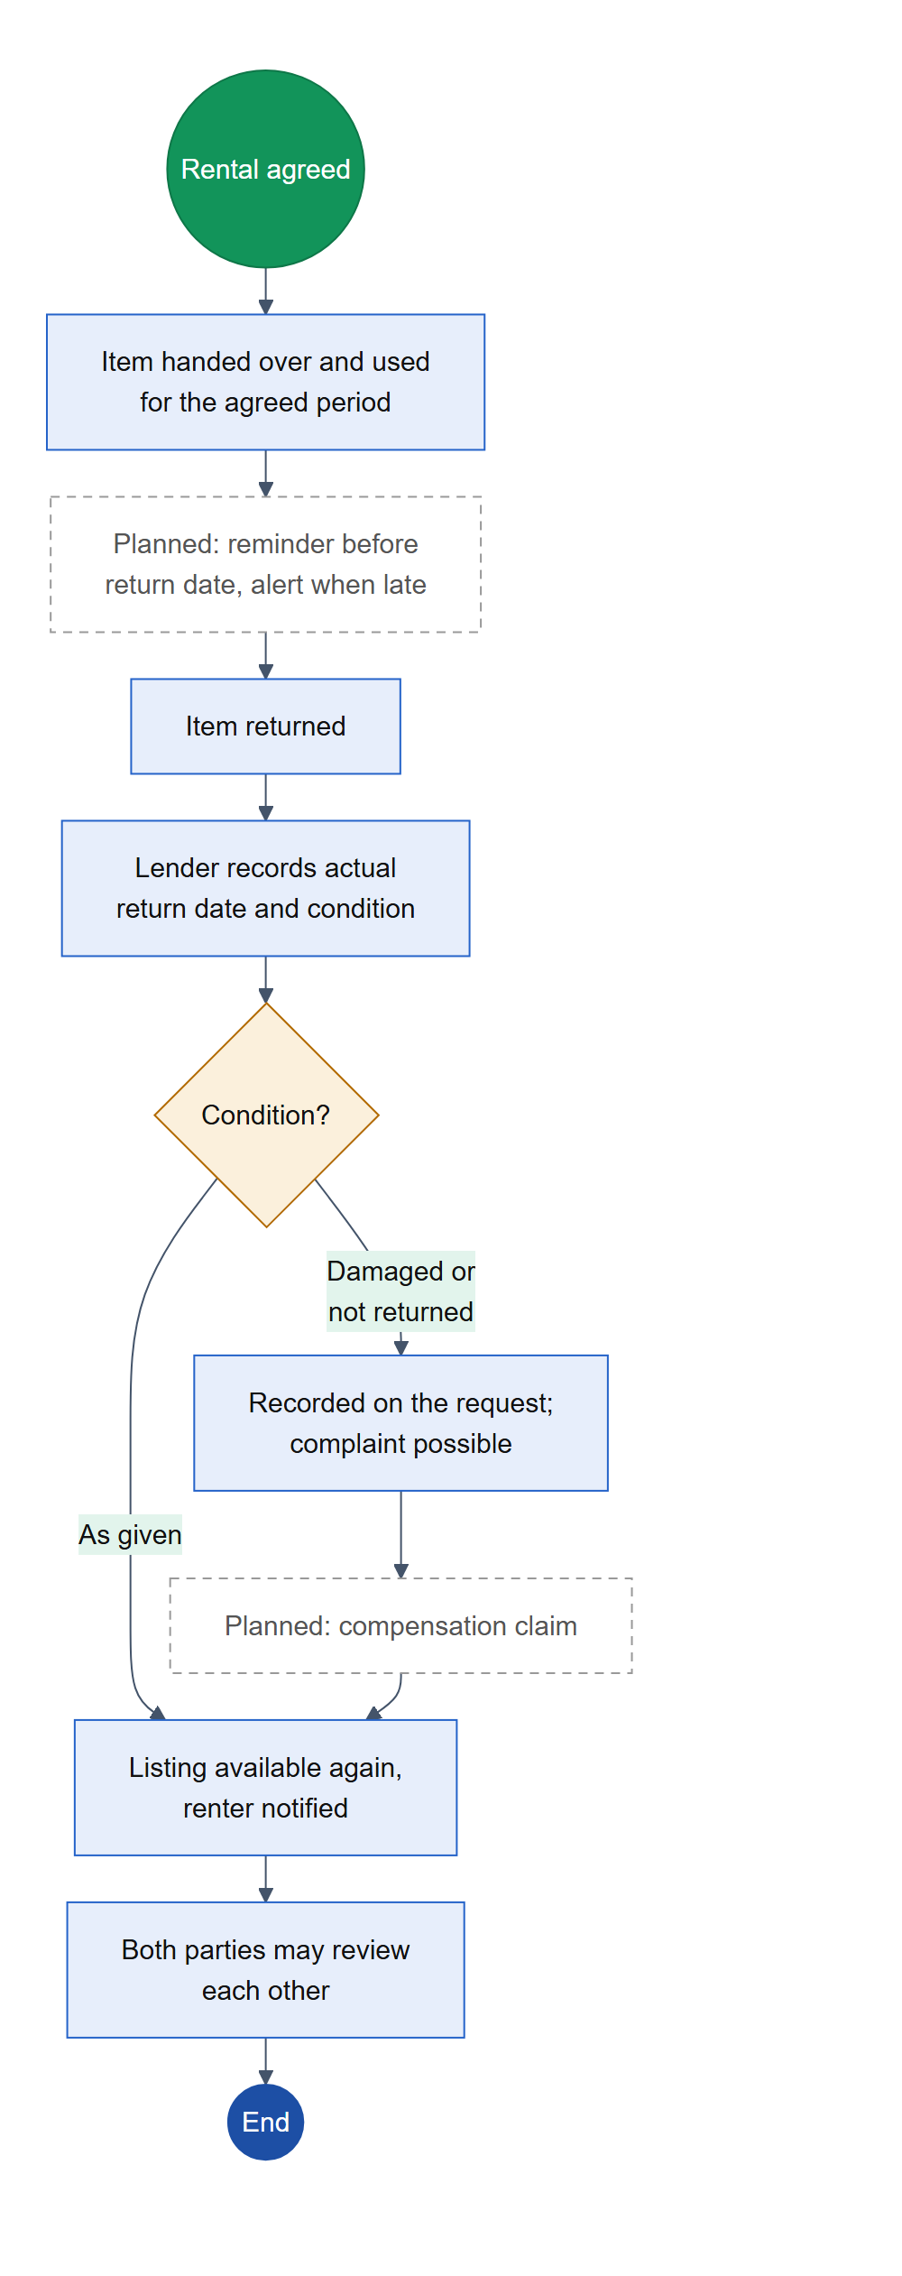
Figure 17: Activity — renting or borrowing, part 2: return and review

6. Current Progress

6.1 Progress against the system requirements
The interim assessment criteria are all met:
Table 13: Interim criteria
Interim criterion | Status | Evidence
Authentication works for all users | Met | Registration, sign-in and sign-out for members and administrators; access guards refuse signed-out and non-admin users; CSRF enforced on every form
All user interfaces implemented and navigable | Met | 54 routes, every page reachable from the shared navigation; admin pages share a side menu. A final manual click-through is scheduled
Four CRUD operations per student on four entities | Met | All 16 operations built and exercised against the live database (Table 14)

Table 14: The graded CRUD operations — all complete
Member | Entity | Create | Read | Update | Delete
1 | listings | Post an item with photos | Browse, search, filter, detail, my listings | Edit details, photos and availability; choose main photo | Delete, with its photos
2 | requests | Send a buy, rent, borrow or donation request, with dates for rentals | Sent, received and detail views | Accept or reject (dates adjustable); mark returned with condition; complete | Withdraw a pending or accepted request
3 | reviews | Rate 1–5 and review after a completed exchange | My reviews; reviews and rating breakdown on profiles | Edit own review | Delete own review
4 | notifications | Raised automatically by every module; admin broadcast | Header count, centred pop-up, full page | Mark read, unread, all read | Dismiss one; clear all read

Supporting CRUD sets are also complete for categories and user accounts (administrator), complaints (members file, edit and delete while open; administrators resolve), and messages (create and read).
Measured against every actor requirement in section 3.2 (88 in all):
Table 15: Progress by actor
Actor | Requirements | Done | Partly done | Not started | Out of scope | Complete*
Admin | 12 | 6 | 3 | 3 | 0 | 63%
Seller | 13 | 9 | 1 | 2 | 1 | 79%
Buyer | 15 | 9 | 2 | 2 | 2 | 77%
Lender | 15 | 10 | 4 | 1 | 0 | 80%
Renter | 14 | 9 | 2 | 2 | 1 | 77%
Donor | 9 | 3 | 3 | 3 | 0 | 50%
Donation receiver | 10 | 2 | 2 | 6 | 0 | 30%
Total | 88 | 48 | 17 | 19 | 4 | 67%
* Done plus half of partly done, as a share of in-scope requirements.

The flow of listing, requesting, exchanging and reviewing is complete for all four exchange types, so the Seller, Buyer, Lender and Renter actors are largely finished. The Donor and Donation receiver actors score lowest because the proposal describes a second donation flow — a receiver posts a need and donors pledge to it — which is not built yet. The requirements not yet complete are:
Table 16: Requirements not yet complete
ID | Requirement | Status | What remains
FR-AD-04 | Summary dashboard | Partly | Built (users, listings, requests, reviews, complaints); a transactions-over-time view to add
FR-AD-05 | View all listings and transactions | Partly | Only the latest few are shown; full admin lists with filters needed
FR-AD-07 | Notify individual users or groups | Partly | Groups done; a single named member to add
FR-AD-08 | Generate reports | Not started | Monthly and date-range reports with CSV export
FR-AD-10, FR-AD-12 | Validate listings; verify users | Not started | Admin-granted verified badge; optional approval queue
FR-BU-08 | Wishlist | Not started | Save, list and remove listings
FR-BU-09 | Shopping cart | Not started | Conflicts with scope; to be dropped or redefined (3.4)
FR-BU-10 | Place orders | Partly | Done as a buy request; no checkout, by design
FR-BU-13 | Review products and sellers | Partly | Sellers reviewed; product-level rating display to add
FR-SE-08 | Verify account | Not started | Verified badge (with FR-AD-12)
FR-SE-10, FR-LE-15 | Reset forgotten password | Partly | Administrator can reset; self-service needs email on the deployed server
FR-SE-12, FR-LE-13 | Reply to reviews | Not started | One reply per review
FR-DO-02, 03, 09 | Browse and filter donation requests; pledge notifications | Not started | Donation requests and pledges
FR-DO-04, 05, 08 | Cancel pledge; pledge status; donation history | Partly | Covered by the current donation flow; full support with pledges and a history filter
FR-DR-02 to 06, 09 | Donation requests and pledges | Not started | New donation_requests and pledges entities
FR-DR-08, 10 | Pledge notifications; mark received | Partly | Receiver-side confirmation to add
FR-LE-09, 14 | Compensation; report late returns | Partly | Damage is recorded and a complaint can be filed; compensation claims and automatic late detection to add
FR-LE-11 | Availability period | Partly | Available / reserved only; a date calendar to add
FR-RE-07 | Return reminders | Not started | Reminder before the return date, alert when late
FR-RE-09, 10 | Return on time; confirm return | Partly | Dates stored; renter-side confirmation to add
FR-RE-12 | Edit a pending request | Not started | Change dates or message while pending
FR-SYS-02 to 05 | Reminders, penalties, compensation, disposal | Not started | See section 6.3

Non-functional requirements. Security (NFR-01), privacy (NFR-02), usability (NFR-03), responsiveness (NFR-04), integrity (NFR-06), maintainability (NFR-07), portability (NFR-08) and compatibility (NFR-09) are met in the interim build. Performance (NFR-05) is met for the browse page, which is paginated; other long lists are not yet paginated and page times have not been measured formally. Accessibility (NFR-10) needs a full audit, and availability (NFR-11) depends on the final deployment. Screens of the working system are in Appendix B.

6.2 Estimated completion
Table 17: Completion estimate
Part of the project | Estimate | Basis
Functional requirements | 67% | Table 15: 48 done and 17 partly done out of 84 in-scope actor requirements
Non-functional requirements | About 75% | 8 of 11 met; 3 partly met or pending deployment
Design documentation | About 70% | Architecture, use-case, class, ER and activity diagrams in this report; Figma mockups and a user manual remain
Testing | About 25% | Every feature checked against the live database during development; formal unit, integration and user-acceptance testing remain
Deployment | Not started | Runs locally; free-tier hosting planned for the final demonstration

Overall, we estimate the system is approximately 60% complete. The core platform is finished and working end to end; what remains is a set of well-defined extensions, and the testing, deployment and documentation that the proposal lists as deliverables.

6.3 Remaining tasks
Table 18: Remaining tasks and upcoming features
# | Task | Requirements closed | Owner | Size
1 | Donation requests and pledges — receivers post a need; donors browse, filter and pledge; receivers accept or reject; donors can cancel while pending | FR-DO-02 to 09, FR-DR-02 to 10 | M1 + M2 | Large
2 | Return reminders and late-return alerts, with a 24-hour grace period as the survey preferred | FR-RE-07, FR-LE-14, FR-SYS-02 | M2 + M4 | Medium
3 | Compensation claims — lender claims after a damaged or missing return; renter accepts or disputes; a dispute becomes a complaint | FR-LE-09, FR-SYS-04 | M2 | Medium
4 | Recorded late penalty — a per-day late fee shown to both parties (not charged) | FR-SYS-03 | M1 + M2 | Small
5 | Admin: all listings and all requests, with filters and the ability to hide a listing | FR-AD-05 | M4 | Medium
6 | Admin reports — monthly and date-range figures with CSV export | FR-AD-08, FR-AD-04 | M4 | Medium
7 | Notify one member from the admin broadcast page | FR-AD-07 | M4 | Small
8 | Verified badge granted by an administrator, shown on profiles and listings | FR-AD-10, FR-AD-12, FR-SE-08 | M4 + M3 | Medium
9 | Reply to reviews and product-level ratings on listings | FR-SE-12, FR-LE-13, FR-BU-13 | M3 | Small
10 | Edit a pending request; renter and receiver confirmation of return or receipt | FR-RE-09, 10, 12, FR-DR-10 | M2 | Small
11 | Wishlist, disposal listing type, and exchange-type filters on listing and request history | FR-BU-08, FR-SYS-05, FR-DO-08 | M1 | Small
12 | Availability calendar for rental items | FR-LE-11 | M1 + M2 | Medium
13 | Self-service password reset on the deployed server | FR-SE-10, FR-LE-15 | M4 | Small
14 | Survey-driven improvements — condition guide and photo requirement, optional deposit, pickup flag, trust signals on listings | Survey (section 2.3) | M1 + M3 | Medium
15 | Security hardening — sign-in rate limiting, admin audit log, debug output off for the demonstration | NFR-01 | M4 | Small
16 | Testing — unit tests for business rules, an integration test script, and user-acceptance testing with people outside the group | Deliverable | All | Medium
17 | Deployment to a free-tier PHP and MySQL host; push the repository to GitHub | NFR-11, deliverable | All | Small
18 | Documentation — Figma mockups, user manual, final report and presentation | Deliverable | All | Medium

Order of work. Tasks 1 to 3 close the largest gaps and each adds a new entity with its own create, read, update and delete operations, so they come first. Tasks 4 to 13 follow, then the survey-driven and security work, with testing, deployment and documentation running alongside and completing last.
The cart, in-app payment and delivery tracking are not on this list: they are outside the agreed scope (section 3.4).

6.4 Member contributions
Each member owns one module end to end — its controller, model, views and database queries — and the entity whose four CRUD operations they are assessed on. Shared foundations were built together.
Table 19: Member contributions
Member | Area of responsibility | Components | Final-phase tasks (6.3)
Member 1  [Name]  [Index number] | Listings and catalogue — posting, editing and deleting listings with photos; browse, keyword search and filters; home page; related items. CRUD entity: listings | ListingController, HomeController; Listing, ListingImage, Category; views listings/*, home/*; listing card partial | 1 (requests board), 4, 11, 12, 14
Member 2  [Name]  [Index number] | Requests, rentals and messaging — the request lifecycle for all four exchange types; rental dates and return condition; member-to-member chat. CRUD entity: requests | RequestController, MessageController; ItemRequest, Conversation, Message; views requests/*, messages/* | 1 (pledge flow), 2, 3, 10, 12
Member 3  [Name]  [Index number] | Profiles, reviews and complaints — profiles and profile pictures; reviews and rating breakdown; complaints; terms, privacy and contact pages; donation dialog. CRUD entity: reviews | ProfileController, ReviewController, ComplaintController, PageController; Review, Complaint; views profile/*, reviews/*, complaints/*, pages/* | 8 (badge display), 9, 14
Member 4  [Name]  [Index number] | Authentication, notifications and administration — registration and sign-in; notifications and the pop-up; admin dashboard, users, categories, complaints and broadcast. CRUD entity: notifications | AuthController, NotificationController, four Admin controllers; User, Notification; views auth/*, notifications/*, admin/* | 2 (scheduling), 5, 6, 7, 8, 13, 15
All members | Shared foundations — MVC core (router, base classes, database, session), shared layout and design system, database schema and seed data, README; this report | app/Core, layouts, app.css, app.js, database/ | 16, 17, 18

Appendix A — Data dictionary
Every column of the ten tables. PK primary key, FK foreign key, UK unique.

users
Column | Type | Key | Notes
user_id | INT | PK | Account id
name | VARCHAR(100) |  | Display name
email | VARCHAR(190) | UK | Sign-in name, stored lower-case
password_hash | VARCHAR(255) |  | bcrypt hash
phone | VARCHAR(20) |  | Optional; shared only after a request is accepted
address | VARCHAR(255) |  | Optional
city | VARCHAR(80) |  | Optional; shown to signed-in members
bio | TEXT |  | Optional profile description
avatar_path | VARCHAR(255) |  | Profile picture, relative path
role | ENUM('admin','member') |  | Account role
status | ENUM('active','suspended') |  | Suspended accounts cannot sign in
created_at | DATETIME |  | Joined

categories
Column | Type | Key | Notes
category_id | INT | PK
name | VARCHAR(80) |  | Display name
slug | VARCHAR(80) | UK | URL-safe name
created_at | DATETIME

listings
Column | Type | Key | Notes
listing_id | INT | PK
user_id | INT | FK users | Owner
category_id | INT | FK categories | Nullable; set to NULL if the category is deleted
title | VARCHAR(150)
description | TEXT
item_condition | ENUM('new','like_new','good','fair','poor') |  | CONDITION is reserved in MySQL
listing_type | ENUM('sell','rent','share','donate') |  | Exchange type
price | DECIMAL(10,2) |  | Sale price, or rent per day; NULL when free
location | VARCHAR(120) |  | Shown to signed-in members only
status | ENUM('available','reserved','completed','removed')
created_at, updated_at | DATETIME

listing_images
Column | Type | Key | Notes
image_id | INT | PK
listing_id | INT | FK listings | Deleted with the listing
image_path | VARCHAR(255) |  | Random file name under uploads/
is_primary | TINYINT(1) |  | The main photo
created_at | DATETIME

requests
Column | Type | Key | Notes
request_id | INT | PK
listing_id | INT | FK listings
requester_id | INT | FK users | Buyer, renter or receiver
owner_id | INT | FK users | Listing owner at the time of the request
request_type | ENUM('buy','rent','borrow','donation')
message | TEXT |  | Note from the requester
status | ENUM('pending','accepted','rejected','withdrawn','completed') |  | Fixed sequence
start_date, return_date | DATE |  | Rent and borrow only
actual_return_date | DATE |  | Recorded on return
return_condition | ENUM('as_given','minor_damage','major_damage','not_returned') |  | Recorded on return
owner_note | VARCHAR(500) |  | Note from the owner
created_at, updated_at | DATETIME

reviews
Column | Type | Key | Notes
review_id | INT | PK
request_id | INT | FK requests | A completed request
reviewer_id | INT | FK users
reviewee_id | INT | FK users
rating | TINYINT |  | 1 to 5
comment | TEXT
created_at, updated_at | DATETIME

complaints
Column | Type | Key | Notes
complaint_id | INT | PK
complainant_id | INT | FK users
against_user_id | INT | FK users | Nullable
listing_id | INT | FK listings | Nullable
subject | VARCHAR(150)
description | TEXT
status | ENUM('open','reviewing','resolved','dismissed')
admin_note | VARCHAR(500) |  | Visible to the complainant
created_at, updated_at | DATETIME

notifications
Column | Type | Key | Notes
notification_id | INT | PK
user_id | INT | FK users | Recipient
type | ENUM(request, accepted, rejected, withdrawn, returned, review, complaint, broadcast, message, system)
title | VARCHAR(150)
message | VARCHAR(500)
link | VARCHAR(255) |  | Page the notification opens
is_read | TINYINT(1)
created_at | DATETIME

conversations
Column | Type | Key | Notes
conversation_id | INT | PK
listing_id | INT | FK listings | The item being discussed
buyer_id | INT | FK users | The interested member
owner_id | INT | FK users | The listing owner
created_at, last_message_at | DATETIME

messages
Column | Type | Key | Notes
message_id | INT | PK
conversation_id | INT | FK conversations
sender_id | INT | FK users
body | VARCHAR(2000)
is_read | TINYINT(1) |  | Read receipt
created_at | DATETIME

Appendix B — Screens of the current system
Captured from the running interim system with the demonstration data loaded.
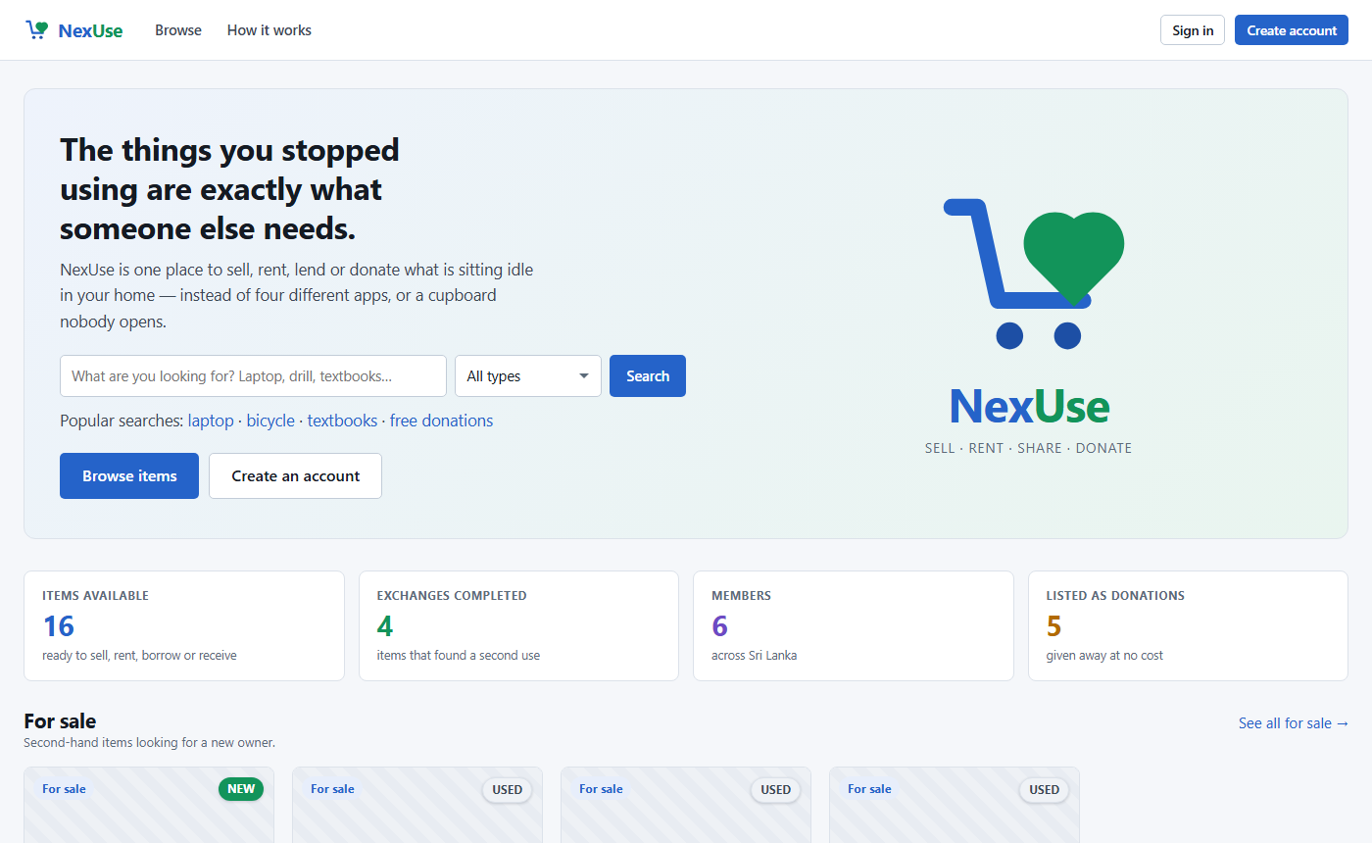
Figure 18: Home page (signed out) — search across every exchange type
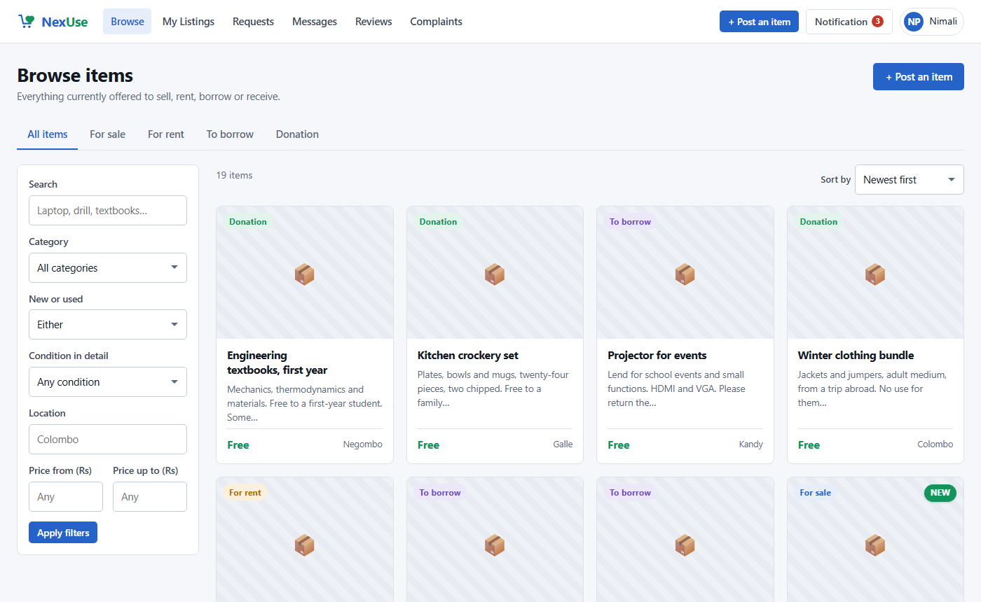
Figure 19: Browse — filters stay in place while the items scroll
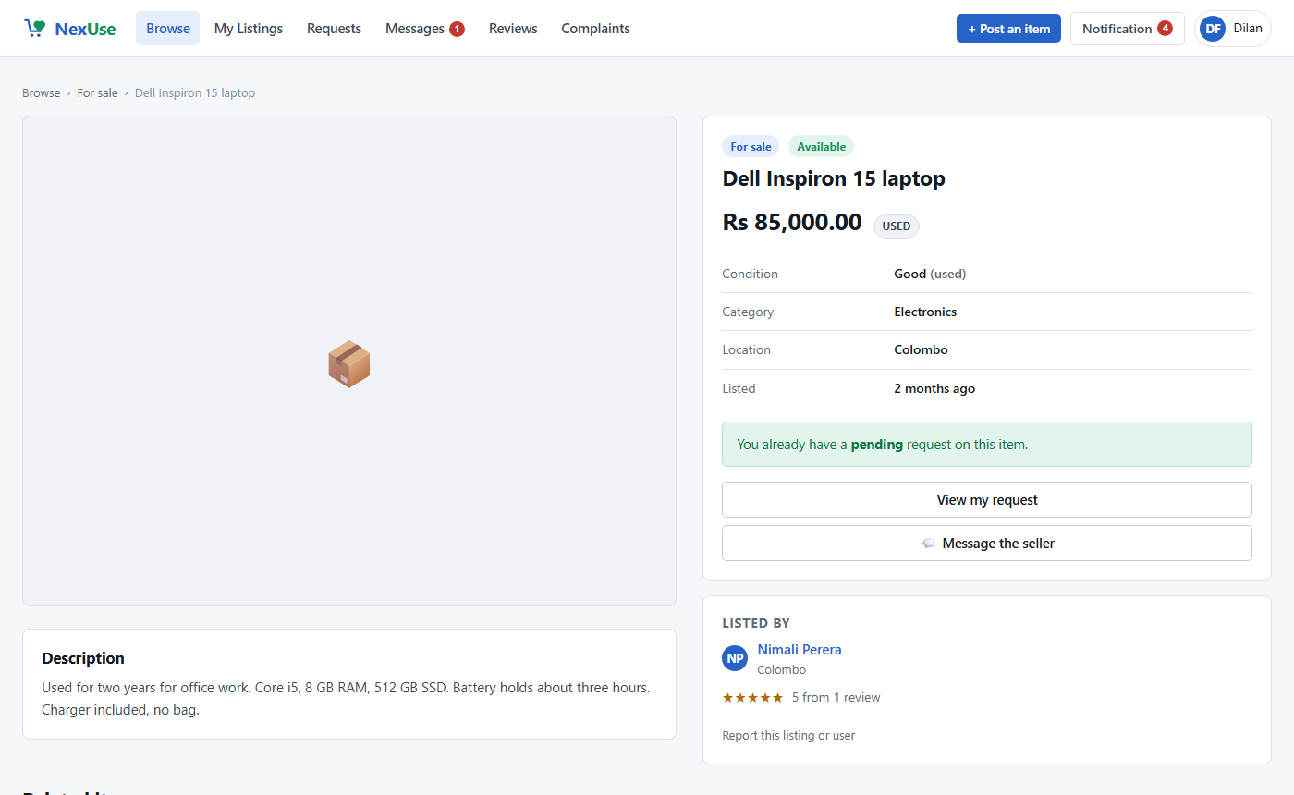
Figure 20: A listing, seen by a member who has already requested it
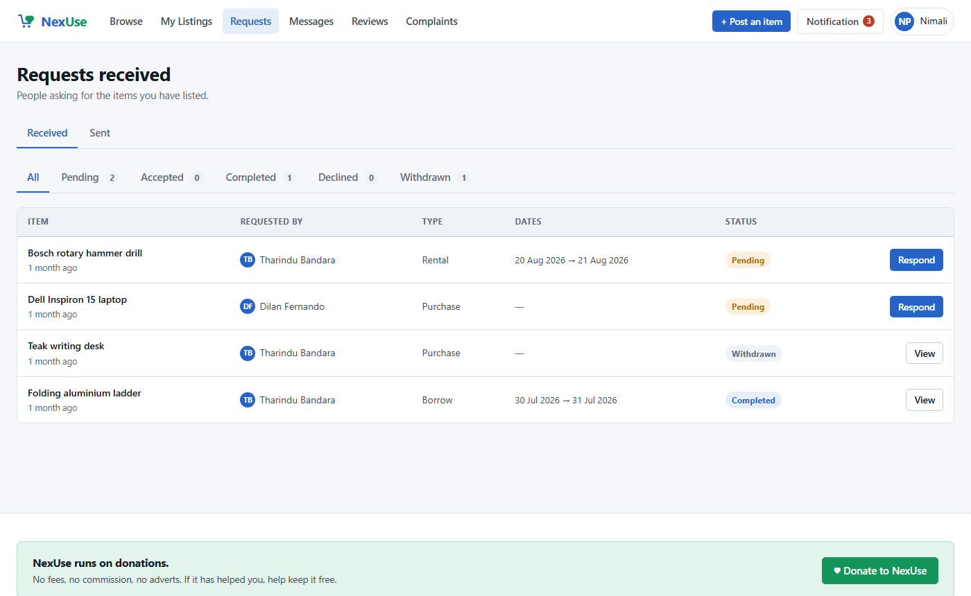
Figure 21: Requests received, with status tabs
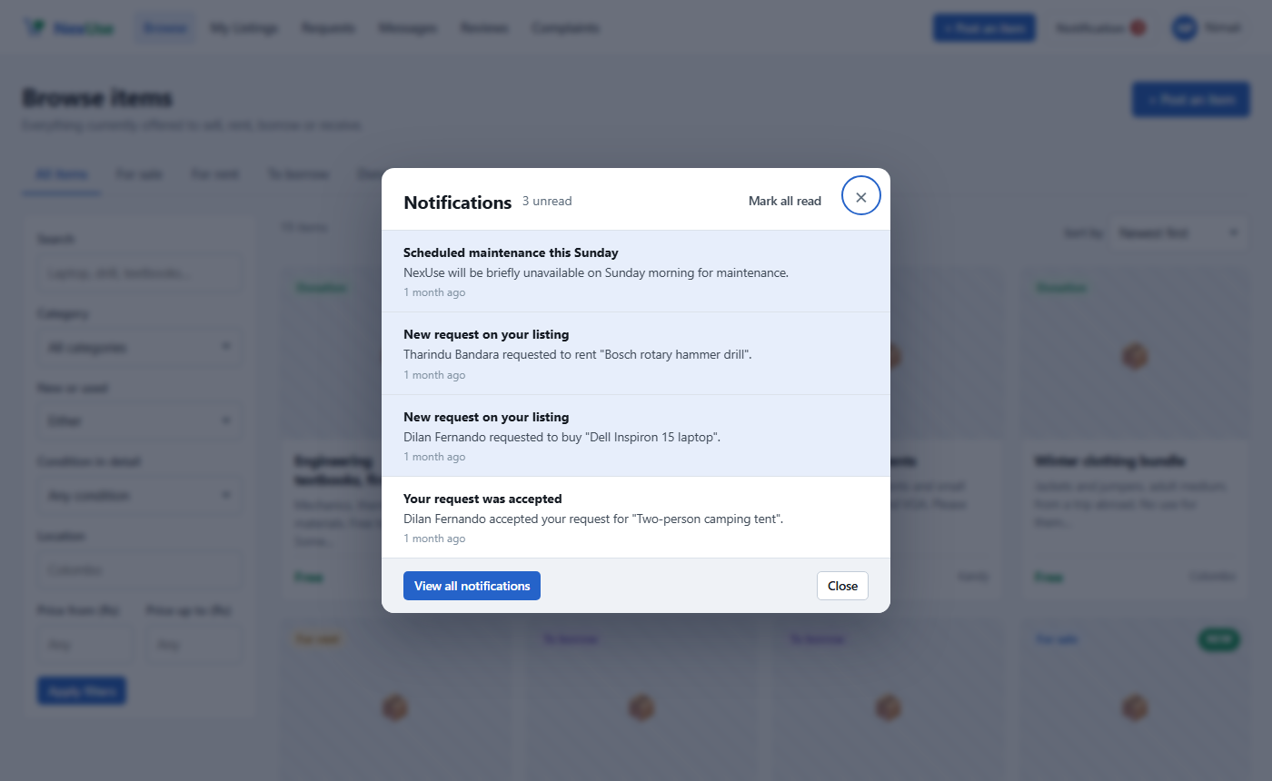
Figure 22: The notifications pop-up
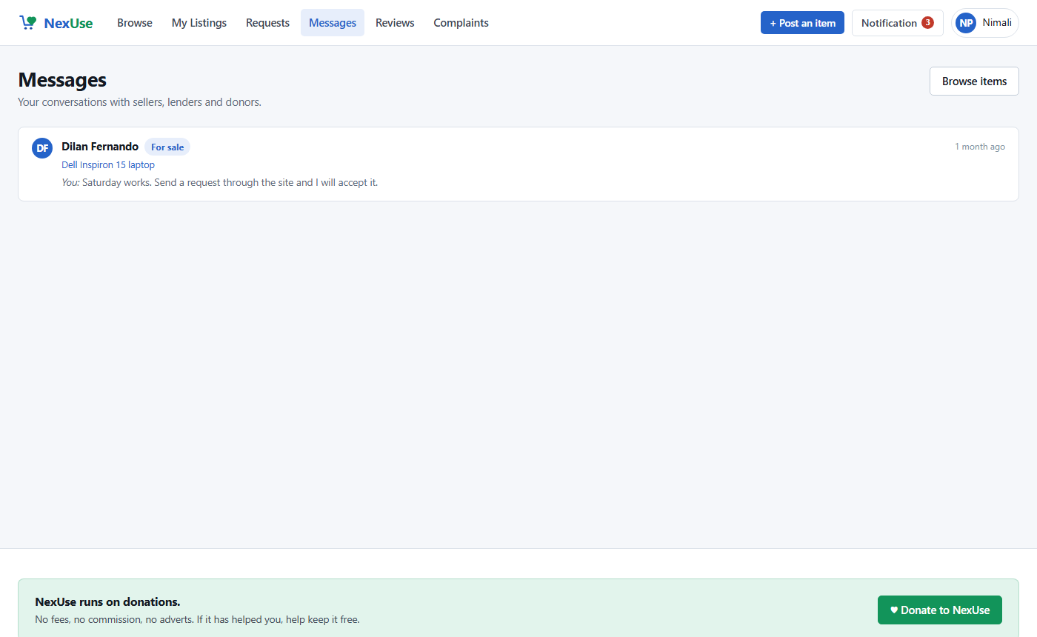
Figure 23: Messages — one conversation per listing and member
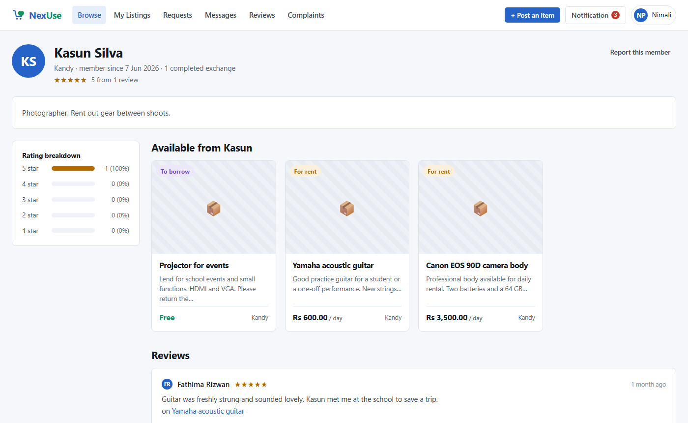
Figure 24: A member profile with rating breakdown
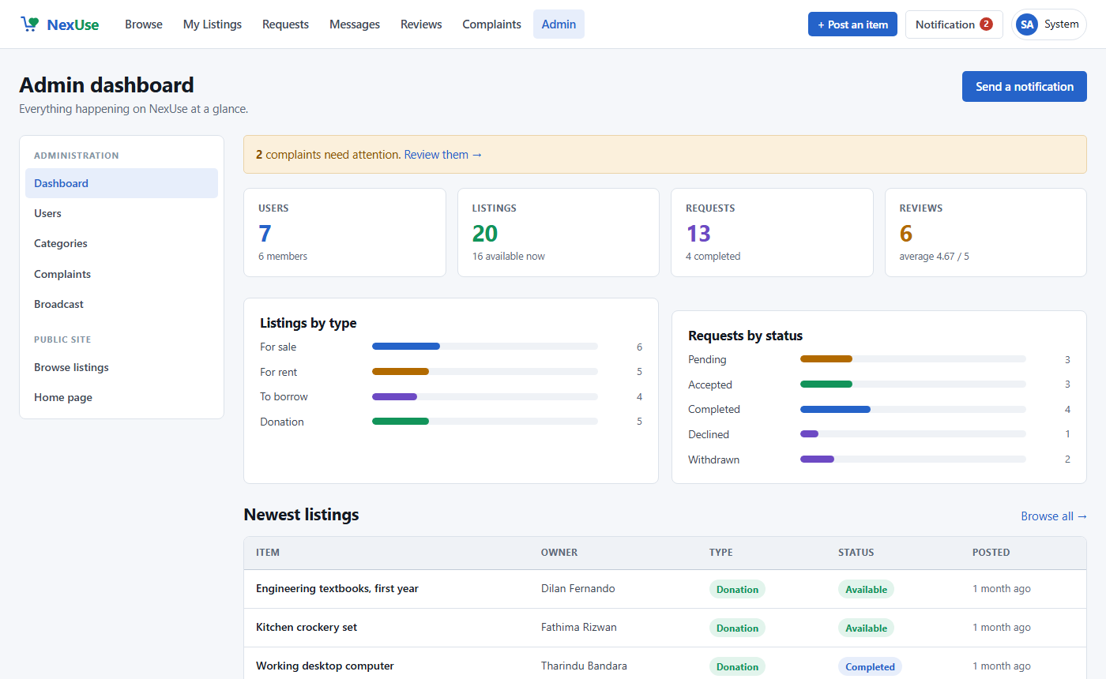
Figure 25: Admin dashboard

