Sri Lanka Institute of information Technology

Modern Topics in IT
IT4020

Assignment 1
Individual Assignment

ChatGPT Vs Gemini

IT22322326 Niruththika E
Y4S2
Table of Contents
Common prompts For ChatGPT and Gemini 5
Create the environment 5
Create the app 6
Create the UI 7
Refinement Versions of the Prompt 8
Create the environment 8
Create the app 8
Create the UI 8
ChatGPT error message prompts 9
Sqlite3 connection error message prompt 9
Name is not defined error message, prompts and solution 11
error message 11
prompts 11
solution 11
ChatGpt Deliverable codes 12
Folder structure 12
app.py code 12
add_task.html 17
dashboard.html 18
login.html 19
register .html 20
update_task.html 21
ChatGPT Debug Code and Output 22
Register User 22
Login User 22
Add task 22
View Task 23
Update task 23
Delete task 23
When after register / login / add / delete / update task get the flash message 24
Task added Successfully 24
Task updated successfully 24
Task deleted successfully 24
Registered successfully 25
Login successfully 25
Manual Work 26
Put the validations 26
Password must include 8 characters 26
if user name or password incorrect cant login 26
Task fields are mandatory 26
Gemini error message prompts 27
Login_required is not defined error message and prompt 27
error message 27
prompt 27
Error 2 and prompt 28
Error message 28
Prompt 28
Gemini Deliverable codes 29
Folder structure 29
app.py code 29
auth.py code 31
extensions.py code 32
models.py code 32
base.html code 33
dashboard.html code 34
home.html 39
login.html code 41
register.html code 42
update.html 45
Debug code and Output 49
Register user 49
Login user 49
Add and view the task 50
Update the task 50
Delete the task 51
Validations 52
If user already registered can’t register again 52
Password must include 8 characters 52
if username or password incorrect can’t login 53
Task field is mandatory to fill 53
Manual work 54
Add the notification when register/login add, update, delete task 54
Comparative Evaluation of Generative AI Tools 55
Output Quality Evaluation 55
ChatGPT – Output Analysis 55
Gemini – Output Analysis 55
Critical Analysis 56
Prompt Sensitivity Analysis 57
Initial Prompt Characteristics 57
Refinement Prompt 57
Prompt Sensitivity 57
Critical Analysis 58
Technical Limitations 59
ChatGPT Limitations 59
Gemini Limitations 59
Critical Technical Analysis 59
Performance Metrics 60
Response Speed 60
Code Accuracy 60
Debugging and Explanation 60

Content of Table
Table 1. Evaluation based on output quality 56
Table 2. Evaluation based on Prompt Sensitivity 58
Table 3. Evaluation based on Technical Limitations 59
Table 4. Evaluation based on Performance Metrics 60

Task 1

Common prompts For ChatGPT and Gemini

Create the environment
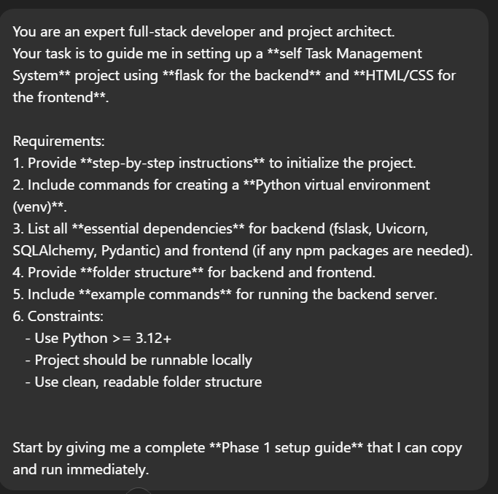

Create the app
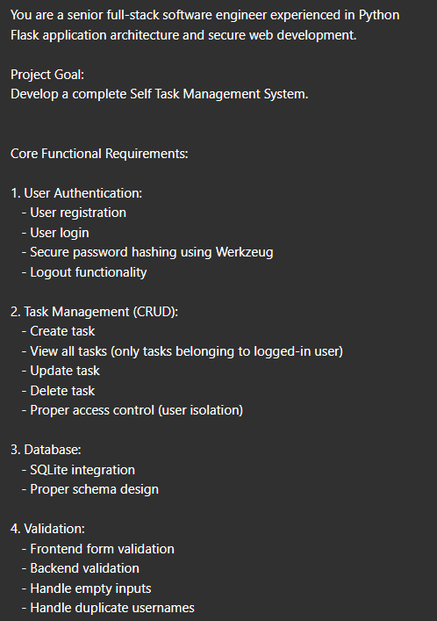
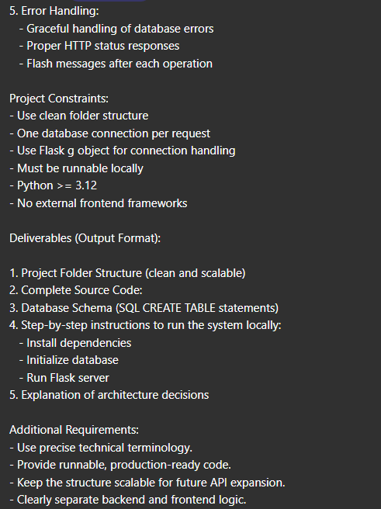

Create the UI
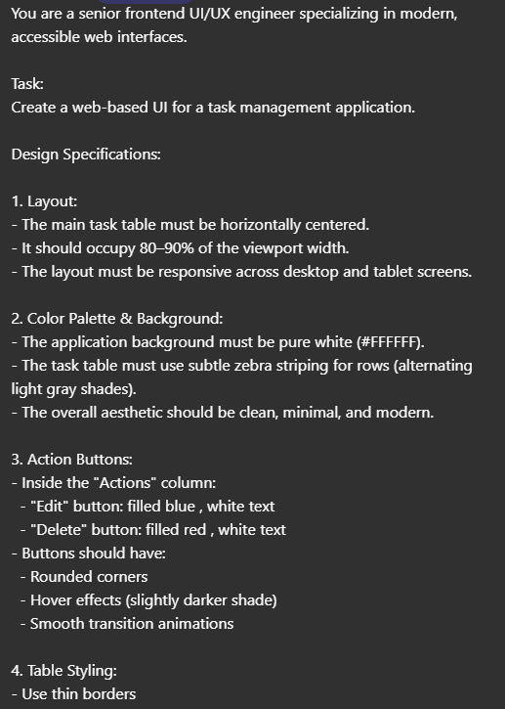
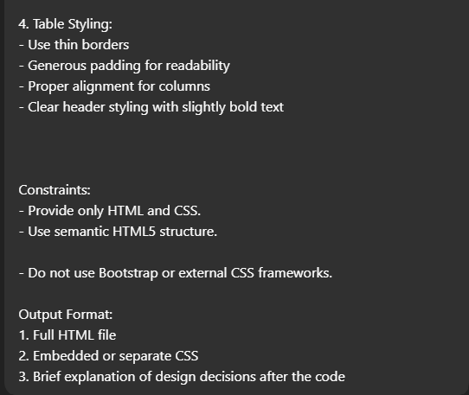

Refinement Versions of the Prompt

Create the environment


Create the app
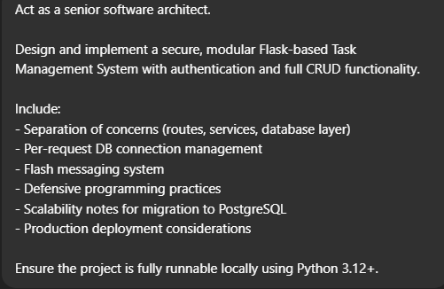

Create the UI
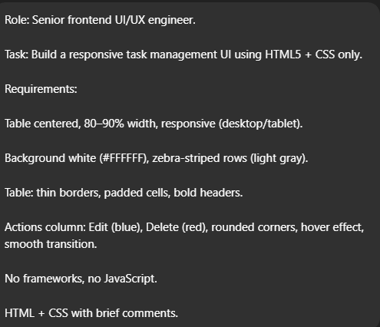

ChatGPT error message prompts

Sqlite3 connection error message prompt
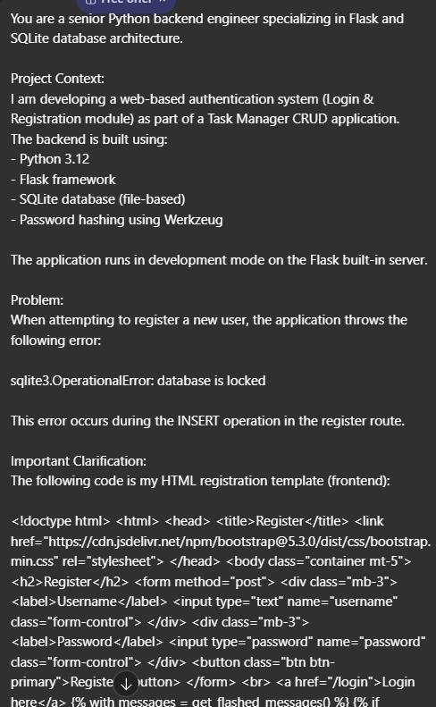
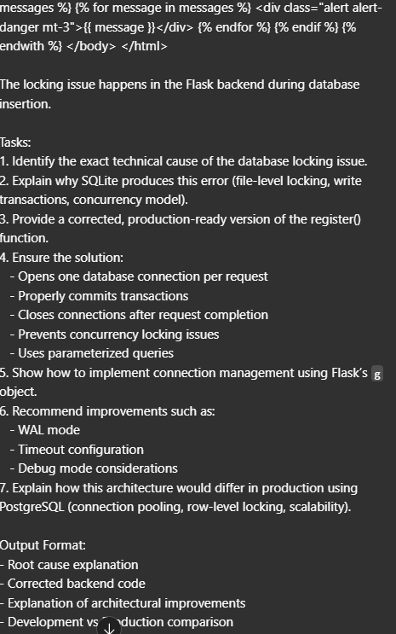

Name is not defined error message, prompts and solution

error message
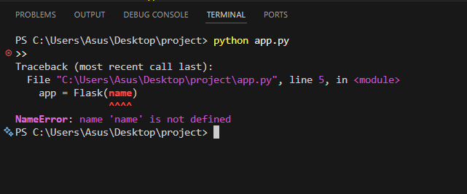

prompts
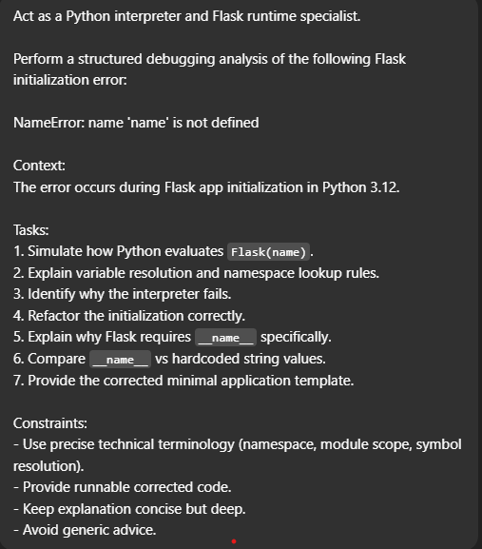
solution
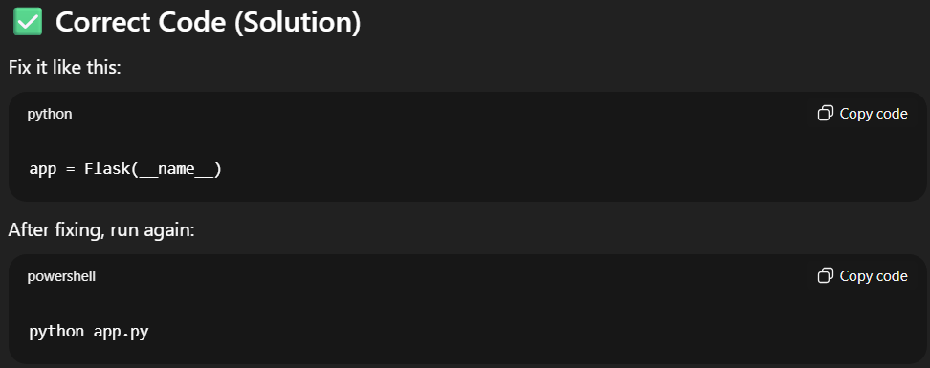

ChatGpt Deliverable codes

Folder structure
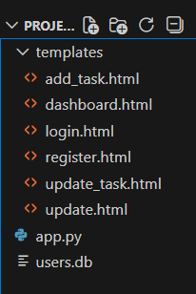

app.py code
- from flask import Flask, render_template, request, redirect, session, flash, url_for
- import sqlite3
- from werkzeug.security import generate_password_hash, check_password_hash
- import os

- app = Flask(__name__)
- app.secret_key = "secretkey123"
- DATABASE = "users.db"

- # ------------------------
- # Database connection helper
- # ------------------------
- def get_db_connection():
- # Waits 10 seconds if DB is locked, allows multi-thread
- conn = sqlite3.connect(DATABASE, timeout=10, check_same_thread=False)
- conn.row_factory = sqlite3.Row
- return conn

- # ------------------------
- # Database setup
- # ------------------------
- def create_tables():
- if not os.path.exists(DATABASE):
- with get_db_connection() as conn:
- cursor = conn.cursor()
- cursor.execute("""
- CREATE TABLE IF NOT EXISTS users (
- id INTEGER PRIMARY KEY AUTOINCREMENT,
- username TEXT UNIQUE NOT NULL,
- password TEXT NOT NULL
- )
- """)
- cursor.execute("""
- CREATE TABLE IF NOT EXISTS tasks (
- id INTEGER PRIMARY KEY AUTOINCREMENT,
- user_id INTEGER NOT NULL,
- title TEXT NOT NULL,
- description TEXT,
- FOREIGN KEY (user_id) REFERENCES users(id)
- )
- """)
- conn.commit()

- create_tables()

- # ------------------------
- # Home
- # ------------------------
- @app.route("/")
- def home():
- return redirect("/login")

- # ------------------------
- # Register
- # ------------------------
- @app.route("/register", methods=["GET", "POST"])
- def register():
- if request.method == "POST":
- username = request.form["username"].strip()
- password = request.form["password"].strip()

- if not username or not password:
- flash("Fields cannot be empty")
- return redirect("/register")

- if not any(char.isupper() for char in password):
- flash("Password must contain at least one uppercase letter")
- return redirect("/register")

- if not any(char.isdigit() for char in password):
- flash("Password must contain at least one number")
- return redirect("/register")

- hashed_password = generate_password_hash(password)

- try:
- with get_db_connection() as conn:
- cursor = conn.cursor()
- cursor.execute(
- "INSERT INTO users (username, password) VALUES (?, ?)",
- (username, hashed_password)
- )
- conn.commit()
- flash("Registration successful")
- return redirect("/login")
- except sqlite3.IntegrityError:
- flash("Username already exists")
- return redirect("/register")
- except sqlite3.OperationalError as e:
- flash(f"Database error: {e}")
- return redirect("/register")

- return render_template("register.html")

- # ------------------------
- # Login
- # ------------------------
- @app.route("/login", methods=["GET", "POST"])
- def login():
- if request.method == "POST":
- username = request.form["username"].strip()
- password = request.form["password"].strip()

- with get_db_connection() as conn:
- cursor = conn.cursor()
- cursor.execute("SELECT id, password FROM users WHERE username = ?", (username,))
- user = cursor.fetchone()

- if user and check_password_hash(user["password"], password):
- session["user_id"] = user["id"]
- session["username"] = username
- flash("Login successful")
- return redirect("/dashboard")
- else:
- flash("Invalid username or password")
- return redirect("/login")

- return render_template("login.html")

- # ------------------------
- # Dashboard
- # ------------------------
- @app.route("/dashboard")
- def dashboard():
- if "user_id" not in session:
- flash("Please login first")
- return redirect("/login")

- with get_db_connection() as conn:
- cursor = conn.cursor()
- cursor.execute("SELECT id, title, description FROM tasks WHERE user_id=?", (session["user_id"],))
- tasks = cursor.fetchall()

- return render_template("dashboard.html", username=session["username"], tasks=tasks)

- # ------------------------
- # Add Task
- # ------------------------
- @app.route("/add_task", methods=["GET", "POST"])
- def add_task():
- if "user_id" not in session:
- flash("Please login first")
- return redirect("/login")

- if request.method == "POST":
- title = request.form["title"].strip()
- description = request.form["description"].strip()

- if not title:
- flash("Task title cannot be empty")
- return redirect("/add_task")

- with get_db_connection() as conn:
- cursor = conn.cursor()
- cursor.execute("INSERT INTO tasks (user_id, title, description) VALUES (?, ?, ?)",
- (session["user_id"], title, description))
- conn.commit()
- flash("Task added successfully")
- return redirect("/dashboard")

- return render_template("add_task.html")

- # ------------------------
- # Update Task
- # ------------------------
- @app.route("/update_task/<int:id>", methods=["GET", "POST"])
- def update_task(id):
- if "user_id" not in session:
- flash("Please login first")
- return redirect("/login")

- with get_db_connection() as conn:
- cursor = conn.cursor()
- cursor.execute("SELECT id, title, description FROM tasks WHERE id=? AND user_id=?", (id, session["user_id"]))
- task = cursor.fetchone()

- if not task:
- flash("Task not found")
- return redirect("/dashboard")

- if request.method == "POST":
- title = request.form["title"].strip()
- description = request.form["description"].strip()

- if not title:
- flash("Task title cannot be empty")
- return redirect(f"/update_task/{id}")

- cursor.execute("UPDATE tasks SET title=?, description=? WHERE id=?", (title, description, id))
- conn.commit()
- flash("Task updated successfully")
- return redirect("/dashboard")

- return render_template("update_task.html", task=task)

- # ------------------------
- # Delete Task
- # ------------------------
- @app.route("/delete_task/<int:id>")
- def delete_task(id):
- if "user_id" not in session:
- flash("Please login first")
- return redirect("/login")

- with get_db_connection() as conn:
- cursor = conn.cursor()
- cursor.execute("DELETE FROM tasks WHERE id=? AND user_id=?", (id, session["user_id"]))
- conn.commit()

- flash("Task deleted successfully")
- return redirect("/dashboard")

- # ------------------------
- # Logout
- # ------------------------
- @app.route("/logout")
- def logout():
- session.clear()
- flash("Logged out")
- return redirect("/login")

- # ------------------------
- # Run
- # ------------------------
- if __name__ == "__main__":
- app.run(debug=True, threaded=True)

add_task.html
<!doctype html>
<html>
<head>
<title>Add Task</title>
<link href="https://cdn.jsdelivr.net/npm/bootstrap@5.3.0/dist/css/bootstrap.min.css" rel="stylesheet">
</head>
<body class="container mt-5">
<h2>Add Task</h2>
<form method="post">
<div class="mb-3">
<label>Title</label>
<!-- <input type="text" name="title" class="form-control"> -->
<input type="text" name="title" class="form-control" required>
</div>
<div class="mb-3">
<label>Description</label>
<textarea name="description" class="form-control" required></textarea>
</div>
<button class="btn btn-success">Add Task</button>
<a href="/dashboard" class="btn btn-secondary">Cancel</a>
</form>
</body>
</html>

dashboard.html
<!doctype html>
<html>
<head>
<title>Dashboard</title>
<link href="https://cdn.jsdelivr.net/npm/bootstrap@5.3.0/dist/css/bootstrap.min.css" rel="stylesheet">
</head>
<body class="container mt-5">

<h2>Welcome, {{ username }}</h2>
<a href="/logout" class="btn btn-warning mb-3">Logout</a>

<!-- Flash messages -->
{% with messages = get_flashed_messages(with_categories=true) %}
{% if messages %}
{% for category, message in messages %}
<div class="alert alert-{{ category }} alert-dismissible fade show" role="alert">
{{ message }}
<button type="button" class="btn-close" data-bs-dismiss="alert" aria-label="Close"></button>
</div>
{% endfor %}
{% endif %}
{% endwith %}

<h3>Your Tasks</h3>
<a href="/add_task" class="btn btn-success mb-2">Add Task</a>

<table class="table table-bordered">
<thead>
<tr>
<th>ID</th>
<th>Title</th>
<th>Description</th>
<th>Actions</th>
</tr>
</thead>
<tbody>
{% for task in tasks %}
<tr>
<td>{{ task['id'] }}</td>
<td>{{ task['title'] }}</td>
<td>{{ task['description'] }}</td>
<td>
<a href="/update_task/{{ task['id'] }}" class="btn btn-sm btn-info">Edit</a>
<a href="/delete_task/{{ task['id'] }}" class="btn btn-sm btn-danger">Delete</a>
</td>
</tr>
{% endfor %}
</tbody>
</table>

<script src="https://cdn.jsdelivr.net/npm/bootstrap@5.3.0/dist/js/bootstrap.bundle.min.js"></script>
</body>
</html>

login.html
<!doctype html>
<html>
<head>
<title>Login</title>
<link href="https://cdn.jsdelivr.net/npm/bootstrap@5.3.0/dist/css/bootstrap.min.css" rel="stylesheet">
</head>
<body class="container mt-5">
<h2>Login</h2>
<form method="post">
<div class="mb-3">
<label>Username</label>
<input type="text" name="username" class="form-control">
</div>
<div class="mb-3">
<label>Password</label>
<input type="password" name="password" class="form-control">
</div>
<button class="btn btn-primary">Login</button>
</form>
<br>
<a href="/register">Register here</a>
{% with messages = get_flashed_messages() %}
{% if messages %}
{% for message in messages %}
<div class="alert alert-danger mt-3">{{ message }}</div>
{% endfor %}
{% endif %}
{% endwith %}
</body>
</html>

register .html
<!doctype html>
<html>
<head>
<title>Register</title>
<link href="https://cdn.jsdelivr.net/npm/bootstrap@5.3.0/dist/css/bootstrap.min.css" rel="stylesheet">
</head>
<body class="container mt-5">
<h2>Register</h2>
<form method="post">
<div class="mb-3">
<label>Username</label>
<input type="text" name="username" class="form-control">
</div>
<div class="mb-3">
<label>Password</label>
<input type="password" name="password" class="form-control">
</div>
<button class="btn btn-primary">Register</button>
</form>
<br>
<a href="/login">Login here</a>

{% with messages = get_flashed_messages() %}
{% if messages %}
{% for message in messages %}
<div class="alert alert-danger mt-3">{{ message }}</div>
{% endfor %}
{% endif %}
{% endwith %}
</body>
</html>

update_task.html
<!doctype html>
<html>
<head>
<title>Update Task</title>
<link href="https://cdn.jsdelivr.net/npm/bootstrap@5.3.0/dist/css/bootstrap.min.css" rel="stylesheet">
</head>
<body class="container mt-5">

<h2>Update Task</h2>

<!-- Flash messages -->
{% with messages = get_flashed_messages(with_categories=true) %}
{% if messages %}
{% for category, message in messages %}
<div class="alert alert-{{ category }} alert-dismissible fade show" role="alert">
{{ message }}
<button type="button" class="btn-close" data-bs-dismiss="alert" aria-label="Close"></button>
</div>
{% endfor %}
{% endif %}
{% endwith %}

<form method="post">
<div class="mb-3">
<label>Title</label>
<input type="text" name="title" value="{{ task[1] }}" class="form-control" required>
</div>
<div class="mb-3">
<label>Description</label>
<textarea name="description" class="form-control" required>{{ task[2] }}</textarea>
</div>
<button class="btn btn-primary">Update Task</button>
<a href="/dashboard" class="btn btn-secondary">Cancel</a>
</form>

<script src="https://cdn.jsdelivr.net/npm/bootstrap@5.3.0/dist/js/bootstrap.bundle.min.js"></script>
</body>
</html>

ChatGPT Debug Code and Output
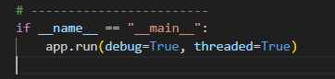

Register User
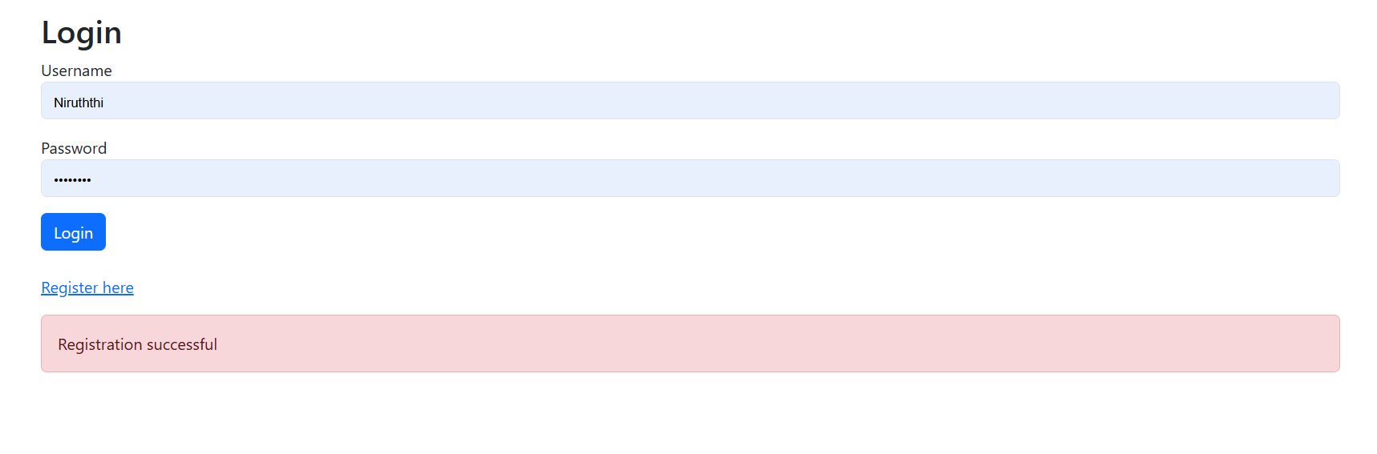

Login User
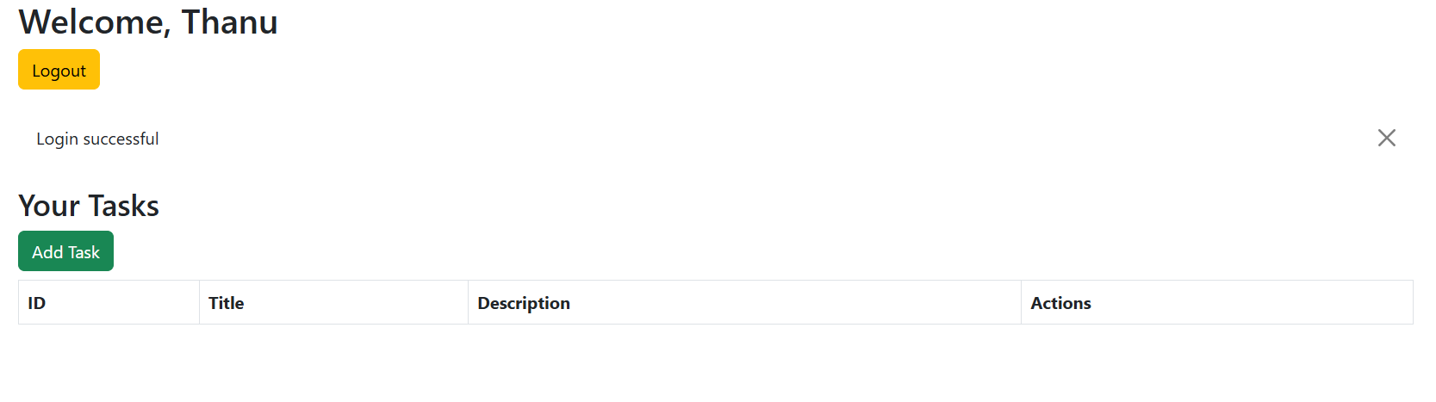

Add task
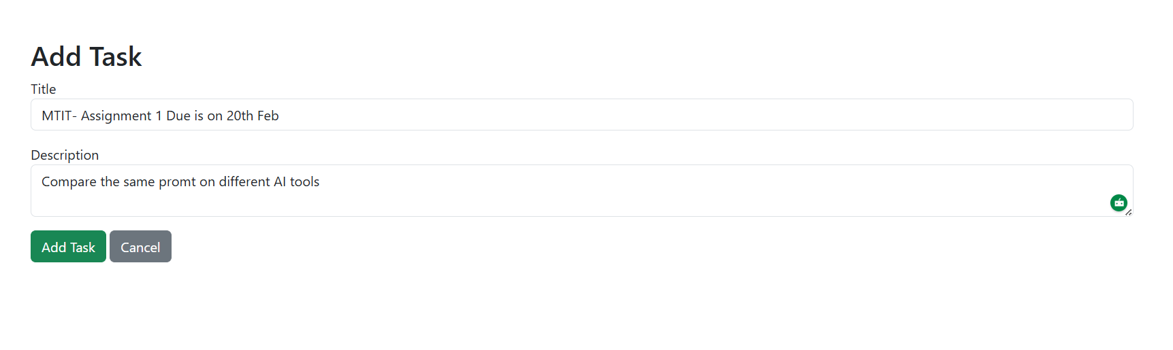

View Task
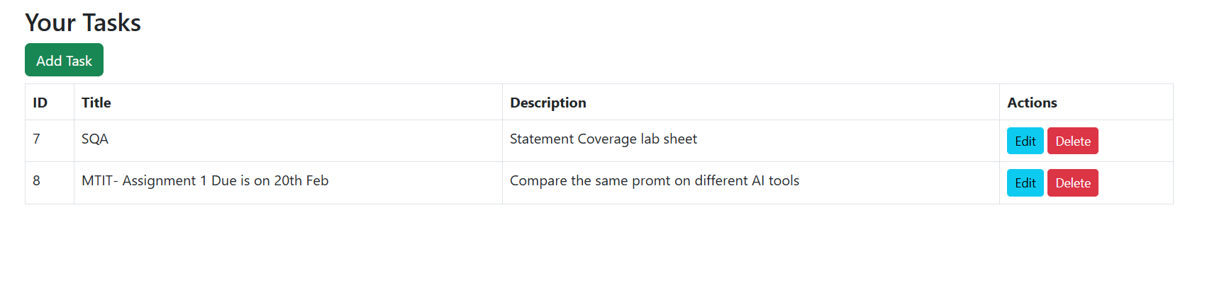

Update task
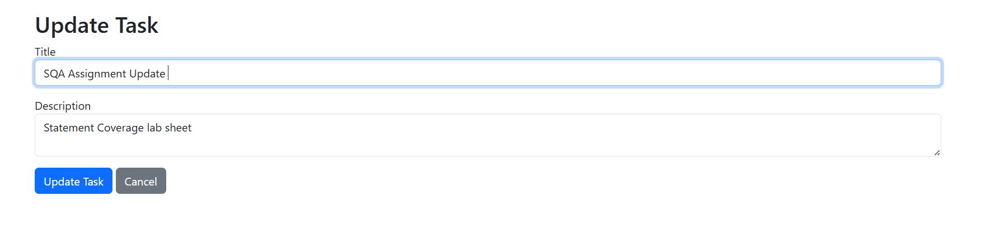

Delete task
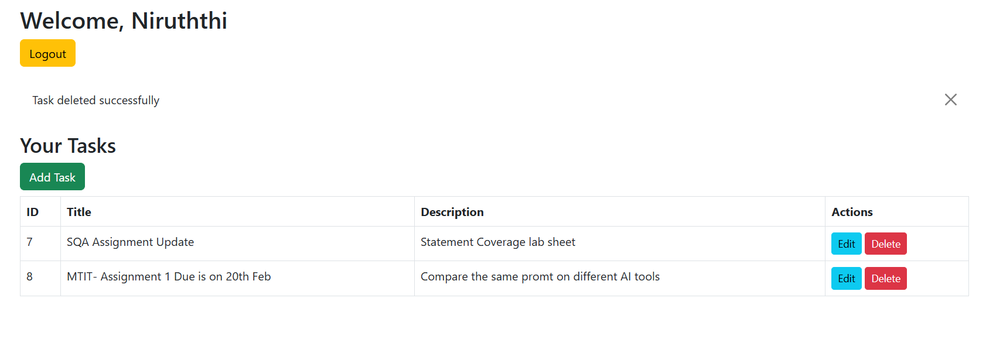

When after register / login / add / delete / update task get the flash message

Task added Successfully
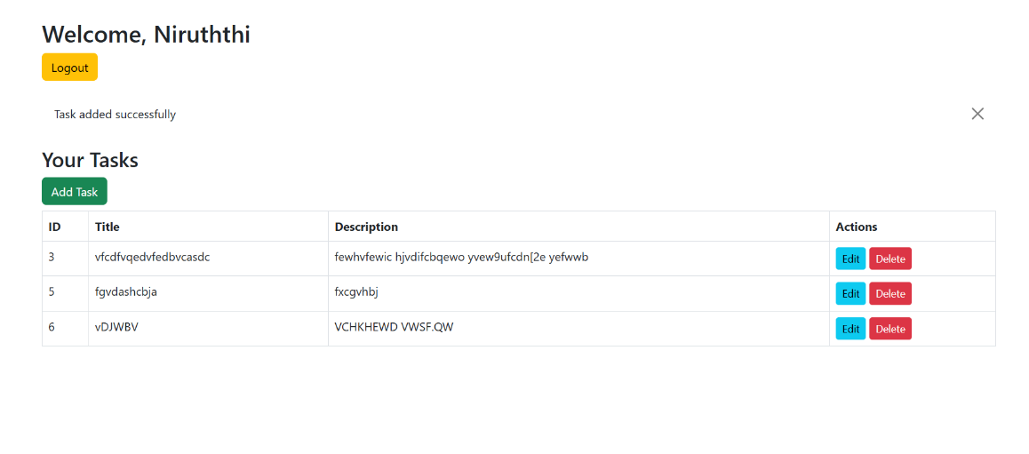

Task updated successfully
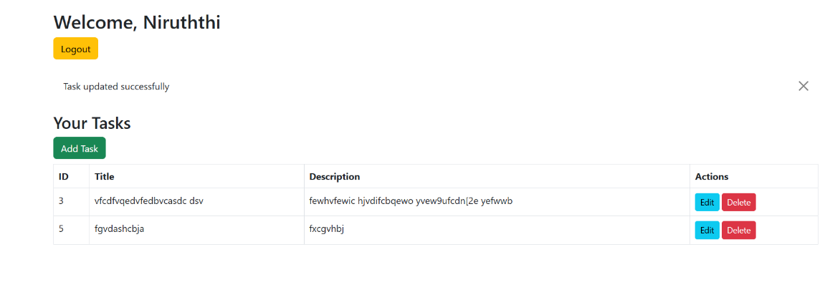

Task deleted successfully
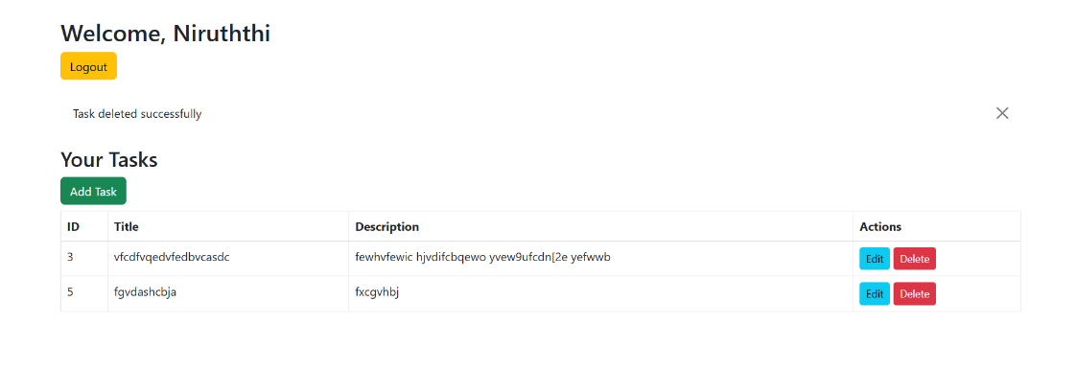

Registered successfully


Login successfully


Manual Work
Put the validations
If user already registered can’t register again
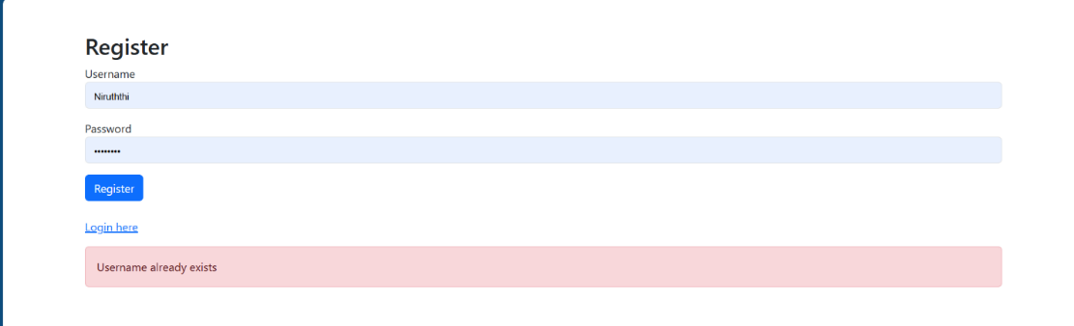

Password must include 8 characters
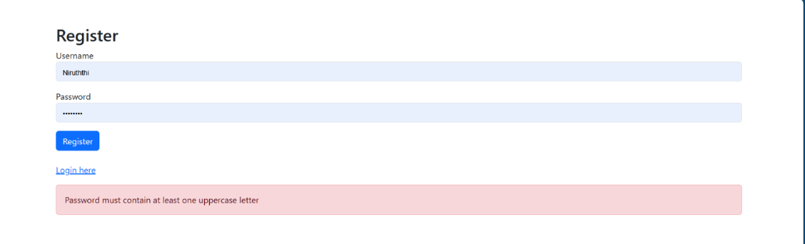

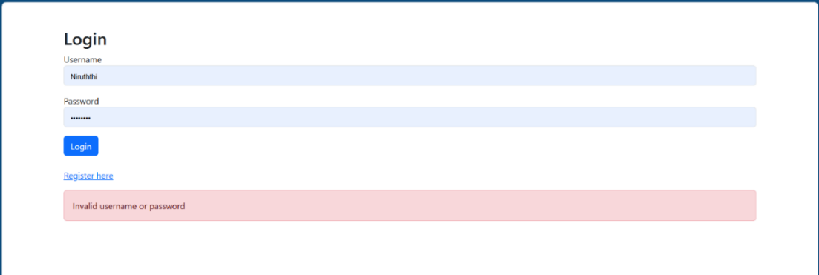
if user name or password incorrect cant login

Task fields are mandatory
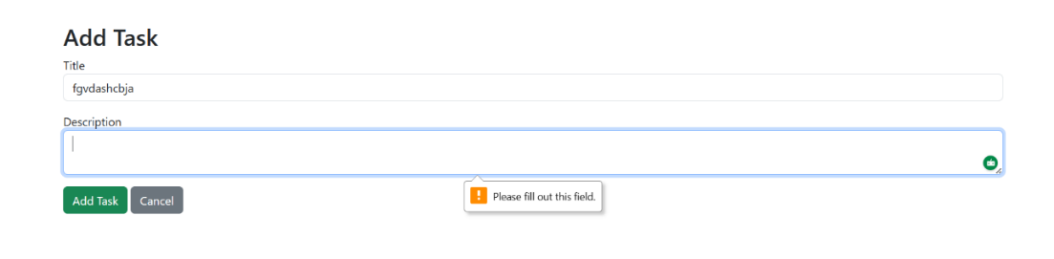

Gemini error message prompts

Login_required is not defined error message and prompt

error message
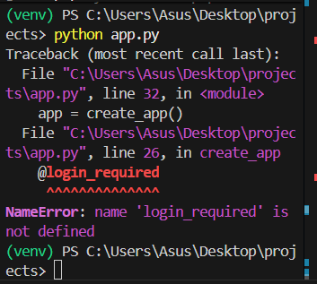

prompt

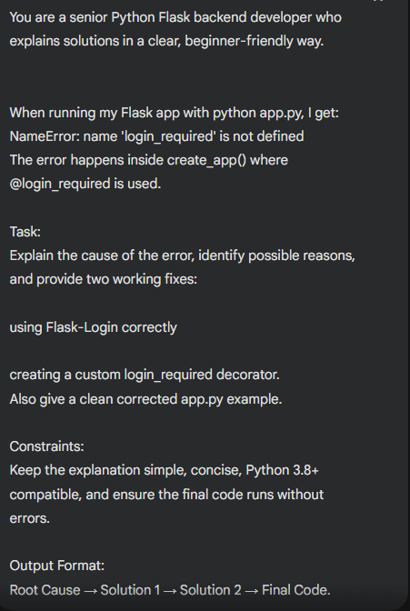

Error 2 and prompt

Error message
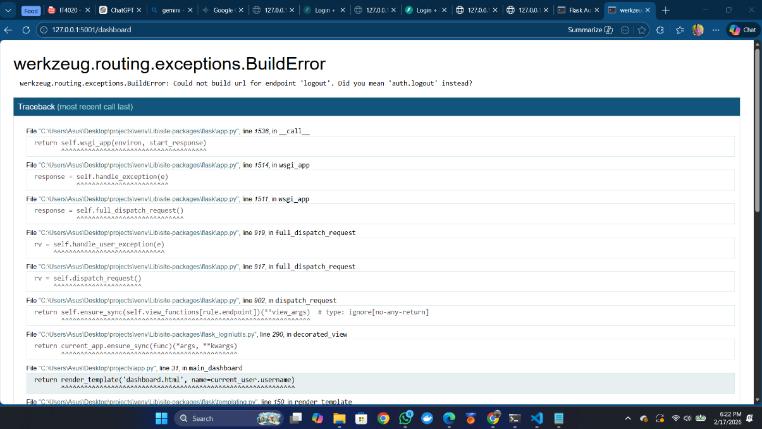

Prompt
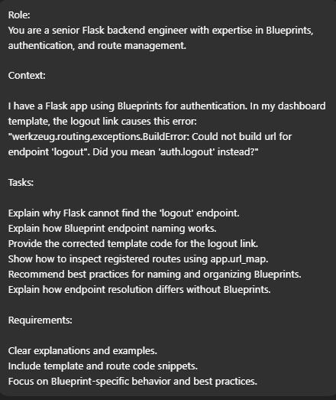

Gemini Deliverable codes

Folder structure
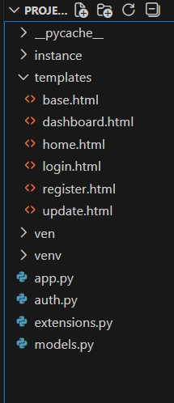

app.py code
- from flask import Flask, render_template, request, redirect, url_for, flash
- from flask_login import login_required, current_user
- from extensions import db, login_manager
- from models import User, Task
- from auth import auth as auth_blueprint

- def create_app():
- app = Flask(__name__)
- app.config['SECRET_KEY'] = 'dev-key-123'
- app.config['SQLALCHEMY_DATABASE_URI'] = 'sqlite:///db.sqlite'

- db.init_app(app)
- login_manager.init_app(app)
- login_manager.login_view = 'auth.login'

- @login_manager.user_loader
- def load_user(user_id):
- return db.session.get(User, int(user_id))

- app.register_blueprint(auth_blueprint)

- @app.route('/')
- def index():
- return render_template('base.html')

- # --- CRUD ROUTES ---

- @app.route('/dashboard', methods=['POST', 'GET'])
- @login_required
- def main_dashboard():
- if request.method == 'POST':
- task_content = request.form.get('content')
- if task_content:
- new_task = Task(content=task_content, user_id=current_user.id)
- db.session.add(new_task)
- db.session.commit()
- # Correctly flash when adding a task
- flash('Task added successfully!', 'success')
- return redirect(url_for('main_dashboard'))

- # READ: Get only the tasks belonging to the current user
- user_tasks = Task.query.filter_by(user_id=current_user.id).order_by(Task.date_created).all()
- return render_template('dashboard.html', name=current_user.username, tasks=user_tasks)

- @app.route('/delete/<int:id>')
- @login_required
- def delete(id):
- task_to_delete = db.session.get(Task, id)
- # Security check: Ensure user owns the task
- if task_to_delete and task_to_delete.user_id == current_user.id:
- db.session.delete(task_to_delete)
- db.session.commit()
- flash('Task deleted!', 'info')
- return redirect(url_for('main_dashboard'))

- @app.route('/update/<int:id>', methods=['GET', 'POST'])
- @login_required
- def update(id):
- task = db.session.get(Task, id)

- # If task doesn't exist or isn't yours, just go back
- if not task or task.user_id != current_user.id:
- return redirect(url_for('main_dashboard'))

- if request.method == 'POST':
- task.content = request.form.get('content')
- db.session.commit()
- # Flash success message ONLY after successful commit
- flash('Task updated successfully!', 'success')
- return redirect(url_for('main_dashboard'))

- return render_template('update.html', task=task)

- return app

- if __name__ == '__main__':
- app = create_app()
- with app.app_context():
- db.create_all()
- app.run(debug=True, port=5001)

auth.py code
- from flask import Blueprint, render_template, redirect, url_for, request, flash
- from werkzeug.security import generate_password_hash, check_password_hash
- from flask_login import login_user, logout_user, login_required
- from extensions import db
- from models import User

- auth = Blueprint('auth', __name__)

- @auth.route('/login', methods=['GET', 'POST'])
- def login():
- if request.method == 'POST':
- username = request.form.get('username')
- password = request.form.get('password')
- user = User.query.filter_by(username=username).first()

- if user and check_password_hash(user.password, password):
- login_user(user)
- return redirect(url_for('main_dashboard'))
- flash('Invalid username or password', 'danger')
- return render_template('login.html')

- @auth.route('/register', methods=['GET', 'POST'])
- def register():
- if request.method == 'POST':
- username = request.form.get('username')
- password = request.form.get('password')

- if User.query.filter_by(username=username).first():
- flash('Username already exists', 'danger')
- return redirect(url_for('auth.register'))

- hashed_pw = generate_password_hash(password, method='scrypt')
- new_user = User(username=username, password=hashed_pw)
- db.session.add(new_user)
- db.session.commit()

- flash('Account created! Please log in.', 'success')
- return redirect(url_for('auth.login'))
- return render_template('register.html')

- @auth.route('/logout')
- @login_required
- def logout():
- logout_user()
- return redirect(url_for('auth.login'))

extensions.py code
from flask_sqlalchemy import SQLAlchemy
from flask_login import LoginManager

db = SQLAlchemy()
login_manager = LoginManager()

models.py code
- # from extensions import db
- # from flask_login import UserMixin

- # class User(UserMixin, db.Model):
- # id = db.Column(db.Integer, primary_key=True)
- # username = db.Column(db.String(150), unique=True, nullable=False)
- # password = db.Column(db.String(150), nullable=False)

- from extensions import db
- from flask_login import UserMixin
- from datetime import datetime

- class User(UserMixin, db.Model):
- id = db.Column(db.Integer, primary_key=True)
- username = db.Column(db.String(150), unique=True, nullable=False)
- password = db.Column(db.String(150), nullable=False)
- # Relationship to link tasks to the user
- tasks = db.relationship('Task', backref='owner', lazy=True)

- class Task(db.Model):
- id = db.Column(db.Integer, primary_key=True)
- content = db.Column(db.String(200), nullable=False)
- date_created = db.Column(db.DateTime, default=datetime.utcnow)
- user_id = db.Column(db.Integer, db.ForeignKey('user.id'), nullable=False)

base.html code
- <!DOCTYPE html>
- <html lang="en">
- <head>
- <meta charset="UTF-8">
- <meta name="viewport" content="width=device-width, initial-scale=1.0">
- <title>TaskMaster | Manage your Life</title>
- <link href="https://fonts.googleapis.com/css2?family=Inter:wght@300;400;600&display=swap" rel="stylesheet">
- <style>
- :root {
- --primary: #4f46e5;
- --primary-hover: #4338ca;
- --bg: #f9fafb;
- --text: #111827;
- }
- body {
- font-family: 'Inter', sans-serif;
- background-color: var(--bg);
- color: var(--text);
- margin: 0;
- display: flex;
- flex-direction: column;
- min-height: 100vh;
- }
- .container { max-width: 1000px; margin: 0 auto; padding: 20px; }

- /* Flash Message Styling */
- .flash {
- padding: 1rem;
- margin-bottom: 1rem;
- border-radius: 8px;
- text-align: center;
- background-color: #dcfce7;
- color: #166534;
- border: 1px solid #bbf7d0;
- }
- </style>
- </head>
- <body>
- {% with messages = get_flashed_messages() %}
- {% if messages %}
- {% for msg in messages %}
- <div class="flash">{{ msg }}</div>
- {% endfor %}
- {% endif %}
- {% endwith %}

- {% block content %}{% endblock %}
- </body>
- </html>

dashboard.html code
{% extends "base.html" %}
{% block content %}

<style>
body {
background-color: #f2f6fc;
font-family: 'Segoe UI', Tahoma, Geneva, Verdana, sans-serif;
}

/* Flash Message Styling */
.alert-custom {
border-radius: 50px;
padding: 0.75rem 1.5rem;
display: flex;
align-items: center;
gap: 10px;
margin-bottom: 20px;
box-shadow: 0 4px 15px rgba(0,0,0,0.05);
}
.alert-success { background-color: #d4edda; color: #155724; }
.alert-info { background-color: #d1ecf1; color: #0c5460; }

.container {
max-width: 1000px;
margin: 0 auto;
padding: 40px 20px;
}

.header-section {
display: flex;
justify-content: space-between;
align-items: center;
margin-bottom: 30px;
}
.header-section h2 {
font-size: 1.8rem;
font-weight: 700;
color: #34495e;
}

/* Card Styling */
.card {
background: #fff;
border-radius: 20px;
box-shadow: 0 10px 25px rgba(0,0,0,0.05);
margin-bottom: 30px;
border: none;
padding: 30px;
}
.card-title {
font-weight: 600;
color: #333;
font-size: 1.2rem;
margin-bottom: 20px;
}

/* Form */
.form-control {
border-radius: 50px;
padding: 0.75rem 1.25rem;
border: 1px solid #d1d5db;
width: 90%;
font-size: 1rem;
}

.btn {
border-radius: 50px;
padding: 0.65rem 1.5rem;
font-weight: 500;
display: inline-flex;
align-items: center;
justify-content: center;
gap: 5px;
cursor: pointer;
transition: all 0.2s ease-in-out;
}
.btn:hover {
transform: translateY(-1px);
}
.btn-success {
background-color: #4CAF50;
color: white;
border: none;
}
.btn-success:hover {
background-color: #45a049;
}
.btn-danger {
background-color: #e74c3c;
color: white;
border: none;
}
.btn-danger:hover {
background-color: #c0392b;
}
.btn-primary {
background-color: #3498db;
color: white;
border: none;
}
.btn-primary:hover {
background-color: #2980b9;
}
.btn-sm {
padding: 0.4rem 0.9rem;
font-size: 0.85rem;
}

/* Table Styling */
table {
width: 100%;
border-collapse: collapse;
}
th {
background-color: #34495e;
color: white;
font-weight: 600;
padding: 12px 15px;
text-align: left;
}
td {
padding: 12px 15px;
border-bottom: 1px solid #e0e0e0;
color: #555;
}
tr:hover {
background-color: #f1f5f9;
}
.actions-cell {
white-space: nowrap;
}
.text-muted {
color: #6c757d;
}

/* Responsive Table */
@media (max-width: 768px) {
.header-section {
flex-direction: column;
gap: 15px;
}
.actions-cell {
display: flex;
flex-direction: column;
gap: 5px;
}
}
</style>

<div class="container">

<!-- Flash Messages -->
{% with messages = get_flashed_messages(with_categories=true) %}
{% if messages %}
{% for category, message in messages %}
<div class="alert-custom alert-{{ category if category != 'message' else 'success' }}">
<i class="bi bi-check-circle-fill"></i>
{{ message }}
</div>
{% endfor %}
{% endif %}
{% endwith %}

<!-- Header -->
<div class="header-section">
<h2>Welcome, {{ name }}!</h2>
<a href="{{ url_for('auth.logout') }}" class="btn btn-danger">Logout</a>
</div>

<!-- Add Task Card -->
<div class="card">
<div class="card-body">
<h4 class="card-title">Add a Task</h4>
<form method="POST" class="d-flex gap-3">
<input type="text" name="content" class="form-control" placeholder="Enter a new task..." required>
<button type="submit" class="btn btn-success">Add Task</button>
</form>
</div>
</div>

<!-- Tasks Table Card -->
<div class="card">
<div class="card-body">
<h4 class="card-title">Your Tasks</h4>
{% if tasks %}
<div class="table-responsive">
<table>
<thead>
<tr>
<th>Task</th>
<th>Created</th>
<th>Actions</th>
</tr>
</thead>
<tbody>
{% for task in tasks %}
<tr>
<td>{{ task.content }}</td>
<td>{{ task.date_created.strftime('%Y-%m-%d') }}</td>
<td class="actions-cell">
<a href="{{ url_for('update', id=task.id) }}" class="btn btn-sm btn-primary">
<i class="bi bi-pencil-square"></i> Update
</a>
<a href="{{ url_for('delete', id=task.id) }}" class="btn btn-sm btn-danger">
<i class="bi bi-trash"></i> Delete
</a>
</td>
</tr>
{% endfor %}
</tbody>
</table>
</div>
{% else %}
<p class="text-muted text-center py-4">No tasks found. Add your first task above!</p>
{% endif %}
</div>
</div>

</div>

<link rel="stylesheet" href="https://cdn.jsdelivr.net/npm/bootstrap-icons@1.10.5/font/bootstrap-icons.css">

{% endblock %}

home.html
- {% extends "base.html" %}

- {% block content %}
- <style>
- .hero {
- display: flex;
- flex-direction: column;
- align-items: center;
- justify-content: center;
- text-align: center;
- height: 80vh;
- padding: 0 20px;
- }

- .hero h1 {
- font-size: 4rem;
- font-weight: 800;
- margin-bottom: 1rem;
- background: linear-gradient(to right, #4f46e5, #ec4899);
- -webkit-background-clip: text;
- -webkit-text-fill-color: transparent;
- letter-spacing: -0.05em;
- }

- .hero p {
- font-size: 1.25rem;
- color: #4b5563;
- margin-bottom: 2.5rem;
- max-width: 600px;
- }

- .btn-group {
- display: flex;
- gap: 15px;
- }

- .btn {
- padding: 12px 32px;
- border-radius: 9999px;
- font-weight: 600;
- text-decoration: none;
- transition: all 0.2s ease;
- }

- .btn-primary {
- background-color: var(--primary);
- color: white;
- box-shadow: 0 10px 15px -3px rgba(79, 70, 229, 0.3);
- }

- .btn-primary:hover {
- background-color: var(--primary-hover);
- transform: translateY(-2px);
- }

- .btn-secondary {
- background-color: white;
- color: var(--text);
- border: 1px solid #e5e7eb;
- }

- .btn-secondary:hover {
- background-color: #f3f4f6;
- transform: translateY(-2px);
- }
- </style>

- <div class="hero">
- <h1>Organize your work<br>and life, finally.</h1>
- <p>Become focused, organized, and calm with TaskMaster. The world’s simplest task manager and to-do list app.</p>

- <div class="btn-group">
- <a href="{{ url_for('auth.login') }}" class="btn btn-primary">Login to Dashboard</a>
- <a href="{{ url_for('auth.register') }}" class="btn btn-secondary">Create Account</a>
- </div>
- </div>
- {% endblock %}

login.html code
- {% extends "base.html" %}
- {% block content %}
- <div class="container" style="display:flex; justify-content:center; align-items:center; min-height:80vh;">
- <div style="background: #ffffff; padding: 40px; border-radius: 20px; box-shadow: 0 10px 30px rgba(0,0,0,0.1); width: 100%; max-width: 400px;">

- <h2 style="text-align:center; font-size: 2rem; font-weight:600; margin-bottom:10px;">Welcome Back</h2>
- <p style="text-align:center; color:#6b7280; margin-bottom:30px;">Sign in to continue your journey with TaskMaster</p>

- <form method="POST" style="display:flex; flex-direction:column; gap:20px;">
- <div>
- <label for="username" style="font-weight:600; margin-bottom:5px; display:block;">Username</label>
- <input type="text" name="username" id="username" required
- style="width:100%; padding:12px; border:1px solid #d1d5db; border-radius:12px; outline:none;">
- </div>
- <div>
- <label for="password" style="font-weight:600; margin-bottom:5px; display:block;">Password</label>
- <input type="password" name="password" id="password" required
- style="width:100%; padding:12px; border:1px solid #d1d5db; border-radius:12px; outline:none;">
- </div>
- <button type="submit" style="padding:15px; background-color:var(--primary); color:white; font-weight:600; border:none; border-radius:12px; cursor:pointer;">
- Sign In
- </button>
- </form>

- <p style="text-align:center; margin-top:20px; color:#6b7280;">
- New member?
- <a href="{{ url_for('auth.register') }}" style="color:var(--primary); font-weight:600;">Create account</a>
- </p>
- </div>
- </div>
- {% endblock %}

register.html code
- {% extends "base.html" %}
- {% block content %}

- <style>
- body {
- background-color: #f2f6fc;
- font-family: 'Segoe UI', Tahoma, Geneva, Verdana, sans-serif;
- }

- .container {
- max-width: 450px;
- margin: 60px auto;
- padding: 20px;
- }

- .card {
- background-color: #fff;
- border-radius: 25px;
- padding: 40px 30px;
- box-shadow: 0 15px 35px rgba(0,0,0,0.08);
- border: 1px solid #e5e7eb;
- }

- h2 {
- font-size: 2rem;
- font-weight: 700;
- color: #111827;
- margin-bottom: 8px;
- }

- p.subtitle {
- color: #6b7280;
- margin-bottom: 30px;
- }

- input.form-control {
- width: 90%;
- padding: 0.85rem 1.25rem;
- border-radius: 20px;
- border: 1px solid #d1d5db;
- font-size: 1rem;
- outline: none;
- transition: all 0.2s;
- }
- input.form-control:focus {
- border-color: #3b82f6;
- box-shadow: 0 0 0 3px rgba(59,130,246,0.2);
- }

- button.btn-primary {
- width: 100%;
- background: #3b82f6;
- color: white;
- padding: 0.85rem;
- border-radius: 20px;
- font-weight: 600;
- font-size: 1rem;
- border: none;
- cursor: pointer;
- transition: all 0.2s;
- box-shadow: 0 8px 20px rgba(59,130,246,0.3);
- }
- button.btn-primary:hover {
- background: #2563eb;
- transform: translateY(-2px);
- box-shadow: 0 12px 25px rgba(59,130,246,0.35);
- }

- p.text-center {
- margin-top: 25px;
- color: #6b7280;
- }
- p.text-center a {
- color: #3b82f6;
- font-weight: 600;
- text-decoration: none;
- }
- p.text-center a:hover {
- text-decoration: underline;
- }

- /* Flash Messages */
- .alert-custom {
- border-radius: 50px;
- padding: 0.75rem 1.5rem;
- display: flex;
- align-items: center;
- gap: 10px;
- margin-bottom: 20px;
- box-shadow: 0 4px 15px rgba(0,0,0,0.05);
- color: #155724;
- background-color: #d4edda;
- border: 1px solid #c3e6cb;
- font-weight: 500;
- }
- </style>

- <div class="container">
- <div class="card">

- <h2>Create Account</h2>
- <p class="subtitle">Join TaskMaster today</p>

- <!-- Flash Messages -->
- {% with messages = get_flashed_messages(with_categories=true) %}
- {% if messages %}
- {% for category, message in messages %}
- <div class="alert-custom">
- {{ message }}
- </div>
- {% endfor %}
- {% endif %}
- {% endwith %}

- <form method="POST" class="space-y-6">
- <div>
- <label class="block text-sm font-semibold text-gray-700 mb-2">Username</label>
- <input type="text" name="username"
- class="form-control"
- placeholder="At least 4 characters"
- minlength="4" maxlength="20" required>
- </div>

- <div>
- <label class="block text-sm font-semibold text-gray-700 mb-2">Password</label>
- <input type="password" name="password"
- class="form-control"
- placeholder="Min. 8 characters"
- minlength="8" required>
- <p class="text-xs text-gray-400 mt-2">Must be at least 8 characters long.</p>
- </div>

- <button type="submit" class="btn-primary">Register Now</button>
- </form>

- <p class="text-center">
- Already have an account? <a href="{{ url_for('auth.login') }}">Sign in</a>
- </p>

- </div>
- </div>

- {% endblock %}

update.html code
- {% extends "base.html" %}
- {% block content %}

- <style>
- body {
- background-color: #f2f6fc;
- font-family: 'Segoe UI', Tahoma, Geneva, Verdana, sans-serif;
- }

- .container {
- max-width: 700px;
- margin: 50px auto;
- padding: 20px;
- }

- .card {
- background-color: #fff;
- border-radius: 20px;
- box-shadow: 0 10px 25px rgba(0,0,0,0.05);
- padding: 30px;
- }

- h2 {
- font-size: 1.8rem;
- font-weight: 600;
- margin-bottom: 20px;
- color: #34495e;
- text-align: center;
- }

- .form-control {
- max-width: 700px;
- padding: 1rem 1.5rem; /* bigger padding */
- border-radius: 50px;
- border: 1px solid #d1d5db;
- font-size: 1rem;
- margin-bottom: 20px;
- outline: none;
- }

- .btn {
- padding: 0.65rem 1.5rem;
- border-radius: 50px;
- font-weight: 500;
- cursor: pointer;
- transition: all 0.2s ease-in-out;
- text-align: center;
- display: inline-block;
- }

- .btn:hover {
- transform: translateY(-1px);
- }

- .btn-success {
- background-color: #4CAF50;
- color: white;
- border: none;
- margin-right: 10px;
- }
- .btn-success:hover {
- background-color: #45a049;
- }

- .btn-secondary {
- background-color: #6c757d;
- color: white;
- border: none;
- text-decoration: none;
- padding: 0.65rem 1.5rem;
- }
- .btn-secondary:hover {
- background-color: #5a6268;
- }

- /* Flash Messages */
- .alert-custom {
- border-radius: 50px;
- padding: 0.75rem 1.5rem;
- display: flex;
- align-items: center;
- gap: 10px;
- margin-bottom: 20px;
- box-shadow: 0 4px 15px rgba(0,0,0,0.05);
- color: #155724;
- background-color: #d4edda;
- border: 1px solid #c3e6cb;
- }
- </style>

- <div class="container">
- <div class="card">
- <h2>Update Task</h2>

- <!-- Flash Messages -->
- {% with messages = get_flashed_messages(with_categories=true) %}
- {% if messages %}
- {% for category, message in messages %}
- <div class="alert-custom">
- {{ message }}
- </div>
- {% endfor %}
- {% endif %}
- {% endwith %}

- <!-- Update Form -->
- <form method="POST">
- <input type="text" name="content" class="form-control" value="{{ task.content }}" placeholder="Edit your task..." required>
- <div style="display: flex; justify-content: flex-start; gap: 10px;">
- <button type="submit" class="btn btn-success">Save Changes</button>
- <a href="{{ url_for('main_dashboard') }}" class="btn btn-secondary">Cancel</a>
- </div>
- </form>
- </div>
- </div>

- {% endblock %}

Debug code and Output
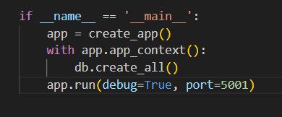

Register user
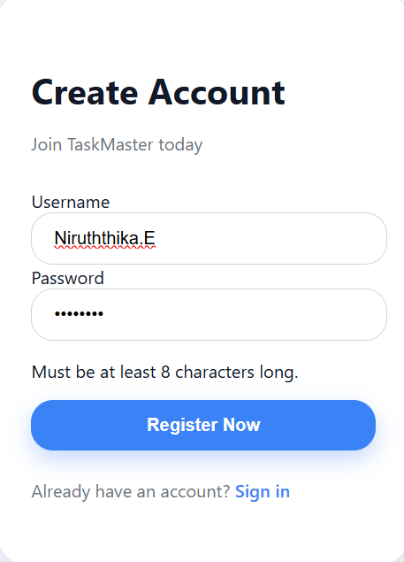

Login user
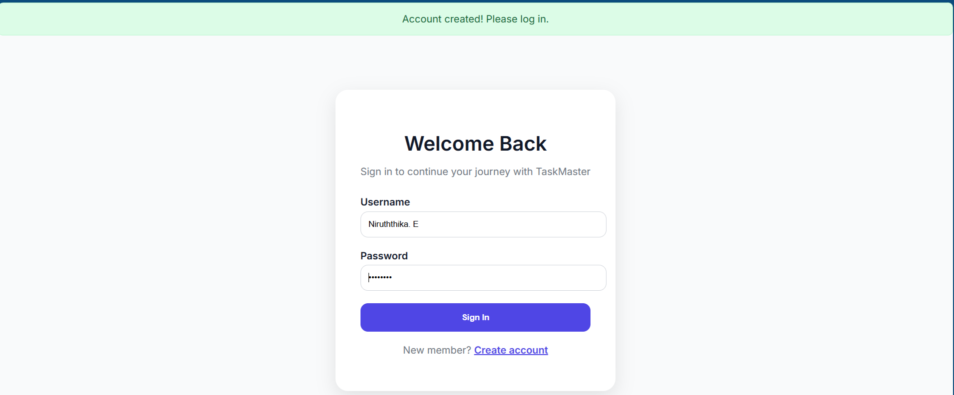

Add and view the task
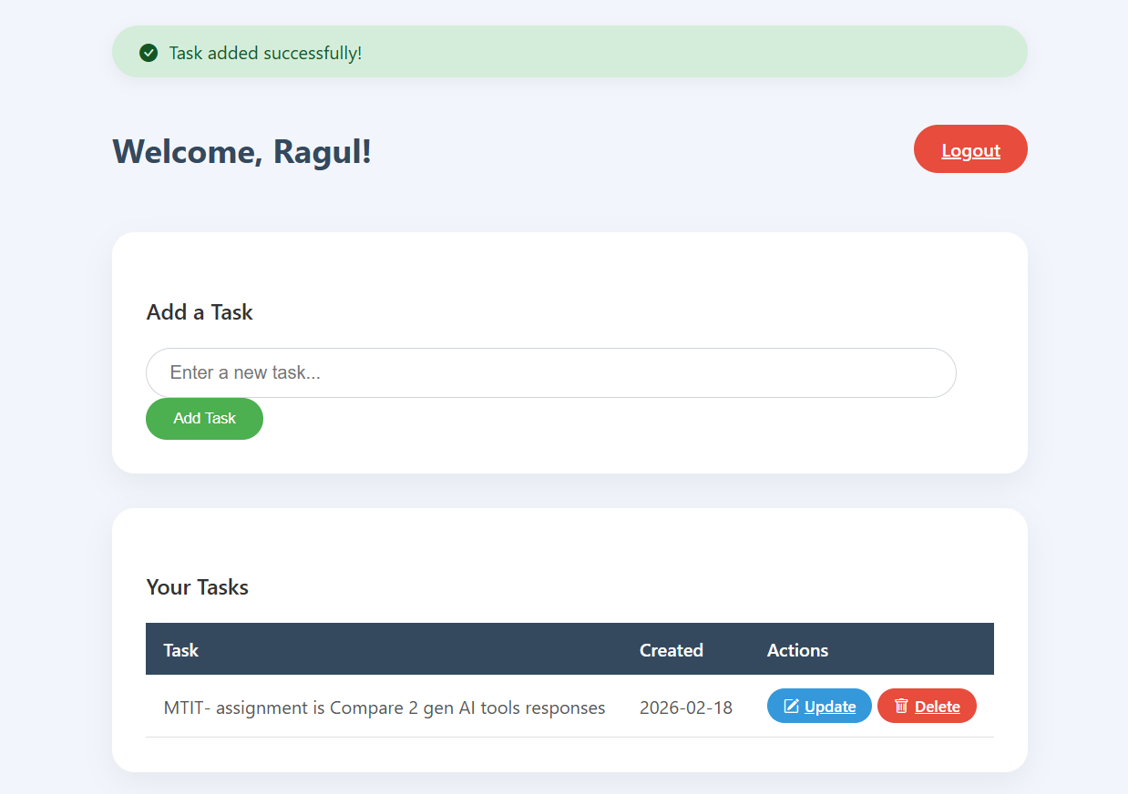

Update the task
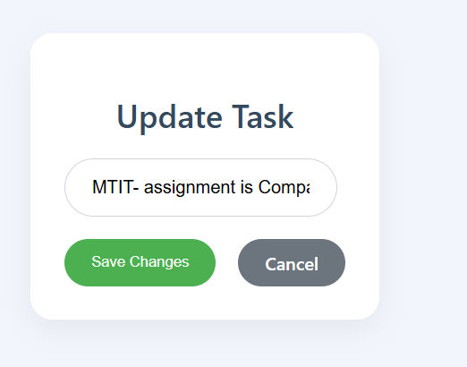

Delete the task
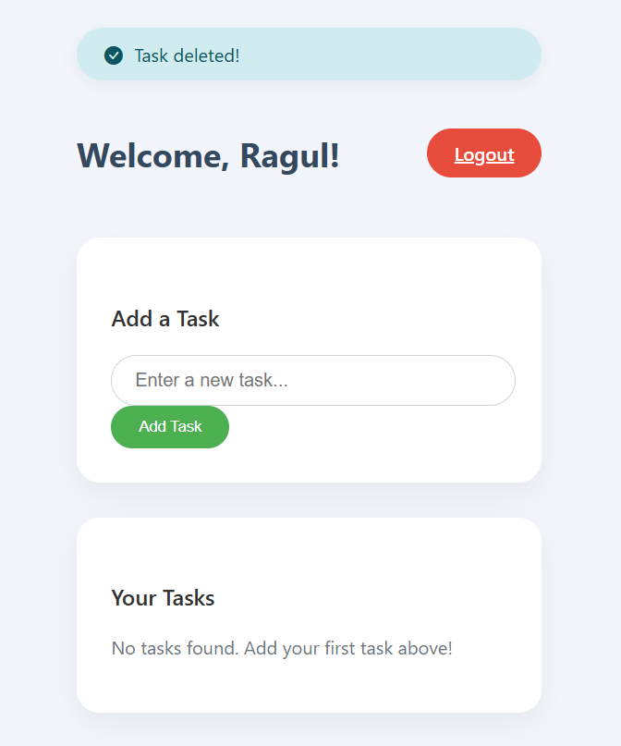

Validations

If user already registered can’t register again
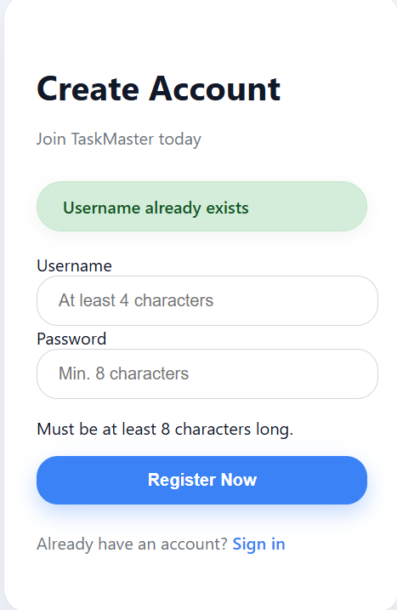

Password must include 8 characters
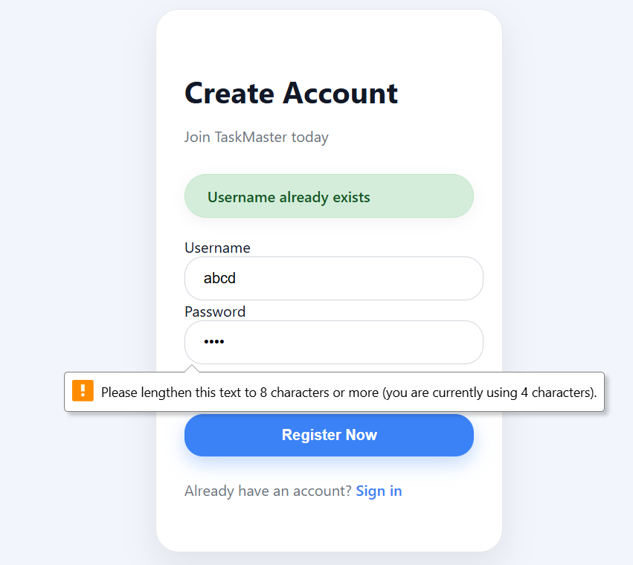

if username or password incorrect can’t login

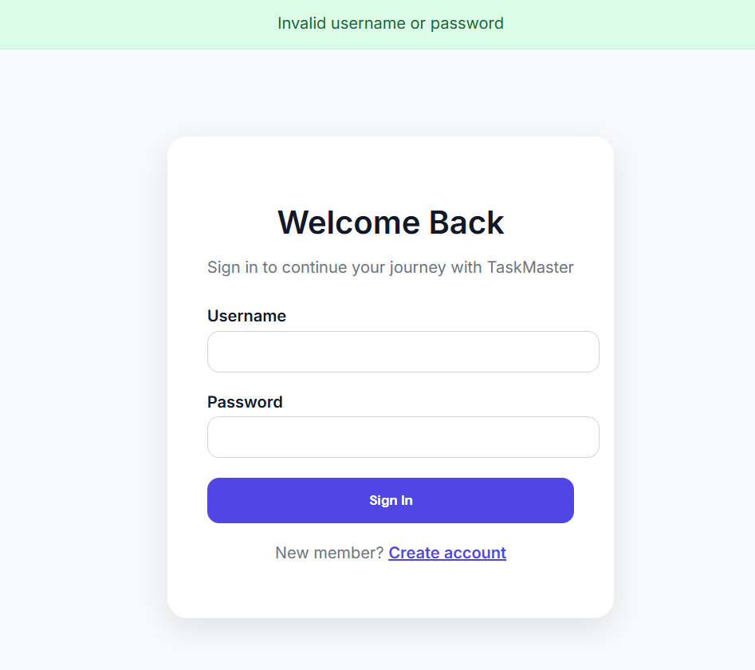

Task field is mandatory to fill
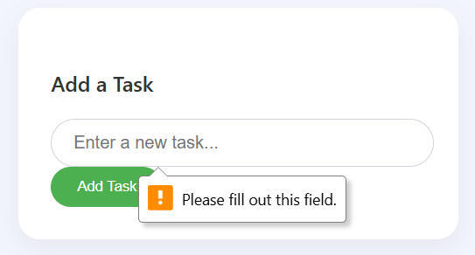

Manual work

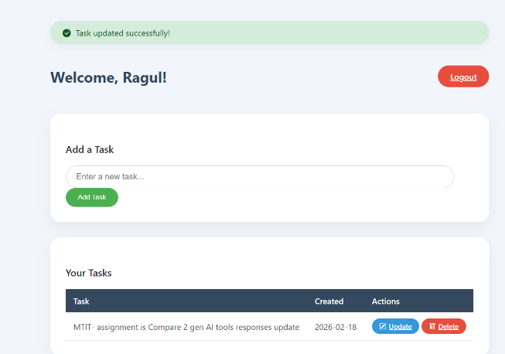
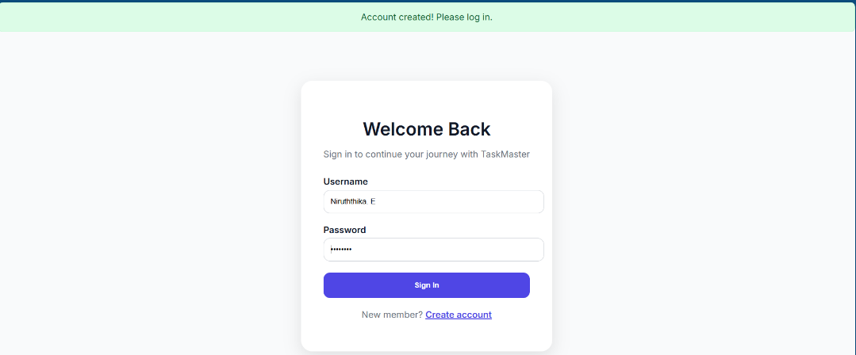
Add the notification when register/login add, update, delete task
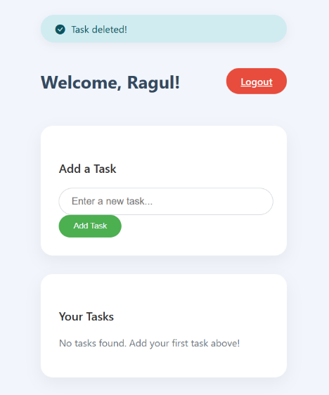
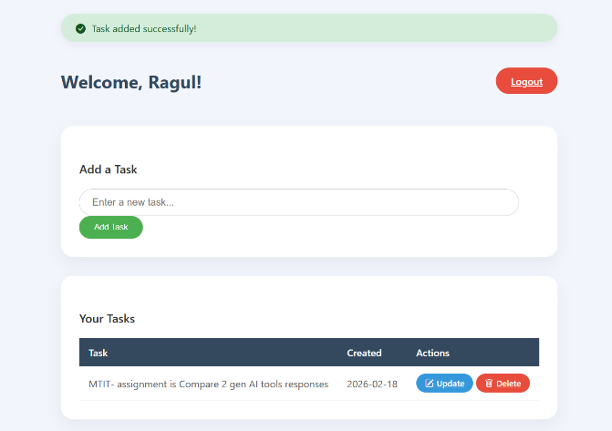
Change the form fields
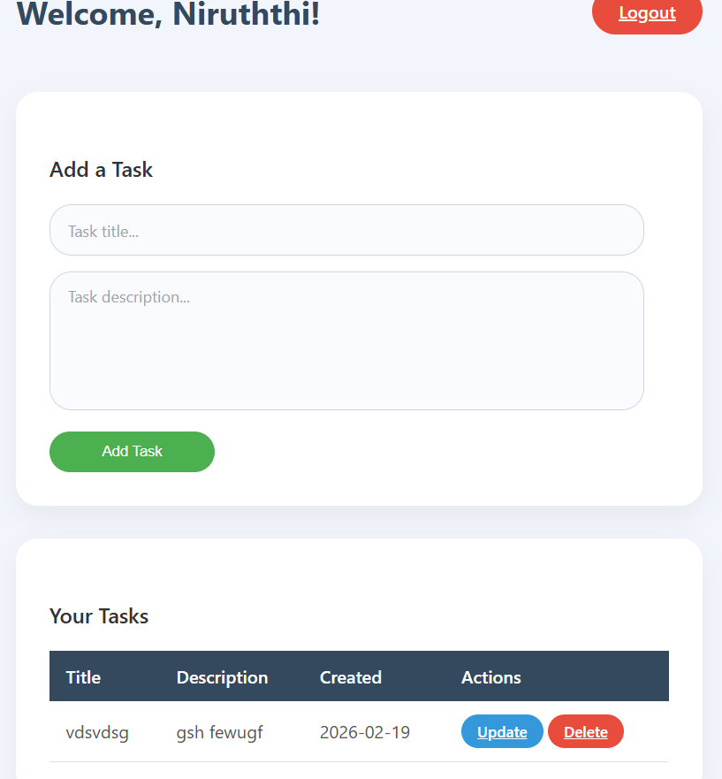
Task 2

Comparative Evaluation of Generative AI Tools
Tools Evaluated: ChatGPT and Google Gemini
Application Developed: Web-based Task Manager CRUD Application (Login, Register, Create, Read, Update, Delete Tasks)

Output Quality Evaluation
Output quality was evaluated based on functionality, correctness, structural design, UI/UX clarity, completeness of features, and the extent of manual corrections required.

ChatGPT – Output Analysis
- Fully functional authentication system (Login & Registration)
- Complete CRUD operations
- Notification system for task operations
- A structured dashboard interface
- Separation between form and task display
The dashboard design included an “Add Task” button, which dynamically opened a form. This approach demonstrated a better understanding of UI/UX principles by reducing visual clutter and improving user interaction flow.
However, ChatGPT did not initially implement comprehensive input validation. Client-side and backend validation had to be manually integrated. This indicates that while ChatGPT prioritizes functional completeness and usability, it may omit strict validation logic unless explicitly specified.
From a software engineering perspective, the architecture was more modular and readable, demonstrating better code maintainability.

Gemini – Output Analysis
- Functional authentication system
- CRUD operations
- Built-in input validation logic
Unlike ChatGPT, Gemini automatically included validation checks for user inputs. This suggests stronger backend correctness assumptions.
However, the dashboard design displayed the task form permanently above the task table. While functionally correct, this design reduced usability and aesthetic clarity. The lack of a notification system further reduced user interaction quality.
Gemini’s implementation focused more on backend logic correctness rather than interface optimization or user experience design.
Evaluation Criterion | ChatGPT | Gemini
Functional Correctness | High | High
Validation | Moderate (manual improvement required) | High
UI/UX Design | High | Moderate
Notification System | Implemented | Not implemented
Code Structure | Modular and clean | Compact but less structured
Manual Improvements Required | Validation | Notification + UI
Table 1. Evaluation based on output quality

Critical Analysis
ChatGPT produced a more user-oriented and production-ready structure, whereas Gemini emphasized backend validation. While both tools generated technically functional systems, ChatGPT demonstrated stronger interface awareness and system modularity, whereas Gemini demonstrated better default validation handling.
Overall, ChatGPT’s output quality was superior in terms of usability and design clarity, while Gemini showed strength in defensive programming practices.

Prompt Sensitivity Analysis
Prompt sensitivity was evaluated by comparing results from:
- Initial Detailed Prompt
- Refinement Prompt (Simplified and More Structured)

Initial Prompt Characteristics
- Full system requirements
- CRUD functionality specifications
- UI layout expectations
- Authentication requirements
- Dashboard structure
- Technology stack instructions
Both tools generated largely correct outputs under this detailed instruction
However, the results revealed differences:
- ChatGPT focused on system completeness and UI separation.
- Gemini emphasized validation and logical checks.

Refinement Prompt
A second iteration was conducted using a simplified refinement prompt.
The refinement prompt was:
- More concise
- More structured
- Focused on correcting specific missing features
- Less verbose than the initial version

Prompt Sensitivity
ChatGPT
- Highly responsive to refinement prompts.
- Improved layout when given UI-specific instructions.
- Demonstrated strong iterative improvement capability.
ChatGPT showed clear adaptability and prompt interpretation depth. The refined prompt significantly enhanced output precision without requiring excessive detail.

Gemini
- Also responded to refinement prompts.
- Required clearer and more explicit UI instructions to improve layout.
- Showed moderate improvement after refinement.
Gemini appeared less sensitive to subtle UI refinement instructions and required more direct specification.
Criterion | ChatGPT | Gemini
Response to Detailed Prompt | Strong | Strong
Response to Simplified Refinement Prompt | Very High | Moderate
Iterative Improvement | Significant | Moderate
UI Sensitivity | High | Lower
Backend Validation Sensitivity | Moderate | High
Table 2. Evaluation based on Prompt Sensitivity

Critical Analysis
The experiment demonstrates that ChatGPT exhibits higher prompt sensitivity, especially during iterative refinement. It responds effectively to both detailed and simplified prompts and adapts outputs accordingly.
Gemini performs well under detailed prompts but requires more explicit refinement instructions for interface or architectural changes.

Technical Limitations

ChatGPT Limitations
- Did not automatically enforce validation constraints.
- Assumed implicit validation unless explicitly required.
- May prioritize completeness over defensive programming.

Gemini Limitations
- Limited UI/UX awareness by default.
- No automatic notification integration.
- Less modular dashboard separation.
Technical Dimension | ChatGPT | Gemini
Default Input Validation | Not included automatically | Included automatically
UI/UX Design Awareness | High | Moderate
Notification Mechanism | Implemented | Not implemented
Modular Code Structure | More modular | Less modular
Prompt Dependency | Highly sensitive to explicit instructions | Moderately sensitive
Backend Defensive Programming | Moderate | Stronger
Table 3. Evaluation based on Technical Limitations

Critical Technical Analysis
ChatGPT demonstrates strengths in architectural structuring and user interaction modeling but requires explicit instructions for validation and security constraints.
Gemini demonstrates stronger automatic validation behavior but lacks interface sophistication and modular clarity.
Generative AI models generate syntactically correct and logically coherent code, but they do not inherently enforce enterprise-grade security, architectural best practices, or full-stack optimization unless explicitly prompted.

Performance Metrics
Performance was evaluated based on:
- Response time
- Code accuracy
- Feature completeness
- Explanation depth
- Debugging assistance

Response Speed
Both tools produced outputs within acceptable timeframes.
ChatGPT responses were slightly more consistent in formatting and explanation.

Code Accuracy
Both systems generated executable CRUD systems with minimal logical errors. Minor adjustments were required in both cases.

Debugging and Explanation
ChatGPT provided clearer explanations when debugging was requested.
Gemini focused more on direct code output rather than conceptual reasoning.

Metric | ChatGPT | Gemini
Speed | Fast | Moderate
Accuracy | High | High
UI Quality | High | Moderate
Validation Handling | Moderate | High
Explanation Quality | Detailed | Moderate
Iterative Enhancement | Strong | Moderate
Table 4. Evaluation based on Performance Metrics

