**A Project Report**

**On**

**Smart Restroom System Using 8051 Microcontroller**

**By**

**Nirvan Tamhane**

Bachelor of Technology in Electronics and Telecommunications Engineering

**Outcome of the Project**

The consumption of water and electricity has increased drastically over time due to increase in population which has caused a limited supply of water and electricity. In this case, we cannot afford to waste the remaining resources that we have to sustain future generations. Therefore, in order to save on both, water, and electricity in places like public, or maybe even private restrooms, an automated system must be used. This will not only have a great impact on resource consumption, but it will also have a higher rate of sanitization and convenience.

An automatic restroom system will help in automatically controlling the light by sensing the presence of a human being with the help of the Passive Infrared sensor and will also partially automate the flushing mechanism with the help of a water pump and Infrared sensor activation assembly.

This system monitors the presence of a human being and automatically switches ON/OFF the light automatically with the help of a relay circuit when a human is detected, thus saving heavily on electricity.

This system also monitors the presence of a human hand and switches ON/OFF the flush automatically with the help of a relay circuit when a human hand is detected, thus saving on water consumption as well.

**Project Equipment List**

* AT89S51 Microcontroller IC
* 11.059 MHz Crystal Oscillator
* 22pF Ceramic Capacitors
* 10uF 50V Electrolytic Capacitor
* 104 Ceramic Capacitor
* LM7805 Voltage Regulator
* 100uF Electrolytic Capacitor
* 1N4007 Diode
* 5mm 5V LED RED
* 10K Resistor
* 4-pin 6mm Push Button
* 4.7K Resistor Array
* PIR Sensor
* Infrared Sensor
* 4 In-line Relay Module
* Perfboard
* 220V AC to 5v 1A DC adapter
* LM2596 voltage regulator

**Block Diagram**



**Circuit Diagram**

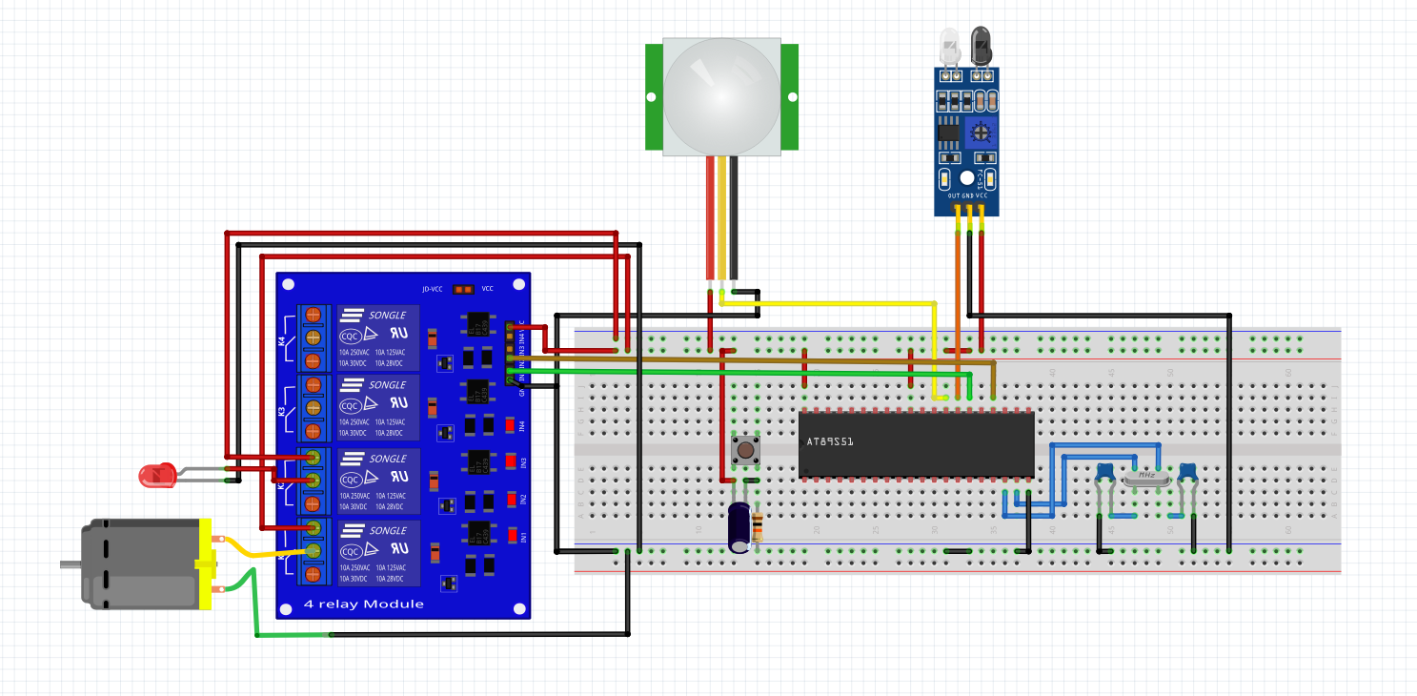

**Code:**

#include<reg51.h>

sbit PIR = P2^7;

sbit IR = P2^6;

sbit RELAY1 = P2^5;

sbit RELAY2 = P2^3;

void MSdelay(unsigned int val)

{

unsigned int i,j;

for(i=0;i<=val;i++)

for(j=0;j<112;j++); /* Delay of 1 ms for 11.0592MHz Frequency */

}

void main (void) {

while(1) {

if(PIR==1){

RELAY1 = 0; /PIR delay is set using the trimpot on the sensor/

if(IR==1){

RELAY2 = 0;

}

else{

RELAY2 = 1;

MSdelay(5000);

}

}

else{

RELAY1 = 1;

}

}

}