

FOUNDATIONS OF AGENTIC AI
Continuous Assessment 3 (CA-3): Project Report
ReturnWise
A Multi-Agent AI System for Intelligent E-commerce Return and Refund Resolution
Submitted by
Name | PRN
Neel Lakhani | 24070126120
Nirvan Uttamchandani | 24070126125

Faculty Guide
Dr. Harshal Raut
Symbiosis Institute of Technology, Pune
Constituent of Symbiosis International (Deemed University)

Abstract
Handling product returns is a high-volume, rule-heavy task in e-commerce. Each request needs an order lookup, a policy lookup, a return-window calculation and a decision about refund, replacement, rejection or escalation, and the decision must be explainable afterwards. This report presents ReturnWise, a proof-of-concept multi-agent system that automates the recommendation step. Five specialised agents (Intake and Planning, Order and Policy Research, Eligibility Evaluation, Resolution, and Validation) run in a fixed order under one orchestrator; each agent's output becomes the next agent's input, and an independent Validation agent re-checks the decision with eight checks and can force one bounded correction. The system is implemented in Python with a SQLite database of synthetic data and a Streamlit user interface. It was verified with 206 automated backend tests and twelve built-in scenarios, all of which pass; the output of every scenario is reproduced in Section 6 from the running application. The agents use deterministic rules rather than a language model, which makes results reproducible; the main limitations and the planned extensions are set out in Sections 7 and 8.
Keywords: multi-agent systems, agentic AI, orchestration, validation agent, e-commerce returns, Streamlit.

Contents
1. Introduction and Problem Statement 3
2. Literature Review 3
3. Existing Business Challenge and Proposed Solution 4
4. Agent Roles, Orchestration and Architecture 5
5. Implementation and Streamlit Proof of Concept 9
6. Output Validation and Results 10
7. Limitations 18
8. Future Scope 18
9. Conclusion 19
References 19

1. Introduction and Problem Statement

1.1 Background
Online retailers receive a steady stream of return requests. For every request a support employee must open the order, find the policy for that product category, count the days since delivery, judge whether the stated reason is acceptable and, if so, work out the amount to refund. These steps follow written rules, yet they are still done by hand and repeated thousands of times. Recent work on agentic AI shows that complex tasks can be split between cooperating agents with defined roles [1], [2], [3]; ReturnWise applies that idea to a narrow, well-defined business process.

1.2 Problem Statement
Support teams must decide, for every return request, whether to refund, replace, reject or escalate it. Doing this manually is slow, two employees can reach different decisions for the same case, refund amounts can be mis-typed, restricted items can be approved by mistake, and there is no reliable record of why a decision was taken. The problem addressed in this project is: how can a return request be analysed and resolved consistently, with every step explainable and every decision independently checked, using cooperating software agents?

1.3 Domain Justification
E-commerce returns were chosen because the domain has four properties that make a multi-agent design natural rather than forced:
- Explicit rules. Eligibility depends on facts a program can check: order status, product category, days since delivery and the stated reason.
- Costly errors. A wrong refund amount, or approval of a non-returnable item, is direct financial loss, so an independent second check has real value.
- Audit requirement. Each decision must be explainable later: what data was read, which rules passed or failed, and which component decided what.
- Naturally staged work. Intake, research, rule evaluation, decision and review are distinct jobs, which map to distinct agents with clear inputs and outputs.

1.4 Objectives and Scope
- Design five agents with clearly separated roles and an orchestrator that passes each agent's output to the next.
- Add an independent Validation agent that re-checks every decision and can trigger one bounded correction.
- Build a working Streamlit proof of concept on synthetic data, with every agent step visible to the user.
- Verify the system with automated tests and with scripted scenarios whose outputs are shown in this report.
The system only recommends an outcome. It never moves money, and its labels read “Refund Recommended”, never “Refunded”. All data (20 orders, 8 product categories, fictional policies) is synthetic, and the reference date is fixed at 15 February 2025 so that results are reproducible.

2. Literature Review
Seven peer-reviewed papers and preprints published after 2022 were reviewed. They fall into three groups: multi-agent frameworks [1], [2], [3]; evaluation of agents in policy-driven customer-service settings and of their failures [4], [7]; and critique, refinement and judging of model outputs [5], [6]. Table 1 summarises each work and its relevance to ReturnWise. Every entry was checked against the paper's abstract page.
Table 1. Literature review of related work published after 2022
Ref. | Authors, year and venue | Focus and key finding | Relevance to ReturnWise
[1] | Wu et al., 2023. AutoGen. arXiv:2308.08155 | Open framework for applications built from several conversable agents that combine LLMs, tools and human input; interactions are scripted in natural language and code. | Supports the use of role-based agents. ReturnWise differs by using fixed, deterministic hand-offs instead of free conversation, which makes runs repeatable.
[2] | Hong et al., 2023. MetaGPT. ICLR 2024 | Encodes human standard operating procedures into prompt sequences so role-based agents work like an assembly line, limiting errors that compound when LLMs are chained naively. | Closest in spirit: a staged pipeline with defined outputs per role, like the Intake, Research, Eligibility and Resolution stages.
[3] | Guo et al., 2024. LLM-based multi-agents: progress and challenges. IJCAI 2024 (survey) | Surveys how multi-agent systems are profiled, how agents communicate and how capabilities grow; lists benchmarks and open challenges. | Provides the vocabulary (planner, executor, critic) used to name the roles in this project.
[4] | Yao et al., 2024. τ-bench. ICLR 2025 | Benchmark of tool-using agents talking to simulated users under domain policies (retail, airline). The best model tested reached about 61% pass^1 on retail and under 25% pass^8, i.e. results were inconsistent across repeated trials. | Shows that policy-bound customer-service decisions are hard to make consistently, which motivates enforcing the rules in code and validating each result.
[5] | Madaan et al., 2023. Self-Refine. NeurIPS 2023 | A model generates an answer, critiques it and revises it repeatedly without extra training; reported average gain of about 20% (absolute) over one-step generation on seven tasks. | The Validation-then-correction loop follows the same generate, critique, revise pattern, but the critic is a separate agent and the loop is bounded to one correction.
[6] | Zheng et al., 2023. LLM-as-a-Judge, MT-Bench and Chatbot Arena. NeurIPS 2023 (Datasets and Benchmarks) | Studies strong LLMs as judges of other models' outputs; GPT-4-level judges agreed with human preferences more than 80% of the time. | Supports the idea of a separate evaluator. ReturnWise's Critic uses explicit rule checks, not an LLM judge, so its verdicts are deterministic.
[7] | Cemri et al., 2025. Why do multi-agent LLM systems fail? arXiv:2503.13657 | Analyses over 1,600 annotated traces from seven frameworks and proposes a taxonomy of 14 failure modes in three categories. | Motivates explicit verification, early stop on agent errors and a bounded correction loop, all present in ReturnWise.

Research gap and contribution. The reviewed systems are mostly built around language models and report accuracy on benchmarks. Less attention is given to a small, transparent pipeline in which every hand-off is visible, every rule is traceable and an independent checker can overrule the decision. ReturnWise takes this complementary route: it adopts the role separation of [1]–[3], the critique-and-revise loop of [5], and the verification emphasis of [4] and [7], but implements the agents as testable Python rules. Its results should therefore be read as a demonstration of the architecture on synthetic data, not as a comparison with LLM-based agents.

3. Existing Business Challenge and Proposed Solution
Table 2. Existing challenges and how ReturnWise addresses them
Existing challenge (manual process) | Proposed solution (ReturnWise)
Staff open the order, look for the policy and count the days themselves. | Five agents run one after another; each agent's output is the next agent's input.
Two employees can handle the same case differently. | The same rules are applied every time, so the same case always gets the same answer.
Refund amounts are typed by hand. | The amount is read from the order record and never typed.
Restricted items can be approved by mistake. | A Validation agent runs eight independent checks and can send the decision back for one correction.
Unclear or inconsistent cases are not clearly flagged. | Unclear or inconsistent cases are routed to manual review instead of being guessed.
There is no reliable record of why a decision was taken. | Every step's input, output and verdict is stored in the database for audit.

The solution is deliberately conservative. The agents are plain Python with fixed rules (no language model and no API key), so the same input always gives the same result and every behaviour can be tested. The system recommends and explains; a human remains responsible for acting on the recommendation.

4. Agent Roles, Orchestration and Architecture

4.1 Agent Roles and Responsibilities
Table 3 lists the five agents. The columns “Reads” and “Produces” show the hand-off: each agent consumes the output of the previous stage, and the Validation agent additionally receives the Research and Eligibility outputs so that it can re-derive the facts instead of trusting the Resolution agent.
Table 3. Agent roles, inputs and outputs
Agent (role) | Responsibility | Reads | Produces
1. Intake and Planning (Planner) | Validates the order ID, normalises the reason, flags keywords in the description and builds the task plan. | Form input | order_id, reason, description_flags, task_plan
2. Order and Policy Research (Research) | Reads the order and product policy from SQLite, computes days since delivery and the window check, and checks the data is consistent. | Intake output | order, policy, days_since_delivery, within_window, data_issues, evidence
3. Eligibility Evaluation (Executor) | Applies four policy rules and safeguards, then calculates the refund amount. | Research output and reason | eligibility, permitted_actions, refund_amount, rule_checks, failed_rules
4. Resolution (Business Automation) | Picks refund, replacement, reject or manual review from the permitted actions and explains why. | Intake, Research and Eligibility outputs | recommended_action, refund_amount, policy_explanation, confidence
5. Validation (Critic) | Runs eight independent checks, proposes corrected values if one fails, and re-checks once. | Resolution, Research and Eligibility outputs | validation_status, detected_errors, corrected_action and amount

4.2 Orchestration Workflow
The orchestrator (workflow.py) is a hub-and-spoke controller. Figure 1 shows the order of execution. A request first passes input validation in the service layer; the orchestrator then calls Agents 1 to 4 in sequence and tests each result. If any agent reports an error, the run stops early: the failing agent is logged as an error, all later agents are stored as SKIPPED, and the request is marked failed without inventing a recommendation. If Agent 4 succeeds, Agent 5 validates the result. A passed verdict saves the request as validated. A failed verdict starts the single correction loop: the Resolution agent copies the Critic's corrected values (step 6) and the Critic re-checks them (step 7). If the second verdict still fails, the request is saved as Manual Review Required. The whole run, from agent step 1 to step 7, is written in one database transaction, so a partial run is never recorded as complete.
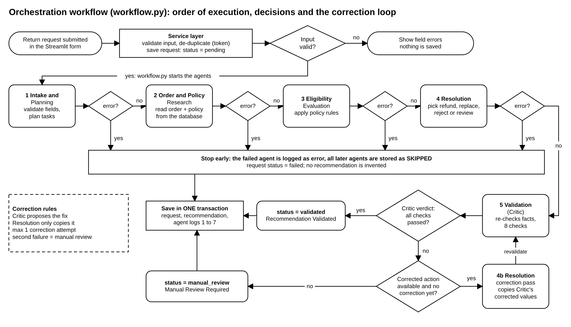
Figure 1. Orchestration workflow: order of execution, decisions and the correction loop

4.3 System Architecture
Figure 2 shows the layers of the system. The presentation layer (Streamlit pages) contains no business rules; it calls the service layer, which validates input, removes duplicate submissions and calls the orchestrator through process_return(). The agent layer holds the five agents. The agents use three tools: the rule functions in policies/rules.py (return-window and data-integrity checks), the policy document return_policy.json, and the parameterised SQL functions in database/repository.py. All agents read from and the orchestrator writes to a single SQLite database. The dashed box marks the optional React and FastAPI web interface that reuses the same service layer and is not required for the proof of concept.
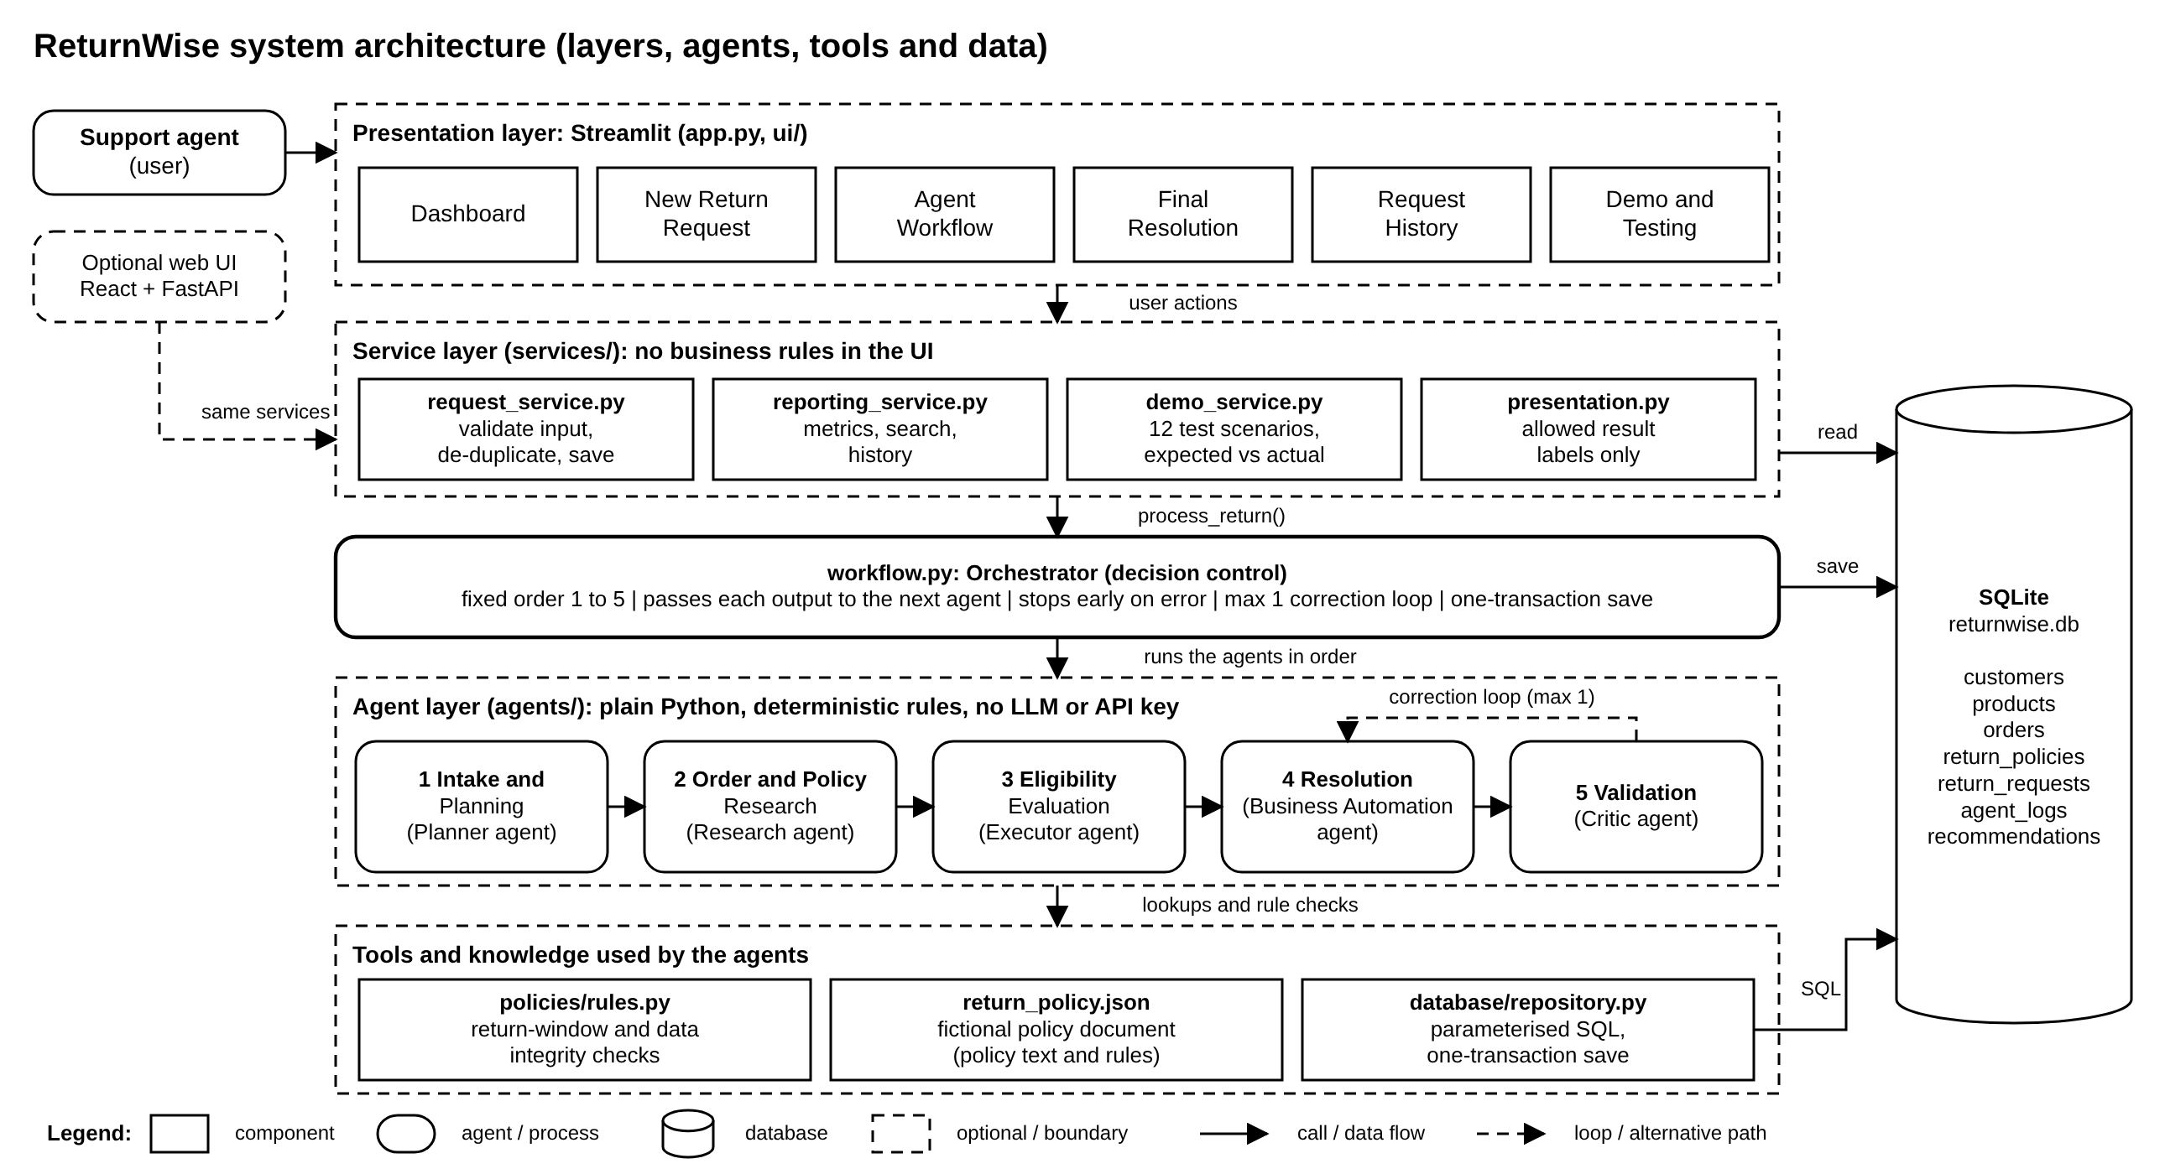
Figure 2. System architecture: layers, agents, tools and data store

4.4 Agent Collaboration and Data Flow
Figure 3 shows what is handed from one agent to the next. Hand-off 1 carries the validated order ID, the normalised reason and the task plan. Hand-off 2 carries the order row, the policy row, the days since delivery and the window result. Hand-off 3 carries the eligibility verdict, permitted actions and refund amount, and Hand-off 4 carries the recommended action and its explanation. The dashed arrow shows that the Critic also receives the Research and Eligibility outputs, and the dotted loop shows corrected values returning to the Resolution agent at most once. The lower part of the figure shows that the orchestrator stores every input and output in the agent_logs table. This property was tested: in a matrix of 100 runs (20 orders with 5 reasons each) the order ID, refund amount and eligibility were identical at every hand-off, and the saved recommendation equalled the final Resolution output.
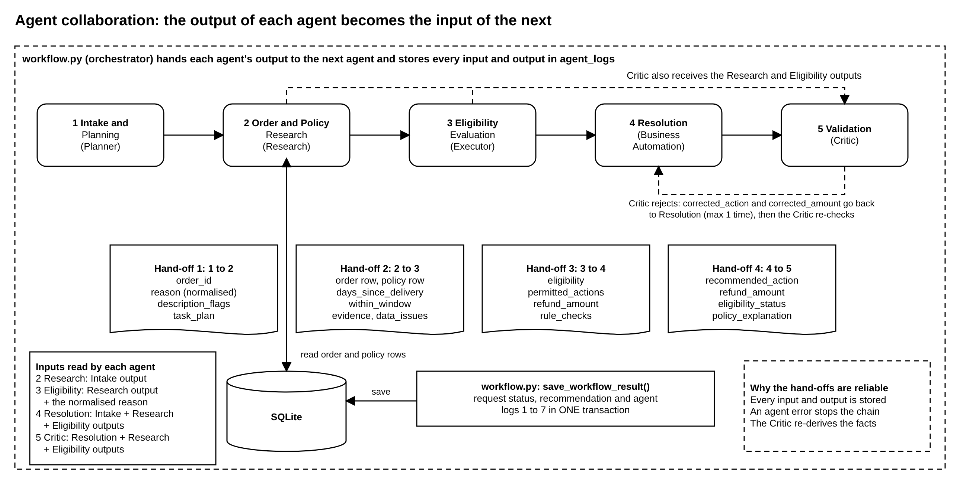
Figure 3. Agent collaboration: the output of each agent becomes the input of the next

4.5 Decision-Making: Eligibility Rules
Figure 4 shows how Agent 3 decides. First, four rules are always evaluated and any failure is collected: the order status must be delivered, the category must be returnable, the request must fall inside the return window, and the reason must be accepted by the policy. Then the outcome is chosen in a fixed order: inconsistent order data or a missing delivery date gives manual review; the reason “other” gives manual review; any failed rule gives ineligible; a replacement-only category gives replacement; and otherwise the refund amount (equal to the order total) is accepted only if it lies between 0 and 50,000, else the case goes to manual review. The Resolution agent then maps these results to a recommended action and never grants an action the Eligibility agent did not permit.
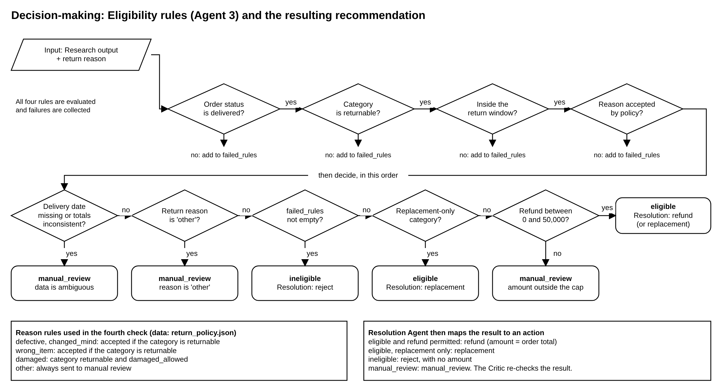
Figure 4. Eligibility rules (Agent 3) and the resulting recommendation

4.6 Output Validation: the Critic and the Correction Loop
Figure 5 shows the Validation agent. It performs eight checks: (1) the action is a known action; (2) it is consistent with the eligibility verdict; (3) the refund equals the order total; (4) no non-returnable item is approved; (5) replacement-only goods are never refunded; (6) manual-review cases are not auto-decided; (7) the order status supports the action; and (8) the delivered, returnable and in-window facts are recomputed independently from the order and policy rows. If all checks pass, the status is validated. If not, the Critic proposes a corrected action and amount, the Resolution agent applies them, and the Critic re-runs the same checks once. A second failure ends in manual review, so the loop cannot run indefinitely. The trust boundary is stated in the figure: the Critic does not trust the Resolution or Eligibility agents, but it treats the order record read by the Research agent as the ground truth (see Section 7).
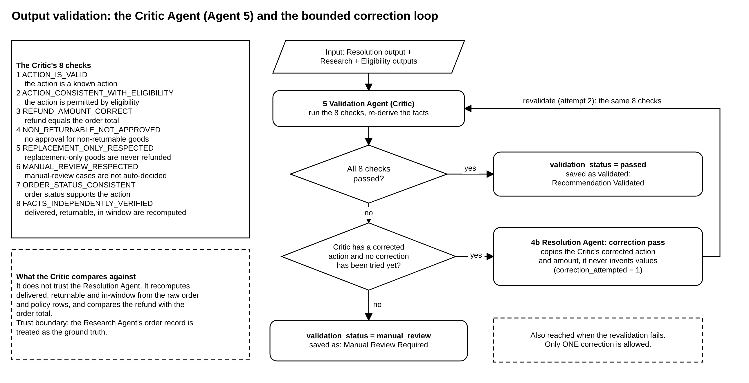
Figure 5. Critic validation (Agent 5) and the bounded correction loop

4.7 Data Model
Figure 6 shows the seven SQLite tables. customers, products, orders and return_policies hold the synthetic business data. return_requests stores each request and its final status, agent_logs stores one row per agent step with its input and output, and recommendations stores the final action, amount and validation result. The link from return_requests to orders is deliberately a soft link rather than a foreign key, so that a request for an unknown order can still be stored as a failed request, as scenario SC-05 shows.
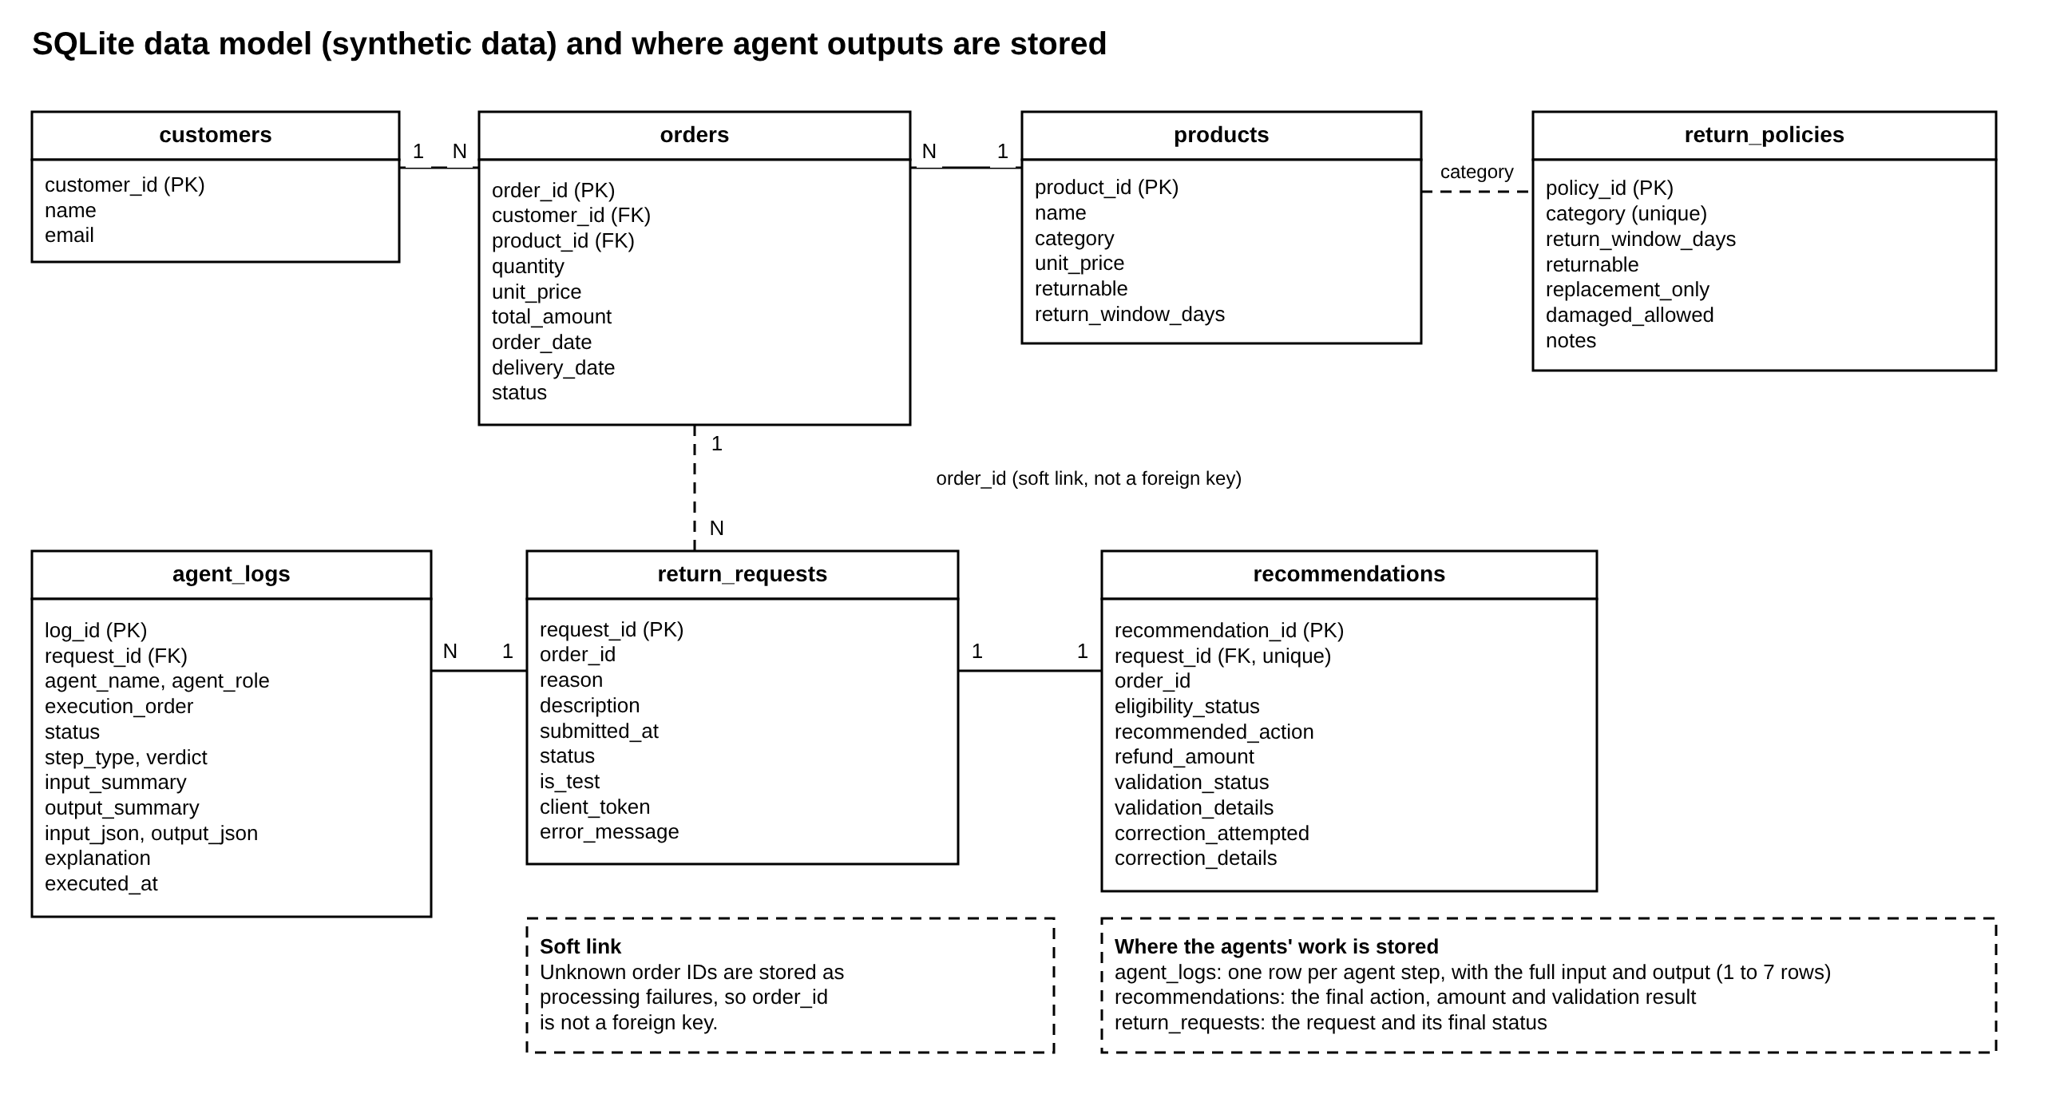
Figure 6. Database schema and where agent outputs are stored

5. Implementation and Streamlit Proof of Concept
The system is implemented in Python 3 with Streamlit 1.66 for the user interface and SQLite for storage. Table 4 maps the project folders to the layers in Figure 2. The application runs with the commands pip install -r requirements.txt followed by streamlit run app.py; no API key or network access is needed.
Table 4. Project structure
Folder or file | Purpose
agents/ | The five agent modules (intake, research, eligibility, resolution, validation).
workflow.py | Orchestrator: calls the agents in order, passes outputs on, runs the correction loop, saves in one transaction.
services/ | Request service (validation, de-duplication), reporting service, demo-scenario service, wording of result labels.
policies/ | Rule functions and the fictional policy document (return_policy.json).
database/ | Schema, synthetic seed data (20 orders, 8 categories) and the repository with parameterised SQL.
ui/ and app.py | Streamlit pages: Dashboard, New Return Request, Agent Workflow, Final Resolution, Request History, Demo and Testing.
tests/ | Automated tests (206 backend tests) including the collaboration and fault-injection tests.

Figures 7 to 10 show the main pages. The Dashboard shows counts read from the database (requests processed, refund, replacement and rejection recommendations, manual reviews, validation failures and corrections). The New Return Request page takes an order ID, a reason and an optional description; a one-time token prevents a refresh from creating a duplicate request. The Final Resolution page shows the recommendation, the order and policy facts behind it, the supporting evidence and the table of Critic checks. The Agent Workflow page, used extensively in Section 6, shows each agent as a step with its status and, between steps, a line naming the data handed from one agent to the next.
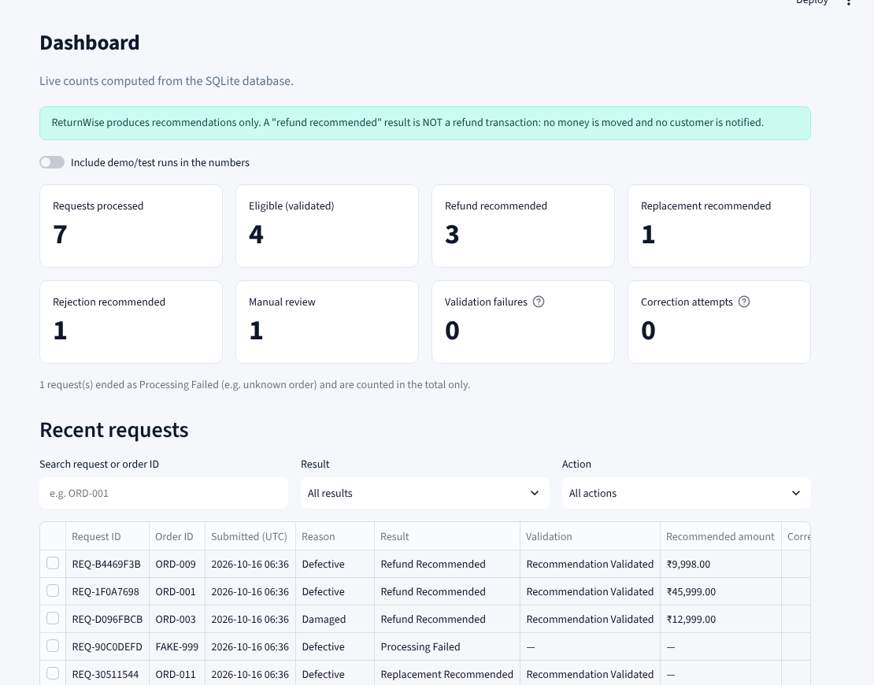 | 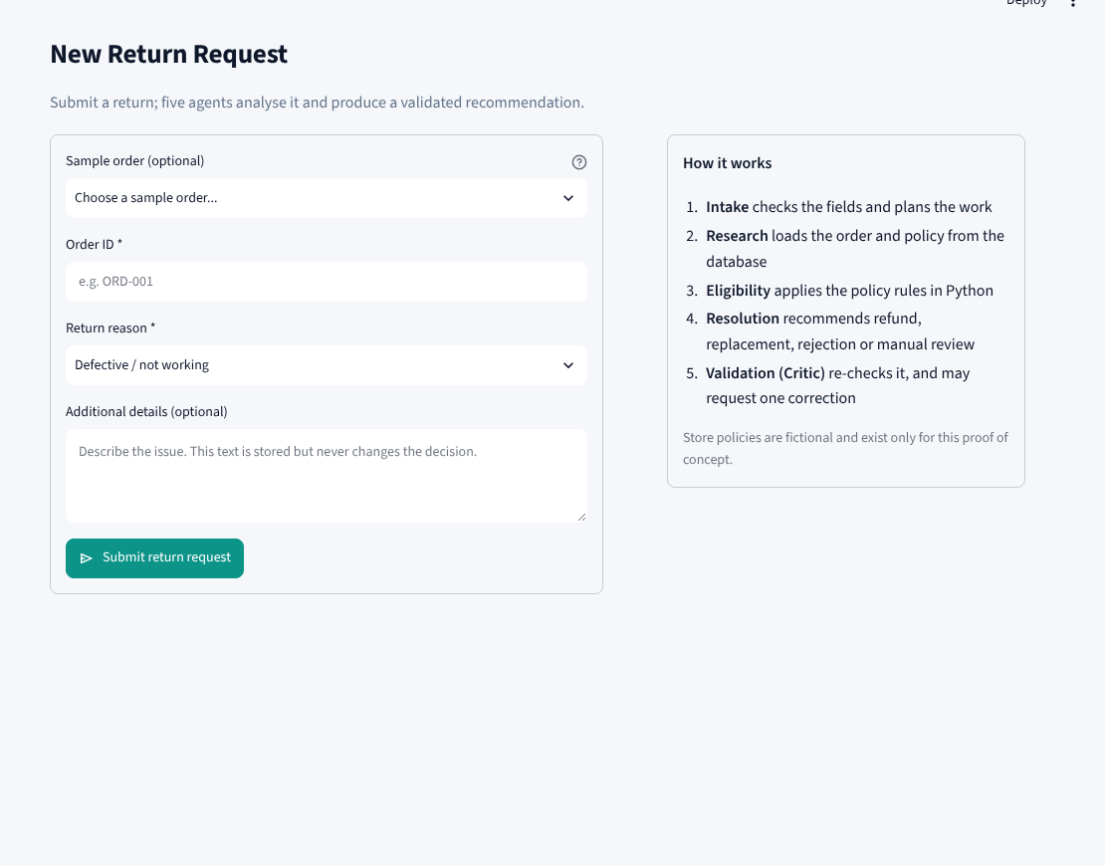
Figure 7. Dashboard. | Figure 8. New Return Request.
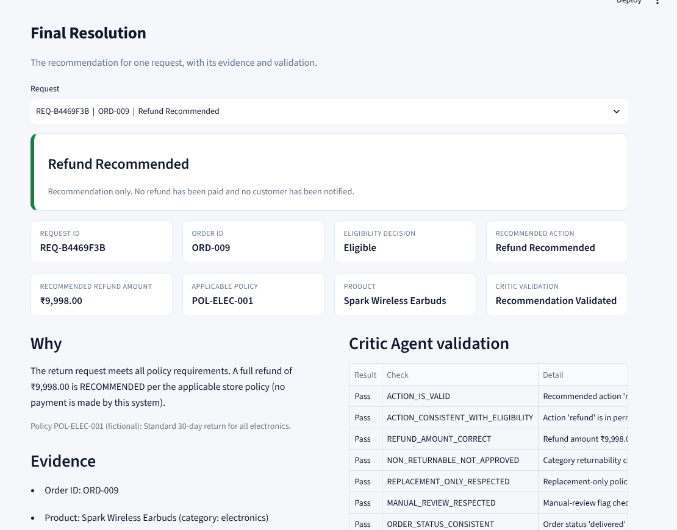 | 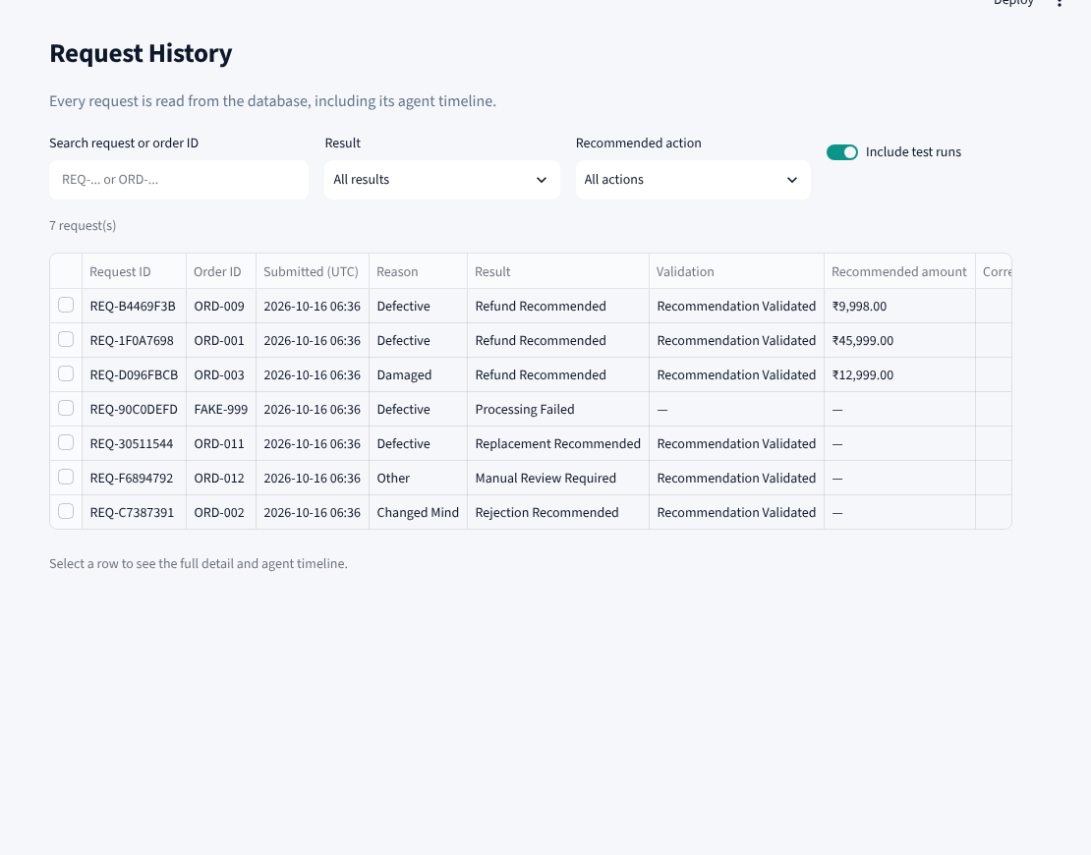
Figure 9. Final Resolution. | Figure 10. Request History.

6. Output Validation and Results

6.1 Validation Strategy
Output validation was done at three levels. (a) At run time, the Validation agent checks every decision with the eight checks of Section 4.6. (b) Automated tests check the code: 206 backend tests pass in about 8.5 seconds (Table 5). They include fault-injection tests, in which a wrong amount or action is planted and the Critic must catch and correct it, and the 100-run collaboration matrix described in Section 4.4. (c) Scenario testing runs twelve scripted scenarios through the real workflow from the Demo and Testing page of the application. Each scenario states its expected outcome in advance, and a scenario is marked Passed only if every expected value matches the value stored in the database; pressing Run alone does not count as a pass.
Table 5. Automated backend tests by area (206 passed in 8.5 s)
Test area | Tests | Test area | Tests
Agents (unit) | 38 | Policy rules | 17
Workflow (orchestration) | 38 | Validation (Critic) | 14
Optional API layer | 36 | Demo scenarios | 14
Database and repository | 26 | UI (Streamlit AppTest) | 18
Collaboration (hand-offs) | 5 | Total | 206 passed

The automated tests check logic and displayed text only. How the pages look was checked separately by opening them in a browser and inspecting the screenshots reproduced in this report; this was done at a screen size of 1440 × 900 pixels, and no user study was carried out.

6.2 Scenario Results at a Glance
Table 6 summarises the twelve scenarios. Sections 6.3 to 6.5 reproduce the output of each one exactly as the application displayed it.
Table 6. Summary of the twelve demonstration scenarios (12 of 12 passed)
ID | Scenario (order, reason) | Expected outcome | Result
SC-01 | Valid return within window (ORD-001, defective) | Refund Rs. 45,999; validated | Pass
SC-02 | Expired return window (ORD-002, changed mind) | Reject; validated | Pass
SC-03 | Damaged product within window (ORD-003, damaged) | Refund Rs. 12,999; validated | Pass
SC-04 | Restricted product, digital licence (ORD-006, changed mind) | Reject; validated | Pass
SC-05 | Unknown order (FAKE-999, defective) | Failed; agents 3 to 5 skipped | Pass
SC-06 | Missing order ID (blank, defective) | Rejected at intake; nothing saved | Pass
SC-07 | Reason “other” (ORD-012) | Manual review | Pass
SC-08 | Replacement-only category (ORD-011, defective) | Replacement; no cash amount | Pass
SC-09 | Injected wrong amount (ORD-001) | Critic fails it; corrected to Rs. 45,999; revalidated | Pass
SC-10 | Injected wrong action on restricted item (ORD-006) | Critic fails it; corrected to Reject; revalidated | Pass
SC-11 | Persistent error that correction cannot fix (ORD-002) | Escalated to manual review | Pass
SC-12 | Already-returned order (ORD-008, defective) | Reject; validated | Pass

6.3 Normal Cases: Refund, Rejection and Replacement
SC-01: Valid return within the window. Order ORD-001 (electronics, delivered 10 days earlier) is returned as defective. All four rules pass, so the Resolution agent recommends a full refund of Rs. 45,999 and the Critic passes all checks. Every expected value matches the stored result.
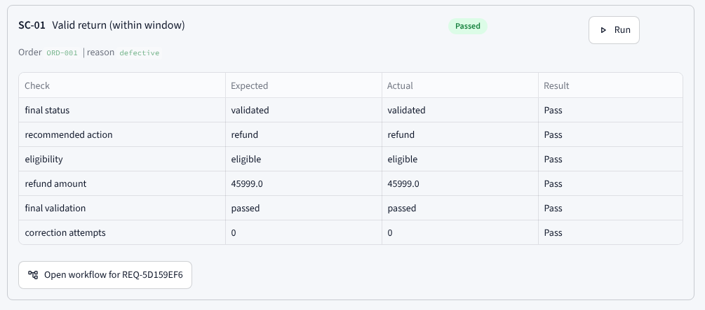
Figure 11. Output of SC-01 in the Demo and Testing page
SC-02: Expired return window. Order ORD-002 (clothing) was delivered 70 days earlier and the category window is 60 days. The window rule fails, the request is ineligible, the recommendation is Reject with no amount, and the Critic validates it.
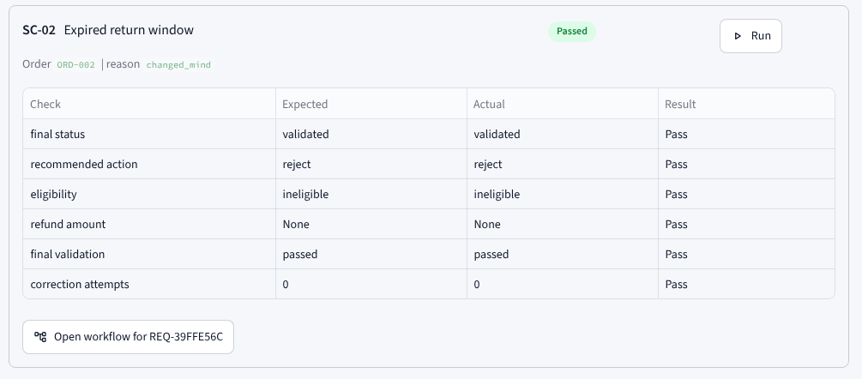
Figure 12. Output of SC-02 in the Demo and Testing page
SC-03: Damaged product within the window. Order ORD-003 is returned as damaged. The category is returnable and accepts damage claims, so a refund of Rs. 12,999 (the order total) is recommended and validated.
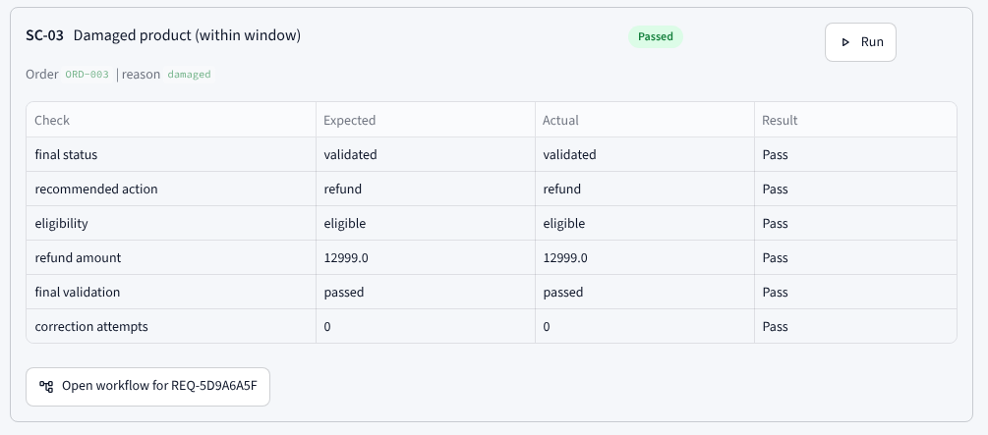
Figure 13. Output of SC-03 in the Demo and Testing page
SC-04: Restricted product. Order ORD-006 is a digital licence, which the policy marks as non-returnable. The category rule fails and the request is rejected even though the customer gives a reason.
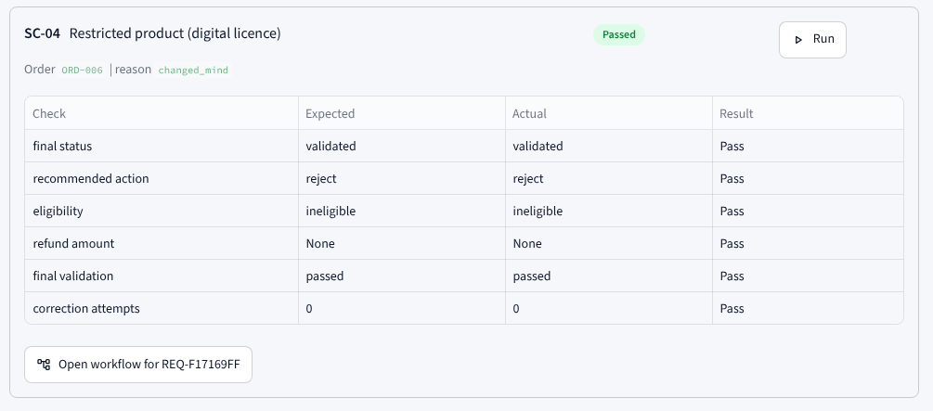
Figure 14. Output of SC-04 in the Demo and Testing page
SC-08: Replacement-only category. Order ORD-011 belongs to a health and safety category where only replacement is permitted. The Eligibility agent permits “replacement” only, the Resolution agent recommends replacement, and no cash amount is shown.
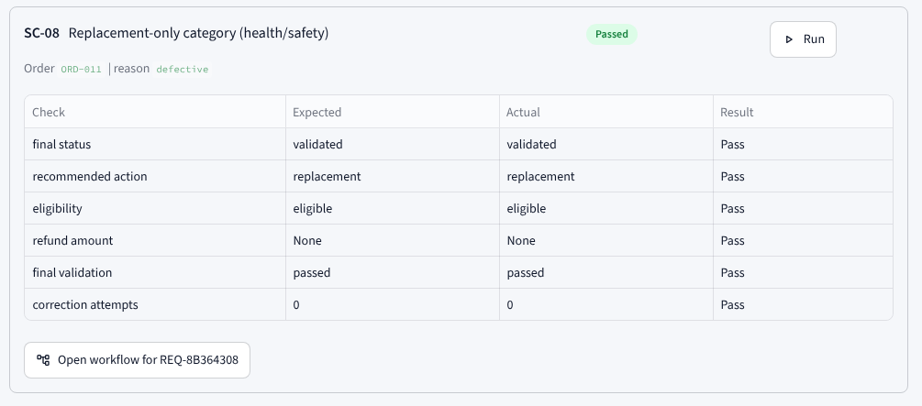
Figure 15. Output of SC-08 in the Demo and Testing page
SC-12: Already-returned order. Order ORD-008 has already been returned. The order-status rule fails, so the request is rejected; this prevents a second refund for the same order.
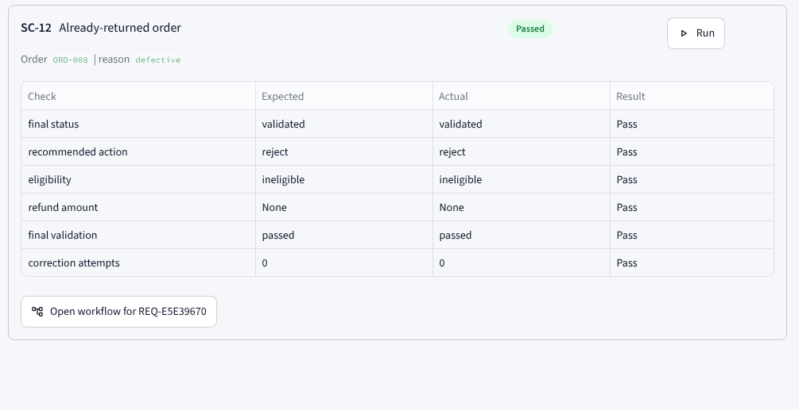
Figure 16. Output of SC-12 in the Demo and Testing page

6.4 Edge Cases: Invalid Input, Unknown Orders and Manual Review
SC-05: Unknown order. Order ID FAKE-999 does not exist. The Research agent fails with “order not found”, so Agents 3, 4 and 5 are skipped and the request is saved as Processing Failed without any recommendation.
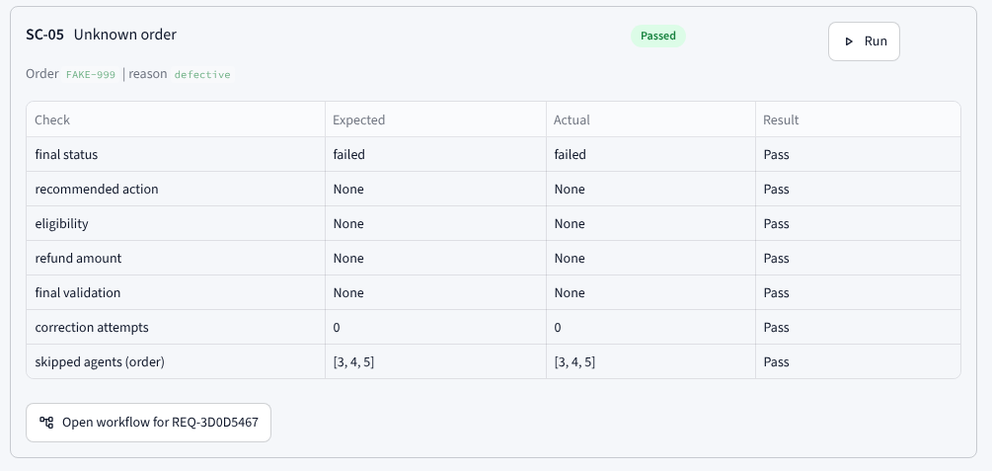
Figure 17. Output of SC-05 in the Demo and Testing page
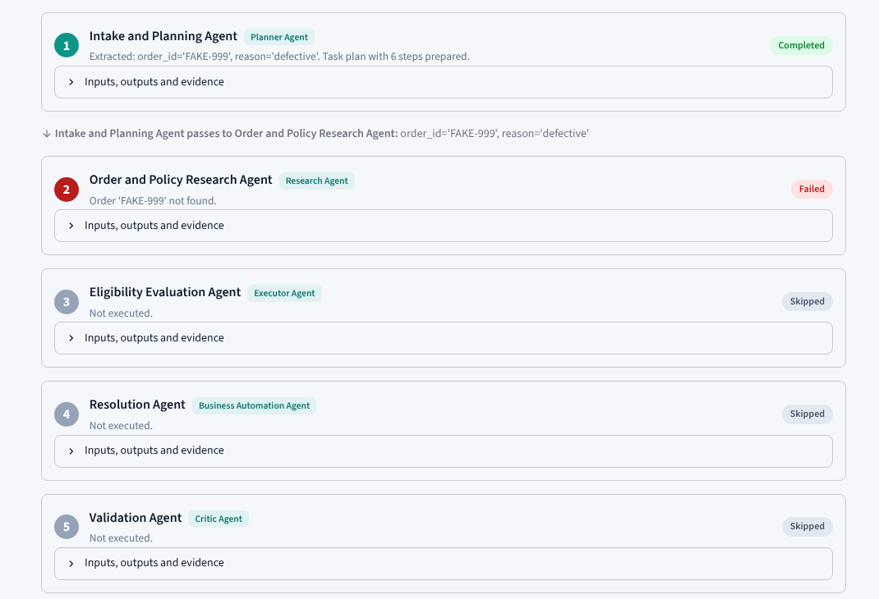
Figure 18. Agent Workflow page for SC-05: Agent 2 fails and Agents 3 to 5 are shown as Skipped
SC-06: Missing required field. The order ID is left blank. The service layer rejects the input and the Intake check reports order_id as the faulty field. No request row is created, which is why the scenario expects 0 rows.
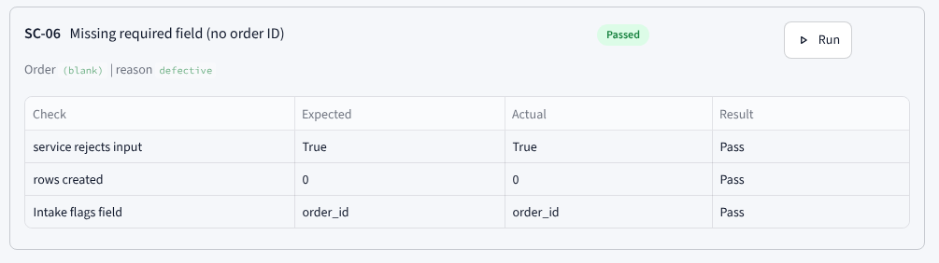
Figure 19. Output of SC-06 in the Demo and Testing page
SC-07: Reason “other”. Order ORD-012 is submitted with the reason “other”. The policy requires a human to look at unspecified reasons, so the Eligibility agent returns manual_review and the Resolution agent does not decide.
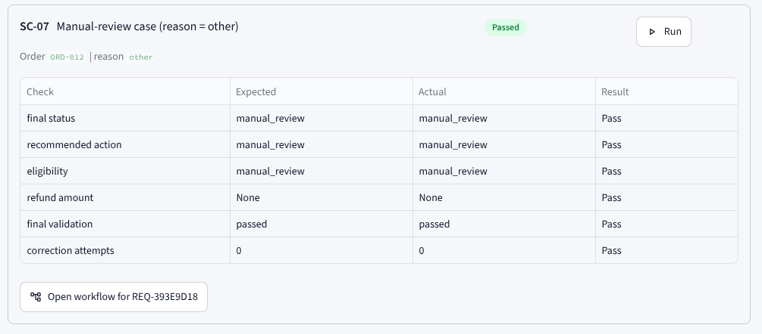
Figure 20. Output of SC-07 in the Demo and Testing page

6.5 Validation Cases: Fault Injection and the Correction Loop
In these scenarios a deliberate fault is planted in the Resolution agent's output (marked TEST FAULT in the interface) to show that the Validation agent detects it and that the correction loop behaves as designed.
SC-09: Injected wrong amount. The Resolution agent's refund for ORD-001 is replaced by Rs. 4,599.90. The Critic fails the first validation (7 of 8 checks) because the amount differs from the order total, the Resolution agent applies the corrected amount of Rs. 45,999, and the revalidation passes (8 of 8). The request ends as validated with one correction.
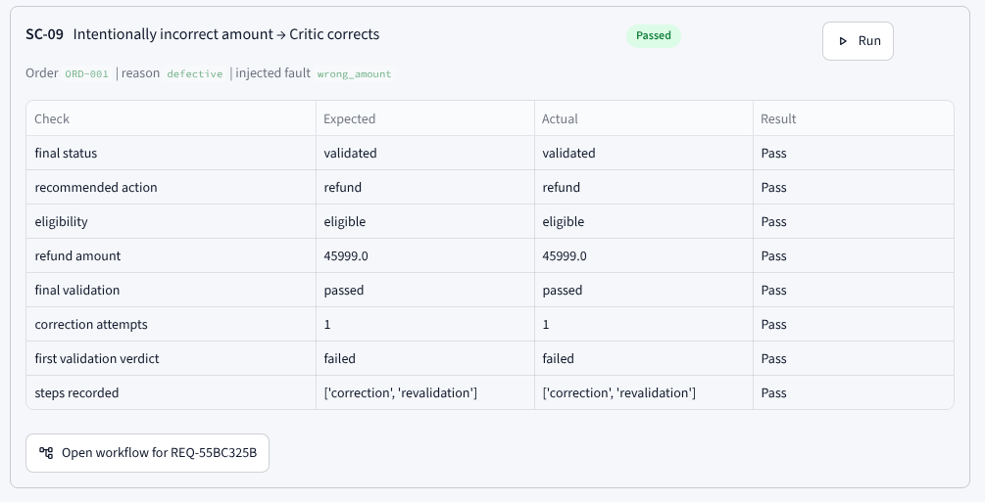
Figure 21. Output of SC-09 in the Demo and Testing page
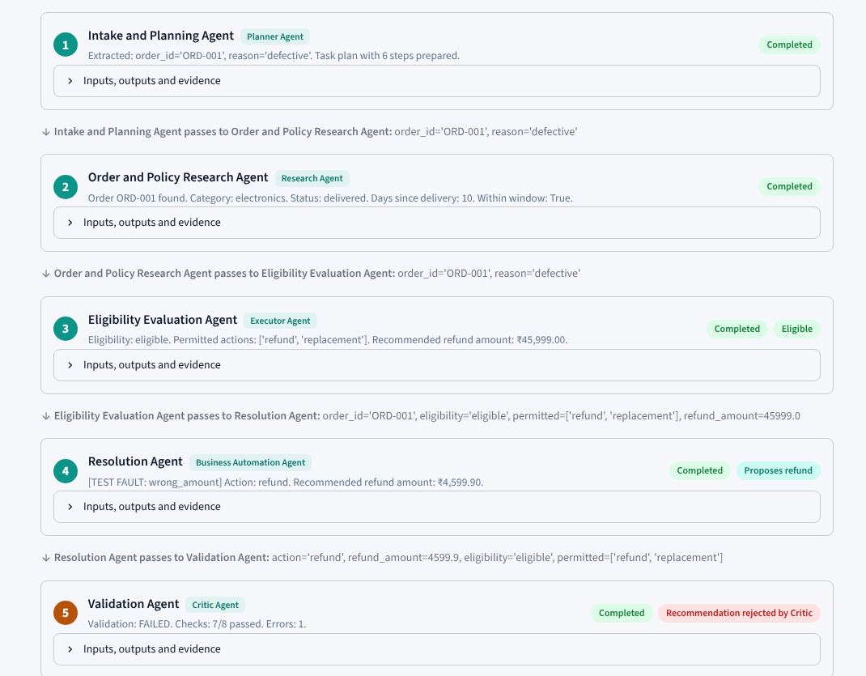
Figure 22. Agent Workflow page for SC-09 (first part): hand-offs between Agents 1 to 5 and the Critic rejecting the amount
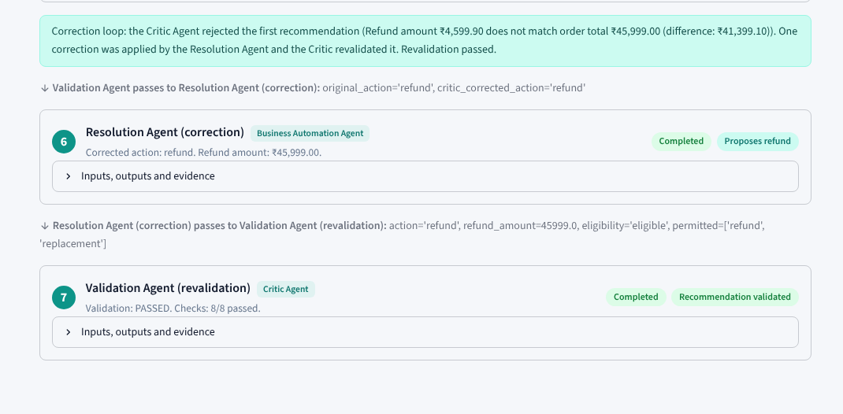
Figure 23. Agent Workflow page for SC-09 (second part): correction step 6 and revalidation step 7 pass
SC-10: Injected wrong action on a restricted item. A refund is planted for restricted order ORD-006. The Critic detects that a non-returnable item cannot be approved, proposes Reject, the correction is applied and the revalidation passes.
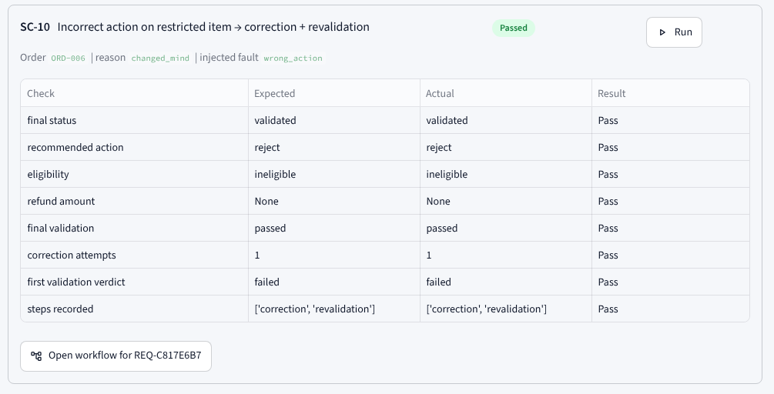
Figure 24. Output of SC-10 in the Demo and Testing page
SC-11: Correction that cannot fix the error. For ORD-002 the planted error persists after the correction. The first validation fails, the correction is applied, and the revalidation fails again (6 of 8 checks), so the loop stops and the request is escalated to Manual Review Required rather than looping or approving a refund.
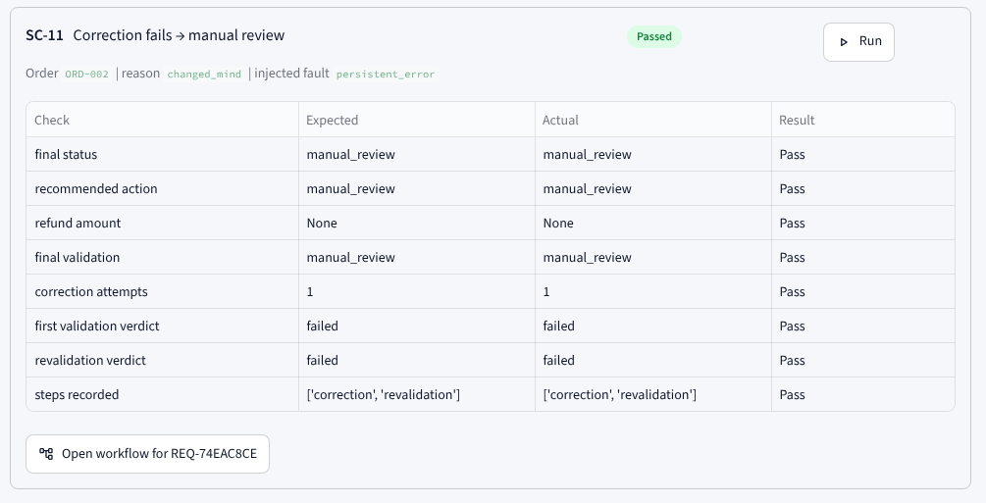
Figure 25. Output of SC-11 in the Demo and Testing page
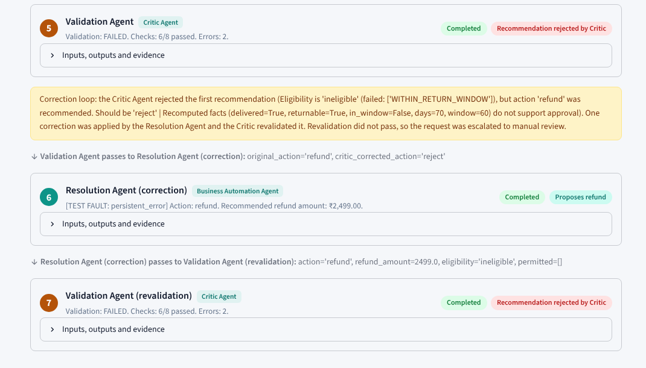
Figure 26. Agent Workflow page for SC-11: the revalidation also fails, so the request is escalated to manual review

6.6 Discussion of Results
All twelve scenarios behaved as specified. The normal cases show that the rules produce the expected refund, replacement and rejection outcomes; the edge cases show that invalid or unknown input never produces a recommendation; and the validation cases show that the Critic catches planted errors, that a correction is applied at most once and that an unfixable case ends in manual review. Together with the 206 passing tests, this supports the claim that the architecture works as designed on the synthetic data. It does not show how the system would perform on real return data, which has more variety than the 20 orders used here.

7. Limitations
- Synthetic data only. The 20 orders and the policies are fictional and the reference date is fixed at 15 February 2025.
- Rule-based agents. The agents are deterministic Python rules, not language models. The free-text description is only keyword-flagged and is not understood.
- Critic trust boundary. The Critic re-verifies the Eligibility and Resolution agents, but it treats the order record read by the Research agent as ground truth. A wrong order record would therefore not be caught; a test that tampers with the Research output confirmed this behaviour.
- Narrow business scope. Only full refunds are supported: no partial refunds, restocking fees, shipping costs, photo evidence or fraud signals.
- No integrations. There is no real payment, notification or order-management connection, and no login or user roles.
- Scale and display. SQLite is a single-writer database, and the layout was checked on a laptop-sized screen only.

8. Future Scope
- Add a language model carefully. Use an LLM only to summarise or classify the customer's description, treat its output as untrusted, and never let it override the rules.
- Strengthen the Critic. Let the Validation agent read the order directly from the database so it no longer relies on the Research agent's record.
- Richer policies. Support partial refunds, restocking fees, photo evidence and fraud signals, with a policy editor.
- Real integrations. Connect payment, order-management and notification systems, with human approval before any money moves.
- Production backend. Move to a server database with a job queue, and add login, roles and monitoring.
- Evaluation on real data. Test on anonymised real returns and measure agreement with human decisions, as benchmarks such as τ-bench [4] do for LLM agents.

9. Conclusion
ReturnWise shows that a return request can be processed by five cooperating agents with explicit hand-offs, an orchestrator that stops on errors, and an independent Validation agent that can overrule a decision once before escalating to a human. The Streamlit proof of concept makes every step visible. All 206 backend tests and all twelve scenarios pass, and their outputs are reproduced in this report. The main limits are the synthetic data, the rule-based agents and the Critic's trust in the Research agent's order record; the future scope addresses each of them. The same design pattern (specialised roles, visible hand-offs, a bounded verifier) could be reused for other policy-driven back-office tasks.

References
[1] Q. Wu, G. Bansal, J. Zhang et al., “AutoGen: Enabling next-gen LLM applications via multi-agent conversation,” arXiv:2308.08155, Aug. 2023.
[2] S. Hong et al., “MetaGPT: Meta programming for a multi-agent collaborative framework,” in Proc. Int. Conf. Learning Representations (ICLR), 2024. arXiv:2308.00352.
[3] T. Guo, X. Chen, Y. Wang, R. Chang, S. Pei, N. V. Chawla, O. Wiest and X. Zhang, “Large language model based multi-agents: A survey of progress and challenges,” in Proc. Int. Joint Conf. Artificial Intelligence (IJCAI), 2024. arXiv:2402.01680.
[4] S. Yao, N. Shinn, P. Razavi and K. Narasimhan, “τ-bench: A benchmark for tool-agent-user interaction in real-world domains,” in Proc. ICLR, 2025. arXiv:2406.12045.
[5] A. Madaan et al., “Self-Refine: Iterative refinement with self-feedback,” in Advances in Neural Information Processing Systems (NeurIPS), vol. 36, 2023. arXiv:2303.17651.
[6] L. Zheng, W.-L. Chiang, Y. Sheng et al., “Judging LLM-as-a-judge with MT-Bench and Chatbot Arena,” in Advances in Neural Information Processing Systems (NeurIPS), vol. 36, Datasets and Benchmarks Track, 2023.
[7] M. Cemri, M. Z. Pan, S. Yang et al., “Why do multi-agent LLM systems fail?,” arXiv:2503.13657, Mar. 2025.

