# 

**SYSTEM REQUIREMENTS SPECIFICATION**

# TABLE OF CONTENTS

**TABLE OF CONTENTS** **2**

**LIST OF FIGURES** **4**

**LIST OF TABLES** **4**

**1.0 Introduction** **4**

1.1 Purpose of Document 4

1.2 High-Level Product Overview 5

1.3 Acronyms & Extrapolations 5

**2.0 PROJECT CONSIDERATIONS** **7**

2.1 Identified Costs 7

2.2 Possible Tools 7

2.3 Open Issues and Questions 8

2.4 Long-Term Plans for Future Releases and Features 8

**3.0 PROJECT SCOPE** **9**

APP Version 9

Browser version 9

Hardware Version 10

3.1 User Profile 10

APP Version 10

Browser Version 11

3.2 User Interface Map 12

APP Version 12

Browser Version 12

3.3 System Architecture Diagram 13

**4.0 FUNCTIONAL REQUIREMENTS** **14**

APP Version 14

Browser Version 22

Hardware Version 36

Database 39

APP Version 39

Browser Version 39

Hardware Version 39

**5.0 NON-FUNCTIONAL REQUIREMENTS** **40**

App Version 40

Browser Version 41

Hardware Version 42

**6.0 USE CASE DIAGRAM** **43**

App Version 43

Browser Version 43

**7.0 USE CASE DESCRIPTIONS** **44**

App Version 44

Browser Version 46

# 

# LIST OF FIGURES

Figure A_3-1:User-Interface Map of LTC-TMS(APP version)

Figure B_3-1: User-Interface Map of LTC-TMS(Browser version)

Figure M_3-1: System architecture of LTC-TMS

Figure A_6-2: Use case diagram(APP version)

Figure B_6-1: Use case diagram(Browser version)

# LIST OF TABLES

Table M_1-1: Acronyms and definitions

Table M_2-1: Demand buying list

Table O_4-1: The Old Table of Family Mobile Functional Requirements

Table O_4-2: The Old Table of CNA Mobile Functional Requirements

Table O_4-3: Table of old Functional Requirements

Table A_4-1: The New Table of Family Mobile Functional Requirements

Table A_4-2: The New table of CNA Mobile Functional Requirements

Table O_4-3: Table of old Functional Requirements

Table B_4-1: Table of new or modified Functional Requirements

Table O_4-4: Table of old Functional Requirements

Table H_4-1: Table of New or Modified Functional Requirements

Table A_4-3: Functional Requirements

Table B_4-2: Functional Requirements

Table H_4-2: Functional Requirements

Table A_7-1: Fully Developed Use Case Description for View Task Instruction

Table B_7-1: Fully Developed Use Case Description for View Task Instruction

### 

# 1.0 Introduction

## 1.1 Purpose of Document

This document is the Software Requirements Specification for the Long-Term Care Task Management System. The purpose of this document is to list all project considerations, define the project scope, list all functional and nonfunctional requirements, and create use case diagrams with proper descriptions. The project considerations section identifies all potential expenses, problems, ongoing questions, and tools. The project scope section lists all functions that the Long-Term Care Task Management System must provide. The section also lists the different roles and actions that each user may take. The System Architecture Diagram section is a visual representation of the flow of information inside the Long-Term Care Task Management System from a hardware perspective. Sections four and five lists all of the functional and nonfunctional requirements. Existing functional requirements are given a category, requirement ID, description, and priority level. New functional requirements, as well as changes to existing requirements, are given a new requirements ID or corresponding ID respectively. Nonfunctional requirements are given a purpose and a metric used to quantify each requirement. Section six and seven detail the use cases of the system.

## 1.2 High-Level Product Overview

The Long-Term Care Task Management System is a product that will provide a convenient data logging, tracking and patient monitoring system for healthcare facilities to document and manage their patients, facility, and staff. The system will provide applications that are available through a web browser and smartphones. These applications allow staff to document patient information as well as manage their work schedule and store notes relevant to their many tasks on a daily basis. The system provides a hierarchical management interface which allows a Supervisor to delegate and oversee tasks that are given to the Chief Nursing Officer or Certified Nursing Assistant. The Chief Nursing Officer may also oversee and delegate tasks for the Certified Nursing Assistant. The system will gather patient metrics such as heart rate through a wearable device as well as track conditions such as air quality through static hardware located in each patient's room. A database will store all of the information related to the Long-Term Care Task Management System.

## 1.3 Acronyms & Extrapolations

Listed below in Table 1 are all of the acronyms used in the Software Requirements Specification. All acronyms and definitions may be used interchangeably throughout the document.

Table M_1-1: Acronyms and definitions

|  |  |
| --- | --- |
| Acronym | Definition |
| KU | Kutztown University of Pennsylvania |
| MCU | Ming Chuan University |
| SRS | Software Requirements Specification |
| ID | Identifier |
| IT | Information Technology |
| AI | Artificial Intelligence |
| LTC-TMS | Long-Term Care Task Management System |
| CNO | Chief Nursing Officer |
| CNA | Certified Nursing Assistant |
| App | Application |
| HIPPA | Health Insurance Portability and Accountability Act |
| FR | Functional Requirement |
| DB | Database |
| HW | Hardware |
| PM | Project Management |
| SPP | Software Project Plan |
| PDF | Portable Document Format |
| AN | Indicates new Application requirement (ID number) |
| AM | Indicates change in Application requirement (ID number) |
| BN | Indicates new Browser requirement (ID number) |
| BM | Indicates change in Browser requirement (ID number) |
| HN | Indicates new Hardware requirement (ID number) |
| HM | Indicates change in Hardware requirement (ID number) |

# 2.0 PROJECT CONSIDERATIONS

Section 2.0 outlines information regarding the project in terms of costs, tools, concerns, future development and adherence to industry standards.

## 2.1 Identified Costs

Costs are being structured to only have the needed products and future progress will be with this guideline in mind. As of this moment, Firebase has been picked as the database/Host. Hardware will be the largest expense based on acquiring micro:bit and Raspberry Pi with all needed accessories such as groove shield and other sensors. The Table 2.1 below shows the demand buying list of the project.

Table M_2-1: Demand buying list

|  |  |  |  |  |  |  |
| --- | --- | --- | --- | --- | --- | --- |
| SPRING SEMESTER BUYING LIST | | | | | | |
| ITEM | | PRICE | DESCRIPTION | | | Total |
| Raspberry Pi 3 B+ | | $1890 | 1. Raspberry PI 3 B+  2. 專用六片組合外殼+散熱風扇  3. 32G記憶卡  4. 專用散熱片 | | | $1890 |
| Micro bit | | $450 | 單片Micro bit | | | $1800 |

## 2.2 Possible Tools

Tools will be clearly stated, whether in terms of Firebase (Real-Time Database) modifications or hardware structure. Firebase Cloud server will be used for the duration of the project. Communication/file sharing tools used are Google-based services such as google hangouts/drive. For overall class communication slack is used. Lucidchart was used for the creation of all diagram. GitHub will be used for storing all code and will be shared for the entire class.

Hardware Tools:

The following is showing all the possible tools we need for the project.

* Raspberry Pi 3 B+ and power cord
* iUniker Dual Fan Cooling System Module with Heat sink
* slave Micro: bit
* master Micro: bit
* Heart Rate Sensor
* Adafruit ADS1015
* seven Breadboard Jumper cables
* USB A-Male to micro B cable
* HDMI cable
* 16 GB SD card
* Grove GPS sensor
* Temperature sensor
* Air quality sensor

Programming

* JavaScript
* python
* makecode editor

## 2.3 Open Issues and Questions

Open concerns that will continue throughout the duration of the project are in terms of scalability and structure of data processing. How much storage in Firebase will be required to store patient data? How frequently can the database be updated and how long will client information be held in the database? What limits are set on the internal users as to what they can and can't see? Will those Restrictions be the same for the external users as well? Will the MCU team be able to duplicate the computing environment of KU? Will the MCU team be able to maintain and improve the LTC-TMS system handed over by KU?

Another important issue is the availability of the proper technological infrastructure at the LTC building. Do they already possess the adequate hardware and networking facilities needed to implement this new system? How many routers or access points would be necessary to have a stable internet connection? Also, we need to consider the fact that if we are to connect multiple PCs via ethernet cables and switches there might need to be some running of wires or light construction done in or around the building. These are things we should keep in mind if we are to successfully implement the new system.

Furthermore, there are concerns about data loss and data security. How will security in the current version be implemented? How might future versions improve security? Will user data be safe? To what extent is hashing and encryption used throughout? Could future versions implement local buffer servers to store and distribute data locally in case of network failure? These are some of the concerns that we should ethically consider very seriously as should future development groups, however, existing time and budget constraints are always a force for compromise on the issue. Setting an ideal compromise that ensures sufficient security while allowing the system to be feasible with our resources will be a difficult issue.

## 2.4 Long-Term Plans for Future Releases and Features

The project is initially going to be an incremental improvement over version 2.0 and hopefully will have the necessary functionality for it to be an iterative evolution once the following steps are implemented.

* Close to real-time data logging and patient monitoring on browser and application client via data from Hardware units.
* Improve cost scaling allowing more Wearable (Microbit Units) to connect communicate with one Base Station (Raspberry Pi unit)
* Improvement of Usability across the whole system
* Implement improved user account access
* Creating a document of possible future features and improvements.

# 3.0 PROJECT SCOPE

LTC-TMS will aim to reduce the paperwork of the facilities staff, have data available digitally with increased retrieval efficiency, effective hierarchical communication, and increase productivity. As well as let the families check on the patient quickly and conveniently.

### APP Version

CNA Perspective:

The CNA receives information from CNO/ Director, and view the information by utilizing the following services:

* View task instruction
* View CNA portfolio
* View announcement
* View opening time
* Create/View daily status
* Create/View AI status
* Create/View vital status
* View working schedule

Family Perspective:

A Family receives information from a CNO/ Director, and they will be viewing it by utilizing the following services:

* View task instruction
* View patient portfolio
* View announcement
* View opening time
* View daily status
* View AI status
* View vital status

### Browser version

Director and CNO Perspective:

The Director and CNO of the Long Term Care Center able to create and assign task into CNA and the patient. The following list is all the services that the Director and CNO able to do:

* Create a task
* Edit a task
* Delete a task
* Assign a task to a CNA
* Assign a task to patient
* Input center schedule
* Edit center schedule
* Delete center schedule
* Create announcement
* Edit announcement
* Delete announcement
* View the status record of a patient
* View a report of a patient
* View the task list
* View e-portfolio of CNA and patients
* Give feedback to staff and family

IT Admin Perspective

The IT Admin mostly deals with the system and account management. IT admin has to be able to do:

* Create a director or CNO account
* Delete user account
* Modify user account
* Give feedback to users

### Hardware Version

Microbit Perspective:

The CNA will attach the Microbit to the Patient. The micro:bit wearable will support the following:

* heart rate sensor
* fall sensor
* Distress/calling button
* communicate data/state to the base station (Raspberry Pi)

Raspberry Pi with attached Master Microbit unit will serve as the Hardware base station for the hardware system. The base station will also serve a number of functions such as:

* Temperature sensor
* air quality sensor
* Live data monitoring from wearable unit’s sensors
* Audio/Visual patient monitoring capabilities via installed camera and microphone

## 3.1 User Profile

### APP Version

The users of LTC-TMS APP version is intended for two main users, Family and CNA. Family and CNA will generally have a similar function while using the APP. However, it is expected that the Family will be more convenient to check up the patient status. While CNA could be more efficient to check up the information on their job.

Family:

Are able to view the patient’s status, patient’s portfolio, task instruction, and check up announcement and schedule. They also could click the setting bottom to switch between two languages(Chinese and English). Also, the task instruction is utilized if they are not really familiar with some emergency work procedure, they could view it step by step. Therefore, Family should be able to understand how to use mobile devices with a different operating system based on what they currently available. However, except input ID for logging in purpose, family can not input other data or information to LTC-TMS through app version.

CNA:

Are able to view their own portfolio, task instruction, and check up announcement and schedule. They also could switch languages in setting page and view the task instructions. In addition, they could view the working hours and working schedule. Therefore, CNA should be able to understand how to use mobile devices with a different operating system based on what they currently available. However, except for inputting ID for login purpose, CNA can not input other data or information to LTC-TMS through app version.

### Browser Version

LTC-TMS browser version is intended for Director and CNO to work on. The Director and CNO will focus more on inputting information into the system for view. Both Director and CNO will have similar functions regarding the use of the LTC-TMS browser version. However, CNO is given most of the privilege to work on the system on a daily basis. Director will act in place of the CNO to perform most of the functions only if the CNO is not available. (for example, CNO will make use of the function “create a new announcement” on a daily basis. However, if the CNO is not available, the Director will make use of the function to create a new announcement instead). Also, the major difference between the Director and CNO is that the Director is given the authority to create and edit information in the portfolio, CNO is only given the authority to view an existing portfolio.

Director:

Will mainly be able to create and edit portfolios. They will input all the personal information for both Staffs and patients separately according to the designed format. Moreover, a Director is allowed to create and edit announcement and task instructions. In addition, they are also allowed to assign task instructions to others. The Director would only input information when the need arises. Thus, given the highest authority in the LTC-TMS. However, director is limited to his/her personal account. Director are not allowed to access CNO account. Lastly, Director must be able to have basic knowledge on computer skill set such as typing, uploading files, using web browser and understanding on the LTC-TMS browser version capability.

CNO:

The CNO is not able to create or edit any portfolio. He/she is only given the authority to view portfolio. CNO will be able to create and edit announcement and task instructions. In addition, they are able to assign the task instructions too. Moreover, CNO are not allowed to access Director’s account. Furthermore, CNO must have the basic knowledge about computer skills such as accessing browsers, typing, uploading files from the computer and knowing and understanding the browser interface of LTC-TMS.

## 3.2 User Interface Map

### APP Version

User Interface Designs are used to make the application as simple, quick, and painless to use by anyone who ends up interacting with it. To come up with a good one some people will make a diagram, similar to a flow chart, to show how the user, in this case, the CNA, will get to the screen. User Interface Designs are utilized to create an application that is simple and quick for any end user. It gives the developer an overview of how the app should look and feel to the end user before, during, and after implementing the UI design. To design a high-quality app, diagrams are used to illustrate the workflow of the typical user interaction. The map will provide a bird's eye view of the entire user journey and Reveals the gaps between various channels and departments.

Figure A_3-1The purpose of the user interface map is to understand what customers go through and improve the quality of your customer experience, ensuring consistency and seamless experience at all touchpoints and across all channels. It will allow the LTC to zoom-in a single user journey in a specific channel.

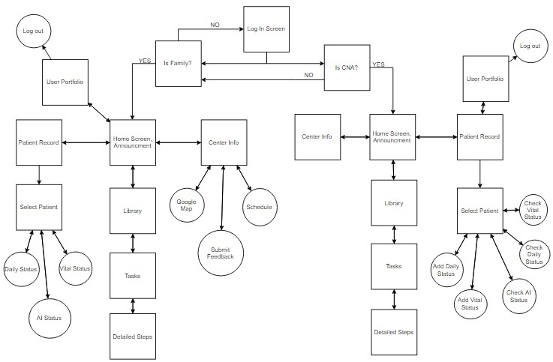

Figure A_3-1:User-Interface Map of LTC-TMS(APP version)

### Browser Version

The following Figure B_3-1 displays the user interface map of the LTC-TMS Browser version. The box describes the main function design in each web-page while the arrows illustrates the menu path throughout the application. Basically in this diagram, it shows the interconnection between different screens in the browser application.

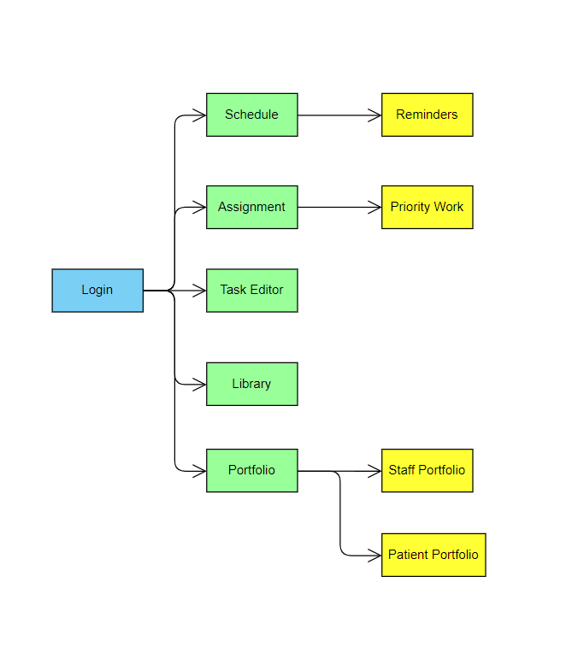

Figure B_3-1: User-Interface Map of LTC-TMS(Browser version)

## 3.3 System Architecture Diagram

The following diagram (Figure M_3-1)shows the communication between the devices’ data binding with the servers and the database. The initial request sent from the user’s end device through a web application. The server receives the request and interacts with the database but with the change of version from v1.1 to v2.0 we moved our database to Firebase and for v2.1 we want to continue to use Firebase. On the other hand, App version is using React Native with the Firebase extensions to make the connection between the app and the database. The database will respond to the request from the server by retrieving the proper data. Finally, the server then will send the data back to the devices.

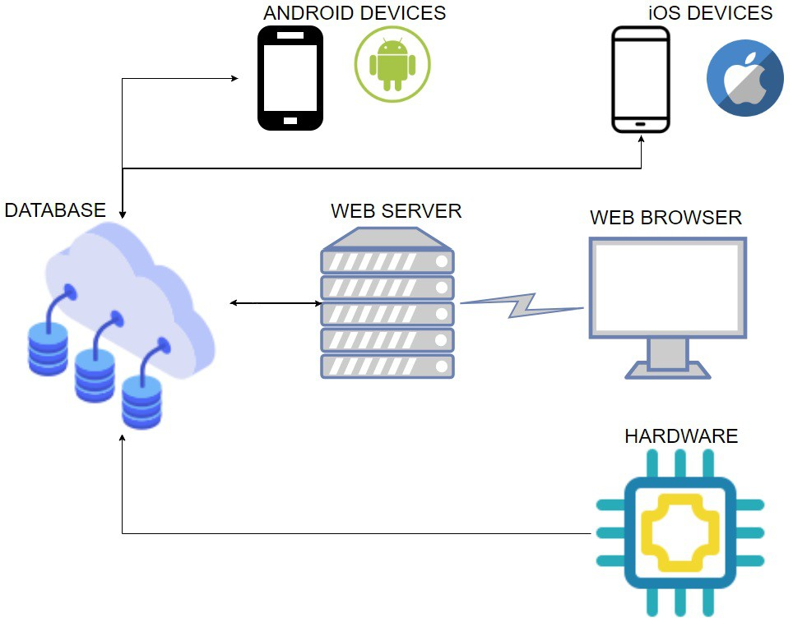

Figure M_3-1: System architecture of LTC-TMS

# 4.0 FUNCTIONAL REQUIREMENTS

Tables A_4-1 (family mobile), Table A_4-2 (CNA mobile), Table H 4-1 (database/hardware), and Table B_4-1 (browser) are the current functional requirements for the LTC-TMS project. Each table is organized into a category that represents a larger scope than one individual requirement, “Requirement ID” is an identification number assigned to each requirement. The “Requirement Description” column is a listing of the requirements themselves, with the “Explanation” being how the teams intend to facilitate the requirement. The priority number given to each requirement indicates the necessity for it to be in the project, with 1 being a base requirement, 2 as something that would be very beneficial to have in the application, and 3 as a requirement that would be nice to have, but not a necessity.

### APP Version

Table O_4-1 shows the functional requirements for the mobile version of LTC-TMS 2.0 with a family member as the intended user. Table O_4-2 lists the functional requirements for the mobile version of LTC-TMS with CNA as the intended user.

Table A_4-2 is the table of functional requirements for the mobile version and table version of LTC-TMS 2.1 with a CNA as the intended user.

Table O_4-1: The Old Table of Family Mobile Functional Requirements

|  |  |  |  |  |
| --- | --- | --- | --- | --- |
| **Category** | **Requirement ID** | **Requirement Description** | **Explanation** | **Priority** |
| User Login | 1 | Family member must be able to login to the system. | Family will be provided with default login info which can be changed to enable secure login. | 1 |
| Tasks Instruction Viewing | 2 | Family member must be able to select the instruction type. | All task instructions are created from the browser page and this enables Family to select the instruction type. | 1 |
| 3 | Family member must be able to view the page of tasks instruction list. | System will list task instructions on the page. | 1 |
| 4 | Family member must be able to view task instructions. | Task instructions will be shown. | 1 |
| Daily Status Record Viewing | 5 | Family member must be able to view Daily StatusRecord page | Daily status record will be shown. | 1 |
| 6 | Family member must be able to access a Status Record page by date. | In the page, users need to select a date in order to let the app to show the status record data for the selected date. | 1 |
| 7 | Family member must be able to view status record with a selected date. | After selecting a date, the status record data will be shown to family. | 1 |
| Announcement Board Viewing | 8 | Family member must be able to view the announcement board. | App will retrieve announcement board information from the LTC-TMS database, that is generated in the browser version. | 1 |
| Portfolio Viewing | 9 | Family member must be able to view portfolio page. | App will display portfolio information. | 1 |
| Feedback Sending | 10 | Family member must be able to submit feedback. | Family is able to submit the feedback to the database which is also forwarded to CNO/Director. | 1 |
| 11 | Family member ID must be captured along with the feedback sent back. | Each feedback is entitled to a user, for CNO/Director to locate and reply to the user. | 1 |
| Voice Output | 12 | Family member is able to listen to the information when they click on the sound icon as voice. | Family are able to listen to a voice version of the information when click on the sound icon. | 2 |
| Voice Input | 13 | Family member is able to input information using their voice. | Family are able to speak into the device to input data in fields when tapping the microphone icon. | 1 |

Table O_4-2: The Old Table of CNA Mobile Functional Requirements

|  |  |  |  |  |
| --- | --- | --- | --- | --- |
| **Category** | **Requirement ID** | **Requirement** | **Description** | **Priority** |
| User Login | 14 | A CNA must be able to login to the system. | CNA will be provided with default login info which can be changed to enable secure login. | 1 |
| Tasks Instruction Viewing | 15 | A CNA must be able to select the instruction type. | All task instructions are created from the browser page and this enables a CNA to select the instruction type. | 1 |
| 16 | A CNA must be able to view the page of tasks instruction list. | System will list tasks on the page. | 1 |
| 17 | A CNA must be able to view task instructions. | Task instructions will be listed for selected task. | 1 |
| Daily Status Record Viewing | 18 | A CNA must be able to view Daily Status Record page | Daily status information will be shown. | 1 |
| 19 | A CNA must be able to access a Status Record page by date. | In the page, users need to select a date in order to let the app to show the status record data for the selected date. | 1 |
| 20 | A CNA must be able to view status record with a selected date. | After selecting a date, the status record data will be shown to family. | 1 |
| Announcement Board Viewing | 21 | A CNA must be able to enter home page and view the announcement board. | Announcement board will be displayed. | 1 |
| Portfolio Viewing | 22 | A CNA must be able to enter and view portfolio page. | Portfolio page will be displayed. | 1 |
| Center Schedule Viewing | 23 | A CNA must be able to view all the center schedules for the month. | Home page will show a sample table that include events for 5 days (past 2 days/today/next 2 days) | 1 |
| 24 | A CNA must be able to view all the center schedules for the month. | If a CNA clicks on the Center schedule on the home page, the app opens the calendar for the current month. Users can switch to different months for the center schedule. | 1 |
| Working Schedule Viewing | 25 | A CNA must be able to view working schedule for the month. | CNA can select the work schedule in menu page, which opens the working schedule page. The CNA is able to switch months and view data. | 1 |
| Working hour data Viewing | 26 | A CNA must be able to view the number of hours they work for the month. | CNA can select work schedule in menu page, the app will direct to working hour page, and also allow CNA to switch months and view data. | 1 |
| Feedback Sending | 27 | A CNA must be able to send feedback. | CNA is able to submit the feedback which is forwarded to CNO/Director. | 1 |
| 28 | A CNA’s ID must be captured along with the feedback sent back. | Each feedback is entitled to a user, for CNO/Director to locate and reply the user. | 1 |
| Voice Output | 29 | A CNA is able to listen to the information when they click on the sound icon as voice. | CNA is able to listen to a voice version of the information when click on the sound icon. | 2 |
| Voice Input | 30 | A CNA is able to input information using their voice. | CNA are able to speak into the device to input data in fields when tapping the microphone icon. | 1 |
| Patient from a room selection | 31 | A CNA must be able to select a patient from the room. | When the CNA initiate the tablet version, he/she needs to select a patient from a room in order to update the selected patient’s status. | 1 |
| Daily Status Updating | 32 | A CNA must be able to input data. | The CNA needs to be able to fill in data to the fields, and select appropriate checkboxes provided on the tablet version. | 1 |
| 33 | A CNA must be able to identify themselves before submitting the data to the database. | Each batch of data submitted is identified with the CNA in charge. | 1 |
| 34 | A CNA must be able to receive the confirmation of the data entered. | Before the data is stored, the CNA receives a pop-up dialog box to ensure the accuracy of the data. | 1 |
| Vital Status Updating | 35 | A CNA must be able to update vital status. | The CNA needs to be able to fill in data to the fields provided on the tablet version. | 1 |
| 36 | A CNA must be able to identify themselves before submitting the data to the database. | Each batch of data submitted to the database is identified with the CNA in charge. | 1 |
| 37 | A CNA must be able to receive the confirmation of the data entered. | Before the data is, the CNA receives a pop-up dialog box to ensure the accuracy of the data. | 1 |
| AI Status Viewing | 38 | A CNA is able to view the patient’s automated recorded status. | There are sensors placed in the center as well as on the patient’s wearables, the CNA are able to view the collected data of the patient which is organized and displayed on the tablet version. | 1 |
| Voice Input | 39 | A CNA is able to input information using their voice. | A CNA is able to speak into the device to input data in fields when tapping the microphone icon. | 1 |

Table A_4-1: The New Table of Family Mobile Functional Requirements

|  |  |  |  |  |
| --- | --- | --- | --- | --- |
| Category | Requirement ID | Requirement Description | Explanation | Priority |
| User Login  (iOS & Android) | AM-1 | The family is able to login to the system by google account. | Family can link their account with a google account (use firebase to recognize the account) so that CNA can choose default login or google login. | 1 |
| Tasks Instruction Viewing | AM-2 | The family member must be able to select the instruction type. | All task instructions are created from the browser page and this enables Family to select the instruction type. | 1 |
| AM-3 | The family member must be able to view the page of tasks instruction list. | The system will list task instructions on the page. | 1 |
| AM-4 | The family member must be able to view task instructions. | Task instructions will be shown. | 1 |
| Daily Status Record Viewing | AM-5 | The family member must be able to view the Daily Status Record page | The daily status record will be shown. | 1 |
| AM-6 | The family member must be able to access a Status Record page by date. | In the page, users need to select a date in order to let the app to show the status record data for the selected date. | 1 |
| AM-7 | The family member must be able to view status record with a selected date. | After selecting a date, the status record data will be shown to the family. | 1 |
| Announcement Board Viewing | AM-8 | The family member must be able to view the announcement board. | The app will retrieve announcement board information from the LTC-TMS database, that is generated in the browser version. | 1 |
| Portfolio Viewing | AM-9 | The family member must be able to view the portfolio page. | The app will display portfolio information. | 1 |

Table A_4-2: The New table of CNA Mobile Functional Requirements

|  |  |  |  |  |
| --- | --- | --- | --- | --- |
| Category | Requirement ID | Requirement | Description | Priority |
| User Login  (iOS & Android) | AN-40 | A CNA is able to login to the system by google account. | CNA can link their account with a google account (use firebase to recognize the account) so that CNA can choose default login or google login. | 2 |
| Tasks Library Instruction Viewing | AM-11 | A CNA must be able to view the page of tasks instruction list and the detailed step of task instruction. | The system will list tasks on the page. Detailed step of task instructions will be in the drop-down menu for the selected task. | 1 |
| AM-12 | A CNA must be able to view the completed time of each task. | Each task with the completion time are created from the browser page and it is displayed to the right of the task name. | 1 |
| Patient Record Viewing | AM-13 | A CNA must be able to view all of his/her own patients. | All patients in a room will be listed. CNA can see the photo and ID of each patient in the room. | 1 |
| AM-14 | A CNA must be able to select a patient from the room. | When the CNA initiate the system, he/she needs to select a patient from a room in order to update the selected patient’s status. | 1 |
| AM-15 | A CNA must be able to view the options of daily status record. | After CNA selected the patient, there is a drop-down menu that will have all the options in the daily status record  (include add daily status, check daily status, Check AI status, Check Vital status and add vital status). | 1 |
| Add Daily Status Viewing | AN-41 | A CNA must be able to access daily status add page by date. | In the page, CNA needs to select a date in order to let the app to know which day it is recording. | 1 |
|  | AN-42 | A CNA must be able to select what data they want to record. | In the page, the system has the selected button in each of showered/Ate/Brush teeth/poop/urinate options.  User can choose what data they want to record by clicking the button on. | 1 |
|  | AN-43 | A CNA must be able to enter the time in the selected options. | After CNA selected the data options, there is a drop-down menu to enter the accurate happen time. | 1 |
| Check Daily status Viewing | AN-44 | A CNA must be able to access daily status read page by date. | In the page, CNA needs to select a date in order to let the app to show the daily status record data for the selected date. | 1 |
|  | AN-45 | A CNA must be able to view daily status record with a selected date. | After selecting a date, the showered/Ate/Brush teeth/poop/urinate data will be shown to the CNA. | 1 |
| AI status read Viewing | AN-46 | A CNA must be able to access AI status read page by date. | In the page, CNA needs to select a date in order to let the app to show the AI status record data for the selected date. | 1 |
| AN-47 | A CNA is able to view the patient’s automated recorded status with a selected date. | After selecting a date, there are sensors placed in the center as well as on the patient’s wearables, the CNA is able to view the collected data of the patient which is organized and displayed on the mobile and tablet version. | 1 |
| Add Vital Status Viewing | AN-48 | A CNA must be able to access daily status add page by date. | In the page, users need to select a date in order to let the app to know which day it is recording. | 1 |
| Check vital status Viewing | AN-49 | A CNA must be able to update vital status. | CNA needs to be able to fill in data to the fields provided on the tablet version. | 1 |
| AN-50 | A CNA must be able to access check vital status page by date. | In the page, CNA needs to select a date in order to let the app to show the Vital status record data for the selected date. | 1 |
| AN-51 | A CNA must be able to view vital status record with a selected date. | After selecting a date, the vital status data will be shown to the CNA. | 1 |
| Home Viewing | AN-52 | A CNA must be able to view the announcement board. | Announcement board will be displayed. All announcements will have an assigned title, date and details. | 1 |
| Portfolio Viewing | AN-53 | A CNA must be able to enter and view the portfolio page. | The user’s portfolio page will be displayed. | 1 |
|  | AM-54 | A CNA must be able to log out of the system. | The user can log out the system by clicking on the top right button on the page. |  |
| Center Info Viewing | AN-55 | A CNA must be able to view all the center schedules for the month. | The center info page will show a calendar for the current month and automatically updating the schedule from the database. Users can switch to different months for the center schedule. | 1 |
| AN-56 | A CNA must be able to view long term care center location. | CNA can see where is the long term care center in google map. | 1 |
|  | AN-57 | A CNA can call the center. | CNA can make a one-click call to the center in a crisis situation. | 1 |

### 

### Browser Version

Table B_4-1 provides each of the functional requirements of the LTC-TMS system in the area of browser functionalities. The functional requirements will each have a category name, requirement ID (unique), requirement (name), description, and priority (1-3).

Table O_4-3: Table of old Functional Requirements

|  |  |  |  |  |
| --- | --- | --- | --- | --- |
| Category | REQ ID | Requirement | Description | Priority |
| Create and Edit Portfolio | 1 | IT Admin must be able to create a portfolio. | When a new staff member/patient joins the Facility, IT Admin should be able to create a Portfolio for them. | 1 |
| 2 | Director must be able to create a portfolio. | When a new staff member/patient joins the Facility, the Director should be able to create a Portfolio for them. | 1 |
| 3 | IT Admin must be able to edit existing portfolio. | When a patient/staff changes their personal information, IT Admin should be able to edit the Portfolio. | 1 |
| 4 | Director must be able to edit existing portfolio. | When a patient/staff changes their personal information, Director should be able to edit the Portfolio. | 1 |
| 5 | IT Admin must be able to view an existing portfolio. | IT Admin should be able to review a staff member's/patient's Portfolio. | 1 |
| 6 | Director must be able to view an existing portfolio. | Director should be able to review a staff member's/patient's Portfolio. | 1 |
| 7 | IT Admin must be able to embed picture(s) into the portfolio. | IT Admin must be able to upload a staff member's/patient's picture as needed. | 1 |
| 8 | Director must be able to embed picture(s) into the portfolio. | Director must be able to upload a staff member's/patient's picture as needed. | 1 |
| 9 | CNO must be able to view an existing portfolio. | CNO should be able to review existing staff/patient Portfolio. | 1 |
| 10 | IT Admin must be able to remove an existing portfolio. | When a staff/patient quits the facility, IT Admin should be able to remove an existing portfolio. | 1 |
| 11 | Director must be able to remove an existing portfolio. | When a staff/patient quits the facility, Director should be able to remove an existing portfolio. | 1 |
| Create and Edit Announcement | 12 | Director must be able to create an Announcement. | When Director wants to deliver news, they must be able to create a new Announcement | 1 |
| 13 | CNO must be able to create an Announcement. | When CNO wants to deliver news, they must be able to create a new Announcement | 1 |
| 14 | Director must be able to edit existing Announcement. | Given there is an error in the published announcement, Director must be able to edit an announcement. | 1 |
| 15 | CNO must be able to edit existing Announcement. | Given there is an error in the published announcement, CNO must be able to edit an announcement. | 1 |
| 16 | Director must be able to delete existing Announcement. | Given there is an unwanted announcement, Director must be able to delete the announcement. | 1 |
| 17 | CNO must be able to delete existing Announcement. | Given there is an unwanted announcement, CNO must be able to delete the announcement. | 1 |
| Create and Edit Memo | 18 | Director must be able to create a Memo | If Director needs a personal reminder, they must be able to create a memo. | 1 |
| 19 | CNO must be able to create a Memo | If CNO needs a personal reminder, they must be able to create a memo. | 1 |
| 20 | Director must be able to edit a Memo. | Given that a memo must be changed, Director must be able to edit memos. | 1 |
| 21 | CNO must be able to edit a Memo. | Given that a memo must be changed, CNO must be able to edit memos. | 1 |
| 22 | Director must be able to delete a Memo. | Deleting Memo allows Director to delete unwanted Memo. | 1 |
| 23 | CNO must be able to delete a Memo. | Deleting Memo allows CNO to delete unwanted Memo. | 1 |
| View Status Record | 24 | Director must be able to view the daily status record. | After CNA submitted a patient’s daily status record of the day, Director must be able to view it. | 1 |
| 25 | CNO must be able to view the daily status record. | After CNA submitted a patient’s daily status record of the day, CNO must be able to view it. | 1 |
| 26 | Director must be able to view vital status record. | After CNA submitted a patient’s vital status record of the day, Director must be able to view it. | 1 |
| 27 | CNO must be able to view vital status record. | After CNA submitted a patient’s vital status record of the day, CNO must be able to view it. | 1 |
| 28 | Director must be able to view AI status record. | After CNA submitted a patient's AI status record of the day, Director must be able to view it. | 1 |
| 29 | CNO must be able to view AI status record. | After CNA submitted patient's AI status record of the day, CNO must be able to view it. | 1 |
| 30 | Director must be able to select a group of patients filtered by room numbers | When Director has to input status records, Director must be able to find all patients' names listed according to the room number. | 2 |
| 31 | CNO must be able to select a group of patients filtered by room numbers | When CNO must input status records, CNO must be able to find every patient's name listed according to the room number. | 2 |
| Create and Edit Event | 32 | Director must be able to create an event. | When there is a new event for the facility, Director must be able to create a new event. | 1 |
| 33 | CNO must be able to create an event. | When there is a new event for the facility, CNO must be able to create a new event. | 1 |
| 34 | Director must be able to edit an event. | When an event is inaccurate, Director must be able to edit an event | 1 |
| 35 | CNO must be able to edit an event. | When an event is inaccurate, CNO must be able to edit an event | 1 |
| 36 | Director must be able to key in event's date | After an event is created, Director must be able to set event's date | 1 |
| 37 | CNO must be able to key in event’s date | After an event is created, CNO must be able to set event's date | 1 |
| 38 | Director must be able to edit an event's date | When there is an error in the date of an event, Director must be able to edit the event's date. | 1 |
| 39 | CNO must be able to edit an event’s date. | When there is an error in the date of an event, CNO must be able to edit the event's date. | 1 |
| 40 | Director must be able to delete event. | When an event is expired or invalid, Director must be able to delete an existing event. | 2 |
| 41 | CNO must be able to delete event. | When an event is expired or invalid, CNO must be able to delete an existing event. | 3 |
| Upload Work Schedule and Working Hour | 42 | Director must be able to upload schedule file(s). | Given that a work schedule file is to be submitted Director must be able to upload the file. | 1 |
| 43 | CNO must be able to upload schedule file(s). | Given that a work schedule file is to be submitted CNO must be able to upload the file. | 1 |
| 44 | Director must be able to delete uploaded schedule file(s). | After file expired/out of date, Directors are allowed to remove the file from the website. | 2 |
| 45 | CNO must be able to delete uploaded schedule file(s). | After file expired/out of date, CNO are allowed to remove the file from the website. | 2 |
| Create and Edit Task | 46 | Director must be able to create a new task. | When a lesson or command needed to be delivered, Director must be able to create new task instruction. | 1 |
| 47 | CNO must be able to create a new task. | When a lesson or command needed to be delivered, CNO must be able to create new task instruction. | 1 |
| 48 | Director must be able to add main steps to a task. | After a task has been created, Director must be able to add main steps to a certain task when needed. | 1 |
| 49 | CNO must be able to add main steps to a task. | After a task has been created, CNO must be able to add main steps to a certain task when needed. | 1 |
| 50 | Director must be able to add detail steps to a task. | After the main step has been created, Director must be able to add detail steps to each main step correspondingly. | 1 |
| 51 | CNO must be able to add detail steps to a task. | After the main step has been created, CNO must be able to add detail steps to each main step correspondingly. | 1 |
| 52 | Director must be able to remove task. | Given that a task is no longer needed, Directors should be able to remove a specific task. | 2 |
| 53 | CNO must be able to remove task. | Given that a task is no longer needed, CNO should be able to remove a specific task. | 2 |
| 54 | Director must be able to remove the main steps from a task. | When a main step is not needed, Director should be able to delete that main step. | 1 |
| 55 | CNO must be able to remove the main steps from a task. | When a main step is not needed, CNO should be able to delete that main step. | 1 |
| 56 | Director must be able to remove detailed steps from a task. | When a detailed step should be removed, Director must be able to delete a detail step. | 1 |
| 57 | CNO must be able to remove detailed steps from a task. | When a detailed step should be removed, CNO must be able to delete a detail step. | 1 |
| 58 | Director must be able to embed image(s) into a task. | If an image can help explain a step, Director must be able to upload an image. | 1 |
| 59 | CNO must be able to embed image(s) into a task. | If an image can help explain a step, CNO must be able to upload an image. | 1 |
| 60 | Director must be able to embed video(s) into a task. | Given that the steps for a given task require a demonstration, Director should be able to upload a video. | 1 |
| 61 | CNO must be able to embed video(s) into a task. | Given that the steps for a given task require a demonstration, CNO should be able to upload a video. | 1 |
| 62 | Director must be able to access a task from the database. | When Director wishes to edit a task, Director must be able to retrieve the task from the database. | 1 |
| 63 | CNO must be able to access task from the database. | When CNO wishes to edit a task, CNO must be able to retrieve the task from the database. | 1 |
| 64 | Director must be able to edit a task. | When a task’s information needs to be changed, Director should be able to change task information. | 1 |
| 65 | CNO must be able to edit a task. | When a task’s information needs to be changed, CNO should be able to change task information. | 1 |
| 66 | Director must be able to save unfinished tasks as draft. | Saving tasks before completion would give flexibility to Director to work on a task at different times | 2 |
| 67 | CNO must be able to save unfinished tasks as draft. | Saving tasks before completion would give flexibility to CNO to work on a task at different times | 2 |
| 68 | Director must be able to save completed tasks to the Task Library | Once a task is completed, it must be saved to the Task Library. | 1 |
| 69 | CNO must be able to save completed tasks to the Task Library. | Once a task is completed, it must be saved to the Task Library. | 1 |
| 70 | Director must be able to create a new keyword for a task. | Keywords allow tasks to be found without knowing their full name | 2 |
| 71 | CNO must be able to create a new keyword for a task. | Keywords allow tasks to be found without knowing their full name | 2 |
| 72 | Director must be able to choose an existing keyword for a task. | Preset keywords allow tasks to be found without knowing their full name using common keywords. | 2 |
| 73 | CNO must be able to choose an existing keyword for a task. | Preset keywords allow tasks to be found without knowing their full name using common keywords. | 2 |
| 74 | Director must be able to edit the main steps of a task. | Given that the main steps of a task need to be changed, Director must be able modify the main steps. | 1 |
| 75 | CNO must be able to edit the main steps of a task. | Given that the main steps of a task need to be changed, CNO must be able modify the main steps. | 1 |
| 76 | Director should be able to reorder the main steps when creating a task. | The Director can switch step positions instead of deleting and rewriting the step. | 2 |
| 77 | CNO should be able to reorder the main steps when creating a task. | CNO can switch step positions instead of deleting and rewriting the step. | 2 |
| 78 | Director should be able to reorder the main steps when editing a task. | The Director can switch step positions instead of deleting and rewriting the step. | 2 |
| 79 | CNO should be able to reorder the main steps when editing a task. | CNO can switch step positions instead of deleting and rewriting the step. | 2 |
| 80 | Director must be able to edit detailed steps. | When the detailed steps must be changed, Director must be able to edit the detailed step. | 1 |
| 81 | CNO must be able to edit detailed steps. | When the detailed steps must be changed, CNO must be able to edit the detailed step. | 1 |
| 82 | Director should be able to reorder detailed steps when creating a task. | The Director can switch step positions instead of deleting and rewriting the step. | 2 |
| 83 | CNO should be able to reorder detailed steps when creating a task. | The CNO can switch step positions instead of deleting and rewriting the step. | 2 |
| 84 | Director should be able to reorder detailed steps when editing a task. | The Director can switch step positions instead of deleting and rewriting the step. | 2 |
| 85 | CNO should be able to reorder detailed steps when editing a task. | The CNO can switch step positions instead of deleting and rewriting the step. | 2 |
| 86 | Director must be able to set a task's status to visible. | The Director can set a task to visible so it can be assigned to patients. | 1 |
| 87 | CNO must be able to set a task's status to visible. | The CNO can set a task to visible so it can be assigned to patients. | 1 |
| 88 | Director must be able to set a task's status to invisible | The Director can set a task to invisible so it cannot be assigned to patients. | 1 |
| 89 | CNO must be able to set a task's status to invisible | The CNO can set a task to invisible so it cannot be assigned to patients. | 1 |
| Assign Tasks | 90 | Director must be able to distribute a task an individual patient. | Director wishes to assign a task to an individual patient. | 1 |
| 91 | CNO must be able to distribute a task to an individual patient. | CNO wishes to assign a task to an individual patient. | 1 |
| 92 | Director must be able to distribute a task to specific groups of patients. | Director wishes to assign a task to a specific group of patients. | 1 |
| 93 | CNO must be able to distribute a task to specific groups of patients. | CNO wishes to send a task to a specific group of patients. | 1 |
| 94 | Director must be able to cancel assigned task(s). | In the event a task is no longer applicable to its assignee(s), the Director should be able to un-assign the task. | 2 |
| 95 | CNO must be able to cancel assigned tasks | In the event a task is no longer applicable to its assignee(s), the CNO should be able to un-assign the task. | 2 |
| View Task Library | 96 | Director must be able to view Task Library. | After a task is created, Director should be able to view it in the task library. | 1 |
| 97 | CNO must be able to view Task Library. | After a task is created, CNO should be able to view it in the task library. | 1 |
| Login | 98 | IT Admin must be able to log in with the provided account. | IT Admin with an account must be able to login to the browser version of LTC-TMS. | 1 |
| 99 | Director must be able to log in with the provided account. | Director with an account must be able to login to the browser version of LTC-TMS. | 1 |
| 100 | CNO must be able to log in with the provided account. | CNO with an account must be able to login to the browser version of LTC-TMS. | 1 |
| Logout | 101 | IT Admin must be able to logout of their session. | IT Admin must be able to logout from the browser version of LTC-TMS. | 1 |
| 102 | Director must be able to logout of their session. | Director must be able to logout from the browser version of LTC-TMS. | 1 |
| 103 | CNO must be able to logout of their session. | CNO must be able to logout from the browser version of LTC-TMS. | 1 |
| Query Function | 104 | Director is able to search for tasks from task library. | Director is able to search for a task in the task library. | 3 |
| 105 | CNO is able to search for tasks from task library. | CNO is able to search for a task in the task library. | 3 |
| 106 | IT Admin is able to search for patients from patient user list | IT Admin is able to search for a patient in the patient user list. | 3 |
| 107 | Director is able to search for patients from patient user list | Director is able to search for a patient in the patient user list. | 3 |
| 108 | CNO is able to search for patients from patient user list | CNO is able to search for a patient in the patient user list. | 3 |
| 109 | IT Admin is able to search for staff members from staff member user list | IT Admin is able to search for a staff member in the staff member user list. | 3 |
| 110 | Director is able to search for staff members from staff member user list | Director is able to search for a staff member in the staff member user list. | 3 |
| 111 | CNO is able to search for staff members from staff member user list | CNO is able to search for a staff member in the staff member user list. | 3 |
| Voice Input | 112 | Director is able to dictate information to be translated to text while creating tasks. | Director’s speech will be translated to text while creating tasks. | 1 |
| 113 | CNO is able to dictate information to be translated to text while creating tasks. | CNO’s speech will be translated to text while creating tasks. | 1 |
| 114 | Director is able to dictate information to be translated to text while editing tasks. | Director’s speech will be translated to text while editing tasks. | 1 |
| 115 | CNO is able to dictate information to be translated to text while editing tasks. | CNO’s speech will be translated to text while editing tasks. | 1 |
| Voice Output | 116 | Director is able to listen to the information when the sound icon is clicked. | Director is able to listen to a voice version of the information the sound icon is clicked while viewing tasks. | 2 |
| 117 | CNO is able to listen to the information when the sound icon is clicked. | CNO is able to listen to a voice version of the information the sound icon is clicked while viewing tasks. | 2 |
| Show QR Code | 118 | User is able to view QR code from the home page. | User is able to view QR code from the home page. | 2 |
| View Help and Support | 119 | Director is able to view feedback on the facility. | Director is able to view comments and suggestions from users about the long-term care facility. | 2 |
| 120 | CNO is able to view feedback on the facility. | CNO is able to view comments and suggestions from users about the long-term care facility. | 2 |
| 121 | Director is able to submit feedback on LTC-TMS. | Director is able to add comments and suggestions for LTC-TMS | 3 |
| 122 | CNO is able to submit feedback on LTC-TMS. | CNO is able to add comments and suggestions for LTC-TMS | 3 |
| 123 | IT Admin is able to view feedback on LTC-TMS | IT Admin is able to view comments and suggestions from users about LTC-TMS |  |
| Language | 124 | IT Admin should be able to choose the language in which they want to view the system. | IT Admin would be able to select the language they prefer which would increase usability | 3 |
| 125 | Director should be able to choose the language in which they want to view the system. | Director would be able to select the language they prefer which would increase usability | 3 |
| 126 | CNO should be able to choose the language in which they want to view the system. | CNO would be able to select the language they prefer which would increase usability | 3 |
| Browser Support | 127 | IT Admin must be able to use the system on Chrome browser. | IT Admin should be able to use Chrome when using the system | 1 |
| 128 | Director must be able to use the system on Chrome browser. | Director should be able to use Chrome when using the system | 1 |
| 129 | CNO must be able to use the system on Chrome browser. | CNO should be able to use Chrome when using the system | 1 |
| 130 | IT Admin must be able to use the system on Firefox browser. | IT Admin should be able to use Firefox when using the system | 1 |
| 131 | Director must be able to use the system on Firefox browser. | Director should be able to use Firefox when using the system | 1 |
| 132 | CNO must be able to use the system on Firefox browser. | CNO should be able to use Firefox when using the system | 1 |
| 133 | IT Admin must be able to use the system on Safari browser | IT Admin should be able to use Safari when using the system | 1 |
| 134 | Director must be able to use the system on Safari browser | Director should be able to use Safari when using the system | 1 |
| 135 | CNO must be able to use the system on Safari browser | CNO should be able to use Safari when using the system | 1 |
| 136 | IT Admin must be able to use the system on Internet Explorer browser | IT Admin should be able to use Internet Explorer when using the system | 1 |
| 137 | Director must be able to use the system on Internet Explorer browser | Director should be able to use Internet Explorer when using the system | 1 |
| 138 | CNO must be able to use the system on Internet Explorer browser | CNO should be able to use Internet Explorer when using the system | 1 |
| 139 | IT Admin must be able to use the system on Edge browser | IT Admin should be able to use Edge when using the system | 1 |
| 140 | Director must be able to use the system on Edge browser | Director should be able to use Edge when using the system | 1 |
| 141 | CNO must be able to use the system on Edge browser | CNO should be able to use Edge when using the system | 1 |

Table B_4-1: Table of new or modified Functional Requirements

|  |  |  |  |  |
| --- | --- | --- | --- | --- |
| Category | Req ID | Requirement | Description | Priority |
| Edit and View About Us | BM-1 | Director must be able to edit the Introduction | When Director wants to change the introduction, they must be able to edit the introduction. | 1 |
| BM-2 | Director must be able to view the Introduction | After Director change the introduction, they must be able to view the introduction. | 1 |
| BM-3 | CNO must be able to edit the Introduction | When CNO wants to change the introduction, they must be able to edit the introduction. | 1 |
| BM-4 | CNO must be able to view the Introduction | After CNO change the introduction, they must be able to view the introduction. | 1 |
| BM-5 | Director must be able to edit the Center Info | When Director wants to change the Center Info, they must be able to edit the Center Info. | 1 |
| BM-6 | Director must be able to view the Center Info | After Director change the Center Info, they must be able to view the Center Info. | 1 |
| BM-7 | CNO must be able to edit the Center Info | When CNO wants to change the Center Info, they must be able to edit the Center Info. | 1 |
| BM-8 | CNO must be able to view the Center Info | After CNO change the Center Info, they must be able to view the Center Info. | 1 |
| BM-9 | Director must be able to add the Sponsored | When Director wants to plus the sponsored, they must be able to add the sponsored. | 2 |
| BM-10 | Director must be able to remove the Sponsored | When Director wants to delete the sponsored, they must be able to remove the sponsored. | 2 |
| BM-11 | Director must be able to view the Sponsored | After Director change the sponsored, they must be able to view the sponsored.. | 1 |
| BM-12 | CNO must be able to add the Sponsored | When CNO wants to plus the sponsored, they must be able to add the sponsored. | 2 |
| BM-13 | CNO must be able to remove the Sponsored | When CNO wants to delete the sponsored, they must be able to remove the sponsored. | 2 |
| BM-14 | CNO must be able to view the Sponsored | After CNO change the sponsored, they must be able to view the sponsored.. | 1 |
| Create and Edit Schedule and Memo | BM-15 | Director must be able to view the Center schedule in calendar view | Director must be able to view the center schedule in calendar after if there is a schedule | 1 |
| BM-16 | Director must be able to input the center schedule into the calendar | Director able to put the center open and close time into the calendar | 1 |
| BM-17 | Director must be able to edit the center schedule | Director able to edit existing center schedule in the calendar | 1 |
| BM-18 | Director must be able to view the memo in a specific date in a calendar | Director able to see existing memo in the calendar | 1 |
| BM-19 | Director must be able to input a memo into a specific date in a calendar | Director able to create a memo and put it into specific date | 1 |
| BM-20 | Director must be able to edit a memo in the calendar | Director able to edit an existing memo | 1 |
| BM-21 | Director must be able to zoom in to the calendar and view the memo by hourly | Director able to view the details of the memo by showing the time of the memo | 1 |
| BM-22 | Director must be able to view the schedule difference in color depending on the center schedule | Center open will have green in color. Center closed will have red in color. Irregular time will be yellow in color | 1 |
| View Status Record and Report | BN-142 | Director is able to read the record from hardware. | Implement the status record feature, and make sure the feature is able to connect to hardware. | 1 |
| BN-143 | Director is able to read the status record and generate a report at the same time. | Change the reports page and combine it with status record by listing all available records | 2 |
| BN-147 | Director is able to generate a report after reading the record | Create a button below the status recorded, and Director is able to generate a report. | 2 |
| BN-148 | Director is able to read previous status record from database. | Setting the environment for database, and make sure connects to the status record. | 1 |
| BN-149 | CNO must be able to view the status record | After CNA submitted a patient’s status record of the day, CNO must be able to view it. | 1 |
| View and Edit Help and Support | BM-23 | Director is able to view the message on the facility. | Make sure this function is able to implement on browser. | 1 |
| BM-24 | CNO is able to view the message on the facility. | Make sure this function is able to implement on browser. | 1 |
| BM-25 | Director is able to reply the message to other users on the facility. | Director is able to reply to the feedback of the staff and other users. | 1 |
| BM-26 | CNO is able to reply the message to other users on the facility. | CNO is able to reply to the feedback of the staff and other users. | 1 |
| BM-27 | Director is able to read about us feature in view and edit help and support function. | About us function is not necessary to divide into independent function. | 2 |
| View and Edit Profile | BM-28 | Director don’t need to read the account each webpage all the time. | The account profile is not necessary to display all the time. | 1 |
| BM-29 | Director is able to read the account profile which combines with setting function. | Put the profile into the drop down list together with setting function in which includes language option and logout. | 1 |
| Contact Us-IT admin | BM-30 | It Admin is able to edit the information about the facility. | It Admin is able to edit the information about the facility. | 1 |
| Feedback - IT Admin | BM-31 | It Admin is able to view feedback on LTC-TMS. | It Admin is able to view comments and suggestions from users about LTC-TMS. | 2 |
| BM-32 | It Admin is able to edit feedback on LTC-TMS. | It Admin is able to edit comments and suggestions about LTC-TMS. | 2 |
| User Management - IT admin | BM-33 | It Admin must be able to create an account. | When a new staff member/patient joins the facility, It Admin should be able to create an account for them. | 1 |
| BM-34 | It Admin must be able to edit existing account. | When a patient/staff change their personal information, It Admin should be able to edit the account. | 1 |
| BM-35 | It Admin must be able to remove an existing account. | When a staff/patient quits the facility, It Admin should be able to remove an existing account. | 1 |
| BM-36 | It Admin is able to search for patient from patient list. | It Admin is able to search for patient from patient list. | 3 |
| BM-37 | It Admin is able to monitor the user activity(login - logout). | It Admin is able to check the login and logout time of accounts. | 3 |

### Hardware Version

Table O_4-4 provides each of the functional requirements of the LTC-TMS system in the areas of database and hardware. The functional requirements will each have a category name, requirement ID (unique), requirement (name), description, and priority (1-3).

Table O_4-4: Table of old Functional Requirements

|  |  |  |  |  |
| --- | --- | --- | --- | --- |
| Category | Requirement ID | Requirement | Description | Priority |
| Hardware | 001 | Build the wearable device for patient to record their vitals. | Constructing the wearable technology for the patient will be fulfilled using the hardware components purchased. | 1 |
| Hardware | 002 | Assemble the raspberry pi with a case for each room. | Each room will have a raspberry pi that will receive the data from the wearable device the patient has and send it to the database. | 1 |
| Hardware | 003 | Maintain the hardware. | This will involve ensuring the battery is charged and wearable is functioning for the CNA to use with the patient. | 1 |
| Hardware | 004 | Log data from the sensors. | When sensors are being used, the DB/HW team will be responsible for ensuring the proper data is being captured (e.g. heart rate sensor recording heart rate, not another vital). | 1 |
| Hardware | 005 | Send data to the DB over Wi-Fi. | The hardware device will be capable of sending patient vitals (data) over Wi-Fi connection to the database. | 1 |
| Hardware | 006 | Sensor will send data to micro:bit via radio frequency. | Patient vital data will be sent over radio frequency from the sensors to the micro:bit | 1 |
| Hardware | 007 | Ensure that micro:bit and sensor use the same radio frequency. | Each sensor will be channeled to the same radio frequency as the micro:bit. | 1 |
| Hardware | 008 | Ensure the patient does not inadvertently break the device. | The wearable sensors will be worn in a location that would not be in the way of the patient’s day to day life. | 3 |
| Hardware | 009 | Ensure the security of the hardware device. | The CNA and CNO will monitor the device throughout the day, ensuring it does not leave the room. | 2 |
| Hardware | 010 | The speaker must trigger a sound to alarm the CNA on duty. | The speaker will sound when the patient’s heart rate is below or above a normal rate. | 1 |

The Table H_4-1 below shows the modification and changes about the hardware.

Table H_4-1: Table of New or Modified Functional Requirements

|  |  |  |  |  |
| --- | --- | --- | --- | --- |
| Category | Requirement ID | Requirement | Description | Priority |
| Hardware | HM-002 | Maintain the hardware. | Designing and implementing new battery holder for smaller coin cell type batteries for use on the wearable units, to reduce size. | 1 |
| Hardware | HM-003 | Log data from the sensors. | Data will now be sent from the wearable unit more frequently to ensure as close to real-time monitoring possible | 1 |
| Hardware | HM-005 | Sensor wearables data to base station via radio frequency. | Wearables to base station connections will be implemented as “many to one” to reduce cost of installation and improve system scalability. | 2 |
| Hardware | HM-006 | Ensure that data collisions do not occur when multiple wearables are assigned to the same base station. | Each wearable must either have it’s own radio channel or designated transmission time. | 2 |
| Hardware | HN-011 | Live, visual patient monitoring to check the patient's condition | Each raspberry pi will have a camera installed so an APP user can visually check patient’s condition status in real-time. | 3 |
| Hardware | HN-012 | Live monitoring of air quality condition in patient area. | Install an air quality sensor on Base station units to monitor the quality of air. | 2 |
| Hardware | HN-013 | Base Station status display. | An LCD screen on the raspberry pi will show the data of its sensors. | 1 |

### Database

The tables below show the functional requirement connect with firebase.

### APP Version

Table A_4-3: Functional Requirements

|  |  |  |  |
| --- | --- | --- | --- |
| ​V/X | Requirement | Description | Implementation |
|  | Retrieve Data | The system will retrieve data depending on account type. |  |
|  | Verified ID | Make sure CNA/Family input the right ID, that is, they are able to login if input ID is correct. |  |
|  | Send Data | CNA is able to send patient record data to the database. |  |

### 

### Browser Version

Table B_4-2: Functional Requirements

|  |  |  |  |
| --- | --- | --- | --- |
| ​V/X | Requirement | Description | Implementation |
|  | Retrieve Data | The system will retrieve data depending on account type. |  |
|  | Verified ID | Make sure CNO/Director input the right ID, that is, they are able to login if input ID is correct. |  |
|  | Send Data | CNO is able to send patient record data to the database. |  |

### Hardware Version

Table H_4-2: Functional Requirements

|  |  |  |
| --- | --- | --- |
| V/X | Requirement | Description |
|  | Send Data | Send the data from the sensor. Allow APP and Browser and get reliable data from the database. |
|  | Record Temperature | Send the data from Raspberry Pi to the database |
|  | Record Heartrate | Send the data from BBC Micro:bit slave unit through RF to master unit BBC Micro:bit |
|  | Fall Down Detector | Detect if patient fall down, it sends a signal to the database. |

# 5.0 NON-FUNCTIONAL REQUIREMENTS

### App Version

Table A_5-1:The five non-functional requirements that the APP Team used for LTC-TMS are performance, security, compatibility, privacy, and memory. These non-functional requirements make our application work more efficiently and conveniently. In addition, LTC-TMS app version must be able to handle new and different versions of iOS and Android.

Table A_5-1: Non-functional Requirements

|  |  |  |
| --- | --- | --- |
| Requirement | Purpose | How The Requirement Will Be Measured |
| Performance | The App Version is designed for CNA to enter patients’ daily health record. Performance is necessary to save time. | The performance will be measured from millisecond to second to complete a specific task. |
| Security | The App Version is designed for CNA to enter patients’ daily health record. CNA must sign in with their ID and password. Lockouts after 5 repeated failed attempts. Tablets can only be used inside care center premises. | The employee who lockouts after 5 repeated failed attempts. The application will send a message to the administration. The employee needs to contact the administration to use the ID card or other things that can show their identity. |
| Compatibility | LTC-TMS app version will meet the expectations for the end users by creating the application so that it is compatible with different operating systems. | LTC-TMS app version will be developed with software testing to ensure compatibility of the system/application/website built with various other objects such as other web browsers, hardware platforms. |
| Privacy | LTC-TMS app version is designed for Family/CNA to view data in order to get important information about a patient or the Long-term Care Center.  The data is submitted by CNO or Director from LTC-TMS browser version. | To view all the information which are provided by LTC-TMS app version, users must log in with their own ID. The content which is displayed differs from user to user. |
| Memory | LTC-TMS app version will be able to remember the user id and password after user login and unless the user clicks the logout function the app will keep in logged on. | Users can open their app without seeing the login page. |

### Browser Version

Non-functional requirements will describe how the system works. These are criteria that are used to judge the operation of a system, rather than specific behaviors. We will take a look at the system’s non-functional requirements by looking at the performance, reliability, usability, and security aspects.

Table B_5-1: Non-functional Requirements

|  |  |  |
| --- | --- | --- |
| Requirement | Changes in Focus | Metric to Measure Requirement |
| Performance | We believe the performance achieved by the KU development group is good enough and our focus is now on improving other aspects of the system. Therefore we just want to maintain the current performance metric. | Average response time, the amount of time it takes the system to respond to a request sent by one user or multiple requests from many users at the same time, will be monitored. Performance will be considered satisfactory if average response time is 3 seconds or less. |
| Reliability | A reliable system should perform its basic functionality consistently and without failure. Reliability is crucial since the system will be used to keep track of staff, patient, and facility information in a fast-paced health care setting. | Performance will be used to measure reliability. Consistent performance of 3 seconds or less contributes to classifying the system as reliable. Additionally, testing the availability of the server at different times of the day will be completed. To do this, testers will attempt to access the system once every hour for 24 hours during a test. The server must be accessible at least 90% of the time with performance speeds of 3 seconds or less to be considered satisfactorily reliable. |
| Usability | Our new focus for the usability is to make the system to have a better user friendliness which we will improve the User Experience and the User Interface of the website. We want the website to appear better and improve design flow. | We want to make sure the User to focus on the important information on each page therefore unnecessary UI elements have been modified. We want to reduce the number of clicks required to perform on the page. The system also will appear |
| Security | Security is one of the important  factor of a website. The security of the account will be enhanced so that it will not be prone to attack from third party. The data that is sent and retrieved from the database will be securely protected. We also will protect the private data and information by creating a secure security protocol to protect the information. | A third party cannot get access to the account and cannot get access to all the data for the account such as account name and password. The data in the database is not open and cannot be breached. |

### Hardware Version

Table H_5-1: Non-functional Requirements

|  |  |  |
| --- | --- | --- |
| Requirement | Changes in Focus | Metric to Measure Requirement |
| Performance | We intend to make the data logging from the wearables and base stations more frequent. | Average amount of time between data updates from the Hardware units. Target cycle time is 1 second between updates. |
| Reliability | Hardware units must be reliable and produce accurate, reliable and consistent results so that false readings regarding patient health and status are not generated. | Testing of wearables will be required, and their output values must be compared against each other to make sure each sensor and wearable unit is detecting and reporting its data accurately and consistently. Fall sensor and alarms will also need to be carefully calibrated to prevent false alarms.  To accomplish this, all test results must fall within 5% of the control value. |

# 6.0 USE CASE DIAGRAM

### App Version

Figure A_6-2 shows a complete use case diagram for the LTC-TMS APP version. Readers are able to understand more of the system function through the use case diagram and get a clear picture of the system. CNA and Family can all access to this system. Both can view task instruction, notification, schedule, announcement, and portfolio but only CNA can create, edit or modify certain parts of the system.

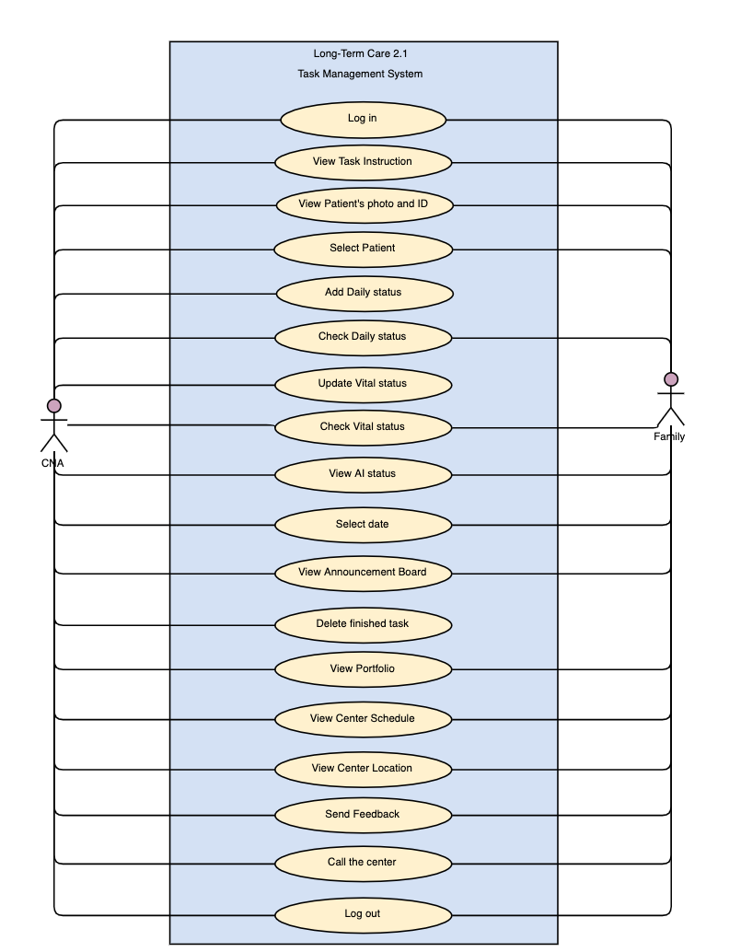

Figure A_6-2: Use case diagram(APP version)

### Browser Version

Figure B_6-2- show a complete use case diagram for the LTC-TMS Browser version.

Use cases describe activities that LTC-TMS in browser platform could perform which illustrate the interactions between actor(s) and the system.

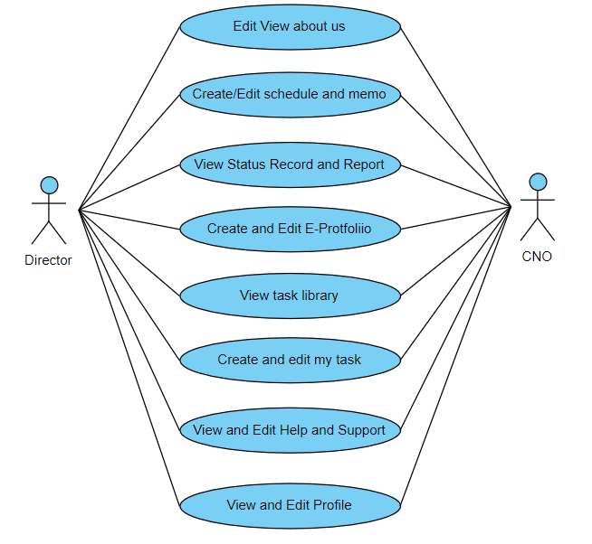

Figure B_6-1: Use case diagram(Browser version)

# 7.0 USE CASE DESCRIPTIONS

### App Version

Fully Developed Use Case Description: View Task Instruction

Table A_7-1 shows the fully developed use case description for the view task instruction use case. The Scenario for this use case assumes that users enter the hamburger menu page, click on the task instruction. Users can view the task instruction steps by steps. In this use case, the preconditions show that existing objects must already exist before the use case can be viewed. The postcondition describes the state of the system at the end of the use case.

Table A_7-1: Fully Developed Use Case Description for View Task Instruction

|  |  |
| --- | --- |
| Use Case Name | View Task Instruction |
| Scenario | Let users view the task instruction. |
| Triggering event | Users log in and view the given task instruction. |
| Brief Description | The system provides tasks to be viewed on the task instruction page. Within the task there are main steps and detail steps displayed, when CNA or Family click on the main step then the system might return a video demo page, next, when CNA or Family click on detail step the system might return a photo demo page. |
| Actors | CNA and Family. |
| Stakeholders | CNA and Family. |
| Pre-Conditions | 1. User_ID must exist to enable login.  2. Users must log in. |
| Post-Conditions | 1. The System has to output task instruction.  2. Staff received notification due to the creation of task instruction.  3. System stored the task instruction into the library. |
| Flow of Activities | |  |  | | --- | --- | | Actor | System | | 1. Users click the Library button. | 1.1 System direct to the Your Assigned Tasks page.  1.1 System list tasks. | | 2. Users select a specific task. | 2.1 System will show steps of that specific task with a brief explanation. | | 3. Users select the step in task instruction. | 3.1 System will show a detailed explanation of that step.  3.2 System shows the video which is attached to the main step. | |
|
| Exception Conditions | 1. If the type-in ID is wrong, the user will not be able to login LTC-TMS.  2. If there is no internet connection, the user can’t log in. |

### Browser Version

Table B_7-1 shows the fully developed use case description for create new portfolio. The Scenario for this use case assumes that there’s a new staff/patient enter the facility and need a new portfolio.

Table B_7-1: Fully Developed Use Case Description for View Task Instruction

|  |  |
| --- | --- |
| Use Case Name | Create an Eportfolio |
| Scenario | There is a new portfolio are going to be creative. |
| Triggering Event | New staff/patient comes to the facility and need a new portfolio. |
| Brief Description | CNO/Director create, edit or edit a new portfolio in to the system and store the information in the database. |
| Actors | CNO, Director |
| Related Use Cases | Create and Edit E-Portfolio |
| Stakeholders | CNO, Director |
| Pre-Conditions | 1. Must be logged-in. |
| Post-Conditions | 1. New portfolio is stored in the database. |
| Use Case Name | Create a Task instruction |
| Flow of Activities | |  |  | | --- | --- | | Actor | System | | 1. CNO/ Director have to select and click the Create Portfolio button. | 1.1 System retrieve Web page from the database.  1.2 System display Web page for the actor to view. | | 2. Insert the information of staff/patient and click on the create button. | 2.1 Insert the information of portfolio in the database. | |
| Exception Condition | 1.Data loss during transportation during poor connectivity  2. Webpage format failure. |