S-23 Sierpinski Database

Databases Project 2025

Project Details

* **Name**: S-23 Sierpinski Database
* **Team Members:**

Mara-Teodora Bandila (mbandila@constructor.university),

Rostislav Zherebilov (rzherebilo@constructor.university)

* **Team Number:** 523 (?)

Our project is based on a mining facility: S-23 Sierpinksi, a fictional location from the science-fiction video game SIGNALIS.

Intended Functionality:

It functions as a request management system. Users with certain clearance levels can create requests based on their assigned department and/or assets. Admins with high enough clearance can approve requests and create/manage tasks by assigning personnel and other assets. They can therefore view the personnel tables and sort by roles, experience and availability. Users with low clearance can see only the task assigned to them and make reports on their progress, which can then be evaluated by the administrators and/or their managers who update the status of the task itself. Due to the asset delivery requests, the system also has certain inventory management capabilities. The admin/manager concept also implies “reports to” hierarchies. Clearance level also applies to locations, there has to be at least one user with a matching clearance level assigned to the task (or the clearance level has to be temporarily updated). The minimal functionality is viewing to which task the user is assigned to, and to write reports related to this tasks.

Glossary

**Replika:** The word for android

**Gestalt:** The word for human. In S-23 Sierpinski humans serve their sentence by working at this camp

ER diagram

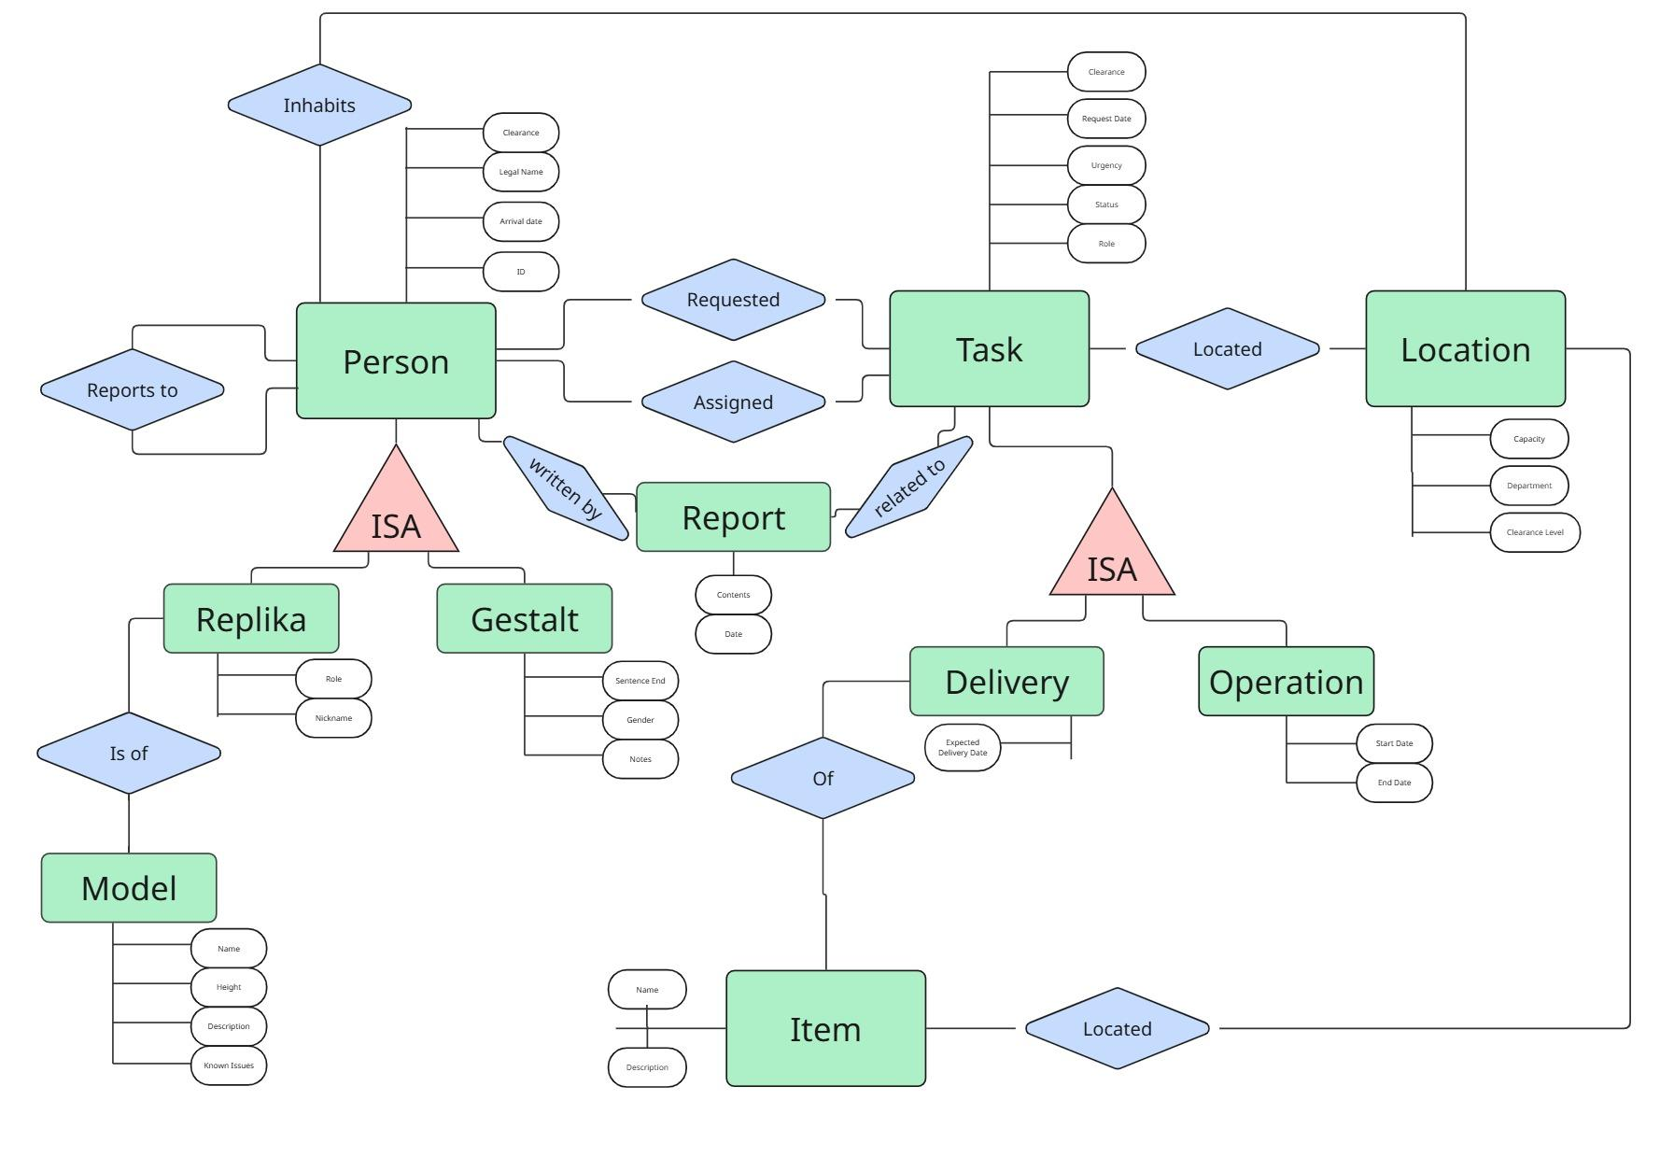

User Interactions

**LEGAL INTERACTIONS:**

* User can view the task they’ve been assigned to
* User can submit requests
* Admin can assign persons to a task
* Admin can add/remove persons from the database
* User can see tasks with either the same or lower clearance level

**ILLEGAL INTERACTIONS**

* Case where: None of the users assigned to the task have sufficient clearance for required location; is illegal
* User cannot view tasks above their clearance level
* Only admins can change descriptions and other defining characteristics
* Reports can be written only in case they are made by the assigned person or by one with higher/equal clearance