NATIONAL COLLEGE OF COMPUTER STUDIES(NCCS)
Paknajol, Kathmandu

A PROJECT REPORT
ON
“Heart Health Classification”

Submitted to:

National College of Computer Studies (NCCS)
Department of Information Technology
Paknajol, Kathmandu

In partial fulfillment of the requirements for the bachelor’s degree
In Information Management (BIM)

Submitted by:
Nishan Prajapati

Under the supervision of
Sumit Ghising
Rikesh Shrestha

29, Jun 2025

Acknowledgement
I would like to express my special thanks of gratitude to our teacher Mister Sumit Ghising who provided me with this golden opportunity to work on this project of Computer Science on “Heart Health Classification in Python”.
Secondly, I would like to thank our parents, friends and classmates who helped us gather information and supporting us to finalize this project within this time frame. Also like to express thanks to our vice principal Sir, Mr. Santosh Raj Maskey who motivated us throughout all the phases of this project work.
And finally, appreciating the support from our coordinator, friends, families who help making this work successful.
Nishan Prajapati

Abstract

This project focuses on predicting the 10-year risk of coronary heart disease (CHD) using a logistic regression model trained on clinical and demographic features. The dataset, comprising various health indicators such as age, blood pressure, cholesterol levels, and smoking status, was preprocessed by handling missing values through removal and selecting.

The model was trained using logistic regression with achieving classification performance evaluated through accuracy, confusion matrix, and a detailed classification report. Key features influencing the prediction. Additionally, the results were visualized using a heatmap of the confusion matrix to illustrate the model's predictive performance across classes.
Despite the simplicity of the approach, this project demonstrates the effectiveness of logistic regression in medical risk prediction while highlighting challenges such as class imbalance and the importance of feature selection. Future improvements could include handling categorical variables, addressing class imbalance, and exploring more complex models to enhance predictive accuracy. This work serves as a foundational step toward developing robust clinical decision-support tools for early coronary heart disease CHD risk assessment.

List of figures
Figure 1 selection of 5 datas 11
Figure 2 missing values 11
Figure 3 values representation 11
Figure 4 Confusion matrix. 12

Table of Contents
Acknowledgement i
Abstract iii
List of figures iv
Table of Contents v
Chapter 1 1
1.1 Introduction 1
1.2. Limitations 2
1.3. Objectives 2
Chapter 2: 4
Implementation 4
2.1 Tools Uses 4
2.2 Implementation detail of module 5
1. Data Loading & Preprocessing 5
2. Feature-Target Separation 5
3. Feature Selection 6
4. Train-Test Split 6
5. Model Training (Logistic Regression) 6
6. Model Evaluation 6
7. Visualization 7
sns.heatmap(confusion_matrix(...), annot=True, fmt='d', cmap='coolwarm'): 7
Plots the confusion matrix as a heatmap with annotations. 7
plt.xlabel(), plt.ylabel(), plt.title(): 7
Adds labels and a title to the plot. 7
plt.show(): 7
Displays the visualization. 7
Chapter 3: 8
Source code 8
Chapter 4 11
Output 11
Chapter 5: 13
Conclusion 13
References 14

Chapter 1

1.1 Introduction
pythonCardiovascular diseases (CVDs) are the leading cause of global mortality, accounting for nearly 18 million deaths annually (WHO). Early detection of heart disease risk can significantly improve patient outcomes through timely intervention. This project leverages machine learning to predict the 10-year risk of coronary heart disease (CHD) using clinical and lifestyle data.
Python is a versatile, high-level programming language renowned for its simplicity, readability, and extensive ecosystem of libraries. Designed with an emphasis on code readability through its clean, whitespace-sensitive syntax, Python supports multiple programming paradigms, including procedural, object-oriented, and functional programming. It is widely used in web development (Django, Flask), data science (Pandas, NumPy), machine learning (TensorFlow, scikit-learn), automation, and scripting. Python's cross-platform compatibility and dynamic typing make it beginner-friendly, while its powerful standard library and active community support enable rapid development across diverse applications.
The Notebook Format, popularized by Jupyter Notebook, is an interactive document format that combines executable code, visualizations, and rich text (Markdown, LaTeX, images, and HTML) in a single file (.ipynb). Unlike traditional script-based programming, notebooks allow cell-by-cell execution, enabling iterative development, real-time feedback, and seamless integration of analysis with explanatory text—making them ideal for data science, research, and education.
Heart health classification
This mini project in python. This project focuses on predicting the 10-year risk of coronary heart disease (CHD) using a logistic regression model trained on clinical and demographic features. The dataset, comprising various health indicators such as age, blood pressure, cholesterol levels, and smoking status, was preprocessed by handling missing values through removal and selecting.
The program utilizes several key Python libraries and their functions for data analysis and machine learning. Pandas (pd) is used for data handling, with functions like pd.read_csv() to load the dataset into a DataFrame, .head() to inspect the data, .isnull().sum() to check for missing values, .dropna() to remove incomplete rows, .drop() to exclude specific columns, and .columns[] to access feature names. NumPy (np) supports numerical operations. The sklearn.model_selection function train_test_split divides the data into training (80%) and testing (20%) sets, with random_state=42 ensuring reproducibility. LogisticRegression from sklearn.linear_model is trained with max_iter=1000 and solver='liblinear', leveraging .fit() for training, and .coef_ to examine feature importance. For prediction accuracy, confusion_matrix for error analysis Visualization is handled by seaborn (sns) and matplotlib (plt), where sns.heatmap() plots the confusion matrix with annotations (annot=True) and a color gradient (cmap='coolwarm'), while plt.figure(), axis labels, titles, tight_layout(), and show() structure and display the plot..

1.2. Limitations
Limitation in my project include just in the form of train and testing of the data. But we could use by taking the data and presenting the high risk or no risk and other forms of data representation of the patent.

1.3. Objectives
The primary objective of this project is to train and test the project on the basis of provided 4240 data training on 80% of the data and testing on the remaining 20% of the data.
- . Training: The logistic regression model (LogisticRegression) is trained on X_train and y_train using .fit(). The solver 'liblinear' is chosen for small datasets, and max_iter=1000 ensures convergence.
- Testing: The trained model predicts outcomes (y_pred) on X_test. Performance is assessed using:
  - Accuracy (accuracy_score) – Overall correctness.
  - Confusion Matrix – Breakdown of true vs. predicted classes (TN, FP, FN, TP).
  - Classification Report – Precision, recall, and F1-score for each class.
  - Feature Coefficients – Importance of each selected feature in predictions.
  - A heatmap visualizes the confusion matrix for intuitive error analysis.

Chapter 2:

Implementation

2.1 Tools Uses
The entirety of this code is coded in Python is a versatile, high-level programming language renowned for its simplicity, readability, and extensive ecosystem of libraries. It supports multiple programming paradigms, including procedural, object-oriented, and functional programming, making it suitable for a wide range of applications—from web development and data analysis (Pandas, NumPy) to machine learning and automation. Its large, active community contributes to a rich repository of open-source packages, ensuring robust solutions for diverse challenges. Its scalability and ease of use have made it one of the most popular languages in the world.
The report itself is created in Microsoft Word or MS Word (often called Word) is a graphical word processing program that users can type with. It is made by the computer company Microsoft. Its purpose is to allow users to type and save documents.

2.2 Implementation detail of module
The program is based on machine learning model following steps.
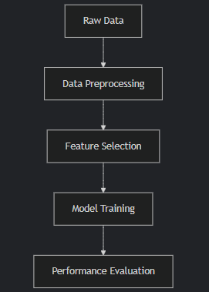

Data Loading & Preprocessing
pd.read_csv():
Reads the dataset from a CSV file into a Pandas DataFrame (df).
df.head():
Displays the first 5 rows to inspect the data structure.
df.isnull().sum():
Checks for missing values in each column.
df.dropna():
Removes rows containing missing values to ensure clean data.

Feature-Target Separation
df.drop("TenYearCHD", axis=1):
Separates features (X) by dropping the target column (TenYearCHD).
df["TenYearCHD"]:
Extracts the target variable (y) for classification.

Feature Selection
SelectKBest(score_func=f_classif, k=10):
Selects the top 10 most relevant features using ANOVA F-test (f_classif).
selector.fit_transform(X, y):
Fits the selector to the data and returns the reduced feature set (X_selected).
selector.get_support():
Retrieves a boolean mask of selected features for interpretation

Train-Test Split
train_test_split(X_selected, y, test_size=0.2, random_state=42):
Splits data into 80% training (X_train, y_train) and 20% testing (X_test, y_test) sets.
random_state=42 ensures reproducibility.

Model Training (Logistic Regression)
LogisticRegression(max_iter=1000, solver='liblinear'):
Initializes a logistic regression model with:
max_iter=1000: Ensures convergence.
solver='liblinear': Suitable for small datasets.
model.fit(X_train, y_train):
Trains the model on the training data.

Model Evaluation
model.predict(X_test):
Generates predictions (y_pred) on the test set.
accuracy_score(y_test, y_pred):
Computes prediction accuracy (correct predictions / total predictions).
confusion_matrix(y_test, y_pred):
Shows True Positives (TP), False Positives (FP), True Negatives (TN), False Negatives (FN).
classification_report(y_test, y_pred, zero_division=0):
Provides precision, recall, F1-score, and support for each class.
zero_division=0 handles cases where no predictions are made for a class.

Visualization

sns.heatmap(confusion_matrix(...), annot=True, fmt='d', cmap='coolwarm'):

Plots the confusion matrix as a heatmap with annotations.

plt.xlabel(), plt.ylabel(), plt.title():

Adds labels and a title to the plot.

plt.show():

Displays the visualization.

Chapter 3:

Source code
import pandas as pd
import numpy as np
from sklearn.feature_selection import SelectKBest, f_classif
from sklearn.model_selection import train_test_split
from sklearn.linear_model import LogisticRegression
from sklearn.metrics import accuracy_score, confusion_matrix, classification_report
import seaborn as sns
import matplotlib.pyplot as plt

# Step 1: Load dataset
datapath = "D:\heart_disease_classifacation\heart-disease-prediction_ca9d91fb-0255-41f2-9e92-d5cd33edca38.csv"
df = pd.read_csv(datapath)
print(df.head())

# Step 2: Check and handle missing values
print("\nMissing values:\n", df.isnull().sum())
df = df.dropna()

# Step 3: Separate features and target
X = df.drop("TenYearCHD", axis=1)
y = df["TenYearCHD"]

# Step 4: Feature selection (select top 10 features)
selector = SelectKBest(score_func=f_classif, k=10)
X_selected = selector.fit_transform(X, y)
selected_features = X.columns[selector.get_support()]
print("\nSelected Features:\n", selected_features)

# Step 5: Split data
X_train, X_test, y_train, y_test = train_test_split(X_selected, y, test_size=0.2, random_state=42)

# Step 6: Train logistic regression model
if len(np.unique(y_train)) < 2:
print("Error: y_train contains only one class. Model training skipped.")
model = None
else:
model = LogisticRegression(max_iter=1000, solver='liblinear')
model.fit(X_train, y_train)

# Step 7: Predict and evaluate
if model is not None:
y_pred = model.predict(X_test)

print("\nAccuracy:", accuracy_score(y_test, y_pred))
print("\nConfusion Matrix:\n", confusion_matrix(y_test, y_pred))
print("\nClassification Report:\n", classification_report(y_test, y_pred, zero_division=0))

# Display feature coefficients
print("\nModel coefficients (Feature: Coefficient):")
for feature, coef in zip(selected_features, model.coef_[0]):
print(f"{feature}: {coef:.4f}")
else:
print("Model was not trained. Skipping evaluation and coefficient display.")

# Step 8: Visualize confusion matrix
if model is not None:
plt.figure(figsize=(6, 4))
sns.heatmap(confusion_matrix(y_test, y_pred), annot=True, fmt='d', cmap='coolwarm')
plt.xlabel("Predicted")
plt.ylabel("Actual")
plt.title("Confusion Matrix")
plt.tight_layout()
plt.show()
else:
print("Confusion matrix cannot be displayed as the model was not trained.")

Chapter 4

Output
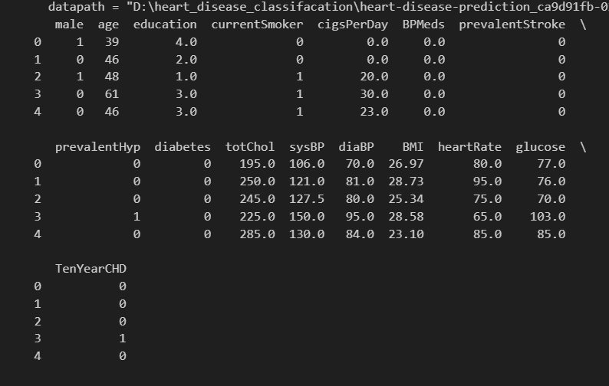

Figure 1 selection of 5 datas

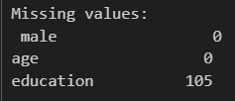

Figure 2 missing values
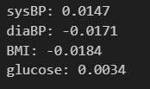

Figure 3 values representation
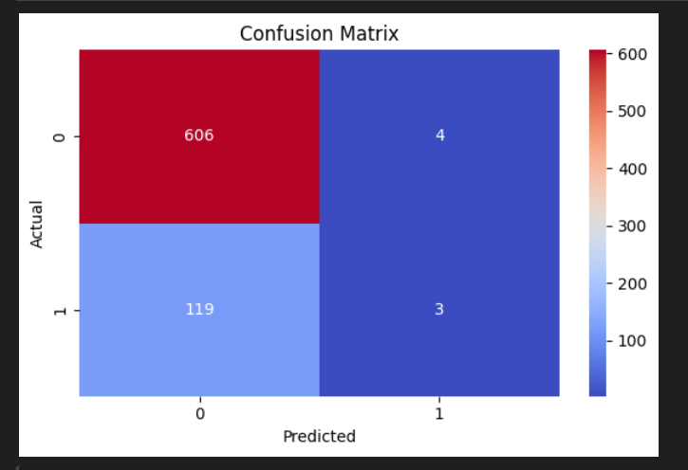
Figure 4 Confusion matrix.

Chapter 5:

Conclusion
This heart disease prediction project successfully implemented a machine learning workflow using logistic regression to assess the 10-year risk of coronary heart disease. The process involved data cleaning, feature selection using training with scikit-learn's LogisticRegression, and comprehensive evaluation through accuracy metrics, confusion matrix analysis, and feature importance interpretation. The model demonstrated practical predictive capabilities while the selected features provided meaningful medical insights into key risk factors. The project showcases how machine learning can contribute to preventive healthcare by identifying at-risk individuals, though further improvements like handling class imbalance and exploring alternative algorithms could enhance performance. This implementation serves as a foundation for developing more advanced medical diagnostic tools and highlights the growing role of data science in healthcare decision-making, where early risk prediction can lead to better patient outcomes through timely intervention and lifestyle modifications.

References
SelectKBest: https://scikit-learn.org/stable/modules/generated/sklearn.feature_selection.SelectKBest.html
f_classif: https://scikit-learn.org/stable/modules/generated/sklearn.feature_selection.f_classif.html
train_test_split: https://scikit-learn.org/stable/modules/generated/sklearn.model_selection.train_test_split.html
LogisticRegression: https://scikit-learn.org/stable/modules/generated/sklearn.linear_model.LogisticRegression.html
accuracy_score: https://scikit-learn.org/stable/modules/generated/sklearn.metrics.accuracy_score.html
confusion_matrix: https://scikit-learn.org/stable/modules/generated/sklearn.metrics.confusion_matrix.html
classification_report: https://scikit-learn.org/stable/modules/generated/sklearn.metrics.classification_report.html

