CSF425 - Deep Learning
Project Report

Problem Definition:
- To understand the intuition and architecture of the Mask RCNN model by studying the paper it was introduced in.
- To implement Mask RCNN using tools and libraries provided in python.
- To verify our implementation of the Mask RCNN model by generating results on a small experimental dataset i.e. the kangaroo images dataset.
- To suggest improvements, which will provide better results and verify these improvements on the experimental dataset.

A brief history of RCNN

2014: R-CNN - An Early Application of CNNs to Object Detection

The process of identifying and categorising the various items in a picture is known as object detection.
The research team discovered that using Krizhevsky's findings, this issue can be resolved through testing on the widely used PASCAL VOC Challenge, which is similar to ImageNet in terms of object detection.

Comprehending R-CNN:

R-CNN's objective is to correctly detect the locations of the principal objects in a picture by using a bounding box.⦁
- Inputs: Image
- Outputs: Bounding boxes + labels for each object in the image.
However, how can we locate these bounding boxes? In addition to what we may naturally do, R-CNN proposes a number of boxes in the image and determines which ones genuinely belong to objects.
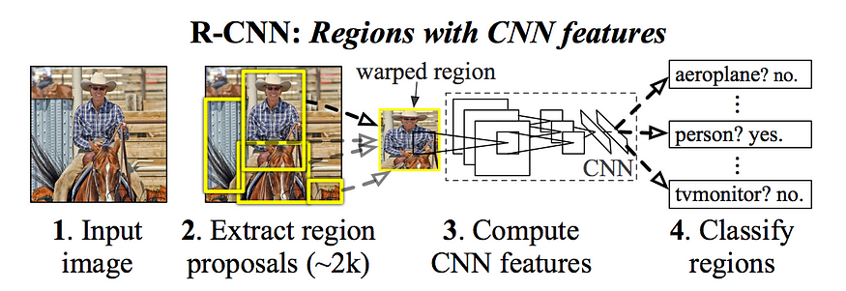
These bounding boxes, or region suggestions, are produced by R-CNN through a procedure known as Selective Search, which you can learn more about here. In summary, Selective Search (shown in the figure above) groups nearby pixels based on texture, colour, or intensity to detect objects by examining the image via windows of varying sizes.
R-CNN adds a Support Vector Machine (SVM) to the CNN's last layer, which performs the simple task of classifying whether or not this is an object and, if so, what kind of item.
To sum up, R-CNN consists of the following steps:
- Generate a set of proposals for bounding boxes.
- Run the images in the bounding boxes through a pre-trained AlexNet and finally an SVM to see what object the image in the box is.
- Run the box through a linear regression model to output tighter coordinates for the box once the object has been classified.

2015: Fast R-CNN - Speeding up and Simplifying R-CNN

R-CNN functions effectively, although it moves slowly for a few straightforward reasons:
Every single region proposal for every single image necessitates a forward pass of CNN (AlexNet), which equates to about 2000 forward passes per image.
The CNN, which creates image features, the classifier, which determines the class, and the regression model, which tightens the bounding boxes, must all be trained independently. Because of this, training the pipeline is very challenging.
- Fast R-CNN Insight 1: RoI (Region of Interest) Pooling
- Fast R-CNN Insight 2: Combine All Models into One Network
Here are the inputs and outputs to this overall model:
- Inputs: Images with region proposals.
- Outputs: Object classifications of each region along with tighter bounding boxes.

2017: Mask R-CNN - Extending Faster R-CNN for Pixel Level Segmentation
The fundamental concept of Mask R-CNN is similar to that of Fast R-CNN and Faster R-CNN, with the exception that Mask R-CNN additionally returns the object mask in addition to the class name and bounding box coordinates for each object. Segmentation at the pixel level is used to mask.

Image Segmentation
Each object in the image is given a pixel-by-pixel mask thanks to image segmentation. With the help of this method, we can comprehend the object or objects in the picture much more precisely. The following image can assist you in comprehending the concept of image segmentation:
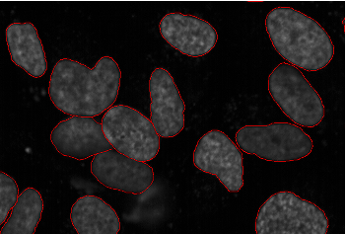
Here, you can observe that every object—in this case, the cells in this image—has undergone segmentation. This is the process of segmenting images.
Semantic segmentation and instance segmentation are the two categories of image segmentation. Once more, let's look at an illustration to comprehend each of these types:
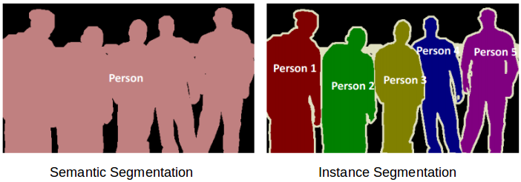
The five things on the left are all human beings. Semantic segmentation will therefore classify each individual as a single instance. Now, there are five items in the image on the right as well—all of them are individuals. However, in this case, distinct instances of the same class have been given to different objects. An illustration of instance segmentation is this. Semantic segmentation is just an extension of instance segmentation.
In order to do this, Mask R-CNN extends Faster R-CNN with a branch that produces a binary mask that indicates whether a particular pixel is a part of an object.
Here are its inputs and outputs:
- Inputs: CNN Feature Map.
- Outputs: Matrix with 1s on all locations where the pixel belongs to the object and 0s elsewhere (this is known as a binary mask). .
RoiAlign - Realigning RoIPool to be More Accurate

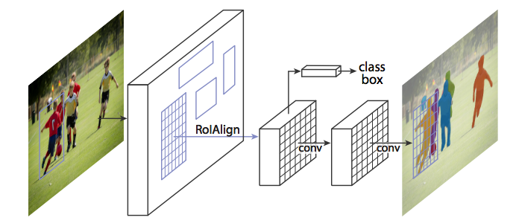
To get such amazingly accurate segmentations, Mask R-CNN combines these masks with the bounding boxes and classifications from Faster R-CNN.
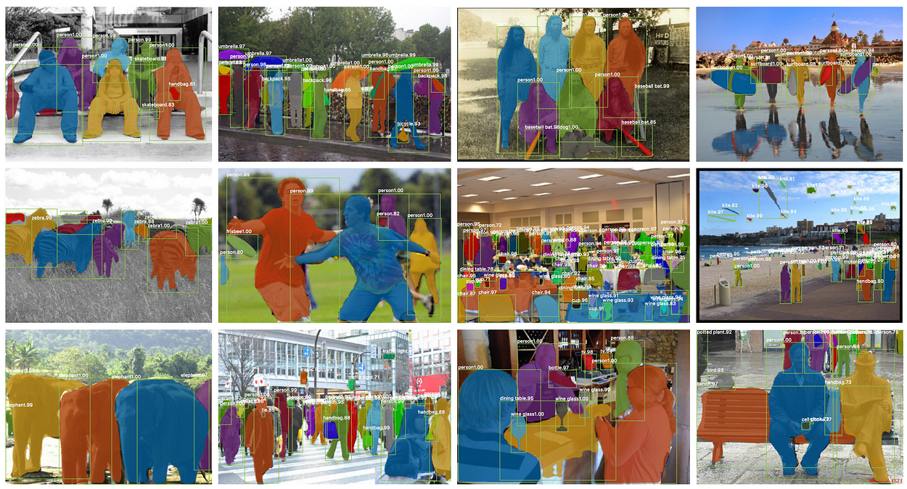
Suggested Improvement:
We first trained our model only on the kangaroo dataset, however due to the small size of the dataset we could not get our desired results on the test dataset.
To overcome this shortage of data we tried to improve our model’s results by using the principles of transfer learning. We imported weights that the Mask RCNN learned when it was trained on the MS COCO dataset, which is a very large object detection and image segmentation dataset, these weights make for a very good base model for image segmentation tasks. After importing the weights, we fine-tuned the weights on our small kangaroo dataset. And as we have shown below our results improved and our model could differentiate between kangaroos and other objects way better than before.
Results before Improvement (i.e. model only trained on kangaroo dataset)
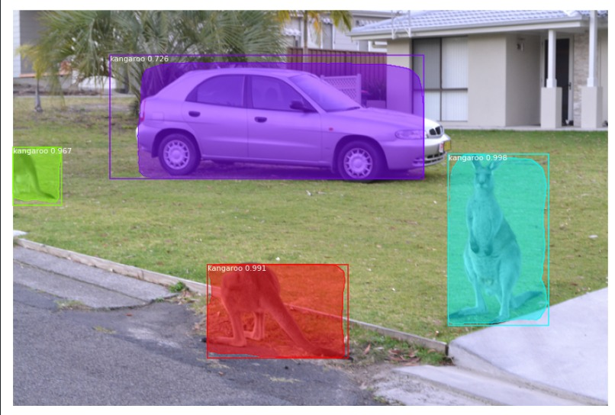
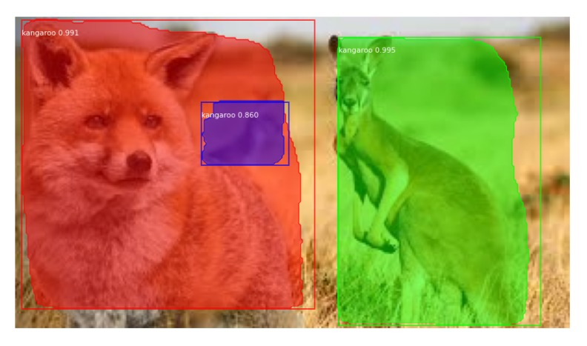
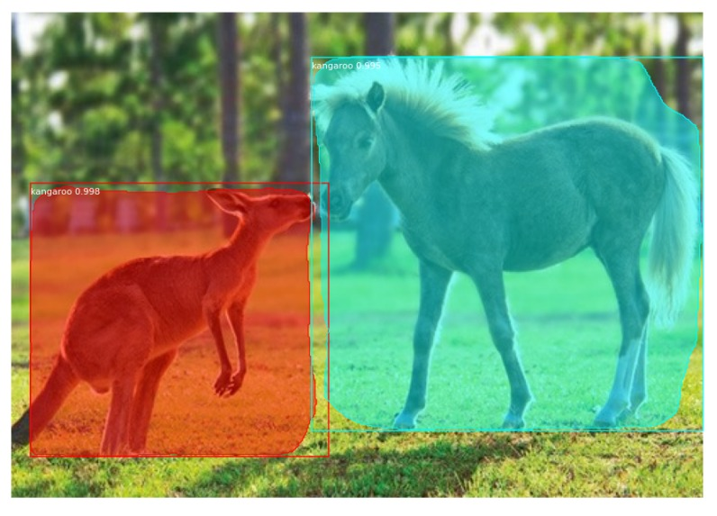
Results after Improvement (i.e. weights learned from MS COCO dataset imported and fine-tuned on the kangaroo dataset)

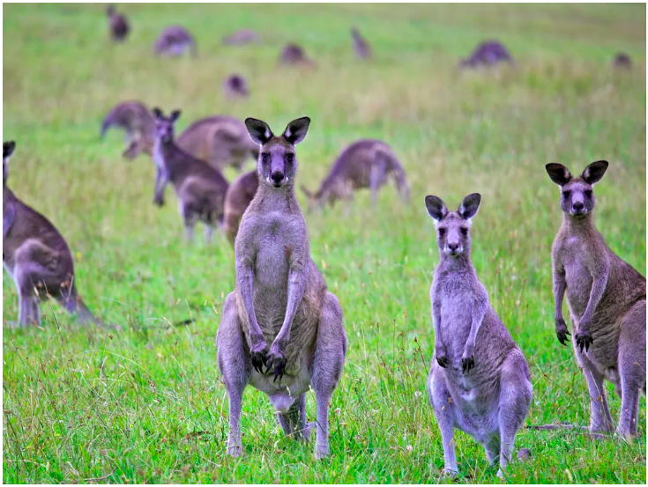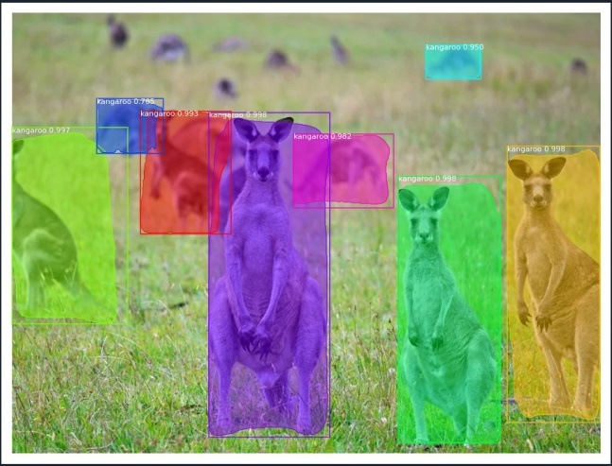

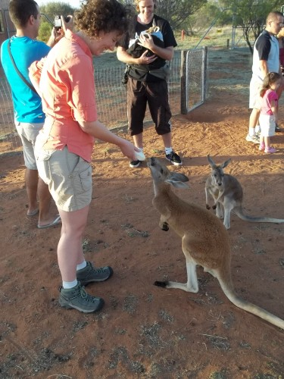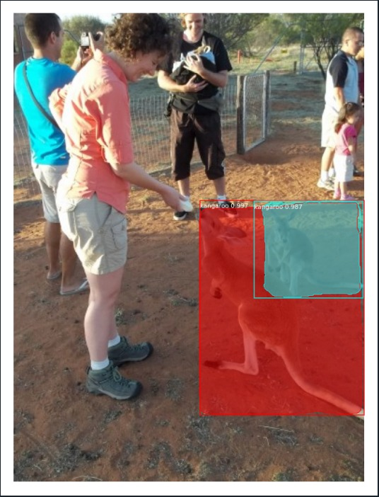

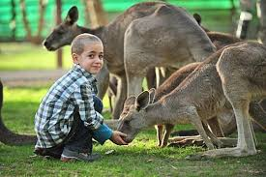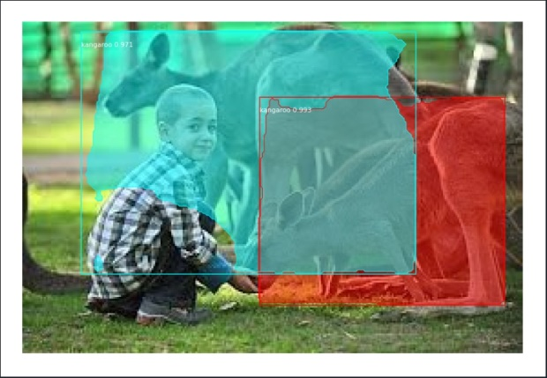
Testing on some unclear images:
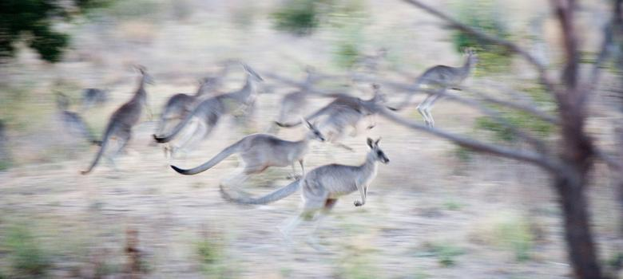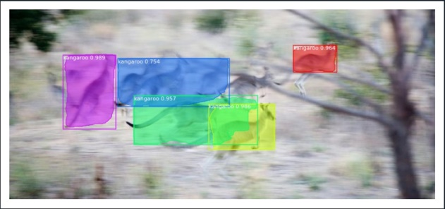
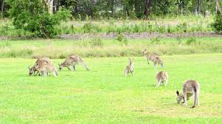
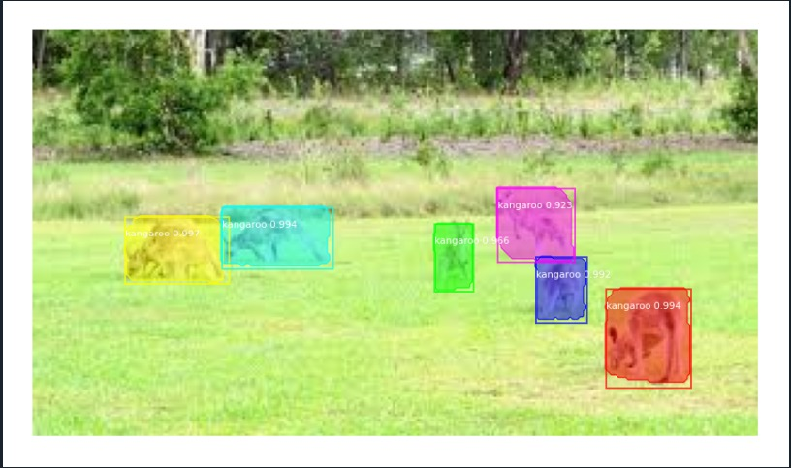

Conclusion:

Finally after the improvement we achieved desirable results on our small experiment dataset (kangaroo dataset). Through the above experiments and improvements to our model we were able to verify our implementation of the Mask RCNN model and successfully used it for a specific image segmentation task.

References:
Primary reference: Mask RCNN
Link: https://arxiv.org/pdf/1703.06870.pdf

