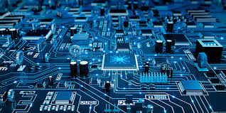LITERACY INDIA COMMUNITY COLLEGE(LICC)

Programs offered

* Robotics/Tinkering
* Computer Hardware
* Mobile Repairing
* Cooking/Hospitality
* Beauty& Wellness
* Stitching & Cutting
* Electrical Troubleshooting
* Two-wheeler Repairing
* Mobile Journalism
* Computer Science
* 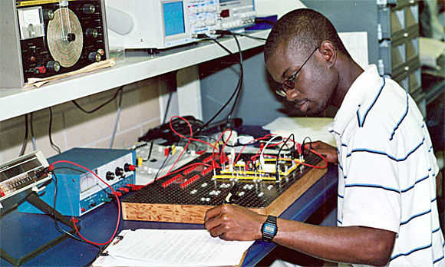Call Centre/BPO
* Logistics
* Data Digitization
* Natural Farming Market Connect
* Banking

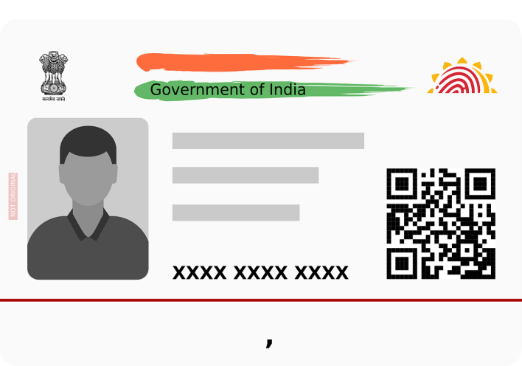[WWW.literacyindia.org](http://WWW.literacyindia.org)

Session Starts From

January 2024

Register Now Limited Seats

Contact no - 8588853380