**A**

**Project Report On**

**“Tours and Travels Management”**

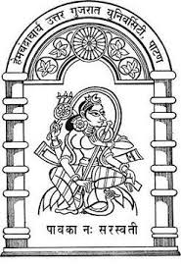

**Submitted To:**

**Department Of Computer Science,**

**Hemchandracharya North Gujarat University,**

**Patan(N.G.)**

M.C.A.(Int.) SEM-VI

INTERNAL GUIDE: SUBMITTED BY:

Mr. Kirit Chokhawala Dharmik Soni [Seat no: 02]

Nisarg patel [seat no: 05]

INDEX

1 PROJECT PROFILE 01

2 ORGANIZATION PROFILE 02

3 INTRODUCTION 03

4 PREFACE 04

5 ACKNOWLEDGEMENT 05

6 PROJECT MODULE 07

7 DATA FLOW DIAGRAM 09

8 DATA DICTIONARY 24

9 SCREEN SHOTS 36

10 conclusion 95

11 bibliography 96