# Proposal

# Google Trends API for getting the current trending topics on the internet

**Your Name here**

**Your Student ID**

**Semester**

Contents

Proposal 1

Google Trends API for getting the current trending topics on the internet 1

Introduction: 3

Objective: 3

Significance: 3

# Introduction:

Google Trends is a platform where Google keeps the data from their daily search history, this website analyzes and list the most popular search results based on Google search. These trends are based on different regions, countries, people, etc. I selected crawling data from online social media websites and identify trending topics. For this purpose, the data from Google is a good choice, so I selected Google Trends data which is openly available on Google Trends website, Google provides an API that helps us fetch the data into Python by using the PyTrends package.

The Google Trends site gives an examination of various query items from Google Search because of different rules like districts, time, and language. As a designer, you can utilize Google Trends API in python to obtain similar outcomes as introduced on the Google Trends site through Pytrends.

# Objective:

Google Trends is a site by Google that dissects the fame of top hunt questions in Google Search across different areas and dialects. The site utilizes charts to analyze the hunt volume of various questions over the long haul.

Google Trends standardizes search information to make correlations between terms simpler. List items are standardized to the general setting of an inquiry by the accompanying system: Each information point is isolated by the all-out searches of the topography and time range it addresses to look at relative notoriety.

The main objective of this case study is to use Google Trends to find the trends, To find the trend line of anything specifically, the data of that item or thing should be available to you. To obtain the data, the Google Trend website and the PyTrend Python module help us. The data of every click and search of anything we search on google is kept safe on Google Trend. To get the data of a specific thing from Google Trend, we have to use the Pytrend module. We will be analyzing different types of data like products, actors, and popular websites to give comparisons, etc.

# Significance:

Google Trends is a helpful pursuit pattern include that shows how now and again a given hunt term is placed into Google's web index compared with the webpage's all-out search volume throughout a given timeframe. Google Trends is a web-based information investigation device that highlights continuous hunt information from Google. Clients can investigate individuals' hunt advantages and observe extra information like the most applicable articles, premium over the long run, premium by area, moving inquiries, and related themes.

This helps the companies, businesses, and small startups to know what is going on in the market. For example, a startup wants to sell a product but they are completely unaware of the results of the product. They don’t know whether the product will fail or succeed. Google Trends helps in this situation, if the startup does some research before launching the product, then they can take some useful decisions. For example, a skin product is first analyzed with PyTrends, all the searches of a specific product on google are analyzed, their reviews, etc., the graphs of searches and many, now based on this, a business can decide that they should put the product into the market or not?

# Methodology:

The overall methodology of this project is given below:

## Possible Approaches:

As the goal of this project is to analyze the Google Trends data using Python, so we used a module called PyTrends, this module is not a Google Trends native module but this can help us get the data from the Google Trends website directly to the Python environment in a real-time basis. There are many ways to get the data from Google searches like we have Google Analytics and many other websites which provides us the historically searched results on Google but the best way to see what’s been searched on Google is the Google Trends itself. There are also many other ways to fetch data from Google Trends in real-time but the most feasible way is to use Python’s PyTrends module, easy to use and results efficiently.

## Why Google Trends:

Google Trends standardizes search information to make examinations between terms simpler. Query items are standardized to the general setting of a question by the accompanying system: Each information point is partitioned by the all-out searches of the topography and time range it addresses to look at relative fame. Google Trends is a site by Google that breaks down the prominence of top hunt questions in Google Search across different districts and dialects. The site utilizes diagrams to think about the pursuit volume of various inquiries after some time. We selected Google trends for our project because, to know what is searching on Google, this website has all the information we need to know.

## Approach with technical details:

As mentioned above, there are many ways to get the google search results from the internet, the best and most feasible one is to fetch the data from Google’s native website called Google Trends. Now to fetch the data from google to our Python environment for analysis purposes, we have to use a module called PyTrends, the first step is to install this module on the PC by using a command-line script (pip install by trends). After installing the module, the next step is to make a Python environment, we are using the Jupyter Notebook and Anaconda for our project, we will import all the required libraries and start fetching the data and perform the analysis.

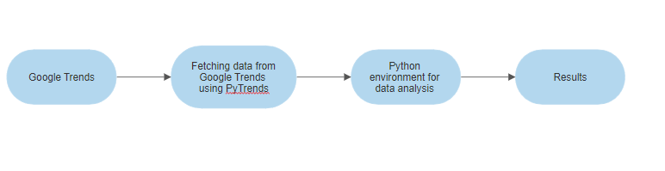

Flow chart of the process

We will fetch data from Google Trends using python’s module and then perform data analysis on the data we get, then we will show the results in the form of graphs and charts.

## Data Description:

Google Trends information considers looking through individuals make Google consistently, however, it can likewise reflect sporadic hunt movement, for example, computerized searches or inquiries that might be related to endeavors to spam our query items. We will fetch the data in real-time in the form of searches.

# Analysis of Results/Findings:

In this section, we will look at all the code we have performed and show the results we get. As the goal of this project is to fetch data of Google searches from Google Trends and perform analysis on the fetched data, to achieve this we will first make a Python environment and then perform all the data analysis and data fetching.

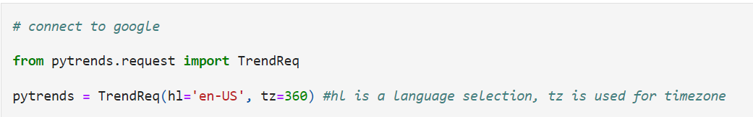

The first step we took is to import the PyTrends module that we have installed, this module will help us to fetch the data from Google in real-time. We are importing it as TrendReq, we are setting the time zone and language.

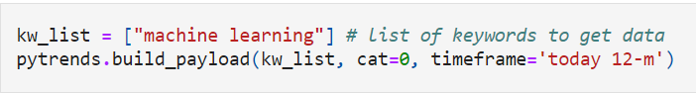

We will make a payload, The build_payload method from Pytrends is used to build a list of keywords you want to search in Google Trends. You can also specify the timeframe to gather data and the category to query the data from. For this example, we will search trends for the “machine learning” keyword. You can also add more keywords into kw_list as many as you want.

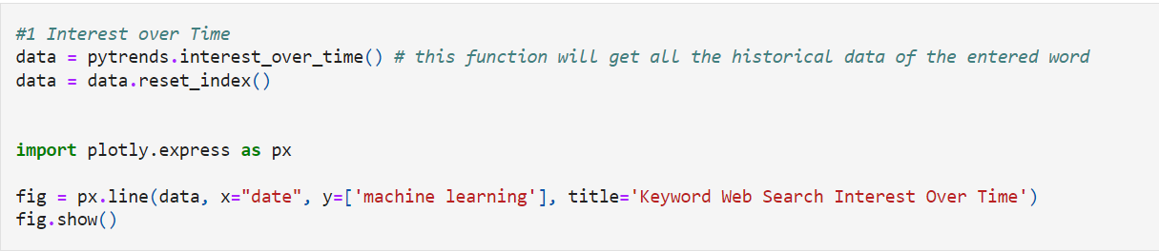

The primary API strategy from my trends is interest_over_time; this technique will return authentic information of the looking through watchword from Google Trend as per the period you have indicated in the build_payload strategy.

Then we can picture the information gathered by utilizing the Plotly library to get additional knowledge from the information. We got the following useful graph.

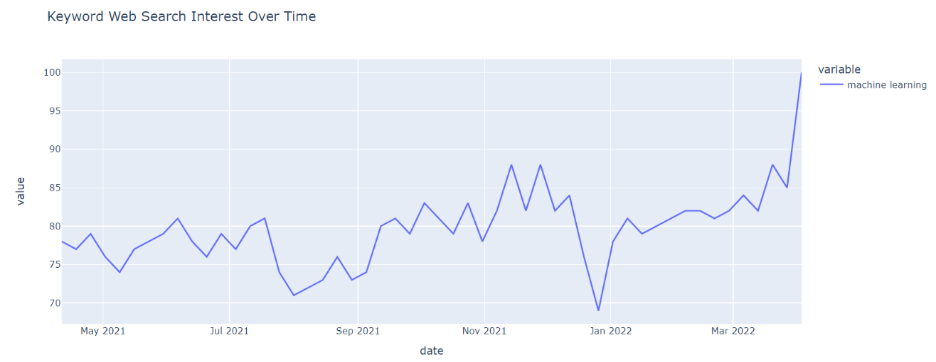

Searches of machine learning keywords over time

From the above graph, you can see the keyword "machine learning" has been searched mostly from March 2021 to July 2021.

We can pass more than one keyword so see the comparison for example we are passing the following keyword to see their comparison

* machine learning
* data science
* deep learning

The purpose of doing this is to see which of the following keywords is searched the most?

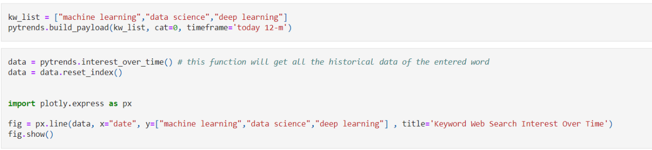

We are passing the above keywords in the kw_list, then we are using the same over time function, and by doing so, we the following results.

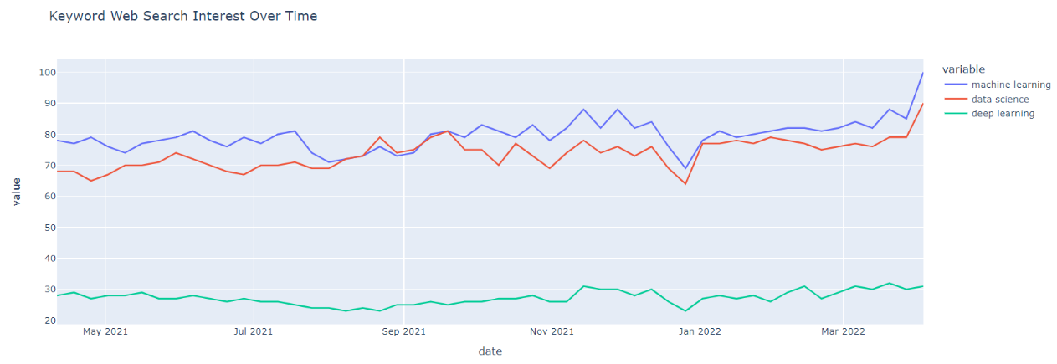

As you can see that the keywords machine learning and data science are searched more, their graphs are competitive but the deep learning is out of their competition.

Now let’s do something interesting, we are going to see the searches of major mobile phone companies like iPhone, Samsung, etc, and see the trend line. For this purpose, we will do the same thing but just change the list, in the list, we will pass the following company names.

* Apple
* Samsung
* Hawaii
* vivo

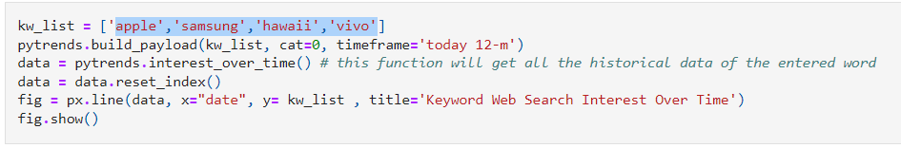

By running the above script, we got the following results.

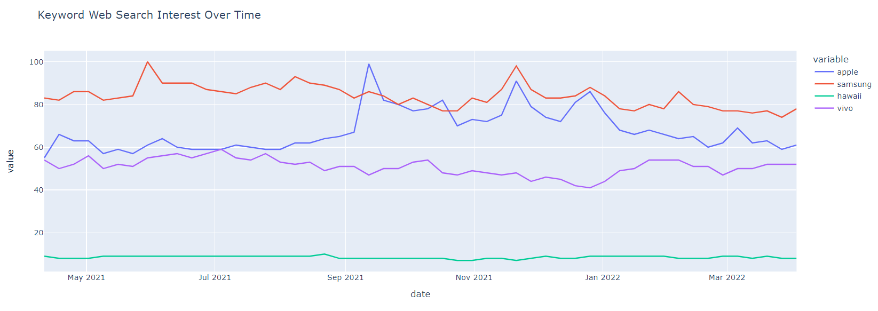

As you can see Apple and Samsung are the best competitors, Hawaii is somehow trying to compete but Vivo is out of it.

Now let's give some comparison of Bollywood Actors. To do so, we will pass the names of the actors we want to compare to the kw_list.

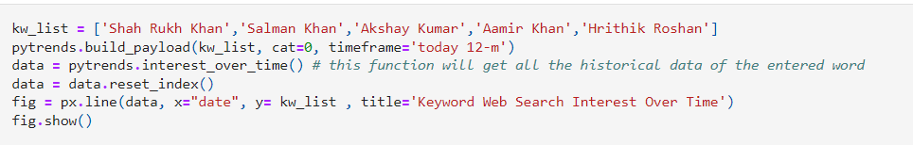

We are passing the actors' names; the purpose is to see the fame and trend line of these actors.

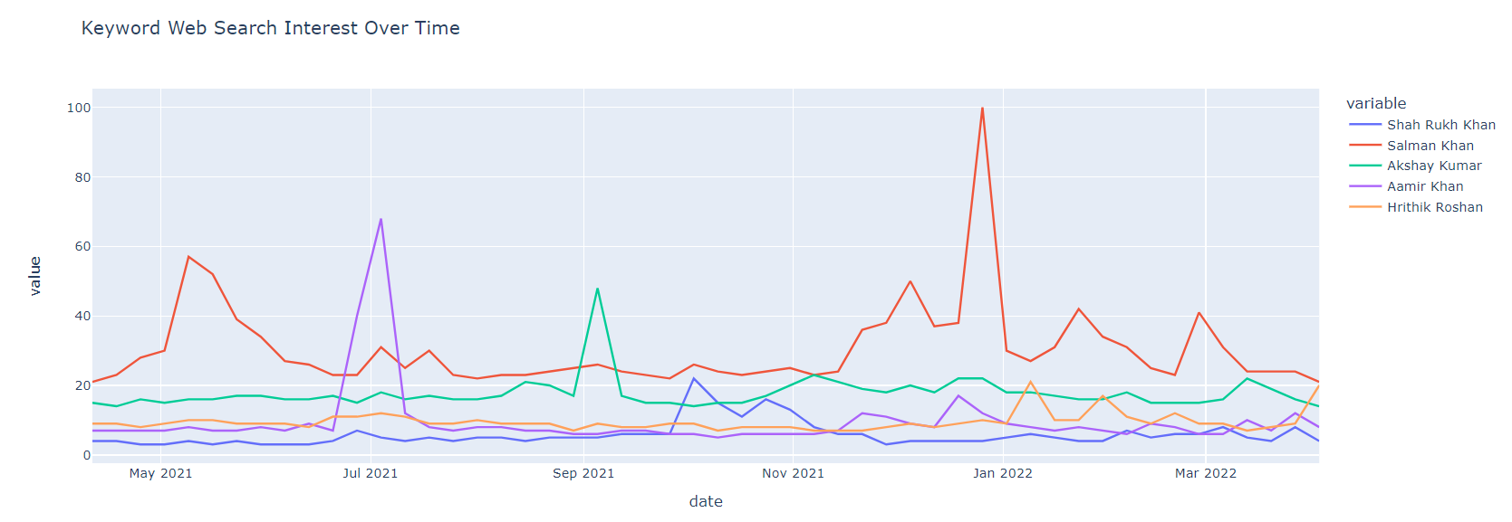

We got the above results; we can see that Salman Khan was trending during Jan-2022. This is the beauty of using Google Trends.

If you are interested in the hourly interest of the keyword, you can use the get_historical_intereset() method to fetch hourly data according to the time you have specified. Now let’s say we are going to trace the data of these Bollywood actors hourly wise.

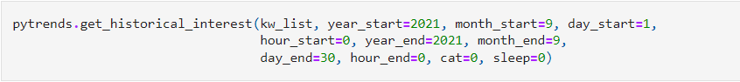

We are passing the same actors list to the get_historical_interest, this will give us the hourly search rate of these actors.

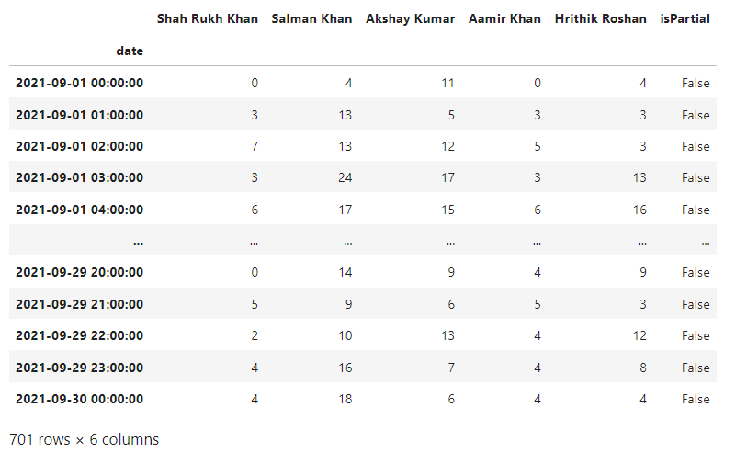

The above table gives us the hourly search results, we can see that on 2021-09-01, on 1c, the shah rukh khan was not searched, Salman khan was searched 4 times in an hour, and so on.

Now we are interested in finding the regions where these actors are being searched, this is possible.

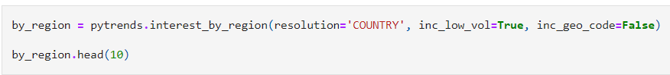

By running the above script, we got the following results.

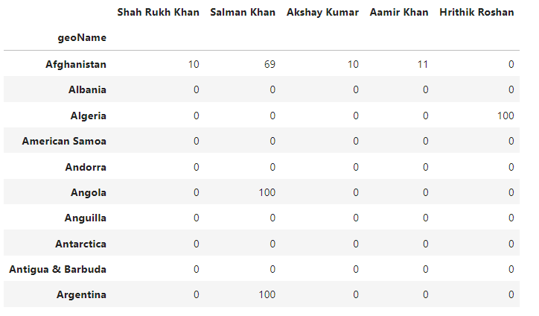

Now we can see the searches region-wise. We can play with the above data frame, like what if I want to show the searches above 40.

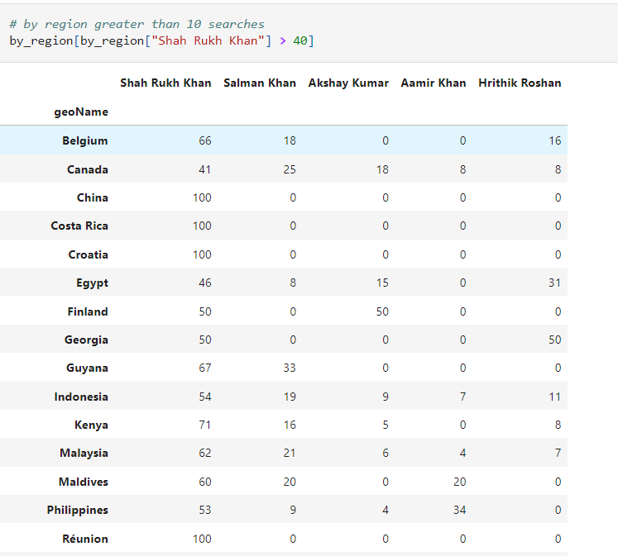

By applying some restrictions, we got those searches that are above 40.

Pytrends can also help you find keywords that are closely tied to a primary keyword of your choice and then return a list of related keywords shown on Google Trends. Let us find a list of related queries for “machine learning” and return the top queries.

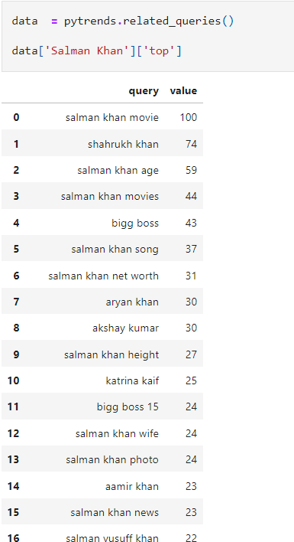

As you can see that the related_queries function gave us all the results which are being searched.

# Conclusion:

The goal of this project is to scrape the data from Google Trends and perform data analysis on the data we get and show the trending topics. We performed all the analysis on the data and found very interesting results and graphs. We got some very useful information about what is going on and what is being searched the most. This small research project can help businesses and startups to perform interesting research about any products etc. The Pytrends help us fetch the data in real-time and analysis of the data we fetch can help us find trends.

# References

PyTrends module: <https://pypi.org/project/pytrends/>

Google Trends: <https://trends.google.com/trends/>