Predicting wine types with different

classiﬁcation techniques

Predicting wine types with different

classiﬁcation techniques

# Predicting Wine Types with different Classification Techniques

Contents

Predicting Wine Types with different Classification Techniques 1

Abstract: 1

Introduction: 1

Data Description: 3

Methodology: 3

Modelling 3

Random forest: 4

Support Vector Machine: 4

Decision Tree: 4

Results: 5

Discussion: 6

Bibliography 7

# Abstract:

In the advanced world, wine has turned into a piece of life and culture. With the improvement of creation strategies, winemaking has been transformed into a type of craftsmanship and a part of science. This report endeavors to group the various kinds of wine based on various constituents recorded as wine information. To get done with this job, we utilized the Decision Tree Classifier, Random Forest Classifier, Support Vector Classifier, KNeighbors Classifier. We have broken down the consequences of these without a trace of the Outliers, We have utilized exactness, Classifications Report as the estimating measures of grouping procedures.

# Introduction:

n this paper, some statistical computing has been performed using some statistical packages

from CRAN mirror library (https://cran.r-project.org/). In R platform, calculation of LDA, MLR, RF, and SVM can

be done using “MASS”, “nnet”, “randomForest”, and “e1071” library respectively

n this paper, some statistical computing has been performed using some statistical packages

from CRAN mirror library (https://cran.r-project.org/). In R platform, calculation of LDA, MLR, RF, and SVM can

be done using “MASS”, “nnet”, “randomForest”, and “e1071” library respectively

Wine is the developed juice of grapes or any regular items used especially as a reward, made in various varieties, such as red or white, sweet or dry, notwithstanding everything or gleaming. It contains around 14% alcohol. Wine is essentially made in each nation of the world. These countries are routinely implied as to the old world or the new world. The old world comprises districts with long records of wine creation, similar to Europe and parts of the Mediterranean. A part of the most notable old world wine districts join France, Italy, and Germany, and these regions revolve gigantically around terroir the fascinating characteristics of the soil and climate, which furnish their wine with a sensation of spot [1].

Another world is used to depict more current wine-making regions, similar to the United States, Australia, and Chile. Fresher wine conveyance locales shave additional sizzling conditions and the creators use grapes name for wine checking as opposed to the region used in the old world. Wine creation is extending bit by bit and Italy is one of the most wine imaginative nations. The International Organization of Vine and Wine (OIV) had surveyed that Italy's wine creation in 2016 would be 48.8 million hectoliters at this point according to the detailed informational index, the improvement of wine was more than 50.112 million hectoliters in 2015 (Istat informational collection, 2016). In Italy among the twenty regions, the vitally four manifestations by volume (million hectoliters) are Veneto (9.733), Puglia (7.932), Emilia Romagna (7.382), and Sicilia (5.634) (Istat database, 2016). Wine certiﬁcation and depiction are generally overviewed by compound and material tests (Ebeler, 1999). For the human sense, it is difﬁcult to portray wine as having the least taste contrast (Smith and Margo asked, 2006).In addition, the chemical investigation and wine classiﬁcation are perplexing despite everything not being completely perceived (Legin et al., 2003). Be that as it may, wine classiﬁcation has incredible significance for its creation and business. Wine might be classiﬁed based on region, viniﬁcation strategies and style, grapes type, and tastes (Ewing-Mulligan and McCarthy, 2005) [2].

Foreseeing wine types with different classiﬁcation strategies Mainly wine taste generally depends upon different kinds of grapes and cultivars. The cultivar is the resultant plant that is created by duplicating a speciﬁc variety (or arrangements) of created plant species, much of the time decided to convey speciﬁc wanted characteristics. The cultivar is spread by individuals through things like hybrids, joins together, or clones. There are a few kinds of cultivars in the world. Among them, three cultivars are made in a particular area of Italy. The compound examination of wines concludes the measures of different constituents considered in all of the three sorts of wines and their taste, concealing, cost, etc depend upon how many different constituents. Cultivar classiﬁcation and its expectation from wines are imperative in wine assessment and business [3].

The principal objective of this report is to perform classiﬁcation and prediction of various cultivars in wine information. A few classiﬁcation procedures are well known for both spellbinding and predictive applications allude to the nontrivial extraction of implied, already obscure, and possibly valuable information from information in data sets. To accomplish this objective this report centers around a few decent and notable classiﬁcation techniques, for example, direct discriminant examination (Fukunaga, 1990), multinomial strategic relapse (Kleinbaum &Klein, 2010), arbitrary woods (Ali, 2012), and support vector machine (Conforti and Guido, 2010). In this report, we present an extensive exploratory review of multi-class classiﬁcation. To classify Wine types, we concentrate on the above classiﬁcation methods in presence of exceptions and nonattendance of anomalies. Our study shows that classiﬁcation strategies have a few good properties: ﬁrstly, they are basic and can be easily implemented; besides, they are efﬁcient and the greater part of our analyses just required a couple of moments.

# Data Description:

The wine data set used in this paper was collected from the UCI Machine Learning Repository (Forina et al.,

1991). This secondary data documents the chemical analysis of a set of 178 wines coming from three different

cultivars of the same area of Italy. The analysis determined the quantities of 13 constituents found in each type of

wines and the constituents are: Alcohol, Malic acid, Ash, Alcalinity of ash, Magnesium, Total phenols, Flavanoids,

Nonﬂavanoid phenols, Proanthocyanins, Color intensity, Hue, OD280/OD315 of diluted wines, and Proline. Here

all components are numerical and the cultivar types are categorical. This data set has been used to evaluate the

performance of different classiﬁ

The wine data set used in this paper was collected from the UCI Machine Learning Repository (Forina et al.,

1991). This secondary data documents the chemical analysis of a set of 178 wines coming from three different

cultivars of the same area of Italy. The analysis determined the quantities of 13 constituents found in each type of

wines and the constituents are: Alcohol, Malic acid, Ash, Alcalinity of ash, Magnesium, Total phenols, Flavanoids,

Nonﬂavanoid phenols, Proanthocyanins, Color intensity, Hue, OD280/OD315 of diluted wines, and Proline. Here

all components are numerical and the cultivar types are categorical. This data set has been used to evaluate the

performance of different classiﬁ

The wine data set used in this paper was collected from the UCI Machine Learning Repository (Forina et al.,

1991). This secondary data documents the chemical analysis of a set of 178 wines coming from three different

cultivars of the same area of Italy. The analysis determined the quantities of 13 constituents found in each type of

wines and the constituents are: Alcohol, Malic acid, Ash, Alcalinity of ash, Magnesium, Total phenols, Flavanoids,

Nonﬂavanoid phenols, Proanthocyanins, Color intensity, Hue, OD280/OD315 of diluted wines, and Proline. Here

all components are numerical and the cultivar types are categorical. This data set has been used to evaluate the

performance of different clas

The wine educational record used in this report was accumulated from the UCI Machine Learning Repository (Forina et al.,1991). This helper data records the substance assessment of a lot of 178 wines coming from three distinct cultivars of a comparative area of Italy. The assessment concluded the measures of 13 constituents found in every sort of wine and the constituents are: Alcohol, Malic corrosive, Ash, Alkalinity of debris, Magnesium, Total phenols, Flavanoids, Nonﬂavanoid phenols, Proanthocyanins, Color force, Hue, OD280/OD315 of weakened wines, and Proline. Here all parts are numerical and the cultivar types are total. This instructive assortment has been used to evaluate the presence of different grouping procedures referenced previously.

# Methodology:

Python3 Jupyter Notebook was utilized in this. The dataset was having the

Following columns Alcohol, Malic Acid, Ash, Alkalinity of Ash, Magnesium,

Total Phenols, Flavanoids, Nonflavanoid phenols, Proanthocyannis, Color

Intensity Hue, OD280/OD315 of diluted wines, Proline, Label.

The dataset was having 178 rows and 14 different features including the Labeled feature. We were having having 11 features with Dtype (float) and 2 features with

Dtype (int64) and one of the targeted features with Dtype (Object).

Below are the descriptive statistics of the dataset.

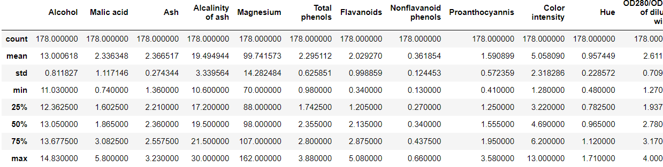

# Modeling

In this report, we have used the following three machine learning models

## Random forest:

Random Forest is a Supervised Machine Learning Algorithm that is utilized broadly in Classification and Regression issues. It assembles choice trees on various examples and takes their larger part vote in favor of order and normal if there should be an occurrence of relapse.

We trained a random forest classifier on the given data of wine and we got good results, we first split the data into test and train sets, then we train the model on the training data and tested it on the testing dataset. The ratio of testing and training datasets is 20% for testing and 80% for training. We got the following results while testing the model.

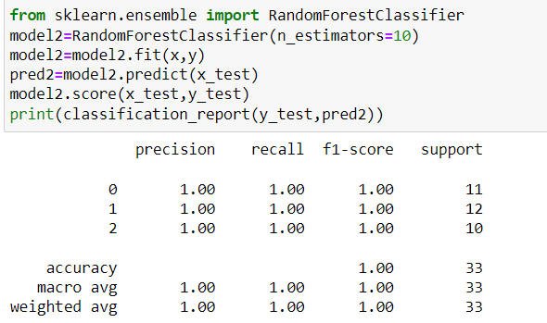

## Support Vector Machine:

Headway and execution of new classiﬁcation procedure SVMs are correct now of amazing interest to theoretical and applied experts in various. SVMs have been successfully applied to classiﬁcation issues and assumptions. SVMs, which are available in both straight and nonlinear versions, include streamlining of a raised incident work under given goals as are unaffected by issues of neighborhood minima. The SVM theory was gathered speciﬁcally for twofold classiﬁcation; we talk about trying to loosen up that procedure ology to multiclass classiﬁcation. A portion of the time data is gotten from different classes, and afterward, it is called multiclass.

Training the SVM model on the same dataset, the same approach is used here, 20% for testing and 80% for training, upon training and testing the model, we got the accuracy of 69%, which is much lesser than the random forest classifier.

# Decision Tree:

A decision tree is a kind of directed AI (supervised machine learning) used to arrange or make forecasts in light of how a past arrangement of inquiries was responded to. The model is a type of directed getting the hang of, implying that the model is prepared and tried on a bunch of information that contains the ideal classification.

The Decision Tree classifier also performed very well, we got a very good accuracy, when testing the model, we got the following classification report.

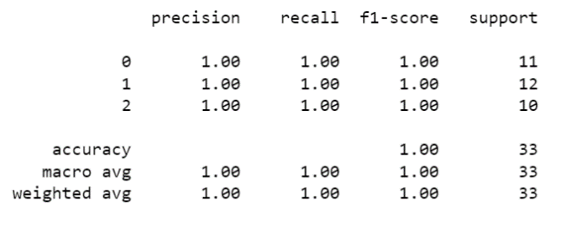

From the Cross-validation technique, we were made to the conclusion that the Random Forest classifier and decision tree classifier performed well and gave the highest accuracy.

# Results:

The main aim of this project was to perform the classification on the wine dataset to predict the labels. To achieve this goal, we trained three different machine learning models.

* Random Forest Classifier
* Decision Tree Classifier
* SVM

We split the data into test and train sets, then we fed this data into the models, the amount of training data is 80% and 20% is testing data size, after training the models, we got the following results.

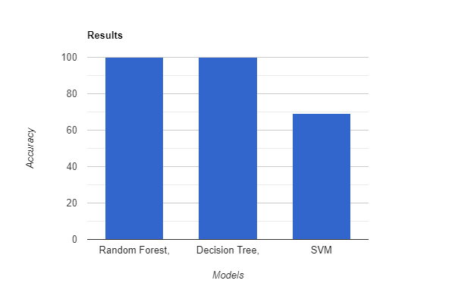

The above graph shows the accuracies of the three used models, we can see that Random Forest Classifier and Decision Tree classifier performed very well than SVM.

# Discussion:

Our goal was to predict the different types of Wine using different machine learning approaches with various statistical things in mind as statistics is the core part of data science and no research exists in which statistics is not involved so basically. To achieve what we want, we have to do some basic data cleansing like checking for any missing values and removing the outliers etc. though out dataset is clear and cleaned, we split the data into test and train sets, we used the train set to train the models and tested them by feeding the test data. We got pretty much good accuracies; each model performed very well. we got our ideal results with the specific data pre-processing and other outliers removal, etc.

# Bibliography

|  |  |
| --- | --- |
| [1] | A. M. F. J. P. Appalasamy, "Classification-based Data Mining Approach for Quality Control in Wine Production," June 2012. |
| [2] | oiv.int, "2016 World wine production estimated at 259 mhl," p. March, 2016. |
| [3] | R. Schuring, "RoboSomm Chapter 1: Predicting Grape Varieties," Medium, 28 April 2019. [Online]. Available: https://towardsdatascience.com/robosomm-chapter-1-predicting-grape-varieties-4c5beb505a7b. |