**VISVESVARAYA TECHNOLOGICAL UNIVERSITY**

**“Jnana Sangama”, Belagavi-590018, Karnataka**



**Report**

**On**

**“DETECTION OF BRAIN TUMOR BY IMAGE PROCESSING USING MATLAB AND MACHINE LEARNING”**

**Bachelor of Engineering in**

**Electronics and Communication Engineering**

**Submitted by**

| **USN** | **NAME** |
| --- | --- |
| **1BI17EC006** | **AFRIN UNNISA S** |
| **1BI17EC007** | **AISHWARYA** |
| **1BI17EC066** | **MULLANGI MANI SASHANK** |

Under the Guidance of

**NARAYANA SWAMY J.C**

**Assistant Professor**

**Department of ECE, BIT**

**Bengaluru-560004**



**DEPARTMENT OF Electronics and Communication Engineering**

**BANGALORE INSTITUTE OF TECHNOLOGY**

K.R. Road, V.V. Pura, Bengaluru-560 004 **2020-21**

**VISVESVARAYA TECHNOLOGICAL UNIVERSITY**

**“Jnana Sangama”,** Belagavi-590018, Karnataka

**BANGALORE INSTITUTE OF TECHNOLOGY**

Bengaluru-560 004



**DEPARTMENT OF Electronics and Communication Engineering**

**CERTIFICATE**

Certified that the project work entitled **“DETECTION OF BRAIN TUMOR BY IMAGE PROCESSING USING MATLAB AND MACHINE LEARNING”** carried out by

| **USN** | **NAME** |
| --- | --- |
| **1BI17EC006** | **AFRIN UNNISA S** |
| **1BI17EC007** | **AISHWARYA** |
| **1BI17EC066** | **MULLANGI MANI SASHANK** |

a bonafide students of VIII semester in partial fulfillment for the award of Bachelor of Engineering in Electronics & Communication Engineering of the **VISVESVARAYA TECHNOLOGICAL UNIVERSITY, Belagavi** during the academic year 2020-21. It is certified that all corrections/suggestions indicated for Internal Assessment have been incorporated in the report deposited in the departmental library. The project report has been approved as it satisfies the academic requirements in respect of Project work prescribed for the said degree.

Name & Signature of the Guide Name & Signature of the HOD Signature of the Principal

External Viva

Name of the examiners & signature with date

1

2

**ABSTRACT**

Brain tumor is an accumulation of anomalous tissue within the brain. Tumors are primarily classified into malignant and benign after they develop. It is life threatening hence it's important to acknowledge and identify the presence of tumors in brain image. This paper proposes a system to come to a decision whether the brain has tumor or is it tumor-free from the MR image using combined technique of K-Means and support vector machine. within the first stage the input image is converted to grey scale using binary thresholding and therefore the spots.

**ACKNOWLEDGEMENT**

The knowledge & satisfaction that accompany the successful completion of any task would be incomplete without mention of people who made it possible, whose guidance and encouragement crowned my effort with success. We would like to thank all and acknowledge the help we have received to carry out this project.

We would like to convey our sincere gratitude to the Principal , **Dr. ASWATH M U** for his constant support and ever-motivating vision.We would like to convey our thanks to the Head of Department **Dr. ASHA T** for being kind enough to provide the necessary support to carry out the project.

We are most humbled to mention the enthusiastic influence provided by the project coordinators **Dr. HEMAVATHI P** and **Prof. NETHRAVTHY V**, on the project for their ideas, time to time suggestions for being a constant guide and co-operation showed during the venture and making this project a great success.

We would like to extend our thanks to **Prof. BHANUSHREE K J** for being a constant beacon of co-operation and for guiding us extensively throughout the project.

We would like to extend our thanks to peer reviewer **Prof. MAMATHA V** for constantly reviewing and guiding our report.

We would also take this opportunity to thank our friends and family for their constant support and help. We are very much pleased to express our sincere gratitude to the friendly cooperation shown by all the staff members of the Computer Science Department,BIT.

**AFRIN UNNISA S (1BI17EC006)**

**AISHWARYA (1BI17EC007)**

**M. MANI SASHANK (1BI17EC066)**

**INTRODUCTION**

**Overview**

Brain tumors are frequently spoken as cancerous also termed as malignant or noncancerous termed as benign cells within the brain. Tumors can likewise be primary or secondary. The benign tumors aren't as aggressive as malignant tumors i.e. the mass or development of bizarre cells doesn't contain cancer cells. These tumors develop gradually and have a tendency not spread into other tissue. The threatening mind tumors contains malignant growth cells and furthermore be likely to not have clear fringes. These tumors are seen increasingly hazardous as they grow rapidly and might attack different pieces of the cerebrum. Doctors may likewise allude to a tumor keen about where the tumor cells began. within the event that the tumor started within the mind, it tends to be named to be a vital cerebrum tumor. within the event that it started in another piece of the body and spread to the mind, it fine is also alluded to as an auxiliary (metastatic) cerebrum tumor. within the date of ninth May 2016, the globe wellbeing organization (WHO) definitively renamed the bulk of the types of cerebrum tumor.

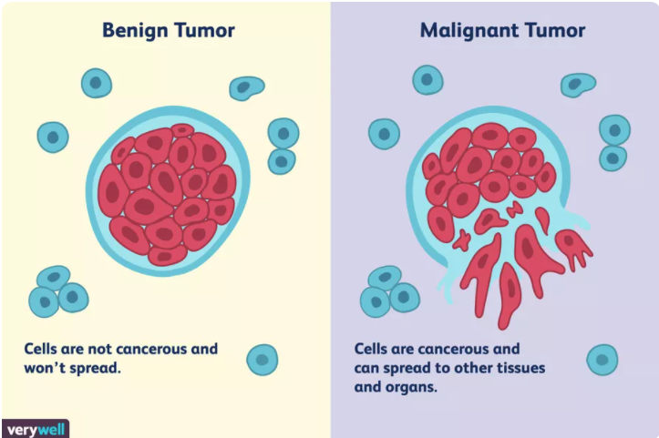

The American Cerebrum Tumor Affiliation (ABTA) gauge that there'll be in more than 79,000 new instances of essential mind tumors analyzed within the US in 2017. In any case, they need assessed that around 33% of those will bethreatening. ABTA inexact that there are without delay around 700,000 individuals living with essential mind tumors within the U.S. As indicated by ABTA, an expected 16,700 individuals will kick the bucket from mind and spinal string tumors in 2017. a large range of cerebrum tumors may create side effects that differ contingent upon the piece of the mind included. A specialist plan tumor assessment relying upon:

* CT filter: A mechanized tomography (CT) examine produces a nitty gritty X-beam image of a patient's mind.
* MRI filter: Attractive reverberation imaging (X-ray) utilizes a solid attractive field and radio waves to deliver a point by point picture of the mind.
* EEG: An electroencephalogram utilizes terminals appended to the head to record cerebrum action looking for variations from the norm.

The diagnostic images of above methods are utilized in detection of brain tumour. There are many varieties of software and applications available to scale back human effort. The main objective in brain tumor detection is to detect the presence of tumor and to calculate the area of tumor spread that is detected.

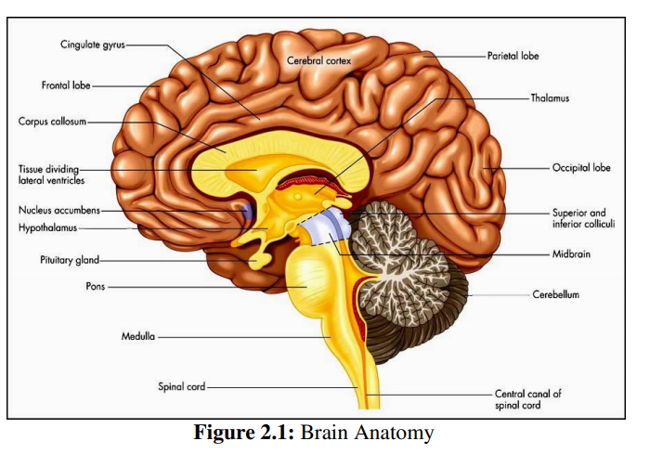

In this paper, MRI images of the brain is employed as input, because these images provide a details of infected and therefore the non-infected tissues. The nextprocess is detecting the spots within the images specified it differentiates between the tumor’s part and therefore the remainder of the brain. the strategy used for this purpose is setting a worth[6] such if the worth is not up to matching value then that part isn't affected and if a value which is larger or adequate to matching value then that part is tormented by the tumor. Then we want to get clusters so we are able to clearly distinguish between the tumor and therefore the non-affected a part of the brain. to attain this the strategy used is K-Means clustering algorithm. Next support vector machine is employed to investigate the information to spot form of cancer. The paper target detection of tumour using image processing from the MR Image using K-Means clustering algorithm.

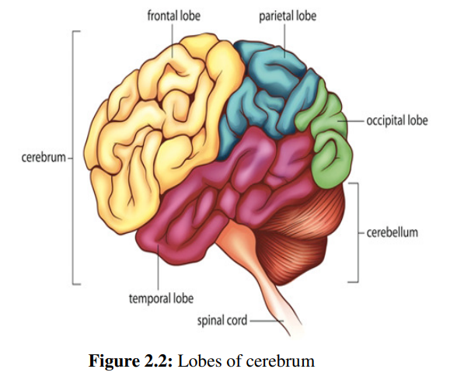

The detected tumor is then classified using SVM classifier. the most purpose of this paper is to detect the tumor present, the whole area spread of the tumor if present and classify it into types. The proposed system is useful in automated detection of brain tumors. during this system, we use combination of K-means which may be a clustering algorithm and support vector machine(SVM) which could be a machine learning method. The system helps in faster detection of the tumors and provides accurate results with low training set.

**Digital Image Processing**

The field of Digital image processing refers to processing digital images by means a digital computer. The digital image processing methods are Acquisition of Image, Enhancement of Image, Segmentation of Image, Representation of Image, Description of Image, Recognition of Image, Interpretation of Image.

Acquisition of Image

The first step in image processing is to acquire the images from any source. The image processing steps are performed to improve the quality of the image. The unprocessed image is acquired as the first step in image processing then the techniques are applied to process the images.

Enhancement of Image

Image enhancement is the modification of the image to improve its visual impact. It converts the image to a form which is better suited for human or machine interpretation. Image enhancement involves the operations such as gray level histogram modifications, smoothing of noisy images and image sharpening to get the images of better quality which are useful for further operations such as segmentation, recognition and description.

Representation of Image

The images are represented using many mathematical terms such as: (1) Vector images, (2) Bitmap images. The vector images are used to represent the image using numbers to describe the images using the position and the size of geometric forms. The geometric forms may be the lines, curves, rectangles, etc. The bitmap and images are also called as the raster image and are used in the digital photographs. The most common form to represent the images is using the bitmap images. The image representation is used to convert the input data into the form, which is suitable for the processing of images using the computers.

Description of Image

The image description is the process, which is used to extract the features that differentiate one class of objects from the other class. The image description extracts the quantitative information from the images.

Recognition of Image

The recognition of the image is to assign the label to an object based on the descriptions. The descriptors are used to assign descriptions in the input images. Interpretation of Image The objects or the images are assigned meaning to provide the proper interpretations. The objects are recognized and the meaning is assigned to each object in image processing

IMAGE PREPROCESSING

The image preprocessing involves certain steps for the removal of noise present in the images, degradation of noise, distortion correction, etc. There are several techniques involved in image preprocessing. They are described below: Smoothing, Subtraction of Background, Dilate, etc.

Filters used for preprocessing

Several filters are used for removing the noise from the input brain images and there are several filters used for preprocessing the brain images, which includes the following Adaptive median Filter, Mean Filter ,Adaptive mean Filter, Histogram equalization Adaptive Median Filter is used to smooth the non-repulsive noise from the 2D images without blurring the edges and preserves the details of the images. This is helpful in enhancing the brain images. Mean filters are used for replacing each pixel by the average value of the intensities in its neighbourhood. It is used for reducing the variance and is easy to implement and is optimal for additive Gaussian noise. Adaptive Mean Filter, in order to improve the blurring effect, an adaptive mean filter is used, which removes the speckle noise from different parts of the images. Histogram Equalization redistributes the gray levels for obtaining the uniform histogram. It is the process for enhancing the contrast of the images. By using the histogram equalization technique, the intensities of the images are distributed evenly on the histogram.

IMAGE SEGMENTATION

The segmentation of an image involves the demarcation or partition of the image into regions of related attributes. In medical imaging processing, segmentation is important for feature extraction, image measurements and image display.Thresholding, Edge based segmentation, Region based segmentation, Segmentation by Clustering.

Thresholding is the simplest method for image segmentation. In this method, the pixels are divided with respect to their intensity level. This method requires prior knowledge or information about image features. There are basically three types of thresholding segmentation namely global thresholding, variable thresholding and multiple thresholding.

The edge based segmentation methods partition an image based on the rapid change of intensity called edge in the image. Edge detection techniques locate the edges where either the first derivative of intensity is greater than a particular threshold or the second derivative has zero crossings. In edge based segmentation methods, first of all the edges are detected and then are connected together to form the object boundaries to segment the required regions. The basic two edge based segmentation methods are: Gray histograms and Gradient based methods. To detect the edges, Sobel, Robert or Canny operators can be used.

The region based segmentation methods are the methods that segments the image into various regions having similar characteristics. There are two basic techniques based on this method namely region growing method and region splitting and merging method.

The clustering based techniques are the techniques, which segment the image into clusters having pixels with similar characteristics. There are two basic categories of clustering methods: Hierarchical method and Partition based method.

**LITERATURE SURVEY**

Praveen et. al. used combination of fuzzy C-Means(FCM) and SVM system with data processing methods for detecting neoplasm from an MRI image. The MRI image scans are improved using enhancement methods contrast enhancement and middle-range extension. Later double threshold with morphological operations are applied for skull stripe. Then FCM clustering is applied for segmentation and detection of the suspicious region. Grey level run length matrix(GLRLM) is employed in acquiring feature from the brain image, then SVM technique is in to classification of brain MRI images. Shruthika Santhosh et.al.[8] applied thresholding and morphological operations in detecting brain tumors. the scale with stage of tumor is detected using database systems method. The MRI image is converted into grayscale and these images have brightness information of the MRI images. The grayscale image is filtered using high pass filtration for filtering unnecessary noise. Thresholding method is employed to extract the objects from background of the MRI image. later morphological operations like dilation and erosion are applied. Dilation combinestwo sets using vector addition whereas erosion combines two sets using vector subtraction. Tumor detection is completed by applying the thresholding method. Calculation of area of tumor is completed for detecting the stage of tumor of the patient.

Hayder Saad Abdulbaqi et.al. proposed detection brain tumour in resonance images using hidden markov random field and threshold method. the photographs from MRI scans are converted into 2D images. Segmentation of images with assigning a label is useful in detection of boundaries of an object and help in analyzing the expansion of the tumor. Here a pixel threshold value is ready and within the images the pixel value which is lesser than the edge are going to be black and also the rest whose threshold value is bigger the set threshold value are going to be having a unique color. this is often helpful in detecting the tumour. Manisha et.al. proposed extraction of tumor region by extracting edges in brain MRI images. this method uses edge detection method in detection of brain tumors from MRI images which are very accurate. MRI may be a 2D image if the image may be a color image then it's converted to grey. Preprocessing is performed to get rid of the noise within the image using median filter. The detection of the tumor is completed for the processed image after median filter, then variance of the image is computed. Later intensity map is about looking on variance. Then unwanted objects are off from the image and so computed the pixel area of the objects in image if the worth is bigger than predefined value then tumor is detected. Dilation is finished to fill the holes within the image. Border detection of the tumor is finished using sobel filter, sobel filter determines the sides using the derivative images.

Praveen et. al. used combination of fuzzy C-Means(FCM) and SVM system with data processing methods for detecting neoplasm from an MRI image. The MRI image scans are improved using enhancement methods contrast enhancement and middle-range extension. Later double threshold with morphological operations are applied for skull stripe. Then FCM clustering is applied for segmentation and detection of the suspicious region. Grey level run length matrix(GLRLM) is employed in acquiring feature from the brain image, then SVM technique is in to classification of brain MRI images. Shruthika Santhosh et.al.[8] applied thresholding and morphological operations in detecting brain tumors. the scale with stage of tumor is detected using database systems method. The MRI image is converted into grayscale and these images have brightness information of the MRI images. The grayscale image is filtered using high pass filtration for filtering unnecessary noise. Thresholding method is employed to extract the objects from background of the MRI image. later morphological operations like dilation and erosion are applied. Dilation combines two sets using vector addition whereas erosion combines two sets using vector subtraction. Tumor detection is completed by applying the thresholding method. Calculation of area of tumor is completed for detecting the stage of tumor of the patient.

Methodology

* The main objective is to detect the presence of tumor using image processing and to classify into types if present.
* MRI images are used as input.
* Pre- processing the image to detect the spots such that it differentiates between tumor part and rest of the brain.
* To obtain clusters we use K- means clustering algorithm.
* Support vector machine is used to analyze the data to identify type of cancer.
* The system helps in faster detection of the tumors and provides accurate results with low training set.

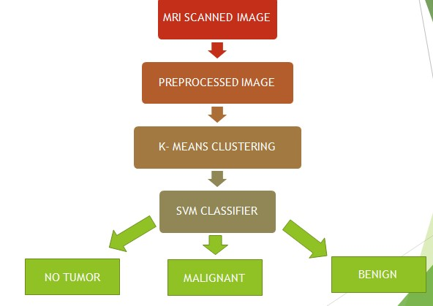

The algorithm of proposed architecture is as shown below:

Algorithm:

•Input: MR Image selected by user.

•Output: The detected tumor is classified.

•Step 1: The selected MR Image is pre-processed using Binary Thresholding.

•Step 2: The preprocessed image is then subjected to K-Means clustering.

•Step 3: Then further classification of tumor is done using SVM Classifier.

•Step 4: After classification is done the result is displayed to the user.

Load Image or Image Acquisition

Median Filter

Noise Removal Eventually the noise in the MRI image may be due to field strength, RF pulses, RF coil, voxel volume, or receiver bandwidth. But the possibilities of arrival of noise in modern MRI scan are very less. It may arrive due to the thermal effect [42]. The main aim of this research work is to detect and segment the tumor. But for the complete system it needs the process of noise removal. For better understanding the function of noise removal, the noise is added artificially with the input image and noise removal process is done. The noise that may present in MRI images are Gaussian, and salt and pepper noise [43] and the MRI images may also be affected by a non-additive noise, which is rician noise [44]. The median filter gives better results for removing the salt and pepper noise and preserves the edges of the image. Non Local Means filter is the strongest Scheme for removing the rician noise. Figure 3.2shows the architecture of the noise removal process of the proposed method

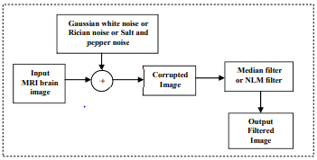

Median Filter In median filter, a window of size 3 x 3 slides along the image. All pixel elements in the sliding window are sorted and the middle element replaces the pixel at the center of the window. Different from the low pass filter, the median filter preserves Input MRI brain image Gaussian white noise or Rician noise or Salt and pepper noise + Corrupted Image Median filter or NLM filter Output Filtered Image the discontinuities in a step function and performs smoothening of pixels whose values differ significantly from their neighborhood without affecting other pixels. The median filtering Algorithm is given as Input: Input Image Output: De-noise Image

Step 1: Initialize window size, // x- row of the , y-column of the

Step 2: Estimate boundary of the window,

Step3: Perform filtering operation, For x= For y= i=0; // Initialize temporary variable 1: // Update window matrix // Increment the index End End End End Figure 3.3 illustrates the function of the median filtering on input image and shows how the output image is filtered from the input image

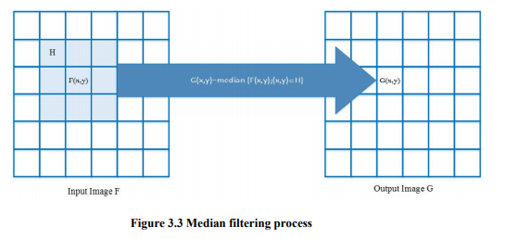

Advantages of Median Filter

1. Excellent in the removal of impulsive noise.

2. Maintains the sharpness of the edges of the image.

3. There is no need for rescaling.

4. Median filter is less sensitive to the noise.

5. It does not shift the boundaries in the image.  
6. Since the edges of the images are degraded minimally, the median filters can be repeatedly applied.

7. Median filter provides excellent reduction of random noise with low blurring than the linear smoothing filter.

8. It is highly effective for the removal of white spots and black spots from the image, since the noise pixel values vary greatly from the values of the median cell.

9. The median filter removes the noise completely, but the average filter just spreads the noise evenly around the image

