Name : De Zoysa R.N.C.

REG No : EG/2020/3886

Q1) /home/scs/staff

Q2)

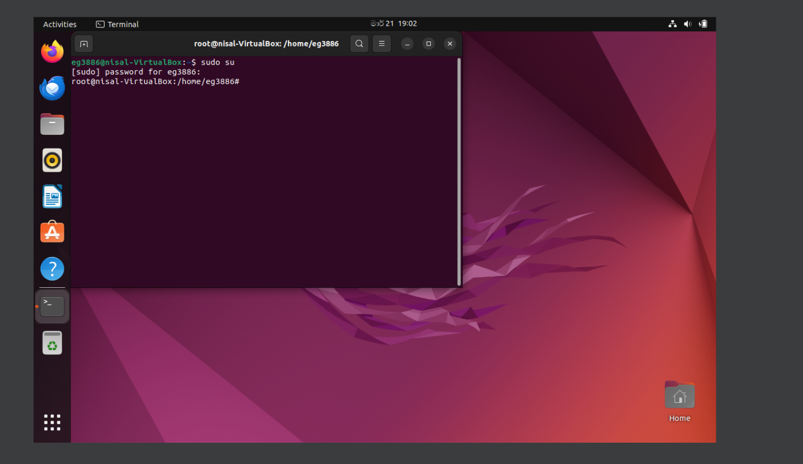

Q3)

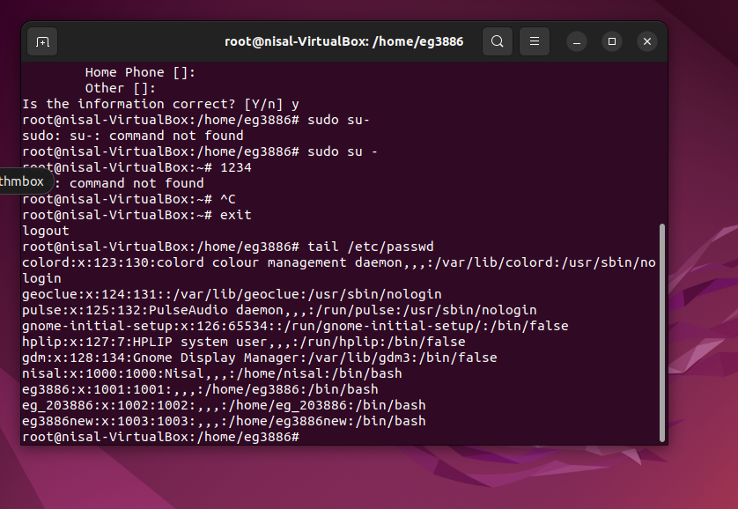

Q4)

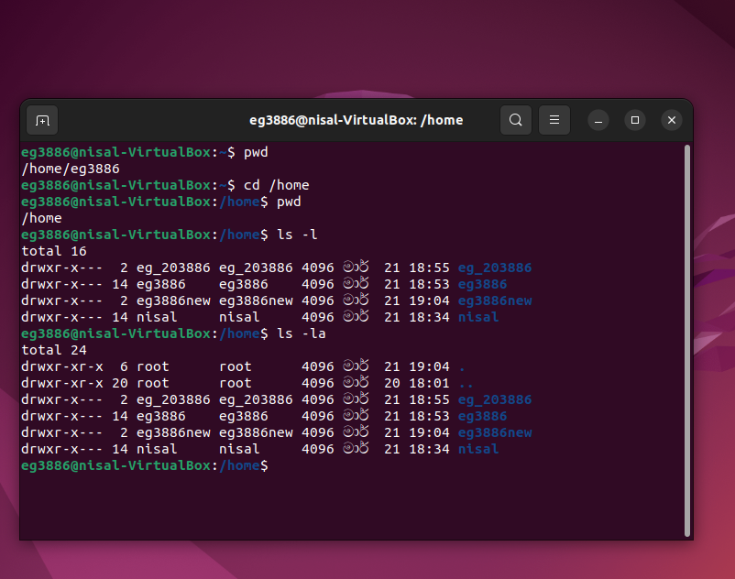

Q5)

* **ls -l** displays the non-hidden files and directories in the current directory.
* **ls -la** command displays detailed information about all files and directories, and also the hidden files as well.
* **-a** stands for all.From this it is telling to include all the files and directories.Beacuse of that ls-la showing more files.

Q6)

* **-r** is doing recursive copying.It is copying recursively directories and their content.

Q7)

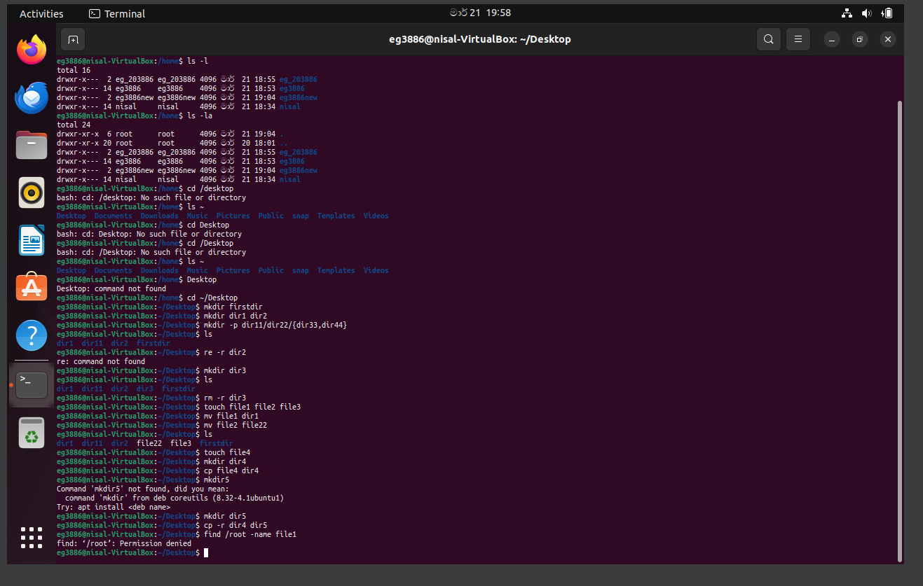

Q8)

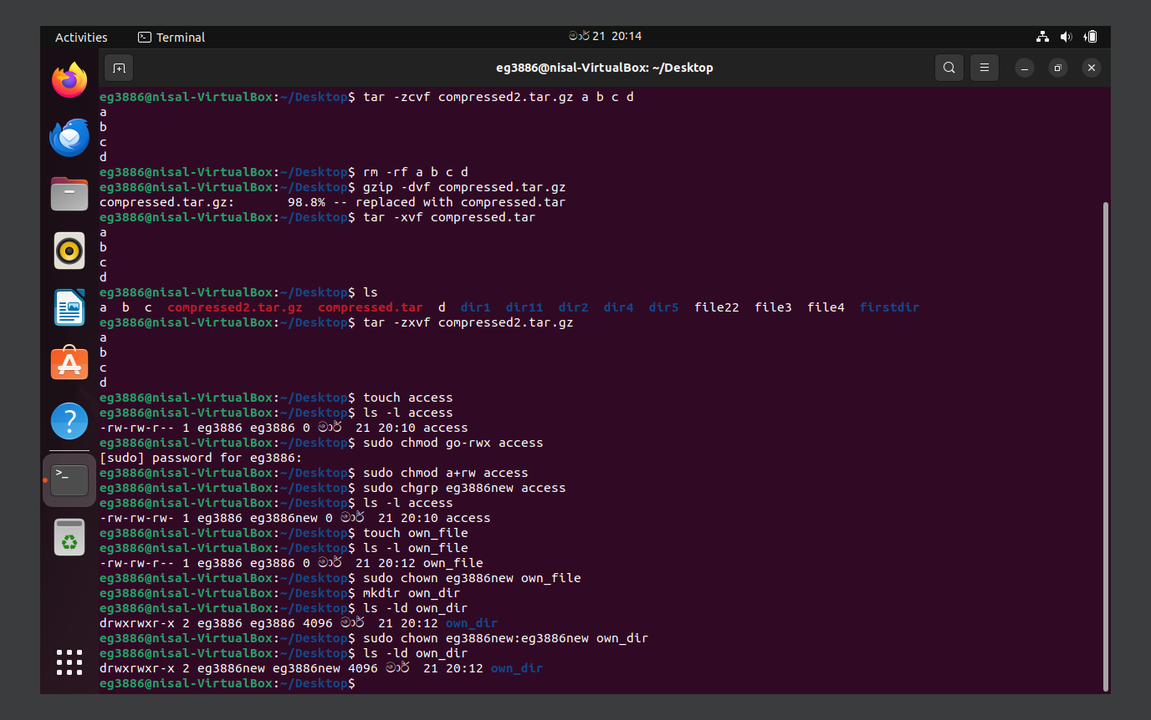

Q)9

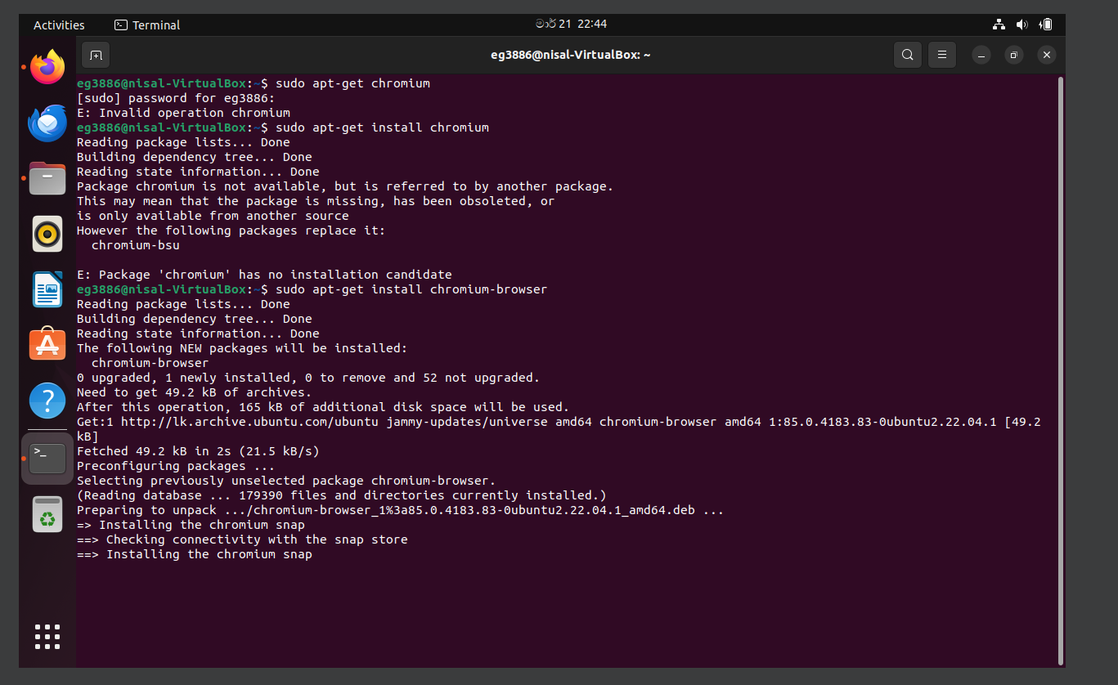

Q) AWS Task

