|  |  |  |
| --- | --- | --- |
| Department | Ip address range | VLAN |
| Sales & Marketing Department (192.168.1.0/24) | 192.168.1.1 - 192.168.1.10 | VLAN 10 |
| Reception Area (192.168.2.0/24) | 192.168.2.1 - 192.168.2.5 | VLAN 20 |
| Administration Department (192.168.3.0/24) | 192.168.3.1 - 192.168.3.30 | VLAN 30 |
| HR Department (192.168.4.0/24) | 192.168.4.1 - 192.168.4.20 | VLAN 40 |
| Accounting & Finance Department (192.168.5.0/24) | 192.168.5.1 - 192.168.5.15 | VLAN 50 |
| Audit Department (192.168.6.0/24) | 192.168.6.1 - 192.168.6.5 | VLAN 60 |
| Business Development Department (192.168.7.0/24) | 192.168.7.1 - 192.168.7.5 | VLAN 70 |
| IT Department (192.168.8.0/24) | 192.168.8.1 - 192.168.8.60 | VLAN 80 |
| Server Room (10.254.9.0/24) | VLAN 90 | |
| Video conferencing room (10.254.10.0/24) | VLAN 100 | |

Colombo branch

Matara branch

|  |  |  |
| --- | --- | --- |
| Department | Ip address range | VLAN |
| Reception Area (192.168.11.0/24) | 192.168.11.1 – 192.168.11.5 | VLAN 110 |
| Administration Department (192.168.12.0/24) | 192.168.12.1 – 192.168.12.10 | VLAN 120 |
| HR Department (192.168.13.0/24) | 192.168.13.1 – 192.168.13.7 | VLAN 130 |
| Accounting & Finance Department (192.168.14.0/24) | 192.168.14.1 – 192.168.14.8 | VLAN 140 |
| IT Department (192.168.15.0/24) | 192.168.15.1 – 192.168.15.50 | VLAN 150 |

Colombo branch router 1 configurations:

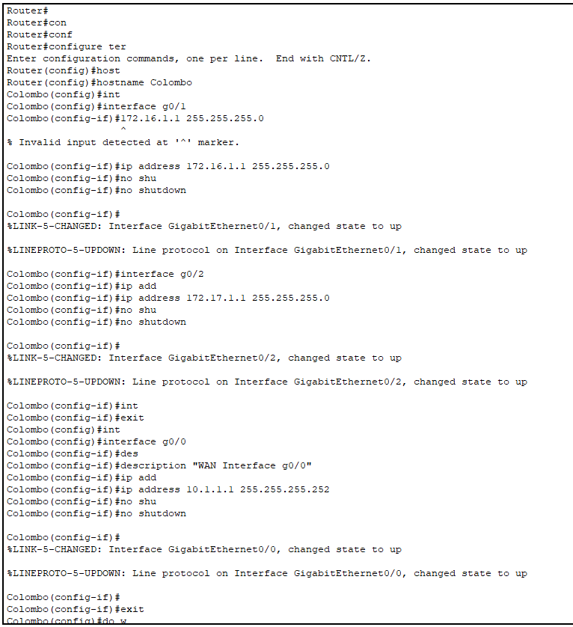

Matara branch router 2 configurations

Ping test between two routers in two branches

VLAN configurations of the switch which is connected to the IT room in colombo

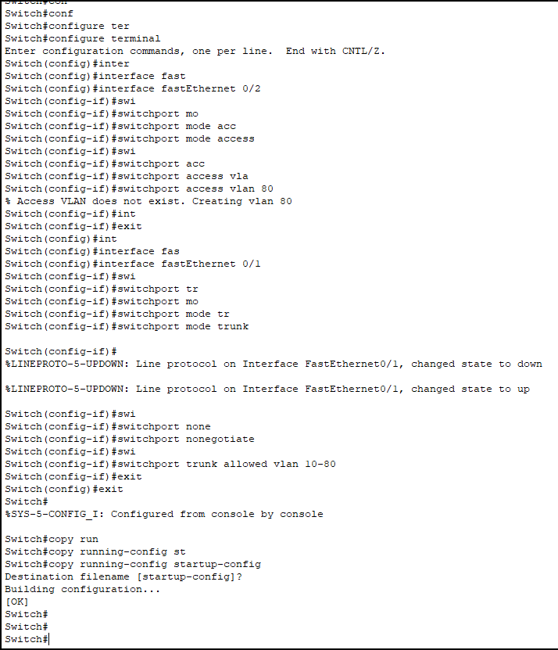

Configuring the switch in the floor one of the colombo branch

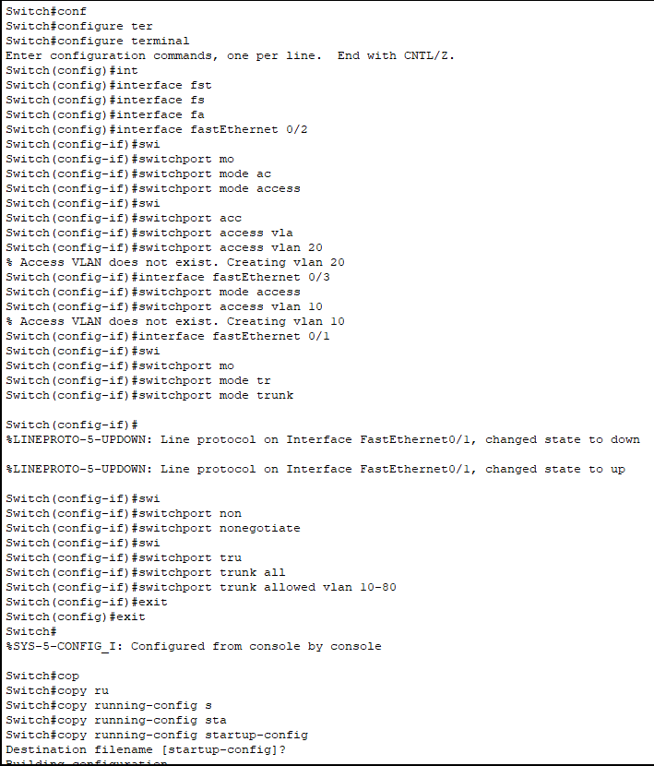

Configuring the PC in a reciption area in colombo branch

Ping test for the same vlan

Ssh configuration on colombo branch router

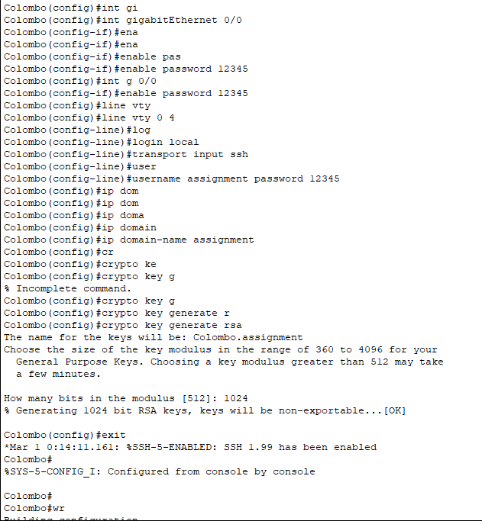

Ssh testing with the accessing the router in colombo branch using pc from reciption area

