**Write a program to implement word count using Pig.**

**INPUT FILE:**

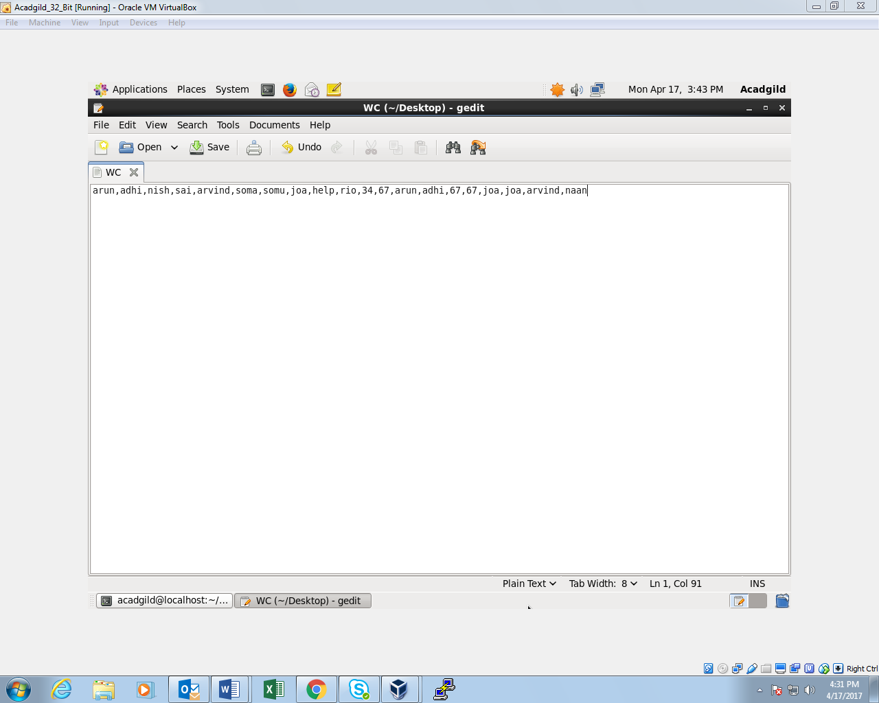

**COMMANDS FOR WORDCOUNT:**

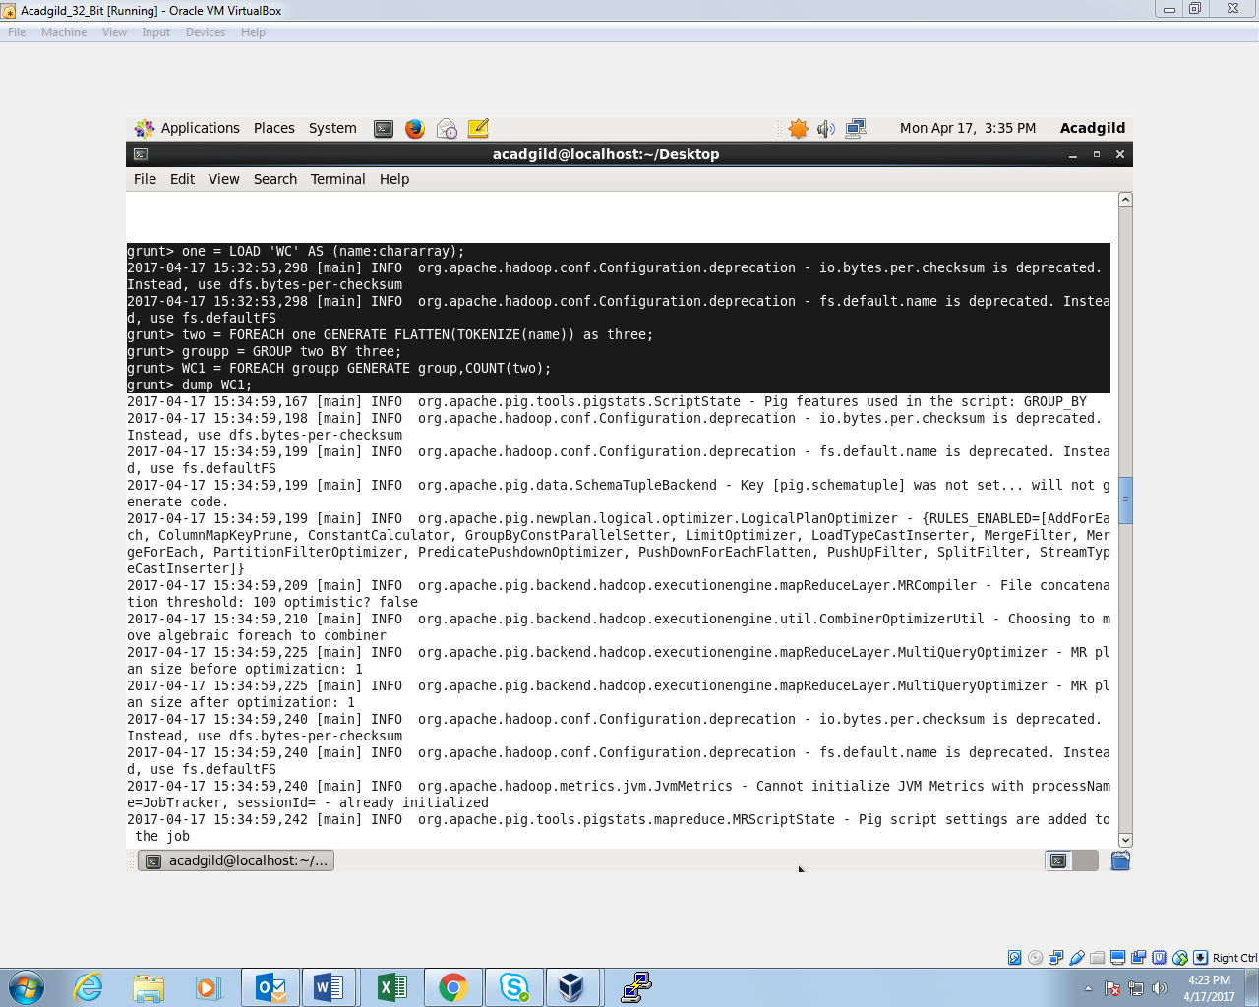

**OUTPUT:**

