**1 Write a pig script find the average age of male and female persons died in the titanic tragedy**

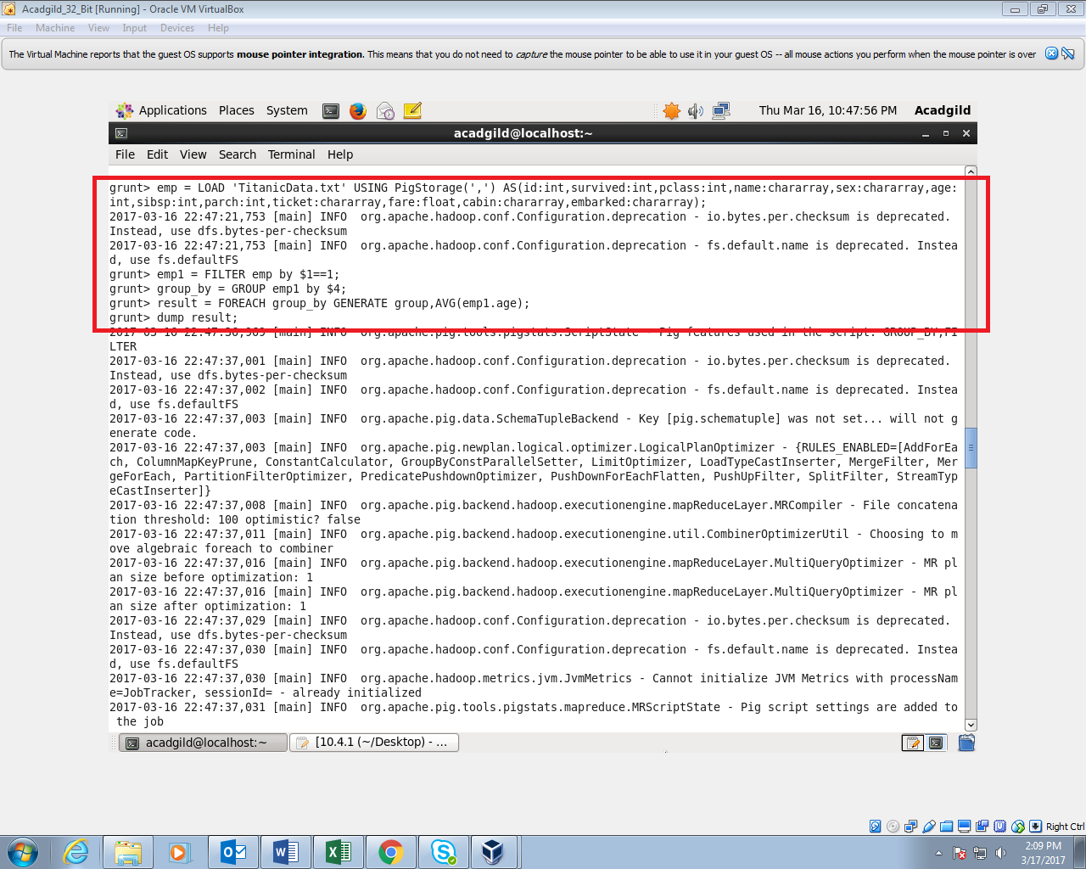

**OUTPUT:**

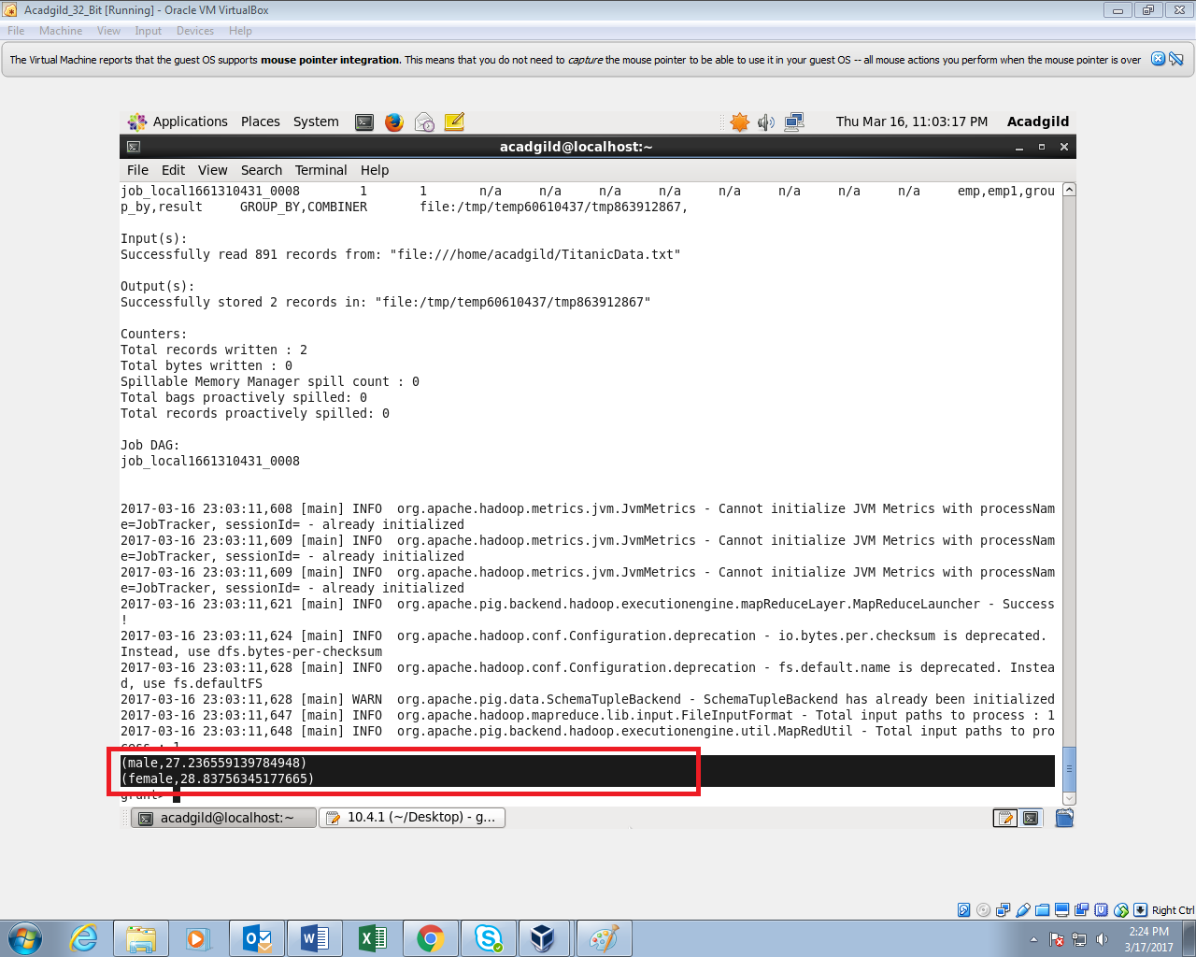

**2 Write a pig script to find the number of people died and survived in each class**

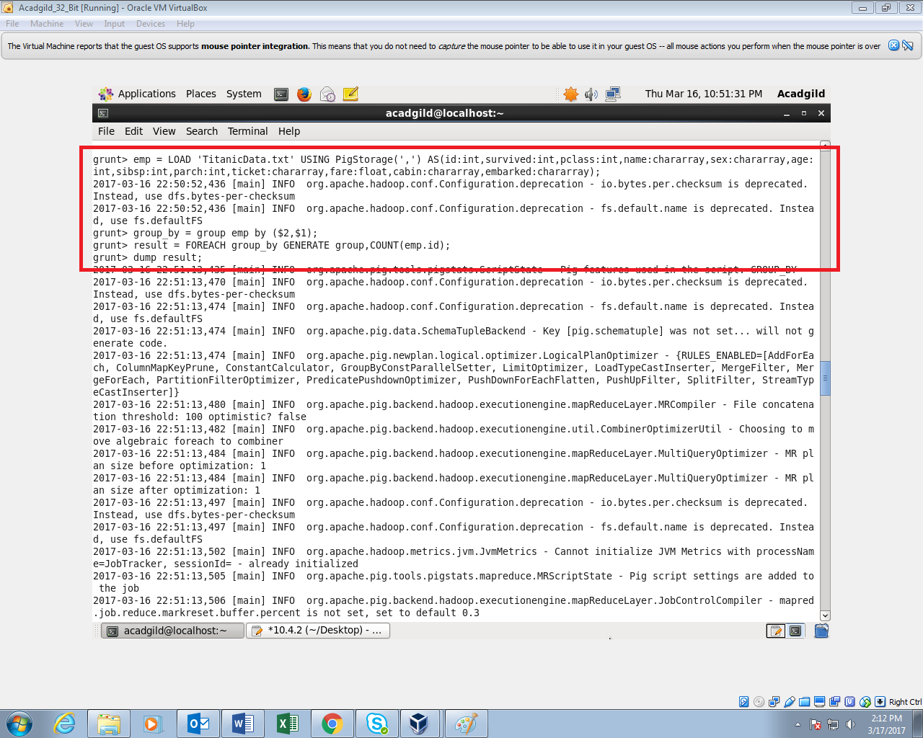

**OUTPUT:**

