**1 Write a pig script to find the minimum temperature observed in a given weather station in a particular year.**

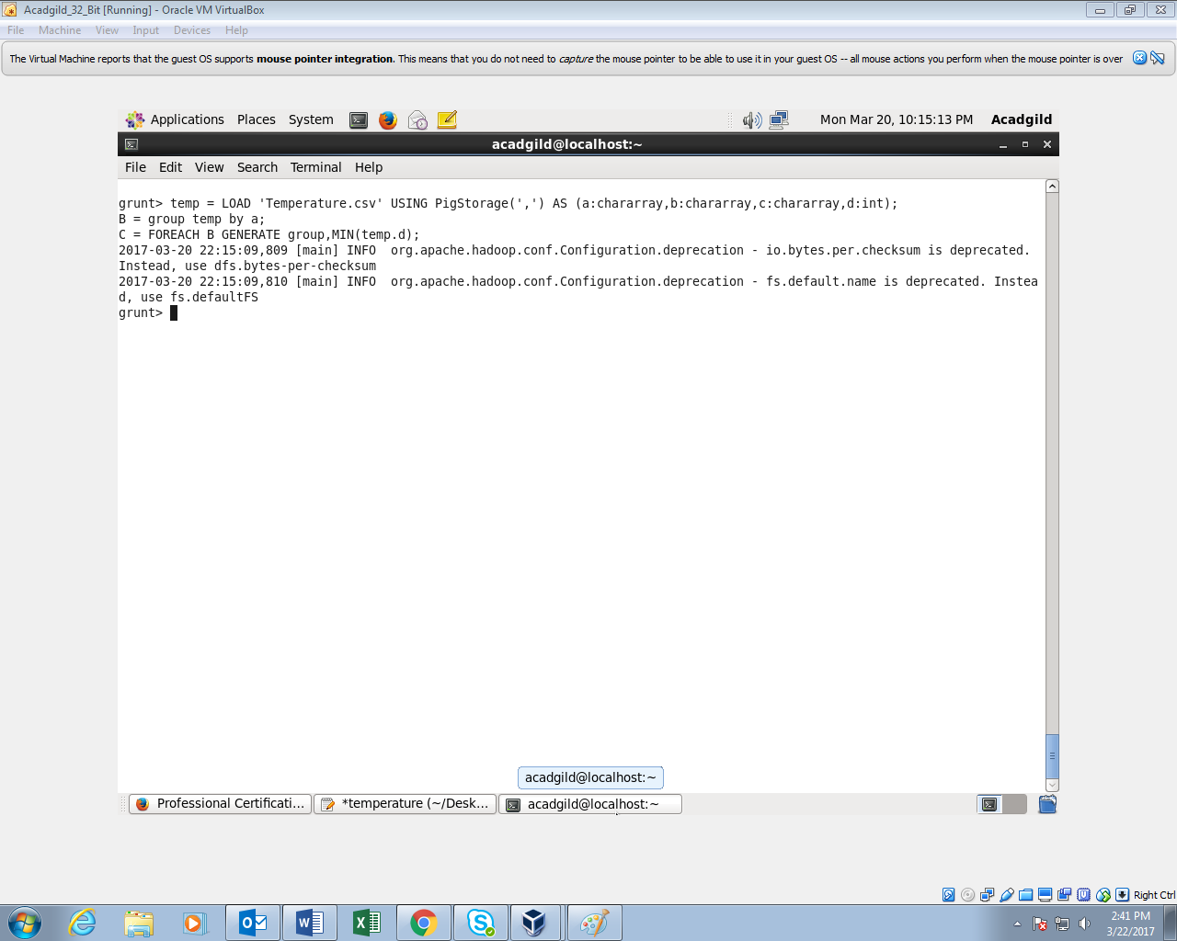

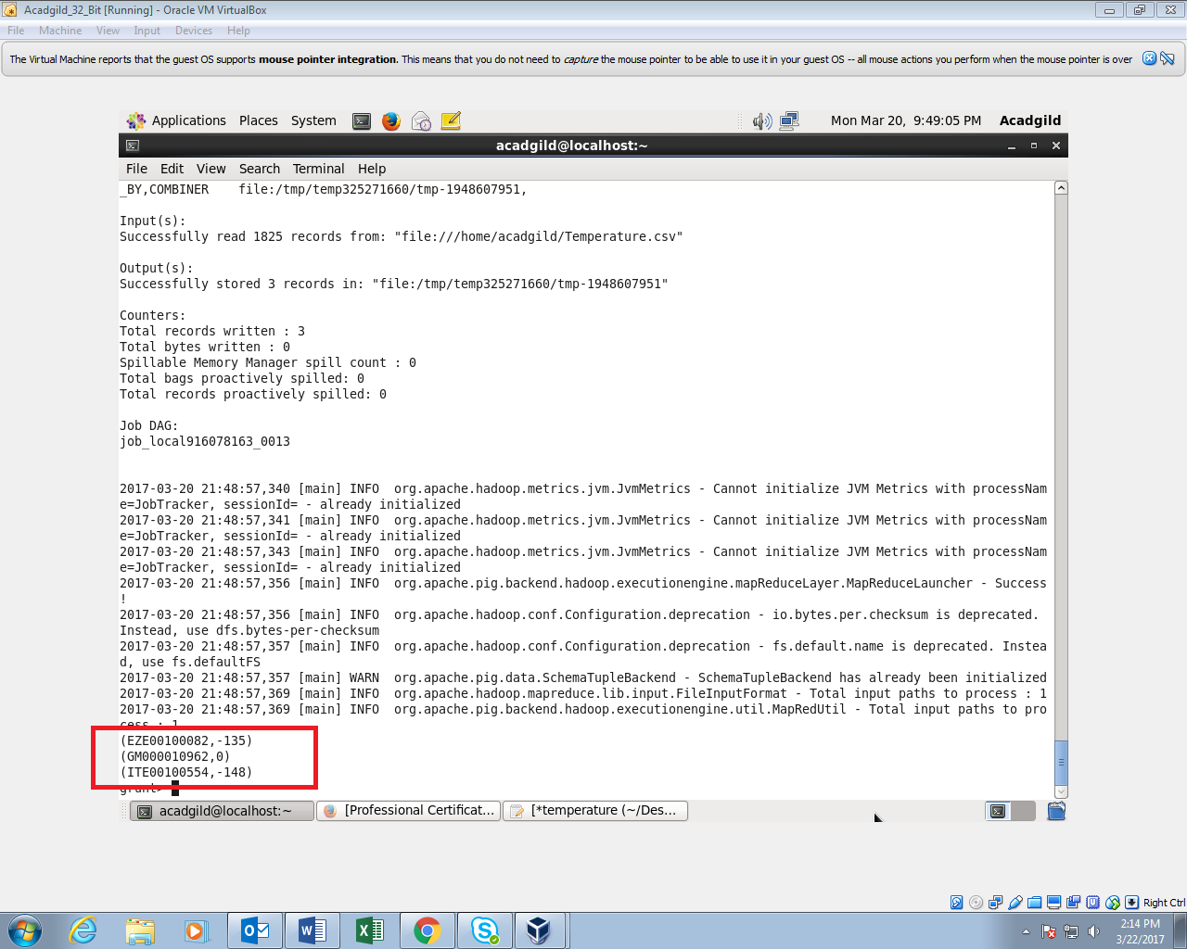

**2. Write a pig script to find the maximum temperature observed in a given weather station in a particular year.**

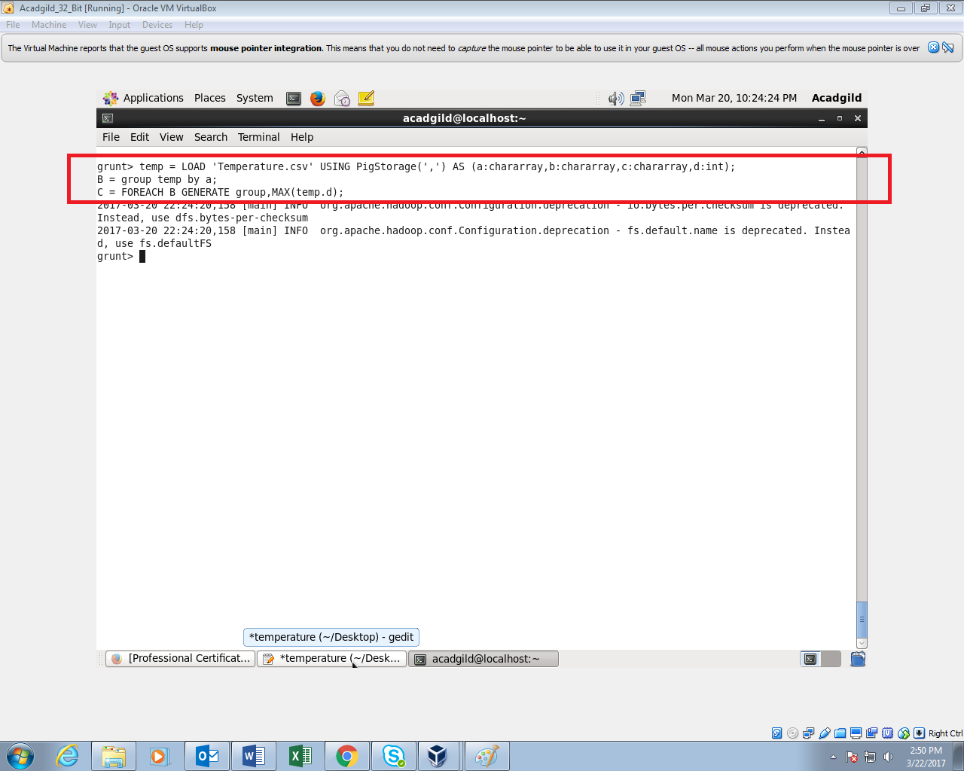

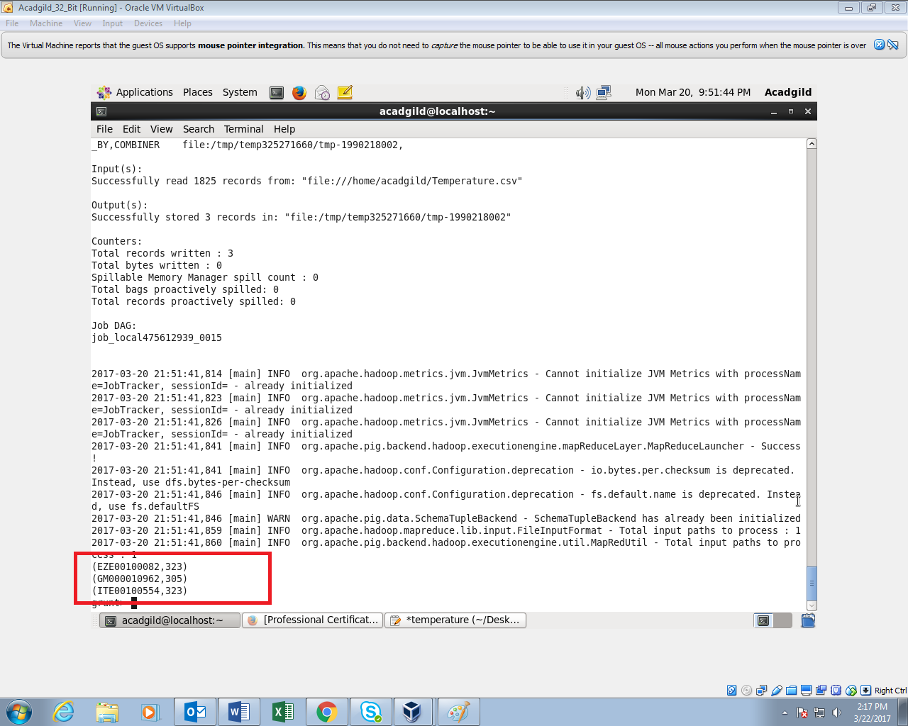

**3. Write a pig script to find the number of readings given by each weather station according to the dataset.**

