**Write the Pig codes to analyze the petroleum data set.**

1. **What is the total amount of petrol in volume sold by every distributor?**

**COMMAND:**

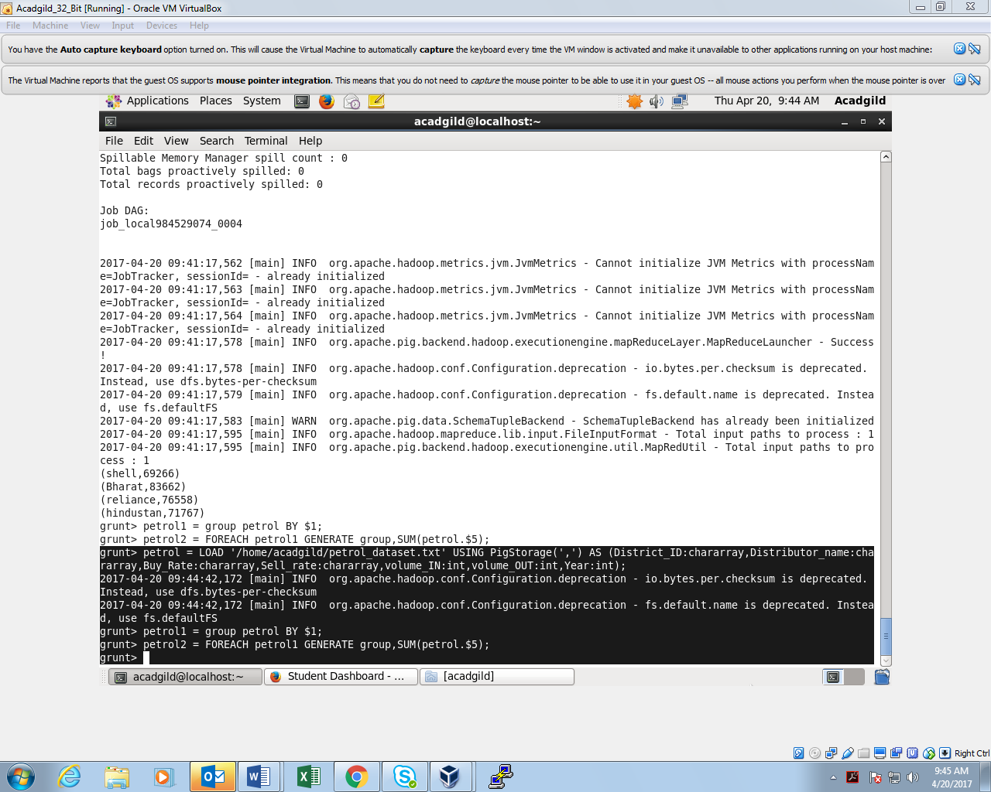

**OUTPUT:**

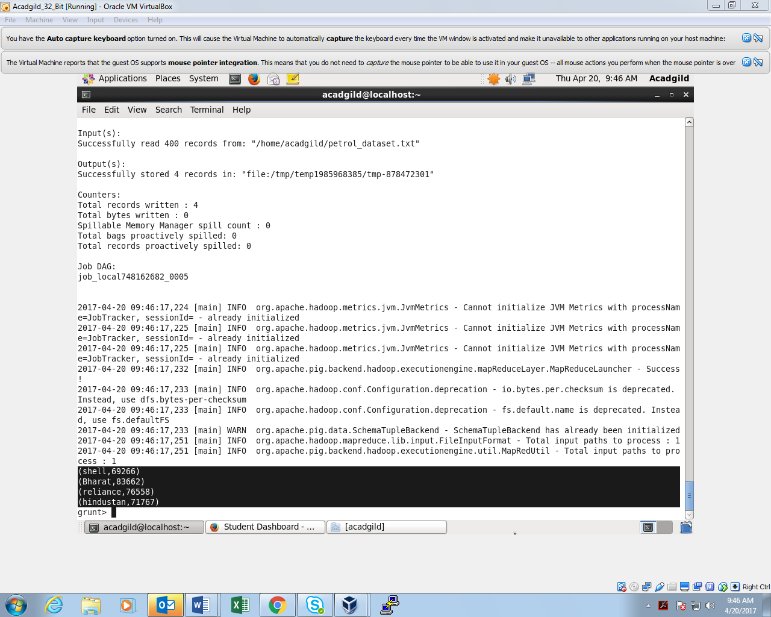

1. **Which are the top 10 distributors ID's for selling petrol? Also display the amount of petrol sold in volume.**

**COMMAND:**

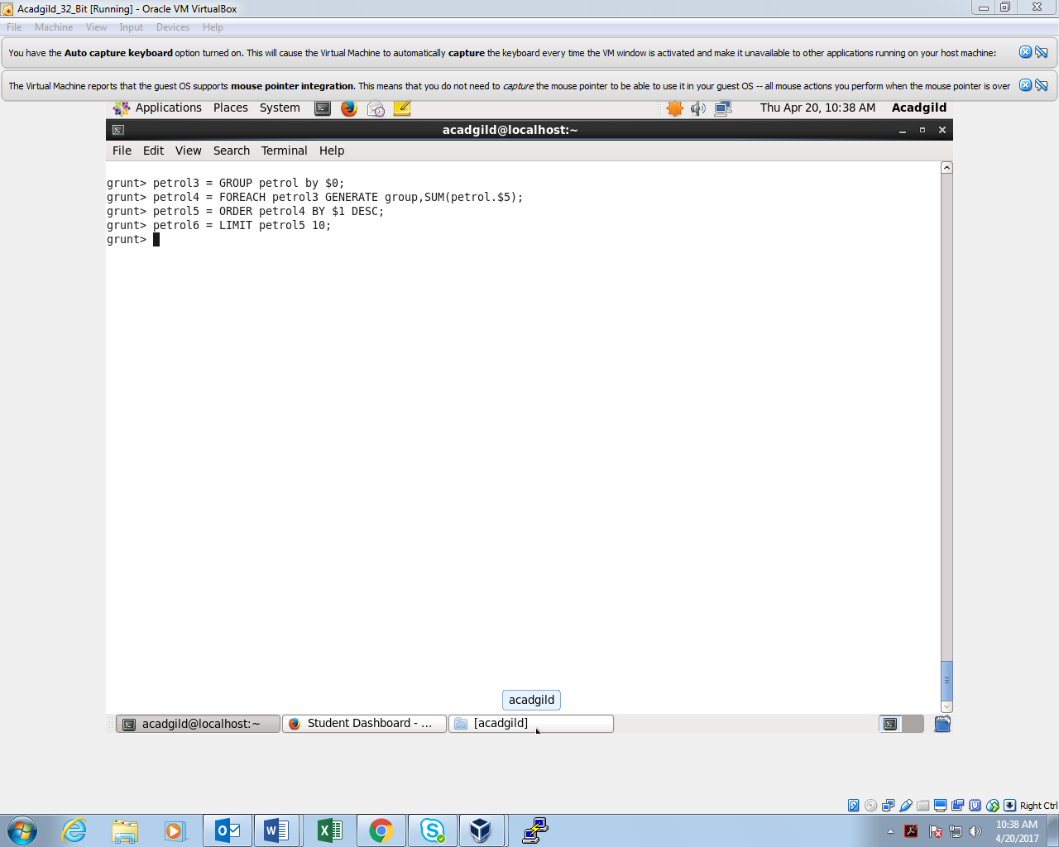

**OUTPUT:**

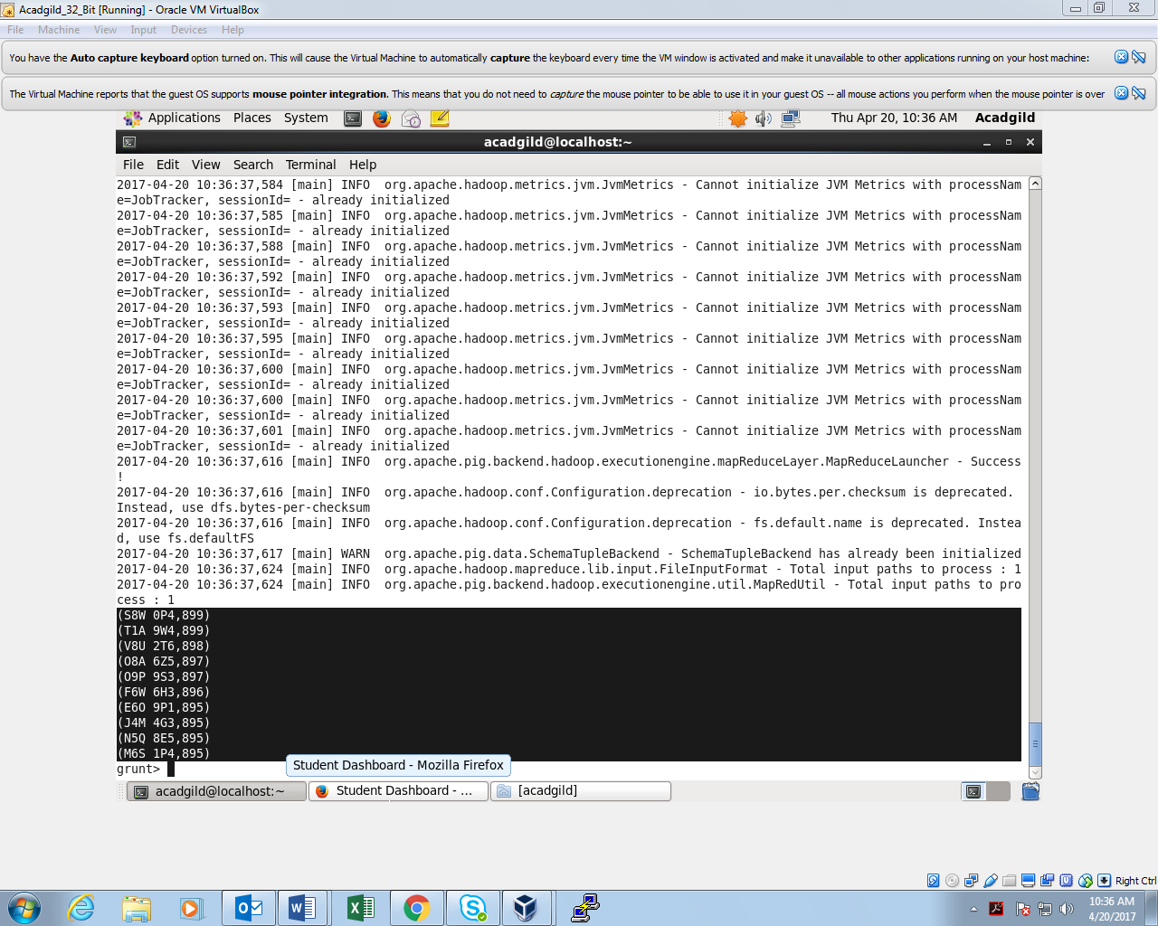

1. **List 10 years where consumption of petrol is more with the distributer id who sold it.**

**COMMAND:**

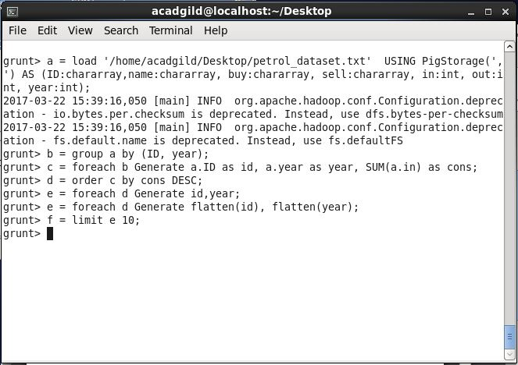

**OUTPUT:**

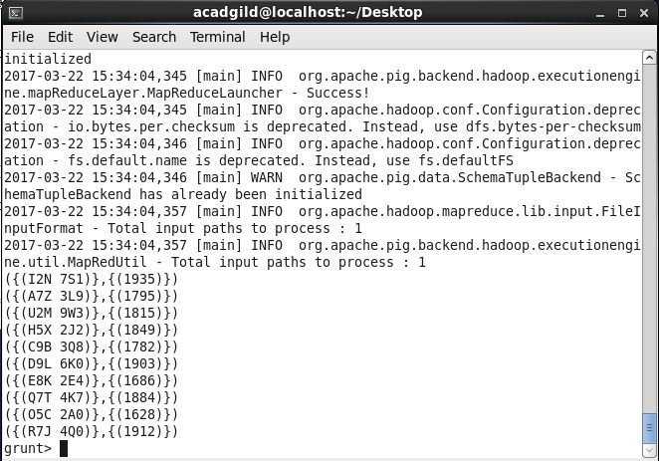

1. **Find the distributer name who sold petrol in least amount**

**COMMAND:**

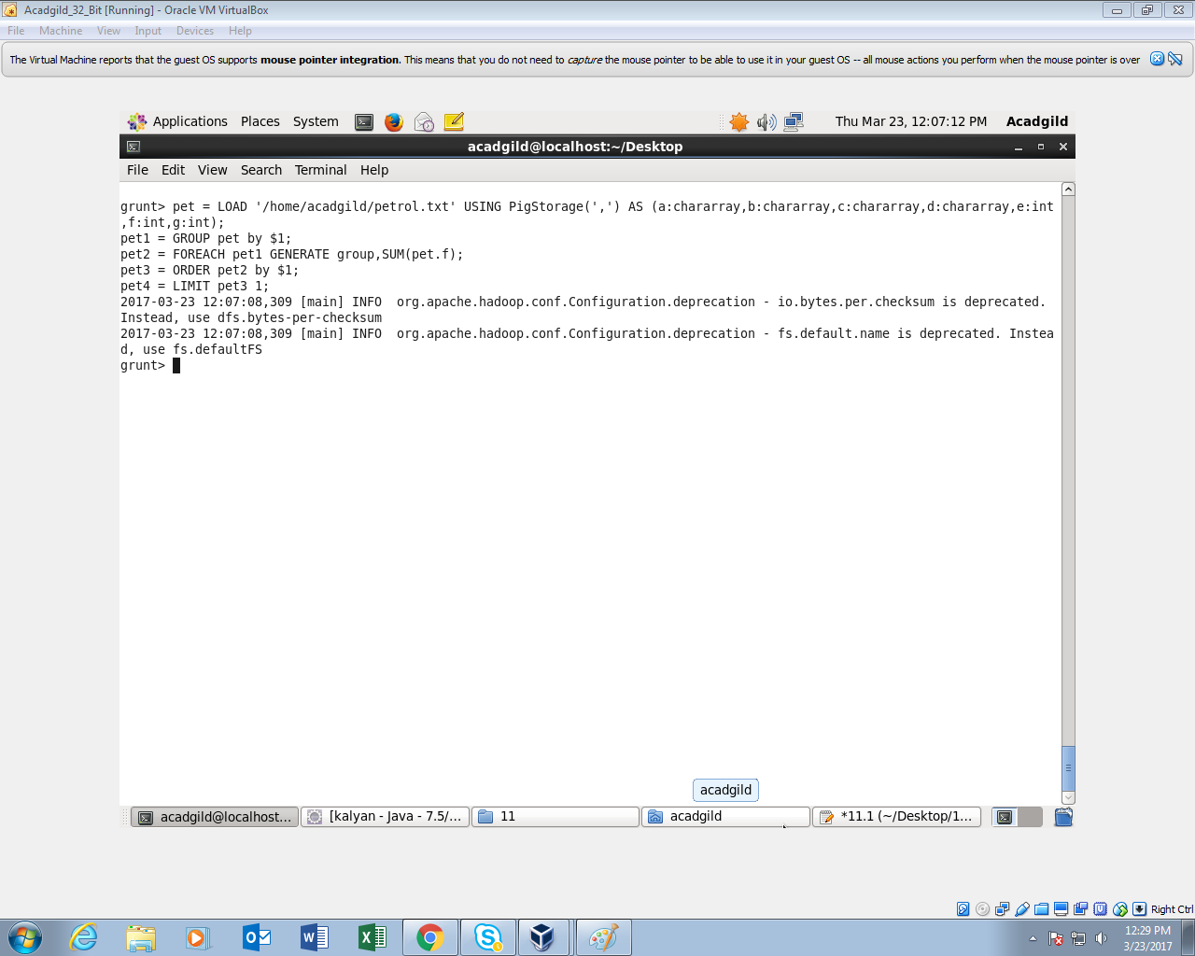

**OUTPUT:**

