**Write the Pig codes to analyze the Student data set.**

1. Find the number of students who scored less than 5(50%).

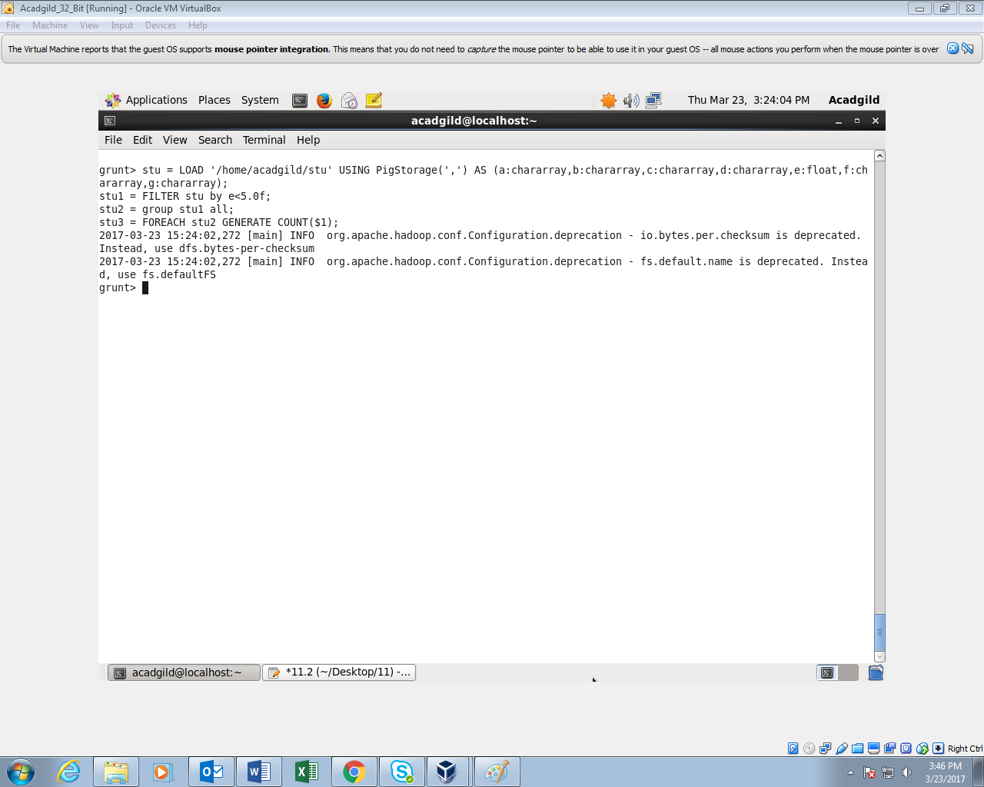

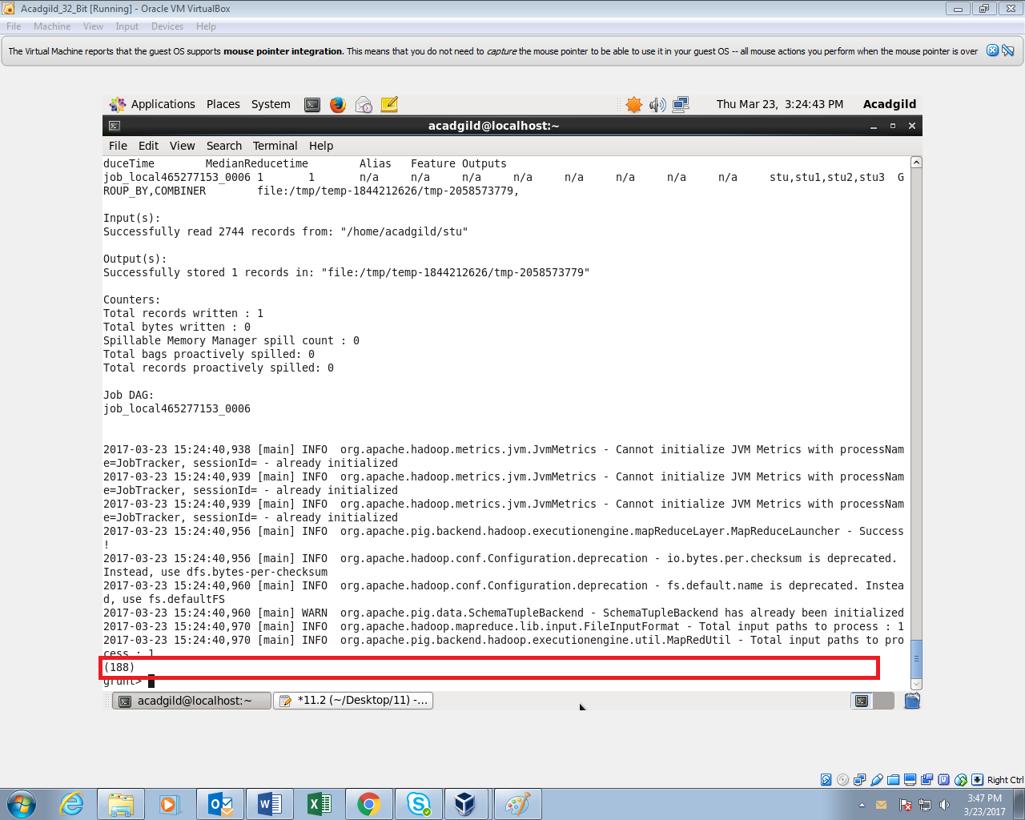

1. **List the name of students who are from Alaska.**

**COMMAND:**

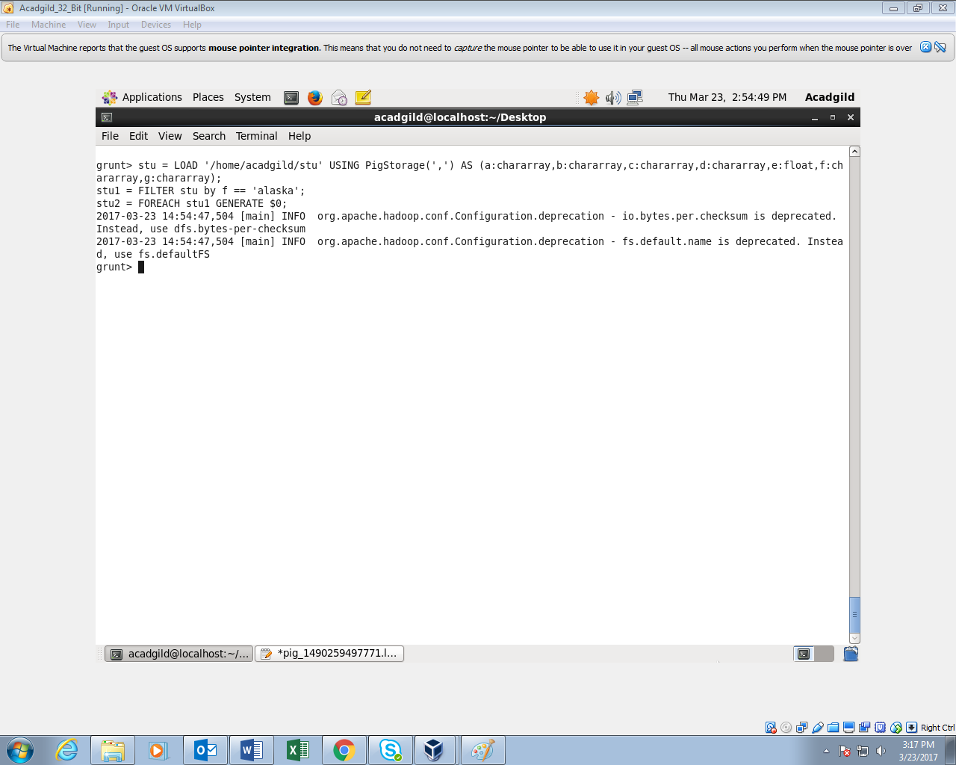

**OUTPUT:**

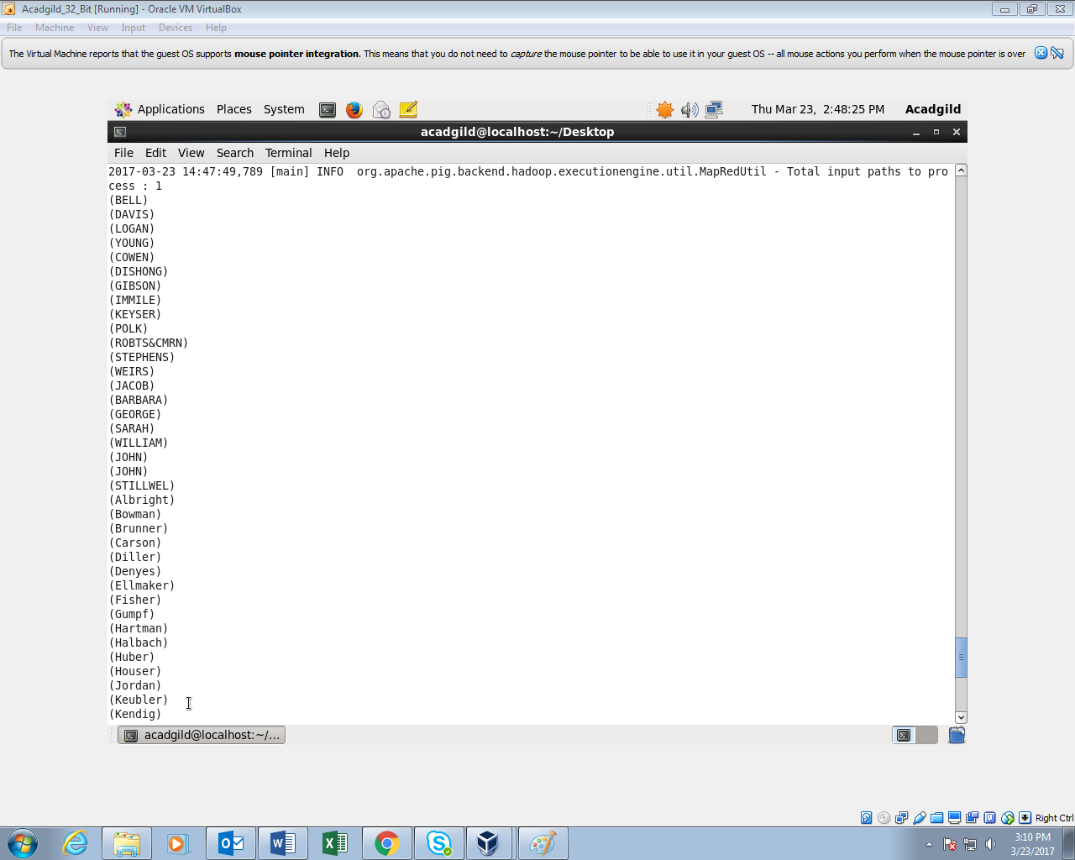

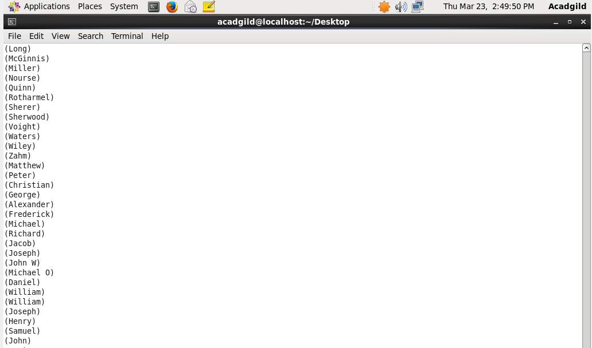

1. **How many government colleges are there in Alabama?**

**COMMAND:**

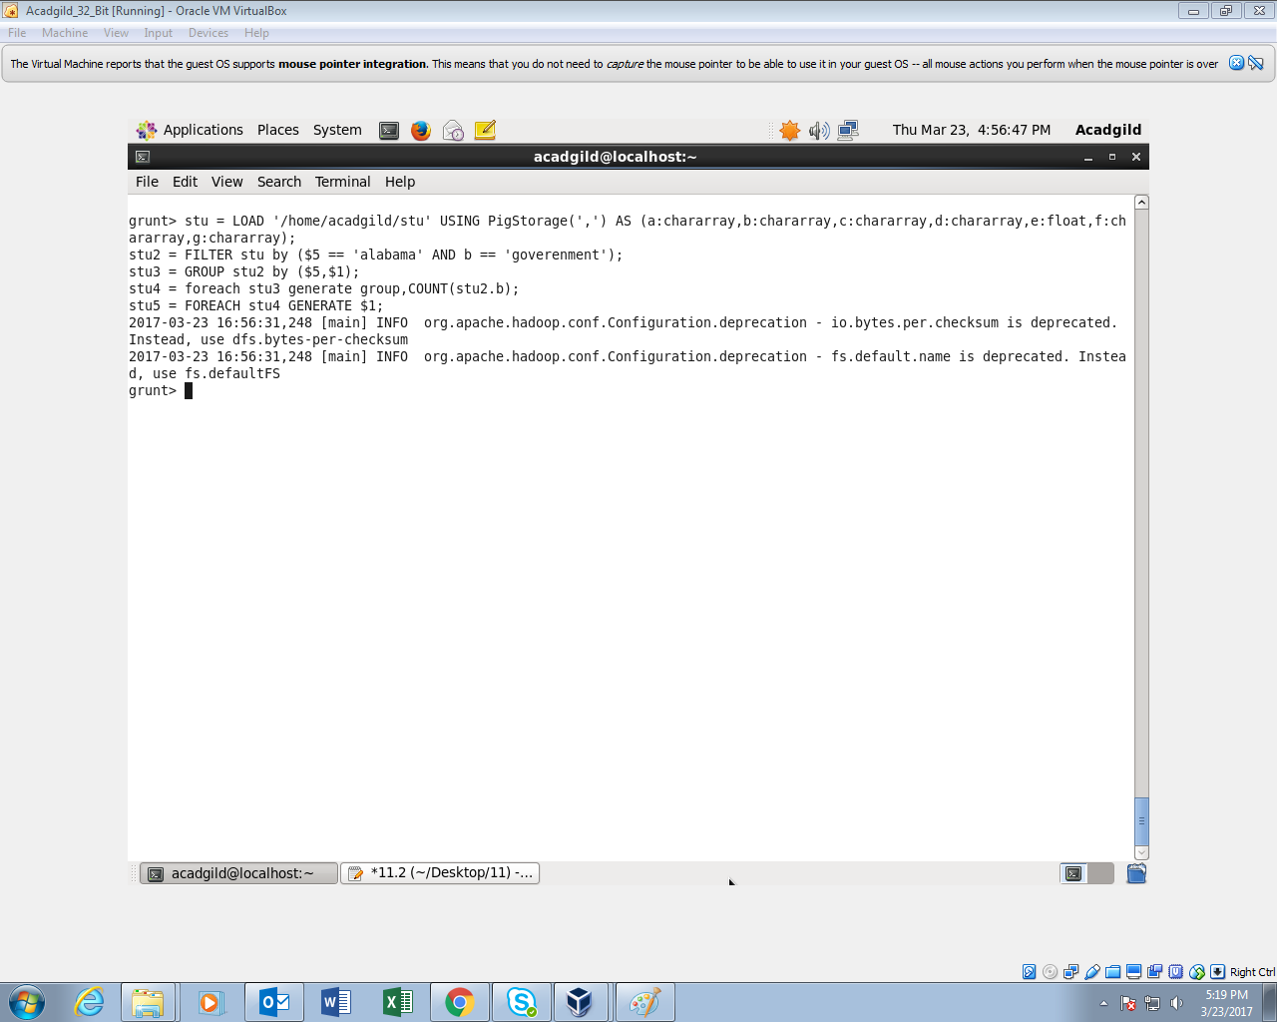

**OUTPUT:**

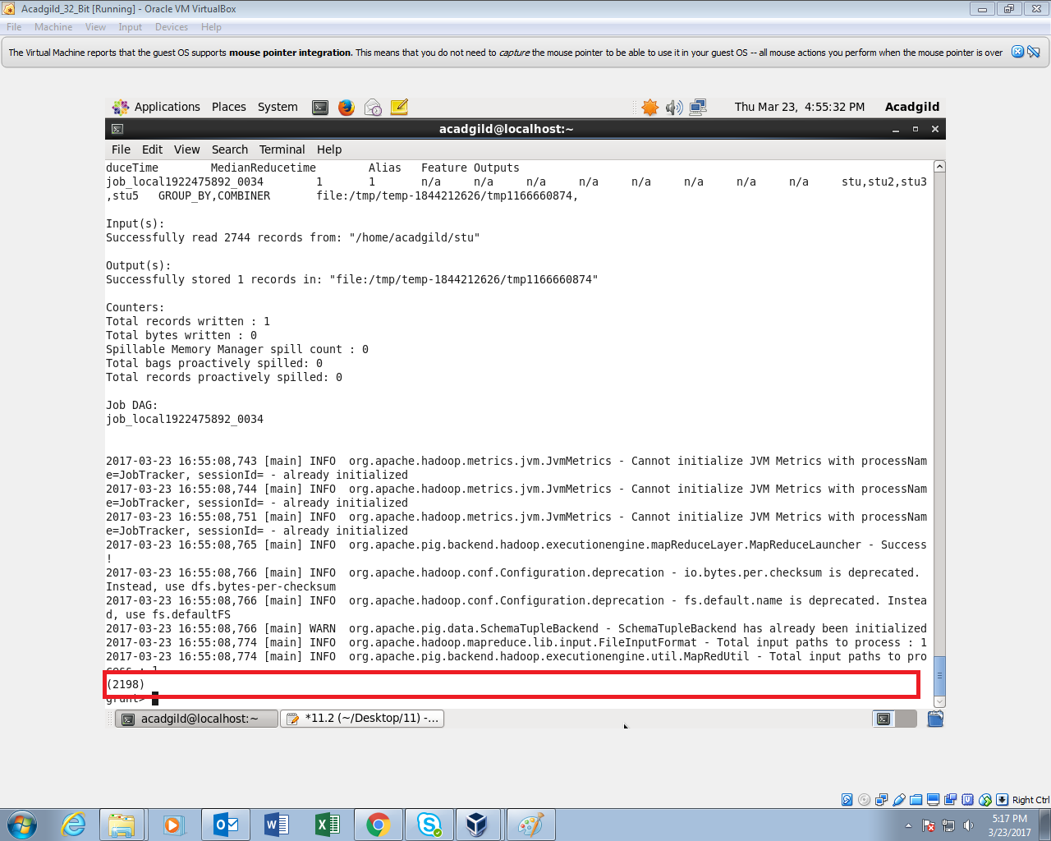

1. **List the name of students who are from Oregon and pursuing BE.**

**COMMAND:**

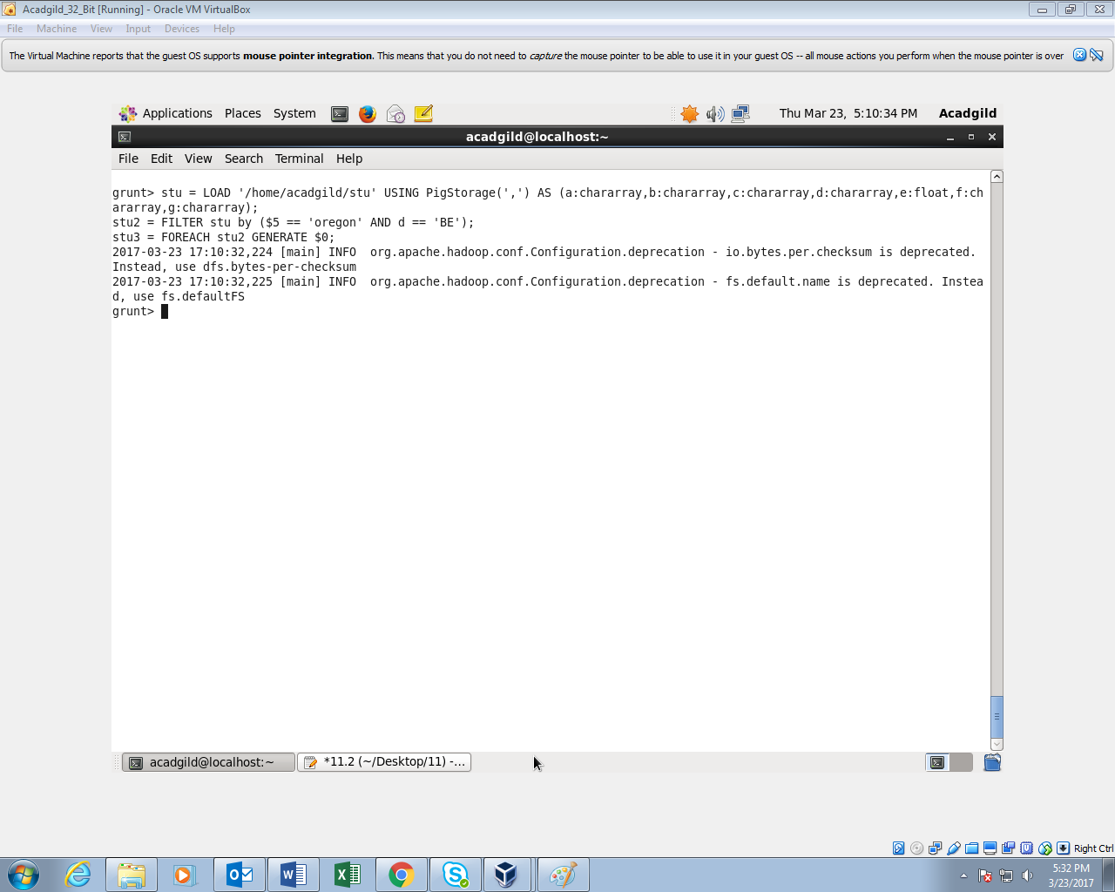

**OUTPUT:**

