**Write a Pig UDF to find the tweets posted by @realDonaldTrump from the given dataset**

**Program:**

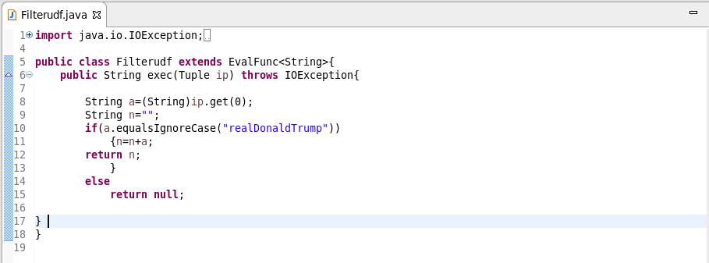

**Pig command:**

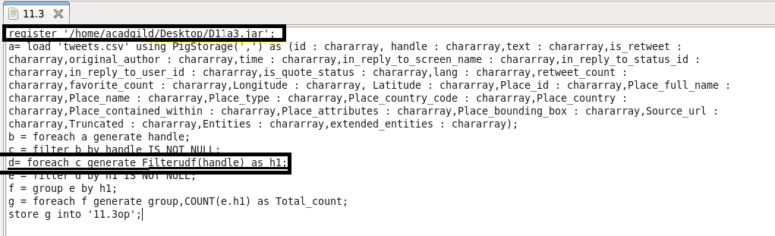

**OUTPUT:**

