**Write a pig script to find the count of each Hashtag in the dataset. You can download the twitter data from the below link**

**FIRST DATA:**

**PIG SCRIPT:**

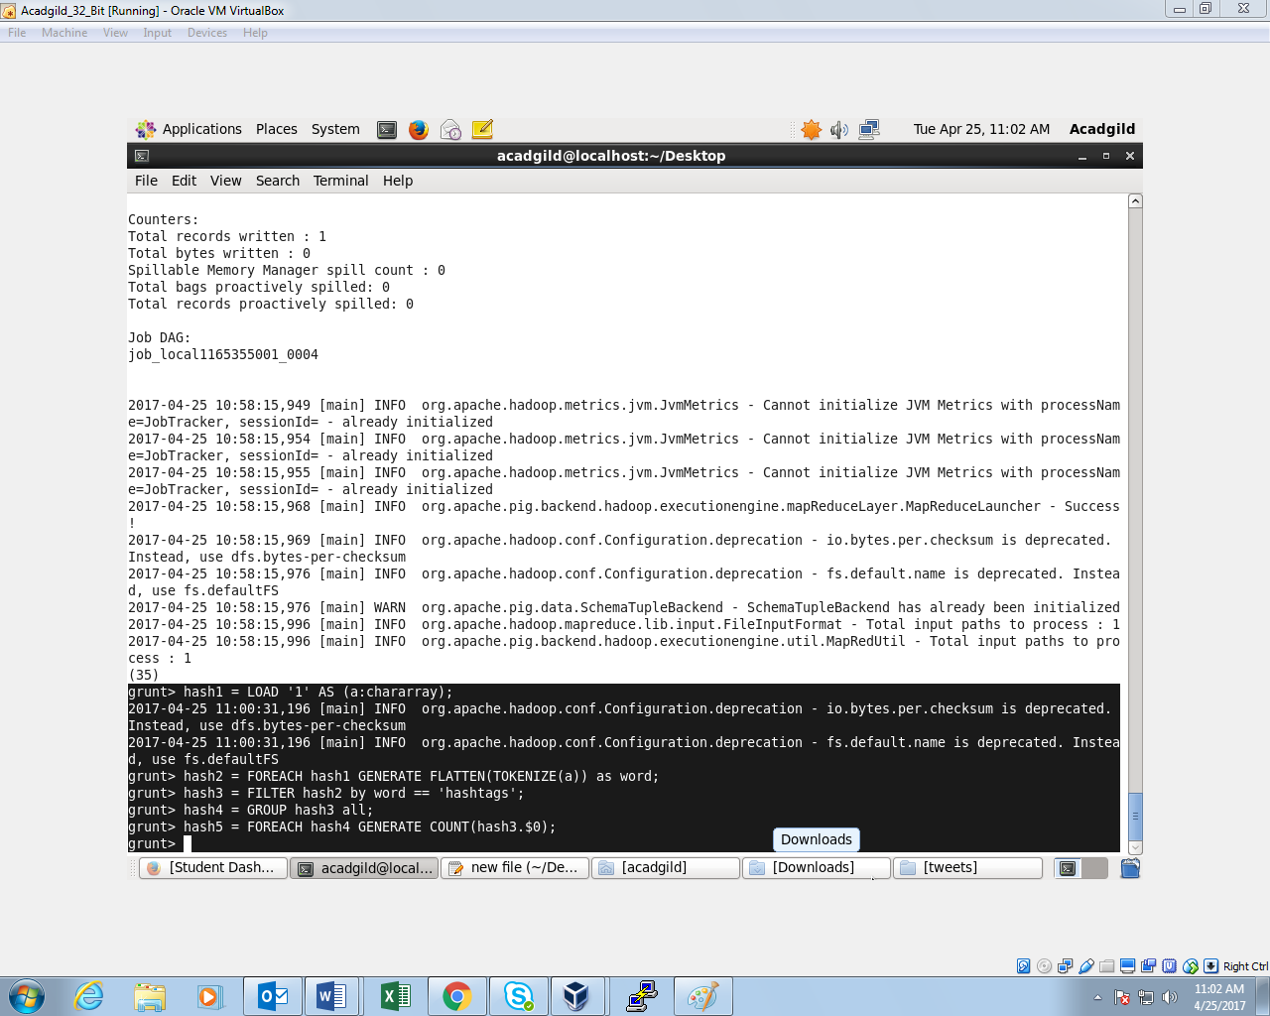

**OUTPUT:**

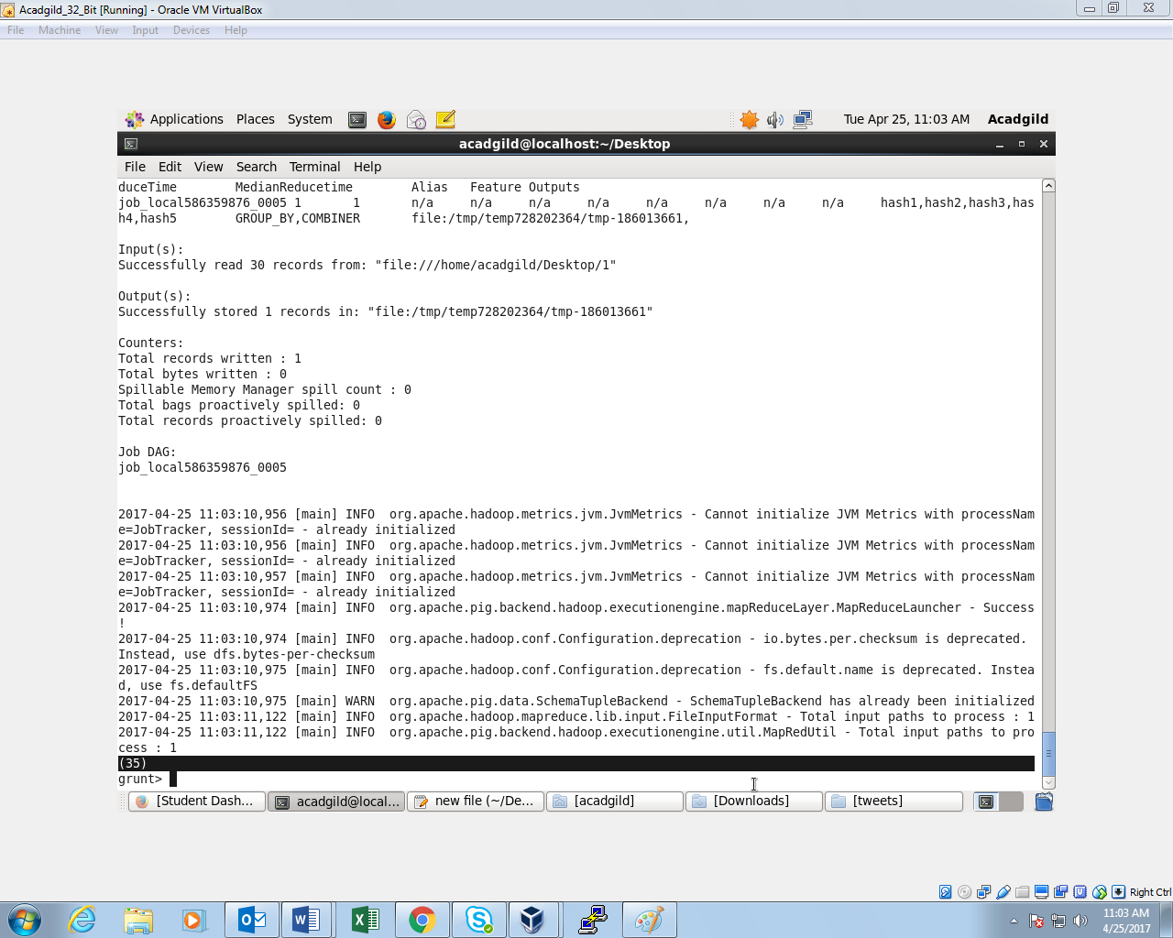

**SECOND DATA:**

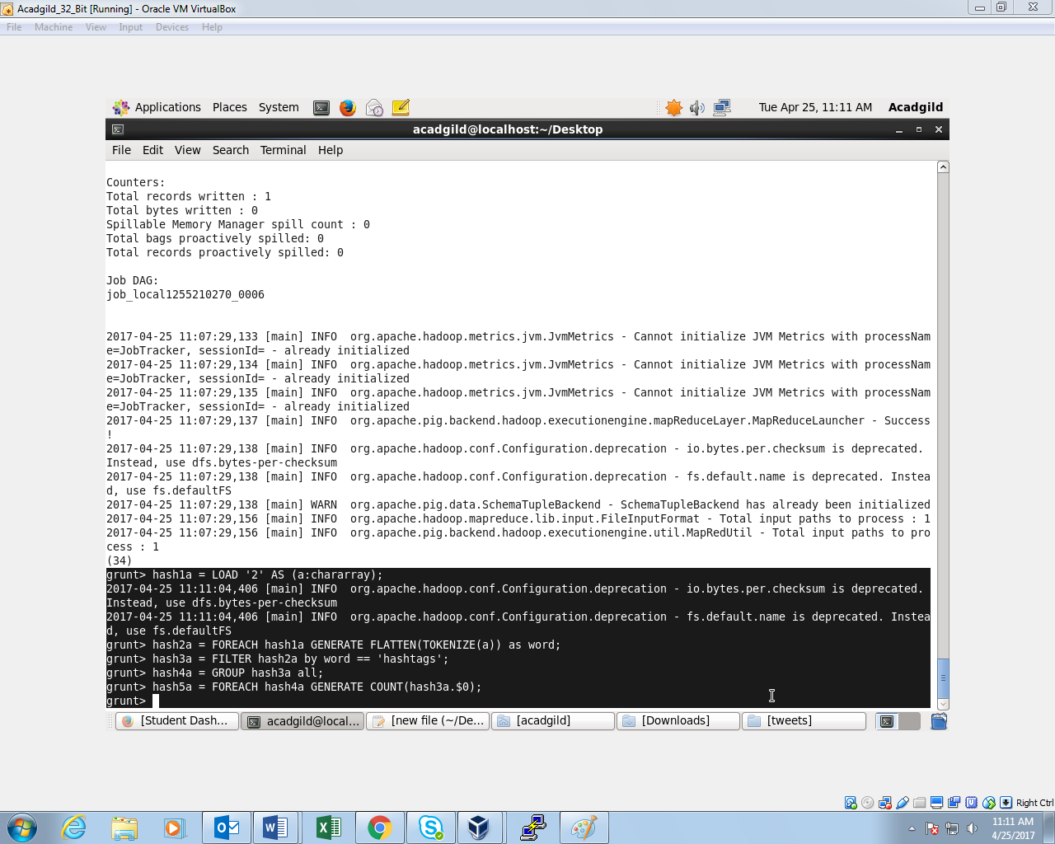

**OUTPUT:**

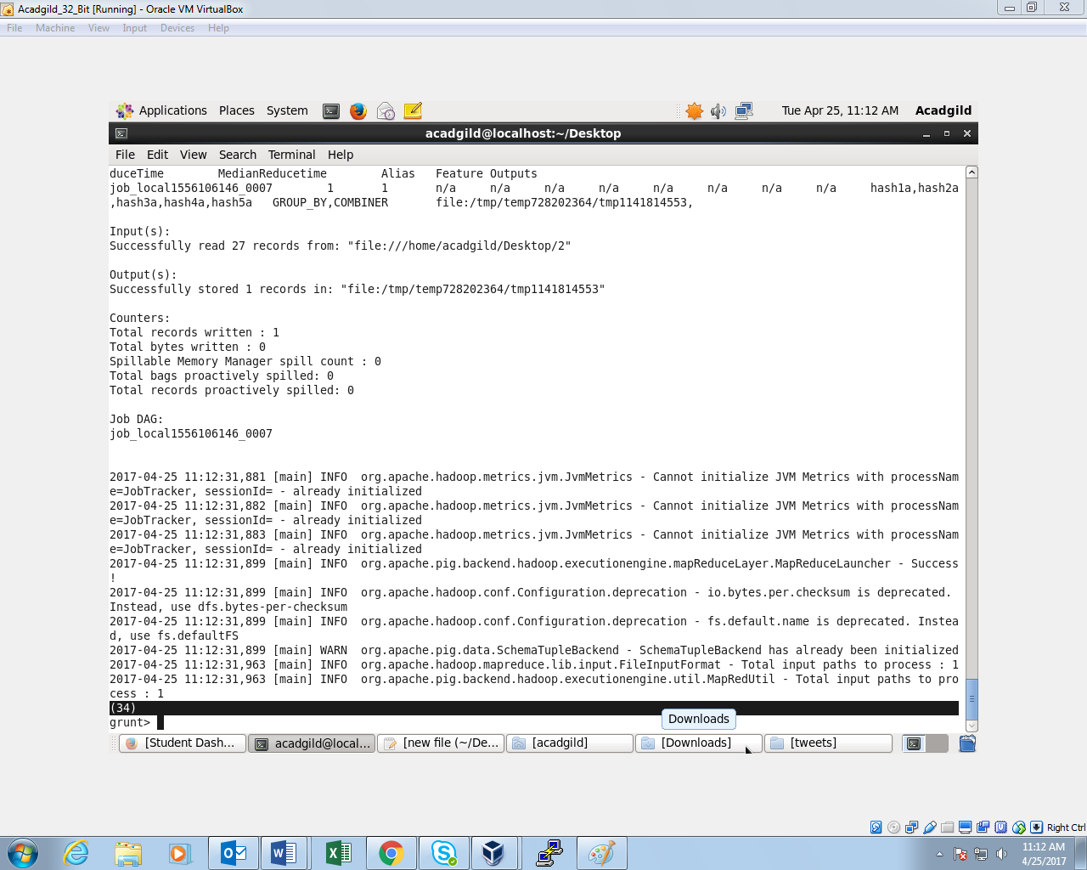

**THIRD DATA:**

**COMMAND:**

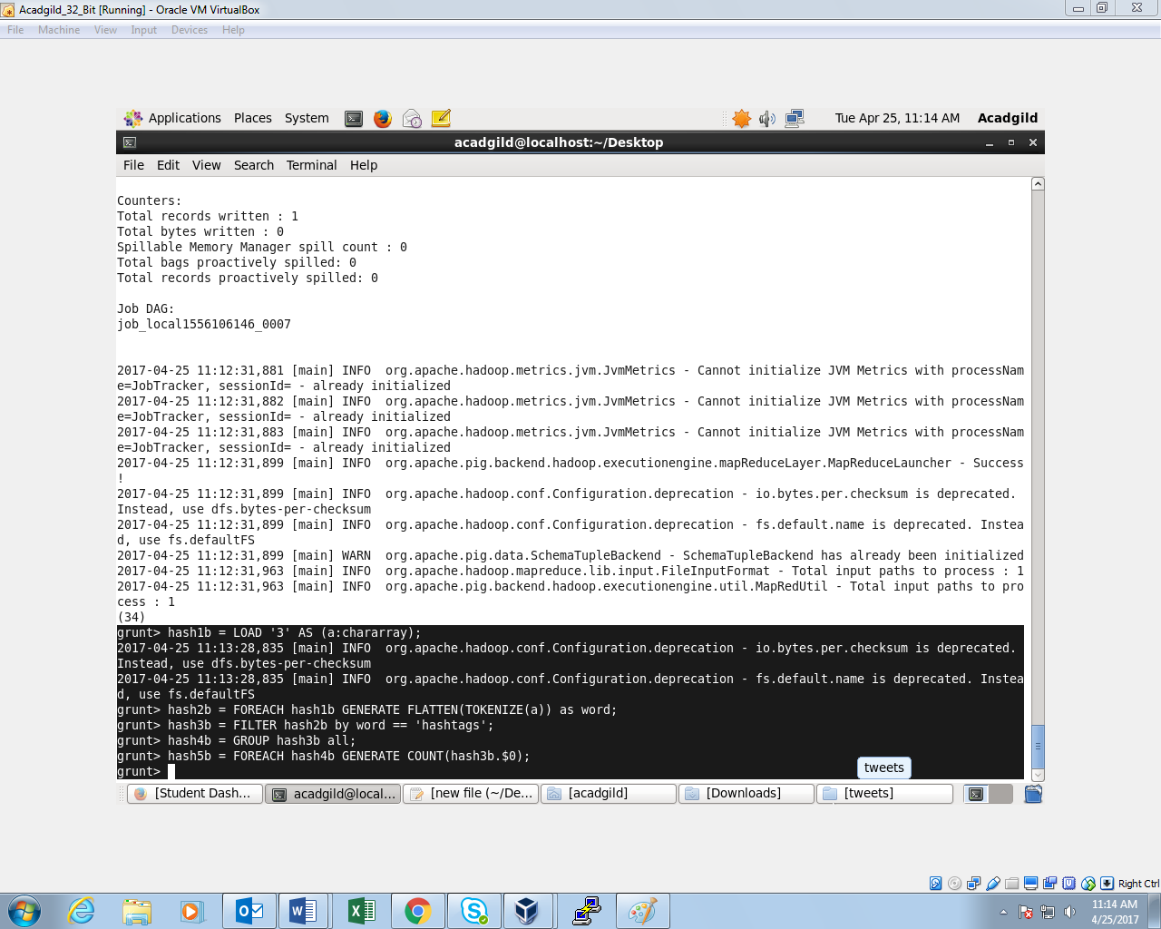

**OUTPUT:**

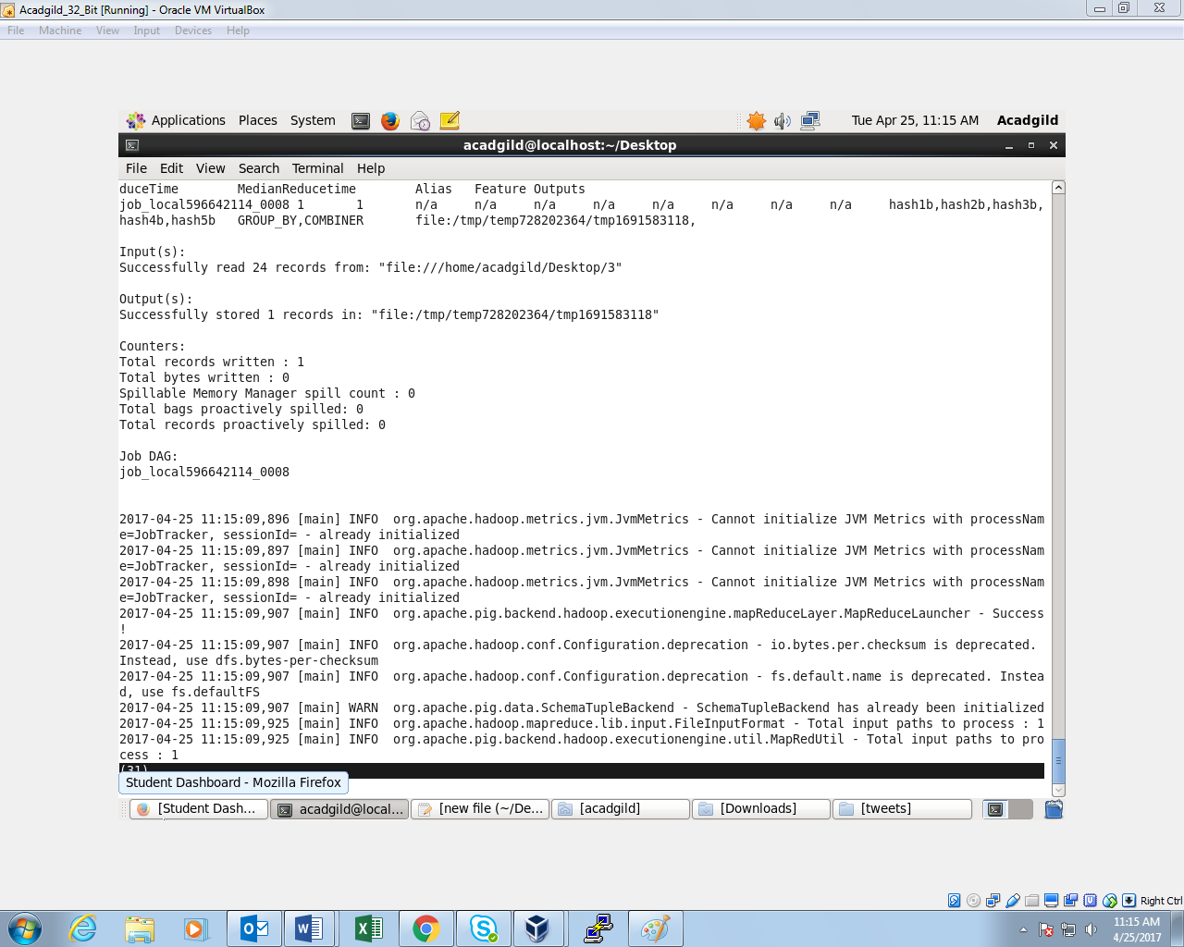

**FOURTH DATA:**

**COMMAND:**

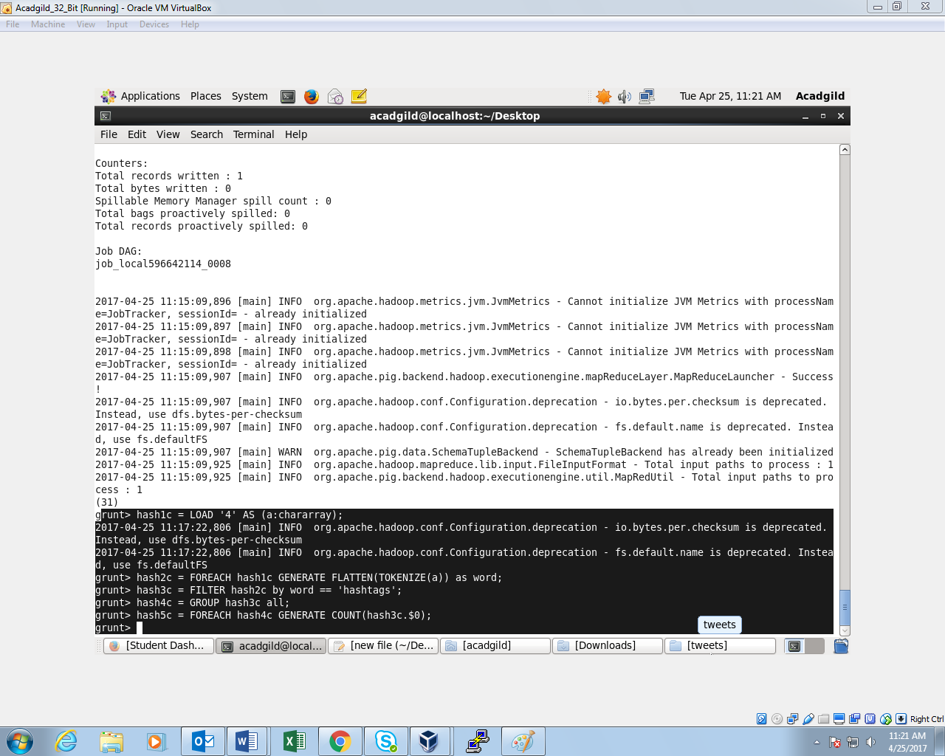

**OUTPUT:**

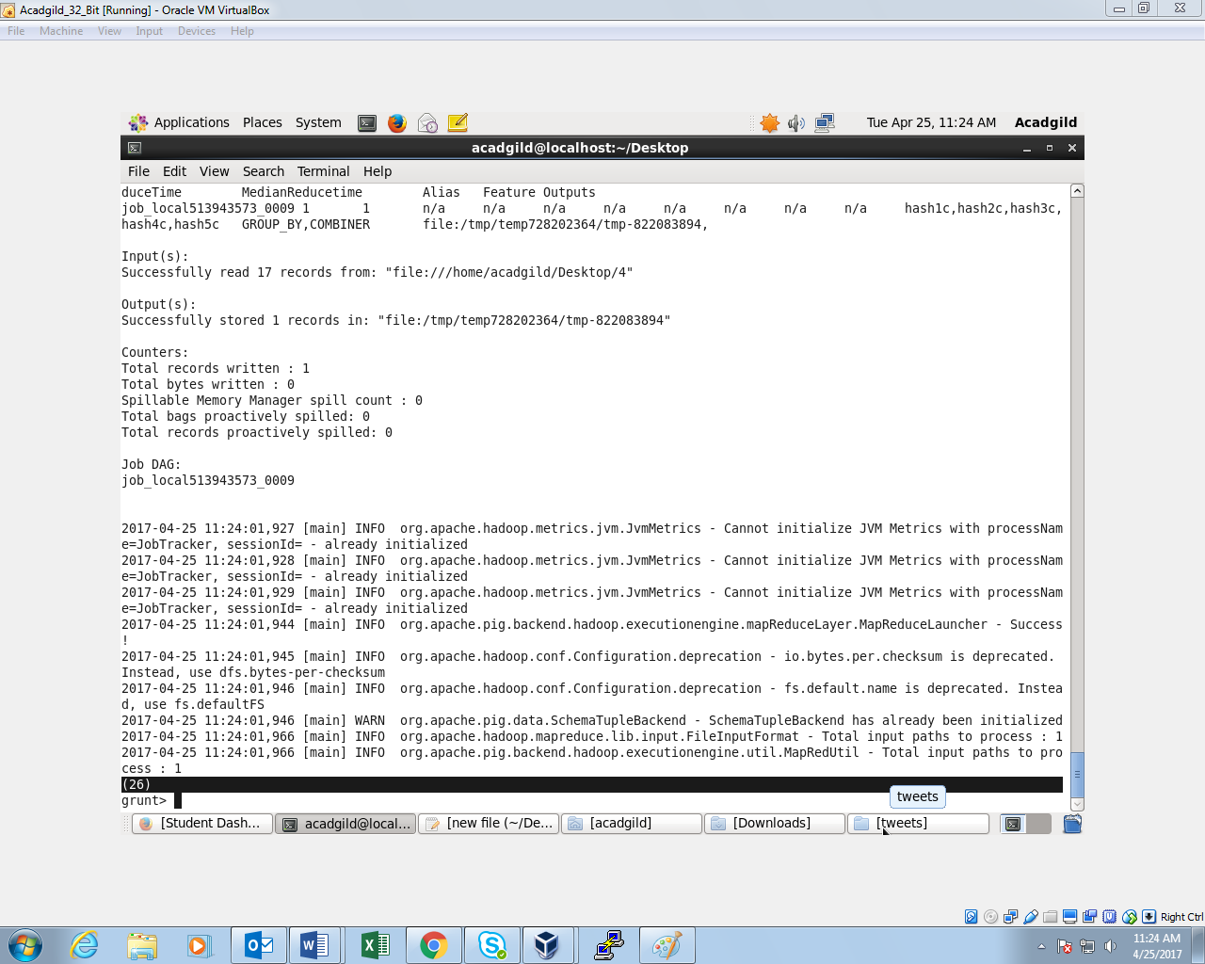

**FIFTH DATA:  
COMMAND:**

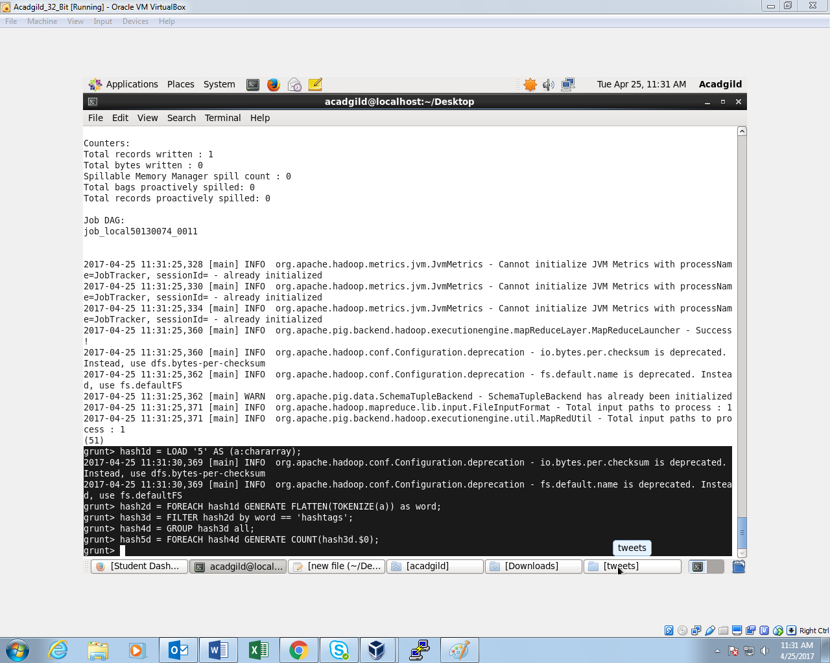

**OUTPUT:**

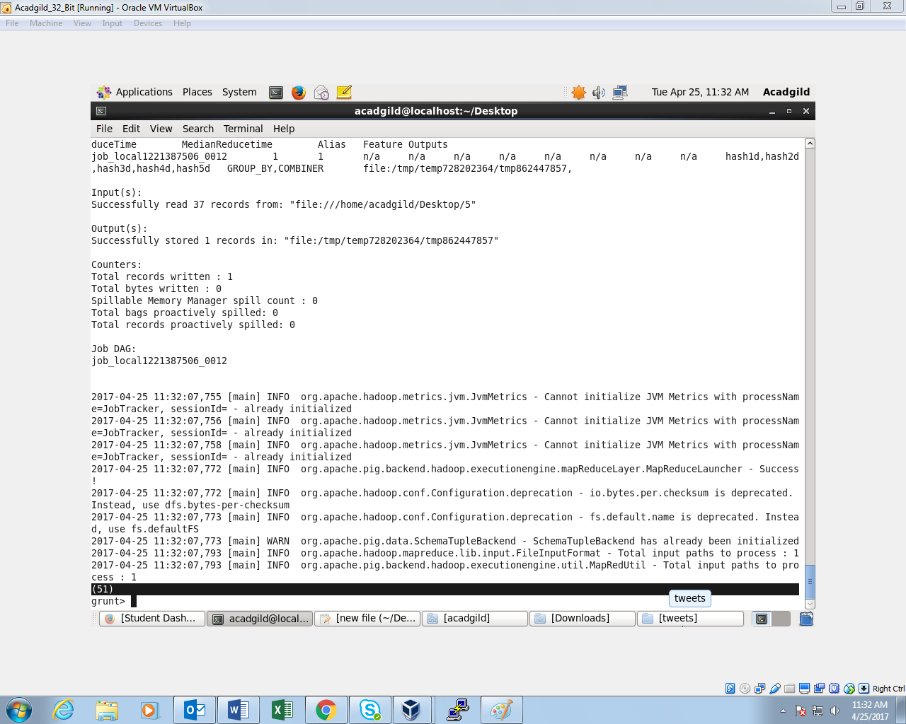

**SIXTH DATA:  
COMMAND:**

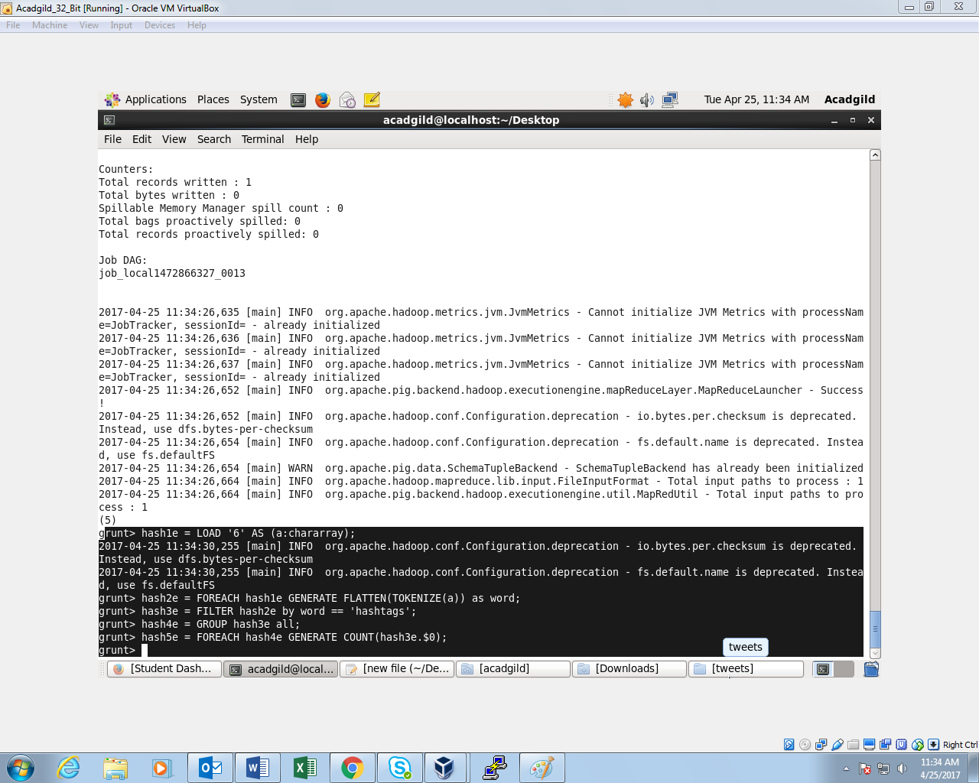

**OUTPUT:**