1. **Find the top five kinds of Google Knowledge_occupation people who were guests in the show, in a particular time period i.e., between '1/11/99' and 6/11/99. You need to write an UDF to compare the dates.**

**UDF:**

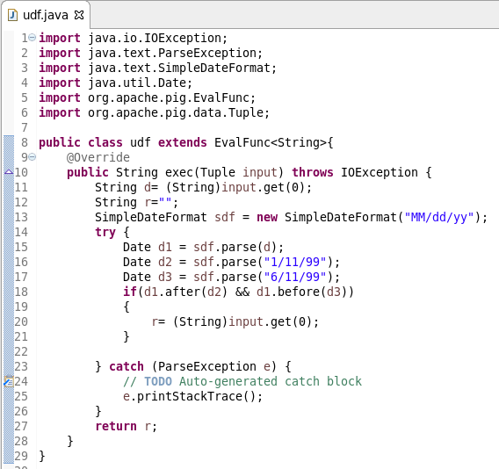

**PIG script**

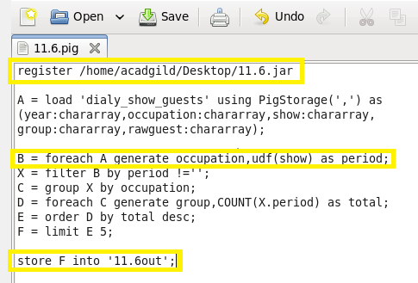

**RUNNING:**

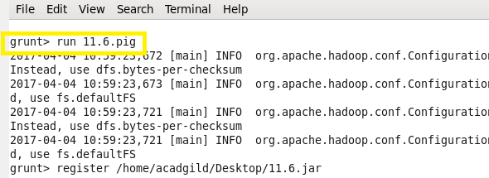

**OUTPUT:**

