**Create a flume agent that streams data from Twitter and stores it in the HDFS cluster.**

**Making a directory:**

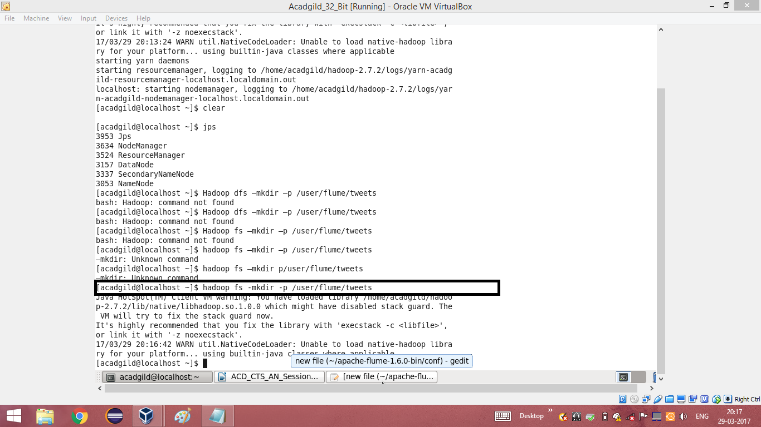

**Editing the configuration file with the generated key, consumerSecret, accessToken and accessTokenSecret.**

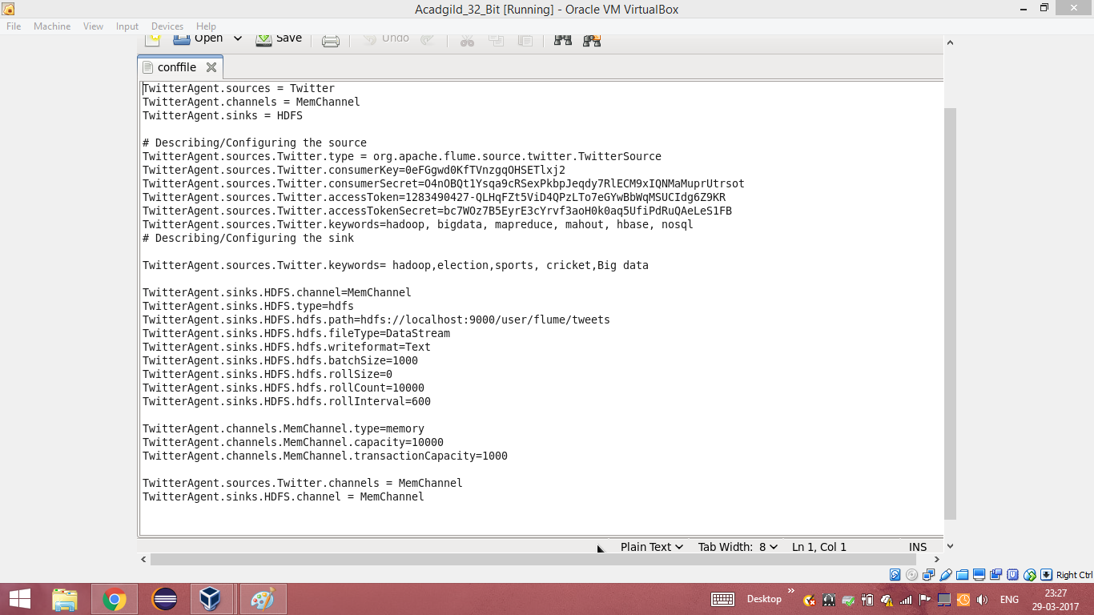

**Running flume:**

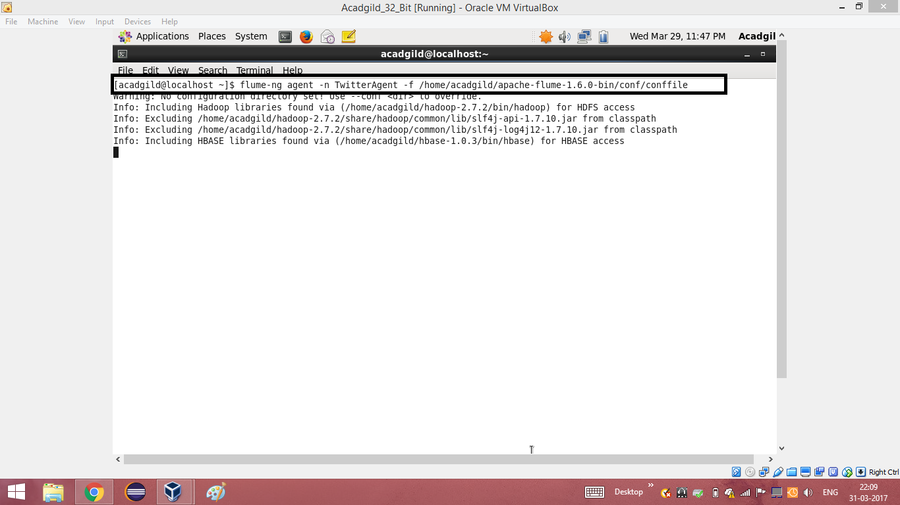

**Listing the contents and reading the data:**

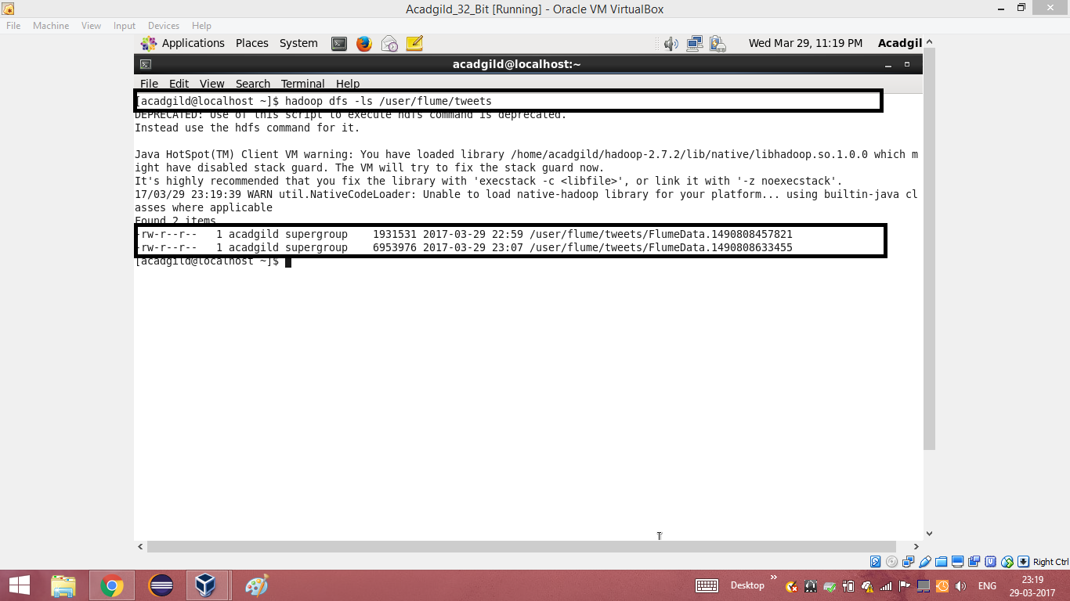

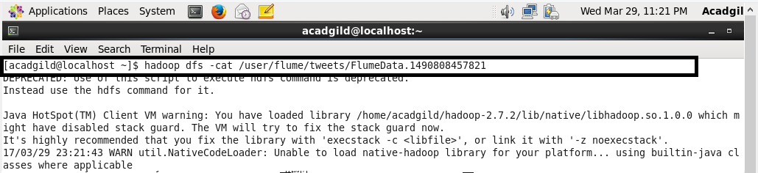

**Data taken from twitter:**

